Angora-Rabits-art - 3/18/14

"The Angora Rabbit" by Mistress Cassandra di Capalletti

NOTE: See also the files: rabbits-msg, pets-msg, rabbit-dishes-msg, fur-msg.

************************************************************************
NOTICE -

This article was submitted to me by the author for inclusion in this set of files, called Stefan's Florilegium.

These files are available on the Internet at: http://www.florilegium.org

Copyright to the contents of this file remains with the author or translator.

While the author will likely give permission for this work to be reprinted in SCA type publications, please check with the author first or check for any permissions granted at the end of this file.

Thank you,
Mark S. Harris...AKA:..Stefan li Rous
stefan at florilegium.org
************************************************************************

This article was first published in the Calon Scrolls, the Arts and Sciences newsletter for the Kingdom of Calontir, in the January 2010 Agriculture issue.

The Angora Rabbit
by Mistress Cassandra di Capalletti

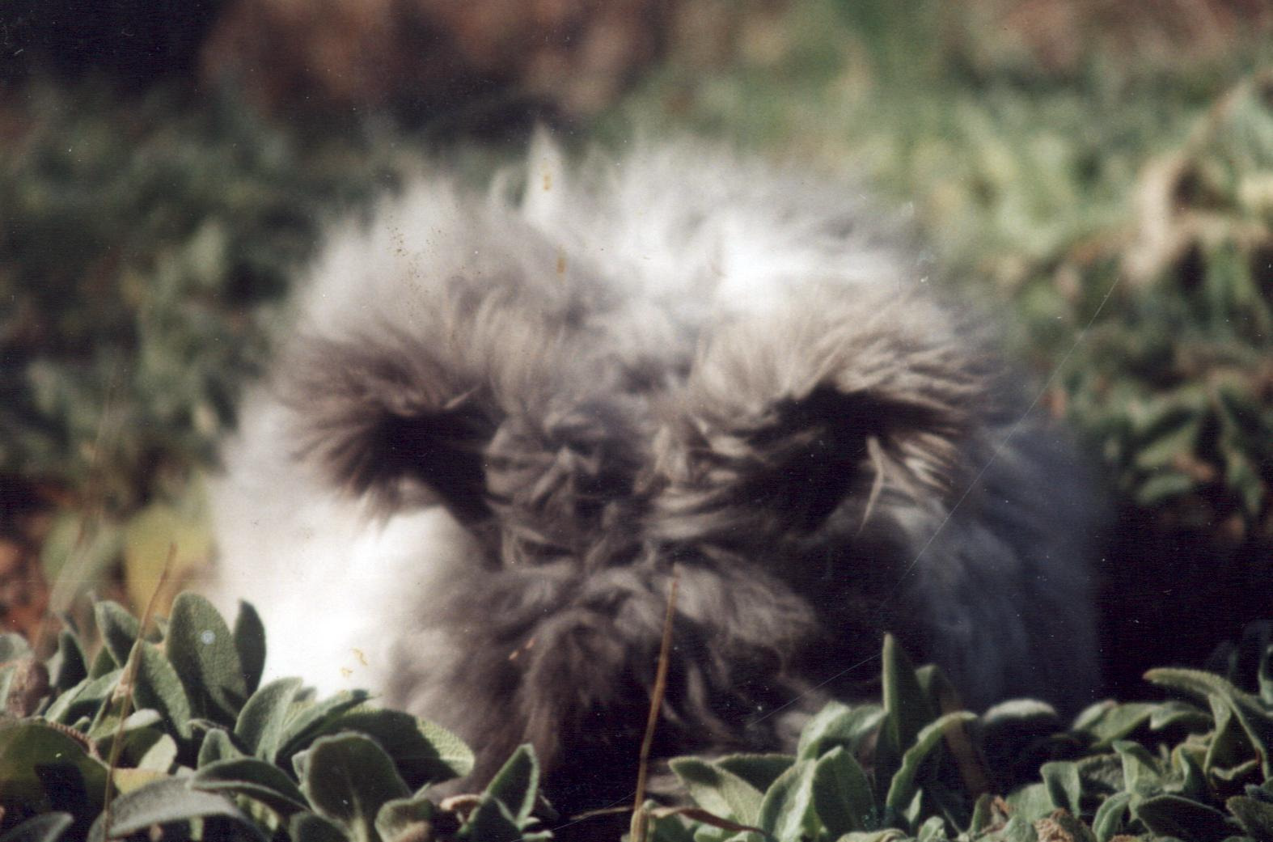

For a long time now modern Angora rabbit breeders have delighted in recounting a long and wondrous history of their beloved breed, a history supplied by an article written for the American Angora News in 1948. This article claims that the long haired rabbit originated in Angora, in Asia Minor, almost a thousand years ago, and that this is from where the breed name comes. It also claims that the Angora rabbit was worshipped in Babylon, that Genghis Khan beheaded some merchants who asked too much for the 'silk rabbit', and that the rabbits were pets in the harems of the sultan. The author gave these rabbits no less fanciful a history after Period. A lot of modern Angora documents relay this origin. Most people know that Angora rabbits come from Angora, Turkey. It's a lovely and exotic origin and we like it that way.

Yet I have searched, and found no documentation to support this Turkish origin or fanciful history. I contend that the 'Angora' label is misleading, and the Turkish background a myth, lovely as it is. Instead, I put forth that the breed originated in France between AD 1550-1600. Simply because the rabbits are named Angora does not mean that they originated there, or were even always so-called. From my research, it seems that the name was given to these lovely rabbits in the early 1700's, a hundred to a hundred and fifty years after I believe they were first bred. Mortimer reported a 'white shock (long haired) Turky Rabbet' in England in 1707, the earliest record I have found that names the breed. [1] By 1750, the 'Lapin Angora' was listed and described as a specific breed of rabbit in the French Encyclopedia of Arts and Sciences. In England at this time they were also known as the 'Silkhaired Rabbit' as export records from England to Germany show. [2]

The longhaired breed of rabbits were probably given the name 'Angora' as a descriptive term, like 'silkhaired' because they had long fur similar to the Angora goat, which does come from the Middle East. Names are often given to objects or animals that are descriptive characteristics of them, but are incorrect terminology. There are several other current rabbit breeds which carry name places in their breed name that have nothing to do with their origins—breeds that have documentation of from where they came.

Such an example is the Dutch rabbit that does not come from the Netherlands, but from England. [3] It has a unique color pattern similar to those of the Dutch Belted cattle, from whom it has probably taken its name. [4] Its cheeks, ears, and hindquarters are a color such as black or blue, while its middle and feet are white, resembling an Oreo cookie. The term "Dutch markings" is used as the definition for this color pattern in the American Rabbit Breeders Association (ARBA) guidelines for accepted colors in all breeds. [5] When a rabbit breeder/showman hears the term, they automatically picture this 'Oreo" color pattern.

.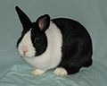
The Dutch rabbit..
(Image from the Wikimedia and permission
to use granted through theCreative Commons License)

The Himalayan rabbit, too, was named using a color-descriptive term rather than an originating place-name. These rabbits do not come from the Himalayan mountain region; they are described in Europe by Darwin. [6] Their markings are unusual, being white all over the body, except for the nose, ears, feet, and tail which are colored, such as with blue or black. This pattern shows up in other breeds, too, and is always described by the term 'Himalayan'. It is also used as definition for an accepted color category in the guidelines from ARBA. The modifier for one of the color gene pairs that controls this color pattern is called the Himi gene, although it is not restricted to the Himalayan rabbit. [7] Ask a rabbit breeder to picture either a Himalayan rabbit, or a rabbit with Himalayan markings, no matter what breed, and this color pattern will come to mind for them. The exotic history that the article in the American Angora News gives the Angora rabbit is very interesting, but not supported by any documentation that I have found.

There is the charming tale of Genghis Khan beheading merchants who asked too much for the 'silk rabbit'. I cannot disprove this particular tale unequivocally, but I can throw a lot of doubt on what I believe to be a breeder's legend. This tale is reputed to be in Marco Polo's recount of his travels in the China/Middle East region. After searching several editions published from the turn of the 16th century to the last few years, I could find no mention of this episode. The only Angora mentioned are garments made from the Angora goat wool, called 'camel' at that time. The only silk mentioned are fiber goods made from the silkworm. There are, in fact, only two references to rabbits in the entire account: one mentions rabbit carcasses sold for meat in the marketplace, and the other mentions that the Khan's gardens were stocked with many animals, including rabbits. [8] The closest reference I could find anywhere to the tale of the 'silk rabbit' was the term 'Silkhaired Rabbit' that was used in England in the 1770's. [9] I have also studied books on trade and influence between Europe and that area of the Middle East in the Middle Ages, and there is no discussion of rabbits or rabbit fur at all. Wearing rabbit fur, and the rabbit trade did not start to be popular until two centuries after Marco Polo. [10] Rabbits had not naturally spread to Mongolia in Genghis Khan's time, and are not there outside of captivity now. [11] Rabbits were not selectively bred or truly domesticated in that time, so, if the tale is true at all, these particular merchants must have had 'sports' and not a true separate breed. [12] Rabbits in the mid-thirteenth century were being kept in monasteries in western Europe, and were just then being introduced to Britain. [13]

Since longhaired rabbits were not bred in the Middle East, or in Europe at this time, it is unlikely, too, that they would have been the pets in the harems of the sultans, as delightful as that may sound. I have found no source that states that rabbits were in Mongolia at all, other than the passing reference from Marco Polo, and the assurances of the Angora News. As they were not in Mongolia, neither were they in Angora, Turkey. I have found no supporting documents that allow for the origins of the breed in Turkey; rather, all of the documentation refutes that particular point. Rabbits were not native to the Middle East, and were not domesticated there.[14] The Angora is not a separate species of rabbit, but is descended from the European wild rabbit, Oryctolagus cuniculus, as all of our modern domesticated breeds are. [15]

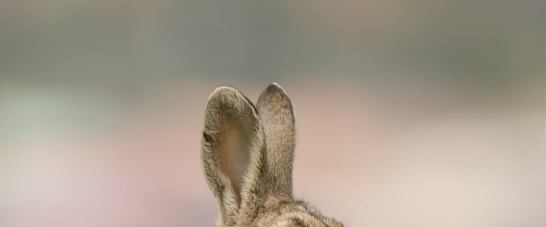
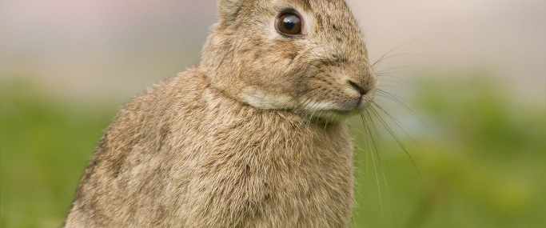
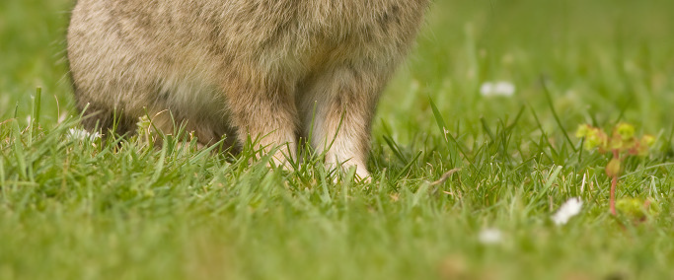

The European Wild Rabbit.
The rabbit all our modern breads are descended from.
(Image from the Wikimedia Commons and use is granted through the
Creative Commons Attribution Share Alike 3.0 Noodlesnacks.com)

The long fur would have had to have been selected for by the keepers of the rabbit warrens for it to have perpetuated. It is a domesticated breed only, for the long wool gene is recessive, and showed up as a mutation. It would not survive as a breed for very long in the wild, for the long wool would be a hindrance to the rabbit, slowing it down and getting it tangled in any briars or bushes. It would be too easy for prey to catch and devour. The rabbits cannot take care of the long, easily matted, coats by themselves, but must be cared for by their human owners and caretakers. To understand how the Angora rabbit may have started as a separate breed, we first need to understand the history and domestication of the European wild rabbit from which it is descended and from which it diverged.

Rabbit fossils are found in the Iberian Peninsula and Spain dating to the Pleistocene era, and seem to have stayed in that area, without humans to interfere. The Phoenicians, who were known as a sailing people, recorded rabbits in Spain around 1100 BC. [16] There are no fossil records of rabbits anywhere in Asia.[17] It would seem that human interaction and encouragement are the pivotal factors for the rabbit's habitation in the rest of western Europe and the British Isles, for naturally they spread very slowly.[18]

The Romans and the Phoenicians transported them to northern Africa and further western Europe. They did not domesticate these animals or rather, did no selective breeding, but instead kept them in man-controlled natural habitats called 'leporaria' in order to hunt them for sport and fatten them for the table. [19] Varro in 36 BC suggested keeping rabbits in these leporaria, as hares were already being kept there.[20] Polybius in 204 BC recorded rabbits in Corsica [21], and Stratus described problems stemming from a breeding pair in the Baleric Islands in 30 BC [22}, and by AD 230 Athenaeus described rabbits in Italy. [23]

The records are relatively quiet regarding new developments in the rabbit-human relationship for the next several hundred years during the Dark Ages, until the Middle Ages, where they hop back into the limelight and where they have stayed ever since.

Monasteries and landed gentry began to be the primary warren-keepers between 600-1000 in western Europe, and began to export them to other European areas. [24] In 1135, the British records show rabbits on Drake Island, and on Skilly Isle by 1176. They reached the British mainland by 1235. [25] In 1221 several purchases were made between abbeys in France and Germany. [26] All the records show rabbits in Europe, but none in Asia Minor. The wild rabbit is European and, since the Angora rabbit is domesticated from the wild rabbit, it is European.

The French Monks are the ones attributed with true domestication and selective breeding of rabbits. [27] They had various reasons for keeping them in close quarters. First, the Catholic Church did not consider the unborn rabbits, called laurices, meat, and so they could be eaten during religious fasts such as during Lent. [28] Secondly, rabbits were kept as pets and companions, as evidenced by the complaints of William Wykeham in 1387 about the nuns



Modern photo of Dolebury Hill Fort.
Image taken by John Thorn, and licensed for reuse under the Creative Commons License.
Link to his image at the end of article.

bringing their rabbits into the church with them during religious services. [29] Not lastly, there was money to be made from the trade and sale of not just the animals themselves, but from the fur as well. Trade records show a thriving and popular rabbit fur trade. By 1555, rabbit skins were a significant part of English export. [30]

Since rabbits were popular at that time, and kept tended, it is only natural that humans
should start breeding traits in them that they considered desirable. This selective breeding, the perpetuance of a desired characteristic by mating pairs that do or may carry that characteristic, started here, in the mid-1500's. [31] Rabbits were kept by the monasteries or landed gentry in either cages or open colonies in manmade and tended warrens. They tunneled in the man-made hills and ate the leftover brewing grains from the monks' brewery, and scraps from the garden. [32] Colonies are groups of rabbits, usually one male and several females in a group, that are put together to live and mate. In cages, or in these colonies, selective breeding could easily have taken place.

Since the rabbits were not living in the wild, but were protected, predators had less chance to destroy them. With the removal of such natural threats, genetic mutations called 'sports' could survive. The long coat of an Angora is just such a sport. The problems the long coat would cause in the wild are mentioned in this report earlier. The longer the coat, the more problems the rabbit would have. There are several reasons why the long fur would have been selected for and perpetuated. Rabbit fur was very popular to wear already, and Angora is an extremely soft, luxurious fiber that is warmer than other types of wool. It would have produced a fine pelt. Angora is also fine for spinning, and since it only needs to be plucked or cut off the rabbit, its productivity is increased. The coat can grow again, and again, and again. Pliny mentions in his Natural History that spinners wished for longer rabbit fur that would be easier to spin. When spun and knitted or woven, Angora makes a soft, beautiful, very warm garment. It also felts very well, and felt was used for hats and to line shoes. [33] Rabbits were also kept as pets and Angoras, because of the handling that the care and harvest of the coat requires, are tame and companionable as well as beautiful.

In this time when selective breeding was first being practiced, we can start to narrow down the true point of the line's origin. We can do this by studying trade records of that time, as well as by studying artifacts of the popular culture. The mid-fifteen hundreds were a big time for rabbit fur trade, being second only to sheep wool. [34] Fur trade records from 1555 in England, a country that traded with all of Europe and the Middle East, show three kinds of rabbit fur being imported/exported. The wild rabbit, agouti, pelt was the most common. After that was the black color, which we can tell was more rare because the price for that color is five times that of the agouti. [36] The third kind is that which we now call the Silver Fox, that is, black which is tipped in silver. The silver-black fur was the most rare of all at that time, since it was five to ten times the price of the black fur. [37]

There is, however, no mention of long fur traded, or pelts with long fur, or rabbits with long fur. So we can assume that either the Angora rabbit was not yet in existence at this time, or was not yet established enough for its fur to be exported.

I have not been able, after searching literally hundreds of books, and museum collections, to find any depiction of an Angora rabbit dated before this time, or during this time. I have found no paintings, engravings, illuminations, tapestries, statues, or carvings that show a rabbit with long fur before the sixteen-hundreds. Texts regarding the wild rabbit and domesticated breeds and their histories all agree that there were no separate breeds or selective breeding of rabbits before the mid-sixteenth century. [38] So Angora rabbits were probably not bred before
1550.

In order to narrow down the time frame that Angoras must have originated in, we must now jump ahead in time. We need to move from the Elizabethan/Renaissance time where rabbits were starting to be selectively bred, to the time of Louis XIV of France, which is the time when my earliest documentation of Angora rabbits exists. The earliest dated pictures I have found are 1660's French miniatures of the devices in the tapestries of the French royalty. [39] They both show an Angora-type rabbit, or rabbit sporting the long hair and body style characteristics of Angoras. These miniatures were painted later than the tapestries were woven (1630s – 1640s) as a boon of the king to display to the public the beauty of the royal tapestries. [40] Engravings made by Sebastian Leclerc of these same devices in the 1660s also show the same two Angora rabbits.[41] The photo following the miniatures is one of my English type of Angora, which has the head furnishings and ear tasseling. I used to raise and show this breed and am familiar with the breed's characteristics.

It is clearly the same (minus the furnishings, which were a trait developed later in Britain). Modern French Angoras look only slightly different than the ones in the paintings, being bigger and longer-bodied nowadays. Using these depictions, I can surmise the following, using several paths of logic: the longhaired rabbit was an established breed by the time of the tapestries, in the 1640's. As mentioned before, the long fur is a genetic mutation, and must have first been found as a 'sport'. This sport was found and perpetuated, using selective breeding. It would have taken many years for the mutation to breed true. Rabbit genetics have been studied and are well known, mainly because the rabbit is a common laboratory research animal. Hereditary factors have been firmly established regarding coat color and length.

Rabbit chromosomes come in pairs, one chromosome inherited from the father, and one from the mother. [42] The long fur gene pair, ll, is doubly recessive to the normal dominant short fur pair gene, LL, [43] So if a rabbit with the normal short fur genes (LL) is mated with a longhaired rabbit (ll), all of their offspring will have short fur because the dominant short fur genes will overrule the recessive long fur genes.

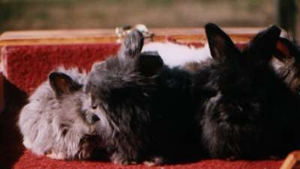

From left to right: lilac, blue, white black baby Angoras.
The white is the most recessive, then lilac, blue, and finally black.

So even if a parent rabbit has one dominant short fur gene, L, and one long fur gene l, inherited from the mother or father (giving him a fur gene pair of Ll), some of his offspring will have short fur. This is true even if he is mated with a longhaired rabbit.

Both parents have to carry the ll genes for all of their offspring to have long fur. The black color of the rabbit in the first picture also indicates that it is from an established breed.

There are five gene pairs that control the color of rabbits, and several modifiers. [44] The natural color, wild gray, has all five pairs as double dominants. The first pair, called the agouti color gene pair is AA. [45] Agouti is the wild rabbit pattern; it shows three colors (what Castle labeled as black, yellow, and red in his experiments) on the hair shaft. An example of an agouti rabbit is the one found in the second picture of this report. This mottled coloring is what provides the camouflage for wild rabbits. The solid black color of the rabbit in the miniature is a mutation, and was selected for; it, too, would have been a hindrance to the survival of the rabbit since it does not camouflage. The gene pair that controls that only one color is shown on the hair shaft is the non-agouti gene pair aa, which again, is doubly recessive to the agouti AA. [46] Any parent having the agouti genes (AA) negates solid color in all of its offspring, even if its mate is solid black. In any parent having one agouti gene and one non-agouti gene (Aa), the agouti gene negates the solid color in at least some of its offspring, no matter if its mate is solid black. Both parents have to carry the double non-agouti genes aa for all of their offspring to be non-agouti.

The fact that the rabbit in the miniatures is not only longhaired, but also black, suggests that it comes from an established line or breed. It takes several years for such recessive phenotypes to breed true by themselves, let alone both together. This is especially so since the rabbits must have been consistently inbred, and this causes genetic problems. The rabbit breeders in the Middle Ages probably used culling of problem animals as a means of selecting.

It takes time to breed selectively, even given people who are familiar with genetics. I, in my rabbitry, have tried for years to breed for two select colors, red and sable. I know what color genetics every rabbit in my barn carries, and I even know which mother and father have the color genetics to produce offspring that would be red or sable. Yet I have only been successful in having two litters carrying any babies that were sable, and none that were red. Unfortunately, the sable offspring I did have, died. Besides being a personal loss I am set back another few years in my colorbreeding program. This likely happened in the Middle Ages, too. I use selective breeding to improve the quality, length, and color of the wool on my rabbits, much as the monks did to start the woolly breed in the beginning.

There is not only the genetics that suggest these Angora-type rabbits in the tapestries are from an established line, but the fact that they are in royal tapestries supports it. A connection to the king, and royalty, and to be put on display as such, concludes the theory that the longhaired breed was an established one. It must have been bred for decades to be so established. Now, then, we can narrow down the timeframe in which the Angora rabbit originated. I think it is safe to say that the Angora mutation was found and bred for before 1600 for it to become in 40 years established enough to be painted in connection with the king.

During the latter half of the sixteenth century there were several new mutations bred for; by the very early 1600s several colors such as black, white, broken (or pied), and yellow existed. [47] It was the age of science, the Renaissance. Hutches were in use, and selective breeding must have been practiced. So it seems clear that the Angora rabbit breed started between 1550 and 1600. I place the origin of the breed in France. I do this for several reasons. The French monasteries were the ones to domesticate rabbits. The tapestries showing the Angoras are French also. We can also use process of elimination— the rabbits obviously started in western Europe, and the Angoras were not exported to Italy and England until the early 1700s, and not to Germany until the 1770s. [48] From there they traveled to Austria, Poland, and Holland. [49] By 1750, the Angora label was already firmly established in France, being in the Encyclopedia. The French were also the ones known for their production of Angora wool garments, and were the ones to invent machines that could handle the delicate fibers to start mass production in the 1700s. [50] By then our breed was firmly established and named. It is a beautiful name, and wonderfully descriptive. Most people know from the name alone that the rabbits have long hair. While it is a beautiful name, reminiscent of an exotic and oriental origin, it is misleading because there is no such origin.

The Angora is a domestic breed descended from the European wild rabbit that originates in Spain. There are no rabbits which originate from the Middle East. Rabbits were not domesticated in the Middle East. It was the European monasteries, which started selective breeding in the sixteenth century. It was in the sixteenth century in Europe that several mutations were bred, such as recessive colors and coat textures.

It is here that the Angora mutation occurred. In the 1550s there is no mention of long rabbit fur being traded, in detailed records, and no depiction of a longhaired rabbit that I have found. By the 1640s there are two longhaired rabbits in the royal French tapestries, showing a longhaired breed had been established, and for some time. So the Angora rabbit was probably bred in late period, between 1550-1600. It was bred in Europe, and originates there, rather than Turkey. It was not even until the 1700s that the breed was given the Angora name.

This true origin is maybe not as exotic or as fancy as we breeders have liked to believe, but it does show a long, wonderful history just the same.

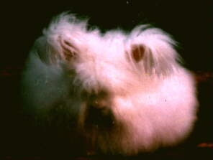

Link to warren image by John Thorn:
<div xmlns:cc="http://creativecommons.org/ns#"about="http://www.geograph.org.uk/photo/91861"><a rel="cc:attributionURL" property="cc:attributionName"
href="http://www.geograph.org.uk/profile/3253">JohnThorn</a> / <a rel="license"
href="http://creativecommons.org/licenses/by-sa/2.0/">CCBY-SA 2.0</a></div>

NOTES

[1] Lynne, Erica Angora: a Handbook for Spinners. Interweavers Press: Colorado, 1992
Sandford, J.C. The Domestic Rabbit. British Rabbit Council: London, 1996

[2] "Angora Wool (from rabbits) Causing Confusion." Angora Journal Dec. 1927

[3] "Rabbit." The Encyclopedia Americana, International ed. vol 23,Grolier Inc.: Connecticut, 1991.

[4] "Rabbit." Cyclopedia of American Agriculture. vol III. L.H. Bailey, ed. MacMillan Co: London, 1910.

[5] American Rabbit Breeders Association. The Standard of Perfection 1996-2000 Iowa, 1996.

[6] "Rabbit." The Encyclopedia Britannica. vol 22. Charles Scribner's Sons: New York, 1886.
Darwin, Charles Animals and Plants Under Domestication. Gramercy Books: New York, 1981.

[7] American Rabbit Breeders Association. The Standard of Perfection 1996-2000 Iowa, 1996.

[8] Frampton, J. The Most Noble and Famous Travels of Marcus Paulus in to the East Partes of the World. published 1579. Reissued with introduction and maps by N.M. Penzer, 1929.

Polo, Marco The Travels. Penguin Books: New York, 1991

Polo, Marco The Travels. Orion Press: New York, 1965

[9] Sandford, J.C. The Domestic Rabbit. British Rabbit Council: London, 1996

[10] "Rabbit." Chamber's Encyclopedia. vol 1. W & R Chambers: Edinburgh, 1877. Blair, John and Nigel Ramsay, eds. English Medieval Industries. Hambledon Press: London, 1991.

Veale, Elspeth The English Fur Trade in the Later Middle Ages. Clarendon Press: Oxford, 1966.

"Angora Wool (from rabbits) Causing Confusion." Angora Journal Dec. 1927

[11] "Rabbit." The Encyclopedia Americana, International ed. vol 23,
Grolier Inc.: Connecticut, 1991.
Walker, Ernest P. Mammals of the World. vol 2. John Hopkins Press: Baltimore, 1964.

Thompson, Harry V. and Carolyn King. The European Rabbit: the History and Biology of a Successful Colonizer. Oxford University Press: New York, 1994.

Sheail, John Rabbits and Their History. Newton Abbot, 1971.

Sandford, J.C. The Domestic Rabbit. British Rabbit Council: London, 1996

[12] Thompson, Harry V. and Carolyn King The European Rabbit: the History and
Biology of a Successful Colonizer. Oxford University Press: New York, 1994.

Lynne, Erica Angora: a Handbook for Spinners. Interweavers Press: Colorado, 1992

Sandford, J.C. The Domestic Rabbit. British Rabbit Council: London, 1996

Sheail, John Rabbits and Their History. Newton Abbot, 1971.

Weisbroth, Steve The Biology of the Laboratory Rabbit. Academic Press: New York, 1974

[13] IBID

[14] "Rabbit." The Encyclopedia Americana, International ed. vol 23, Grolier Inc.: Connecticut, 1991.

Walker, Ernest P. Mammals of the World. vol 2. John Hopkins Press: Baltimore, 1964.

"Rabbit." The Encyclopedia Britannica. vol 22. Charles Scribner's Sons: New York, 1886.

Clutton-Brock, Juliet Domesticated Animals from Early Times. University of Texas Press: Austin, 1981.

Thompson, Harry V. and Carolyn King The European Rabbit: the History and Biology of a Successful Colonizer. Oxford University Press: New York, 1994.

Sandford, J.C. The Domestic Rabbit. British Rabbit Council: London, 1996

Sheail, John Rabbits and Their History. Newton Abbot, 1971.

Weisbroth, Steve The Biology of the Laboratory Rabbit. Academic Press: New York, 1974.

"Lapin." Dictionaire Raisonne de Sciences, des Arts et des Metiers, vol XI, Briasson ed.:Paris, 1757 (original book).

"Lapin." Dictionaire Raisonne de Sciences, des Arts et des Metiers, vol XI, Briasson ed.:Paris 1782

Darwin, Charles The Origin of the Species. Gramercy Books: New York, 1979.

[15] IBID

[16] Thompson, Harry V. and Carolyn King The European Rabbit: the History and Biology of a Successful Colonizer. Oxford University Press: New York, 1994.

Sandford, J.C. The Domestic Rabbit. British Rabbit Council: London, 1996.

[17] IBID

[18] IBID

[19] Thompson, Harry V. and Carolyn King The European Rabbit: the History and Biology of a Successful Colonizer. Oxford University Press: New York, 1994.

Lynne, Erica Angora: a Handbook for Spinners. Interweavers Press: Colorado, 1992.

[20] Thompson, Harry V. and Carolyn King The European Rabbit: the History and Biology of a Successful Colonizer. Oxford University Press: New York, 1994.

Clutton-Brock, Juliet Domesticated Animals from Early Times. University of Texas Press: Austin, 1981.

Sandford, J.C. The Domestic Rabbit. British Rabbit Council: London, 1996.

[21] IBID

[22] IBID

[23] IBID

[24] Thompson, Harry V. and Carolyn King The European Rabbit: the History and Biology of a Successful Colonizer. Oxford University Press: New York, 1994.

Sandford, J.C. The Domestic Rabbit. British Rabbit Council: London, 1996.

[25] Veale, Elspeth The English Fur Trade in the Later Middle Ages. Clarendon
Press: Oxford, 1966.

Sheail, John Rabbits and Their History. Newton Abbot, 1971.

[26] IBID

[27] Clutton-Brock, Juliet Domesticated Animals from Early Times. University of Texas Press: Austin, 1981.

Thompson, Harry V. and Carolyn King The European Rabbit: the History and Biology
of a Successful Colonizer. Oxford University Press: New York, 1994.

Sandford, J.C. The Domestic Rabbit. British Rabbit Council: London, 1996.

Sheail, John Rabbits and Their History. Newton Abbot, 1971.

Weisbroth, Steve The Biology of the Laboratory Rabbit. Academic Press: New York, 1974.

[28] Clutton-Brock, Juliet Domesticated Animals from Early Times. University of Texas Press: Austin, 1981.

Thompson, Harry V. and Carolyn King The European Rabbit: the History and Biology of a Successful Colonizer. Oxford University Press: New York, 1994.

[29] Power, Eileen Medieval People. Barnes & Noble Books: New York, 1924.

Salisbury, Joyce The Beast Within: Animals in the Middle Ages. Routledge: New York, 1994.

[30] Blair, John and Nigel Ramsay, eds. English Medieval Industries. Hambledon Press: London, 1991.

Veale, Elspeth The English Fur Trade in the Later Middle Ages. Clarendon Press: Oxford, 1966.

[31] Thompson, Harry V. and Carolyn King The European Rabbit: the History and Biology of a Successful Colonizer. Oxford University Press: New York, 1994.

Sandford, J.C. The Domestic Rabbit. British Rabbit Council: London, 1996.

Sheail, John Rabbits and Their History. Newton Abbot, 1971.

Weisbroth, Steve The Biology of the Laboratory Rabbit. Academic Press: New York, 1974.

[32] Bement, C. N. Rabbit Fancier. Orange Judd & co.: New York, 1852.

[33] Blair, John and Nigel Ramsay, eds. English Medieval Industries. Hambledon Press: London, 1991.

Veale, Elspeth The English Fur Trade in the Later Middle Ages. Clarendon Press: Oxford, 1966.

[34] Veale, Elspeth The English Fur Trade in the Later Middle Ages. Clarendon Press: Oxford, 1966.

[35] Blair, John and Nigel Ramsay, eds. English Medieval Industries. Hambledon Press: London, 1991.

[36] IBID

[37] IBID

[38] Lynne, Erica Angora: a Handbook for Spinners. Interweavers Press: Colorado, 1992.

"Angora Wool (from rabbits) Causing Confusion." Angora Journal Dec. 1927.

Sandford, J.C. The Domestic Rabbit. British Rabbit Council: London, 1996

[39] Grivel, Marianne and Marc Fumaroli Devises pour les Tapisseries du Roi. Herscher: Paris, 1988.

[40] IBID

[41] Grivel, Marianne and Marc Fumaroli Devises pour les Tapisseries du Roi. Herscher: Paris, 1988.

Bunker, Peter The Fabrication of Louis XIV. Yale University Press: New Haven, 1992.

[42] Bates, Beverly Plain Talk About Color Breeding for the Beginner. author, 1994.

Castle, W.E. Contributions to the Genetics of the Domestic Rabbit. Carnegie Institution of Washington: Washington, 1932.

Dugan, Pat Basics in (color) Genetics. author, 1994.

Castle, W.E. Heredity of Coat Characteristics in Guinea Pigs and Rabbits. Carnegie
Institution of Washington: Washington, 1905.

Haenszel, Candy Color Genetics in Angora Rabbits. Author: Indiana, 1989.

Kilfoyle, Sharon and Leslie Samson Completely Angora. Samson Angoras: Ontario, 1988.

National Angora Rabbit Breeders Club "Color Genetics of the Angora Rabbit." National Angora Rabbit Breeders Club Guidebook. Amanda Richardson, ed. M & D Printing Co.: Illinois, 1992.

Weisbroth, Steve The Biology of the Laboratory Rabbit. Academic Press: New York, 1974.

[43] IBID

[44] IBID

[45] IBID

[46] IBID

[47] Sandford, J.C. The Domestic Rabbit. British Rabbit Council: London, 1996.

[48] IBID

[49] IBID

[50] Kelly, Sandy "Origin of the Angora Rabbit." Northern California Angora Guild Handbook Kathy Spalding and Chris McLelland, eds. 2nd ed.:California, 1991.

Bibliography

American Rabbit Breeders Association. The Standard of Perfection 1996-2000 Illinois, 1996.

"Angora" Chamber's Encyclopedia vol. 1. Edinburgh, 1877.

"Angora Wool (from rabbits) Causing Confusion." Angora Journal Dec. 1927.

Bates, Beverly Plain Talk About Color Breeding for the Beginner. author, 1994.

Bement, C. N. Rabbit Fancier. Orange Judd & co.: New York, 1852.

Blair, John and Nigel Ramsay, eds. English Medieval Industries. Hambledon Press: London, 1991.

Bunker, Peter The Fabrication of Louis XIV. Yale University Press: New Haven, 1992.

Burkhart, Frederick, ed. Charles Darwin's Letters 1825-1859. Cambridge University Press: Cambridge, 1996.

Castle, W.E. Contributions to the Genetics of the Domestic Rabbit. Carnegie Institution
of Washington: Washington, 1932.

Castle, W.E. Heredity of Coat Characteristics in Guinea Pigs and Rabbits. Carnegie Institution of Washington: Washington, 1905.

Clutton-Brock, Juliet Domesticated Animals from Early Times. University of Texas Press: Austin, 1981.

Darwin, Charles The Origin of the Species. Gramercy Books: New York, 1979.

Darwin, Charles Animals and Plants Under Domestication. Gramercy Books: New York 1981.

Du XIX Siecle. Vol. X, Administration du Grand Dictionaire Universal: Paris, 1873.

Dugan, Pat Basics in (color) Genetics. author, 1994.

Frampton, J. The Most Noble and Famous Travels of Marcus Paulus in to the East Partes of the World., 1579. Reissued with introduction and maps by N.M. Penzer, 1929.

Grivel, Marianne and Marc Fumaroli Devises pour les Tapisseries du Roi. Herscher: Paris, 1988.

Haenszel, Candy Color Genetics in Angora Rabbits. Author: Indiana, 1989.

Hulbert, Doretta "Modernizing the Ancient—Early History of the Angora ." American Rabbit Journal Oct 1957: 165.

Kelly, Sandy "Origin of the Angora Rabbit." Northern California Angora Guild Handbook Kathy Spalding and Chris McLelland, eds. 2nd ed.:California, 1991.

Kemp, Elizabeth H. "History of the Angora Rabbit." American Angora News 3 (3-4) ( Nov-Dec 1948).

Kilfoyle, Sharon and Leslie Samson Completely Angora. Samson Angoras: Ontario, 1988.

"Lapin." Dictionaire Raisonne de Sciences, des Arts et des Metiers, vol XI, Briasson ed.:Paris, 1757. (original)

"Lapin." Dictionaire Raisonne de Sciences, des Arts et des Metiers, vol XI, Briasson ed.:Paris 1782. (original)

"Leporidae." The Penny Cyclopaedia vol XIII, Charles Knight & Co.:London, 1889.

"Lepus." Nicholson's British Enclyclopedia of Arts or Dictionary and Sciences.2nd American ed., Mitchell, Ames, & White: Philadelphia, 1818.

Lynne, Erica Angora: a Handbook for Spinners. Interweavers Press: Colorado, 1992.

Meek, Marcellus "The Origin, History, and Full Descriptions of All Recognized Varieties of Domestic Rabbits." The Standard of Perfection for American Domestic Rabbits. American Rabbit Breeders Association: Los Angeles, 1927.

National Angora Rabbit Breeders Club "History of the Angora Rabbit." National Angora Rabbit Breeders Club Guidebook. Amanda Richardson, ed. M & D Printing Co.: Illinois, 1992.

National Angora Rabbit Breeders Club "Color Genetics of the Angora Rabbit." National Angora Rabbit Breeders Club Guidebook. Amanda Richardson, ed. M & D Printing Co.: Illinois, 1992.

Pliny Natural History. Penguin Books: New York, 1992.

Polo, Marco The Travels. Penguin Books: New York, 1991.

Polo, Marco The Travels. Orion Press: New York, 1965.

Polybius The Rise and Fall of the Roman Empire. Penguin Books: New York, 1979.

Power, Eileen Medieval People. Barnes & Noble Books: New York, 1924.

"Rabbit." The Encyclopedia Americana, International ed. vol 23, Grolier Inc.: Connecticut, 1991.

"Rabbit." Cyclopedia of American Agriculture. Vol III. L.H. Bailey, ed. MacMillan Co: London, 1910.

"Rabbit." The New International Encyclopedia. Vol 14. Daniel Coit Gillman Dodd, ed. Mead & Co.: New York, 1903.

"Rabbit." The Standard American Encyclopedia of Arts, Sciences, History, Biography, Geography, Statistics, and General Knowledge. vol VI John Clark Ridpath, ed. American Publishing Co.: New York, 1900.

"Rabbit." The Encyclopedia Britannica. vol 22. Charles Scribner's Sons: New York, 1886.

"Rabbit." Chamber's Encyclopedia. vol 1. W & R Chambers: Edinburgh, 1877.

Salisbury, Joyce The Beast Within: Animals in the Middle Ages. Routledge: New York, 1994.

Sandford, J.C. The Domestic Rabbit. British Rabbit Council: London, 1996.

Sheail, John Rabbits and Their History. Newton Abbot, 1971.

Thompson, Harry V. and Carolyn King The European Rabbit: the History and Biology of a Successful Colonizer. Oxford University Press: New York, 1994.

Travels of Sir John Mandville, The. C.W.R.D. Mosely, trans. Penguin Books, New York, 1983.

Veale, Elspeth The English Fur Trade in the Later Middle Ages. Clarendon Press: Oxford, 1966.

Walker, Ernest P. Mammals of the World. vol 2. John Hopkins Press: Baltimore, 1964.

Weisbroth, Steve The Biology of the Laboratory Rabbit. Academic Press: New York, 1974.

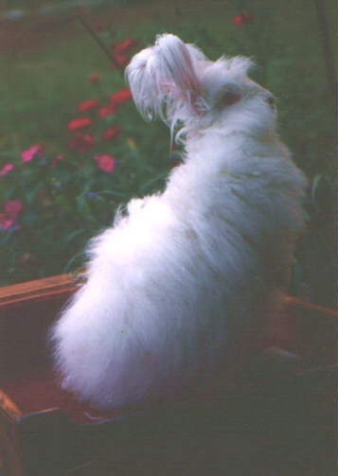
------
Copyright 2010 by Michelle Vincent <cassandradic at yahoo.com>. Permission is granted for republication in SCA-related publications, provided the author is credited. Addresses change, but a reasonable attempt should be made to ensure that the author is notified of the publication and if possible receives a copy.

If this article is reprinted in a publication, please place a notice in the publication that you found this article in the Florilegium. I would also appreciate an email to myself, so that I can track which articles are being reprinted. Thanks. -Stefan.

<the end>

