A-Pig-Hunt-art - 7/25/17

"On Target: A Pig Hunt" by THL Deryk Archer. (Archery Targets)

NOTE: See also the files: Triangle-Targ-art, SCA-T-Archery-art, T-Arch-Child-art, arrows-msg, arch-shoots-msg, Arrow-Matchng-art, bowstrings-msg.

************************************************************************
NOTICE -

This article was added to this set of files, called Stefan's Florilegium, with the permission of the author.

These files are available on the Internet at: http://www.florilegium.org

Copyright to the contents of this file remains with the author or translator.

While the author will likely give permission for this work to be reprinted in SCA type publications, please check with the author first or check for any permissions granted at the end of this file.

Thank you,
Mark S. Harris...AKA:..Stefan li Rous
stefan at florilegium.org
************************************************************************

First published in the Jun 2016 issue of The Æthelmearc Gazette.

On Target: A Pig Hunt
by THL Deryk Archer

This month’s On Target is a pig hunt. I found this target a lot of fun to shoot, but like other store-bought targets, he had a tendency to tumble. Also, he was a little expensive, so to buy several of them for a hunt would cost a lot of money. So I made my own.

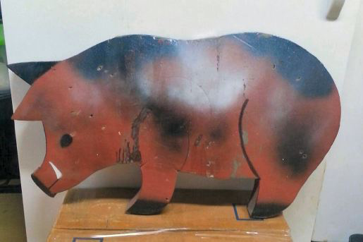

Using him as a stencil, I cut out seven layers of cardboard and one layer of political sign. The top layer is white foam board, which you can leave white or color pink or blue.

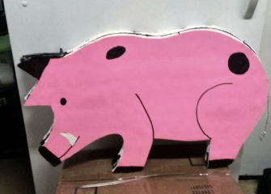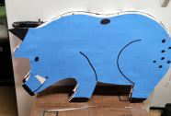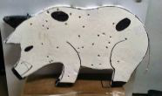

Using the wires from the political sign, you can make the pigs stand up in a natural position. I recommend putting some kind of a mark over the shoulder to use as a vital hit area.

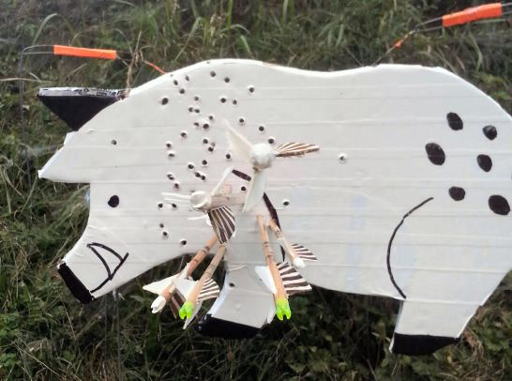

This target is fun for all ages; children will enjoy shooting it at 15 to 20 yards, while more advanced shooters can try it at 35 – 50 yards.

Now, just for fun, go to the dollar store, where you can buy a pair of fairy wings. Attach the wings to a heavy cardboard tube and zip tie it to the pig target. Run a clothesline between two trees, and all day long you can shoot when pigs fly.

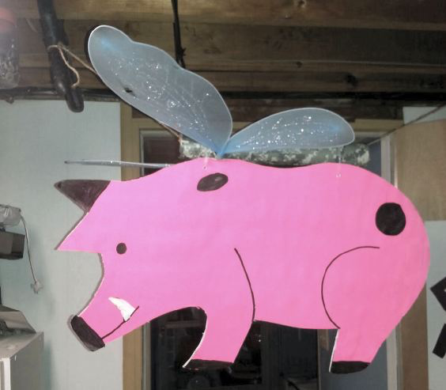

This month’s safety tip, with Pennsic not far away, add to the crest on your arrows. I recommend putting on an extra ring and your initials. A lot of archers may have the exact same crest you have and if you accidentally shoot a light arrow out of a heavier bow, it could shatter and cause an injury.

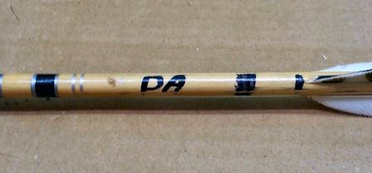

------
Copyright 2017 by Joseph Barlow. <tiger7tlc at gmail.com>. Permission is granted for republication in SCA-related publications, provided the author is credited. Addresses change, but a reasonable attempt should be made to ensure that the author is notified of the publication and if possible receives a copy.

If this article is reprinted in a publication, please place a notice in the publication that you found this article in the Florilegium. I would also appreciate an email to myself, so that I can track which articles are being reprinted. Thanks. -Stefan.

<the end>

