Arrows-w-Flair-art - 2/13/15

"Target Arrows with Medieval Features for Tournament Shooting" by Lord Mungo Napier.

NOTE: See also the files: arrows-msg, Arrow-Making-art, Arrow-Inspect-art, Arrow-Matchng-art, merch-archery-msg, quivers-msg, 16C-Arrow-Bag-art, arch-shoots-msg.

************************************************************************
NOTICE -

This article was submitted to me by the author for inclusion in this set of files, called Stefan's Florilegium.

These files are available on the Internet at: http://www.florilegium.org

Copyright to the contents of this file remains with the author or translator.

While the author will likely give permission for this work to be reprinted in SCA type publications, please check with the author first or check for any permissions granted at the end of this file.

Thank you,
Mark S. Harris...AKA:..Stefan li Rous
stefan at florilegium.org
************************************************************************

This article was first published in Winter 2014-15 issue of "Quivers & Quarrels" The Official Publication for the Archery Community of the Society for Creative Anachronism.

Target Arrows with Medieval Features
for Tournament Shooting
by Lord Mungo Napier, the Archer of Mallard Lodge

Introduction

The purpose of this article is to encourage building "medieval-style" arrows at an appropriate weight and length to fit our light sporting bows. Because these are downsized arrows, they are already a compromise with their historic counterparts. To keep this project as simple as possible, I suggest using purchased supplies and substituting materials where needed. It is the feel we're after here, not strict historical accuracy. Medieval-style arrows are fun to make, can be an extension of our garb and personas, and are an easy introduction to making more accurate full-sized arrows for A&S projects. I recommend you save these arrows for tournaments, rather than getting them all banged up at practices.

Shafts

Only a small number of fancy decorated arrows were made for the very wealthy for sporting or recreational use during the Middle Ages (I know of just two examples in portraits). The vast majority of arrows were plain wood, without any color or cresting. They were sealed, often with boiled linseed oil or a mixture of melted beeswax and lard (yecch!), which gave them a mellow golden color.

Shafts were not turned on a lathe like the shafting we buy today. They were made from square billets, with the edges planed off using a float, then likely smoothed with a file or a rough stone. This left them with frequent flat spots, tool marks, and sometimes not perfectly round.

Originally, I used unsanded Sitka spruce with its prominent grain to suggest hand worked shafts. My sealants left the spruce almost as smooth as my modern cedar "pretty arrows". I have since switched to using unsanded cedar for these medieval arrows, and no longer worry about the grain.

I do not cut the shafts to my draw length or taper the point ends until after the nock reinforcements and self-nocks are cut and finished. If I blow either of these steps, the botched part can be cut off for another try. If the shafts are cut to length first and a shaft is damaged, it is ruined and only useful as an expensive garden stake.

Nock Reinforcement

During the Tudor era, shafts were strengthened with a 2 inch sliver of cow horn inserted in the nock end parallel with the grain. This was needed to prevent splitting with the extremely powerful yew war bows of the time. Whether lighter arrows for civilian use or war arrows from earlier times had these reinforcements is not known. No true medieval arrows survive; most of what we know is based on the Mary Rose shipwreck arrows from 1545.

Cow horn is often too thick for our target shafts, and is rarely flat. To keep this project simple, try using substitute materials. My choice is piano key ivory, which is very thin, but strong. Another possibility is .030 styrene plastic. Styrene is very easy to work. Just score it twice with a sharp hobby knife and snap. It can also be cut with a craft saw, and is easily filed or sanded.

The nock reinforcement is closely tied to cutting the nock directly into the shaft (a "self-nock"). Whether to take these two steps depends on the size of the arrow and your confidence. For shafts with an 11/32 inch diameter, reinforcing the shaft is optional, though recommended (and it looks way cool!). With 5/16 inch shafts, reinforcement is strongly recommended if you plan to your cut nocks into the wood. This will demand considerable care to cut the slot exactly in the center of the shaft, possibly requiring a mechanical scroll saw or jigsaw with a table and fence. If you have any doubt about getting this right on 5/16 inch arrows, substitute plastic nocks and skip these two steps until you have better tools or more confidence.

Mark your shaft on both sides parallel to the grain with a pencil line to the depth you plan to cut. For our size arrows, 1 1/4 inch is a good depth. Make sure your lines are square. If working by hand, wrap your shaft with a rubber jar lid opener or similar material, and clamp it into a vise just tight enough so the shaft can't move, but not tight enough to crush the wood. Cut parallel to the grain. Use a hacksaw or other fine- tooth saw and work slowly to avoid having the blade wander. Widen the slot using a broader tooth saw, hobby knife, thin files, emery boards, and sandpaper. Test-fit your reinforcement material frequently. You need a firm fit, but you must not take out too much wood, nor too little. Either would bend the wood at the base of the cut and cause a weak spot. When you are satisfied with the fit, glue the reinforcement in place with epoxy or slow-setting "super glue". Squeeze the shaft in a soft-jaw clamp and leave it for 24 hours. When completely dry, trim off excess reinforcement material and smooth the edges and end with a fine file. If you see small gaps, fill them with thick epoxy or "super glue" applied with a toothpick, and sand again as needed.

Self-Nocks

Cutting a self-nock into the shaft is much like making the reinforcement slot, but a whole lot easier. Make your cut across the grain and the reinforcement (if present). It should be 1/4 to 5/16 inch deep, just deep enough to take your string. Deeper nocks will weaken the arrow shaft. Make your initial cut with a hacksaw in the vise as before. Widen the cut with a broader tooth saw, hobby knife and files. A small round ("rat tail") file is very useful here. Check your nock frequently on a strung bow. With a flat file, take off a small amount of the square edge around the shaft end to prevent splintering, but don't make the end into a dome. Also remove about 1/32 inch from the mouth of the slot on each side to a depth of about 1/32 inch. This will give you a slight funnel shape at the nock mouth that will help guide the string into the slot. Smooth everything with fine sandpaper.

Sealing

Sealing is not a visual feature of your arrows, but is very important to prevent warping, and makes the arrows easier to clean. This is a good time to do the sealing step. You can use polyurethane for a hard seal. I suggest at least two coats of Minwax Wipe-on Satin for a flat finish. This will tend to smooth out the rough grain that you worked so hard to preserve. An alternative is Minwax Polycrylic Satin, a water- base sealant that may actually roughen up the grain a bit more. Polycrylic is not as tough as polyurethane, but is easy to apply and cleans up with water. Be sure to work the sealant into the nock, but don't overdo it. Remember that for each coat in the nock, you are actually reducing the nock width by two coats, one coat on each side. You want to be sure your shots are not retarded by a nock that is too tight.

Fletching

According to Roger Ascham's Toxophilus (1545), the proper fletching colors are a black or gray cock feather and two white hen feathers. These are the colors of the lag goose, widely raised in Olde England. This isn't much of a color pallet, but it is doubtful that feathers were dyed in bright colors at this time. We can expand our choices to natural barred, gray barred, and brown barred, representing feathers gathered from pea hens, pheasants, or kept birds of prey. You should avoid bright colors. Remember, we're going for the typical look here. My arrows are fletched with a white cock feather and two natural barred hen feathers, a pattern I have used on nearly all my personal arrows since I began fletching seven years ago. This is not truly period, but I see no reason to change.

Fletches on my arrows are cut from TruFlight 5 1/2 inch shield-back feathers (see Figures 1 and 2). Shield-back feathers will have a slight "Roman nose" curve, but this will hardly be noticeable. If it bothers you, consider cutting your own fletches from full-length feathers. You may choose either a "traditional" swallow-tail shape, or a simple square-end triangle shape for your feathers. When cutting your feathers, be sure to leave about 1/4 inch of feather base on "traditional" feathers at the nock end, or about 1/8 inch if using the squared triangle shape. This tab will be needed for tying down the feathers in the next step.

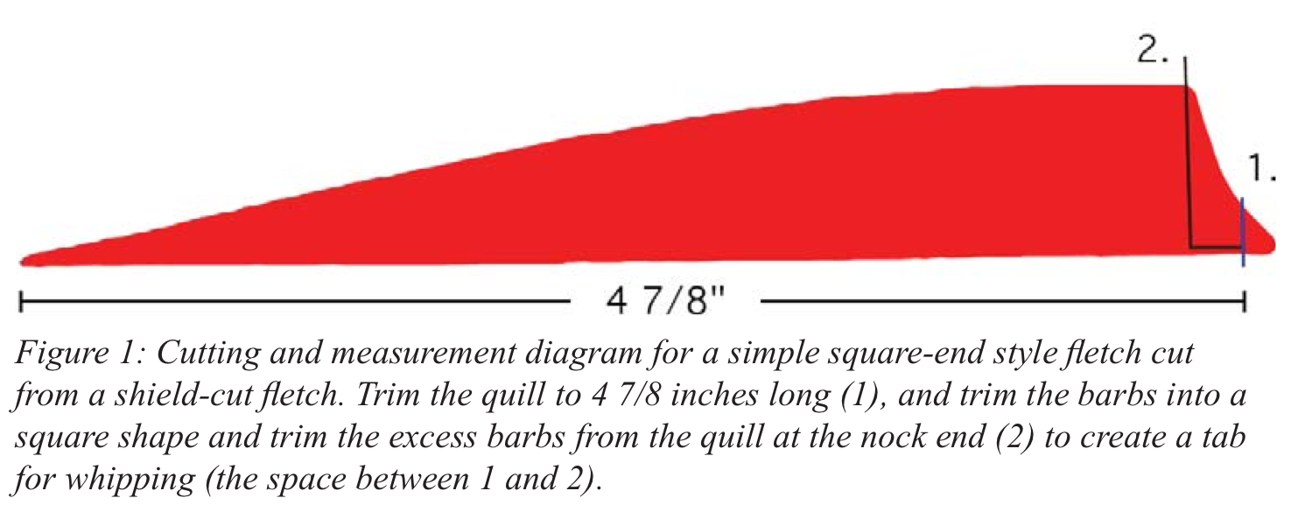

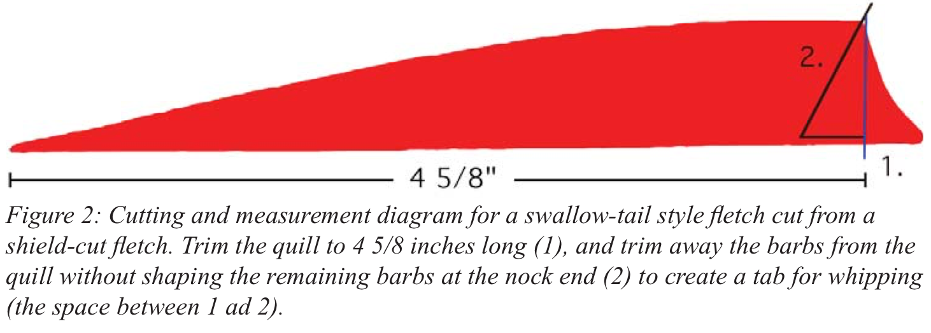

Your feathers may not turn out to be exactly the same length, and this can cause problems with the step later. Match your feathers by length in groups of three as closely as possible, and make sure the pointy ends are aligned at the same distance from the end of the shaft.

Glue your feathers to the shaft using your favorite method. I use an AAE Fletch III fletching tool, which will accept a self-nocked arrow in its rotating collar. For glue I always use Bohning fletching tape. This tape is easy to use, and needs no drying time. I carefully run a flat tool along the feather base after removing the clamp to make sure the glue has good contact with both the feather and the shaft. The rounded back end of tweezers works well for this. If you are mounting "traditional" feathers, move the fletching forward 1/4 to 3/8 inch toward the point to give you some extra room where your fingers grip the shaft.

Whipping

Binding the feathers onto the shaft is not hard, though it does take a bit of practice and some patience. The effect is worthwhile, since nothing says "middle ages" more than a whipped arrow. Most arrows were whipped with a fine linen thread. This is hard to find, so you can substitute crochet thread, or any heavy sewing thread (jeans-weight). Try to find a thread that shows the least weave. Thread can be colored if you wish, or choose ecru to represent undyed linen. Colored thread can set your arrows apart from those of other shooters (assuming you are not the only one with period arrows), but try to pick a color that is typical of the time and not too wild (see Figure 3). Consider using your principal heraldic color. The best-quality arrows were whipped with silk, often red or green. Silk thread is available in most fabric stores.

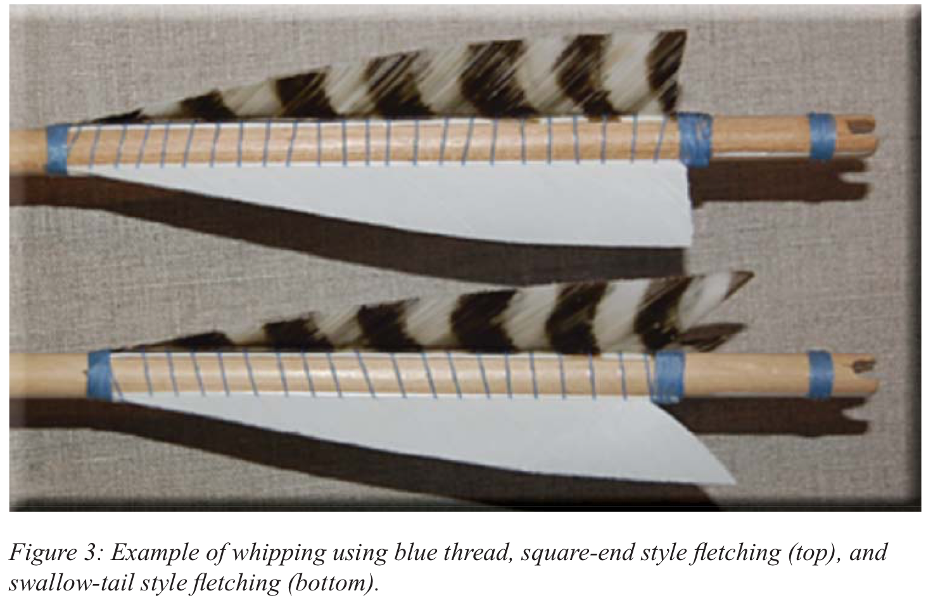

Snip off about 7 feet of thread. Begin wrapping at the point end of your feathers with the knot shown in Figure 4. If you can't get the thread to stay put, try placing a dot of bow wax on the shaft right where the thread will cross. Take four or five turns around the shaft at the feather's point end, then work your turns up onto the feather base. About 1/8 to 3/16 inch is all the wrap you will need. Before you begin spiraling the thread into the feather barbs, stop for a moment. Draw the "working part" of your thread through that loop you left sticking out to the right and pull it tight. Draw the "bitter end" (sticking out to the left) tight, and you will have a tight knot under the wraps. Begin spiraling your thread up the shaft, working it into the barbs as you go and rising about 1/16 inch with each feather.

The actual space between each wrap of the thread should be about 3/16 inch. This will give you approximately five turns to the inch, the proper English military whipping. Any less than four turns will look barren, and more than six turns will look excessive (and is a waste of thread and time). The width between the wraps tends to grow wider near the nock end, and may take several tries to find the right place between the barbs. The thread should rise in an even spiral, but if you get a uneven spacing, it isn't too much to worry about. You can unwrap the whipping back to where you went wrong and try again if you wish. Finish the whipping by wrapping the thread around the small tab of the feather base at the nock end of the feather. To secure this last part, thread on a small curved needle and sew two stitches around the last two or three wraps. Pull tight. Cut off the excess at both ends, except for about 1". We will trim this later. If you cut the ends close now, your knots may unravel.

Some fletchers run their whipping along the shaft to the nock end and add another 1/8 to 1/4 inch wrap just below the nock. I don't like having this thread running along the shaft. It could potentially come loose and catch on something, sending your arrow wild. It is better to start a completely new wrap at the nock. This needs to be tight if it is really going to reinforce your nock. Use the same loop you started with at the point end of the feather, and finish by going through the loop and pulling the "bitter end" tight. Again, trim the tags back to 1 inch.

More Sealing

Now it is time to get out that Minwax Polycrylic again. With a 3/8 inch brush, paint the sealant on the wraps you made at the ends of the feathers and below the nock. Allow the sealant to soak into the threads, which will bind them into a tight mass that isn't likely to unravel.

Also paint the shaft and the thread between the feathers with the sealant to bind the whipping to the shaft. Try not to get any sealant up onto the feather barbs. When the sealant is dry, snip off all those little tag ends of thread you left hanging just a tad above the knots.

Points

We'll finish up by applying the points. Use your favorite method. I prefer to mount my points using 2,400 lb. (so-called "two ton") slow-setting epoxy. I use Devco brand in the twin applicator.

Points should be appropriate to the shaft size and length of your arrows. Most of us will be using 100 or 125-grain points. Some specialty points like hand- forged medieval replicas and the 3Rivers Archery "long bodkin" are too heavy for target use, and will cause your arrows to plunge.

3Rivers sells a short bodkin, and also the well-known Ace Classic Medieval Point, both at 125 grains and fitting an 11/32 inch shaft (see Figure 5). Due to the large surface area on the trailing face of these points, they are prone to pulling off in targets when removed. Any rubberized foam, and bag targets with a plastic "burlap" material, are particularly hard on arrows with these points.

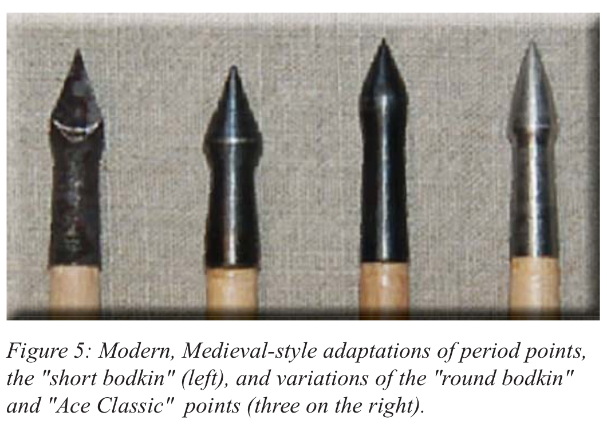

My current favorite is the Bearpaw brand "Modkin", available by mail order from the Longbow Shop in England. These come in 100 and 125 grain weights for 11/32 inch shafts, and 65 or 100 grains for 5/16 inch shafts. The streamlined design of these points makes them easy to remove from a target. These points are like nothing actually made in the middle ages, but they have a very cool look. They are also about half the cost of other comparable points.

I have also had good luck with steel bullet points from the Longbow Shop. These are actually the most accurate points for this project, representing a type in the Museum of London and British Museum collections that were used for target practice. These are available as glue-on or screw-on. The screw-on points have a straight socket, rather than one that is tapered like American points. Instead of tapering the shaft with a 5-degree taper tool, I carefully file the ends of the shaft slightly, just enough for the threads in the socket to bite the wood. I also use epoxy, and a 3Rivers screw-on tool was used to set these points.

Also of interest are the less expensive generic "Modkins" (also known as "Med-heads" or "Mod- bods"), available in black or bare steel and fitting both 11/32 inch and 5/16 inch shafts at various weights. These are slightly less streamlined than the Bearpaw points, and I have had some catch in targets. They are also sold by the Longbow Shop, and by Richard Head Longbows. When ordering from either vendor, plan to buy several dozen points to make shipping worthwhile. If you aren't comfortable ordering from England, the good old PDP field point is the best default choice.

Recently, 3Rivers has added some interesting Top Hat brand points, including a bodkin. Although I have some of these, I have not had a chance to mount them yet.

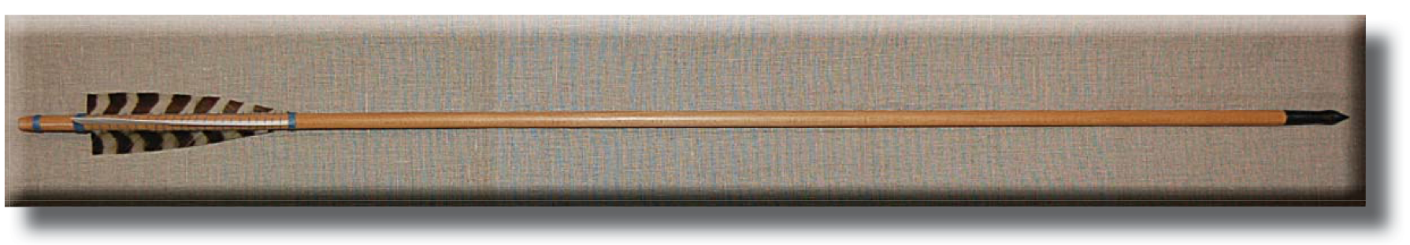

Suggested Supplies

The Longbow Shop
http://www.thelongbowshop.com/
Faux-medieval points.

Richard Head Longbows
http://www.english-longbow.co.uk/
Faux-medieval points.

3Rivers Archery
http://www.3riversarchery.com/
Arrow shafts, including Sitka spruce; 5 1/2" or full- length TruFlight feathers; full-length AMG feathers, AAE Fletch III fletching tool (available in right wing only); Bohning fletching tape.

FS Discount Archery
http://www.fsdiscountarchery.com/
Acme arrow shafts (cedar only); 5 1/2" or full-length TruFlight feathers; Bohning fletching tape.

Walker Piano Key Service
http://www.walkerpiano.com/
Ivory piano key tails.

Lowes, Home Depot, or other hardware/paint stores forMinwax Wipe-on Polyurethane Satin; Minwax Polycrylic Satin, acetone.

Drug store or supermarket cosmetics section for fingernail polish remover (get pure acetone, without aloe or vitamin E).

Any good hobby store for Evergreen styrene sheets #9104, .030 thick, package of two sheets.
------
Copyright 2014 by Garth G. Groff, <ggg9y at virginia.edu>. Permission is granted for republication in SCA-related publications, provided the author is credited. Addresses change, but a reasonable attempt should be made to ensure that the author is notified of the publication and if possible receives a copy.

If this article is reprinted in a publication, I would appreciate a notice in the publication that you found this article in the Florilegium. I would also appreciate an email to myself, so that I can track which articles are being reprinted. Thanks. -Stefan.

<the end>

