Back-Quivers-art - 5/27/15

"The Existance of Back Quivers in the Middle Ages" by Baroness of the Court Moira nic Connell the Strongbow.

NOTE: See also the files: 16C-Arrow-Bag-art, Arrow-Making-art, quivers-msg, Turksh-Flight-art, p-archery-msg, Bow-Tuning-art, arrows-msg, arch-shoots-msg.
************************************************************************
NOTICE -

This article was submitted to me by the author for inclusion in this set of files, called Stefan's Florilegium.

These files are available on the Internet at: http://www.florilegium.org

Copyright to the contents of this file remains with the author or translator.

While the author will likely give permission for this work to be reprinted in SCA type publications, please check with the author first or check for any permissions granted at the end of this file.

Thank you,
Mark S. Harris...AKA:..Stefan li Rous
stefan at florilegium.org
************************************************************************

The Existance of Back Quivers in the Middle Ages
by Baroness of the Court Moira nic Connell the Strongbow

Once again I was told, "Back quivers never existed anywhere in history and certainly not in Europe. There's just no evidence." This person also went on to explain why back quivers are a bad idea. If you bend over your arrows fall out. You can't tell what kind of arrow you are grabbing. They slow you down during times when you must shoot repeatedly and quickly. They get caught on things when you are stalking in underbrush.

Before we get to back quivers, let's look at some pictorial representations of how Medieval archers carried and controlled their arrows.

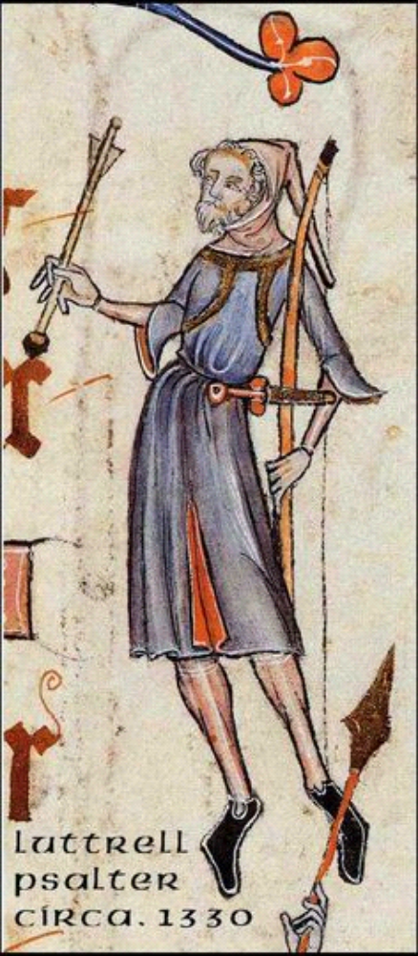

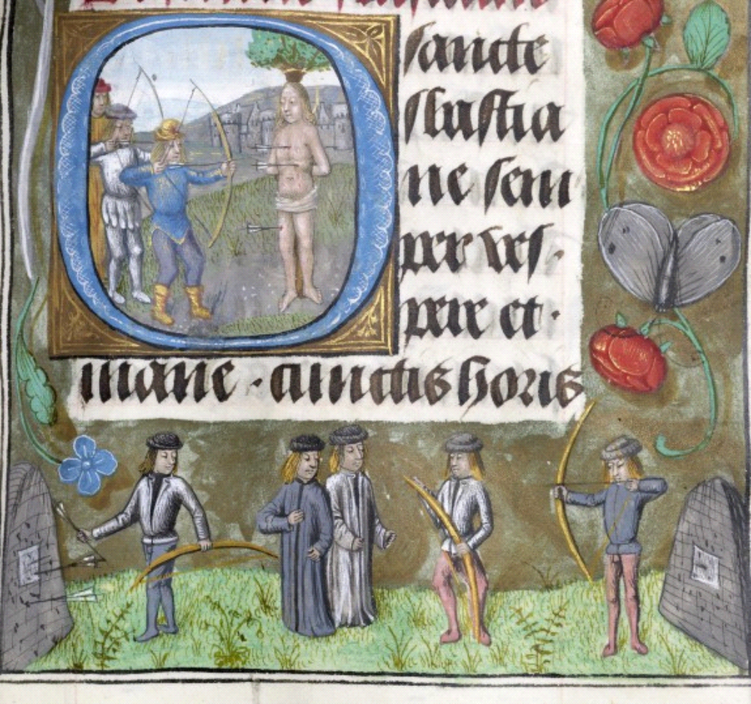

This is perhaps my favorite representation. Most of these archers appear to have gone out for a day of hunting or shooting with no quiver at all and, in some cases, only one arrow. Not likely, but possible.



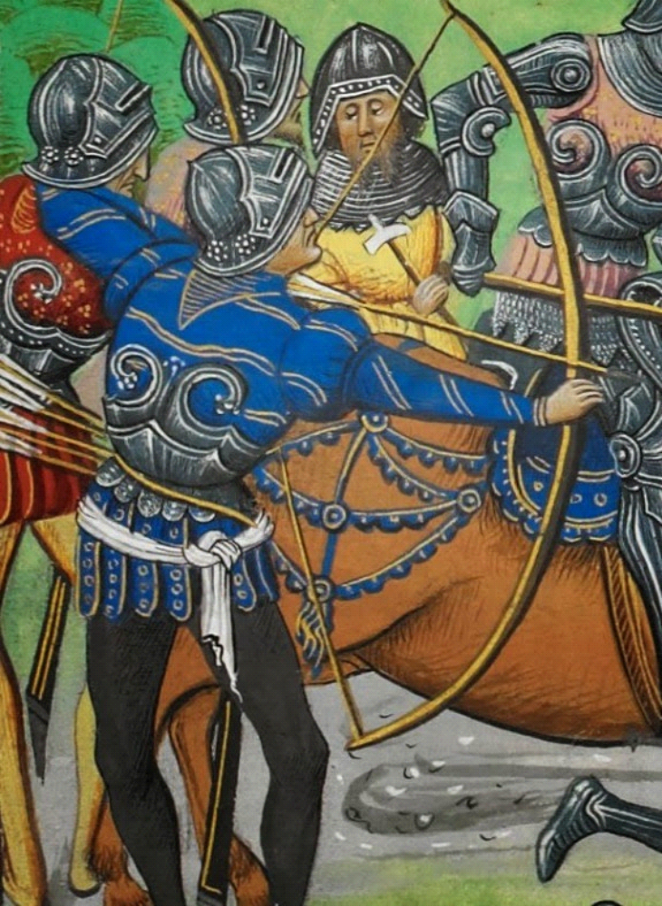

I've gone bow hunting. I have occasionaaly put bird blunts and target points through my belt for convenience. Hunting sharps and war bodkins.....just no. Check the stats. How many bow hunters manage to skewer themselves every year on their own arrows because they tripped and fell on them. The idea of having those really sharp objects that close to my vital organs just makes me cringe in the aticipation of pain. And as far as marching into battle that way... How do you get two score arrows under your belt without having to constantly stop to collect the ones that slither out of the center of the bundle?

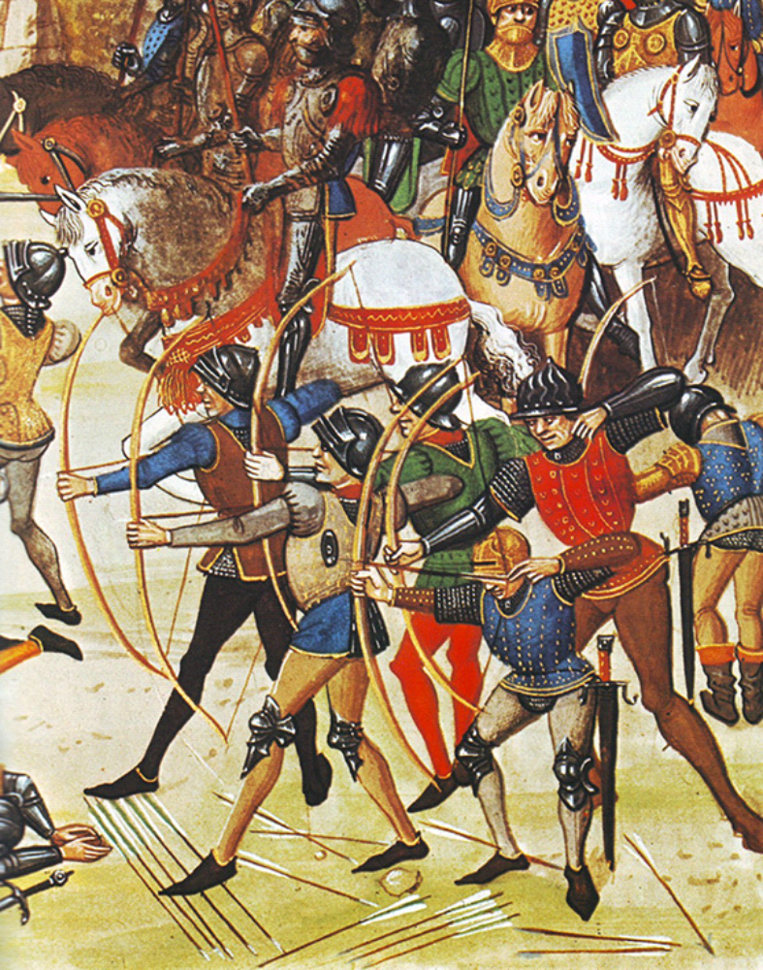

Whether this is meant to represent arrows laid on the ground or stuck in the ground, I'm not sure. I have stuck my arrows in the ground and it can be useful. However, if the ground is too hard and dry you risk breaking your arrows. If the ground is wet and muddy, you wind up wasting time knocking muck off your arrow tips before you loose them. That will slow a timed shoot from eight arrows in 30 seconds to five. Don't even get me started on how long it takes to bend over and pick them up. Ground quivers are a nice option as long as you don't mind carrying the extra weight.

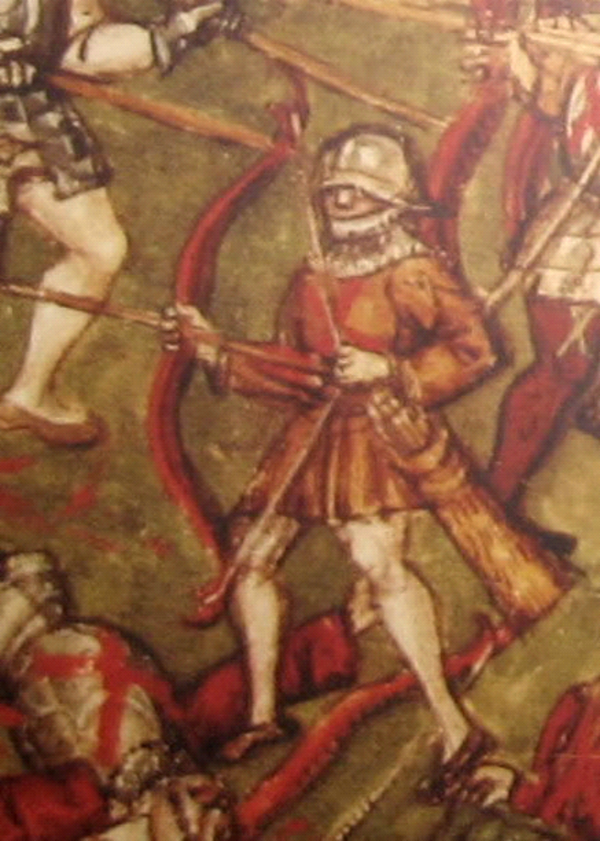

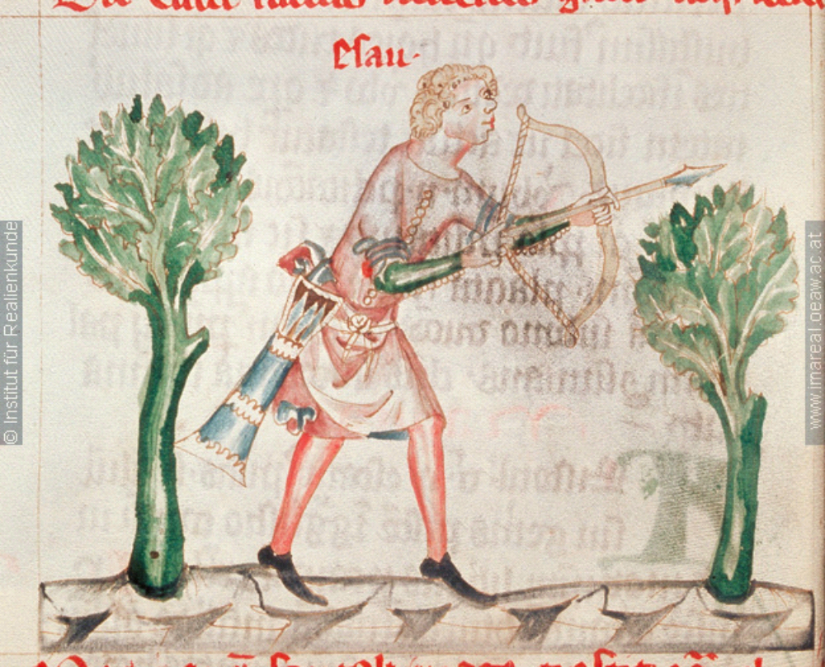

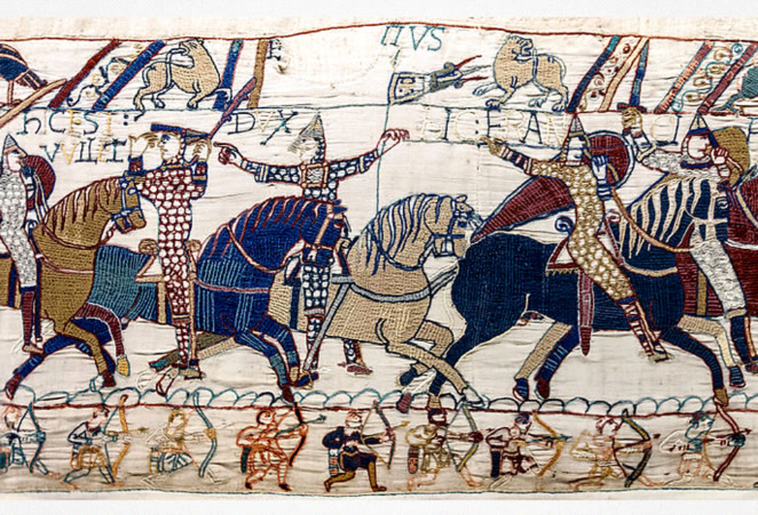

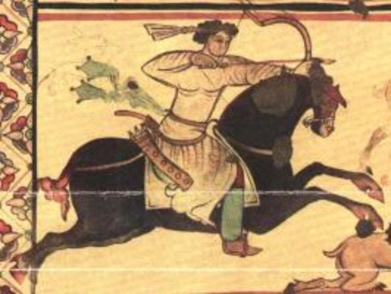

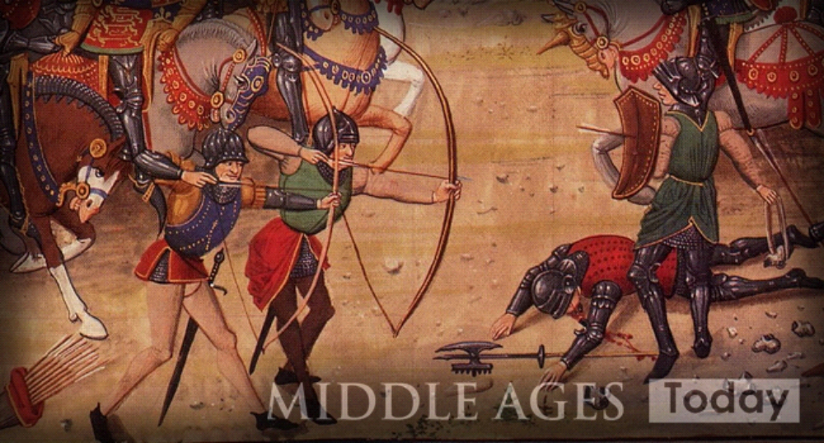

Ah, yes. The ubiquitous hip quiver and I include the arrow bag in this family. The hip quiver really is a wonderful thing. I have used one myself on the range. While hip quivers are very useful for tall archers or horse archers, those of us who are vertically challenged might have issues. I am all of 5'4" on a good day and my arrows are long enough to accomodate my 30.5 inch draw. So, if the quiver hangs straight down from my belt it drags in the grass, catches on undergrowth and trips me up. If I adjust the carry strap to prevent this I wind up with a really weird train and it catches on undergrowth and upon occasion dumps my arrows onto the ground. The plus for hip quivers is one size does pretty much fit all and, if you are outfitting a company of archers, it is cheaper to have them all made the same.

Before we get to back quivers, a note on quiver construction. While we in the Modern Middle Ages have ready access to leather for just about anything, this was not the case in the real Middle Ages. Cattle were far more valuable as dairy animals and draft animals then as hamburgers. The leather that was available was needed for more important things like shoes and harness. Therefore, most quivers would have been made of wood, wicker and cloth or a combination of the three. Most would have gone on the fire or onto the midden at the end of their usefulness. It stands to reason that, as the hip quiver was more common, there would be more of them surviving to this day.

So, on to back quivers.

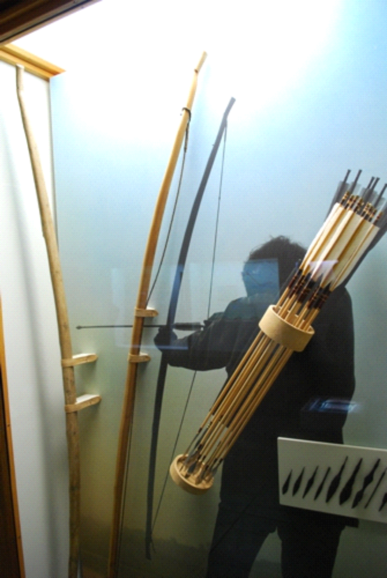

From the display The Vikings of Bjornstad in the Viking Museum of Haithabu. The curator thinks a back quiver of wood and cloth make sense given the length of the arrows and the shortness of the archer.

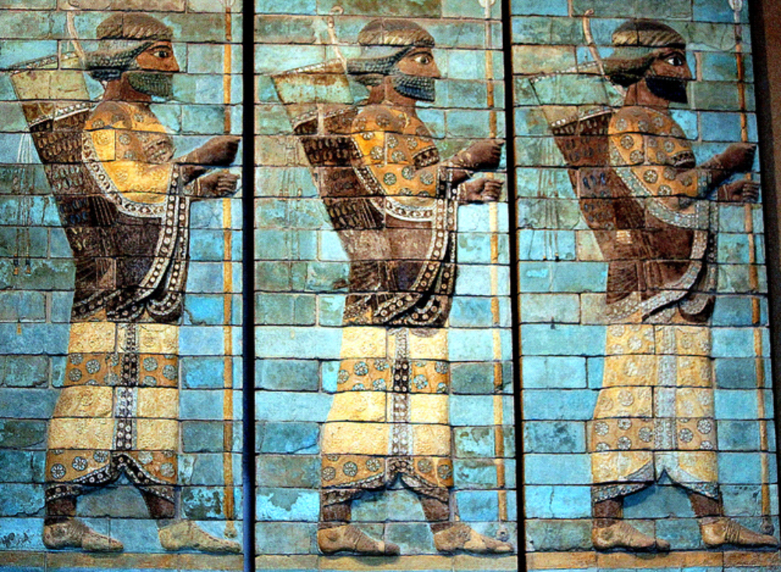

These ancient Persian archers are from a polychrome mud brick relief that once graced the Persepolis in what is now Iran.

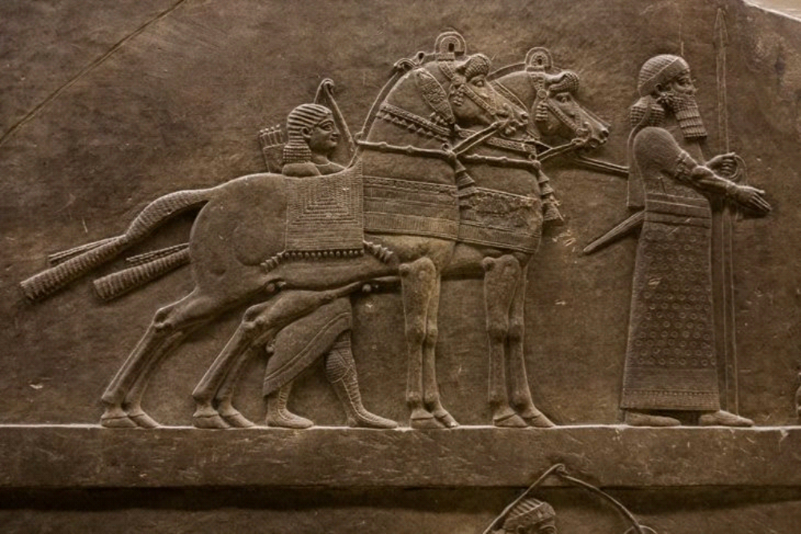

This stone relief of ancient Assyrians is also from what is now Iran.

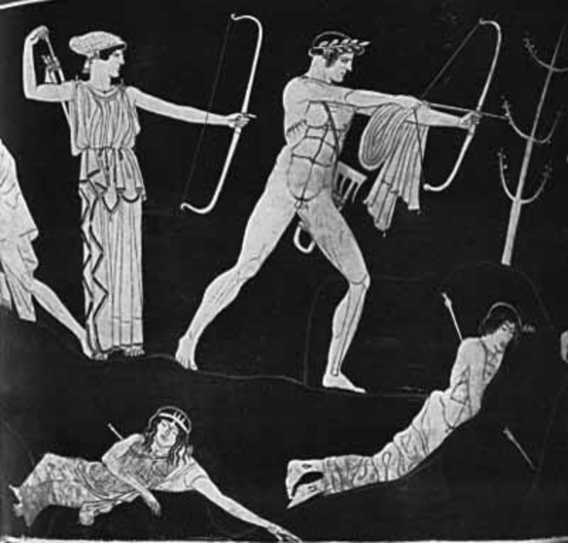

This is from an ancient Greek vase.

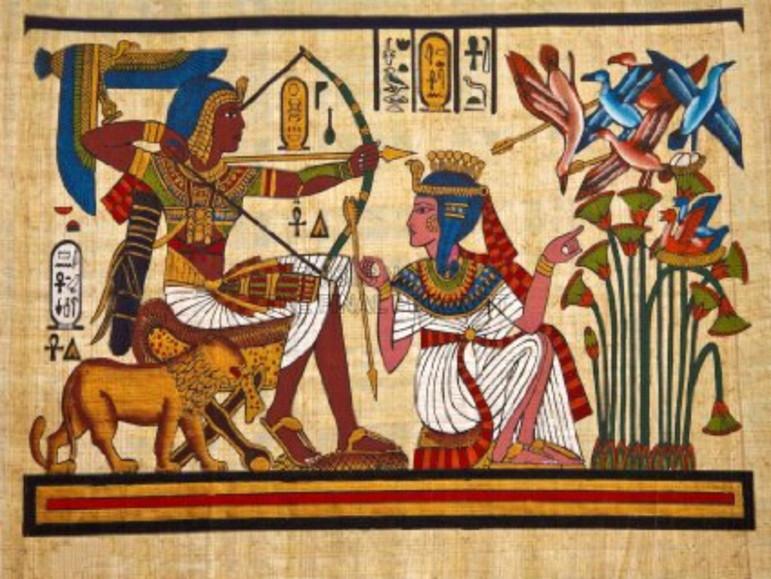

A copy of an Egyptian tomb painting.

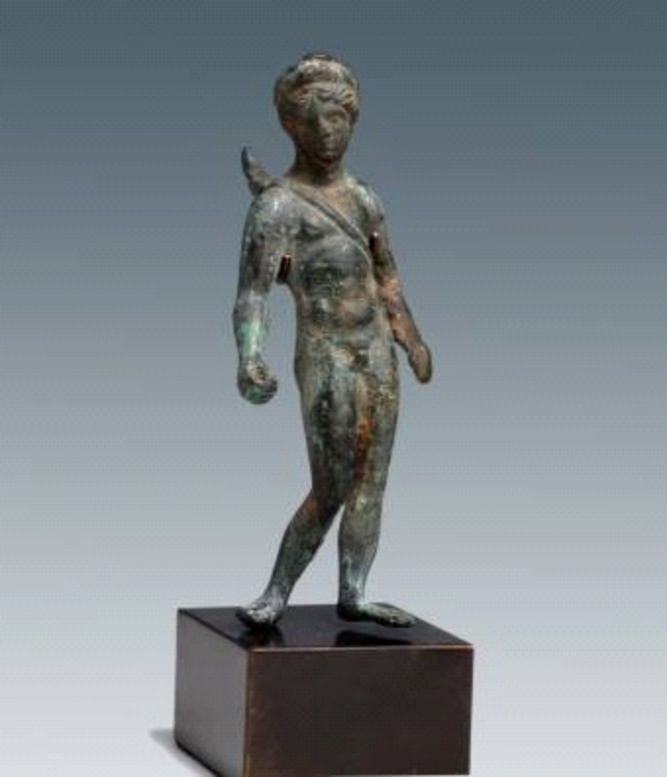

A Roman bronze of the goddess Diana.

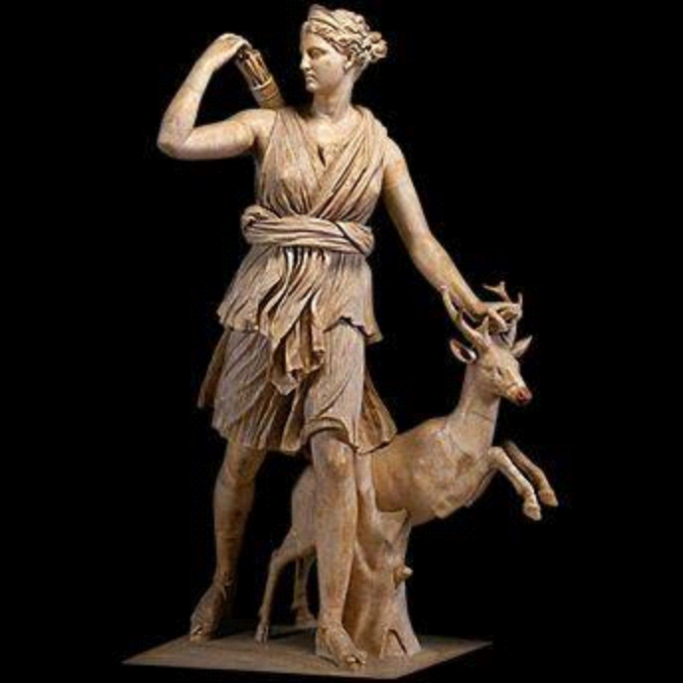

This is the Diana of Versaille dated to the late Medieval or early Rennaisance.

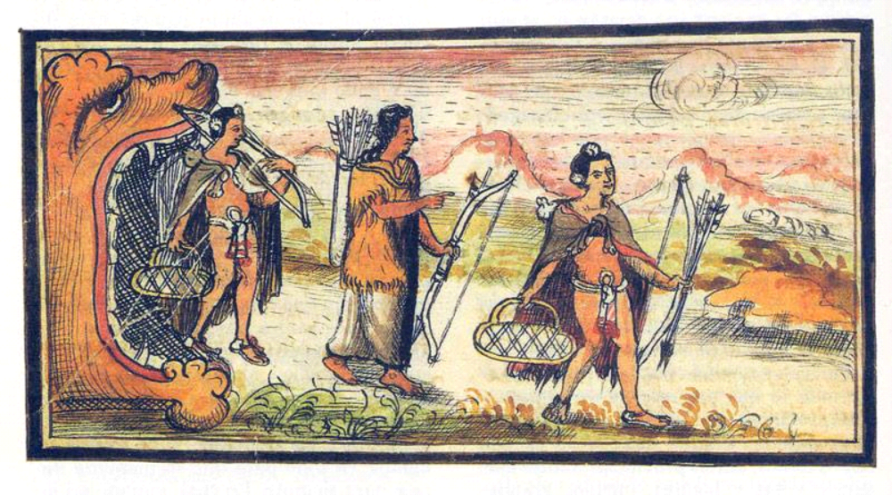

From a Spanish history of the conquest of Mexico and the Aztecs.

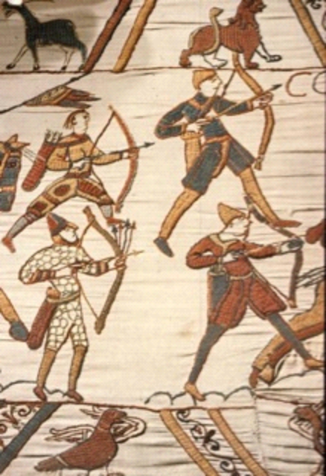

From the Bayeaux Tapestry. Check the archer top left.

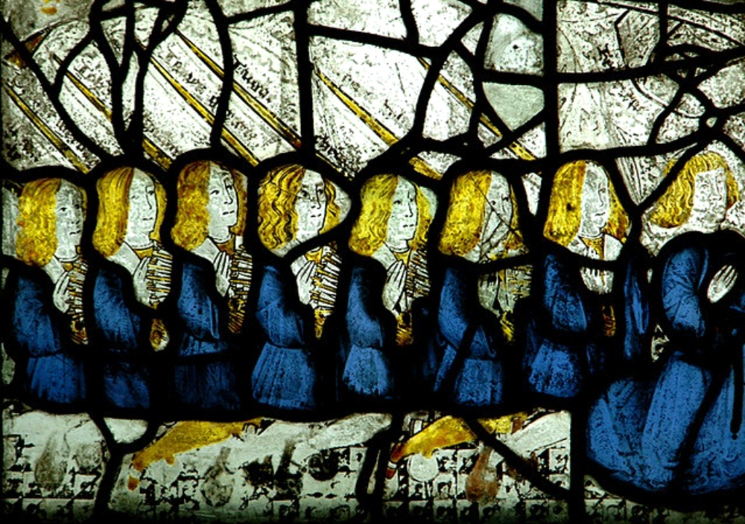

From the Middleton Parish Church, a stained glass window comemorating the archers from the area who fought at the Battle of Flodden Field in 1513.

The only complaint about back quivers I haven't covered is how do you tell what kind of arrow you are pulling from the quiver? How many different kinds of arrows do you carry at a time? In battle it would have been all bodkins. On the range it is all target points. When I hunt I might mix bird blunts and broadheads. It's as simple as an extra bit of wrap or cresting that you feel for when you touch the arrow shaft.

There. I got that out of my system. Please, when you argue about whether or not something is period, avoid using the word never because someone like me or my friend Vladis Bryningsdottir will be listening and we will do the research.
------
Copyright 2015 by Muriel LaRose. <https://www.facebook.com/muriel.larose.75 >. Permission is granted for republication in SCA-related publications, provided the author is credited. Addresses change, but a reasonable attempt should be made to ensure that the author is notified of the publication and if possible receives a copy.

If this article is reprinted in a publication, please place a notice in the publication that you found this article in the Florilegium. I would also appreciate an email to myself, so that I can track which articles are being reprinted. Thanks. -Stefan.

<the end>

