Bow-Tuning-art - 1/25/15

"Simple Bow Tuning for Novice Archers" by Lord Mungo Napier.

NOTE: See also the files: archery-books-msg, bow-making-msg, P-Arch-Target-art, Buyng-Usd-Bow-art, bowstrings-msg, Trubl-Shootng-art, arrows-msg.

************************************************************************
NOTICE -

This article was submitted to me by the author for inclusion in this set of files, called Stefan's Florilegium.

These files are available on the Internet at: http://www.florilegium.org

Copyright to the contents of this file remains with the author or translator.

While the author will likely give permission for this work to be reprinted in SCA type publications, please check with the author first or check for any permissions granted at the end of this file.

Thank you,
Mark S. Harris...AKA:..Stefan li Rous
stefan at florilegium.org
************************************************************************

Simple Bow Tuning for Novice Archers
by Lord Mungo Napier

Shire of Isenfir Target Archery Marshal

BOWSTRINGS: There are two types of bowstrings commonly used for sport-weight handbows in the SCA, and each comes in two variants to fit either longbows or recurves, for a total of four possible combinations. Knowing about these bowstring types will help you make wise choices when your strings wear out.

The most common strings are "double loop endless bowstrings", commonly machine-made using black B-50 Dacron. Nearly all double loop strings have their end loops and return braiding "served", meaning a layer of cord has been wrapped around the loops and for a short distance down the string as wear protection. These strings are also served in the center where arrows are nocked. Double loop strings come as standard equipment on most youth bows, and are made for longer bows as well. These strings are durable and inexpensive, though rather boring. If kept waxed they may last for several years of moderate use.

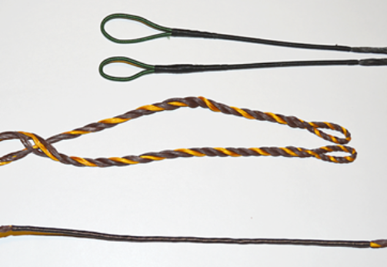
Figure 1. At top is a double loop continuous string. Note the different size of the loops, marking this as a recurve string. A flemish twist longbow string is in the center, with both loops the same size. At the bottom is a Flemish twist string showing the served center section.

In the SCA, the flemish twist string is very popular among experienced archers because of its period look. Flemish strings are also usually made from B-50 Dacron, and may come in interesting, but rather un-period, colors. These strings are rarely served in the loops or on the return braiding, though most are served at the center. Without loop serving, flemish strings wear out faster than double loop strings. Because flemish strings are hand-made and loosely woven, they stretch a lot when new, and may need tightening several times during their early use. Flemish strings cost about twice as much as double loop strings because they are a hand-made product.

A variant of the flemish string has only an upper loop, with the bottom end tied in a bowyers' knot/timber hitch by the archer. While rare, these single-loop strings do turn up on bows occasionally at SCA events, and are accepted as legal.

Both bowstring types are sold either as "recurve" or "longbow" strings. A recurve string has a larger loop at the upper end to allow the unstrung bowstring to slide down the much wider limb. A longbow string usually has smaller loops of the same size at both ends. Recurve strings can be used on longbows without problems, but longbow strings cannot be used on recurves, except possibly for some youth bows with narrow limbs. When slipped down a recurve bow for unstringing, the small loop of a longbow string can become stuck on the wider limb and is very hard to remove without damage.

The "fast flight" string is a variant of which new archers should be aware. These can be made either as a double loop or a flemish twist bowstring. Fast flight strings are woven from Kevlar or similar high-tech synthetic materials. They offer extra speed, and are especially popular with hunters. Most modern high-performance bows are designed for fast flight strings, and are fitted with phenolic tip overlays to cope with the extra stress. While a fast flight-capable bow can use B-50 double loop or flemish bow strings without problems, fast flight strings should NEVER be used on a bow without phenolic overlays. From personal experience, fast flight strings fray quickly in the upper loop and at the nocking point, requiring frequent replacement. For general target shooting, they are not worth the rather extra cost.

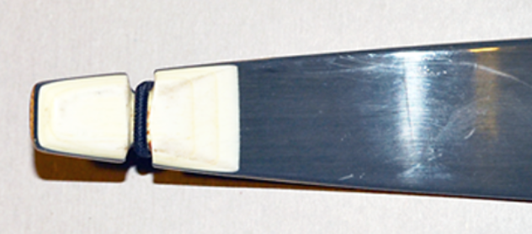
Figure 2. A phenolic tip overlay. Sometimes they are less obvious, and may be noticed only by a thicker limb tip.

BOW WAX: And now two words about bow wax: "Use it!" If not waxed by the manufacturer, new strings should always be waxed, then given two or three full counter-clockwise turns when installed to bind the strands into a tight bundle. The upper loops of strings should be waxed EVERY TIME a bow is strung to prevent fraying as the string slides up and down the limb. You should also wax the string at the nocking point to reduce wear and help arrows release cleanly. The whole string should be waxed several times a year. Keeping your strings waxed may easily double their useful lives. Bow wax is a very inexpensive product, and well worth the investment.

BRACE HEIGHT: Brace height, or fistmele as it was called in the middle ages, is the distance between the "belly" of the bow and the string, when a strung bow is at rest. [In medieval terms, the belly is the side facing the archer, while the part facing the target/enemy/game is the "back"; the analogy recalls a man bending forward from the waist.] This distance was the breadth of the archers palm plus an upraised thumb. This plainly unscientific measurement was "standardized" (sort of) by the Archery Manufacturer's Organization in the early 1950s, set at 7" for adult longbows and 8" for recurves. Bows manufactured before 2003 were usually marked with an AMO length, now simply expressed as the bow length in manufacturers' descriptions. In theory, a string 3" shorter than the AMO length gave that bow a proper brace height. For example, a 62" longbow usually required a 59" string to reach a brace height of 7". There no longer are any standards, and each manufacturer can design a bow with whatever brace height they choose (actually, manufacturers always did that anyway). The '3"-shorter principal' still holds with most bows as a good guide for choosing a string, but is NOT foolproof.

There is considerable debate about from where on the bow's belly you should measure. The AMO recommended the part of the grip furthest from the string. Recurves of that era usually had very deep grips, which explains the 8" measure for them. The current method is to measure from the end of the arrow shelf closest to the archer for all bows, rather than measuring from the grip. On period longbows bows without a grip, simply measure from the bow stave to the string. What is most important is to make sure that when an arrow is nocked, no fletching is on the arrow rest, or with period bows resting on the hand. This would "ruffle" the feathers, so to speak, increasing wind resistance, making the arrow fly poorly, and possibly damaging the fletching.

New high-end bows usually come with instructions from the manufacturer, and their recommended brace height should be followed. When in doubt, use 7" - 7 1/2" for all adult bows. You may vary this somewhat, but don't set the brace height so high that the bow is "over-strung". I suggest that that no bow should ever have a brace height more than 7 1/2" as measured from the arrow shelf unless recommended by the manufacturer. Very small children's bows which draw at 20" or below should probably have a brace height of about 6", and youth bows that draw between 20 and 24" should probably be set around 6 1/2". Any youth bows longer than 55" or so will probably draw to 28", and should be treated the same as adult bows.

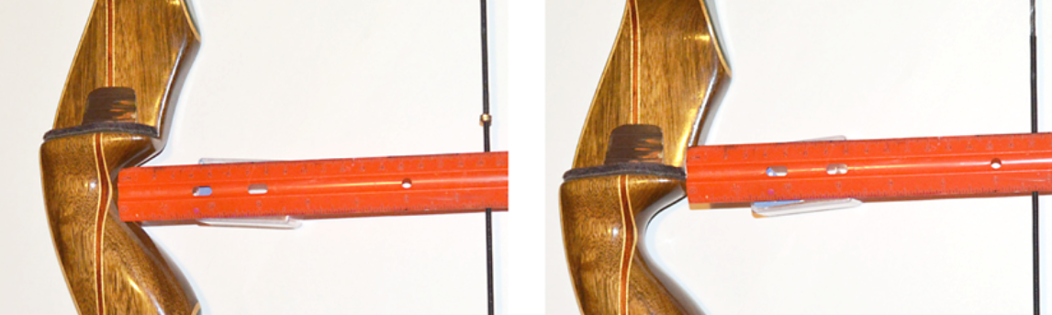

Figure 3. The AMO method of measuring brace height from the deepest part of the grip (left). The more modern method, measuring from the end of the arrow shelf (right).

Besides arrow damage, a low brace height will rob the bow of power, causing arrows to hit lower on the target, or requiring a higher aim point (inconsistency is always a bad thing for accuracy). Even worse, a low brace height will cause the string to slap the archer's forearm, and we all know that isn't a good thing at all.

If you discover that a string 3" shorter than your bow length makes the brace height too low, and a string 4" shorter leaves the brace height too high, you will need use the 3" shorter string and twist it until the desired brace height is achieved. Unstring the bow and slide the upper loop down to where the lower loop can be removed from the bow end. Twist the string's lower end COUNTER-CLOCKWISE. With a bow around 60" in length, 10-12 full twists will usually add about an inch more brace height. When you think you have made enough turns, restring the bow and measure the brace height. Unstring and add or remove twists until you reach the desired distance. It is an art, not a science.

NOCK POINTS: A nock point is essential for consistent shooting. The simplest nock points are small metal C-shaped collars that are crimped onto the string using special pliers. The largest size with the red plastic insert will fit best on a served string. Nock points can also be made using knotted serving string. Mine always unraveled, so I switched to the metal collars. In the SCA, only one nock point is allowed, but somewhat confusingly, it may consist of two indicators. If two indicators are used, the arrow should always be placed between them. The popular "Noglove" and similar rubber nock devices for youth bows use this principle.

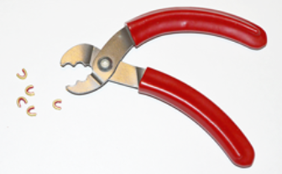

Figure 4. Nocking pliers and nock point indicators. Note the "teeth" in the pliers jaws, used for loosening nock points.

Most archers prefer to nock their arrows above the nock point. This makes arrow nocking simpler and faster than nocking under the nock point, and is helpful during Royal Round timed ends. Archers who use a "three fingers under" draw to the nose will usually nock below the nock point, and push the arrow upward against the nock point with their first finger.

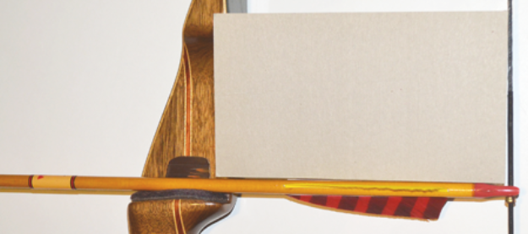

Figure 5. Squaring an arrow to the string. Note the gap just above the nock, indicating the process is not yet complete.

To mount a nock point, take your bow to a place where there are no people around, or do it on the shooting line under the direction of a marshal. While no arrow will actually be drawn, one must be fitted to the string, and accidents can happen. Place the bow flat on the floor or ground and fit an arrow to the string as if ready to shoot. Using a small shop square, or the cardboard backing from a 4 x 6" memo pad, align the arrow so that it is exactly 90 degrees to the string. Apply a nock point below, or above the arrow, as is your preference. Lightly crimp the nock point with your nocking pliers, but leave it just loose enough to slide with your finger. Check one more time to make sure your arrow is still square and then crimp the point tight. You may need to move the nock point in the future, particularly if you are applying it to a new flemish twist string that has not yet stretched. The "tooth" just inside the nock pliers' jaw is fitted into the nock point's gap, and a gentle pressure will reopen the collar. The collars can be reused if not too badly distorted.

ARROW NOCKS: You can also improve shooting performance greatly by a simple nock tuning on your arrows. An arrow should slip easily onto the string, and just as easily come off. If the nock is too tight, your arrow will be held back on release and may hit low on the target. An arrow should be able to hang from the string, but fall free with just a small thump to the string by your finger. A small file or emery board can be used to shave the inner sides the nock slot to give you a smoother release. This will only take a few seconds, and the arrow should frequently be checked on the string as you file. A few passes with very fine 600 grit sandpaper will remove any burrs or rough spots.

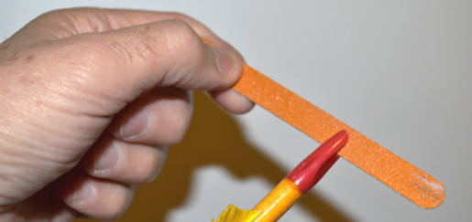

Figure 6. Shaving the inside edges of a nock using an inexpensive emery board. A thin file will also work.

STRING KEEPERS: While not a performance issue, ladies' hair ties wrapped around the upper limb just below the bowstring in its unstrung position will keep the string from coming loose and falling down, or snagging on other bows. Hair ties last longer than rubber bands or plumbing washers, and are very cheap.

STRINGERS: Never string a bow using the step-through method. This will eventually put a twist into the lower limb that will weaken the bow. Always use a bow stringer. A double cup bow stringer is fine for a bow with the string nock set well below the end. However, most bows today have the string nock very close the limb end. A double-cup stringer will often cover the nock slot, making it difficult to slide the string into the slot. Never put the cup onto the limb just by its lip. If it slips off, the bow can flip up and smash you right in the face. The best stringer is one that has a deep cup for the lower limb, and a rubber foot for the upper that is set below the string loop. The "Limbsaver" brand string is the one I use, but there are similar brands that will work equally well. These are usually sold as recurve stringers, but they work just as well for longbows. Even children's bows should be strung with a bow stringer.

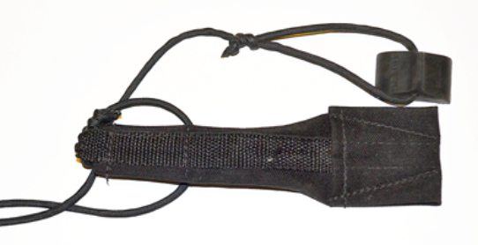
Figure 7. A bow stringer with a rubber foot is the safest way to string your bow.

BOW BAGS: Finally, consider buying a bow bag or sock to protect your bow from damage during transport and storage. Inexpensive vinyl and cloth bags are available from major archery suppliers. All-cloth bags, sometimes with shoulder straps, are usually available from some archery suppliers at Pennsic.
------
Copyright 2014 by Garth G. Groff. <ggg9y at virginia.edu>, <sarahansan at embarqmail.com>. Permission is granted for republication in SCA-related publications, provided the author is credited. Addresses change, but a reasonable attempt should be made to ensure that the author is notified of the publication and if possible receives a copy.

Unauthorized re-publication of this article is strictly prohibited, however SCA members are welcome to make copies for local use provided the text is not changed and credit is given to the author.

If this article is reprinted in a publication, I would appreciate a notice in the publication that you found this article in the Florilegium. I would also appreciate an email to myself, so that I can track which articles are being reprinted. Thanks. -Stefan.

<the end>

