Mk-Japan-Arrow-art - 3/18/18

"Building the Japanese Arrow for Target Archery" by Master Godai Katsunaga, O.L.

NOTE: See also the files: arrows-msg, Arrow-Making-art, Arrow-Matchng-art, Arrow-Inspect-art, Trubl-Shootng-art, Wdn-Arow-Mkng-art, Hbow-vs-Xbow-art.

************************************************************************
NOTICE -

This article was added to this set of files, called Stefan's Florilegium, with the permission of the author.

These files are available on the Internet at: http://www.florilegium.org

Copyright to the contents of this file remains with the author or translator.

While the author will likely give permission for this work to be reprinted in SCA type publications, please check with the author first or check for any permissions granted at the end of this file.

Thank you,
Mark S. Harris...AKA:..Stefan li Rous
stefan at florilegium.org
************************************************************************

Building the Japanese Arrow for Target Archery
by Master Godai Katsunaga, O.L.

The purpose of this paper is to help target archers using a Japanese Yumi bow build accurate arrows for target archery. These arrows will have a period appearance but will not meet the SCA period rules. This process has been refined over 10 plus years of making arrows to shoot with a ymui.

TOOLS

▪ Electronic scale
▪ Fletching Jig with straight clamp
▪ Craft Chop Saw, 2 inch
▪ Fine point marker
▪ Arrow taper tools, 5/16, 11/32 and 23/64
▪ Sharp knife
▪ Diagonal cutters
▪ 7/64 drill bit
▪ Hand drill

SUPPLIES

▪ Arrow shafts
▪ Field points 125 grain in 5/16 and 11/32
▪ Nocks, white or black in 5/16 and 11/32
▪ Feathers, I recommend left wing Kyudo feathers from 3Rivers archery. ▪ Finishing nails 6d, I use 2 inch.
▪ Silk thread, size f
▪ Arrow point adhesive
▪ Arrow nock adhesive
▪ Fletching tape

SHAFTS

I recommend using Tonkin bamboo shafts from China. Several vendors sell the shafts on Amazon and EBay. Tonkin bamboo shafts cost about 2.00 each, while Japanese arrow bamboo can cost around 10.00 a shaft. The disadvantage to Tonkin bamboo is the weight. To achieve the best accuracy do the following:
• Order spine matched shafts at 100 cm or 39.5 inches. Remember that spine is done at 26 inches and each inch longer reduces spine by about 2.5 pounds. Recommend measuring the weight of the bow at your draw length.
- Example, 36 inch draw length with 40 pounds. 10 inches over the spine length add 25 pounds to the required spine of the arrow. A 65 – 70 pound spine would be a good starting place for 40 pounds at 36 inches.
Yumi draw weight is calculated in Kilos at the following lengths:
- Nami-sun – 85cm
- Nisun-nobi – 90cm
- Yonsun-nobi – 95cm
• Order the shafts in large lots. You can weight match the shafts for more accuracy.
• Weigh each shaft using the electronic scale set to grains. Write the shaft weight on the nock end, this should be the smaller end of the shaft.
• Separate the shafts into bundles based on weight, try to stay in maximum of 20 grain groups. The closer the weight the better each group will fly.

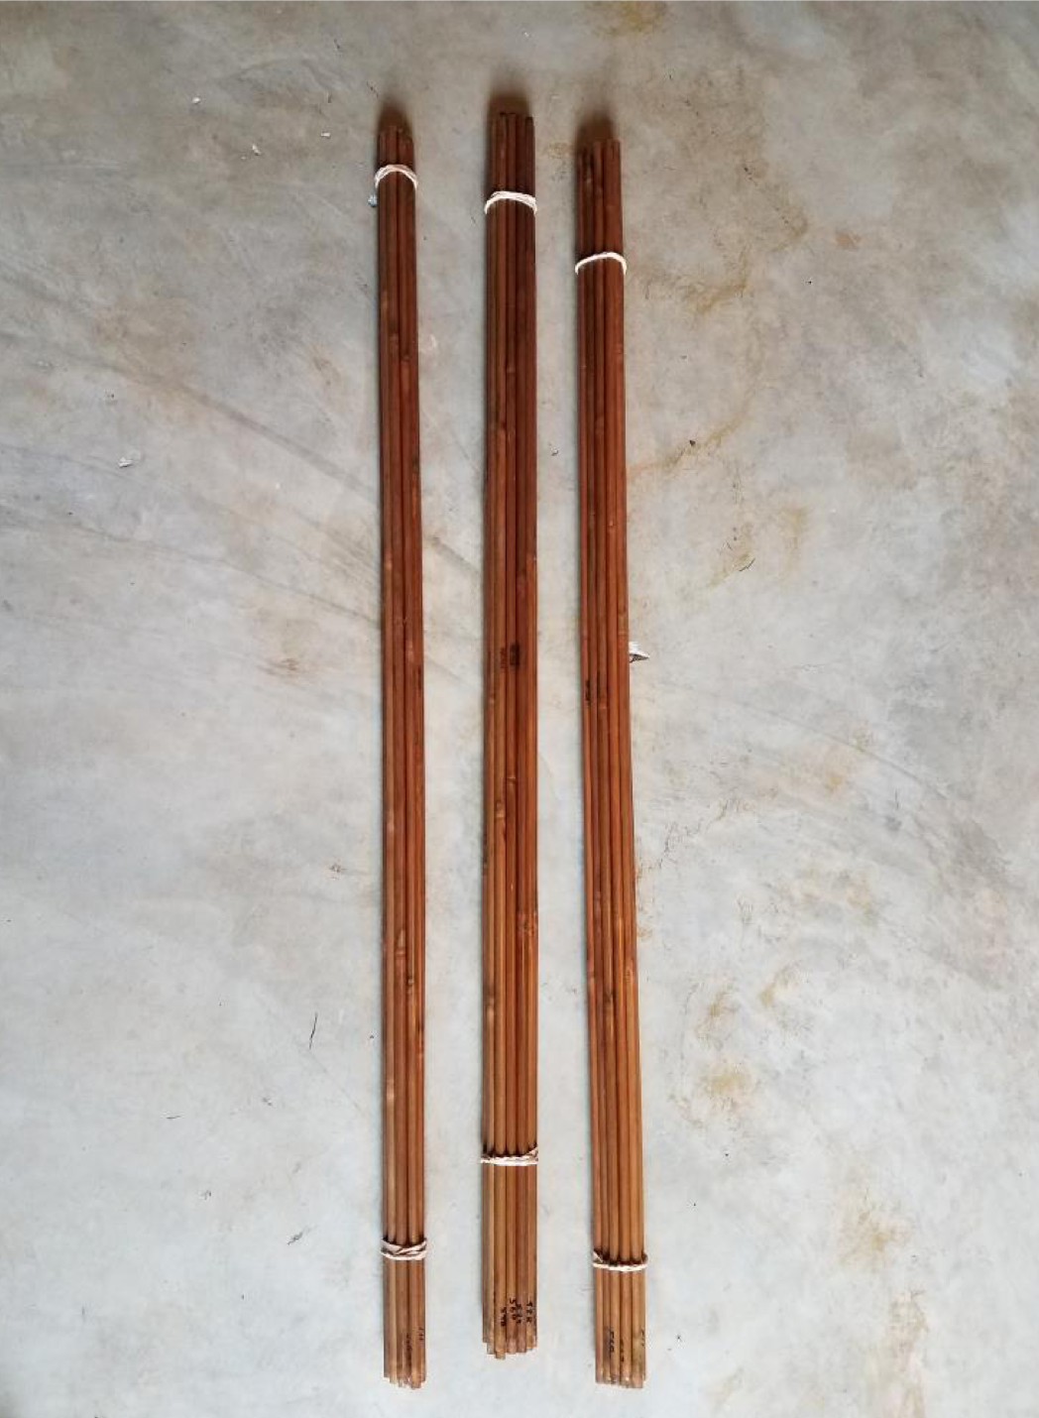
1 - Arrow shafts sorted and bundled

CONSTRUCTION

Shafts need to be cut as the first step in construction.
• With the chop saw, cut off 1/8 to 1⁄4 of the nock end of the arrow shaft. This will give you a flat cut for tapering.
▪ Measure shaft for proper draw length. This should be about 1.5 inches in front of the bow. Mark the point end with a marker and cut off excess.
▪ Taper nock end and use alcohol to remove weight mark.

Aligning the nocks will allow for the arrow to bend properly and consistently during shooting and increase accuracy.
▪ Look at the bamboo shaft and identify the node area of the shaft.
▪ When gluing the nock on the shaft align the nock with the first node in line with the string.
▪ Glue nock on shaft, most shafts will be 5/16 but some will require an 11/32 nock.

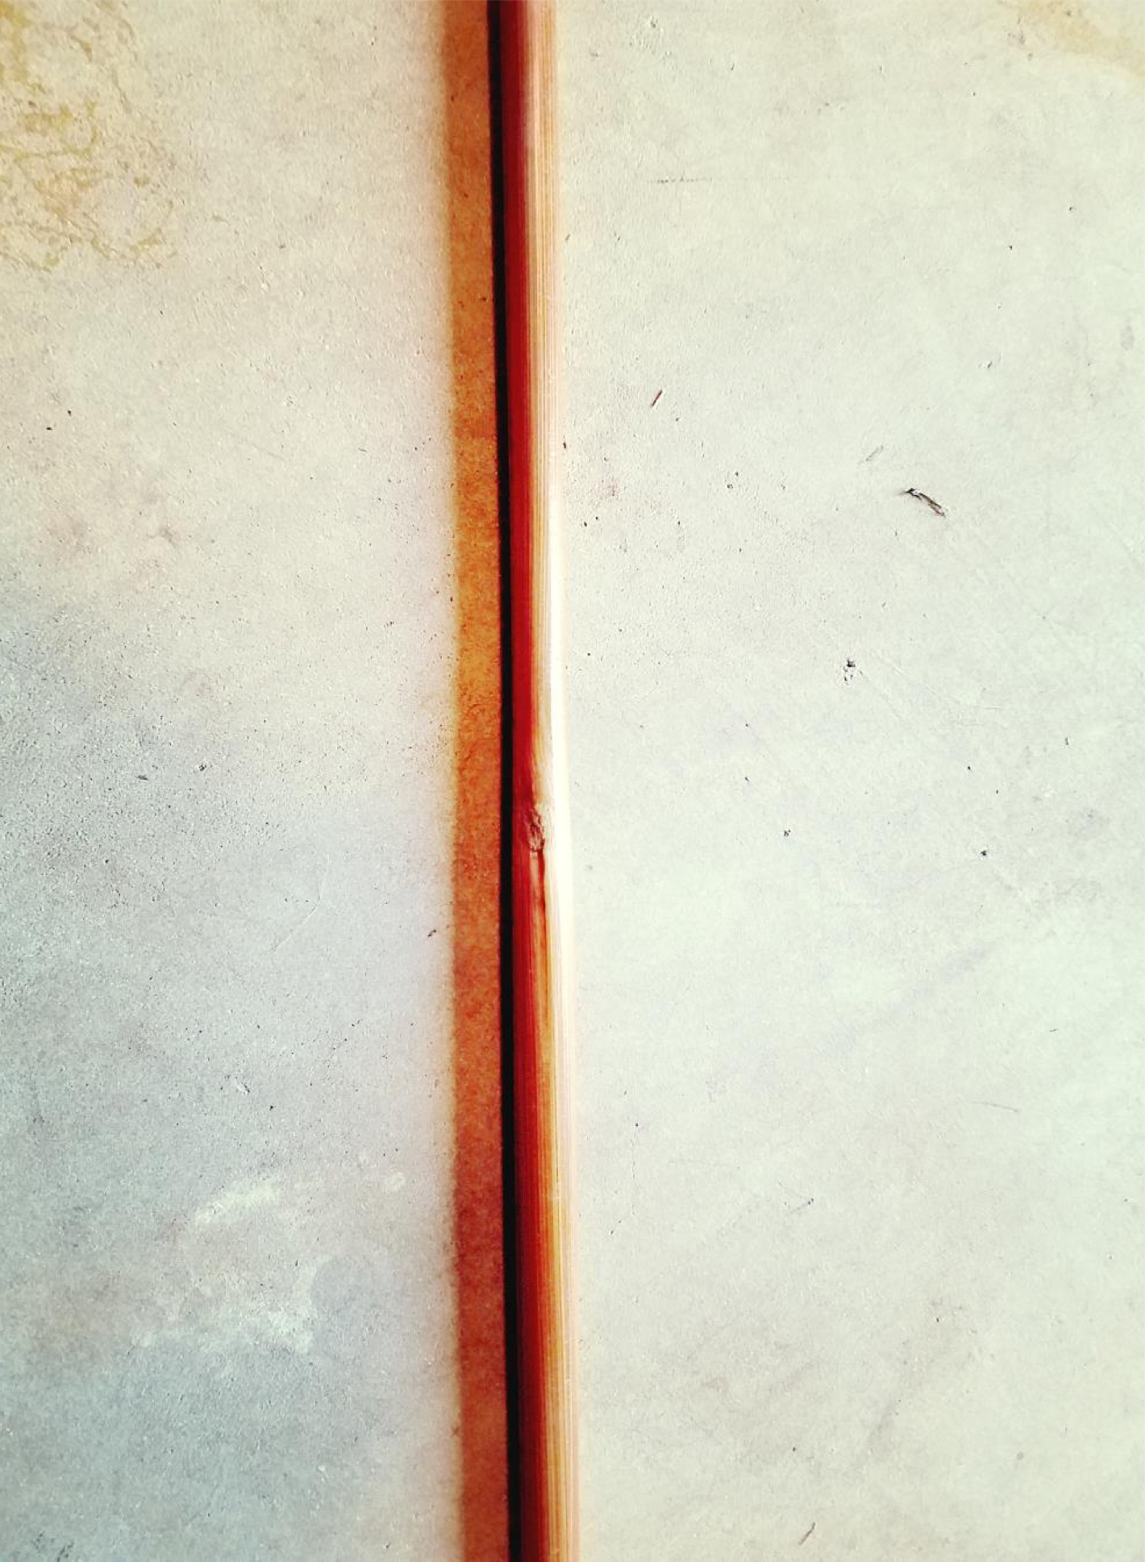
2 - Node in shaft

Fletching will have to be done by hand as most jigs will not accept the longer Kyudo feathers.
▪ Off set the fletching jig for left handed feathers, I recommended the offset be no more than 1/8 inch.
▪ Do not place the feather closer than 1.5 inches to the nock. This will prevent the archer from pushing the arrow off the string during shooting.
▪ Mark the locations at front and back of feather for each index spot.

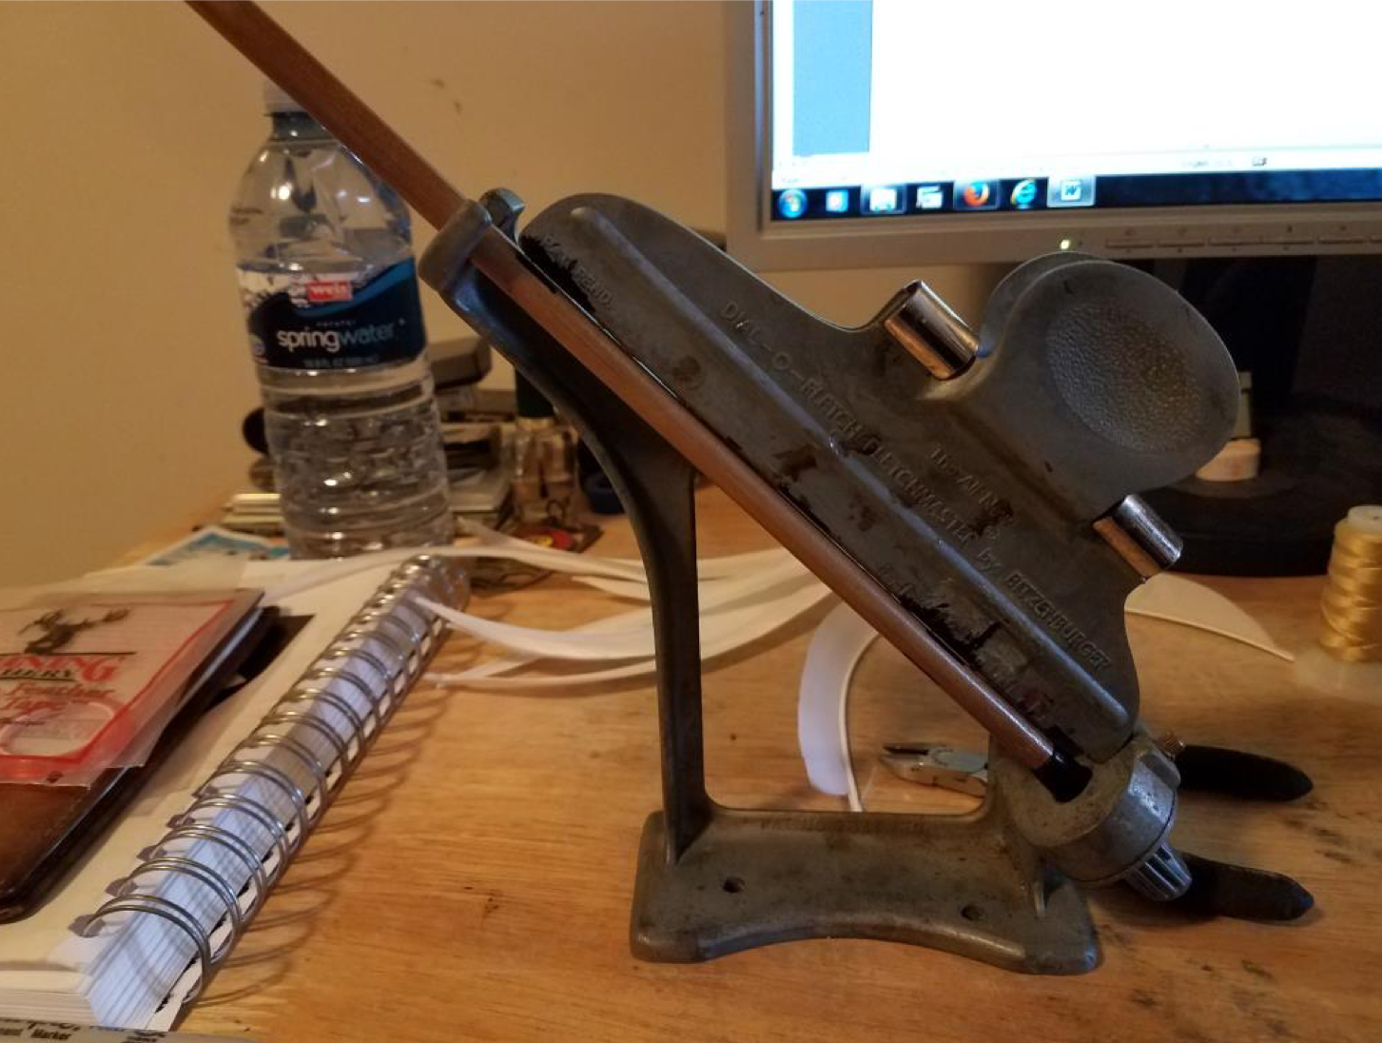
3 - Marking the feather locations

▪ Put the feather in the straight jig, the feather will be longer than the jig. I line up the back of the feather with the back of the jig.
▪ Use the fletching tape and apply it to the feather. I like fletching tape as some adhesives will not adhere to the bamboo shaft well. Cut the tape with the diagonal cutters.

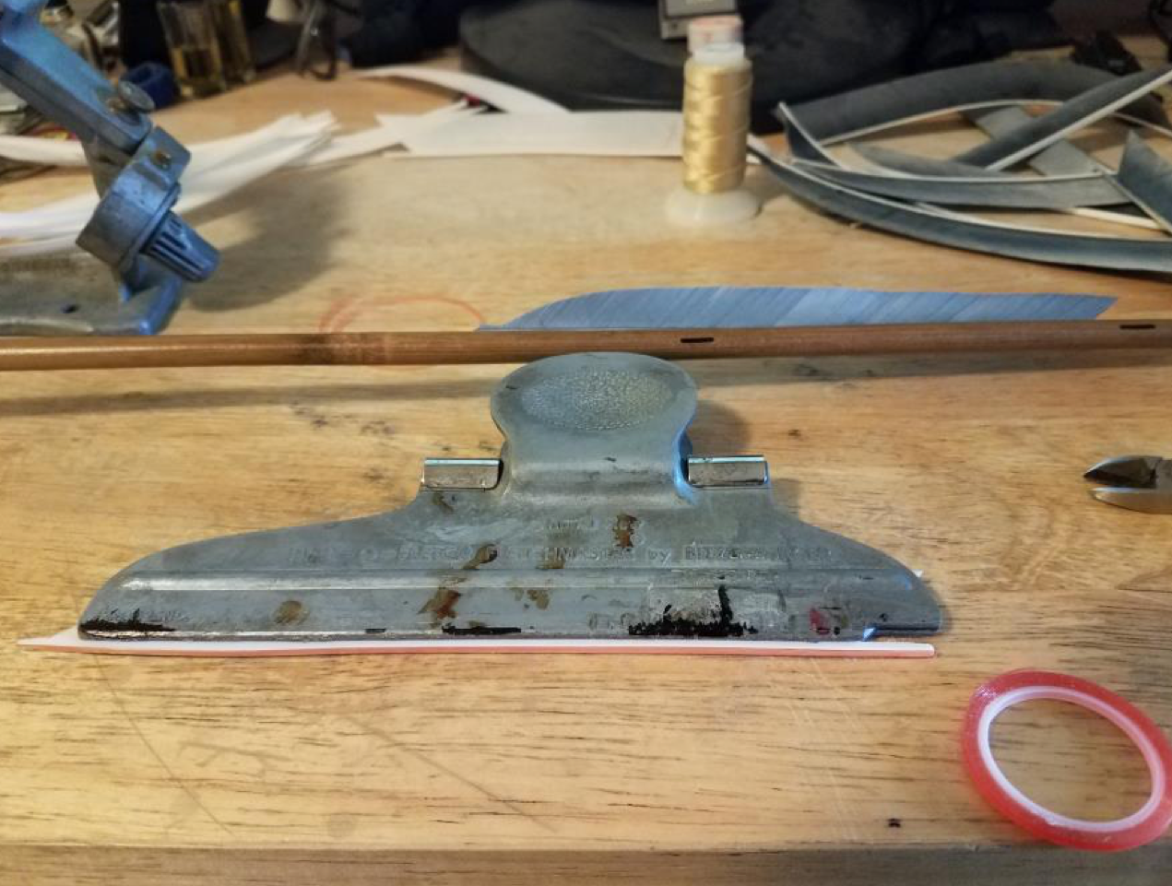
4 - feather in jig with fletching tape
- Peal off the protective layer and apply the feather to the arrow. The feather is difficult to keep straight at first, you will improve with practice. You can remove the feather if needed to reapply.
- Apply the other two feathers keeping the back of the feathers lined up.

Tie the feathers on to the shaft. This is very important when shooting off the hand. I use silk thread; it is easy to work with and gives a period appearance to the arrows.
- Use the diagonal cutters to trim of the excess feathers on both ends.
- With the sharp knife carefully remove any remaining feathers and taper the end to the shaft.
- I then use the cutters to flatten the end of the feather shaft to make a better
- transition when wrapping the silk.

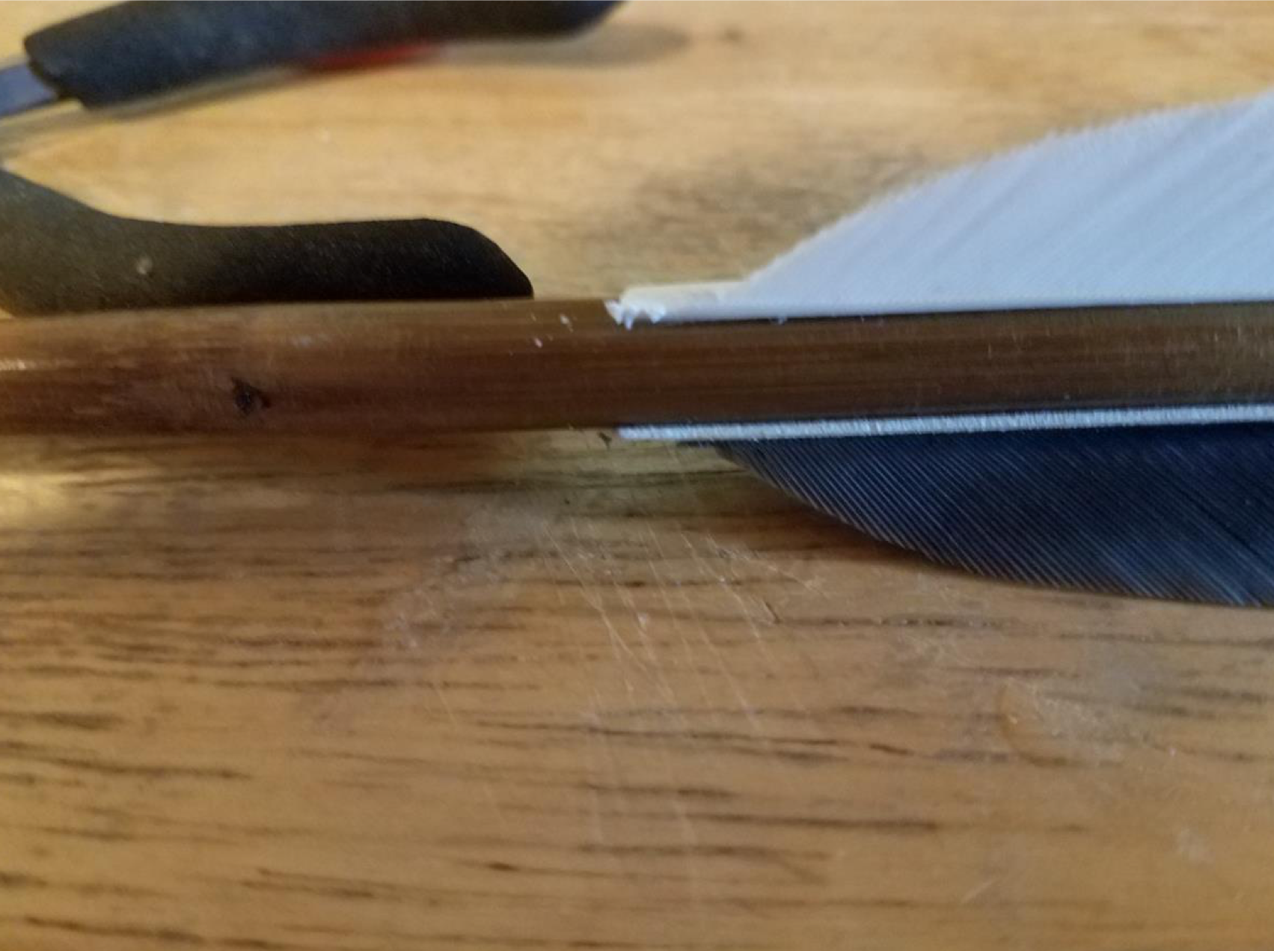
5 - Excess feather removed and end pushed down.

▪ I start the silk wrapping on the feather and work my way to the shaft. For the wrappings I use 40 inches of thread for the front and 36 inches of thread for the back of the feathers.
▪ After wrapping, I use a loop knot and apply a drop of adhesive to hold the knot. I use Gorilla impact-tough Super Glue.
▪ I wrap the front and back of the feathers. The back of the feathers is not required but makes the arrow appear more period. If you do not wrap the back of the feather, apply an adhesive to the back of the feather to help hold it in place.
▪ Apply at least two layers of adhesive to the threads, this will protect them from damage and make your arrow last longer. I use Duco Cement and apply by hand.

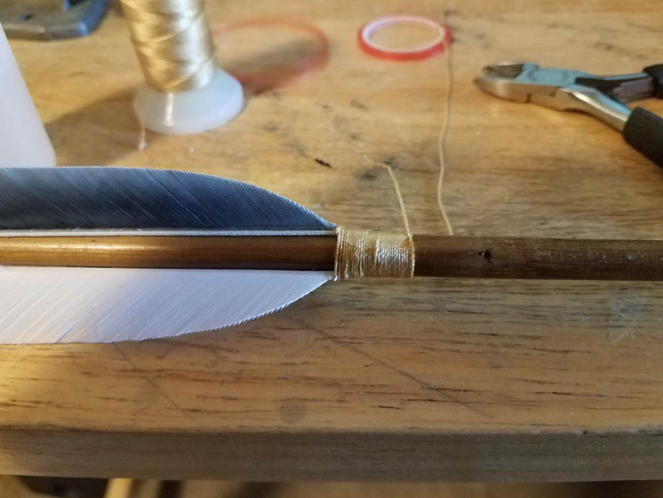
6 - Feather wrapped with silt thread

Points not only allow your arrow to penetrate the target, but set the forward of center (FOC) for your arrow. Bamboo being natural, can come in different sizes for the same spine that is why I recommend 125 grain points in various sizes. To set the proper forward of center, I use a 2 inch 6d finishing nail in the tip under the point, this adds 27 grains of weight to the tip, giving me 152 grain points. With 152 grain points I am able to achieve between 10-12 % FOC.

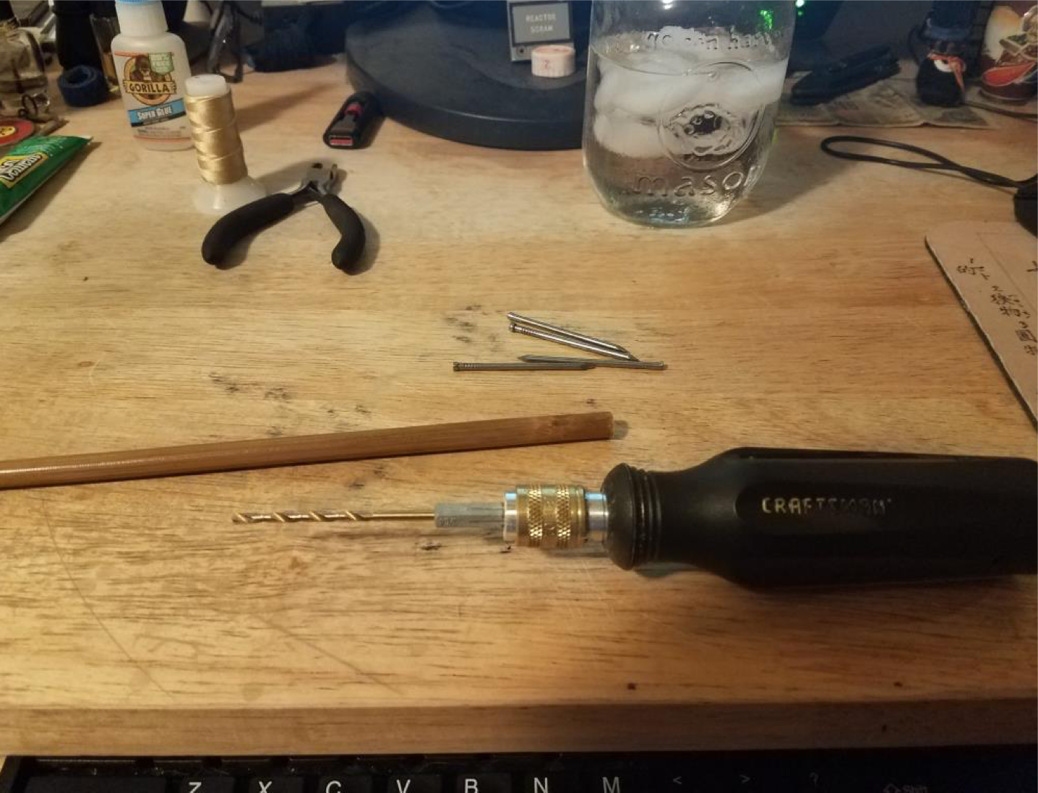
7 - Hand drill

• If you are adding a nail for weight, use a 7/64 drill bit and hand drill the shaft for the nail before tapering the shaft point.

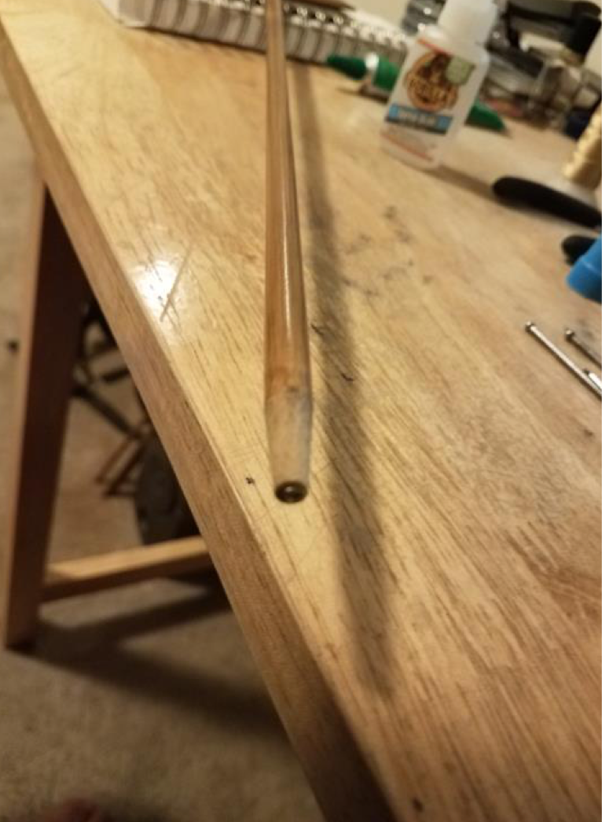
8 - Nail glued into shaft.

• Taper the shaft to accept the field point.
• Glue the nail in the bamboo; I use Gorilla impact-tough Super glue.
• Attach the field point.

Congratulations, you have completed one target arrow.

Conclusion

This is a long process, but if you take your time, you will produce a set of weight matched arrows that will fly well from the Yumi bow. Building a proper arrow is vital to accuracy and will help you become a better archer.

I weigh each completed shaft and mark the shafts with the weight. This allows me to rebuild groups as arrows break and become lost.

Good luck and good shooting.

------
Copyright 2018 by Gordon Kinnie. Permission is granted for republication in SCA-related publications, provided the author is credited. Addresses change, but a reasonable attempt should be made to ensure that the author is notified of the publication and if possible receives a copy.

If this article is reprinted in a publication, please place a notice in the publication that you found this article in the Florilegium. I would also appreciate an email to myself, so that I can track which articles are being reprinted. Thanks. -Stefan.

<the end>

