Scotsh-Archrs-art - 6/3/12

"Scottish Archers? Really?" by Lord Mungo Napier.

NOTE: See also the files: archery-books-msg, bow-making-msg, crossbows-msg, P-Arch-Target-art, War-Archry-SS-art, Scotland-msg, hose-msg, Kilts-1590-art.

************************************************************************
NOTICE -

This article was submitted to me by the author for inclusion in this set of files, called Stefan's Florilegium.

These files are available on the Internet at: http://www.florilegium.org

Copyright to the contents of this file remains with the author or translator.

While the author will likely give permission for this work to be reprinted in SCA type publications, please check with the author first or check for any permissions granted at the end of this file.

Thank you,
Mark S. Harris...AKA:..Stefan li Rous
stefan at florilegium.org
************************************************************************

SCOTTISH ARCHERS? REALLY?

A presentation by
Lord Mungo Napier, Archer of Mallard Lodge
()
ATLANTIA UNIVERSITY, SESSION 74
RICHMOND VIRGINIA, 7 FEBRUARY 2009

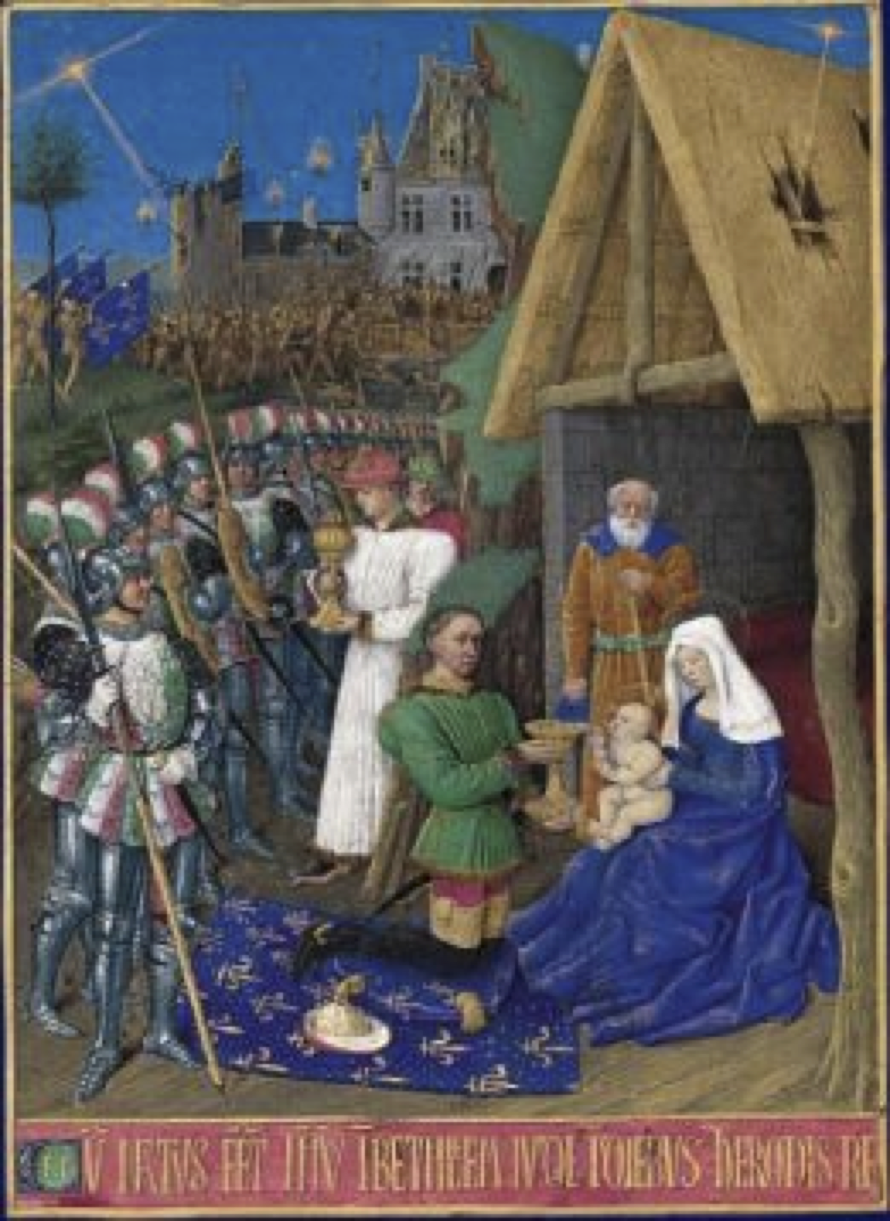

THE HIGHLANDS AND THE LOWLANDS

To understand the medieval history of Scotland, one must first be aware of the differences between the Highlands and the Lowlands. The Highlands are those areas shown in dark on the map at right. The Lowlands are the lighter areas. The demarcation line is the Highland Fault, a geological formation. In reality, this lineis purely artificial, and the differences were largely cultural.

The Lowland culture was very similar to that of England, Anglo-Norman and high feudal. Many of the great Lowland families were descended from Norman knights who had settled in Scotland both before and after William the Conquerer's brief foray north in 1071. These included such families as the Bruces, the Comyns and the St. Clairs (later Sinclairs). Some Anglo-Norman families still had feudal holdings in English France, and so owed fealty to both English and Scottish kings, which made for some interesting politics.

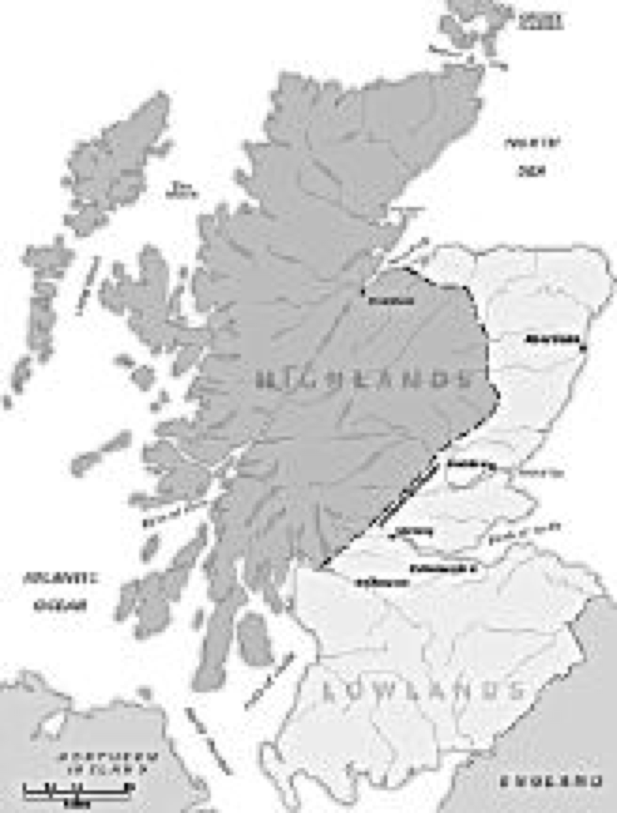
(Source: Wikipedia)

Most of the Scottish-descended Lowland lords had adopted Anglo-Norman lifestyles. Their common language was Scots, a dialect of English. Highland culture was partly feudal, but was overlain by the clan system with all its complicated obligations based on kinship ties. Clan loyalties usually took precedence over feudal ones. Most Highlanders spoke a Gaelic dialect, though many lords also spoke Scots and or French, especially at court. The lords also dressed in the English fashion while at court, usually reverting to Highland garb while on their own lands. In many ways, the Highland culture was materially and militarily far behind that of the Lowlands or England for the commoners, except in the few large towns.

The Highland Fault is a purely arbitrary distinction. Some lords controlled territory that crossed the boundary, such as the Napiers who held both Highland and Lowland areas northwest of Glasgow, or the Sinclairs who held both the lands around Roslyn in the Lowlands, and the Highland Earldom of Caithness in the far north.

ARCHERS IN THE FIRST WAR OF INDEPENDENCE

The earliest period for which good documentation on Scottish archery is available is the First Scottish War of Independence. This was the time of Sir William Wallace and King Robert the Bruce, roughly 1296 to 1329

Information on archers from this era is very sparse, though Scottish archers figured prominently in the Battle of Falkirk (1298) and again at the Battle of Roslyn (1303). Some of the best information comes from gravestones, and interpretations could be found at the former web site of the Scottish reenactment group Gaddgedlar. In 2000 this group sponsored a reenactment of the 1314 Battle of Bannockburn, and published an excellent guide to clothing and equipment.

Lowland archers, especially those in retained service by the great lords, were probably fitted out much as their English counterparts. Gaddgedlar suggests braes, hosen, a loose fitting colorless shirt of linen, with a long-sleeved wool or linen knee-length coat, and period shoes or boots. Better-equipped archers might have worn a padded aketon or gambezon, a mail coif, and possibly a conical or kettle helmet.

Note the two archers shown below. One is carrying a crossbow and the other a longbow with a belt quiver. This longbow was certainly not like the monster English war bows mode of yew and drawing 160 pounds found on the wreck of the Mary Rose. Such bows represent the peak of archery's development. Longbow of the 1300s, whether in the hands of Scots, or the English and Welsh, would often have been made from oak, ash, or some other local wood. Elm was considered one of the best. English yew was rarely used for bows, since it is knotty and twisty. Yew staves imported from the continent would still have been very rare. Longbows of the time probably drew less than 100 pounds.

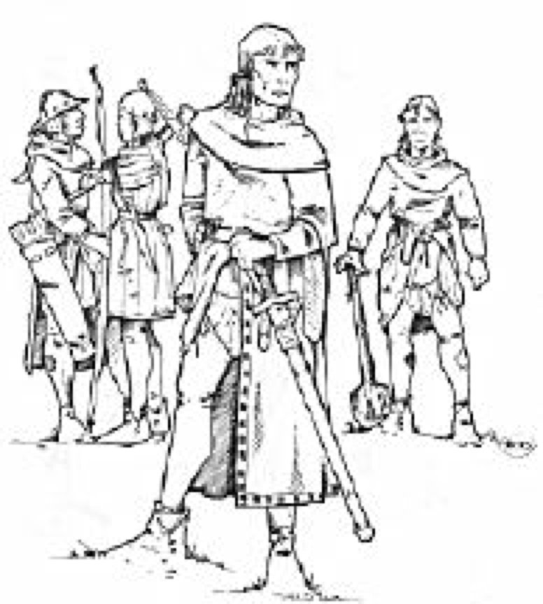
(Source: Gaddgedlar web site)

Highland archers were a special case. Highland infantry, called "Caterans", generally wore a loose fitting hooded garment similar to a Huké, or a hooded poncho-like garment, both probably of

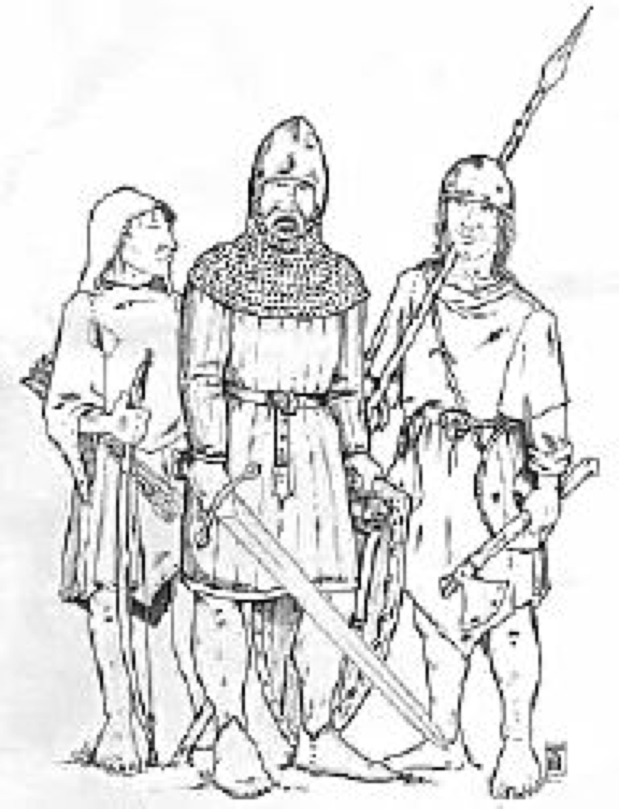
(Source: Gaddgedlar)

wool. This often covered a long linen shirt, and possibly braes and hose. Some highlanders might have worn chain mail shirts, padded jacks, gambezons, or even deerskin shirts (with hair intact, but mercifully worn outward!). Conical or kettle helmets were sometimes worn. The garb of the right and left men in the accompanying illustration is probably typical. The armored warrior at center is probably a noble. Keep in mind that the great kilt, especially with its complex tartan patterns had not been invented yet, though cloth with large checks was known. No, dear friends, William Wallace didn't wear a kilt, assertions by Blind Harry the Bard and Mel Gibson not withstanding. Many Highland soldiers of all classes went barefoot, though the men in our next illustration wear shoes

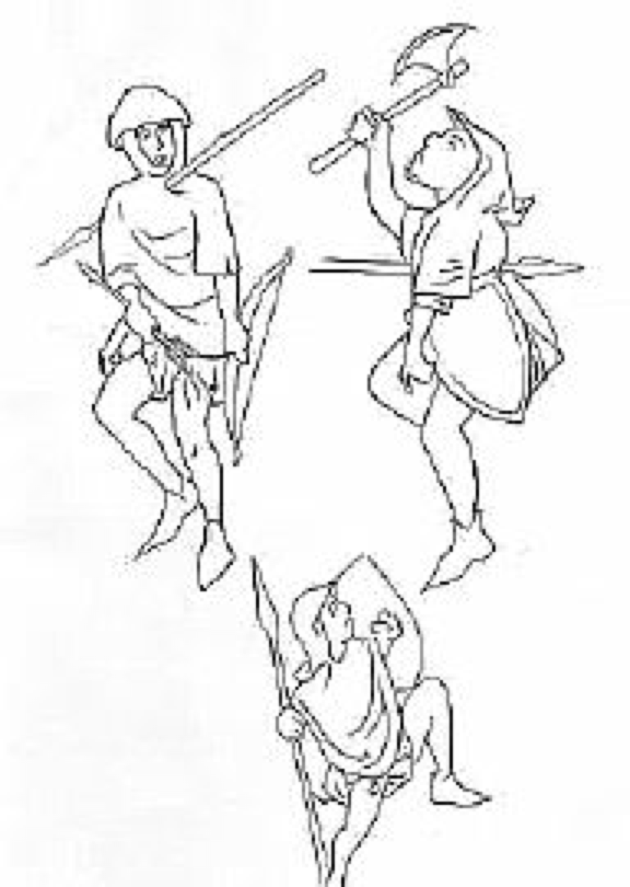

(Source: Gaddgedlar)

Of special interest are the bows. In the illustrations above and at right (from illuminations on the Carlisle Charter) the archers carry short bows, probably about four to four and one-half feet long. The bow carried by the man in our first view is a simple arc, similar to a longbow, though smaller. The archer being uncomfortably impaled with a spear in the illustration carries what might be a recurve bow, though the bow limbs might instead have simple curved horn tips. There is not enough detail here to be sure which. One bow type which can be seen in several period illustrations is a short recurve (see the illustration at the end of our text). These bows appear to have been used in Scotland from the 13th to the 16th centuries.

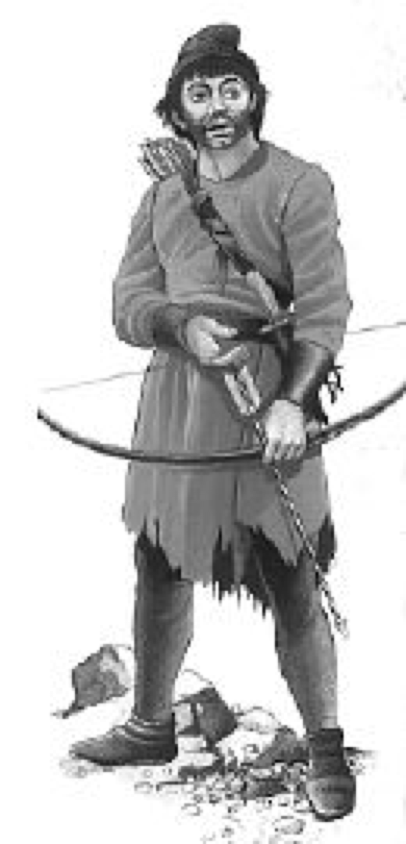
(Source: Rothero)

Another image of a Scottish archer may be found in Christopher Rothero's THE SCOTTISH AND WELSH WARS, 1250-1400, as shown above. This man wears a tattered tunic, hosen or possibly trews, and a shapeless bag hat, probably of wool. His shoes suggest he is a Lowland man, though as our previous illustration shows, this is not always certain. His tunic is belted, and a sheath holds a very large and vicious-looking dagger, the man's only secondary weapon. Though its design is not shown, our archer carries his arrows in a quiver on his back (better for hunting than a side quiver, and suggesting his archery equipment serves a dual purpose). His bow is slightly recurved and probably less than five feet long, unfortunately cut off here (a better illustration is too close to the book's gutter to scan). Sadly, Rothero gives us no information on the source of this image.

This last archer is clothed in a manner little different from English peasants of the time, which brings us back to a previous point, often quoted in both Scadian literature and occasionally in scholarly journals. Lowlanders generally wore similar clothes to people of corresponding rank in England during the late middle ages and renaissance period, allowing that the general poverty in Scotland (relative to England) meant lower quality materials and more patches for all but the greatest lords. Thus illustrations in Clive Bartlett's book ENGLISH LONGBOWMAN, 1330-1515 can also serve as a useful guide for depicting Lowland Scots archers in those years.

One of the earliest laws setting down what weapons and equipment a Scot was to own was enacted by Robert the Bruce's parliament of 1318. It decreed ". . . that each layman of the kingdom having £10 in goods should have for his body in defense of the kingdom a sufficient haqueton, a basinet, and mailed gloves with a lance and sword. And anyone who shall not have a haqueton and a basinet should have a good habergeon or a good iron [coat of mail] for his body, a cap of iron and mailed gloves. . . . Moreover the lord king wishes and commands that anyone having the value of one cow in goods should have a good lance or a good bow with a sheath of arrows, namely twenty-four arrows with the pertinents . . . . " (Source: Royal Parliament of Scotland, 1318/29). All men were directed to present their equipment for inspection by the king's agents the following spring, or face some pretty hefty fines.

ARCHERS IN THE 15TH AND 16TH CENTURIES

n 1415, France's finest army was wiped out by a bunch of disentary-ridden English peasant archers at Agincourt. The young Dauphin, Charles VII, was in a fix. The Burgundians, with several serious beefs with the Dauphin and smelling blood, threw in their lot with the English. Paris was taken by the Burgundians and the English, and Charles was forced to flee to the south of France. More importantly for Charles, Rheims where French kings were always crowned, were in the hands of his enemies. What's was the Dauphin to do? He ordered out!

Charles hired mercenaries from among his allies, with the Scots being the most enthusiastic of his early supporters. In October 1418 "Jehan Stewart" at the head of 100 archers took service with the French. Many other small companies arrived over the next few months, most with archers, many presumably longbowmen. These men supplemented depleted French garrisons in territory the Dauphin still held (Source: Time of Great Armies).

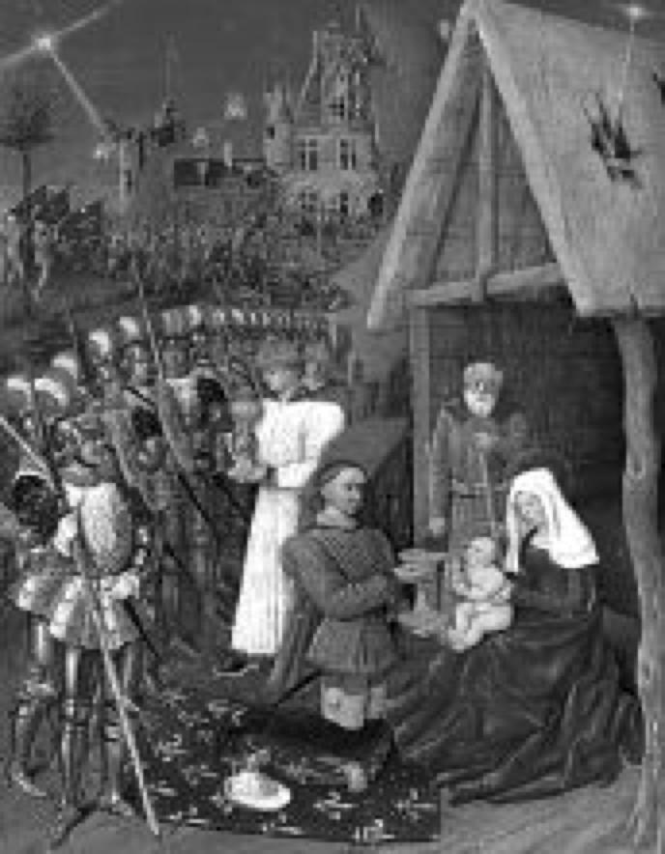
(Source: Wikipedia)

The Dauphin was delighted with the Scottish troops. He took 24 archers into his personal bodyguard as "La Garde Écossaise". The exact date this happened is in doubt, but it was certainly before 1425. A commission in this unit was a much sought-after honor for the sons of both Scottish lords and wealthy burgesses. Many young men who later rose to high office in Scotland first polished their credentials and their French, by serving in La Garde Écossaise. An interesting illustration (at left, and in color on our cover) from Jean Fouquet's BOOK OF HOURS shows Charles VII as one of the Magi in adoration of the infant Jesus. Behind him are a number of soldiers decked out in the finest armor, one might say "fashion plate". These are La Garde Écossaise. Note that some are holding longbows (Source: Bartlet).

What Charles VII really needed was a large "ready-made" army. In June 1419, the Scots sent a force of 5,000-6,000 men under the Earl of Buchan. Many of these soldiers were archers, mostly longbowmen. The army was transported from Scotland to France in a heavily-armed convoy of Castilian ships for protection against English privateers.

The Scots were successful in a number of battles against the English, especially the Battle of Baugé in 1421. There 100 or so archers and a few men-at-arms held a vital bridge long enough for the Scots and their French allies to arm themselves after a surprise attack by a large English army interrupted a football game in the Scottish camp.

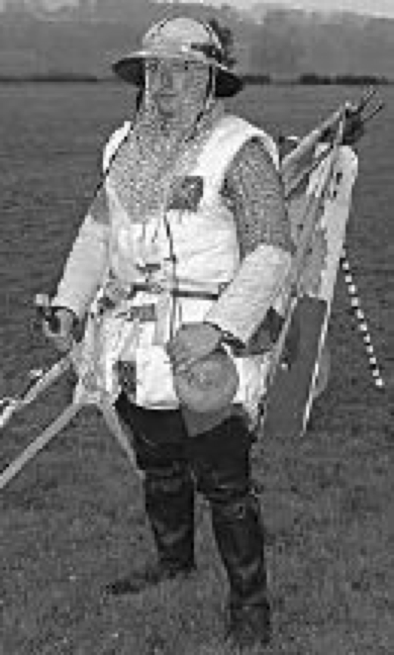
(Source: Gaddgedlar)

Gaddgedlar has again come to the rescue with photos showing gear typical of the Scottish army during the 15th century, especially in French service. The man at left, representing a pikeman, wears a kettle helmet, a mail shirt and coif, gambezon, plus leather leggings, not unreasonable gear for an archer. The man below carries a crossbow, does not wear mail, and his legs are clad only in hosen, though he does have a gambezon and a sallet helmet, (or "salade" in Scots).

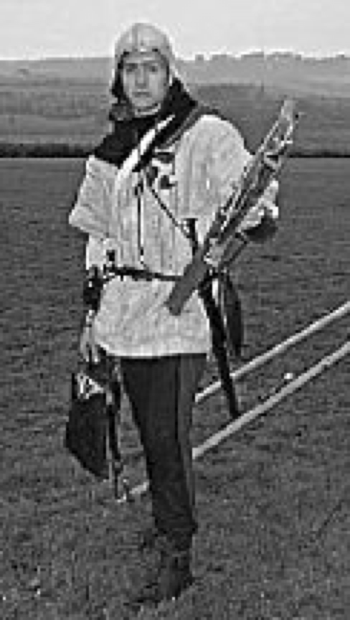
(Source: Gaddgedlar)

Also note that both men wear a small patch showing the saltire or St. Andrew's of Scotland. This is shown here as white on blue. The flag patch was mandated in 1385 by the Scottish Parliament, which specified a simple white cross on dark clothes, or a white cross over a black patch on a white garment. The patch could be round or rectangular (Source: Royal Parliament of Scotland, 1385/6/4). The earliest known use of the saltire on a flag dates from 1503, a white cross on a red field. The white cross on blue still flown today was adopted in 1540, but was probably in use for some years before then (Source: Wikipedia).

Gaddgedlar's choice of blue may be correct for the time, or might be a compromise to help modern visitors at their demonstrations tell the "Good Guys" (The Scots. Yay!) from the "Bad Guys" (The English. Hiss, Boo!). In any case, it is a detail that should not be ignored for our own garb.

Scotland's King James I, finally back on his throne in Scotland after being a "guest" of the English for 18 years, called a parliament in 1424. One of his first laws was a ban on football (Source: Royal Parliament of Scotland, 1424/19). A few comments about Scottish football are in order here. This was no genteel sport like rugby or American football, with pesky rules and annoying referees. Though weapons were banned, it was more of a free-for-all brawl. The ball was rarely kicked. Kicking was applied to an opponent's jewels, hoping that a missing athletic cup might render the player hors de combat. It was pure hooliganism, and the Scots loved their football.

James I's next law explains the reason for his football ban. " . . . that all men prepare themselves to be archers from when they are twelve years of age. And that in each £10 of land there be made bowmarks, and especially beside parish churches, where men on holy days may come and shoot at least three times and have practice of archery . . . ." (Source: Royal Parliament of Scotland, 1424/20).
This law echoes similar laws in England, such as the 1258 Statute of Winchester that established regular archery practice (Source: Bartlet).

Is it any wonder that James I was one of Scotland's most unpopular kings and his own people eventually knocked him off? Scotland had gotten along for 18 years without a king, thank you, and the Scots were used to making their own decisions. Similar laws banning football continued to be enacted by other Scottish kings, which suggests the bans were largely ignored by the Scots, who had a habit of not doing what their kings wanted anyway. Golf was added to the football ban by James IV's parliament in 1491 (Source: Royal Parliament of Scotland, 1491/4/17), but this law seems to have been equally ignored.

Laws regulating what military equipment Scots were required to own also continued to be passed by successive parliaments, which suggests either a response to changing military technology, or a general lack of compliance by the Scottish public (or both). Since the requirements changed every few years, it is difficult to imagine how the lower classes could afford to arm themselves. Under some of these laws, those who could not afford better gear where allowed to maintain nothing more than a sharpened stick with an iron-shod point. In the early 16th century, yeomen worth £10 (note the inflation here from Robert the Bruce's time, when a yeoman was worth a cow) were to have a bow and sheaf of arrows, sword, buckler and knife. The type of bow is not specified, but the poorest probably made do with the simple short bow we have seen earlier. By 1540, men not wearing "white harness" (full armor) were required to have jacks of plate, halcrets, splints, a 'salade', and gorget (Source: Dickinson).

Weapons were required to be presented for inspection by the king's agents at musters called "wappinshaws" (Scots for "weapons showings"). The frequency of wappinshaws varied over the years. The Bruce's 1318 decree seems to have been a one-time event. Under later parliaments they were ordered semi-annually and even quarterly.

It is interesting to note that all military gear was the responsibility of the individual citizen, though some local lords may have assisted with the cost of arming their vassals. This was in contrast to the English crown's policy of supplying at least some equipment carried by their troops by the 16th century. Nor were Scots paid for their military service while defending their own soil, or raiding into England. They were paid by Charles VII while serving in France, which helps explain why some Scots stayed so long (in addition to grants of land, a nice climate and great wine!). Except possibly for football, knocking English heads together was the Scots' favorite activity, and all the better when they were paid to do it.

Despite the Scots' love for guns and anything else that went "bang", archery continued to be a mainstay of Scottish armies well into the 17th century. In 1595, James VI (soon to be James I of England) sent a bowyer named James Forgeson to England to purchase 10,000 bows and bow staves. He was apparently unsuccessful, and went on to the continent with unknown results (Source: Logan). His failure to buy bows in England is understandable when one considers that Queen Elizabeth had ordered her archers re-equipped with firearms in 1581. However, longbows continued to be in the official inventories of many English armories until the 1620s, so it may be that Forgeson was sent packing just to keep those now-redundant bows out of the hands of the troublesome Scots.

GALLOWGLASS MERCENARIES

After 1259 some Highlanders found employment as soldiers serving Irish kings and chieftains. It was here they came to be known as "Gallowglasses", an anglicisation of the Irish gallóglaigh, meaning "foreign soldiers" (Source: Wilipedia). In some cases, these Scots were chiefs who had been exiled by their king for various irritations, and some took their entire clans with them to Ireland. The usual arrangement was land and status in exchange for service, and many Scots permanently settled among the Irish. Others offered their services during the fighting season, and returned to Scotland, perhaps just in time for the cattle rustling season. Some contemporary accounts say that most Gallowglasses fought without armor, their courage and their skill at arms being their protection (Source: McKerra), the many did wear armor.

Gallowglassess and their garb are a special case that must be considered separately from the Lowland Scots. Up until sometime in the 16th century, the most common garment for Highland men was the léine, similar to what was widely worn in Ireland. This was a long linen shirt, which could be gathered and belted at the waist, and had enormous sleeves. Chieftains and great warriors sometimes dyed these shirts yellow (or "saffron", though the dyestuff certainly wasn't made from such a rare and expensive herb). At times the léine might be covered with a deerskin vest. The garment at left might easily be confused with a kilt, but the sleeves are

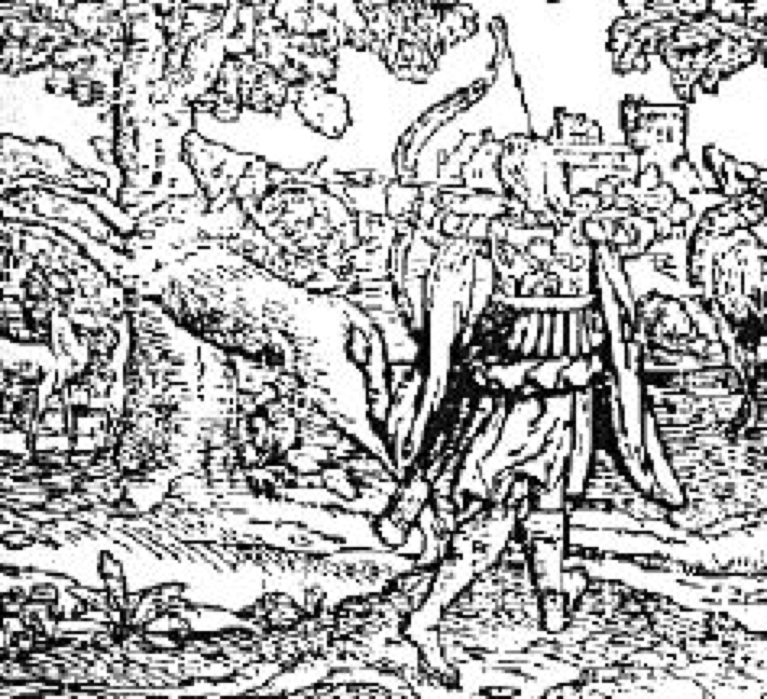
(Source: Wikipedia)

a giveaway that the figure in the previous illustration is wearing a léine. However, it is his bow that is of greatest interest to us. Here we see an excellent representation of a short recurve bow. Since it is powerful enough to kill a hart, the bow is certainly powerful enough for war, at least against lightly armored foes. Note that the right-handed archer oddly carries his arrows in a belt quiver on his left side.

Gallowglass mercenaries found work in Europe as well. The Albrecht Dürer image at left shows two soldiers with their servants in Germany in 1521. The man at the left wears an aketon, along padded coat. The man with the giant sword appears to be wearing a tunic without sleeves under a mail shirt. His helmet is a sallet. His sandals resemble Birkenstocks. His bow is a short recurve, and he carries arrows in his belt after the English fashion. The three men on the right are common Irish soldiers called kerns. The center man, though a kern, wears a tartan as a mantel in the Scottish manner.

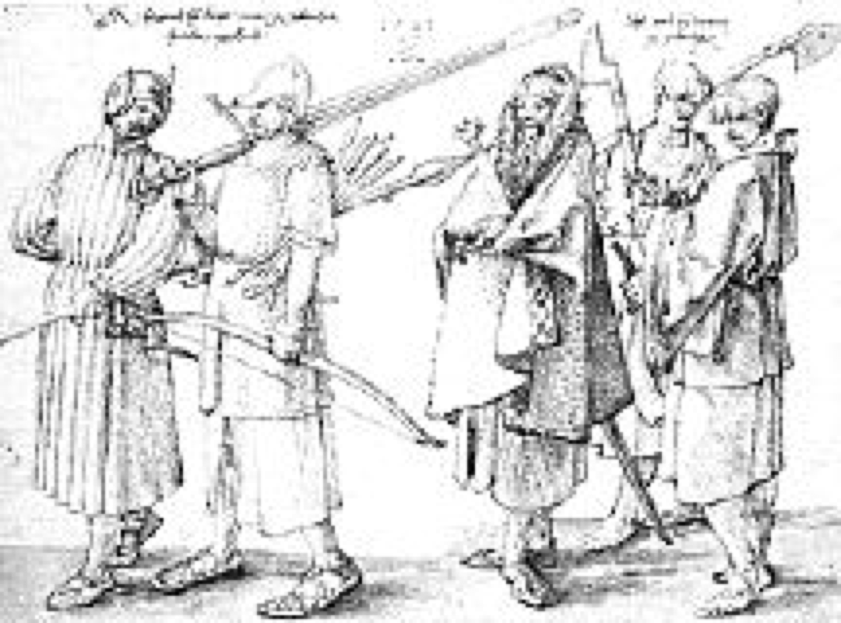
(Source: Wikipedia)

One of the most interesting descriptions of Highland (actually Hebridean) mercenaries is found in the Lughaidh Ó Clerigh's LIFE OF AUDH RUADH Ó DOMHNAILL. It describes some Gallowglasses who took service with Red Hugh O'Donnell, Earl of Tyrconnell in 1594 during his nearly-successful war to chase the English out of Ireland.

" . . . They were recognized among the Irish soldiers by the distinction of their arms and clothing, their habits and language, for their exterior dress was mottled cloaks of many colours with a fringe to their shins and calves, their belts were over their loins outside their cloaks. Many of them had swords with hafts of horn, large and warlike, over their shoulders. It was necessary for the soldier to grip the very haft of his sword with both hands when he would strike a blow with it. Others of them had bows of carved wood strong for use, with well seasoned strings of hemp, and arrows sharp-pointed, whizzing in flight." (Source: Krossa)

Two things are significant about this passage. Once again, we have evidence of Highland archers. "Bows of carved wood" could mean any type of bow, but suggests something more than just a plain bow stave. Since we already have evidence for recurve bows in the hands of the Gallowglasses (with another example to follow), it would not be unreasonable to assume these are indeed recurves. The late date is equally interesting, showing again that military archery remained important to the Scots even well into the firearms era.

The other important nugget to be gleaned from this passage is that this is the first recorded evidence for the great kilt, belted plaid, or feileadh mor. While there are other descriptions of Scottish clothing, which have elements that are similar to the great kilt, and lead to understandable confusion, this description is the first that clearly combines tartan cloth with the belt. Now the great kilt did not simply spring from the soil of Scotland in 1594, but it must have been in use for some time before that date. Applying the logic of SCA's heraldry rules giving a 50-year usage window before a name's first documented appearance, it would not be unreasonable to assume that the great kilt could be worn by a mid-1500s character.

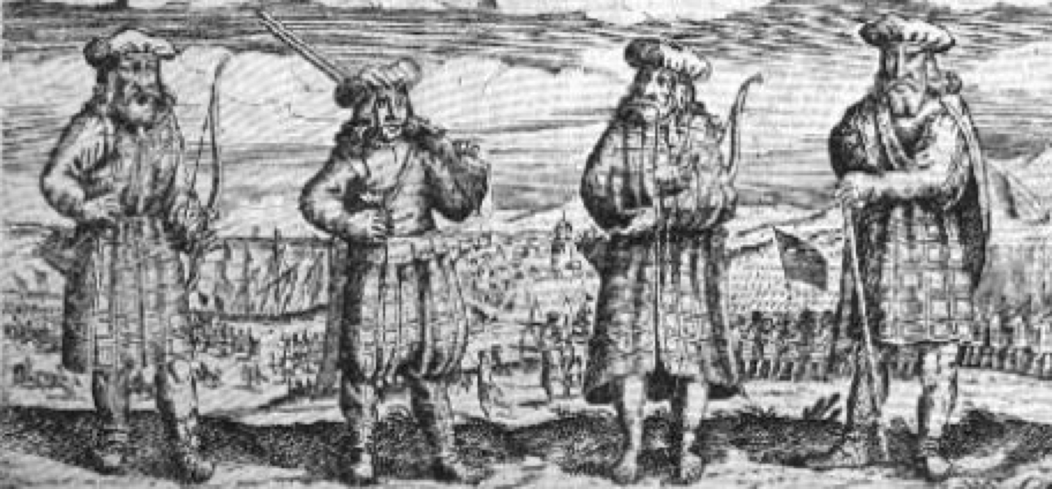
(Source: Wikipedia)

As a final note, I offer you this slightly out of period image, showing Highland mercenaries in service of the King of Sweden during the 30-years war, circa 1632. What is important for our purposes is that two of them are archers, and both appear to be carrying short recurve bows, again suggesting that the Highland Scots continued to use these weapons until the final end of military archery. All four wear tartan clothing. The two men on the ends wear the great kilt. The second man from the left appears to be wearing some sort of baggy trousers or trewes, certainly not the modern fileile beag or short kilt. The third man from the left wears a tartan wrapped very much like a long coat. Their caps, by the way, are no doubt blue. This was an almost universal color for Scottish headgear in both the Highlands and Lowlands beginning in the 1500s, and is often remarked upon in contemporary descriptions.

PRINTED REFERENCES

Bartlett, Clive. ENGLISH LONGBOWMAN, 1330-1515. Oxford, England: Osprey Publishing Co. 1995.

Brydall, Robert. "Notes on Scottish Costume in the fifteenth century." TRANSACTIONS OF THE GLASGOW ARCHAEOLOGICAL SOCIETY. Glasgow: Maclehose & Sons, 1903.

Dickinson, Gladys. "Some notes on the Scottish army in the first half of the sixteenth century." SCOTTISH HISTORICAL REVIEW, v. 28. Edinburgh, Thomas Nelson & Sons, 1949.

Featherstone, Donald. THE BOWMEN OF ENGLAND. Barnsley: Pen and Sword, 2005.

Logan, James. THE SCOTTISH GAEL. Hartford: S. Andrus and Son, 1849.

McKerral, Andrew. "West Highland mercenaries in Ireland." SCOTTISH HISTORICAL REVIEW, v. 30. Edinburgh, Thomas Nelson & Sons, 1951.

Rothero, Christopher. THE SCOTTISH AND WELSH WARS, 1250-1400. Oxford, England: Osprey Publishing Co., 1984.

WEB RESOURCES

Gaddgedlar: Bringing History to Life. http://www.gaddgedlar.com/ . Site now gone.

Krossa, Sharon L. MEDIEVAL SCOTLAND. http://www.medievalscotland.org/clothing/refs/aodhruadh.shtml#oclerigh1948

Records of the Parliaments of Scotland to 1707. http://www.rps.ac.uk/

Time of Great Armies web site. http://www.deremilitari.org/resources/articles/ditcham3.htm

Wilipepedia: "Flag of Scotland". http://en.wikipedia.org/wiki/Flag_of_scotland

Wikipedia: "Gallowglasses". http://en.wikipedia.org/wiki/Gallowglasses

Wikipedia: "Scottish Highlands". http://en.wikipedia.org/wiki/Scottish_highlands
------
Copyright 2012 by Garth G. Groff. <ggg9y at virginia.edu>. Permission is granted for republication in SCA-related publications, provided the author is credited. Addresses change, but a reasonable attempt should be made to ensure that the author is notified of the publication and if possible receives a copy.

If this article is reprinted in a publication, I would appreciate a notice in the publication that you found this article in the Florilegium. I would also appreciate an email to myself, so that I can track which articles are being reprinted. Thanks. -Stefan.

<the end>

