Siloflx-Nocks-art - 5/15/14

"How to Build and Install a Siloflex Nock" by THLady Ingilborg Sigmundardottir of Caid.

NOTE: See also the files: C-A-Basics-art, C-A-Handbook-art, c-archery-msg, CA-Hunt-Tips-art, War-Archry-SS-art, Arch-H-Gntlet-art, arch-supplies-msg.

************************************************************************
NOTICE -

This article was submitted to me by the author for inclusion in this set of files, called Stefan's Florilegium.

These files are available on the Internet at: http://www.florilegium.org

Copyright to the contents of this file remains with the author or translator.

While the author will likely give permission for this work to be reprinted in SCA type publications, please check with the author first or check for any permissions granted at the end of this file.

Thank you,
Mark S. Harris...AKA:..Stefan li Rous
stefan at florilegium.org
************************************************************************

You can find more work by this author on this website: www.argentlupus.com/housestrongbow

How to Build and Install a Siloflex Nock
by THLady Ingilborg Sigmundardottir of Caid.

Disclaimer #1: This is by far not the only method of building or installing Siloflex nocks. There are several others. Visit www.combat-archery.com to see them.

Disclaimer #2: Please check with your local Marshalate before buying/building/using Siloflex nocks.
Disclaimer #3: Remember that Siloflex nocks cannot be allowed to pass more than 1/2" through helm bars, so please measure carefully when you make the V cuts for your bowstring.

Materials you will need:

- Lengths of .75" (3/4") diameter 160 psi Siloflex-equivalent polyethylene pipe. The coiled stuff is fine. Please go to http://www.combat-archery.com for a listing of polyethylene pipe manufacturers approved for SCA combat archery use.

- PVC pipe cutter, or a hacksaw.

- Ruler, or measuring tape.

- Sharpie.

- Leather punch, or drill.

- Heavy cutting shears, dykes or cutting pliers.

- Oven, baking dish and sink half full of very cold water.

- A plumb bob.

- Sharp utility knife.

- Dirt barrier...you need to put something inside the nock to keep dirt out. A simple piece of heavy duct tape will do the job, but won't last long. Film can caps, pop bottle caps etc, have been used, but the absolutely best thing I have ever found is to use 1/2 of a used wine cork. Cut the corks in half horizontally with the PVC pipe cutters or hacksaw and then soak them for a while in a bowl of water with a plate over them to weigh them down, then hammer them in place...immortal, lightweight and works like a charm.

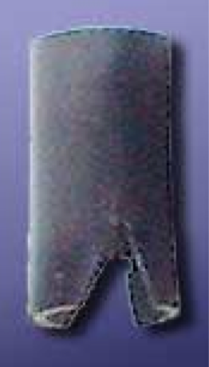

You're ready to start. Heat your oven to 200 degrees, fill a sink halfway with very cold water, put some good music on and get comfy.

Step One: Measure the Nocks and Cut Them Out.
Get comfortable and with your ruler, mark off 2 inch sections along your pipe for as many nocks as you want. Cut off each 2 inch section with the PVC pipe cutters (easy) or the hacksaw (harder). Then gather up each one in your lap and measure on one end a mark 1/2" down on opposite sides. I have a jig made to do this but found it was really more nuisance than value and required the use of a drill. With your Sharpie put a dot at the half-inch mark on each opposing side of the nock.

Step Two: Cut Out the Nock Vee.
Get out your leather punch and every place you put a dot punch a hole. This means one hole on each opposing side of one end of the nock where your bowstring will go. After they're all punched, take your heavy cutting shears or dykes and cut a V with the apex of the V in the hole you punched. Do not worry about sharp edges yet, we'll get to that in a moment.

Step 3: Heat and Expand the Nocks.
Your oven should be nice and warm now. Put your plumb bob on the kitchen counter and make sure the water in the sink is still nice and cold.

Put all of the nocks, V side up, into a baking dish and put them in the oven for about 10-15 minutes. Take the dish out with an oven mitt and then with the mitt still on, take out each nock one at a time and force your plumb bob down into the V end of the nock very firmly. You will see the V's spread out and widen. Then quickly drop the nock into the cold water before it can shrink back to the way it was before. Repeat till they are all done and leave the nocks in the cold water until they are good and cold.

Step 4: Install the Wine Cork Dirt Barrier:
Your nocks are cold and your wine cork halves have been in the water for a while and are nice and soft now. Turn all of your now cold nocks upside down and wedge a half a wine cork into the back end. Seat it in place with a hammer until it is flush. It should not come anywhere near the V if it has been cut in half. As the cork dries it will mold itself and make a perfect seal inside the nock.

Step 5: Trim Rough Spots.
Gather your nocks in a towel and head them back to your work area. Check the V's for rough/sharp spots that can cause your bowstring any grief, and with your utility knife smooth them out and trim them to suit your taste.
Your nocks are now done and ready to install.

Installing Siloflex Nocks: Inga's Method

Materials Needed:

- Nock.

- Arrow, either golf tube or Siloflex.

- Liquid Nails brand contact cement.

- Drill with small bit.

- Doubled length of either artificial sinew or heavy fishing line.

- Blunt leather sewing needle.

- Duct tape

Step One: Adhesive.
Nothing really bonds Siloflex to Siloflex or to golf tube, but the closest thing thus found is Liquid Nails brand contact cement. This is available in any home improvement or hardware store in anything from 1 oz tubes (all you will need) to 5 gallon buckets. So spread a thin coating of Liquid Nails on your nock end or just inside your arrow, and then push the nock down inside the neck of the arrow to the V of the nock slot. As the nocks have been widened by your plumb bob, this should be a natural stopping point. Hold the nock and arrow in place for a couple of minutes until the glue sets, then go on to the next one.

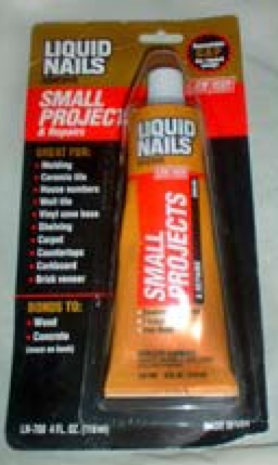

Step Two: Drill and Tie Your Nocks in Place.
Using the drill, drill two holes all the way through the arrow and nock (and preferably through the wine cork too) in a cross configuration. Then thread your leather sewing needle with a doubled length of artificial sinew or heavy fishing line and push it through. Tie a tight square knot on one side when you are done.

Step Three: Cover the Stitching with Duct Tape.
The tie you just made needs to be covered with duct tape to protect it. Wrap a small piece of duct tape around the arrow at this point, and try to make it cover the juncture of the nock and the arrow a little bit too.

Step Four: Final Adjustments.
Check your nocks to make absolutely sure they don't protrude more than 1/2" beyond your arrow. If they do, trim them with your utility knife.

Make any more trims you think are necessary, then go out and shoot someone with them.

Happy Combat Archery!

The Author:

Ingilborg Sigmundardottir is an 11th century Norsewoman. Her husband died long ago on a campaign, and her fair daughter sailed away on a longship to be wedded to a brave Viking prince. She spends her crone years as an accomplished healer, birthing the babies of her village and tending wounded warriors of all types. She contemplates the White Christ, whose teachings she finds sensible and fascinating. She is known as a very accomplished archer, meadmaker, and Healer. She lives away from her village in the surrounding forest and is rarely seen among the villagers, but is intensely loyal to them and offers the services of her bow whenever her village is threatened. Her cottage is rich with plants of all types and she keeps the company of wolves, and the wiser of the villagers know that in times of extreme, she is quite capable of running with them whenever necessary.
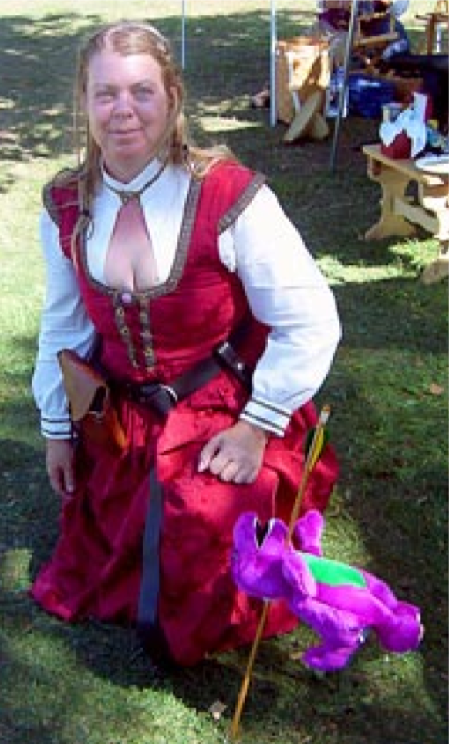

Roberta Ashley is a 21st century Norsewoman, a very accomplished anesthetist who is all too often seen in the hallways of various healing institutions in the City of Angels, where she assists in the birthing of babies and the tending of wounded warriors of all types. She is an accomplished archer, meadmaker, and practices in her spare time a very ancient form of Eastern hands-on healing when it is needed. Her cottage in the more remote canyons of the San Gabriel Mountains is rich with plants of all types and she keeps the company of two rescued captive bred wolves, Cheyenne and Mai-Coh. The wiser of her colleagues know that in times of extreme, she is probably quite capable of running with them whenever necessary.

------
Copyright <year> by Roberta Ashley. <rashley731 at aol.com>. Permission is granted for republication in SCA-related publications, provided the author is credited. Addresses change, but a reasonable attempt should be made to ensure that the author is notified of the publication and if possible receives a copy.

If this article is reprinted in a publication, please place a notice in the publication that you found this article in the Florilegium. I would also appreciate an email to myself, so that I can track which articles are being reprinted. Thanks. -Stefan.

<the end>

