Wdn-Arow-Mkng-art - 8/1/15

"Modern Wooden Arrow Making" by Lord Conrad Engelhart.

NOTE: See also the files: Arrow-Making-art, arrows-msg, Arrow-Inspect-art, 16C-Arrow-Bag-art, Arrow-Matchng-art, quivers-msg, SCA-T-Archery-art.

************************************************************************
NOTICE -

This article was submitted to me by the author for inclusion in this set of files, called Stefan's Florilegium.

These files are available on the Internet at: http://www.florilegium.org

Copyright to the contents of this file remains with the author or translator.

While the author will likely give permission for this work to be reprinted in SCA type publications, please check with the author first or check for any permissions granted at the end of this file.

Thank you,
Mark S. Harris...AKA:..Stefan li Rous
stefan at florilegium.org
************************************************************************

This article was first posted to the "SCA Archery" Facebook group.

Modern Wooden Arrow Making
by Lord Conrad Engelhart

The Kingdom of Meridies and the SCA requires arrows to be made of wood or bamboo shafts and have feather fletches. Exceptions are allowed for beginners and children (up to age 14). Pre-made wooden arrows can cost upwards of $125 a dozen. Making your own arrows can reduce the cost to $5-6 each. It also lets you personalize and repair your arrows, while having the option of making smaller quantities. With the proper tools and know-how, arrow making can be relatively simple and enjoyable.

Step 1:
Select shaft material. The most common wood for arrow making is Port Orford cedar (POC), but other woods such as Douglas fir, Sitka spruce, birch, poplar and bamboo can be used. 11/32" is the most common diameter, but 23/64" is also popular. Standard shaft length is 32". Note: 1/4" dowels should only be used for children's arrows. MR*: Mary Rose "bobtail" arrows were 1/2" in diameter tapered to 3/8" and made of aspen, poplar or ash. In contrast, modern carbon arrows are typically 5/16" in diameter.

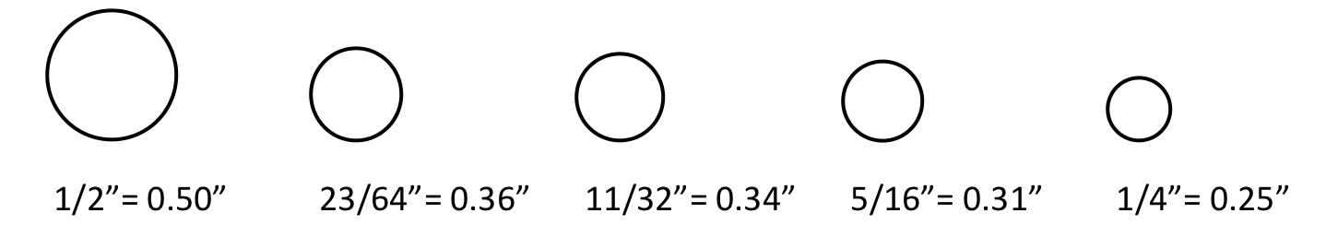

Step 2:
Select the appropriate spine weight. The spine weight is the stiffness, or conversely the flex, of the arrow shaft. Ideally, shaft should be spine weight matched closely to your bow's draw weight, which is typically measured in pounds at 28". For example, a bow that is 45# @ 28" takes 45 lbs. to draw the bow string back 28". If your draw is 26", you may only be pulling 40 lbs. even though your are using a 45 lbs. bow. A bow or luggage scale, which has a hook on one end, can be used to provide your exact draw weight. Matching the draw weight will provide for a consistent flex as your arrow is released and stabilizes. If your arrows are hitting the target at an angle, your arrows are likely under or over-spined. Shafts are purchased by 5 lbs. weight groups, e.g. 40-45 lbs. If you are on the cusp between two groupings, I would recommend the higher spine weight. Note: Using a grossly under-spined arrow with a higher poundage bow can result in a catastrophic failure, i.e. breakage and injury. MR: Reproduction Mary Rose longbows have draw weights of 80# to 120# @ 30". Longbows with a draw weight of 80+ lbs. are sometimes referred to as warbows.

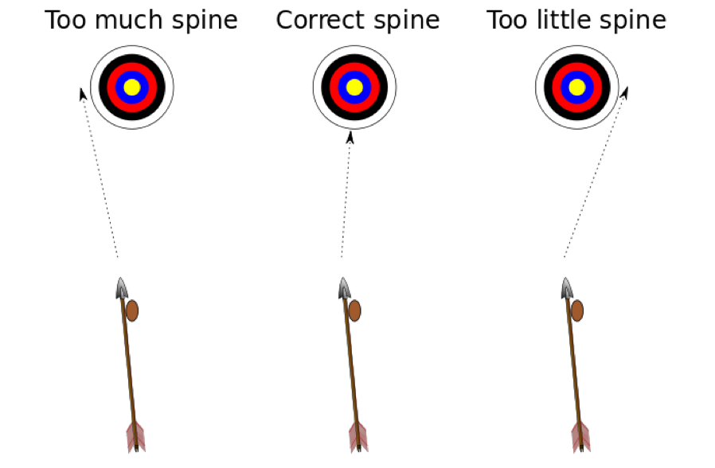

The archer's paradox refers to the phenomenon of an arrow not traveling in the direction it is pointed when drawn, but instead striking the center of the target when the arrow is pointed slightly to the side of the target. The flex of an arrow upon release it due to the fact that the back of the shaft is travelling faster than the front for a brief moment.

Step 3:
Stain the shaft (optional). If you want to stain your shafts, this most be done before sealing. Alcohol-, water-, or oil-based stains can be used. Water-based stains are easy to apply and have low fumes. Alcohol– and oil-based stains provide more vibrant colors, but can be messy and require a well-ventilated area. Note: Black, brown, green or gray stains can make finding missed shots in the ground more difficult. Staining is not recommended for beginners.

*The Mary Rose was an English Tudor navy warship under King Henry VIII, which sunk in 1545 off the coast of Portsmouth in southern England. It was discovered in 1971 and salvaged in 1982. It is the most important archeological discovery of Renaissance archery artifacts, including 137 well-preserved longbows and 3,500 arrows. It provides an invaluable insight into medieval archery.

Step 4.
Seal the shaft. Sealing is required to protect the shaft and prevent warping of the arrow due to moisture and humidity. Gasket lacquer require a rubber gasket tool, but dries quickly. Fletch-Lac requires a dip tube, thinner and longer drying time. For making occasional arrows, I recommend alcohol-based spray polyurethane. Clip cloth pins on one end of the shaft and suspend them from a taut string, wire or clothes hanger. Apply 5-6 thin coats, waiting 30 minutes in between each coat. Note: Use a well-ventilated area when spraying. Pre-finished shafts can also be purchased, but they are more expensive. MR: Medieval arrows were sealed with a drying oil, such as linseed or flaxseed.

Step 5.
Mount the nock. The nock is the part of the arrow that snaps into the bow string. Modern nocks are plastic and come in a variety of styles and colors. I recommend using white or brightly colored nocks so that your eyes can follow the arrow down range after its release. It is also easier to find missed shots in the ground. The grain of the shaft's end should be perpendicular to the bow string to provide for more consistent flex from one arrow to the next.

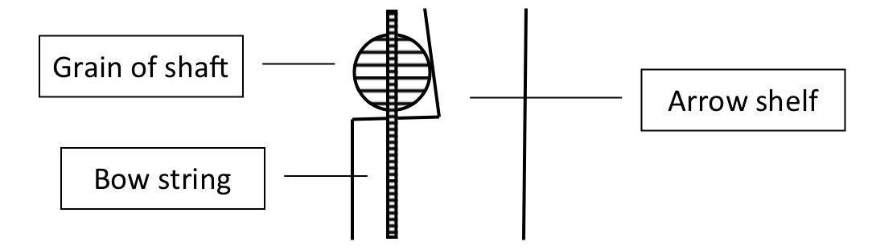

Before you can attached the nock, the end must be tapered. A simple taper tool that resembles a pencil sharpener is required. Note: a taper tool has an 11° taper for the nock and 5° for the point. Once the shaft has been tapered, I recommend using Bohning Fletch-Tite Platinum fletching glue to attach the nock to the shaft. Place glue on the bottom two-thirds of the taper. Twist the nock onto the taper to ensure even distribution of the glue. Use a paper napkin to wipe away excess glue. Hold nock firmly in place for 30 seconds to allow the glue to set. MR: Mary Rose arrows had reinforced self nocks, i.e. the nock is cut into the shaft and reinforced with a 2" sliver of horn.

Step 6:
Cut the shaft. Shafts comes 32" standard, which will create up to a 33" arrow after the nock and point are attached. Ideally, you want the arrow cut so that it is 1" past the end of your bow at full draw once complete. This reduces the arrow's weight, which increases its speed and accuracy. Measure from the end of the nock, but subtract a 1/2" to compensate for the point's length. Use a miter box and miter back saw to cut the shaft and provide a clean cut. MR: Mary Rose arrows had an average draw length of 30" because the medieval archer would pull the string to or even past their ear.

Step 7:
Select field points. A points weight is measure in grains. Weights are available in 70, 100, 125, 145 , 160 and 190 grain, with 125 grain being the most common. Note: Field points must be matched to the diameter of the shaft, i.e. 11/32" points for 11/32" shafts. Steel glue-on field points are inexpensive and durable. Brass bullet nose points add flair but are more than twice as expensive. I personally do not recommend screw-on or crimp-on points.

MR: Medieval points had a variety of shapes for different applications, and they evolved with armor improvements. Broadheads with barbs were used against lightly armored opponents and horses. Long bodkins were used against chainmail. Shorts bodkins were used against plate armor.

Step 8:
Mount the field points. Use taper tool to taper the end of the shaft to 5°. Pour water into a cup. Light candle, heat glue stick and smear thoroughly over the bottom two-thirds of the taper. Place field point in pliers and hold over flame for a moment before placing it on the taper while twisting the shaft to ensure even distribution of the glue. Next, heat the point over the flame while rolling the shaft in your fingers to ensure even heating. Note: Place only the point over the flame, not the wooden shaft. Place the field point on miter box or block of wood and push the shaft downward until you have a snug fit with no taper remaining. Roll the shaft in your fingers to ensure that the field point is on straight. Dip the arrow into water to set the glue. Scrap off the residual glue and discard. Wipe with a paper napkin to remove any soot.

Step 9:
Add cresting, cap or capwrap (optional). Adding cresting, i.e. decorative lines, originated in Victoria England to personalize and distinguish ones arrows. It requires an expensive crester. Painting the entire end of an arrow is referred to as a cap. It requires a dip tube with a rubber gasket. Cresting and cap dipping are not recommended for beginners. As simple alternative is a capwrap, which is a thin vinyl sticker that you apply to the nock end of the shaft. You place the capwrap sticky side up on a mouse pad, line up you shaft and roll it on. Bright colors also aid finding missed shots in the ground.

Step 10:
Select a fletching jig. Fletching requires a jig. Fletching jigs come left wing, right wing or straight. A feather has a lip along the quill that is determined by which side of the bird it originates. Jigs that are specified for a left or right wing have a slight offset to make the arrow spine after its release. Straight jigs can use either wing. Some jigs can only apply 3-fetch, whereas some can do 3- or 4-fletch. The most affordable jig, the AAE Fletch III, is a 3-flecth jig that is designed for right wing feathers.

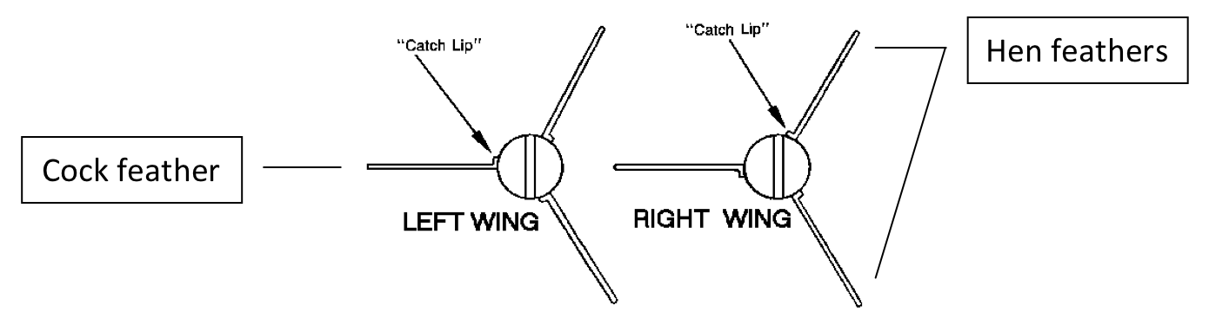
Step 11:
Select fletches. Pre-cut feather fletches are available parabolic or shield cut and come in 4", 5" and 5.5" lengths. For beginners I recommend 3-fletch arrows using 5" fletches, which are the most common. I also recommend brightly colored feathers to aid finding missed shots in the ground. For 3-fletch arrows, the hen feathers are the two that point towards the bow at an angle and are commonly a solid color. The cock feather is the one that points away from the bow and is commonly barred or a contrasting color. Note: Fletches are sold by the dozen. Thus, a dozen 3-fletch arrow will require three dozen fletches. MR: Medieval fletches were typically 6" to 7" long, 3/4" wide and made from goose feathers. Modern feather fletches are almost exclusively from turkeys. A simple way to create traditional "medieval-looking" fletches is cut the back 1/2" off a 5.5" pre-cut shield fletch. Be sure to cut only the quill and not the feathers.



Step 12:
Fletch the shafts. Place the shaft's nock into the dial cradle, making sure it is inserted completely. Place fletch in clamp and line it up with built-in "ruler" so that all fletches will be the same distance from the back of the nock. Note: The rear of the feather should be 1" to 1.5" from the end of the nock to allow enough rooms for your fingers. Apply fletching tape along the bottom of the feather's quill, using scissors to trim the tape. The tape has a colored backing to assist alignment. Peel off the backing, which leaves a clear double-stick tape behind. Start with the cock feather by turning the dial and shaft to the appropriate position and slide the clamp down until the fletching adheres to the shaft. Remove clamp and slide fingernail down the lip of the quill to ensure good adhesion. Rotate the dial and repeat the steps with the hen feathers. Finish the arrows by adding a drop of fletching glue the ends of each feather. The arrow is now complete, but I recommend waiting at least an hour before shooting to allow the glue to fully set.

MR: Medieval fletches were attached to the shafts with pitch and reinforced with a thin linen binding.

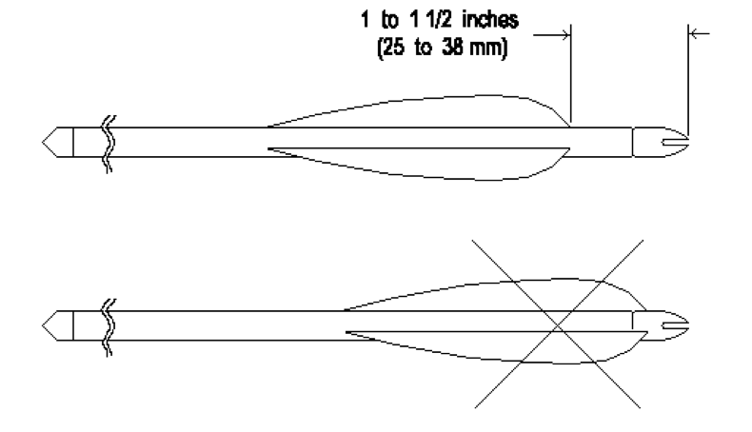
Required Materials:
Shafts - $30-$39/doz. depending type of wood
Fast-drying polyurethane spray - $8-9/can
Nocks - $2.50/doz.
Fletching Glue - $6/tube
Steel glue-on field points - $5/doz. Hot melt point glue - $2/stick
Cap wraps (optional) - $10-$12/doz. Fletching tape - $8.50/roll
Feathers - $8-$12/doz. (or $24-$36 for a doz. 3-fletch arrows)

Required Tools:
Taper tool - $6.25/ea.
Fletching jig - $26-$90/ea.
Miter box - $8-$15/ea.
Miter back saw - $7-$10/ea.
Pliers - <$10/ea.
Pillar candle - $1/ea.
Scissors - $1/ea.

Suggested Links:
http://3riversarchery.com/ ̶ Largest online supplier specializing in traditional archery http://www.trueflightfeathers.com/guide.htm ̶ Excellent fletching guide http://en.wikipedia.org/wiki/English_longbow
http://www.english-longbow.co.uk/ ̶ Richard Head Longbows, maker of fine English longbows http://www.hectorcoleironwork.com/Arrowheads.html ̶ Images of the different types of medieval arrowheads.
http://www.youtube.com/watch?v=WzWrcpzuAp8 ̶ Slow-motion video of the archer's paradox
------
Copyright 2015 by Robert Long. <conrad.engelhart at yahoo.com>. Permission is granted for republication in SCA-related publications, provided the author is credited. Addresses change, but a reasonable attempt should be made to ensure that the author is notified of the publication and if possible receives a copy.

If this article is reprinted in a publication, please place a notice in the publication that you found this article in the Florilegium. I would also appreciate an email to myself, so that I can track which articles are being reprinted. Thanks. -Stefan.

<the end>

