16thC-Beer-p2-art - 7/12/18

"Brewing with Grandpa II: The Mill" by Master Magnus hvalmagi. Recreating a 16th Century Scandinavian Beer, With Some Help.

NOTE: See also the files: 16thC-Beer-p1-art, Malthouse-art, ale-msg, Basic-Beer-art, beer-msg, bev-labels-art, Brew-w-Gruit-art, I-Guid-Brewng-art, Warm-Beere-art, Malt-Acorns-1-art.

************************************************************************
NOTICE -

This article was added to this set of files, called Stefan's Florilegium, with the permission of the author.

These files are available on the Internet at: http://www.florilegium.org

Copyright to the contents of this file remains with the author or translator.

While the author will likely give permission for this work to be reprinted in SCA type publications, please check with the author first or check for any permissions granted at the end of this file.

Thank you,
Mark S. Harris...AKA:..Stefan li Rous
stefan at florilegium.org
************************************************************************

K&Q A&S, A.S. L
Brewing with Grandpa
Recreating a 16th Century Scandinavian Beer, With Some Help
by Master Magnus hvalmagi

OVERVIEW

In 1555, the Swedish archbishop Olaus Magnus published Historia de Gentibus Septentrionalibus (History of the Northern Peoples), an encyclopedic work detailing all facets of existence in mid-16th-century Scandinavia. Included in the text are writings about the production of malt and beer, but they lack the detail needed to readily redact the recipes.

Using supporting information gleaned from contemporary rural Norwegian farmhouse brewing - the kind that grandpa and great-grandpa would've done in the Old Country - as well as numerous other sources, I fill in the gaps and attempt to establish plausible connections that allow the contemporary to inform the period practice, in order to take my best shot at recreating the infrastructure and process indicated in the text.

The project is broken into 3 parts: Part I, the recreation of the malt (including a malting kiln); Part II, the reconstruction of a rotary hand quern; Part III, the development of a coherent recipe and subsequent beer.

Brewing with Grandpa II:

THE MILL
___
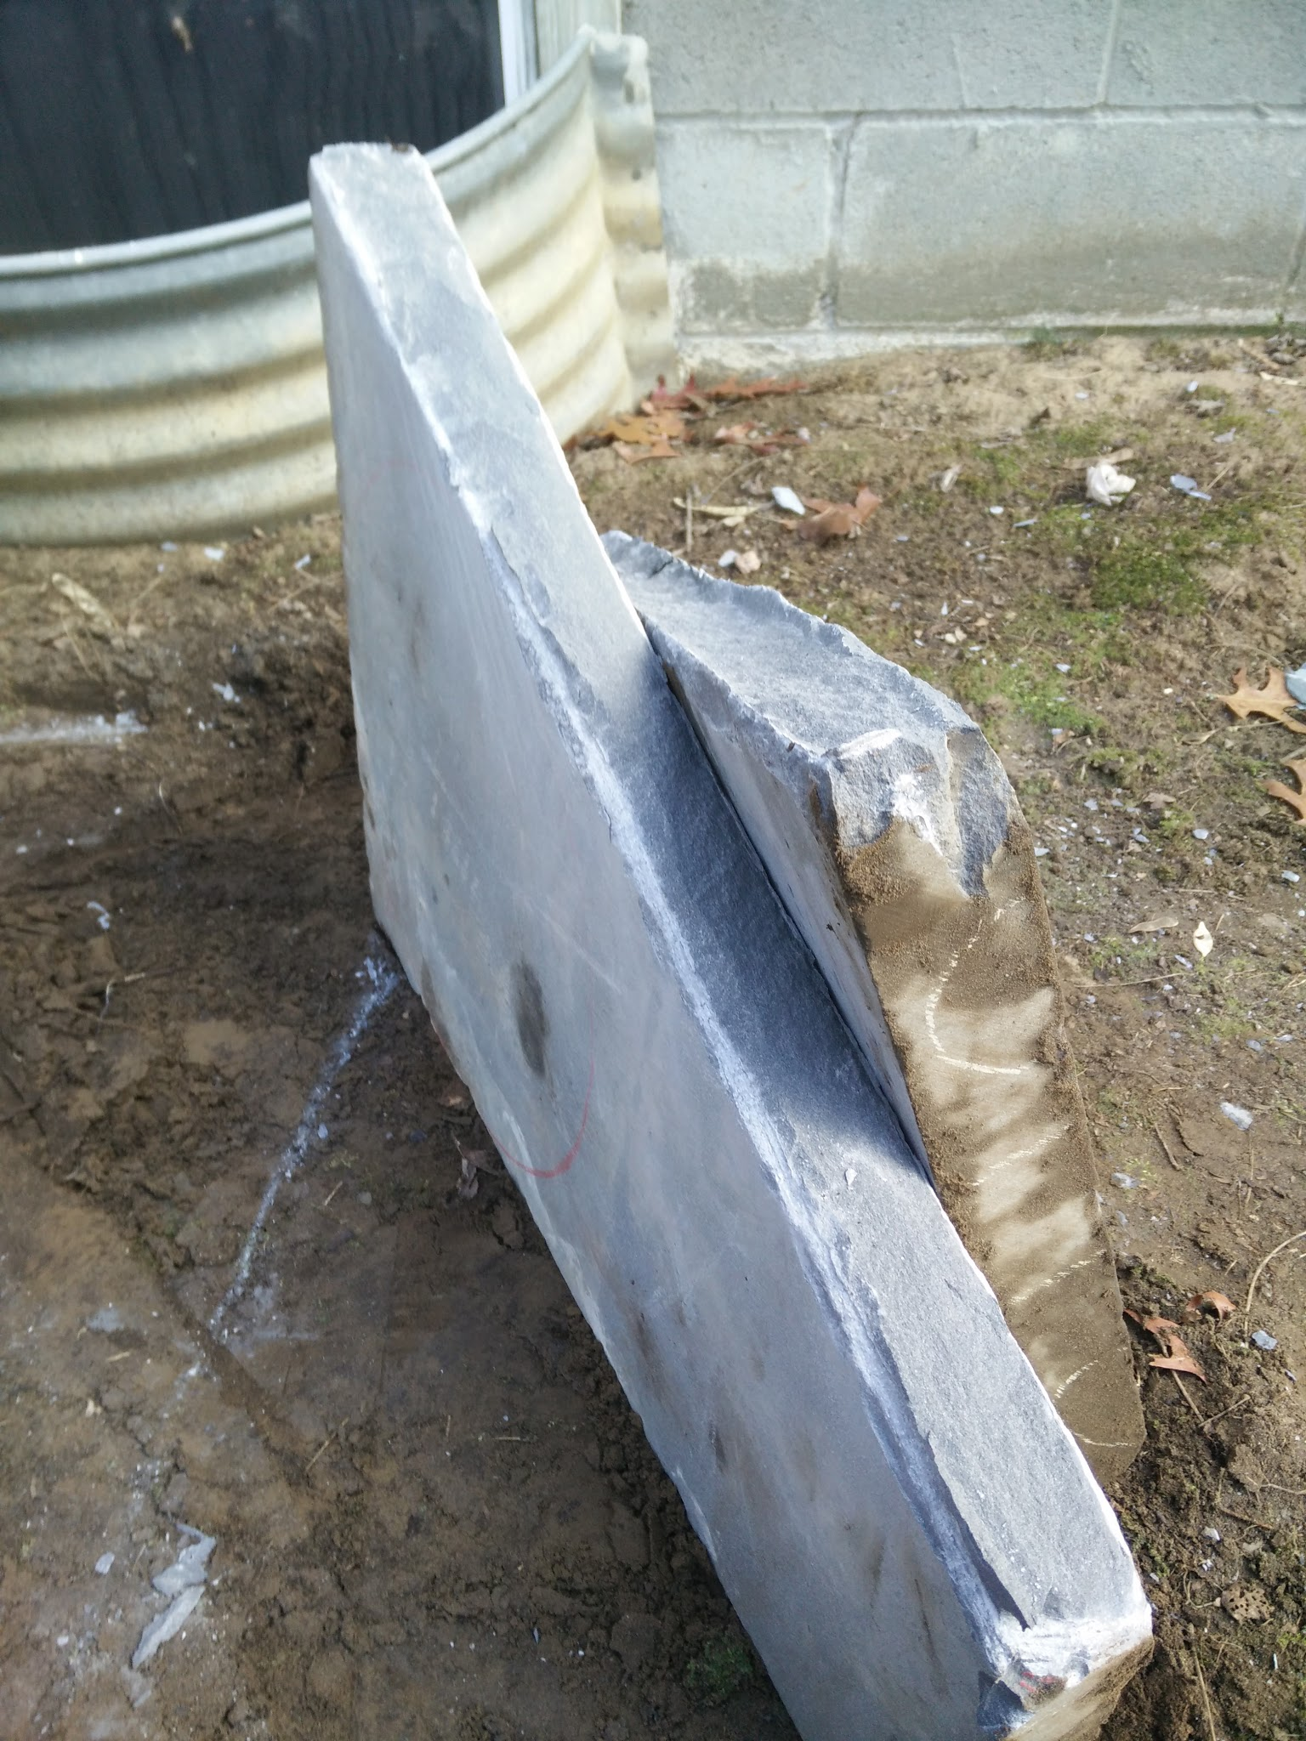
Fig 1. Proceed - if you've got the STONES for it. Hah! See what I did? Stones? I'm so funny!

INTRODUCTION

According to Olaus Magnus, malt prepared by his described method (see BwG I) was ground in a mill prior to brewing. The method of construction is not described, but supplementary research yields some clues. Using local sandstone and hand tools, a replica of an early-period rotary hand quern was constructed. Evidence of continued use of such mills exists all the way into the modern era.

The Method

The text briefly describes the manner in which the malt is prepared prior to brewing (1, 13:26):
Next it is ground for a short time in a mill worked by water, hand, or wind, from which it is called malt…

How wonderfully concise. Earlier in the text [1, 13:11 and 13:12], OM does go into some detail about the construction and use of myriad mills; he devotes the most space to water, wind, and horse-powered mills. Since water, wind, and horse-powered mills are all quite large projects, I chose to focus on a hand-powered mill. Of those, OM says:

Mills, too, that are turned by hand or foot or with treadles are very common and found everywhere in the North, since they represent a quick way of mitigating need, particularly during a siege.

That's still not terribly descriptive, but at least now we know that hand-worked mills were common. Additional details about stone type and construction are absent, though, and we need to look elsewhere for those details.

Sourcing the Stone

While OM is sparse on details, analysis of historical Norwegian and Viking-era Jorvik quern and millstones yields useful information.

Quarrying of millstones in Norway was primarily concentrated in 5 sites throughout history [2, p. 48]. Two particular sites, Hyllestad and Selbu (an area outside of present-day Trondheim), show intense concentration of quarrying activity. In Hyllestad, quarrying was focused on a particular garnet-kyanite mica schist; one such course of schist was softer and appears to be primarily associated with medieval (up to the mid-16th century) hand-quarrying, while the harder (and more desirable) schist was associated with late medieval and post-medieval industrial quarrying (wedging and blasting) techniques [2, pp. 51 - 52]. Stone from Selbu was also schistic, though it has a different specific mineral composition [2, p. 56].

The stone from Hyllestad appears to have been largely hand-quarried directly from the bedrock (though some loose-block quarrying is evident), and this technique was the most commonly-practiced method of millstone quarrying in Norway starting in the 8th century and continuing through the mid-16th century [2, pp. 63 - 64]. Both hand-mill sized and water-mill sized stones are evident during this timeframe.

Going back much earlier, evidence of hand quern use exists in Anglo-Scandinavian York. Several examples of lava and sandstone hand querns exist at 16-22 Coppergate [3, pp. 2547 - 2552][fig 2]. Lava querns appear to have been imported (from the German Meyen formation), but sandstone querns are milled from both Millstone Grit and the Coal Measures (both of which are formations proximal to York) [3, pp. 2551 - 2552].

It seems evident that a significant amount of the millstone quarrying done in medieval Scandinavia focused on domestically-available coarse-to-medium-grained stone.

Unfortunately, importing volcanic rock from Germany or garnet-rich Norwegian schist or British Millstone Grit proved to be prohibitively expensive. However, following the principle of "using domestically-available sedimentary rock," I located a nearby stone quarry in Berne, NY that produces Hudson bluestone (also called Pennsylvania Bluestone).

Hudson bluestone is a dense, fine-grained sandstone (feldspathic greywacke if that means anything to you) that typically saw use as construction material [4]. It's a bit harder and finer than is probably ideal for use as a quern stone, but it's locally-available and fairly inexpensive when purchasing uncut pieces.
Ownership laws prevented me from being able to quarry directly from bedrock, but I was able to procure a slab of bluestone roughly 25" square and approximately 2.25" thick.

II. Picking the Tools

Most hand-held stonemasonry tools have not changed drastically since classical antiquity. The point, tooth, and flat chisel are all evident in toolmarks on antiquarian statues [5].

Examination of tools from a Viking-era toolchest [6] reveals at least 3 chisels, which may have seen use in various shaping. At least one of the chisels appears to resemble an (albeit broken) octagonal flat chisel [6, pl.27]. A variety of hammers are also evident.

OM does not detail the tools used by stonemasons, but he does briefly mention the use of steel in the production of building tools [1, 6:8]:
Here, too, there is such an abundance of quality-tested steel that it meets the perpetual needs of natives and foreigners for every kind of building tool and any sort of arms

Taking this information together, I chose to use mild carbon steel flat and point chisels driven by a 3 lb hand-held drilling hammer. All tools were acquired from Harbor Freight and/or local estate sales. I made use primarily of a 2.75" wide mason's chisel, a 1" wide flat chisel, and a small (5" long) point chisel.

III. Smashing Some Rock

Nordland documents the use of a rotary hand quern in 1969 that appears very similar to Jorvik-era querns [7, pp. 34 - 35][fig 3]. While not definitive evidence, it certainly provides a compelling image that may indicate a conserved tradition. This also helps guide my decisions in quern sizing.

My intent is to use this quern for both Viking-era and mid-16th-century Scandinavian brewing reconstruction. As such, I chose to shape it closely to the dimensions of find 9700 from 16-22 Coppergate [3, p. 2628], as this artifact was shaped from fine-grained sandstone and is a reasonable size for the piece of stone I acquired. The stone is 350 mm in diameter, 60 mm thick, and the central perforation is 75 mm in diameter.

I made a cardboard circle approximately 350 mm in diameter, and used this as a template to mark circles on both sides of the stone.

I will not give a blow-by-blow account of the chiseling and shaping, because all in all it entailed roughly 8 hours of shaping. The collection of photos at the end shows much of the work as it progressed [fig 4].

To shape the circles, I first cut the slab in half along a diagonal [fig 1], and then progressively broke off corners using straight cuts in a more-or-less circular pattern using a wide mason's chisel. This probably would've been more easily done with my point chisel, but I couldn't find it at the time.

To shape the central perforation, I used a small flat chisel and drilled through the stone using alternating straight-line cuts directly into the stone to make layered "X" marks. This essentially pulverized the stone in a column straight through the rock. That took a long time. Once the central hole was drilled, I roughly shaped the circular area that marked the perforation, and began shallow surface chipping in a circular pattern. That also took a long time. That whole process would have been greatly simplified with a point chisel, but I still couldn't find it.

I carved a shallow socket on the upper stone to accommodate a handle (made from scrap poplar dowel I had lying around), and a deeper wider socket on the base stone to accommodate a spindle (made of a chunk of rattan I had lying around). At this point, I had found my point chisel, and made rather short work of the socket holes.

Note to self: invest in point chisels.

Some of the Jorvik querns had dressing marks (cuts in the grinding surfaces of the stones to improve grinding efficiency), but the shape was not indicated. I chose to employ very simple dressing marks - radial lines extending outward from the central perforation and/or spindle. My initial dressing lines were not very efficient, so I wound up beefing them up and adding angled lines attached to the radial lines (see Part III).

I chose to keep the spindle assembly very simple (a peg around which the upper stone turns), as I have no particular evidence indicating spindle assembly in the Jorvik quern.

Overall, while the process was work-intensive, it was not unmanageable. I found it very interesting that one person with simple hand tools and no experience could actually rough out a crude-but-effective rotary hand quern.

Future querns may involve lava stone (basalt) and more judicious application of point chisels. Seriously. Point chisels are awesome.

References

- Magnus, O. A Description of the Northern Peoples. Foote P.G. ed. Fisher P and Higgins H trans. 3 volumes. The Hakluyt Society. London; 1996. Cited in text as (Book:Chapter). Latin text from 1555 edition available at: http://runeberg.org/olmagnus/

- Grenne, T., Heldal, T., Meyer, G.B. and Bloxam, E.G. (2008) From Hyllestad to Selbu: Norwegian millstone quarrying through 1300 years. In Slagstad, T. (ed.) Geology for Society, Geological Survey of Norway Special Publication, 11, pp. 47–66. Available at: http://www.ngu.no/upload/Publikasjoner/Special%20publication/SP11_05_Grenne.pdf

- Mainman AJ and Rogers NSH. The Archaeology of York Volume 17: The Small Finds. Fasc. 14: Craft, Industry, and Everyday Life: Finds from Anglo-Scandinavian York. Council for British Archaeology. York; 2000. Available online (as of 12/26/15): http://www.yorkarchaeology.co.uk/resources/publications/fascicules/

- Pennsylvania Bluestone Association. Compiled information about bluestone. 1) http://www.pabluestoneassoc.com/

- Wooton W et al. "Stoneworking Tools and Toolmarks." The Art of Making in Antiquity. http://www.artofmaking.ac.uk/content/essays/2-stoneworking-tools-and-toolmarks-w-wootton-b-russell-p-rockwell/

- Arwidsson G and Berg G. The Mastermyr Find: A Viking Age Tool Chest from Gotland. Larson Publishing Company. Lompoc; 1999.

- Nordland, Odd. Beer and Brewing Traditions in Norway. Universitetesforlaget. Oslo; 1969.

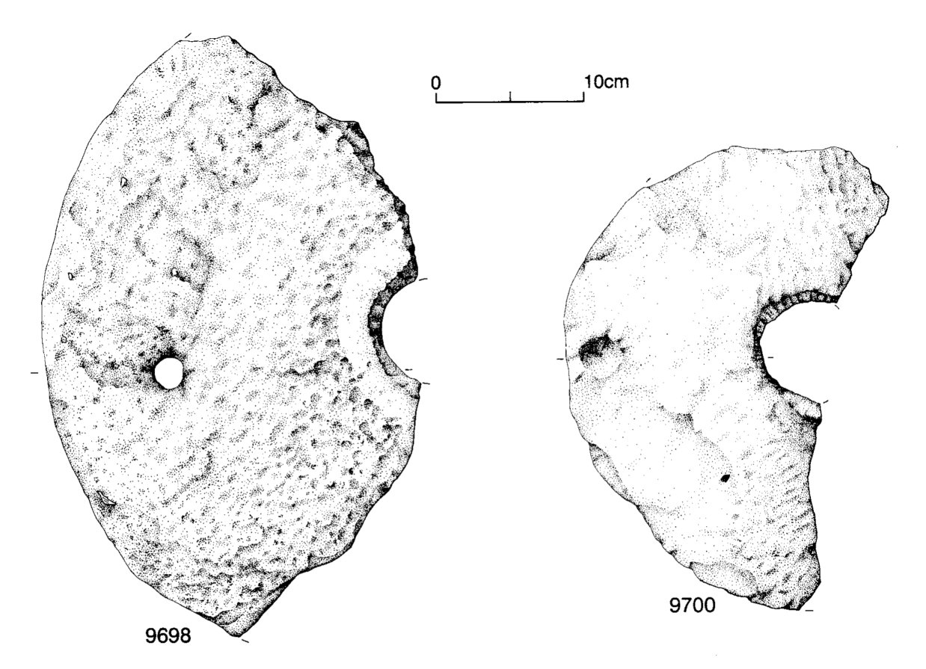
Figure 2: Jorvik Sandstone Querns

While fragmentary, these querns reveal important information about cereals processing. 9700 is my exemplar, though other examples aid in reconstruction.

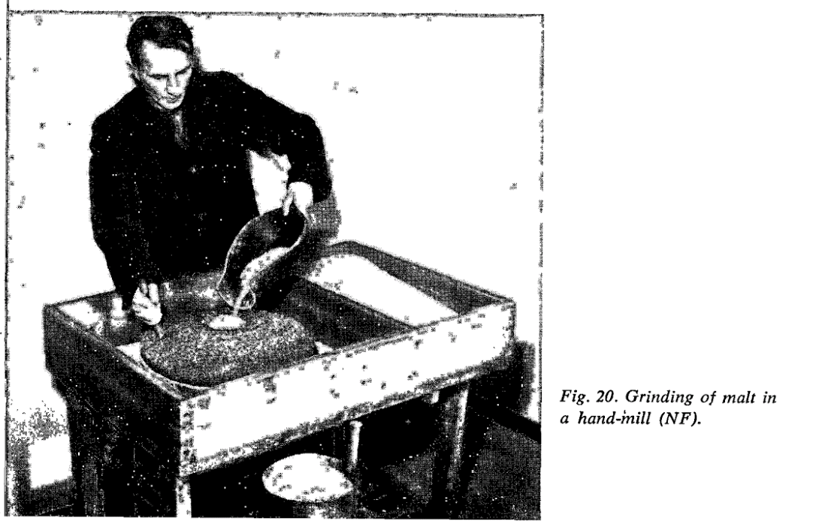
Figure 3: Rocks of Ages

In the lower-left, we see a lava quern find from the Viking era, housed in the Jorvik Viking Center.

The top is Nordland's capture of a man using a rotary quern in the late 60's; the lower right is Lars Garshol documenting the use of one in 2014.

While not definitive evidence of conserved tradition, the images are pretty compelling. The tool works well enough that it remains in use today

.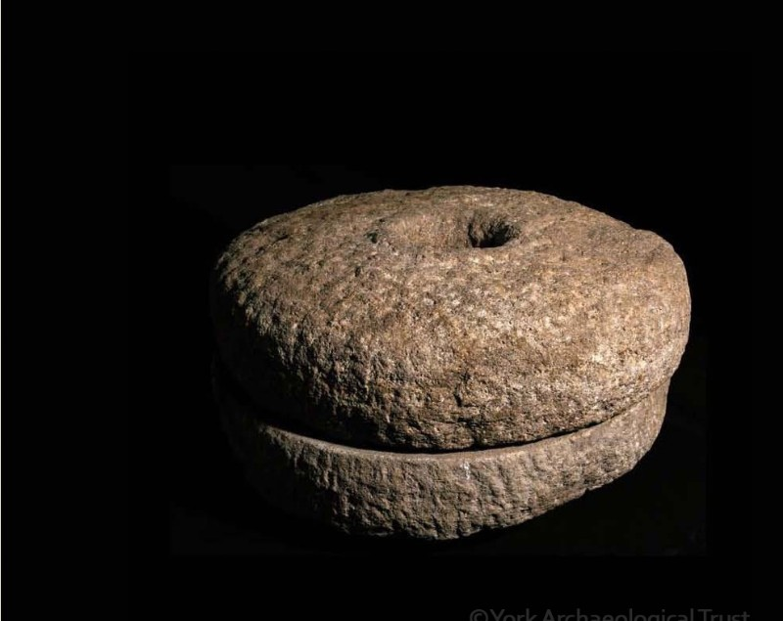 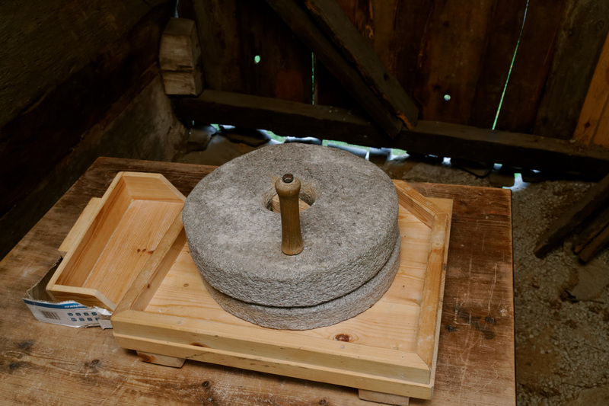
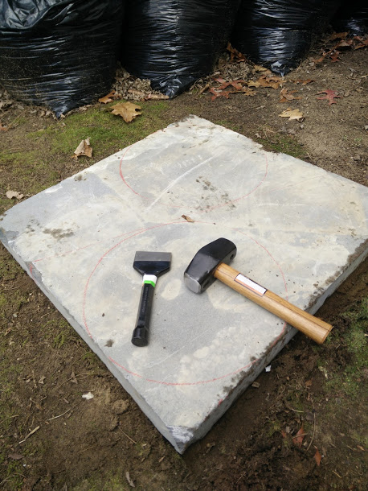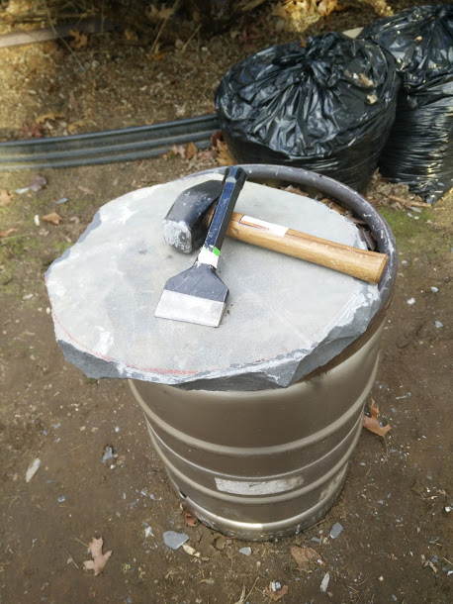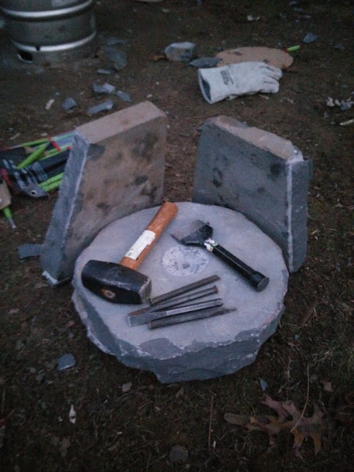

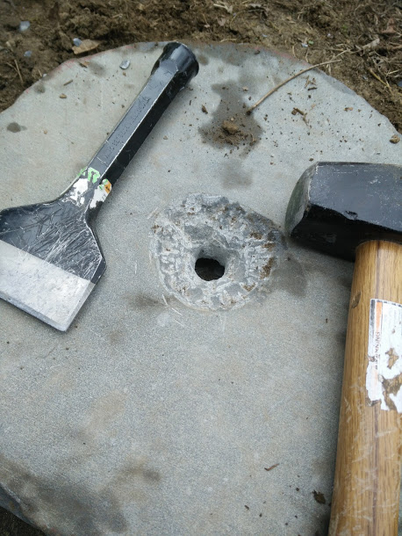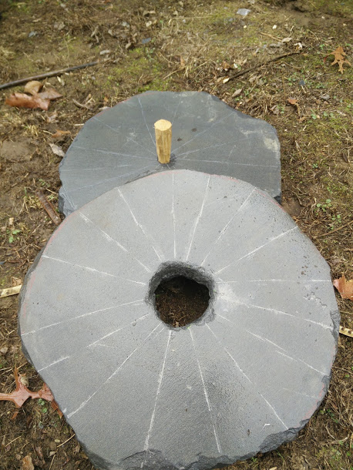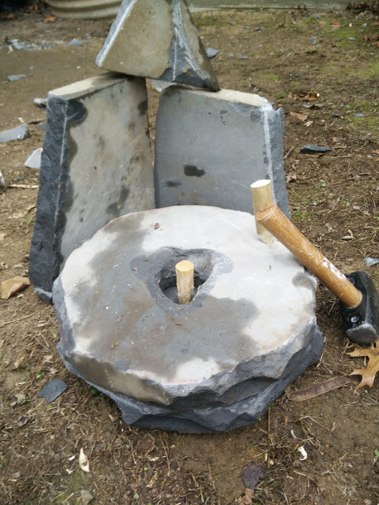
Figure 4: A Work Montage

Through the power of the montage, a quern is produced!

The top 3 pictures are the progress made on day 1 - splitting the stone, roughing out the circle, and punching a hole through the entire stone. The collection of tools in the upper-right picture shows all of the chisels I used throughout the process.

The lower 3 pictures show day 2 - expanding the hole into a central perforation, adding dressing lines, and finally a completed quern. The dressing lines were improved upon later after use showed them to be less effective than desired.

I cannot emphasize enough how useful point chisels are. The broad masonry chisel was good for splitting the stone and hacking off corners, but cutting a circle is made far easier with a point chisel. That, the masonry chisel, and a small flat chisel saw the most use.

------
Copyright 2016 by Peter Olsen. <thewhaleshark [at] frontrowcrew.com>. Permission is granted for republication in SCA-related publications, provided the author is credited. Addresses change, but a reasonable attempt should be made to ensure that the author is notified of the publication and if possible receives a copy.

If this article is reprinted in a publication, please place a notice in the publication that you found this article in the Florilegium. I would also appreciate an email to myself, so that I can track which articles are being reprinted. Thanks. -Stefan.

<the end>

