The-Egg-Test-art - 3/29/14

"The Egg Test for Period Brewers and Mead Makers" by Mistress Roheisa le Sarjent.

NOTE: See also the files: brewing-msg, wine-msg, Basic-Beer-art, 13thC-Mead-art, eggs-msg, cider-msg.

************************************************************************
NOTICE -

This article was submitted to me by the author for inclusion in this set of files, called Stefan's Florilegium.

These files are available on the Internet at: http://www.florilegium.org

Copyright to the contents of this file remains with the author or translator.

While the author will likely give permission for this work to be reprinted in SCA type publications, please check with the author first or check for any permissions granted at the end of this file.

Thank you,
Mark S. Harris...AKA:..Stefan li Rous
stefan at florilegium.org
************************************************************************

The Egg Test for Period Brewers and Mead Makers
by Mistress Roheisa le Sarjent)

Sir Kenelm Digby, (11 July 1603 – 11 June 1665) was a 17th century English courtier, diplomat, privateer, entrepreneur, natural philosopher and inventor of the modern wine bottle, but is perhaps best know for his posthumously published cookbook, The Closet of the Eminently Learned Sir Kenelme Digbie Knight Opened. Compiled from Digby's life long collection of recipes by a close servant and published in 1669, several years after Sir Kenelm's death, it is an excellent source of period brewers recipes, especially those for honey-based drinks.

At least 55 of Digby's recipes (all for meads, metheglens and hydromels) contain the instruction to make your liquor "to bear an egg" or words to that effect. The same instruction appears in a mead recipe from the Danish Koge Bog of 1606, and in numerous pickling recipes of the new world colonies. Some versions are as brief as "try with a new-laid- egg" whilst others go into considerable detail. In this article I will explore those details and see how the egg test might be applied to historical brewing.

How does the "Egg Test" work?

The larger end of a birds egg contains an air cell that forms when the contents cool and contract after the egg is laid. A fresh egg has a relatively small air cell, but the size increases with time as the shell is very slightly porous allowing slow evaporation. An old egg has such a large air cell it will actually float in water and this is often used as the test for whether an egg is fit to eat. A fresh egg, whether fertilized or not, will sink in plain water, however in a solution of sugar or salt the egg will begin to float once the specific gravity of the solution reaches a certain point. This being the case eggs can be used as a sort of primitive hydrometer to test the concentration of a solution. This is especially useful in the case of honey where the level of sugars varies from one honey source to another. A thick, heavy honey will have more sugar per liquid volume that a thin, runny honey. The usual proportions for mead of 1 gallon of water (4.5 ltrs approx) to one quart of honey (1.14 ltrs approx) will result in widely differing sugar levels depending on the quality of the honey used. As the recipe from Digby for MR. PIERCE'S EXCELLENT WHITE METHEGLIN tells us:

"When it is blood-warm, put the honey to it, about one part, to four of water; but because this doth not determine the proportions exactly (for some honey will make it stronger then other) you must do that by bearing up an Egge."

And the recipe for MR. CORSELLISES ANTWERP MEATH tells us:

"When all is dissolved, it must be so strong that an Egge may swim in it with the end upwards. And if it be too sweet or too strong, because there is too much Honey; then you must put more water to it; yet so, that, as above, an Hens Egge may swim with the point upwards"

The way that Digby's recipes refer to the egg test makes it clear that this was a well known and often practised method of testing the honey must (honey and water solution). As with modern cook books the assumption is made that the reader already knows what to do and doesn't need to have the term explained. Most such recipes were never intended to be followed by strangers (let alone 400 years later and on the other side of the world) but written for those already familiar with mead making. Thankfully some of Digby's recipes do appear to have been written for novice brewers and go into greater explanation.

What is Specific Gravity?

Gravity, in the context of brewing, refers to the specific gravity or relative density of the wort (liquid from the boiled grains for beer) or must (fruit juice or diluted honey for wine or mead) compared to water. Water (at sea level and 20°C) has a gravity of 1.0 whilst the original (starting) gravity for worts is around 1.040, and for musts is in the range of 1.060 to 1.130 SG. In modern brewing we use a hydrometer to take a starting and a finishing gravity in order to calculate the alcohol content of the finished product. For the medieval brewer this was not a consideration. The microbiology behind brewing was not understood, so the yeast was simply left to do its thing until it was done, and artificially stopping the yeast to achieve a particular sugar/alcohol balance was not practiced. All the medieval brewer needed to know was if he had enough sugar at the start to get the sweetness he desired by the time the yeast stopped working, so only the initial reading was needed. I used a modern glass hydrometer to measure the specific gravity of refined sugar dissolved in plain water and tested this against a variety of eggs, taking their average to produce an "egg test" table which can be used as a rough substitute for the modern hydrometer. All of my readings were taken at a room temperature of about 20 degrees C at close to sea level.

How to Select Your Egg.

Firstly, Digby is very clear that the egg is to be a new laid hen's egg. Not duck, or goose, or other fowl but hen. This still allows for a substantial variation in eggs, since the breed of the chicken, age, health and diet also affect the size of an egg. MR. PIERCE'S recipe explains:

"...put a good number, (ten or twelve) New-laid-eggs into it, and as round ones as may be; For long ones will deceive you in the swiming; and stale ones, being lighter then new, will emerge out of the Liquor, the breadth of a sixpence, when new ones will not a groats-breadth. Therefore you take many, that you make a medium of their several emergings; unless you be certain, that they which you use, are immediately then laid and very round."

What the Groat?

Whilst often the instruction is merely that the liquor "beareth an Egge boyant" many of the Digby's recipes add "so that the breadth of a groat is out of the water" or other words to similar effect.

A groat is a silver coin, with a value of four pennies. Between 1561 and 1662 the groat was issued irregularly and extant examples are fairly rare. Early groats were hand hammered and varied in size. The more regular milled or machine minted groat only became common in the years before Digby's death. Information about groats available on the Internet is extremely inconsistent, however CoinQuest.com tells us that the groat issued during Digby's lifetime by King Charles 2nd (1625 to 1649) was approximately 20mm in diameter.

MY LADY COWERS WHITE MEATHE USED AT SALISBURY recipe states: "and when the Egge riseth above the water, to the bigness of a groat in sight, it is strong enough of the honey" SIR JOHN ARUNDEL'S WHITE MEATH says: "Then put in a New-laid-egg; if the Liquor beareth the Egg, that you see the breadth of a groat upon the Egg dry you may set it over the fire" and TO MAKE METHEGLIN THAT LOOKS LIKE WHITE-WINE states: "...that is, till you can see no more of the Egge above the water, then a two pence will cover." Between them these descriptions make it clear that the diameter of the egg which shows above the water is the measure being taken.

Other coins mentioned in Digby's recipes (with approximate measurements for Charles IIs reign) are a two pence (16mm), a tuppence (18mm), a six pence (26mm), and a shilling (30mm). One recipe even calls for the "breadth of a hasel-nut swimming above" however the groats-breadth (20 mm) is by far the most common reference.

When to Test and Why

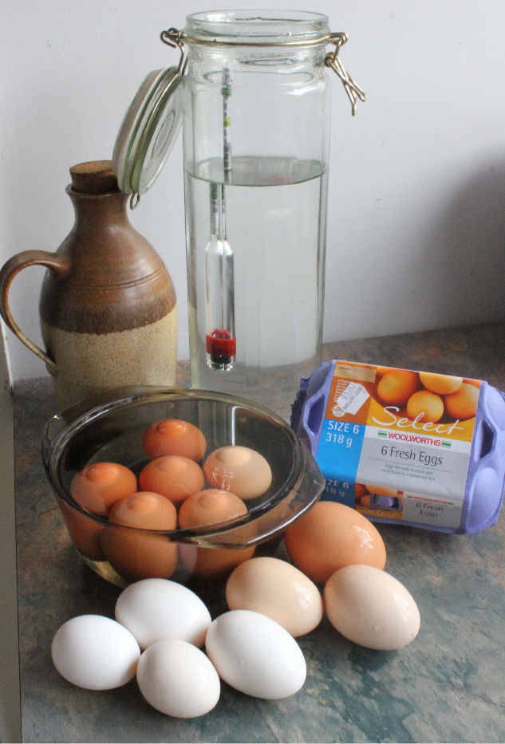
Testing on supermarket and farm eggs

The recipe TO MAKE METHEGLIN explains that "the time of the tryal of the strength is when you incorporate the honey and water together, before the boiling of it." So in fact by the time the yeast is pitched the concentration of sugars will be somewhat higher due to the evaporation from boiling. However it is clear that the medieval mead makers did not understand how temperature affects specific gravity. While most of the recipes call for the test to be given when the must is cold, others state that the solution should be blood warm and MY LADY COWERS WHITE MEATHE USED AT SALISBURY says:

"When the honey is thoroughly melted and ready to boil, put in an Egge with the shell softly; and when the Egge riseth above the water, to the bigness of a groat in sight, it is strong enough of the honey. The Egge will quickly be hard, and so will not rise; Therefore you must put in another, if the first do not rise to your sight; you must put in more water and honey proportionable to the first, because of wasting away in the boiling."

The majority of the recipes clearly state that more honey or more water is to be added until the correct "reading" is achieved. The rest assume the reader knows to do so, but why is this approximate strength consistently recommended?

The previously mention recipe TO MAKE METHEGLIN says:
"If you would have it to drink within two or three months, let it be no stronger then to bear an Egg to the top of the water. If you would have it keep six months, or longer, before you drink it, let it bear up the Egg the breadth of two pence above the water."

And THE LADY VERNON'S WHITE METHEGLIN says:
"and try with a New-laid-egg; and the stronger it is, the longer you may keep it"

These mead recipes are using ale yeast, which generally dies off once the alcohol level reaches approximately 10%. An alcohol level of between 10-12% will kill off most of the nasties which would otherwise spoil meads and fruit wines. The higher the end alcohol percentage the longer the mead will keep, and the higher the starting sugar level the more potential alcohol there is, however too much sugar at the start has a preservative effect which inhibits yeast growth preventing optimal fermentation.

If you want a dry mead you need just enough sugar for most of it to have been consumed by the time the yeast is killed off, but if you want a sweet mead then you need more sugar than the yeast can consume before hitting that lethal alcohol percentage. In the absence of an accurate hydrometer the egg test gives you a ball park sugar level to work with rather than leaving your sweetness and "use by date" to guess work or luck.

The Experiment - Subjects.

I had access to half a dozen fresh (no more than two days old) farm eggs from a variety of chickens, and also a half dozen supermarket eggs with the longest "best before" date I could find, being 28 days from purchase. New Zealand requires eggs to be labeled with a the best before date of 28 days from laying, so these eggs must have been laid on the day of purchase, likely within a few minutes of each other. They were actually fresher and closer to each other in age that the farm eggs.

The farm eggs came from Silver Spangled Hamburgs, which are a pre-1700 breed, Silkie bantums, a Chinese breed and Brown Shavers, which are primarily used for commercial egg production in New Zealand. The supermarket eggs were all Brown Shaver eggs.

The Hamburg eggs were white, long and relatively pointy, so not ideal as Digby says "For long ones will deceive you in the swiming". One reliably bobbed off centre and seems to have been a fertilized egg.

The Silkie bantam eggs were noticeably smaller and rounder. The farm sourced Brown Shaver eggs had pinky shells, and were heavier that the supermarket eggs which were a much browner colour. There was also a giant Brown Shaver egg approaching twice the weight standard Brown Shavers which turned out to be a double yolked egg.

The Experiment – Method

Each egg was floated in a solution of white sugar dissolved in plain water at a specific gravity of 1.100 as measured using a standard brewing hydrometer. A small dot was placed on each egg at the centre of the portion showing above the surface. The eggs were then removed, washed and dried, and using a drafting template a 20mm diameter circle was drawn on each using the dot as the centre point.

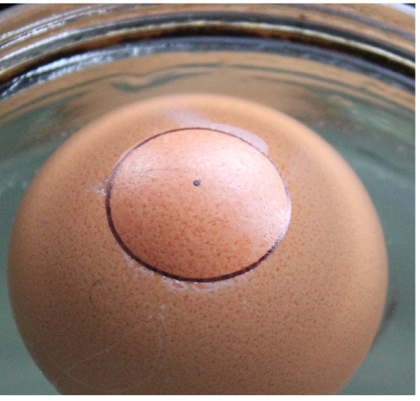
Test Egg floating at exactly 20mm

Each egg was then weighed and measured for diameter. If the egg fit through the mouth of a standard ISO XL5 wine tasting glass it got a tick, or otherwise a note of explanation. The eggs were then re-tested in the sugar solution and the size of the shell showing above the surface recorded on the table below

Source and variety of egg | Number | Weight | NZ  size | AU  size | US  size | Fit XL5 | Exposure
Farm sourced Silver Spangled  Hamburg egg | 1 | 57gm | 6 | Large | Large | easily | 26mm*
Farm sourced Silver Spangled  Hamburg egg | 2 | 56g | 6 | Large | Medium | easily | 18mm
Farm sourced Silkie Bantam egg | 1 | 43g | 4 | Medium | Small | easily | 20mm
Farm sourced Silkie Bantam egg | 2 | 37g | 4 | Small | Peewee | easily | 22mm
Farm sourced Brown Shaver egg | 1 | 65g | 7 | XL | XL | yes | 20mm
Farm sourced Brown Shaver egg | 2 | 63g | 7 | XL | XL | almost | 28mm*
Farm sourced Brown Shaver egg  (double yolk) | 1 | 97g | ? | ? | ? | No | 26mm
Supermarket Brown Shaver egg | 1 | 58g | 6 | Large | Large | yes | 19mm
Supermarket Brown Shaver egg | 2 | 56g | 6 | Large | Medium | yes | 20mm
Supermarket Brown Shaver egg | 3 | 56g | 6 | Large | Medium | yes | 22mm
Supermarket Brown Shaver egg | 4 | 57g | 6 | Large | Large | yes | 20mm
Supermarket Brown Shaver egg | 5 | 59g | 6 | XL | Large | yes | 20mm
Supermarket Brown Shaver egg | 6 | 56g | 6 | Large | Medium | yes | 20mm

As you can see from the "Exposure" column there was a surprising consistency in floatation, despite the differences in size and weight of eggs. The odd ones out which are marked with a * are the two farm sourced eggs which floated with off centre air cells, which turned out to be fertilized eggs, and the double yolker which is an oddity in itself. Surface tension gave an error factor in the readings of about 1mm either way.

The Results – An Egg Test Table.

I had six eggs, which floated the breadth of a groat above the surface (interestingly at pretty much exactly SG 1.1). I washed and dried these and then marked smaller concentric circles on them at 18mm and 16mm and re-tested them, diluting the solution until the eggs began to sink. Most of the eggs floated at the 18mm mark at approximately SG 1.095, however below this point surface tension on the liquid made accuracy difficult, so I gave up on trying to get a 16mm reading. At an SG of 1.085 most of the eggs were barely touching the surface, and at an SG of 1.080 all had either sunk to the bottom or were hovering at various levels below the surface.

I then worked in reverse, increasing my solution from SG 1.100 upwards. At SG 1.110 most of the eggs were showing approximately 26mm of diameter above the surface. Up towards SG 1.120 they began to tip sideways and no longer floated reliably point up so the exposed shell became elliptical. (Recall the instruction that it was too strong if they didn't float point up?) The best reading I could get was an average of about 30mm of shell showing.

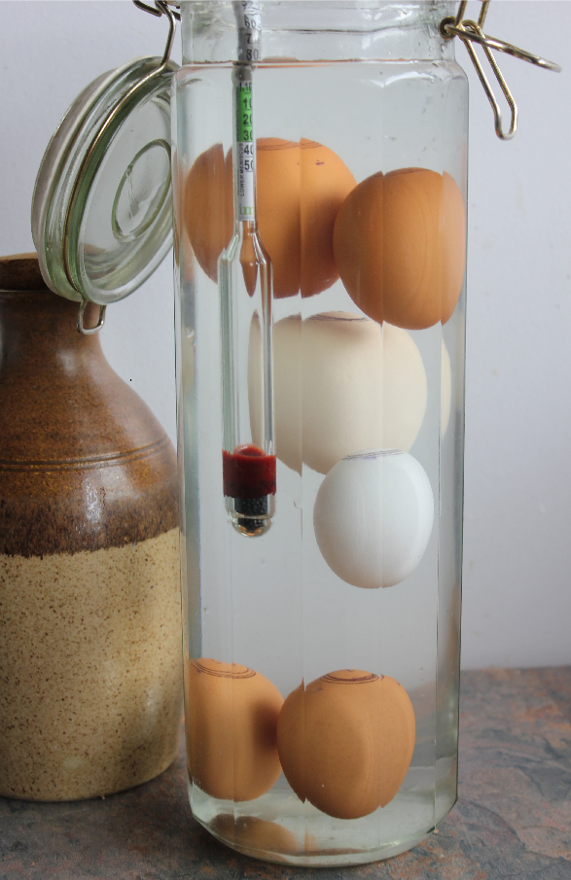
At an SG of 1.080 the eggs hover or sink.

Combining this information with a Specific Gravity chart for mead makers gives the following "egg test" table.

Mead style | End SG | Start SG  10% alcohol  tolerance yeast | Egg reading* | Start SG  12% alcohol  tolerance yeast | Egg reading*
Dry Mead (or Short) | 0.099 to 1.006 | 1.085 | Touches surface | 1.100 | 20mm (groat)
Medium Mead | 1.006 to 1.015 | 1.095 | 18mm (tuppence) | 1.110 | 26mm (sixpence)
Sweet Mead | 1.012 to 1.020 | 1.100 | 20mm (groat) | 1.120 | 30mm (shilling)
Dessert Mead | 1.02 + | 1.100 + | > 20mm | 1.120 + | 30mm +

* Using a freshly laid hens egg no more than two days old, of the roundest kind, weighing approximately 56g and able to fit into the mouth of a standard ISO XL5 wine tasting glass.

If your new-laid-egg does not float there is not enough sugar to feed your yeast and you will end up with too little alcohol so your mead will not keep. If your egg floats so high that it tips on it's side then you have too much honey for the yeast to work properly and fermentation will likely stall. The range at which the average, round new laid hens egg floats point up (SG 1.080 – SG 1.120) turns out to be the ideal range of sugar content for starting a mead.

Note on Accuracy

The egg test is of course nowhere near as accurate as the use of a hydrometer, for all of the many reasons mentioned above. If accuracy is what you are after then please use modern equipment, however if your aim is to make a period mead using period methods you now have the information need to "try it with an egge".

References

The Project Gutenberg EBook of The Closet of Sir Kenelm Digby Knight Opened by Kenelm Digby
http://www.gutenberg.org/files/16441/16441.txt

White mead to make that will be used soon (from Koge Bog, Denmark, 1616 - Maggie Forest, translator, mis-credited on the webpage) http://www.medievalcookery.com/search/display.html?kogeb:24:KBB

Specific Gravity – Wikipedia http://en.wikipedia.org/wiki/Specific_gravity CoinQuest.com http://coinquest.com/cgi-bin/cq/coins?main_coin=15090

The Winemaking Home Page ADVANCED WINEMAKING BASICS Continued - USING YOUR HYDROMETER
http://winemaking.jackkeller.net/hydrom.asp

Rabbit's Foot Meadery
http://www.rabbitsfootmeadery.com/CAGM/guide_to_mead.html
------
Copyright 2014 by Belinda Sibly. <bsibly at paradise.net.nz>. Permission is granted for republication in SCA-related publications, provided the author is credited. Addresses change, but a reasonable attempt should be made to ensure that the author is notified of the publication and if possible receives a copy.

If this article is reprinted in a publication, please place a notice in the publication that you found this article in the Florilegium. I would also appreciate an email to myself, so that I can track which articles are being reprinted. Thanks. -Stefan.

<the end>

