Vintng-Harvst-art - 4/5/09

"A Vineyard Experiment" by Baron Damon Hroarsson.

NOTE: See also the files: Vintng-Tools-art, Vintng-Proces-art, wine-msg, Eiswein-msg, yeasts-msg, brewing-msg, grapes-msg, beverages-msg, coopering-msg.

************************************************************************
NOTICE -

This article was submitted to me by the author for inclusion in this set of files, called Stefan's Florilegium.

These files are available on the Internet at: http://www.florilegium.org

Copyright to the contents of this file remains with the author or translator.

While the author will likely give permission for this work to be reprinted in SCA type publications, please check with the author first or check for any permissions granted at the end of this file.

Thank you,
Mark S. Harris...AKA:..Stefan li Rous
stefan at florilegium.org
************************************************************************

This paper was originally entered in the Kingdom of Ansteorra Arts & Sciences Competition in 2008.

Synopsis:
This is a collection of several documents written by Damon Hroarsson to outline multiple aspects of the vintners' trade as was done in period, the method, and the process by which Damon reproduces those methods.

The first document is a paper outlining a research project done to obtain an understanding of the labor required to harvest a commercially viable vineyard. This is then contrasted with data from a still extant period vineyard site which Damon visited to acquire data.
(This file, Vintng-Harvst-art)

The first appendix examines surviving winemaking tools from the period.
(Available in the Florilegium as Vintng-Tools-art,
http://www.florilegium.org/files/BEVERAGES/Vintng-Tools-art.html )

The second appendix documents the winemaking process as carried out by Damon with comparisons to period methodology and materials.
(Available in the Florilegium as Vintng-Proces-art,
http://www.florilegium.org/files/BEVERAGES/Vintng-Proces-art.html )

HE Damon Hroarsson, The Baron Borrendöhl

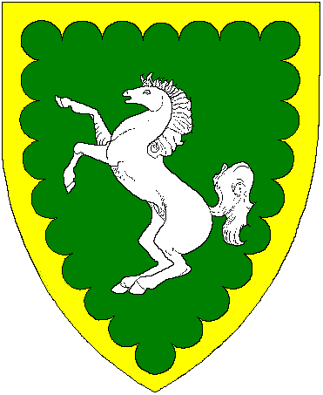

Personae:
Damon Hroarsson was born second son to the Yarl of Hedeby's shipwright during the middle of the 10th. Century. This took him to sea and eventual command of his own ship the Vindanser. Given land and title to Burg Borrendöhl in Frankonia by Otto I, Damon tears his receding hair out trying to take care of his fief, learn the wine trade, and spend time with his former hostage, now wife, Ismet.

Hugh Niewoehner is an Electrical Engineer who designs flight simulators for training pilots of corporate and commercial aircraft. "Born and raised" in the Barony of Three Rivers in the fall of 1977 he was given a firm basis in the ideals of The Society by a number of the founding characters of the region which became Calontir. Relocated to Tulsa (Northkeep) in '87, Damon has tried to contribute to the continued growth and activity of his Barony and Kingdom.
A Vineyard Experiment
by Baron Damon Hroarsson

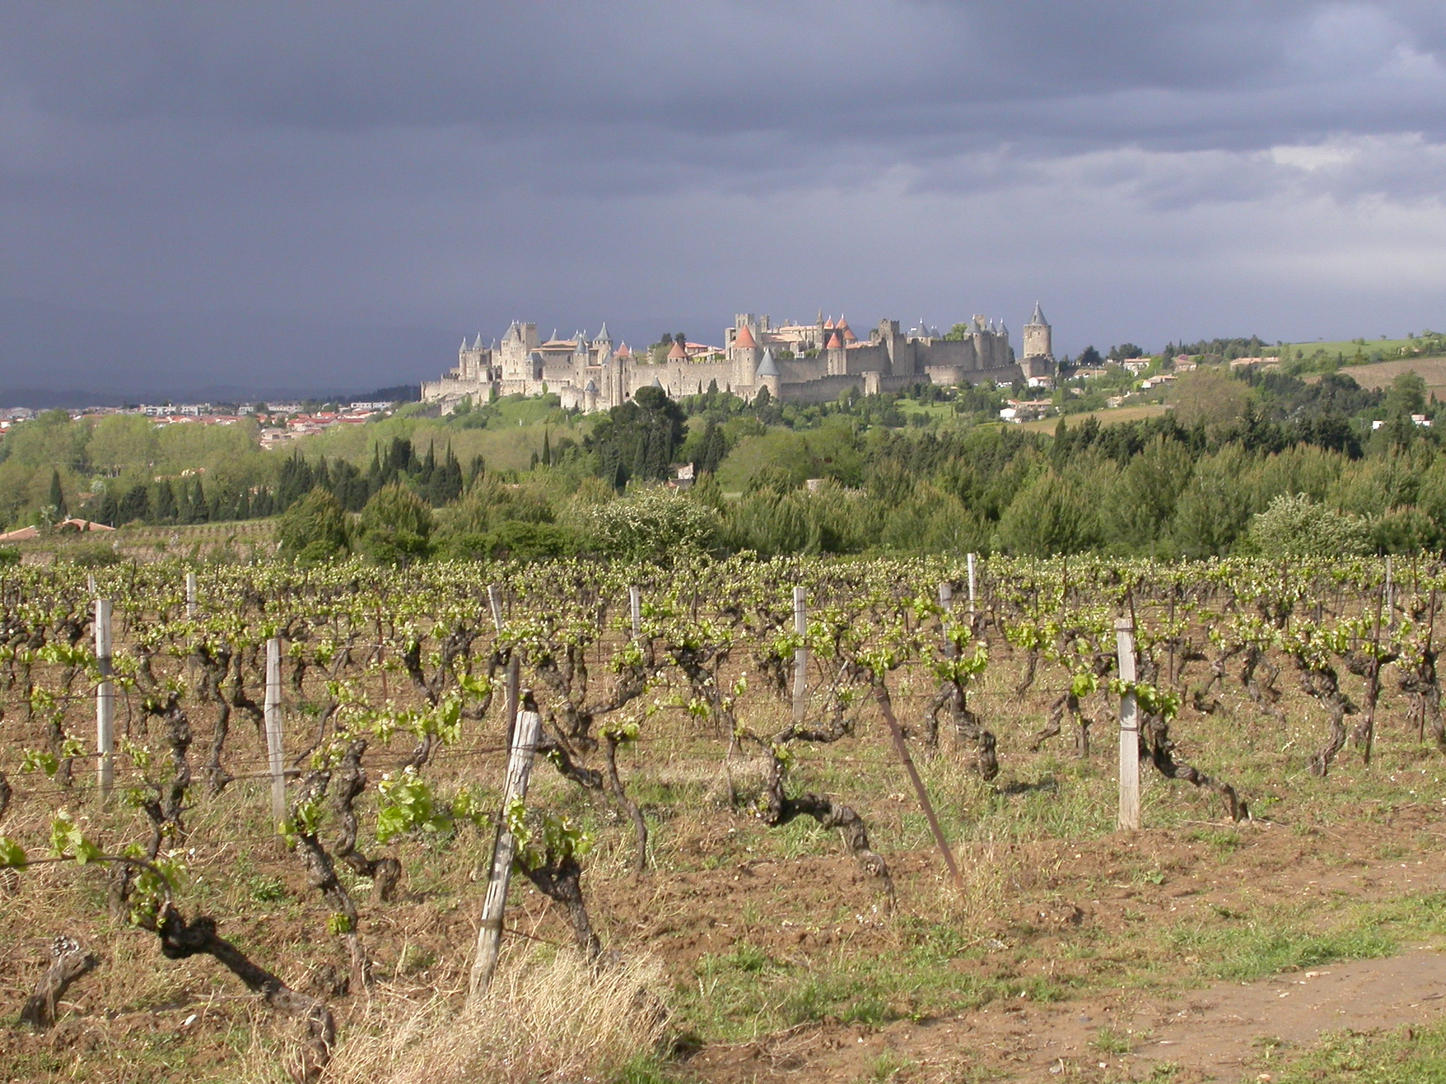

This paper will examine the results of an experiment designed to give myself a better understanding of the manpower required to operate the period vineyard and Winery. Essentially, "how much wine for how much vine" and "how many people to make it happen". This paper will give the details of my personal experiences and compare them with details from a period winemaking establishment. Following an analysis of the vineyard and harvest we will examine examples of period machinery and equipment found at locations in Europe where I gathered a significant amount of this information.

Introduction:
I have been making wine for a number of years and growing sufficient grapes on our property to make a single 5 gallon batch of wine. I've long been curious about the number of people and amount of land required to sustain a productive vineyard using period methods and techniques as we know them.

In order to get a better feel for the method and scale of the harvest task, Ismet and I decided to assist in the harvest of a full scale vineyard gathering grapes for one of the Oklahoma wineries. In the summer of 2004 we assisted with the harvest of Merlot grapes at a vineyard in Holdenville OK to determine the weight of grapes and amount of area which could be harvested by an individual during a working day.

The modern data will be compared to data from medieval records I've been able to locate through books and travel to vineyards which have been under cultivation since the 10th century. For this project the period specifics will come from the records of the Clos de Vougeot, a former Cistercian monastery located in the province of Burgundia, France.

The Modern Data:
The vines of the sample vineyard were trellised on a double canopy wire system with drip irrigation for optimal production. This form of trellising is a modern concept and should expect greater yields than the period methods. The vines were not sprayed with insecticides or Fungicides to prevent disease. The period vineyards I've been studying would have used a single line trellis with natural (rain) irrigation or manual application of water by means of hauling water in barrels. In the vineyard to be harvested there was no apparent disease or insect problems with the crop though yield may have been improved further with increased use of additional modern agricultural methods. The growing environment was heavy soil with very little slope. The ground was clear of rock and trees giving the vines sunlight from dawn to dusk.

There were twenty four of us picking fruit and 3 people collecting the filled boxes and moving boxes to a collection point where the boxes were weighed and then stacked on a trailer for later transport to the winery. We started about 9 a.m. and worked until 4 p.m. with approximately half an hour out for lunch. We were able to harvest four of the acres under viticulture at this farm. We collected 3,300 lbs. of Merlot grapes which give a yield of 825 lb/acre or roughly 130 lbs per person in 6.5 hours. Calculated out this comes to 39 man hours per acre.

Using the industry average of 13 to 15 lbs. of grapes per gallon we end up with approximately 227 gallons expected from this harvest or 55 gallons of finished wine per acre. From discussions with professional wine makers, 20 acres is the minimum number of acres under production to make a viable vineyard economically. Using 825 lb/acre yield we're looking at 16,500 lbs from 20 acres for a final product of 1,100 gallons. Missouri's smallest bonded winery (Gloria Winery in Cabool) makes 3,000 gallons per year and consider themselves barely cost effective. To make 3,000 gallons given the yield encountered above you would need 55 acres under cultivation. 2,145 man hours to pick 55 acres.

The Period Data:
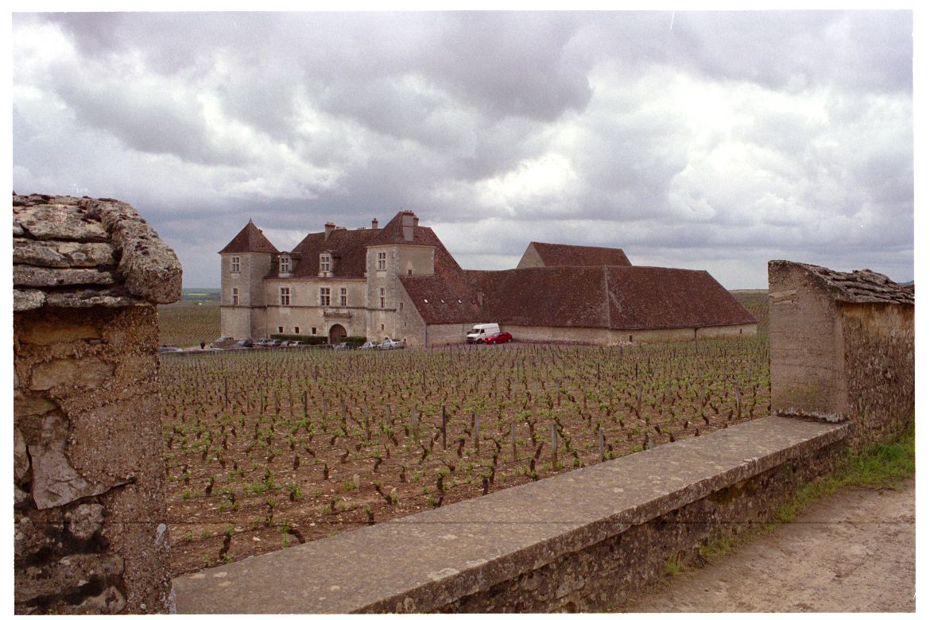
The Clos de Vougeot, Burgundia, France

Established in the early 12th. century, Clos de Vougeot is a holding of the Monastery of Cîteaux and placed in the center of the Burgundian region called the Cote D'Or. The lands of the Cote D'Or is a gently sloping valley ideally suited to the growth of grapes. The Brothers of the Monastery started with a very modest amount of land. However, the holding grew rapidly due to donations and behests granted the Brothers. Examples of such include one gift made by a local minor landholder of 3 Ouvreé of land "for prayers for the salvation of my parents and wife" [1].

First some terminology and definitions as described in a translation of the historical documents found at the Cloister [2].

Surface Area terms:
Ares: 1/10 Acre
Ouvreé: 4.28 Acres (Considered one days work for one person.)
Journal: 8 Ouvreé
Hectacre: 2.47 Acres

Liquid Measures:
Quartaût: 1/4 cask, 57 liters
Feuilliettè: 1/2 hogshead, 1/2 cask, or 114 liters
Pièce: Cask or Tun, 228 liters
Queue: 2 Tuns, 456 liters
Hectoliter: 100 Liters/26.41 gal

A surviving 15th Century record at the Clos indicates that 50 hectacres yielded from 15 to 35 hectolitres of wine per hectacre depending on that year's harvest.

50 Hac. yields 1,500 to 3,500 liters/ Hac. Converted this amounts to 607 to 1,417 Liters per acre or 160 to 347 gallons per acre. Going back to the modern data of 55 gal/acre we can see that the "professional" growers of the period vineyard actually yielded much better than the modern, optimally trellised Oklahoma vineyard.

In order to continue the examination of the productivity of the period vineyard and winery we will look at the finished quantities produced.

The Brothers were able to obtain 153,000 liters ( 40,418.32 gal) from 496,039.5 lb yielding 235,000 bottles. Or, in my terms, roughly 12.57 pounds of fruit per gallon of yield. Not bad…their yield per pound of fruit is within range of those seen in vineyards which use lower irrigation volumes or several of the less meaty varietals such as the Cynthiana.

The Clos has under cultivation 130 Journeaux of vines + 4.5 Ouvreé & 29 Rods of vine inside the walls of the Clos. Working out the numbers it becomes 1,044.5 Ouvreé or 4,470.46 acres under cultivation. Taking our experimental value of 39 man hr/acre we arrive at 174,348 man hours to complete the harvest.

The grapes are at their optimal harvest period for 4 days. Today we know the exact timing of this period through the use of instrumentation and laboratory testing. Tradition, experience, and the science available in the 15th C. would bring the Vineyard master to similar conclusions.

Records give an average of 6.5 to 7.25 hours of daylight in the region of Burgundy during the months of August and September [3]. Personal experience participating in pickings and discussions with professional vineyard owners has shown that you can begin picking approximately half an hour before dawn and can continue until half an hour after sunset. For a working number I will use 7.5 hours and give the brothers one week to carry out the harvest. For an estimate of manpower requirements this equates to:
174,383 man hours / (7.5 hours a day x 7 days) = 3321 men.

The Clos had dormitory space for 200. During harvest they could expect assistance from their Governing Abbey of Cîteaux, 18 miles away. Even so, I don't believe they could come up with the sort of numbers my experimental data indicates would be required. So, I know my data is flawed.

There are several possible sources for differences in the results.

- Productivity. While the raw data worked out to 130 lb. per person, all but 5 of the crew were rank amateurs (first timers). Also, there were varying degrees of attention to detail. Ismet and I each picked 8-10 crates each at ~35 pounds per while others managed to fill only 2 to 5 crates. From discussions with commercial vineyards in the region the output of experienced pickers should be greater than 10 crates over the same time period. I would expect an experienced crew of Brothers to equal or exceed the numbers Ismet and I achieved. They had experience, determination, and an overwhelming work ethic.

- Working day. The brothers may have been perfectly willing to work much harder for longer hours. During one harvest Ismet and I participated in several years ago we started as soon as it was light enough to see the clusters on the vines. If you carried this into the twilight hours you add four to six more hours of harvesting time.

- Ripening cycle. The layout of the vineyard may have offered a somewhat extended harvest period. The vineyard covers a broad sloping valley. Given the same varieties of grape, those vines on the upper levels of the valley would mature slightly earlier than those lower down.
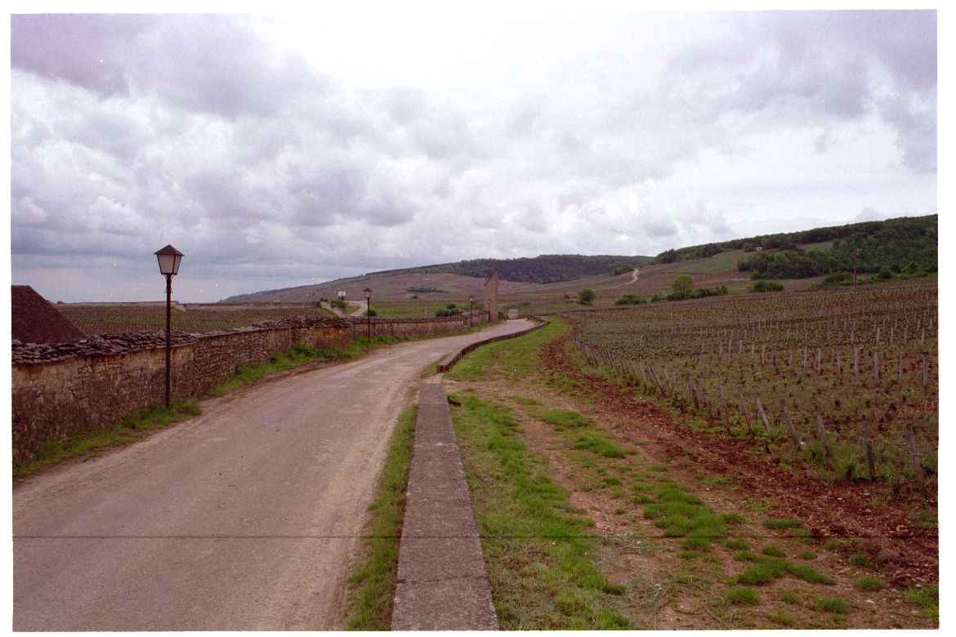
- Quality Variation. "First for the King, Next for the Church, Finally for the common man."- proverb seen at the Monastery. The Cistercian brothers may have been willing to harvest before and after the 'ideal' period. Flavor, alcohol content, etc. would suffer but commercial considerations come into play. Will your market accept a lower quality though still salable product?

Harvest Method
"The demands of the viticultural year are set out in the eleventh-century charter of the Abbey of Muri, southwest of Zurich. It described the essential activities like loosening the soil around the base of the vines so that rainwater would soak in deeper, fertilizing the vines with manure, pruning, tying up the shoots, loosening the soil again before midsummer, and removing the leaves that shaded the clusters from the sun. Once picked, grapes were crushed initially by foot and then pressed, although those destined for better-quality white wine were probably processed first. Wine-presses, particularly of the screw-type, became larger as the volume of the grapes involved increased. Small proprietors, including peasants, could not afford their own presses and instead used those of their lords or wealthier neighbors, usually for payment in wine. Once the juice had been extracted, it was transferred to wooden barrels for fermentation and later transportation. Barrels were generally made out of oak and their size varied by region." [A Short History of Wine, p97] [4].

Harvest and preparation for fermentation.
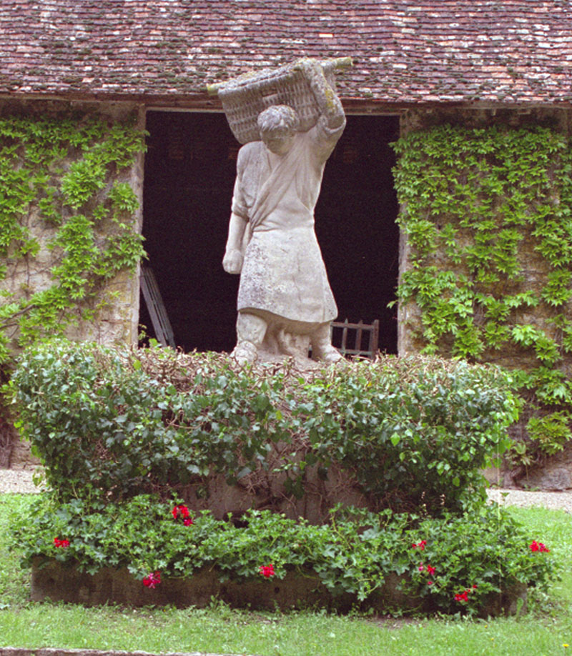
In period the grapes were harvested in baskets and brought to the fermenting shed.

The baskets were strapped over the shoulder of the harvester and could be dumped into wagons or directly into the vats. This statue at the Clos illustrates the harvester with his basket. If we imagine carrying this basket loaded with fruit all day long we get a feel for the meaning the phrase "back breaking labor" Most modern wineries use plastic bins which hold approximately 35 lbs of fruit. These can be easily stacked and loaded on to vehicles for transport to the fermenting shed.

Once picked and brought to the processing shed the grapes would be de-stemmed. Several examples of de-stemming devices exist One of the devices used in medieval times are hung on the walls of the fermenting house at the Clos. A screen shaped like a modern tennis racket, made of interwoven, narrow branches or rope was used which permitted the fruit to be stripped off of the stems. I attempted to get a picture but the items were hung in such a way as to be poorly lit and out of range of my flash unit.

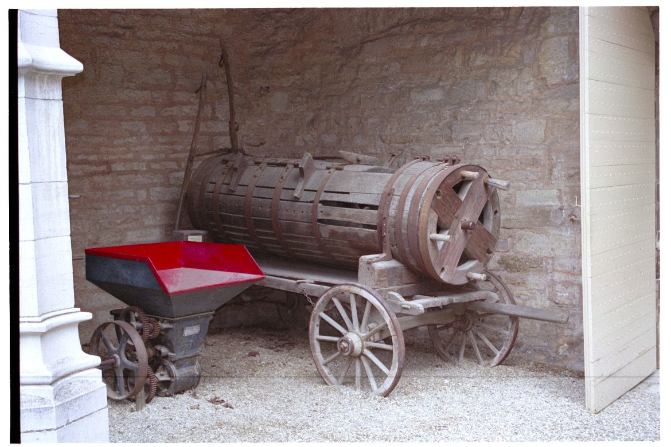
This de-stemmer, found at the Museum of Wine in Beuanne, works in a method very similar to modern devices. The plaque only states that it dates to the 15th Century.

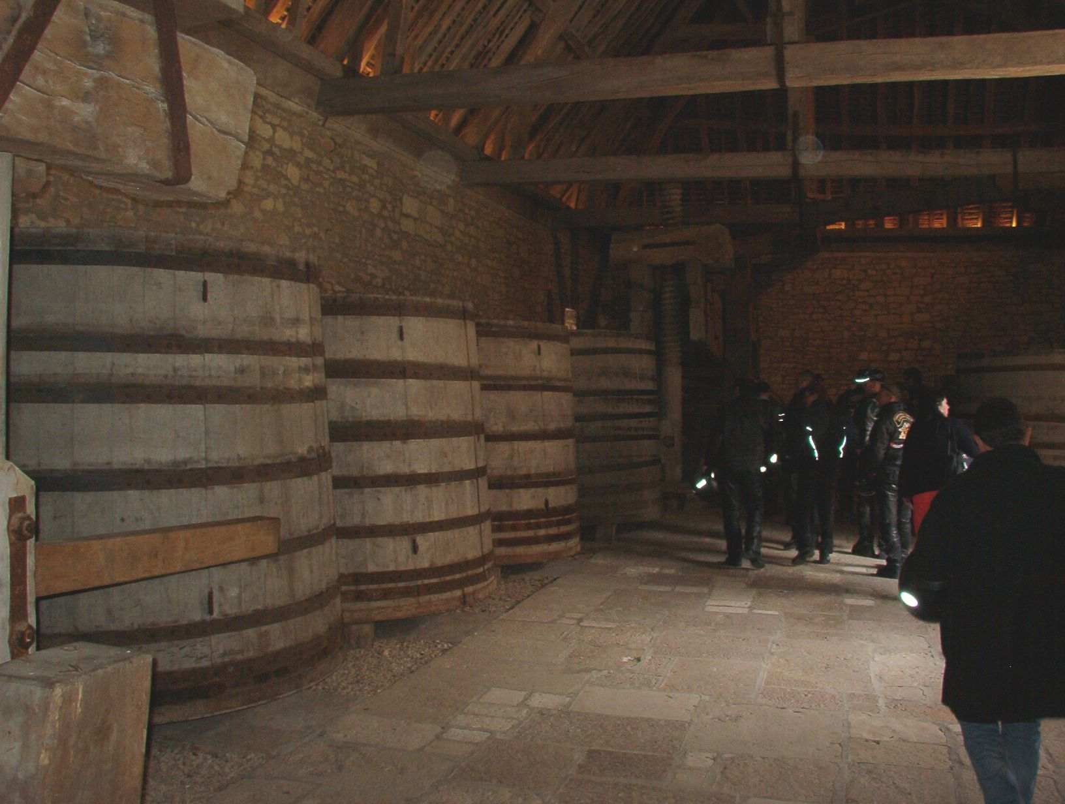
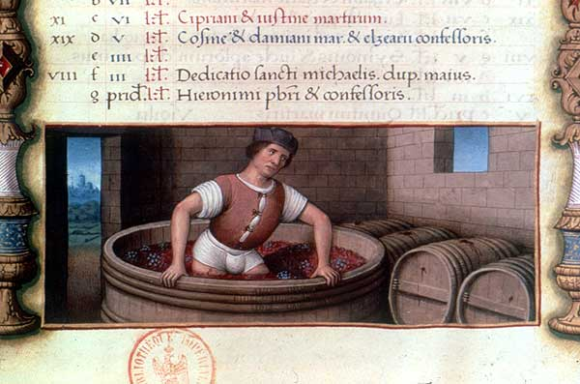

Crushing was performed in the long romanticized method of just walking on the grapes in a large open topped vat. In this case the vats seen at left are of 16,000 liters capacity and the Clos has 26 of them. Here the grapes would undergo primary fermentation converting the sugars to alcohol and extracting tannins, etc. from the fruit prior to pressing.

The Press
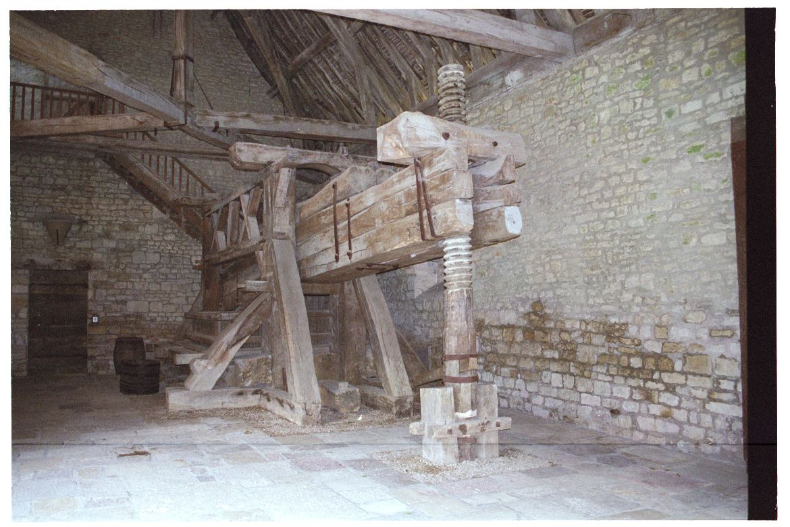
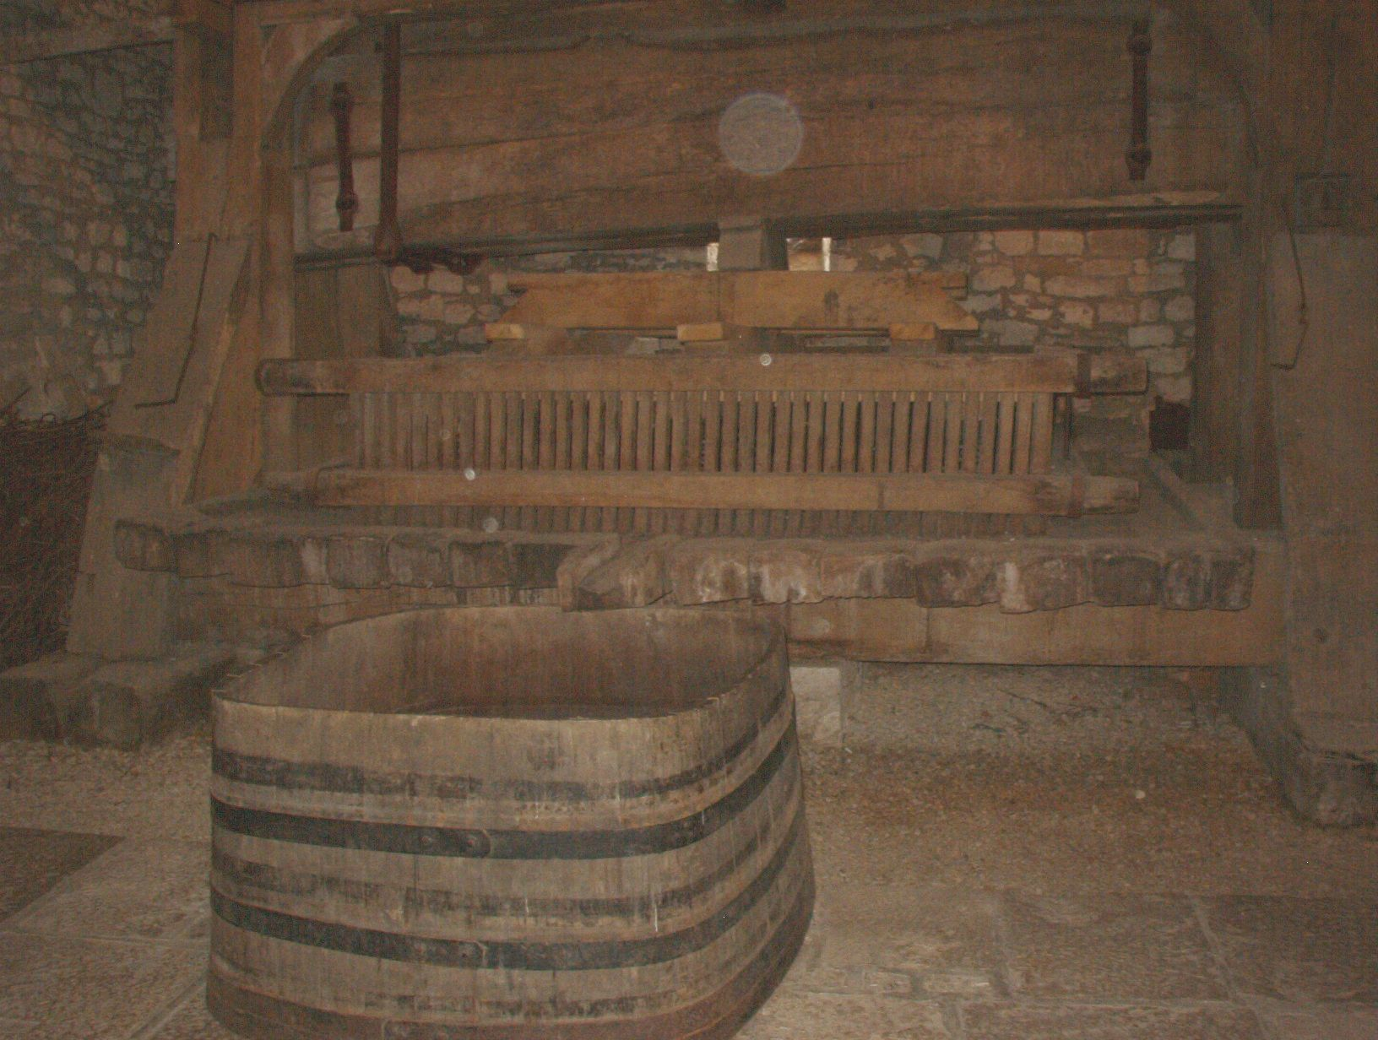
The scale of the press can be determined by comparing it with the size of the door in the wall to the left of the press in the picture above.

The Clos Vougeot has 4 large presses constructed of Oak. As of 2005 the presses are said to be over 700 years old. Analysis of the wood indicates the trees used to construct the presses were approximately 300 years old when harvested. The presses require several individuals to operate and exert over 7 tons of pressure on the fruit within the basket.

Presses such as these appear in a number of illustrations and tapestries. Devices of similar design are still commonly used as shown below.
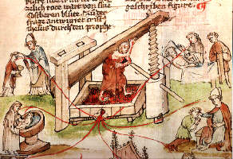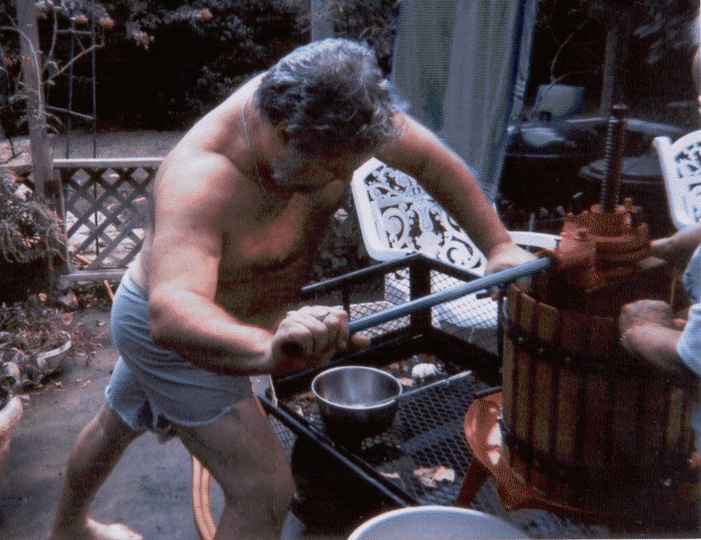
Left: Mystic press. Fifteenth-century manuscript. The Ribeaupierre Bible. Surrounding the press are illustrations of the wine used in sacrament. Public Library of Colmar. Right: Damon operating his press at home.
As the grapes were transferred into the press, juice which comes out before pressure is applied is called the 'free run' juice. This free run must was collected into Oak barrels and aged separately from the must extracted by pressing. The free run wine was considered "premium" even as it is today. Wine made from the free run would be kept separate from the pressed juice. This Vin du Roi was then sent to the Pope or the King. Wine made from juice extracted by press would be was sold to support the monastery and it's works.

The wine, collected into oak barrels, would be aged in the cloisters "cellars" until ready for shipment and delivery. In the image below the entrance to the cellars can be seen at ground level. The Dormitory for the Cistercian Brothers is on the upper floor.
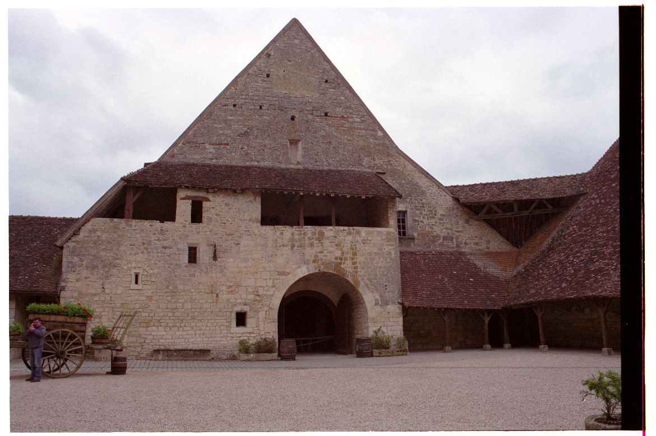

The Clos de Vougeot is, oddly enough, not located in part of the province where caves are readily available for the storage and aging of the wine. Instead an aging cellar was built of thick stone walls. This insured a chamber with a fairly consistent temperature and humidity for quality wine production. For comparison, Veuve Amiot (a small producer) in the Val d'Loire has 18 hectacres (44.46 acres) of tunnels carved into the chalk hillsides of St. Hilaire.

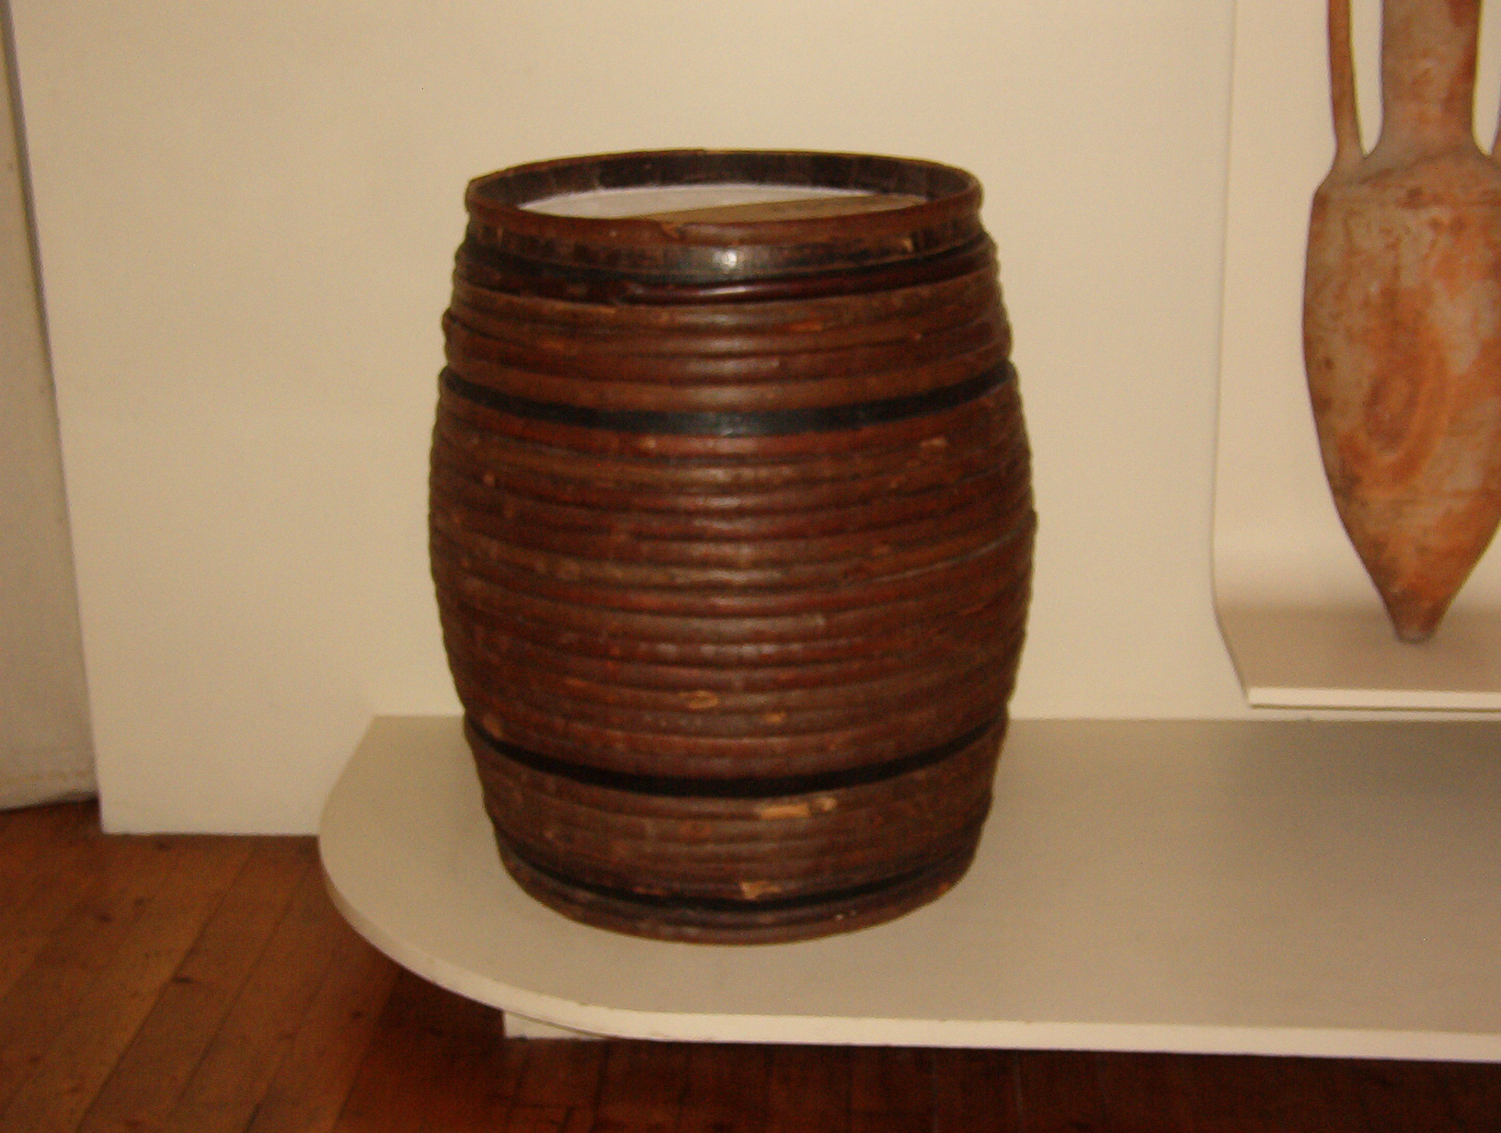
Here is an example of an oak barrel used for aging, storage, and transport. During aging the wine picks up more tannin and flavor from the oak. Thick rope which had been waxed is wrapped tightly around the barrel. This would hold the barrel tightly together to prevent leakage in addition to providing some degree of protection to the wood staves when being moved around the winery and during delivery. Once the barrel arrived at it's ultimate destination the ropes would be cut away.[5]

Conclusion

While the experiment succeeded in it's educational intent of helping me get a better perspective of harvesting a commercial vineyard in period, the numbers are not really useable to compare to the productivity of the period vineyard and vineyard workers. I guess this only means I'm going to have to try again. Yay!

Thanks to the experience gained through participation in several commercial harvest's my visit to the Clos de Vougeot definitely had more impact and I was better able to grasp the effort those Cistercian Brothers went through in gathering the harvest, crushing, pressing, and aging the wine.

Bibliography and source material
Unless otherwise noted, all photographs used in this document are copyright:
Hugh and Belinda Niewoehner © 2008

Person to person:
While I've read a fair number of books I must say that I've gotten my best tips on winemaking from direct discussions with the professionals I've encountered in Germany, France, and the US. In particular, Andrew Post, Cellar Master of the Post Famille Winery, Altus AR.

A History of Wine H. Warner Allen, Horizon Press, 1961
A Short History of Wine Rod Phillips, Harper Collins, 2000 ISBN: 0-00-621282-0
Alcoholic Drinks of the Middle Ages.
Marc Shapiro. Complete Anachronist #60. Society for Creative Anachronism, Inc.
Ancient Wine – The search for the origins of Viniculture
Patrick McGovern Princeton University Press
Art of Making Wine, The Stanly F. Anderson 1970 ISBN: 0-525-48500-7, Hawthorn/Dutton.
BOKE OF NURTURE, John Russell, dates from 1460-1470.
CA Guide to brewing, The Ly. Arwen Evaine fert Rhys ap Gwynedd.
Complete Anachronist #5. 1983, Society for Creative Anachronism, Inc.
Closet of Kenelm Digby, Kt. Opened, The Originally published 1677
Reprinted by Falconwood Press
Growing Wine Grapes The American Wine Society ISBN: 0-9619072-0-7
Making Mead. Bryan Acton & Peter Duncan 1978, SBN: 900841-07-9
Amateur Winemaker Publications Ltd.
Making of Melomels and Flower Metheglins, The
His Grace Sir Shadan Secarius. Tournaments Illuminated. Society for Creative Anachronism, Inc.
Making Wild Wines and Meads Vargas and Gulling, Storey Books ISBN: 1-58017-182-6
Menagier de Paris (1393)
I owned a copy but it disappeared. It can be found on-line at: http://www.best.com/~ddfr/Medieval/Cookbooks/Menagier/Menagier.html#BEVERAGES
The English Housewife Gervase Markham Edited by Michael Best, McGill-Queen's University Press (Sept. 1994) ISBN-13: 978-0773511033
The Forme of Cury (1390).
University Wine Course, Marian Baldy Ph D.
USC Davis dept. of Oenology and Viticulture
Vierka Wine book, The Friedrich Sauer, K.G., Stuttgart Germany.
Wassail! In Mazers of Mead. G. Robert Gayre. 1986, Gayre, Gayre & Nigg.
ISBN 0-937381-00-4 This is perhaps the definitive history of Mead making.
Wine André Domainé, Könemann Verlagsgesellschaft, Köln, Germany
Wine – The 8,000 year old story of the wine trade.
Thomas Pellechia Thunders Mouth Press, New York 2006
Winemaker's Recipe Handbook. Raymond Massaccesi 1976.
Winemaking, Recipes, Equipment, and Techniques for making wine at home.
Stanley F. Anderson & Dorothy Anderson. 1989, Harcourt Brace & Company.
Winemaking, the Concentrate Method. Art Lynch 1988, Crosby and Baker Books.
For professional yeast help I've consulted directly with Dr. Clayton Cone of Lallemand Inc. Technical Director of American Yeast Company, Baltimore, Maryland. (You encounter his work when you open that packet of Lalvin yeast).

Various publications from the Department of Oenology and Viticulture, U.C. – Davis.

And within the SCA the encouragement and pointers given me by Master Gerald Goodwine.

Partial list of published sources I've used (period and otherwise):

Footnotes:

[1] Recorded in the ledger of the Clos de Vougeot, Burgundia. France. Translated and published by Le Museé de Clos de Vougeot.
[2] The following measurements of volume, acreage, etc. are extracted from books, pamphlets, translations of the records which exist at the Clos de Vougeot except where noted. Translated and published by Le Museé de Clos de Vougeot, Burgundia, France.
[3] Mitchell Beazley Classic Wine Library, Burgundy by Anthony Hanson. Octopus publishing group LTD. London 1982 ISBN: 1 84000 913 6
[4] A Short History of Wine Rod Phillips, Harper Collins, 2000 ISBN: 0-00-621282-0
[5] Museé de Vin, Place des Ducs de Bourgogne, Beaune, France
------
Copyright 2008 by Hugh Niewoehner, 6931 S. 73rd. East Ave., Tulsa OK, 74133. <burgborrendohl at valornet dot com>. Permission is granted for republication in SCA-related publications, provided the author is credited. Addresses change, but a reasonable attempt should be made to ensure that the author is notified of the publication and if possible receives a copy.

If this article is reprinted in a publication, I would appreciate a notice in the publication that you found this article in the Florilegium. I would also appreciate an email to myself, so that I can track which articles are being reprinted. Thanks. -Stefan.

<the end>

