Vintng-Tools-art - 4/5/09

"A Vineyard Experiment - Appendix 1: A closer look at some period tools of the trade" by Baron Damon Hroarsson.

NOTE: See also the files: Vintng-Harvst-art, Vintng-Proces-art, wine-msg, Eiswein-msg, yeasts-msg, brewing-msg, grapes-msg, beverages-msg, coopering-msg.

************************************************************************
NOTICE -

This article was submitted to me by the author for inclusion in this set of files, called Stefan's Florilegium.

These files are available on the Internet at: http://www.florilegium.org

Copyright to the contents of this file remains with the author or translator.

While the author will likely give permission for this work to be reprinted in SCA type publications, please check with the author first or check for any permissions granted at the end of this file.

Thank you,
Mark S. Harris...AKA:..Stefan li Rous
stefan at florilegium.org
************************************************************************

This paper was originally entered in the Kingdom of Ansteorra Arts & Sciences Competition in 2008.

Synopsis:
This is a collection of several documents written by Damon Hroarsson to outline multiple aspects of the vintners' trade as was done in period, the method, and the process by which Damon reproduces those methods.

The first document is a paper outlining a research project done to obtain an understanding of the labor required to harvest a commercially viable vineyard. This is then contrasted with data from a still extant period vineyard site which Damon visited to acquire data.
(Available in the Florilegium as Vintng-Harvst-art,
http://www.florilegium.org/files/BEVERAGES/Vintng-Harvst-art.html )

The first appendix examines surviving winemaking tools from the period.
(This file, Vintng-Harvst-art)

The second appendix documents the winemaking process as carried out by Damon with comparisons to period methodology and materials.
(Available in the Florilegium as Vintng-Proces-art,
http://www.florilegium.org/files/BEVERAGES/Vintng-Proces-art.html )

HE Damon Hroarsson, The Baron Borrendöhl

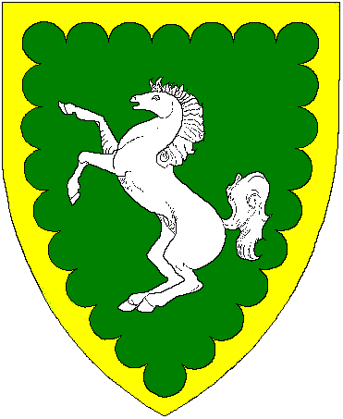

Personae:
Damon Hroarsson was born second son to the Yarl of Hedeby's shipwright during the middle of the 10th. Century. This took him to sea and eventual command of his own ship the Vindanser. Given land and title to Burg Borrendöhl in Frankonia by Otto I, Damon tears his receding hair out trying to take care of his fief, learn the wine trade, and spend time with his former hostage, now wife, Ismet.

Hugh Niewoehner is an Electrical Engineer who designs flight simulators for training pilots of corporate and commercial aircraft. "Born and raised" in the Barony of Three Rivers in the fall of 1977 he was given a firm basis in the ideals of The Society by a number of the founding characters of the region which became Calontir. Relocated to Tulsa (Northkeep) in '87, Damon has tried to contribute to the continued growth and activity of his Barony and Kingdom.
A Vineyard Experiment
by Baron Damon Hroarsson

Appendix 1: A closer look at some period tools of the trade

The wine press:
A wine press large enough to process significant quantities of fruit could be large and expensive item. Small (non-mobile) presses have been found carved into the stone of hillsides in ancient vineyards of Italy and Greece. Suitable for small quantity runs they would be insufficient to the task offered by the quantity of fruit produced in areas such as the Côte D'Or in Burgundia.

Such a press would be a large and expensive piece of equipment. Most of the surviving early Northern European presses were owned by Monasteries, or as an entire village's property at a central location. One village boasts that their press is over 800 years old and was still in use during the 1950's. Wagon mounted presses dating to the 15th. century have been located in France. A few of these can be found at the Museum of Wine in the Palace of the Dukes of Burgundy (Museé de Vin, Place des Ducs de Bourgogne) in the city of Beaunne, France.

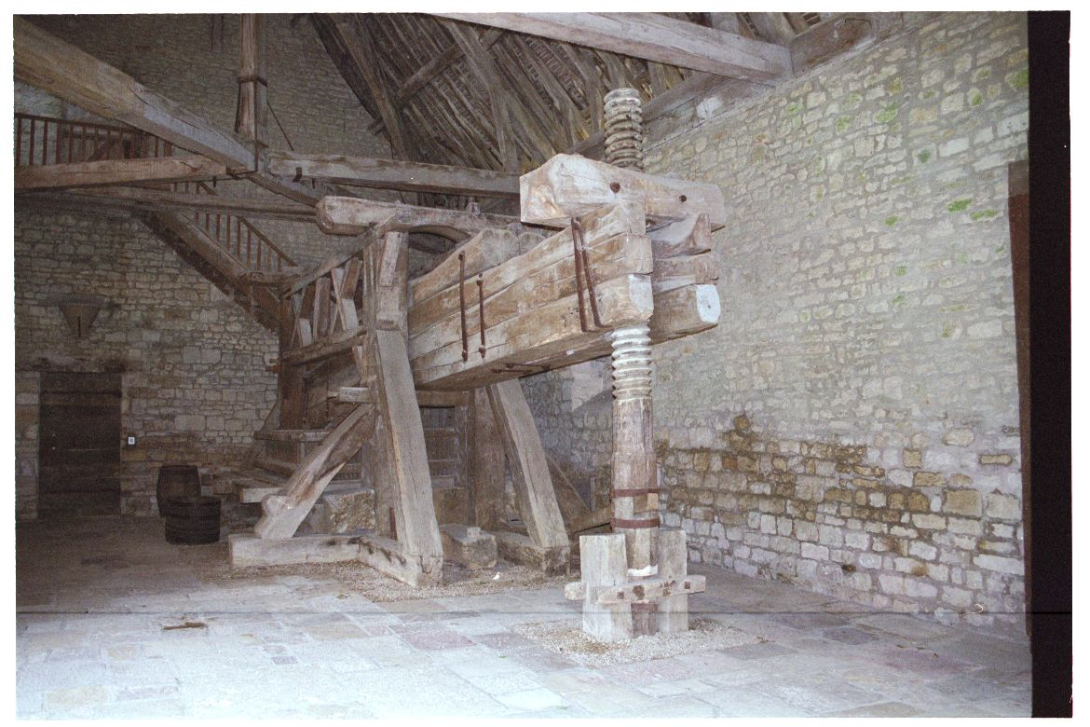
This is the largest example I've encountered in my explorations. There are 4 of these devices at the Clos de Vougeot. The screw would be turned by 2-4 persons using rods inserted through the threaded log above and between the iron straps seen on at the arrow. This raised or lowered the end of the massive oak beams. The arm pivots on top of the lower cross beam. The weight applied at the basket end has been calculated to be approximately 7 tons.

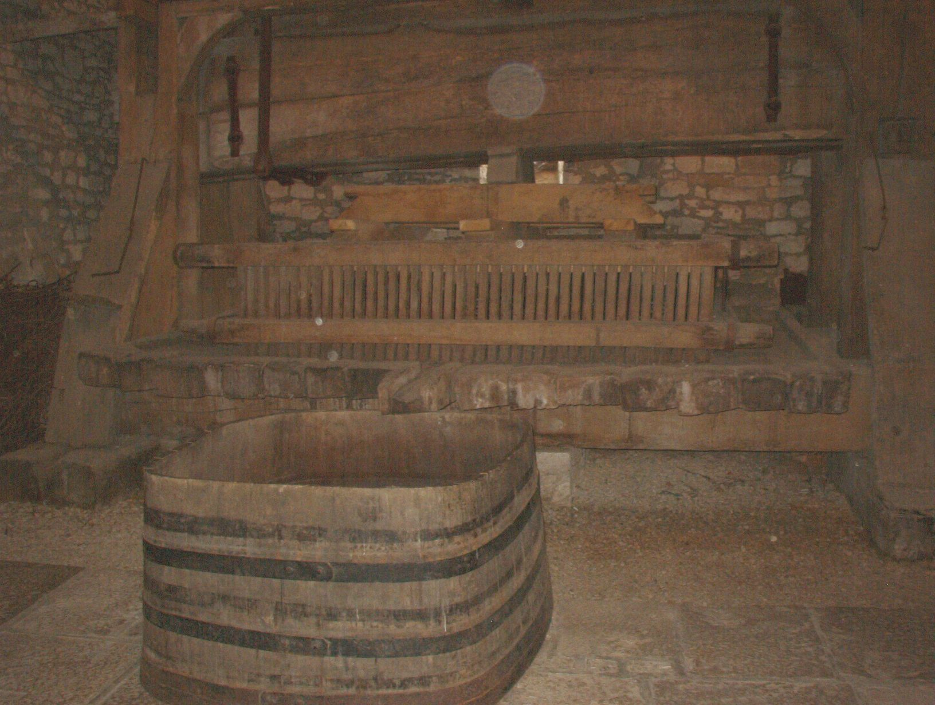
The basket is comprised of several elements. A stone pedestal was built up with a raised perimeter. The surface is sloped toward the 'front' of the press area and a spillway/funnel is formed into the stone leading to a catch tub. The sides are built of spaced oak strips. These contain the pile of grapes as they are pressed. The floor of the pedestal is slightly raised above the bottom of the basket preventing grapes from being forced out under the edge. [I'll attest that under the high pressure of pressing I have had the occasional escapee but not in great quantity. Much more common is a small jet of fruit juice spraying whomever is standing too close on that side.]

Several large planks are on top of the material to be pressed. Spacers are then placed to transfer the weight of the press beam evenly across the press surface.

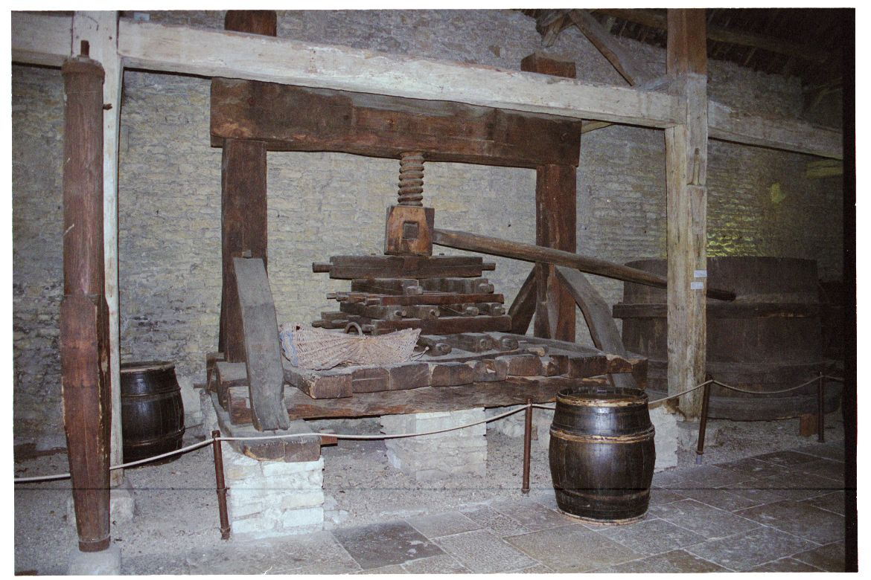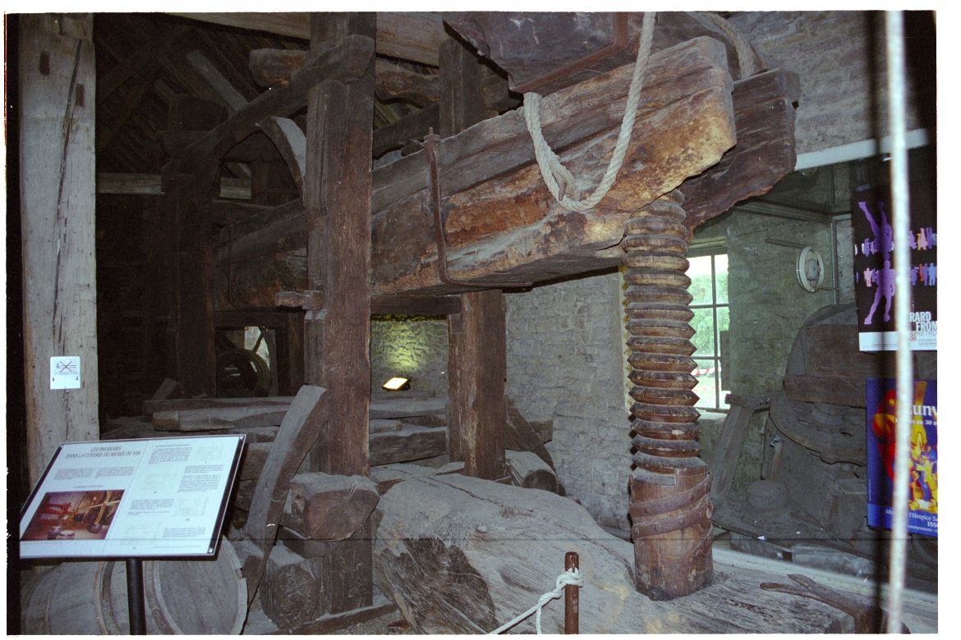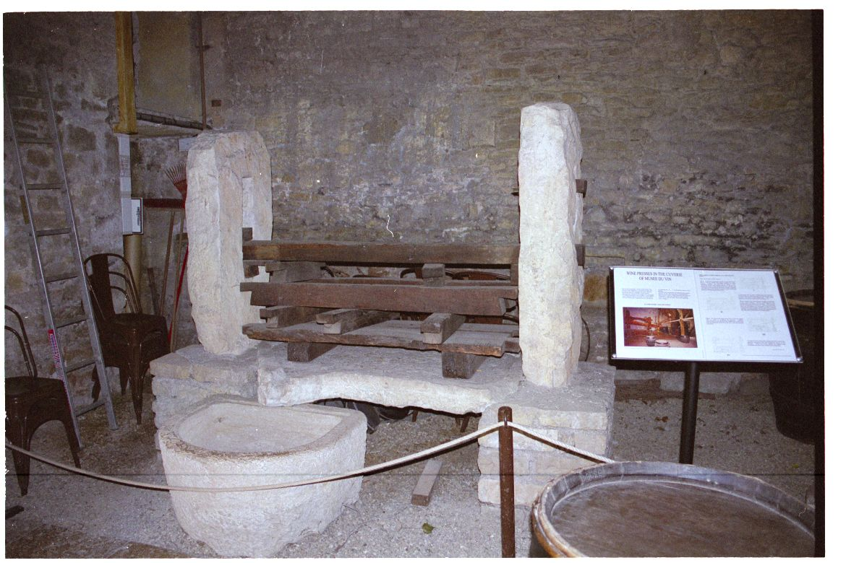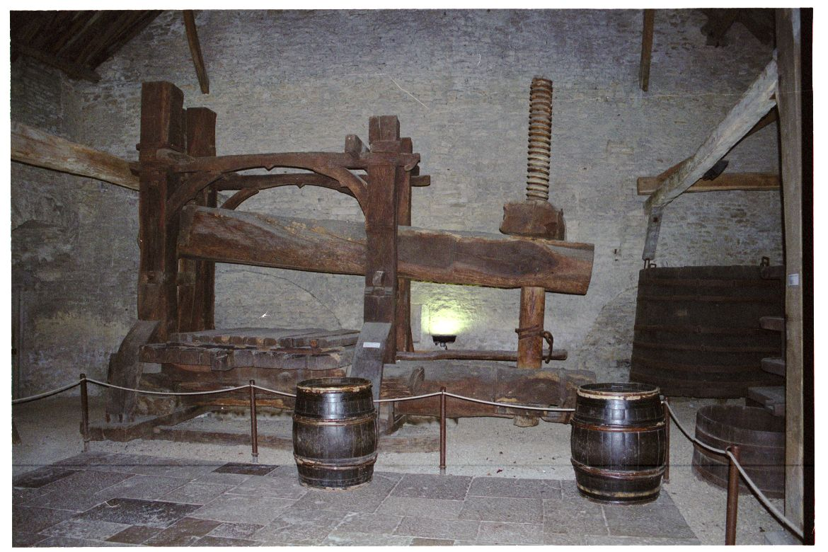These are additional examples which have been recovered and moved to the museum in Beaunne.

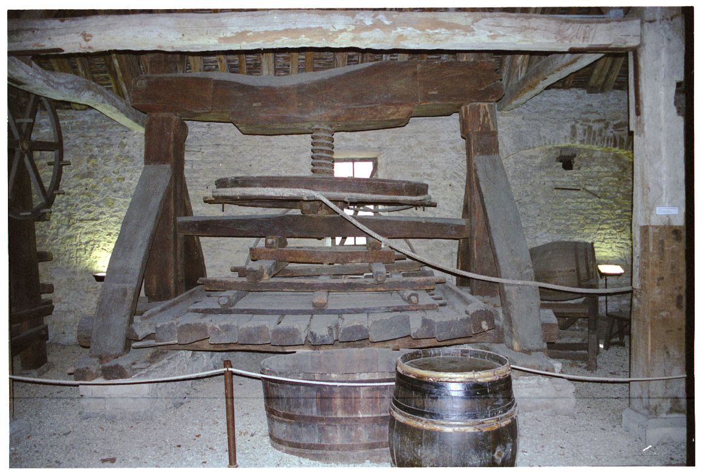
This example was curious because of the large pulley and hawser running to a horse powered mechanism off to the side.

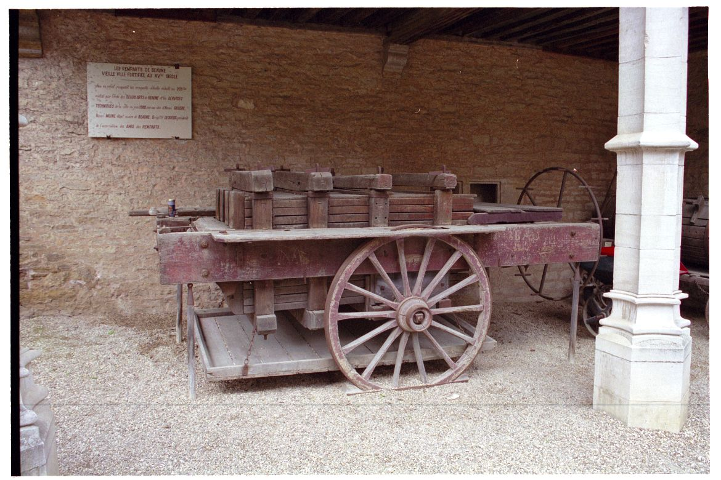
This wagon mounted version is top loaded. The grapes are pressed by a block which travels lengthwise down the wagon. The press is actuated by the large wheel seen at the right end of the wagon. The juice is caught and directed by the pan hanging under the wagon.

The De-stemmer:
There is some question at what time it was decided that removing the stems prior to fermentation was a "good thing". Modern Vintners realize that including the stems leads to excessive tannin levels and potentially overwhelming quantities of spoilage bacteria.

There is a set of implements shaped similar to a pair of large snowshoes hanging on the wall of the Clos. Grape clusters are placed between the two implements which are then passed across each other. The fruit would be stripped from their stems and would fall through into the fermentation vat while the stems remained captured for disposal. Fast? Not really, but possibly effective if you have the manpower to operate them in quantity. I intend to construct a set to experiment with.

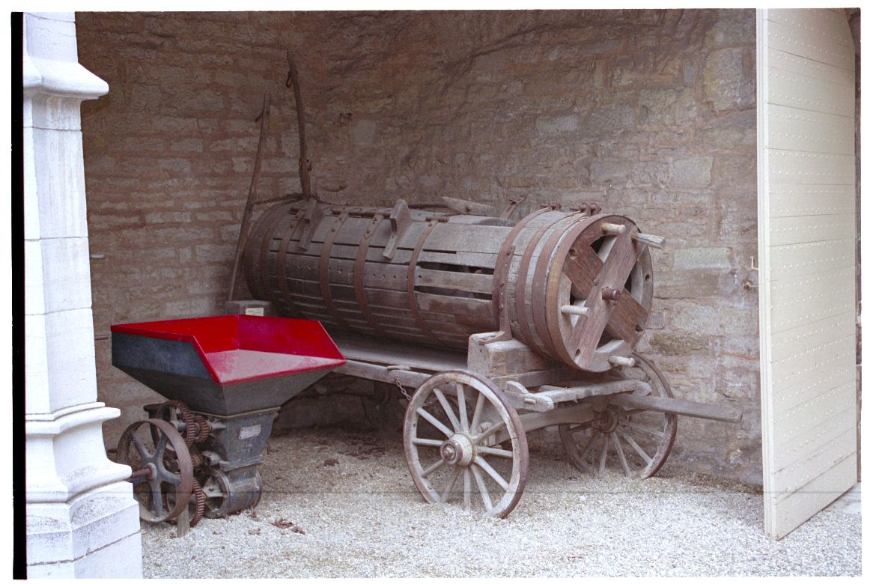
This 15th century, wagon mounted piece works in a manner very similar to modern units although constructed of oak rather than stainless steel. The modern and period wine master would be perfectly familiar with the operation of each others equipment.

Rotating the handles causes fruit which is put in the top to make it's way down the cylinder. Paddles strip the fruit off the stems to fall through holes in a second, internal, cylinder and out the bottom to be caught in tubs for transfer to the crushing and primary fermentation vats. The cleaned stems exit the far end of the device for disposal. Most de-stemming devices claim to remove between 80 and 90 percent of the stems. For those processing's I've observed it is usually a short stub of stem attached to the grape where it stripped off the cluster rather than separating cleanly at the end of the fruit.

Barrels:
While the most common reference is to the Tun or Hogshead barrel (being ~60 gallons) there are surviving examples from small and portable two gallon casks to Burg Heidelberg's massive two hundred twenty thousand (yes thousand!) liter party pleaser.
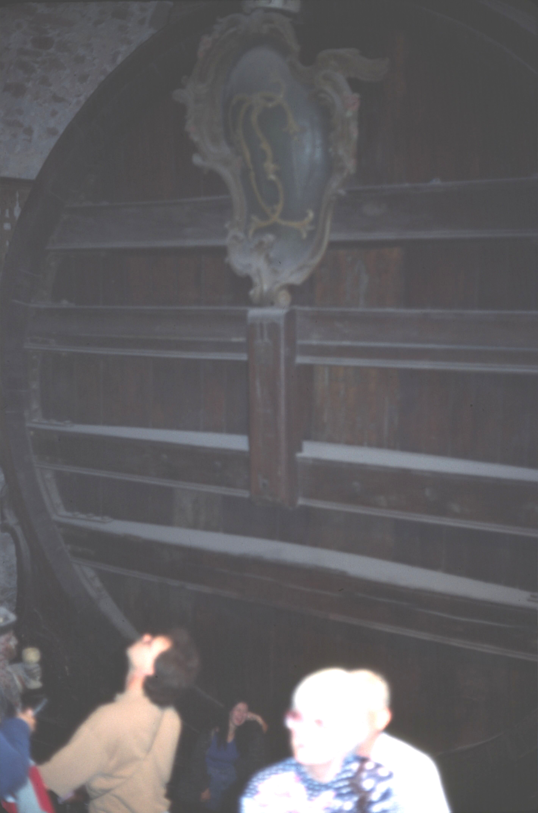
Most wine barrels are constructed of oak being a solid hardwood suitable for long term aging and able to withstand the trials of transportation. As we now know, oak was found to contribute color, tannins and flavor to the aging wine within. This also contributed to protecting the wine from bacteria and other potential spoilage issues.

Beech, cedar, and other woods having strong flavors of their own have been known to be used. In general they have proven unsatisfactory for long term storage. [1] But the use of these other woods sometimes had other purposes. These other woods could be used to hide wine gone bad or even to hide the fact that what was being consumed was something other than wine. London passed a number of laws concerning what could be used to flavor wines as kegs were found to have pine tar added for sweetness and to hide the taste of fouled beverages. [2]

If you look closely you can see Ismet at the bottom center for a sense of scale.

Footnotes:

[1] Museé de Vin, Place des Ducs de Bourgogne, Beaunne, France
[2] A Short History of Wine Rod Phillips, Harper Collins, 2000 ISBN: 0-00-621282-0

------
Copyright 2008 by Hugh Niewoehner, 6931 S. 73rd. East Ave., Tulsa OK, 74133. <burgborrendohl at valornet dot com>. Permission is granted for republication in SCA-related publications, provided the author is credited. Addresses change, but a reasonable attempt should be made to ensure that the author is notified of the publication and if possible receives a copy.

If this article is reprinted in a publication, I would appreciate a notice in the publication that you found this article in the Florilegium. I would also appreciate an email to myself, so that I can track which articles are being reprinted. Thanks. -Stefan.

<the end>

