Chld-Costumes-art - 9/21/08

"Children's Costumes at SCA Events - a personal testimonial" by Mistress Ælflæd of Duckford.

NOTE: See also the files: children-msg, child-clothes-msg, Kindergarb-art, Toys-in-th-MA-art, children-SCA-lnks, babies-msg, clothing-MN-msg, patterns-msg.

************************************************************************
NOTICE -

This article was submitted to me by the author for inclusion in this set of files, called Stefan's Florilegium.

These files are available on the Internet at: http://www.florilegium.org

Copyright to the contents of this file remains with the author or translator.

While the author will likely give permission for this work to be reprinted in SCA type publications, please check with the author first or check for any permissions granted at the end of this file.

Thank you,
Mark S. Harris...AKA:..Stefan li Rous
stefan at florilegium.org
************************************************************************

Other writings by Mistress Ælflæd of Duckford can be found on her website at: http://sandradodd.com/sca

This article originally appeared in an Arts and Sciences special issue of The Outlandish Herald, November A.S.XXII (1987).

CHILDREN'S COSTUMES at SCA EVENTS
a personal testimonial

by Mistress AElflæd of Duckford

In the old days (last year and before that) when I wasn't a mother, I made so bold as to hold that even babies should be in costume, and that when Corpora said everyone who attended events needed to be in costume that it meant everyone. Various mothers from different times and places told me smugly and condescendingly (as mothers are wont to do, and as I probably do now too—it's a hormonal thing) that it just wasn't that easy, that kids couldn't crawl in period clothes (interesting thought, that), that it wasn't worth all the work to make a costume for a kid who wouldn't appreciate it, etc., and that stretch playsuits were close enough.

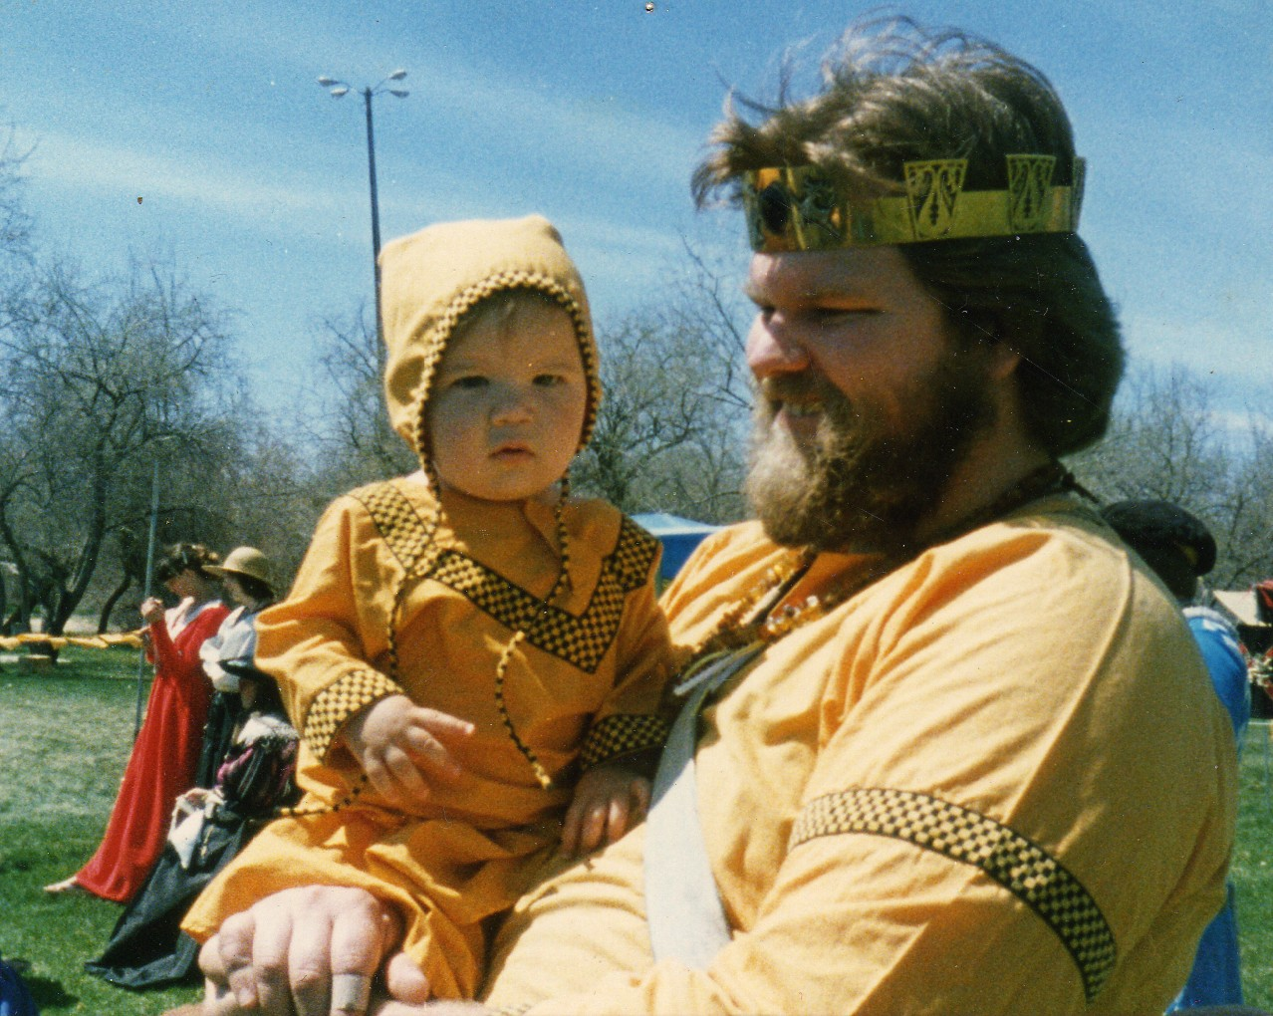
Magnus with Gunwaldt

I've been known to go pretty far to prove a point, and so I had a baby of my own. He's over a year old, and he's always been in costume at events. He has crawled, and he has walked. I made three costumes, received others as gifts or hand-me-downs, and a couple of items were makeshift from mundane parts—in combination with other things, he's worn tights, knitted leggings (heavy tights without feet), a Danish hooded drawstring gown, and a Mexican shirt. I made him breeches with feet and a coif from the pattern of their modern equivalents—bonnet and pajama bottoms (McCall's #9331). Once when he needed to appear in diaper only, I covered up the plastic diaper with a large gauze rectangle, tied in knots at the sides, and it looked just like a cloth diaper, but still had the practical advantages of Ultra Pampers. (I've never been against modern underwear personally, but if you prefer and can create period-to-the-skin costumes, that's great).

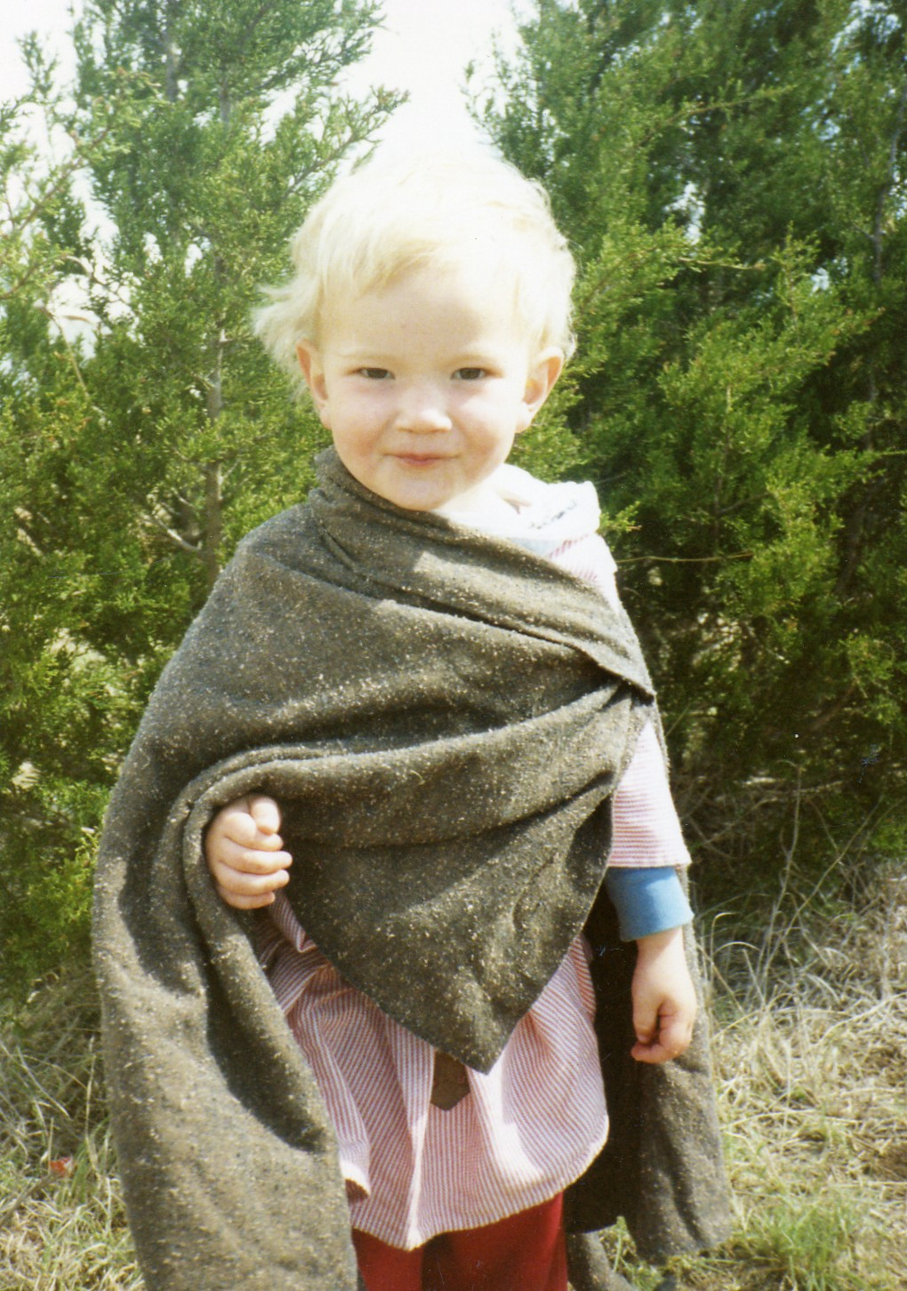
Bardolf at the SCA's Argent Anniversary

Medieval and Renaissance Clothing to Avoid

One very period thing that I recommend against us doing is using swaddling clothes for infants. Even in period there were serious questions about the advisability of the practice and with what's known now about child development and human decency, it's right up there with foot binding and wasp-waist corsets. In O.G. Tomkeieff's Life in Norman England, he suggests that swaddling, "a universal custom," was probably an attempt to prevent rickets. He feels that much of the infant mortality rate can be attributed to babies, once they were unswaddled, crawling "among the unsanitary rushs, with a child's natural instinct to put everything into its mouth." In History of Children's Costume, Elizabeth Ewing wrote of swaddling:

These bands, which varied very little through history, and which turned the child into a tight cocoon, unable to move in any direction, were used with a tenacity that resisted generations of reformers. They had the considerable convenience of allowing the mother or nurse to carry the little parcel around with some degree of safety. . . . There was also a grossly mistaken but probably often honest belief that tight binding would not only protect the child from falls and other accidents but would also encourage the straightness of legs and arms, which were at all times encompassed in the bands. That the child might suffer perilously from lack of freedom and exercise and even die in the convulsions of frustrations, pain or fury seems not to have even been considered.

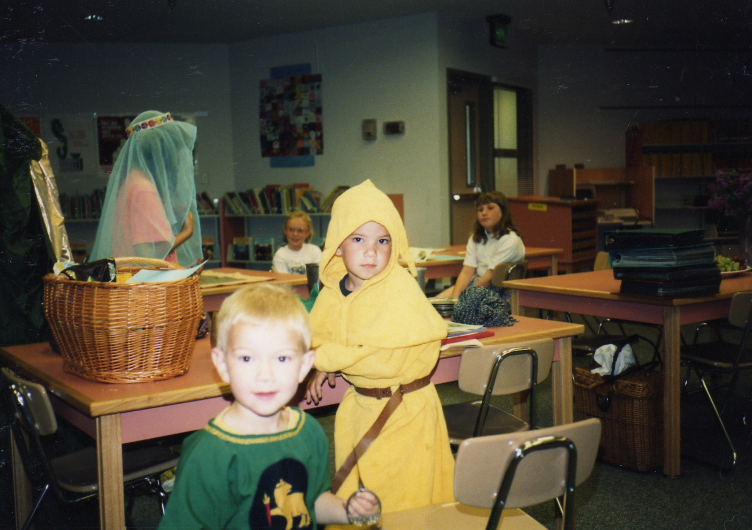
Bardolf and Magnus at a demo in Edgewood

The book goes on about "swatheling" (the period word was spelled with a ð which had a "th" sound) for a couple of pages. It's a 1977 Charles Scribner's publication. I got it at the Albuquerque Public Library.

The Tudor clothing of small boys seems to have been identical to little girls' clothes, at least in formal portraits. "Family portraits galore show such boys in the same full-length bell-shaped skirts as their sisters and mothers," says Ewing, but she says sometimes the bodices weren't identical but had "a hint of manliness in doublet-style designs borrowed from their fathers." Anyway, I don't think it would go over great now to dress any little four-year-old boys like Queen Elizabeth. At the age of six or so, a ceremony was made of dressing the boy in his first breeches, and sending him off to school. If this paragraphs interests you, definitely find History of Children's Costume—it has more.

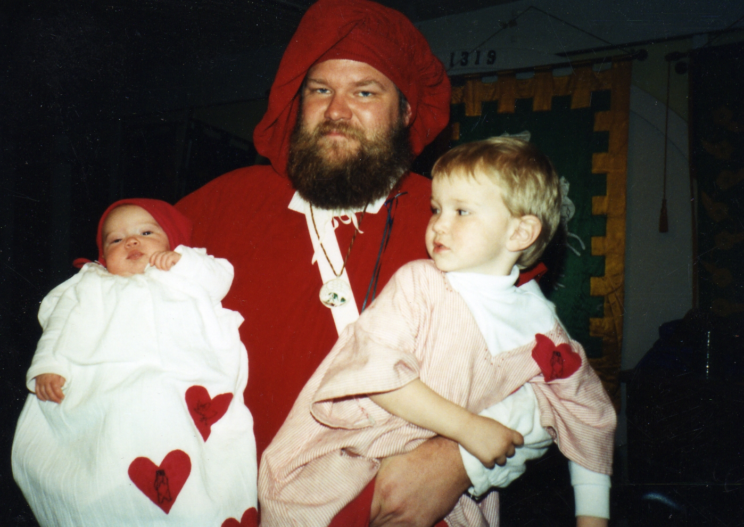
Love Revel in al-Barran; Asta, Gunwaldt, Jeffery Paul (later "Bardolf")

A Few to Try

Reins — When you first saw a kid in a public setting wearing what looked like a Chihuahua harness you probably thought it was some insidious modern invention. Not so! It's an insidious Renaissance invention (or maybe even earlier). A crimson pair of reins made by Mary Queen of Scots for baby James (to be James VI) still survives. Hanging sleeves were used for reins too, so that the whole dress was the harness. An armhole came through the top of the long outer sleeve, and the mom or nurse could hold the sleeves behind. In defense of reins, they're not just for restraint, but can also be used to keep a toddler from falling down if he stumbles. If you're tempted to use a leash on your baby at a big event, make it a period one!

A Pudding — This is a padded roll put around the baby's head as a crash helmet. Falls on stone floors or bumps into iron-clad trunks would go easier! A 1620 (?) Rubens engraving shows a child with a pudding and reins.

Muckinder — "…a large man-sized handkerchief usually attached to the waist of the dress by one corner and hanging down to the floor-length hem," says Ewing. She says it must have had many uses. If you can't think of any, ask a mom. The root word is "muck." Now if you want to hang a drool rag off your kid, you have a great old name to call it. The preferred spelling in the Oxford English Dictionary is "muckender," and their first reference is 1425. Early on the word meant a bib, and later was used more generally as a napkin.

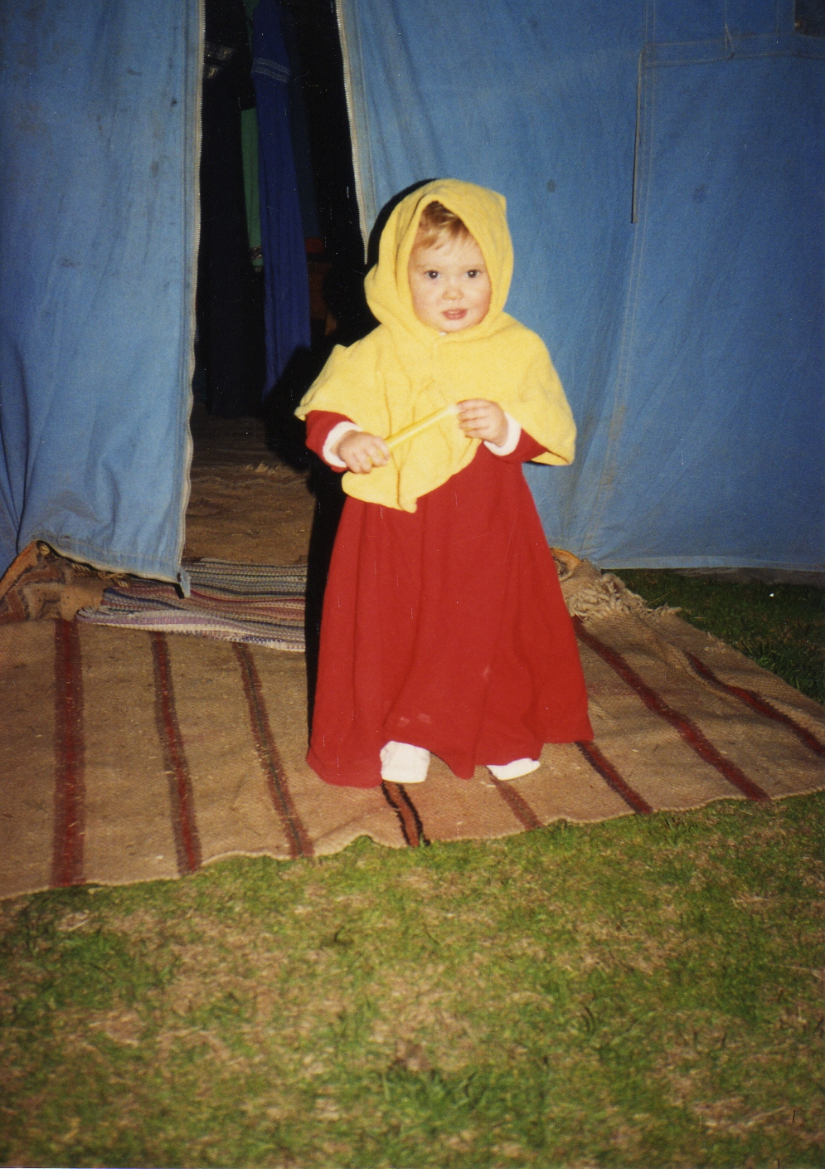
Asta at Estrella, in her brother's yellow hood, her own red dress, white leather baby booties (commercial).

A Compromise

At TYC I saw a good example of adapting modern baby clothes. If you hate to sew or have a baby who never sleeps so you never have a chance to pull out all those scissors and pins (I know the feeling), you might do what this lady had done. Find a solid-color sleeper or gown, and decorate it. There are shirts that fasten between the legs that could be worn over solid-colored pajama bottoms (to cover up the snaps at the waist). You could make a bonnet/hood/coif to match, maybe add trim or embroidery (don't disturb the stretchiness of the material, if any). You might put a household badge on the front of the shirt.

This isn't the best suggestion I've ever made in print, but it beats the heck out of Spiderman or Masters of the Universe pajamas, both of which I have personally seen on human beings (albeit little ones) at events.

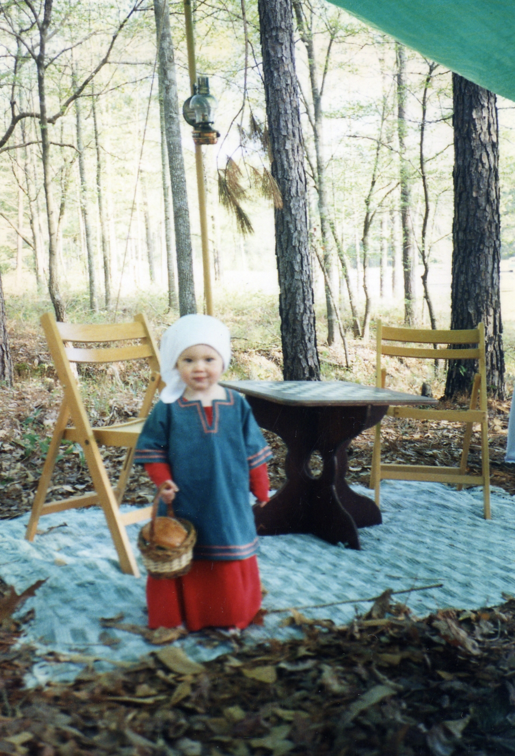
Asta at Fool's War in Meridies, with her lunch in a basket and her paperwork under the lunch

Anatomical Correctness

If you would like to make gifts for other people's babies and you don't have the baby as a model, please consider this: their heads are huge. Their heads are nearly as big as adults' heads. Their bodies aren't. When you hold your hand up in front of your face it goes from your chin to our forehead. A little baby's hand goes chin to nose. Their waists are big, and their bottoms have fat diapers on them. They don't put their clothes on as we do, and so small neck openings make babies scream. I've used snaps covered by trim, and I've used laces and ties. The shoulder and armhole area has to be fairly loose or it will be hard to get the garment on.

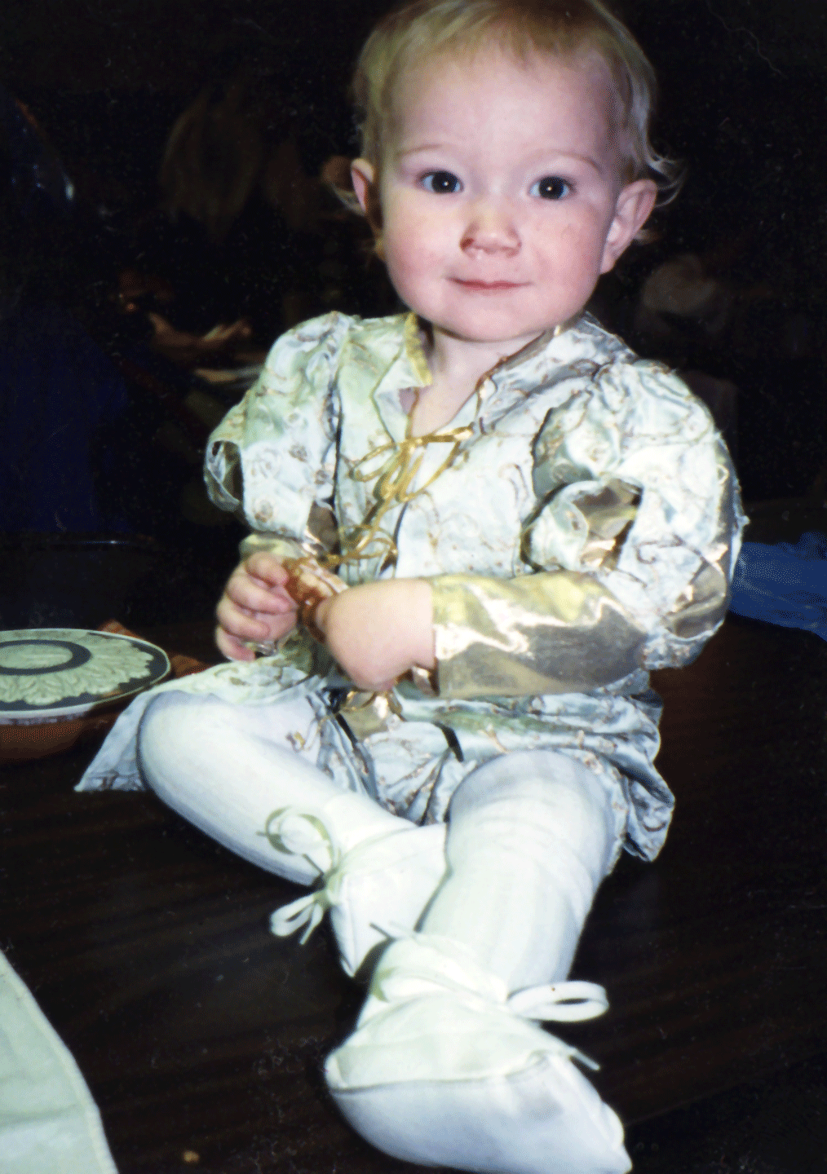

Bardolf (Marty) at a Midwinter feast, in clothing made by Mistress Elenfea of Starwood. The shoes are the same pair his sister Asta's wearing above, with the red dress.

In those days Marty's SCA name was Jeffery Paul, after the mundane names of Artan and Lavan, but when he got older he chose "Bardolf."

Trappings

Please try to avoid aluminum strollers and plastic carriers whenever possible. A willow laundry basket makes a pretty cradle. Beware of split bamboo and other splintery baskets unless you have lots of padding. I've been guilty of a blue plastic mechanical swing, but I tried to keep it covered with cloth or inside a small cloth pavilion. If you use a high chair or hanging seat at a feast, cover it with cloth.

Kids want toys at events. Brass, wooden, and cloth playthings can be found, and if you keep them hidden except for SCA events, the child will be more interested in playing with them. I keep ours in a basket. We have brass bells which can be hung from the handle, a cloth rattling ball Master Greyraven made, a couple of maplewood rattles (being made in New England and currently available), a tiny Mexican box, two wooden Japanese dolls (a gift from Mistress Katherine Holford), Persian brass horses with wheels, and a few other little things. Check garage sales and used baby-things stores. Consider non-toys like napkin rings (for stringing like beads, and a fat cotton cord for that), wooden coasters, small dishes (pewter saucers, wooden relish bowls, metal shot glasses), sturdy model boats for older children. Small animals in brass, wood, or carved stone might be used if they're not too small or too pointy. Check import shops. Use your imagination. Remember safety whenever venturing beyond the toy department with its age recommendations and four-paragraph cautions.
------
Copyright 1987 by Sandra Dodd, 2905 Tahiti Ct. NE, Albuquerque NM 87112. <Sandra at SandraDodd.com>. Permission is granted for republication in SCA-related publications, provided the author is credited. Addresses change, but a reasonable attempt should be made to ensure that the author receives a copy.

If this article is reprinted in a publication, I would appreciate a notice in the publication that you found this article in the Florilegium. I would also appreciate an email to myself, so that I can track which articles are being reprinted. Thanks. -Stefan.

<the end>

