Elzabethn-Gwn-art - 5/21/08

"An Elizabethan Gown of 1575-6" by Mistress Marguerite Dinard, O.L.

NOTE: See also the files: cl-Elzabethan-msg, codpieces-msg, corsets-msg, fashion-msg, hoops-msg, hose-msg, p-shoes-msg, ruffs-msg, Elizabet-Fst-art.

************************************************************************
NOTICE -

This article was submitted to me by the author for inclusion in this set of files, called Stefan's Florilegium.

These files are available on the Internet at: http://www.florilegium.org

Copyright to the contents of this file remains with the author or translator.

While the author will likely give permission for this work to be reprinted in SCA type publications, please check with the author first or check for any permissions granted at the end of this file.

Thank you,
Mark S. Harris...AKA:..Stefan li Rous
stefan at florilegium.org
************************************************************************

An Elizabethan Gown of 1575-6
by Mistress Marguerite Dinard, O.L.

When someone speaks of Elizabethan clothing, they are referring to the time period of Queen Elizabeth I (1533-1603). When we look at the clothing we can see many changes over her life time, but the clothing that stands out the most is during the height of her reign (1570 to her death). We picture big hoops, stiff corsets and ruffs at the neck and wrists. What I hope to do is show a brief overview of the layers of clothing worn by those of the Elizabethan period.

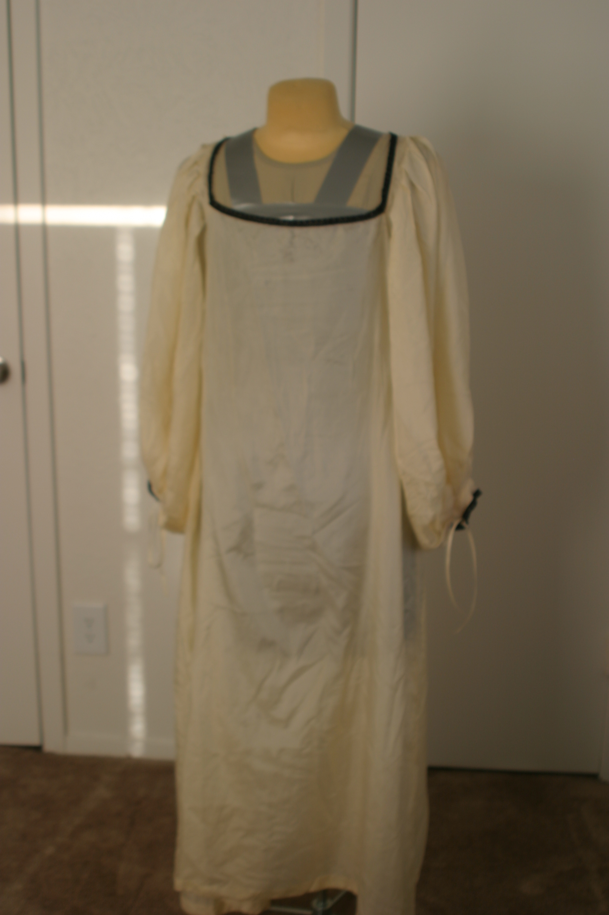

Figure 1 (Chemise)

The first layer is an underdress or chemise (figure 1). This was the layer worn closest to the body. It would have been made linen or silk and could have been plain or decorated with embroidery or trim.

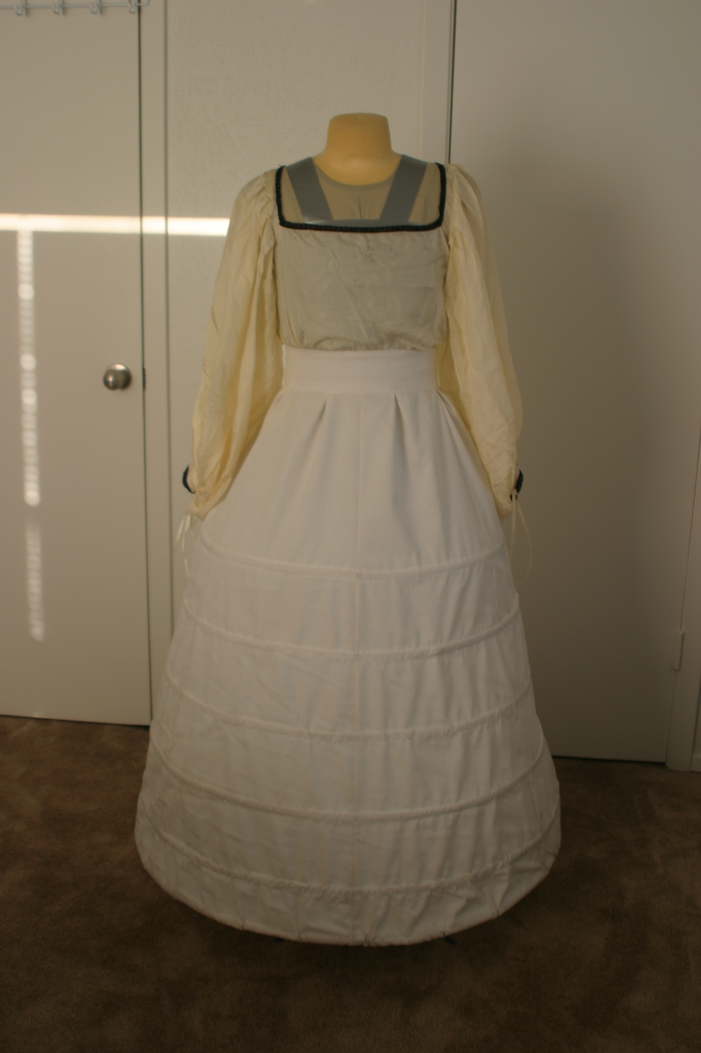

Figure 2 (Hoop skirt)

The next item to be put on is the hoop skirt (figure 2). This is what holds the front panel and overskirt away from the body. The heavier the material of the gown, the more hoops needed.

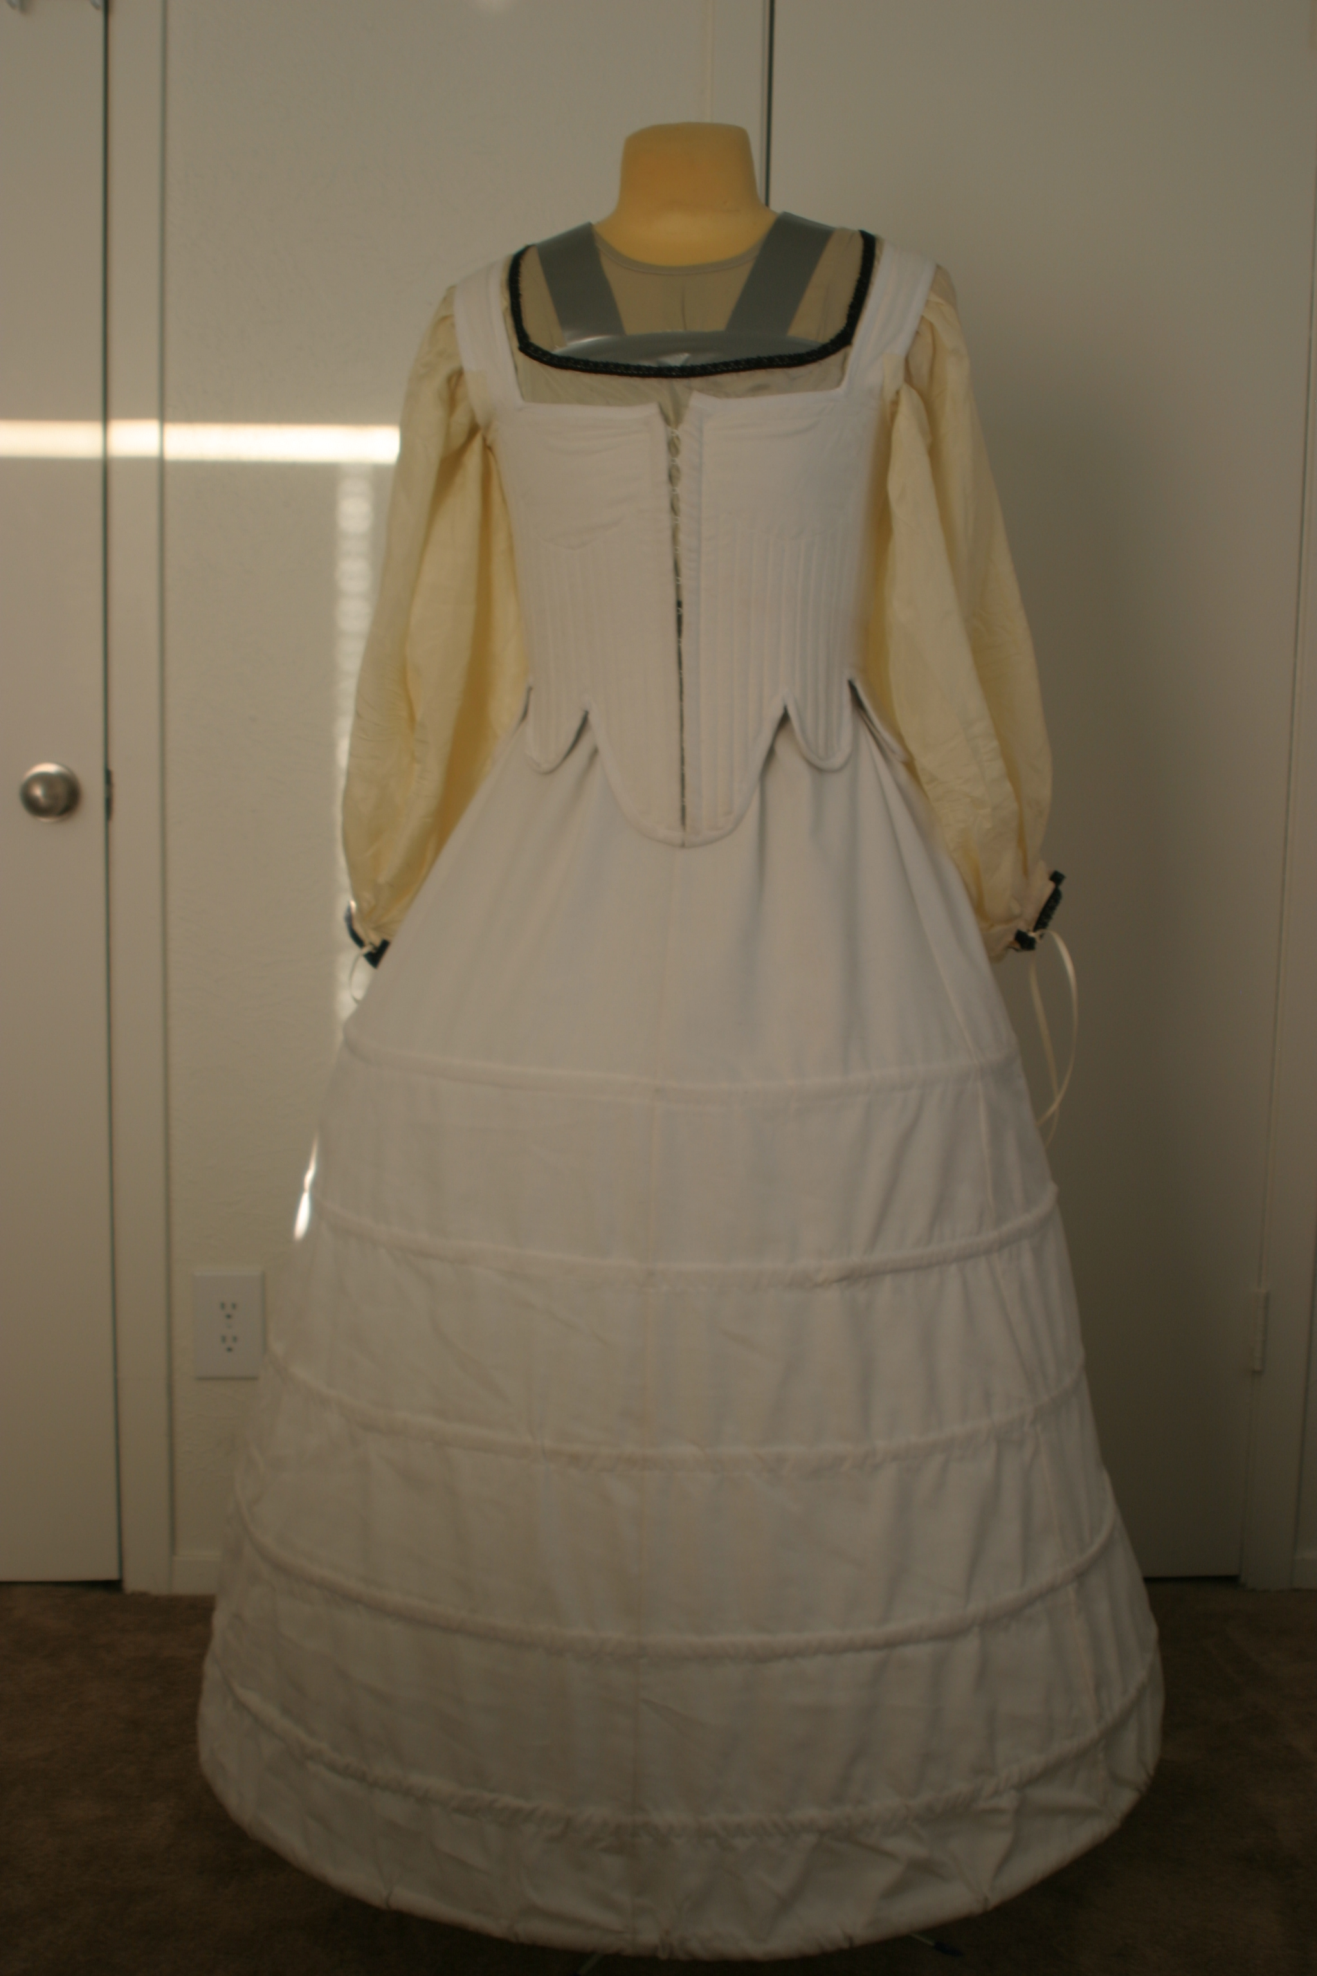

Figure 3 (Corset)

The third item to be put on is the corset (figure 3). This version is a front open, hook and eye tabbed version. The tabs help to displace the weight of the dress from the hips.

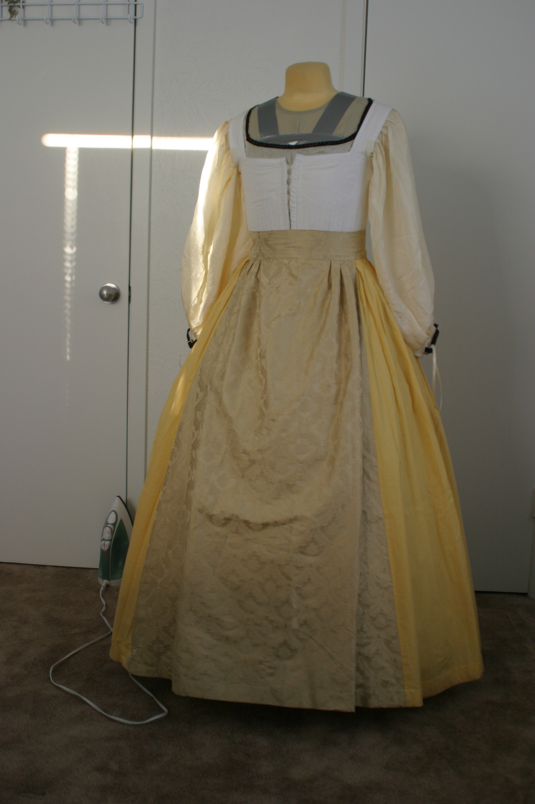

Figure 4 (Forepart)

The following layer is the forepart (figure 4). This is a skirt that is made of a different material or decorative pattern from the over skirt. As seen in the photo, the front of the skirt is made of a higher quality of material than the sides and back. This was done for several reasons. One was to cut down on the cost of the outfit. The second is a more practical reason, it's not seen under the overskirt and therefore not as important.

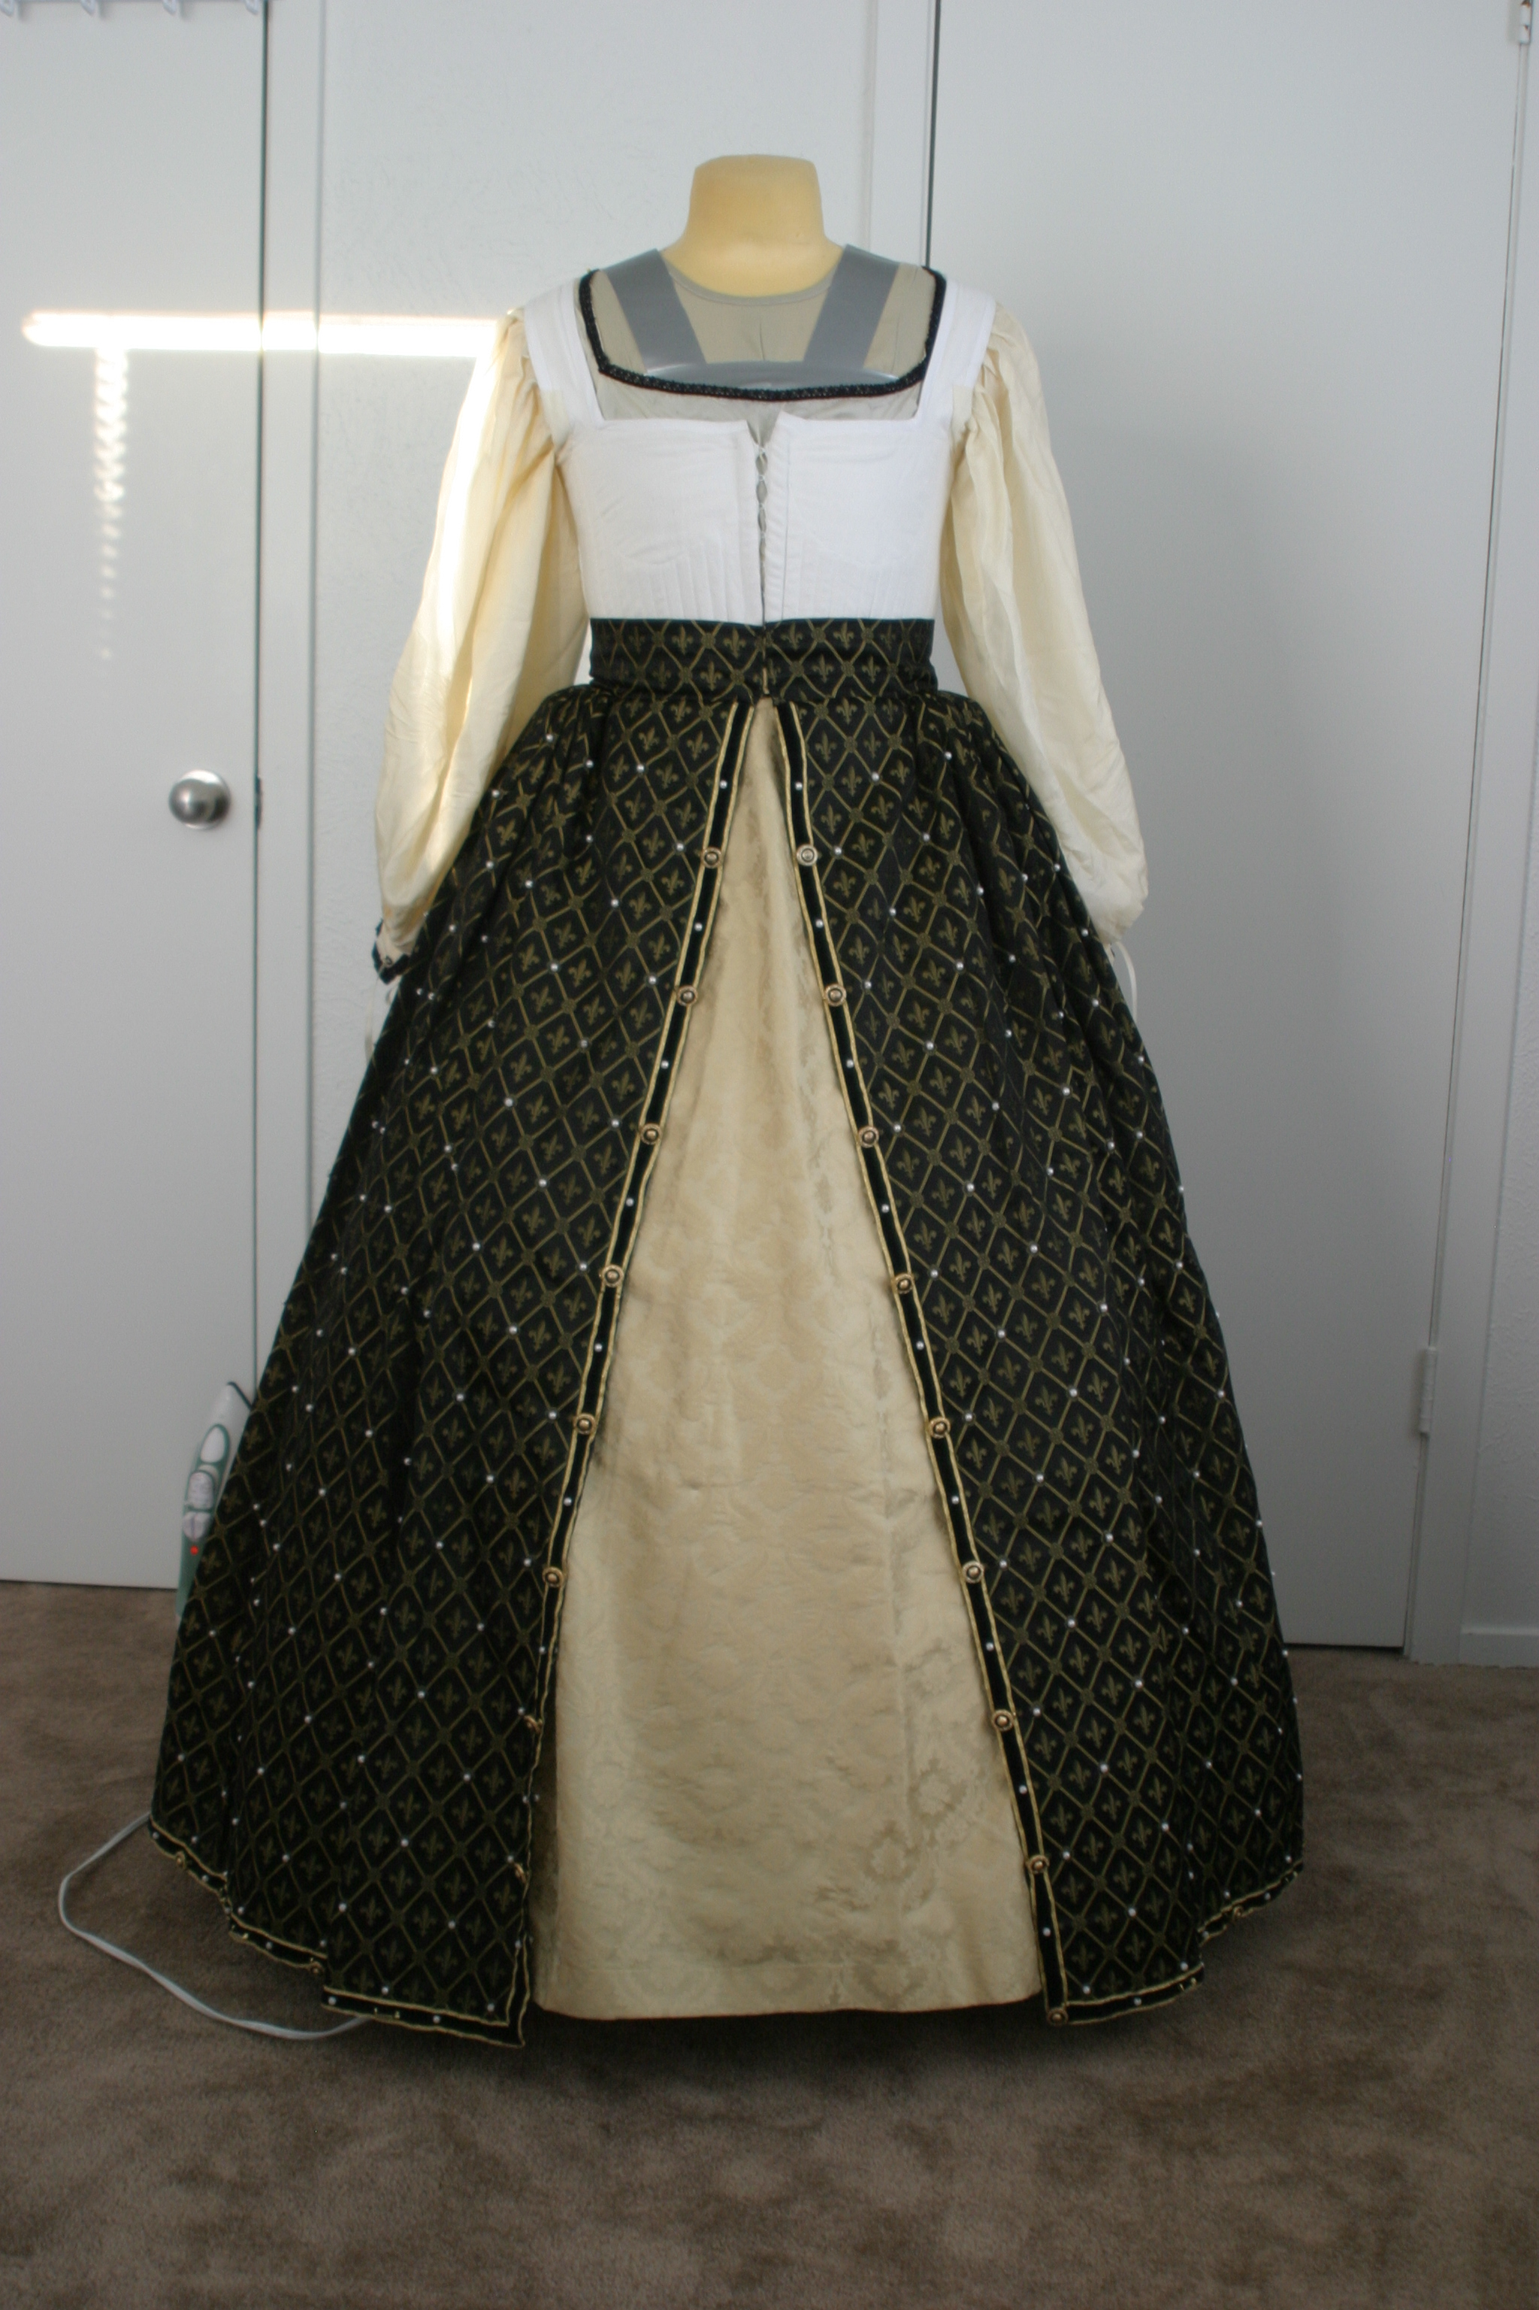

Figure 5 (Overskirt)

The overskirt (figure 5) is worn over the forepart and is the next layer of the ensemble. This usually is a highly decorated or rich material. The skirt is lined in a heaver material (linen and wool were often used) to help the material hang correctly and keep it's shape. The skirt was often cartridge pleated so that the skirt stuck out from the waist. This was to create the illusion of a smaller waistline.

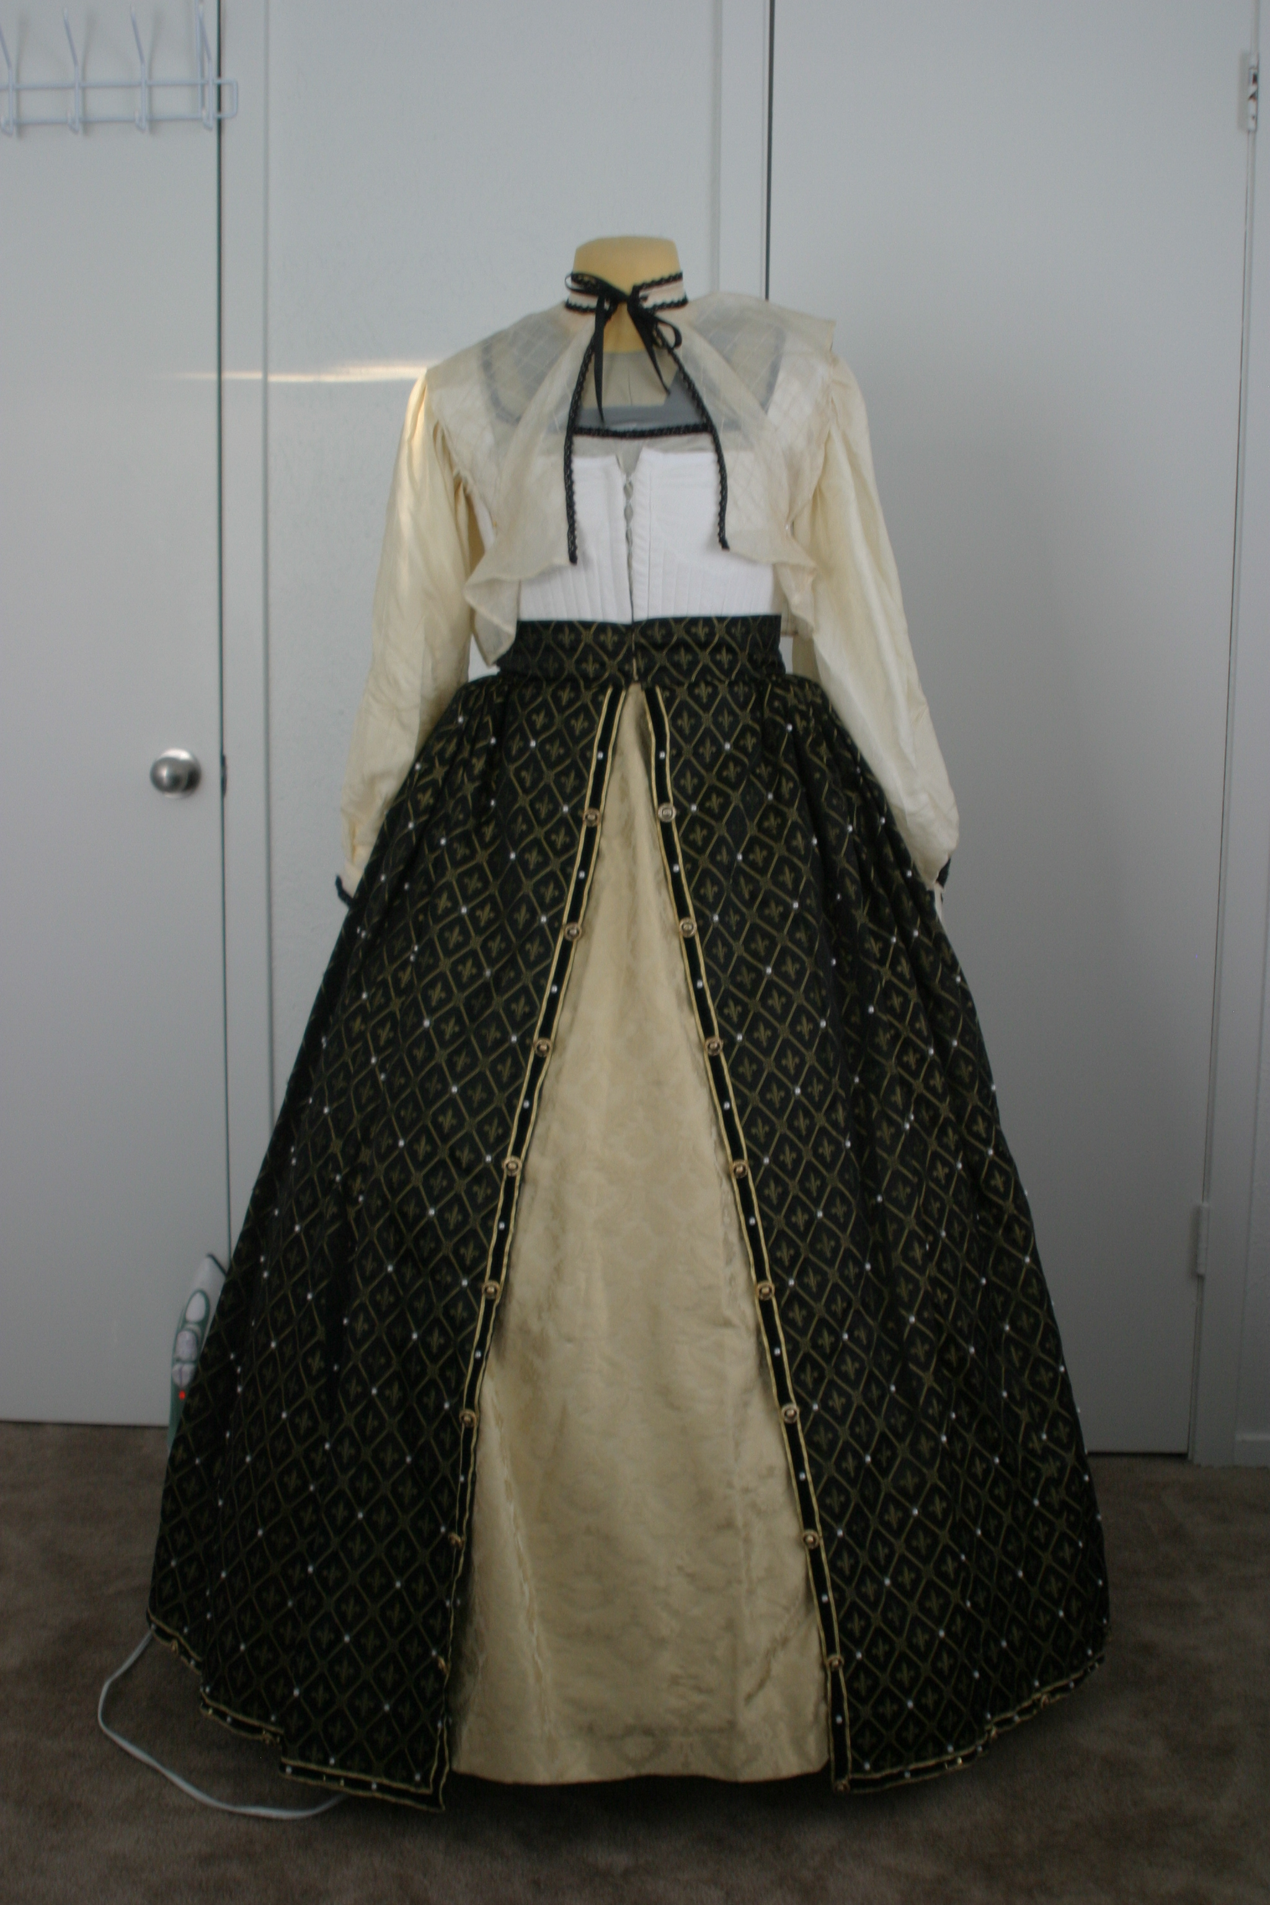

Figure 6 (Partlet)

The partlet (figure 6) is the next item to be put on. Its function is multi-purpose. One is for warmth as it covers the area left open from the dress, the shoulders and chest. Another theory is that is was used as a cover for modesty. Unmarried girls would wear the partlet open and married ladies would keep the partlet edges closed.

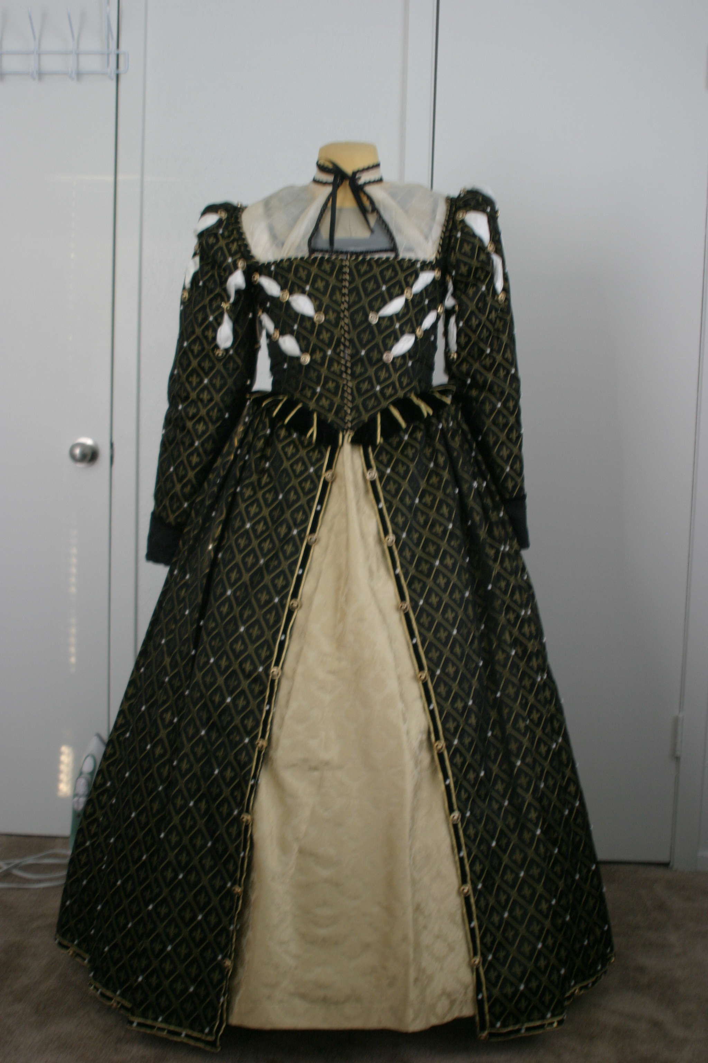

Figure 7 (Bodice)

The last article of clothing to be put on is the bodice (figure 7). This top could be made of the same material as the overskirt or can be made of contrasting material. In this case the sleeves are attached and are also made of the same material as the bodice and overskirt.

To complete the outfit, a hair accessory would have also been worn. A caul would have been worn over the hair and an additional hat may have been worn over the caul.

This is a rather simple overview of an Elizabethan outfit. If you have an interest in learning more about this time period or style of clothing, look to your local Library or the web for a wealth of information. Of special interest is the book "Queen Elizabeth's Wardrobe Unlocked" by Janet Arnold.
------
Copyright 2007 by Tonda Pratt, 4100 Weeks Park Lane, Apt. 245, Wichita Falls, TX 76308. <tlpratt at sw.rr.com>. Permission is granted for republication in SCA-related publications, provided the author is credited. Addresses change, but a reasonable attempt should be made to ensure that the author receives a copy.

If this article is reprinted in a publication, I would appreciate a notice in the publication that you found this article in the Florilegium. I would also appreciate an email to myself, so that I can track which articles are being reprinted. Thanks. -Stefan.

<the end>

