Pleatwrk-Aprn-art - 9/9/17

"The Pleatwork Apron" by Meisterin Felicity Fluβmüllnerin.

NOTE: See also the files: aprons-msg, 14C-Fashion-art, cl-Germany-msg, embroidery-msg, linen-msg, cotton-msg, Landsknechts-msg, Germany-msg.

************************************************************************
NOTICE -

This article was added to this set of files, called Stefan's Florilegium, with the permission of the author.

These files are available on the Internet at: http://www.florilegium.org

Copyright to the contents of this file remains with the author or translator.

While the author will likely give permission for this work to be reprinted in SCA type publications, please check with the author first or check for any permissions granted at the end of this file.

Thank you,
Mark S. Harris...AKA:..Stefan li Rous
stefan at florilegium.org
************************************************************************

You can find more work by this author on the Barony of Deftwood website:
http://delftwood.org/media-library/as-handouts/

The Pleatwork Apron
by Meisterin Felicity Fluβmüllnerin

When?
There is pictorial evidence for pleatwork aprons from the 14th – 16th century.

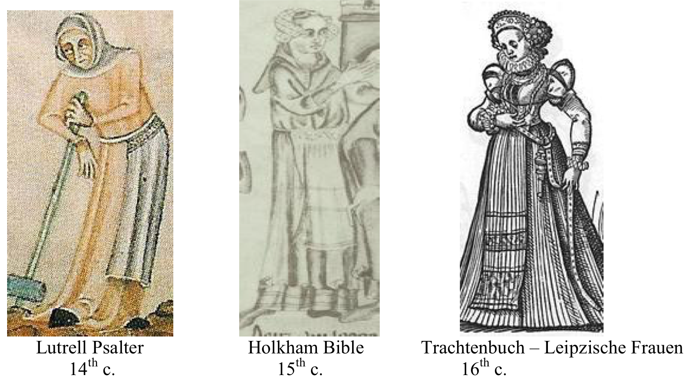

Who?
There are examples of pleatwork aprons being worn by women from all walks of life, from famer's wives and household servants to mayor's wives and royalty. This would be a prized item, often mentioned specially in the lists of a family's belongings.

What?
The pleatwork apron is a style that evolved in order to place a lot of fullness into a small space. Pleatwork can be also be decorated with embroidery to create a truly one-of-a- kind specialty item. The most commonly used fabrics would be linen or linsey-woolsey, although upper class women in the 16th c. could use linen-cotton or cotton. There are examples of many different colors being used for aprons, including white, natural, red, yellow, green, grey, and black.

Oakes and Hill describe the fabrics being used as being made of coarse linen or helpen with "Seckcloth, Dowlas or Lockram," which are all types of fabric used for clothing during the period. They go on to say that the English apron had a uniqueness in style, that it was "honeycombed. that is gathered at the waist and overstitched with the basic stitch of smocking"

Where?
The pleatwork apron was worn throughout Europe. There are plenty of examples in England, Germany, the Lowlands, France, and Italy. There are even a few Spanish examples. As good German ladies, my daughter and I should have this item in our clothing.

How?
1. Prepare your fabric. You will start with a rectangle at the proper finished length. The starting width will be twice that of the finished width. If you need any seams, sew them now. Enclose any raw edges and modern selvages.

2. Put in your running stitch for gathering your fabric. This is done by "going in and out the windows" at regular intervals. I recommend using a contrasting thread so it is easy to see. These threads will be removed in the finished garment. The larger your interval, the deeper the pleats. You can use washable markers to make your dots, if you need a guideline.

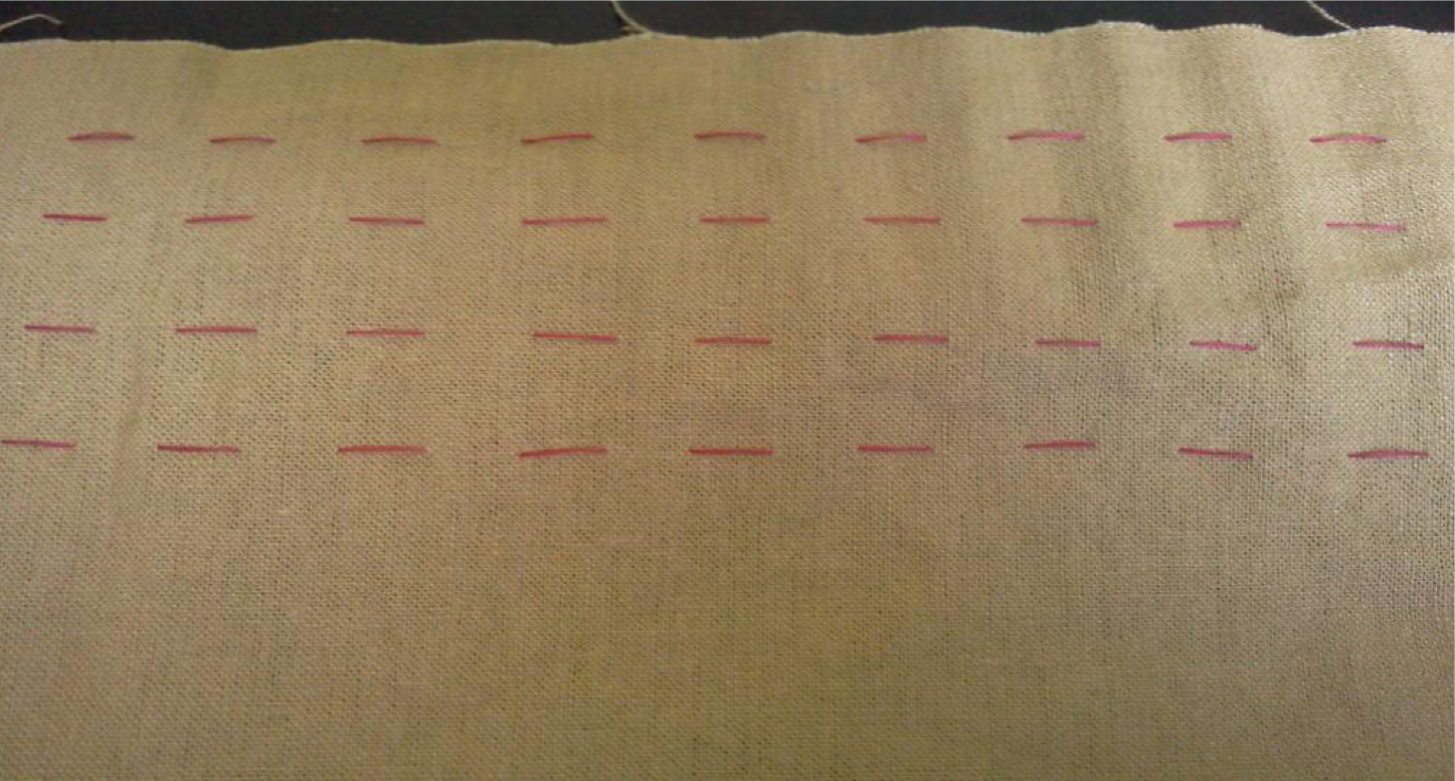

3. Pull the end threads to gather your fabric fairly tightly. Tie off the threads to maintain this level of tension while you work.

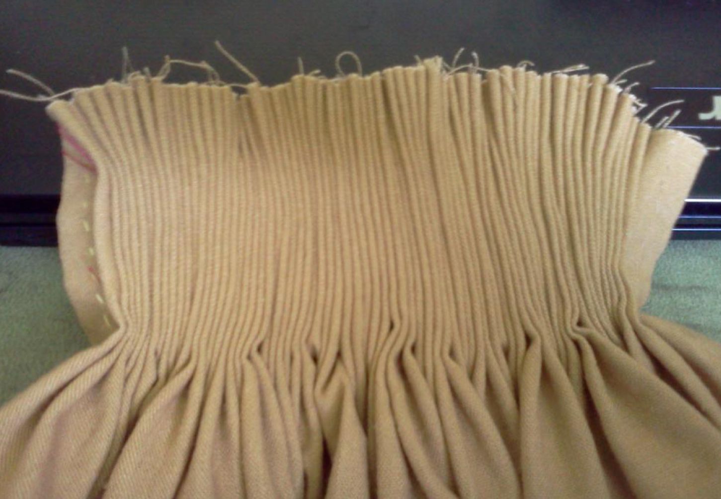

4. Work your honeycomb stitch from left to right, with your needle pointing to the left at all times. You can work this in a contrasting color or matching color thread. You will want to leave at least 5/8" at the top to attach the waistband.

The Honeycomb Stitch
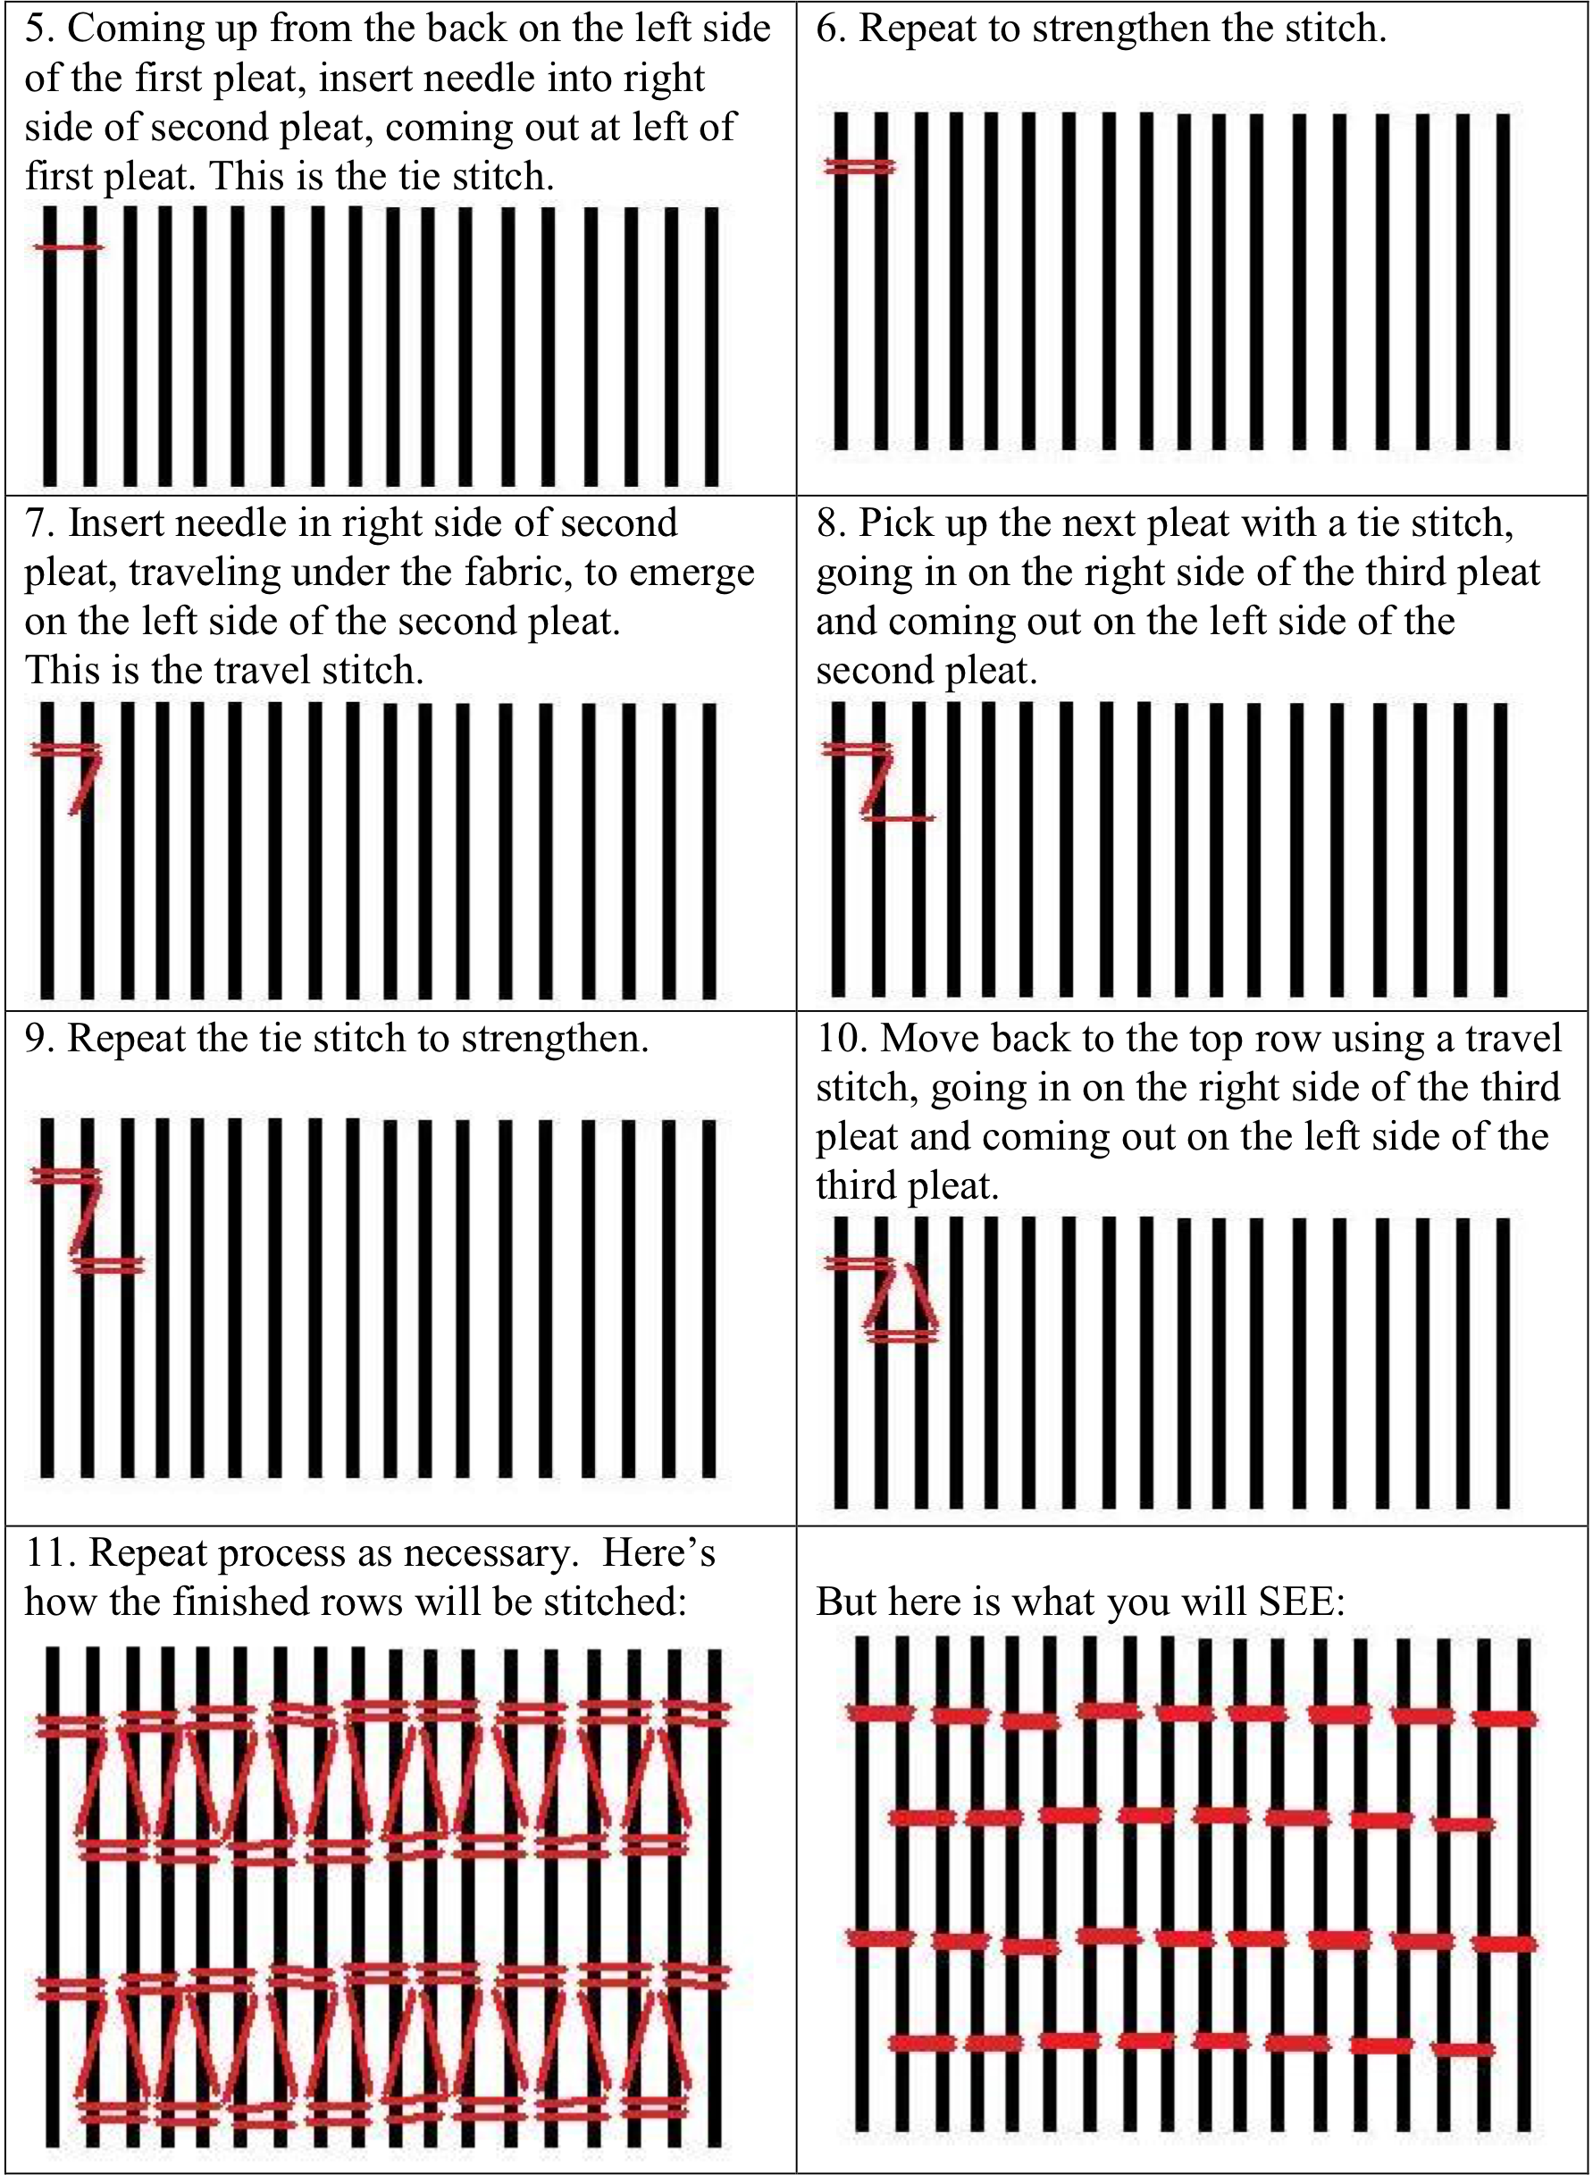

12. Remove the gathering threads, allowing the fabric to relax to a more open pattern. You should see the honeycomb pattern clearly at this point.

13. Attach the waistband by pushing the top of each pleat to the side. If you push them all the same way, you will have knife pleats. If you alternate first one way then the other, you will have box pleats. Either choice is correct.

Our Aprons:
I made these two matching aprons for my daughter and I this summer. There are several examples of children dressing to match their parents, especially within the Landsknecht culture, in both style and status, so we try to do this as often as possible. Both aprons are made out of mustard linen with red wool thread for the embroidery. They are completely hand sewn. I choose the mustard color, since it was a common color in the rolls of aprons found in the chests of 15th and 16th century women and I did not want to have another white apron, as I already have several. The embroidery on the pleatwork was done in red, since it is heraldically correct for us and makes the apron a little dressier. I wanted the aprons to be on the same level as our clothing, which is an officer's wife and daughter rather than a soldier's family. We would have better items for receiving guests and attending church. I sewed the aprons by hand with wool thread so that they would lie correctly on the skirts when finished, as seen in the woodcuts and portrait of the time.

Resources:
Arnold, Janet, Patterns of Fashion 4, Costume and Fashion Pr., 2008

Zander-Siedel, Jutta, Textiler Hausrat, Deutscher Kunstverlag, 1990

Schoen, Edward, Tailor as Lansquenet and Seamstress, German woodcut, 1535

Oakes, Alma and Hill, Margot Hamilton, Rural Costume: Its Origins and Development in Western Europe and the British Isles.Van Nostrand Reihnhold Company, 1970

http://pleatworkembroidery.com/

http://m-silkwork.blogspot.com/search/label/apron http://larsdatter.com/aprons.htm

------
Copyright 2016 by Ciarrai Eaton. <ciarrai.eaton at gmail.com>. Permission is granted for republication in SCA-related publications, provided the author is credited. Addresses change, but a reasonable attempt should be made to ensure that the author is notified of the publication and if possible receives a copy.

If this article is reprinted in a publication, please place a notice in the publication that you found this article in the Florilegium. I would also appreciate an email to myself, so that I can track which articles are being reprinted. Thanks. -Stefan.

<the end>

