Vik-Lea-Shoe-art - 10/29/15

"Making a Viking Leather Slipper" by Mistress Gwendolen Wold.

NOTE: See also the files: shoemaking-msg, shoes-msg, boots-msg, 2Shod-a-Shire-art, Caligae-Boots-art, felting-msg, leather-msg, leather-dyeing-msg.

************************************************************************
NOTICE -

This article was added to this set of files, called Stefan's Florilegium, with the permission of the author.

These files are available on the Internet at: http://www.florilegium.org

Copyright to the contents of this file remains with the author or translator.

While the author will likely give permission for this work to be reprinted in SCA type publications, please check with the author first or check for any permissions granted at the end of this file.

Thank you,
Mark S. Harris...AKA:..Stefan li Rous
stefan at florilegium.org
************************************************************************

You can find more work by this author on her website at:
http://tangibledaydreams.blogspot.com

Making a Viking Leather Slipper
by Mistress Gwendolen Wold

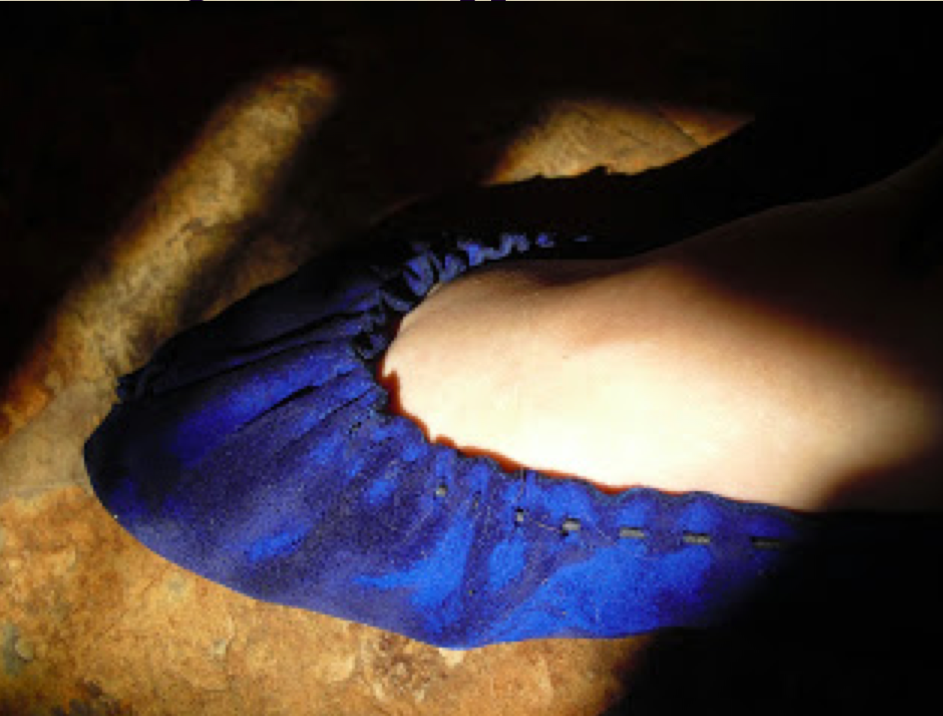

I think being in between major projects is dangerous for me. Because there I am at about 1 AM, wandering through the internet, and I run across a site like this one: http://housebarra.com/EP/ep02/11shoe02.html . It has a pattern for a Viking era pair of shoes, made from a single piece of leather. The original that it is based off of is evidently in the Museum Of Cultural History at Novgorod. And I think, "Hey! Cool!! Period shoes. I bet I could do that. I think I even have the materials pretty much on hand..." And next thing you know, I'm cutting away, making myself a pair of leather slippers for the first time.

Here's what I was up to...

I printed out the pattern from the web site, and blew it up on the copy machine until it looked pretty close to my foot size.

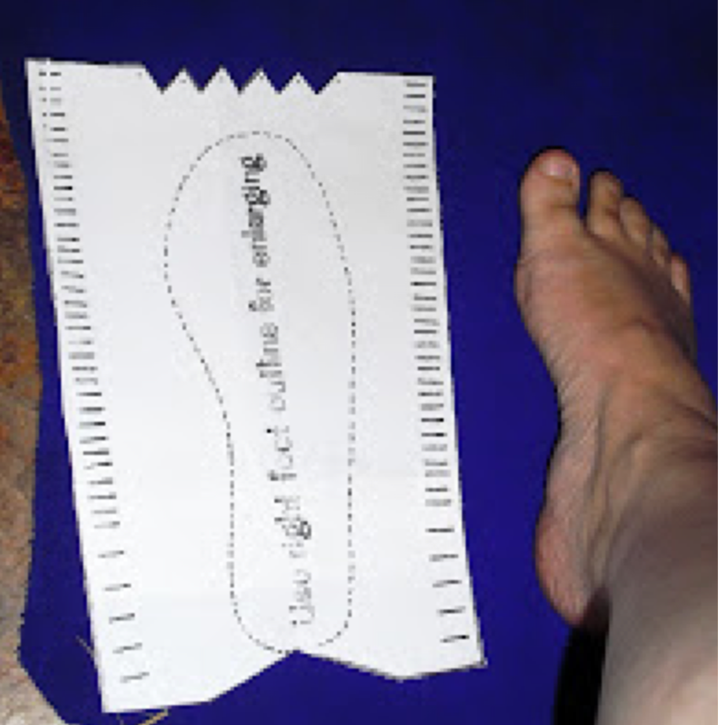

Then I used a scrap of soap to trace the pattern onto my leather. What kind of leather? Um...thick enough to wear well, but still thin enough to be flexible. It just happened to be in my stash, so I really have no clue.

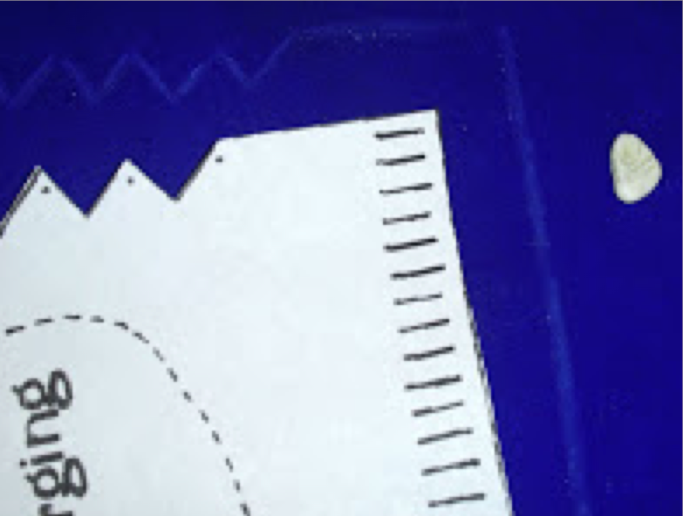

I cut out two pieces of leather.

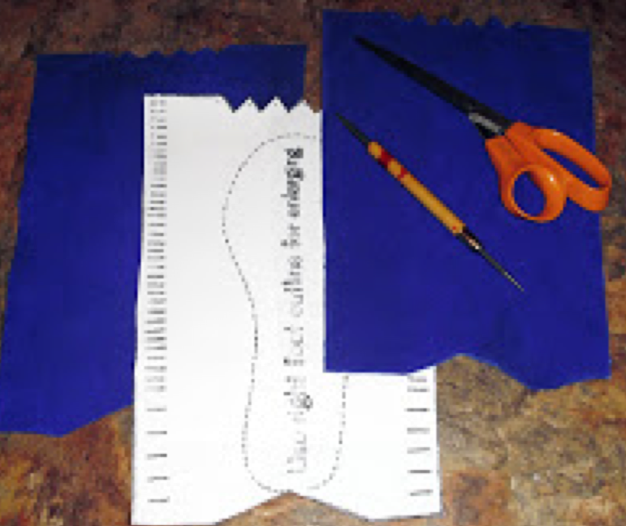

I used an awl to poke needle holes in the zig-zag part that will be the front of the shoe, according to the pattern. I used spare pizza box (I've got teenagers) under the leather so I didn't poke holes in my desk, too. And then I went to bed because, well, 3 AM already.

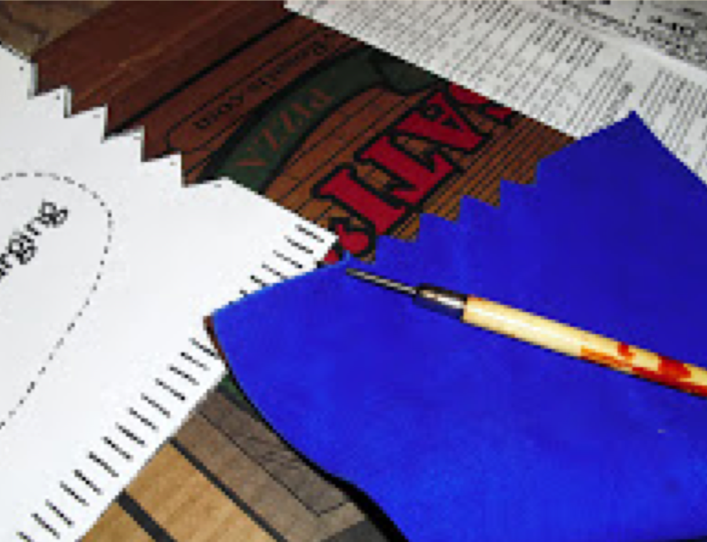

Fast forward to this afternoon. I used that scrap of soap (I really do like it better than tailor's chalk) to mark the location of the lacing slits.

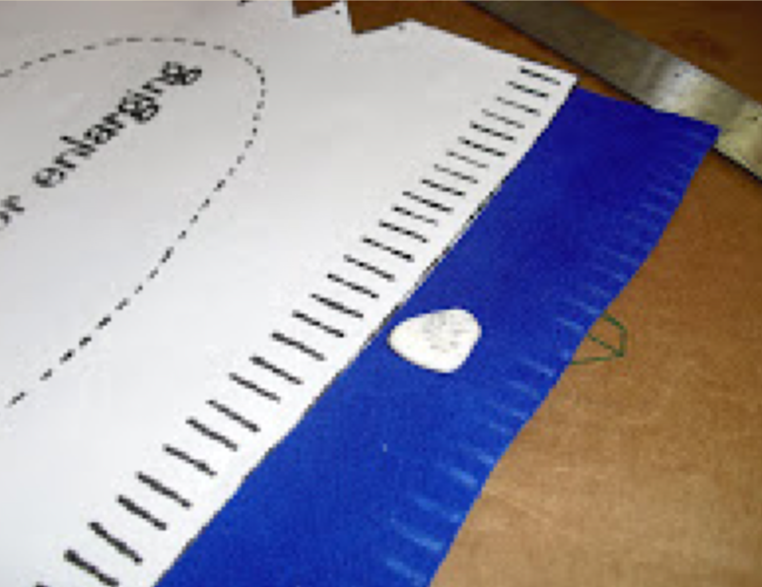

I used the awl poke starter holes, about 3/16 (I eyeballed it) away from the edge of the leather.

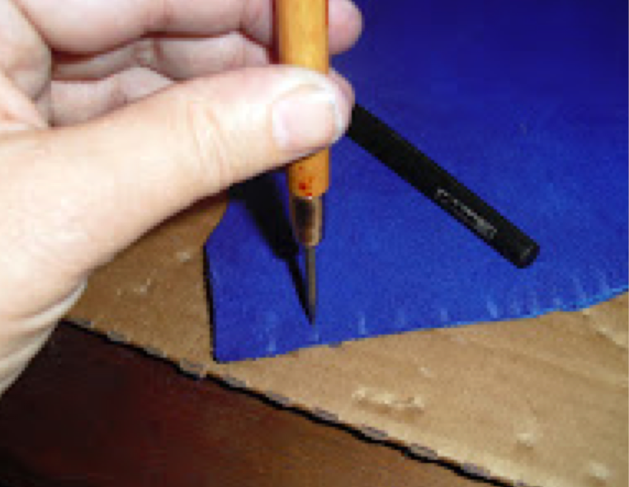

And then I used an exacto knife to cut the slits, large enough for my lacing to poke through.

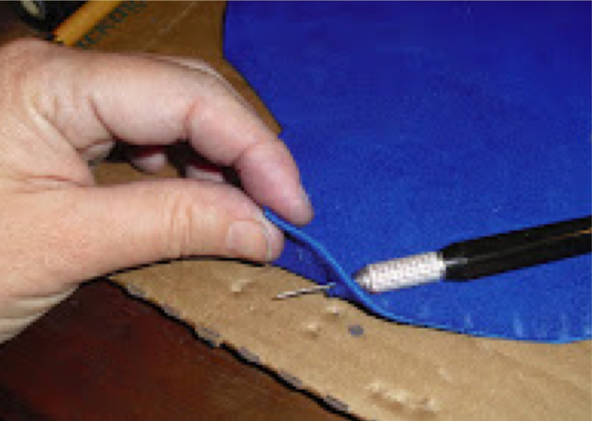

Ok, back to the toe. I used waxed linen, and laced through the holes in the zig-zag...

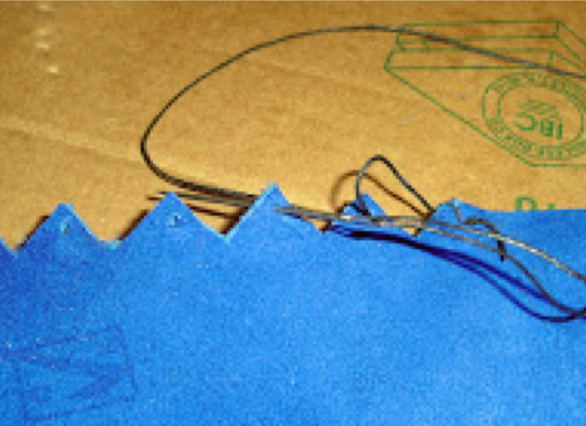

..and then cinched that up to form the front of the shoe.

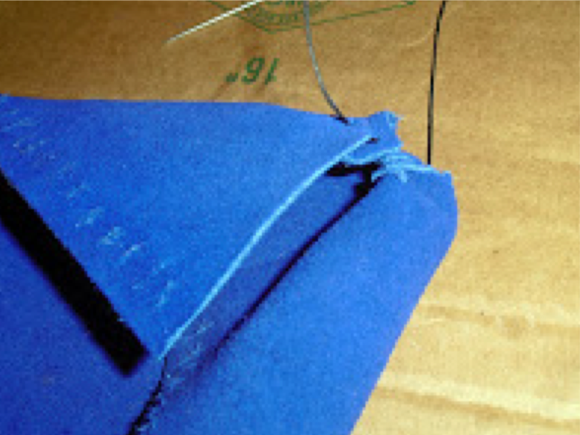

Then I sewed the seam from the toe down the top of the foot.

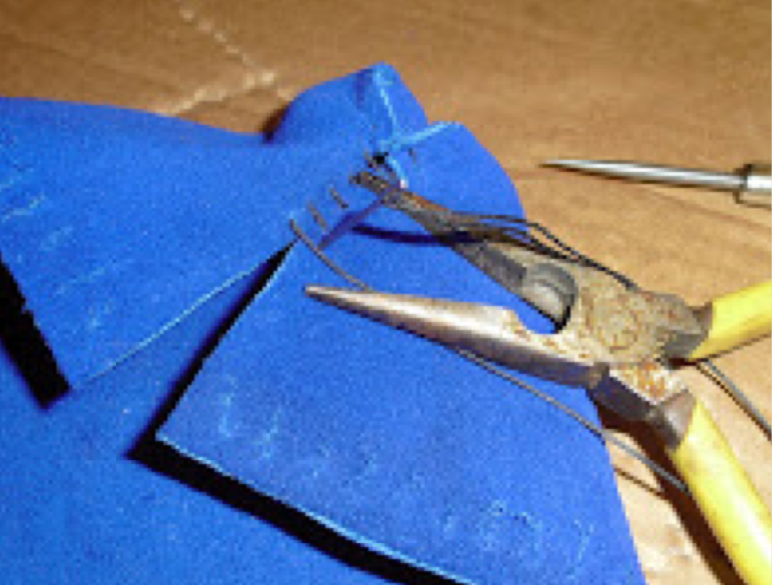

The toe looked like this when I was done.

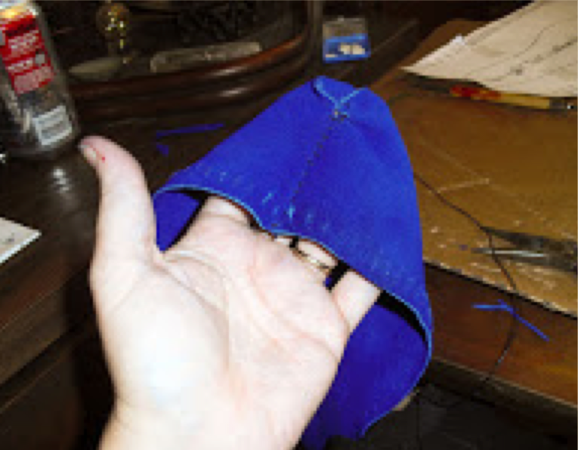

Then I worked on the heel. I folded the shoe in half, and sewed up the heel...

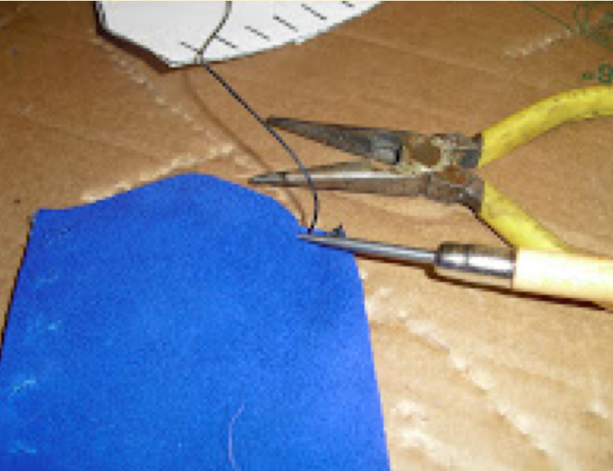

...stopping about an inch from the top.

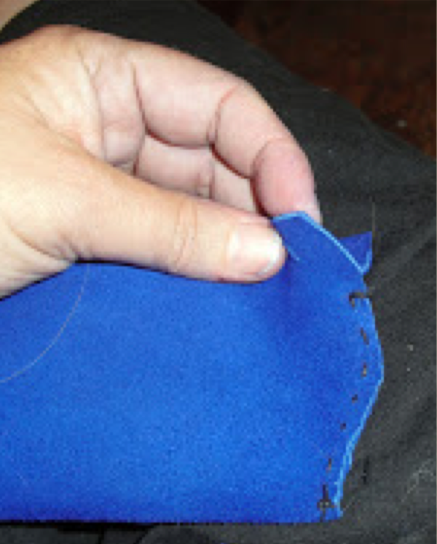

Now, I cut about 6' of leather lacing, and put the mid point of it back up at the toe seam.

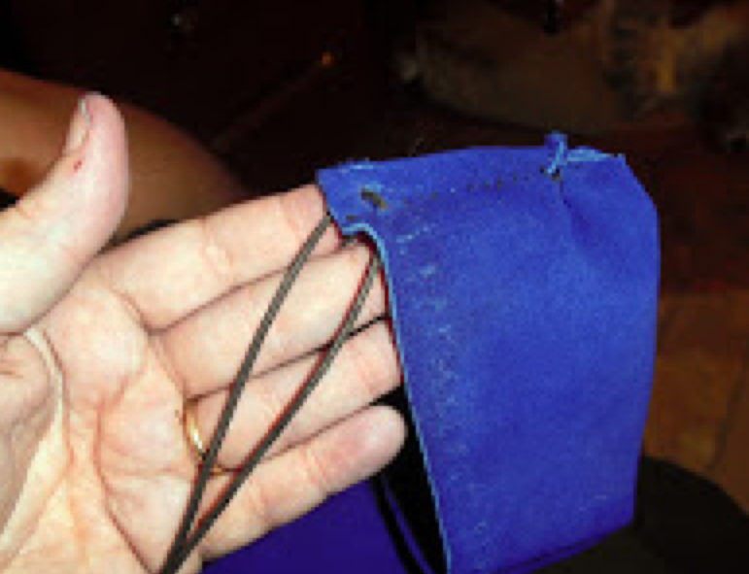

Each tail was woven in and out down the sides to the heel.

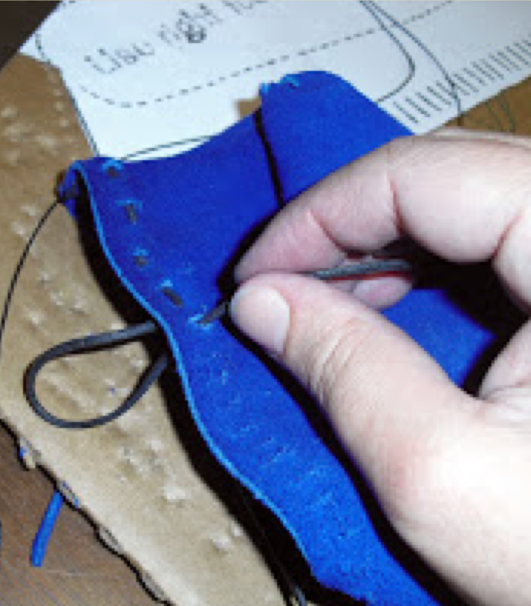

I found it easier to use a very thin pair of needle nose pliers to poke the lace through the slits.

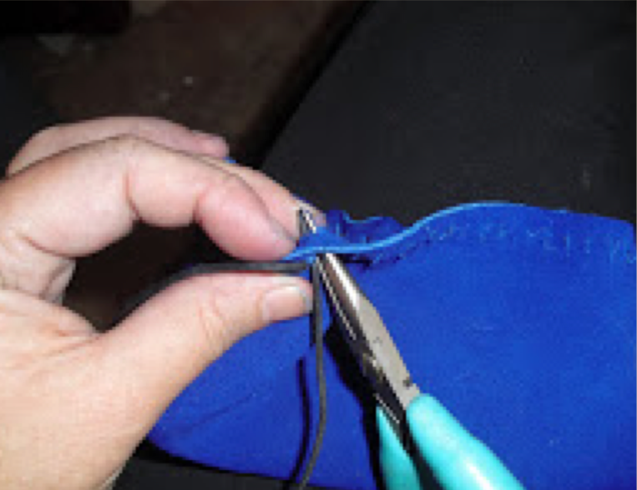

Once I got the lacing all in place, I put it on and pulled on the lacings. It cinched up like a draw-string bag around my foot.

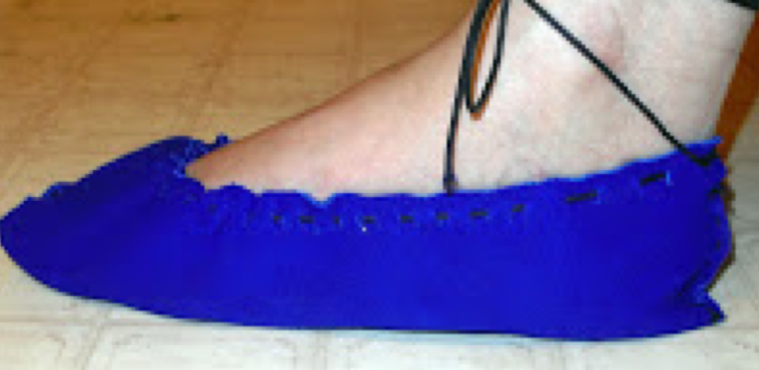

I decided that I wanted an insole, to add a little more protection from the ground. Luckily, I happened to have a scrap or two of my handspun/handwoven wool fabric left from the tunic project.

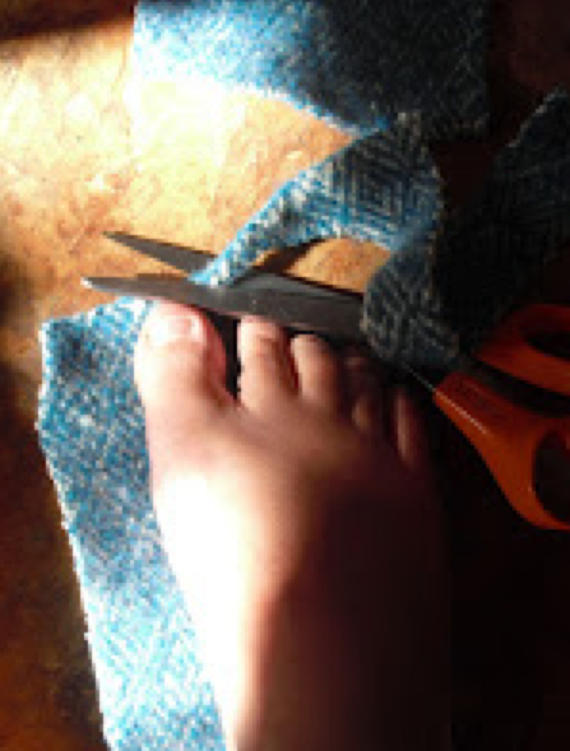

I washed the fabric on hot to felt it up as much as possible, and then stepped on it and cut around my foot.

There. Two insoles. I zig-zagged around the edges with my sewing machine, just to make sure they wouldn't unravel.

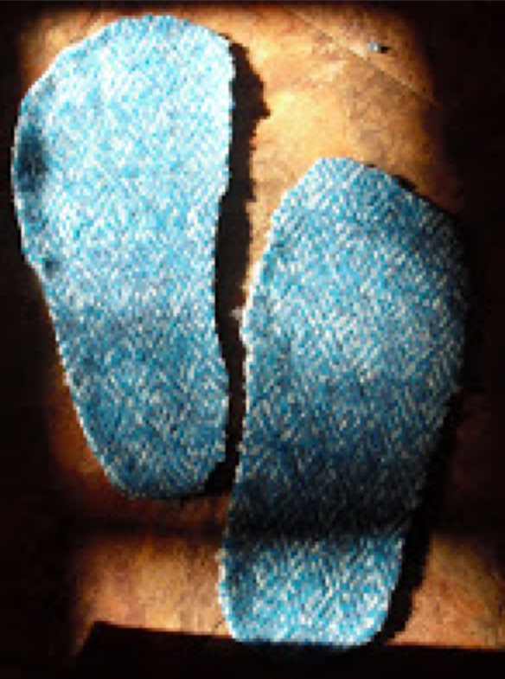

Then I inserted the insole into the slipper.

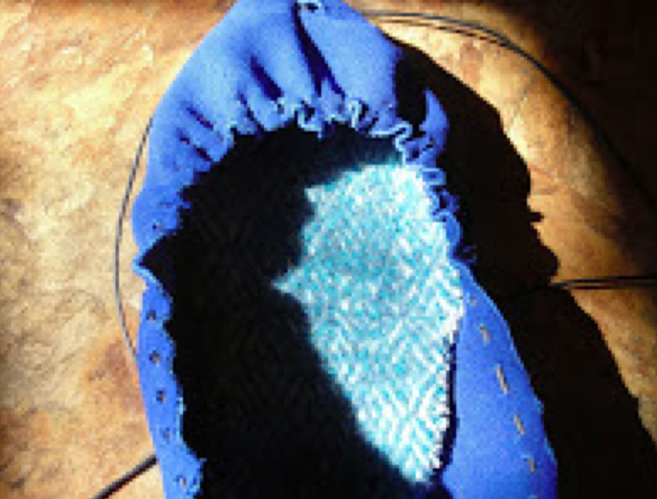

It still felt a little bit like a bag wrapped around my foot, so I put it on, laced it up, and dunked my whole foot into the sink. I'm currently letting the slipper dry on my foot, so it will mold itself better to my body.

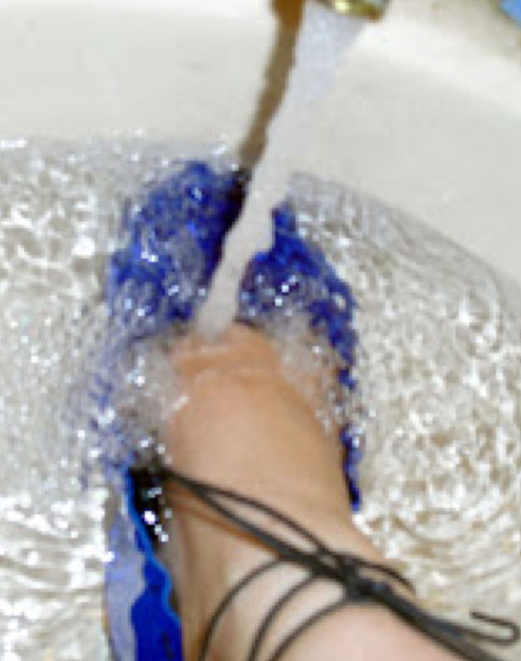

But, not bad! (Do you have any idea how hard it is to get a good picture of your own foot, though??)

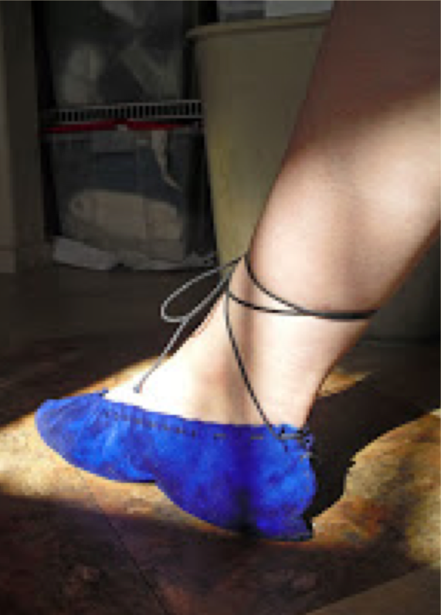

So far, I'm pleased with the results. I'll need to actually wear it around and see how comfortable it is, but it looks like it should be a nice lightweight indoor shoe.

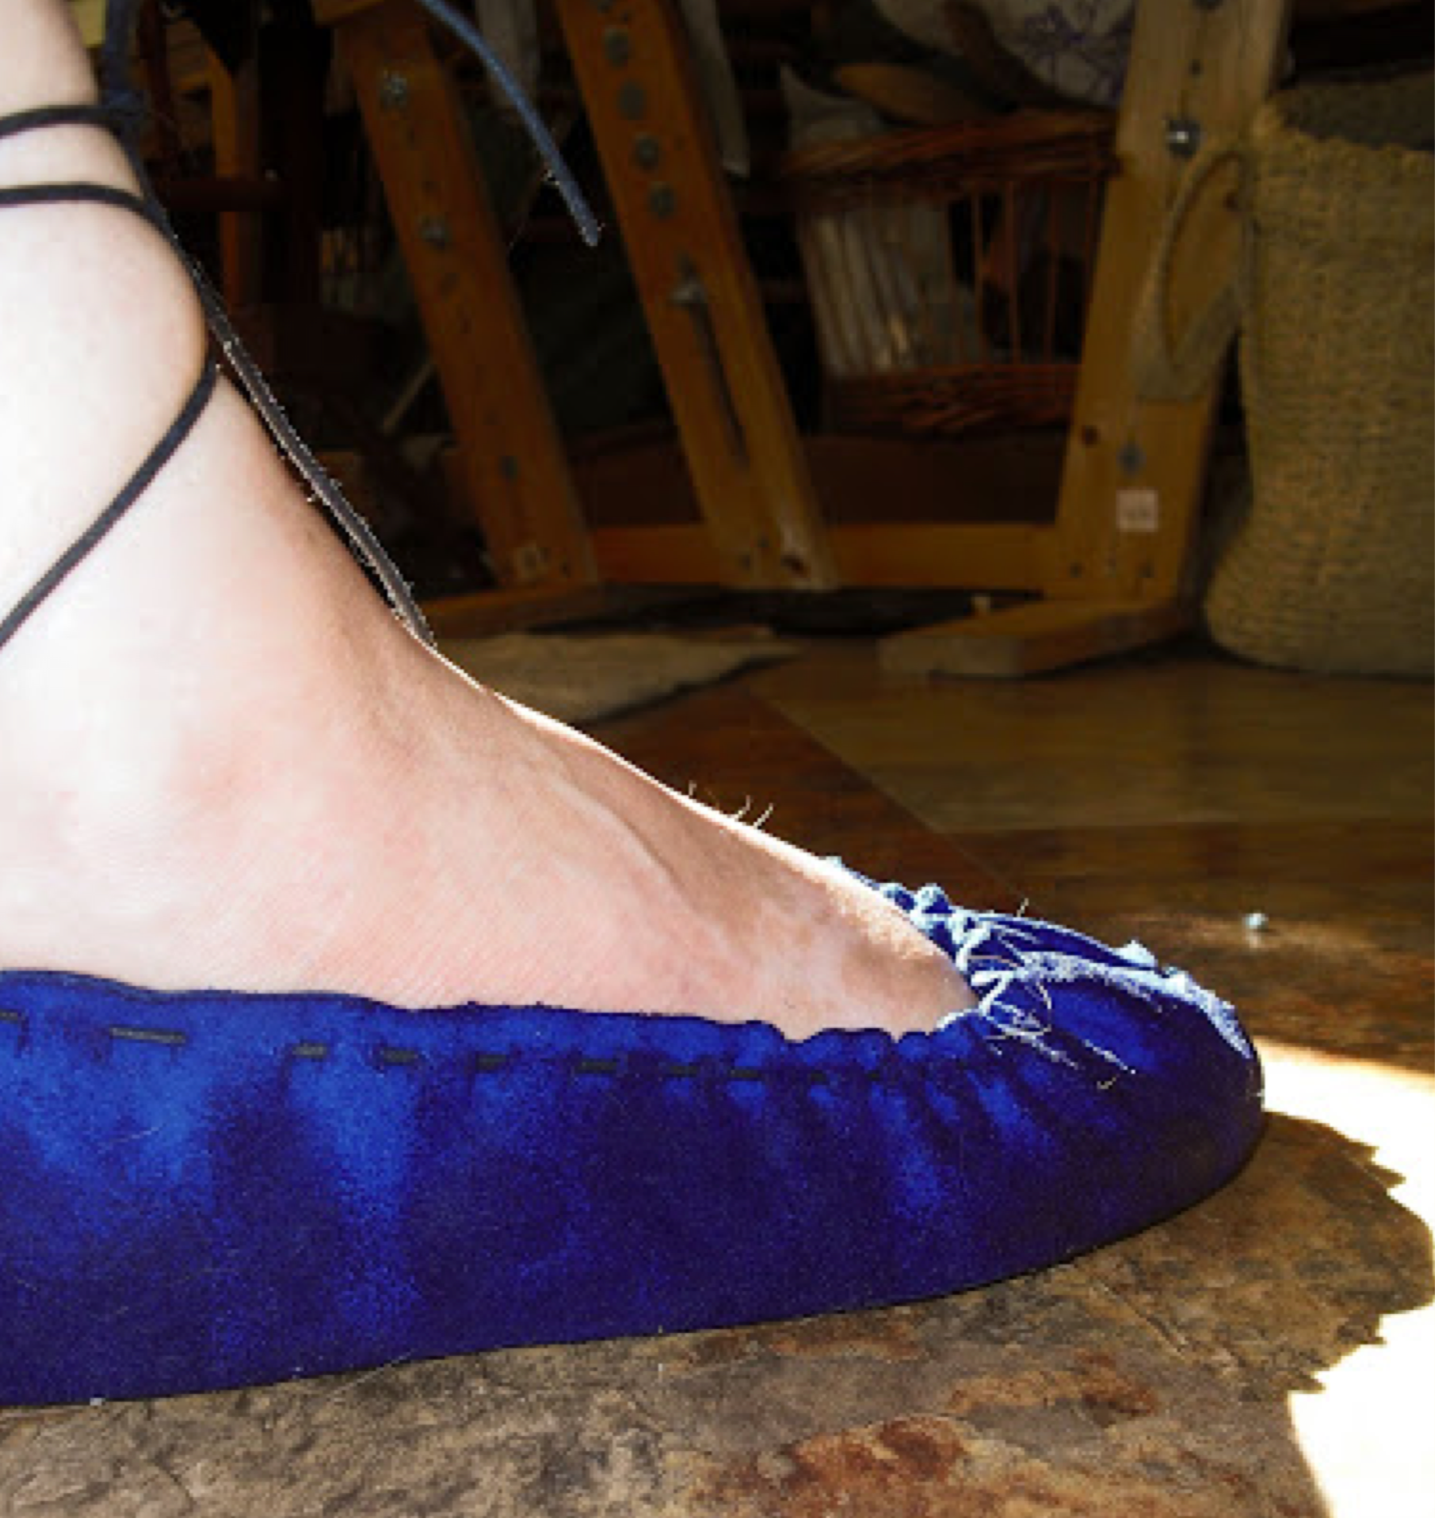

Um...I guess I had better make the second shoe now. Back to work!
------
Copyright 2011 by Melissa McCollum. <lissagwen at cox.net>. Permission is granted for republication in SCA-related publications, provided the author is credited. Addresses change, but a reasonable attempt should be made to ensure that the author is notified of the publication and if possible receives a copy.

If this article is reprinted in a publication, please place a notice in the publication that you found this article in the Florilegium. I would also appreciate an email to myself, so that I can track which articles are being reprinted. Thanks. -Stefan.

<the end>

