Bas-Conditng-art - 8/27/17

"Basic Conditioning for Heavy List Combat" by Baron Matthew Moraveous Avdenmork.

NOTE: See also the files: Wel-Rnded-Ftr-art, Chalngs-Boasts-art, Killing-Blow-art, LH-fighting-msg, On-Warfightng-art, W-T-Shields-art, Shield-Balanc-art.

************************************************************************
NOTICE -

This article was added to this set of files, called Stefan's Florilegium, with the permission of the author.

These files are available on the Internet at: http://www.florilegium.org

Copyright to the contents of this file remains with the author or translator.

While the author will likely give permission for this work to be reprinted in SCA type publications, please check with the author first or check for any permissions granted at the end of this file.

Thank you,
Mark S. Harris...AKA:..Stefan li Rous
stefan at florilegium.org
************************************************************************

This article was first published in the Myrtholt Leadlette, April 2017.

Basic Conditioning for Heavy List Combat
by Baron Matthew Moraveous Avdenmork

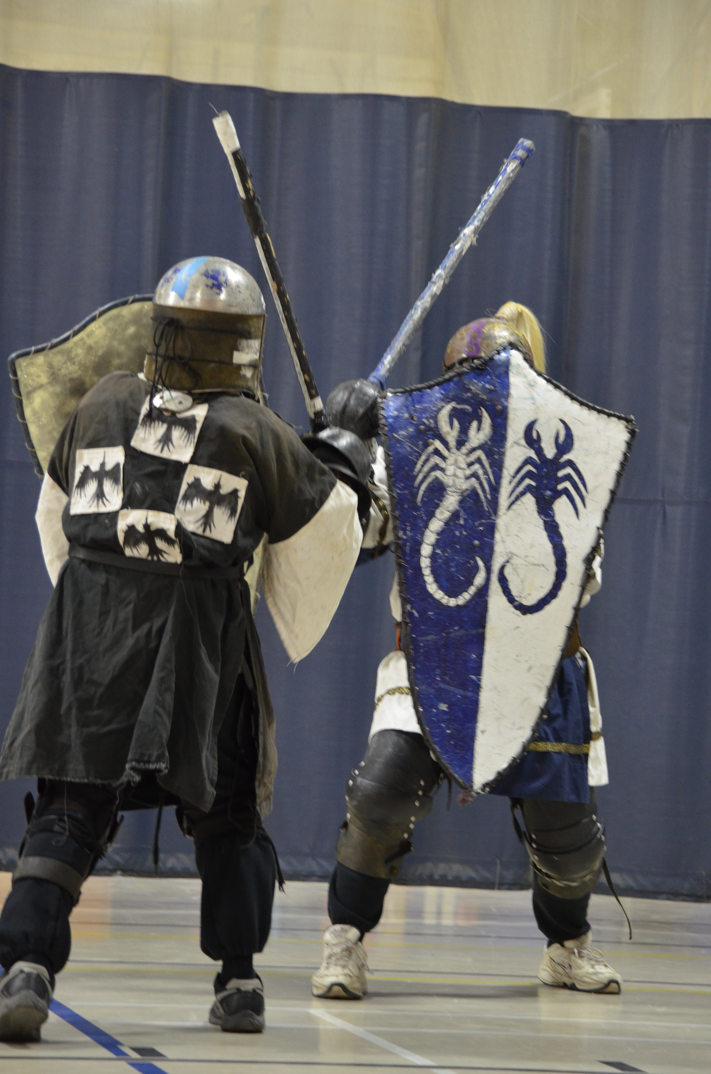

Sword fighting captures a childlike imagination. Most little children have picked up sticks, wiffle ball bats, empty wrapping paper rolls -- anything roughly rod-shaped -- and mimicked knights in armor or samurai or pirates or other sword-wielding heroes. Some of those children grow up and discover the SCA, where it's actually acceptable for adults to pick up facsimiles of real swords and try to smack one another!

The thing most of those people discover early on -- swinging a sword is kinda hard to do. Especially to do it properly, to do it well, and to do it without getting injured.

SCA Heavy list fighting combines the timing and technique of racquet sports, the footwork of boxing and similar martial arts, and the open field tactics of football or rugby, all performed with weights strapped to just about every part of the body. This diverse combination of skills requires a specialized set of physical abilities.

In everyone's excitement to start whacking away with a sword, newbies are usually immediately put into armor, handed a weapon, and told to swing-away. There is great emphasis on technique, with various schools of thought on the specific mechanics of striking a target - each with its own arguable advantages and disadvantages - much like schools of traditional martial arts would often argue over who's kung fu was stronger. However, very few dojos, dojangs, boxing gyms, or the like will throw people into the ring without first training the students, often for months at a time, on basic skills.

As part of this skill development, there is also a more general training of the body to prepare the initiate for the rigors of full on performance. Can the initiate's body withstand the demands involved in their sport? This is called conditioning. Unfortunately, many people come into sword fighting without being physically prepared for the unique stresses wielding weapons will place upon them. Even many experienced fighters are lacking in aspects of their conditioning, which limits performance and increases the risk of injury.

But, how does one train for such an unusual sport? This can be accomplished by breaking down the components to observe where a sword athlete needs to function. This article will attempt to break down the different aspects of function and how training can be tailored to suit the needs of the sword athlete.

In sports, there are three tiers of function: Movement, Performance, and Skills.

Functional Movement

The athlete requires a sufficient base of flexibility, motor control, and strength to perform effectively and safely in their chosen sport. This comes under the category of basic sports screening for injury prevention and for optimal performance. Many of these movements are fairly universal to athletic performance. For example: If someone is able to bend forward and touch their toes without needing to bend their knees and without pain, they have at least a modicum of flexibility in their spine, hips, and hamstrings and enough motor control and balance to utilize that flexibility. If someone can stand on one leg with their eyes closed for greater than 10 seconds, their balance, motor control and proprioception are likely sufficient to keep them from falling at every turn and twisting a knee or ankle. The ability to hold a proper plank [1] position for 60 seconds indicates a certain minimum of core muscle strength and control.

There are a number of different screening methods used by coaches, trainers, physical therapists, and others for assessment of functional movement in determining readiness for a sport. Heavy List has certain physical requirements that are more heavily emphasized than others. These include:

Are you able to easily get down to and back up from the ground? In our sport, we fall down -- a lot. We get knocked over, we die defensively, we trip on gear, we drop to our knees when struck with a good leg shot. If you are unable to move easily from the ground to standing, do you have the flexibility and strength to be able to fight from your knees without risk of damage, or to jump back into the fight when plowed over by a mass of bodies? [2]

Can you twist side-to-side through a good range and without pain? Basic shot mechanics for the various weapons forms involves twisting motions. Power is usually generated from a forceful rotation of the hips. Without sufficient flexibility and core strength to allow these movements in a stable, controlled fashion, there is a high risk of injury - back or groin strain, over-rotating a knee, damaging a shoulder. [3]

Are you able to reach easily overhead? Sword and great weapon techniques often require forcibly moving the arms upward, and doing so against the added leverage of the weapon or shield in hand and against the resistance of sudden impact at the end of a blow or blocking a blow aimed towards you. This requires strength at the extreme ranges of motion of the shoulders for generation of effective power and avoiding damage to the rotator cuff muscles or other aspects of the shoulders. [4], [5]

Do you fall over when you lunge? Basic footwork involves lunging in different directions -- lunging forward to close distance quickly, backwards to escape an attack, to the side to create openings in an opponent's defense. This requires strength, timing, and flexibility. A variety of lunges is foundational to good movement while fighting. [6]

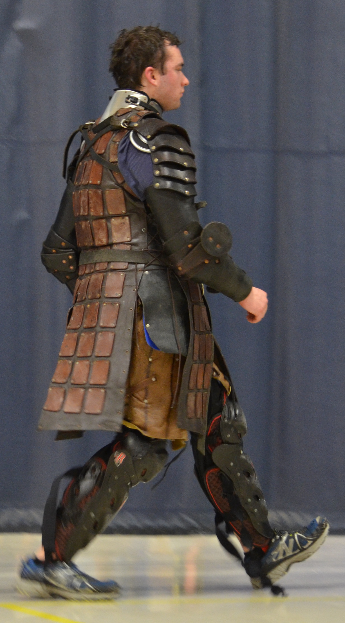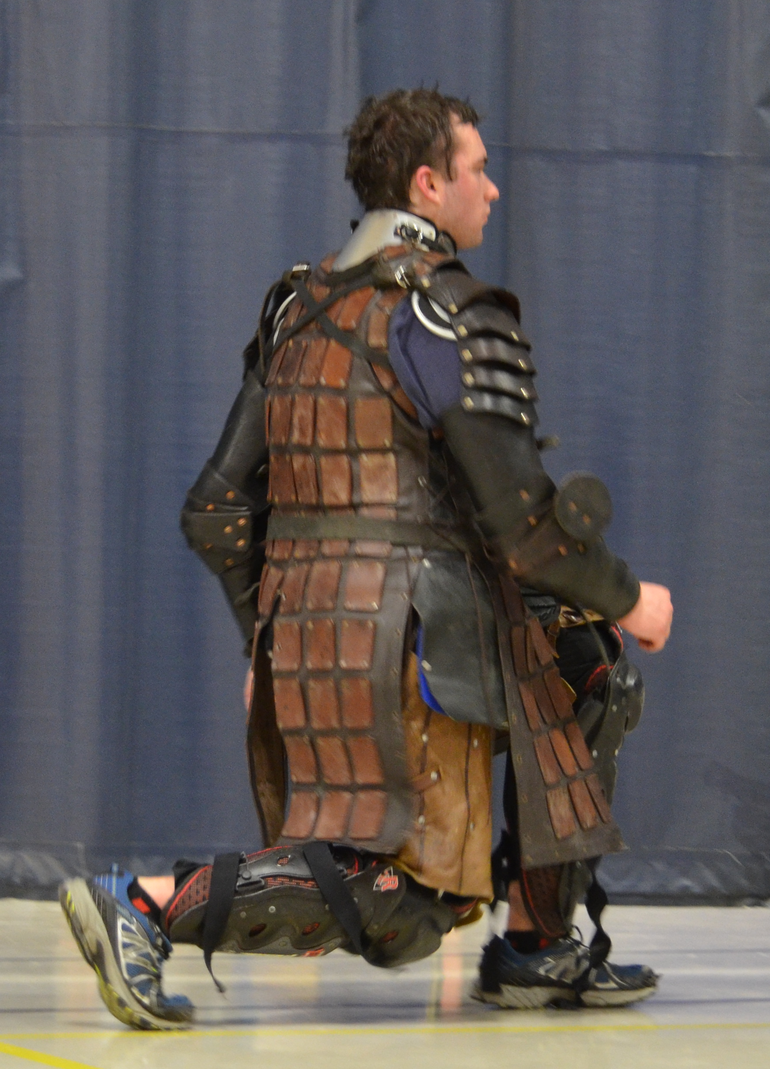
Lunges develop performance skills relevant to Heavy List fighting. They replicate moving into and out of an opponents range, stepping to position for a blow or bracing for impact with a charging shield wall.

Again, a screening is best done by an athletic performance specialist who can dissect movements as well as recommend a course of action to remedy any deficiencies. Sometimes it is as simple as adding stretches for a tight area, sometimes it requires knowledge of neurodevelopmental patterns and movement chains to understand where the deficiency truly lies and how best to address it.

Functional Performance:
Speed, timing, endurance, strength

Whereas Functional Movements indicate the basic ability to perform a task, Functional Performance describes more measurable objectives. How fast can you run? How long are you able to fight for? How many consecutive shots are you able to throw before form starts degrading? This is where most people think of traditional training. Getting on the treadmill, lifting weights, CrossFit or P90X training.

Heavy List fighting creates a number of unique demands. The activities are typically repeated bouts of short, maximal bursts. Combatants will close with one another into a flurry of attacks and blocks, then move away to re-assess their opponent and look for the next opening. This may occur multiple times in any one confrontation, then is repeated through a series of fights in a tournament. Melees involve running bursts with a handful of powerful blows over the course of a few minutes, followed by a rest, then another high-intensity sprint. If the scenario is a resurrection battle, the rests may be very short and the 'bursts' can go on for a long time.

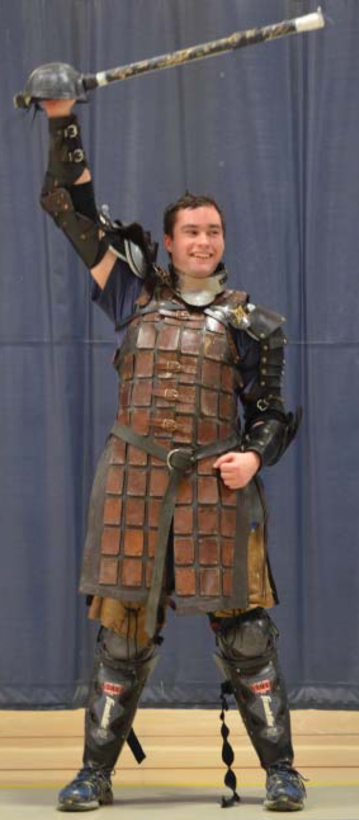
Being able to hold a weapon seems like an easy requirement for fighting in Heavy List, but a fighter needs a surprising amount of strength to be effective with it through a battle. Using your weapons as you would a dumbbell will build necessary muscle endurance. Try holding a sword or polearm and pressing it overhead repeatedly or getting into a guard and holding that position for 30 seconds or longer.

Functional Skill

This is actually putting it together. Going out in full gear to step into the lists and vie for tournament champion; crossing the field at a full run with your brethren at your shoulder; even just being at practice and fighting again and again against whomever has gear on. How fast, accurate, well-timed, and well-positioned one fighter is in relation to another. This is trained most extensively in the SCA. Older generations of fighters have their input with newer fighters and each other, sharing tactics, techniques, and insights, even translating period text to more accurately incorporate the wisdom of past masters-at-arms.

Movements are foundational to Performance is foundational to Skills. Sometimes athletes are able to have a high level of Skill despite lacking in an area of Movement or Performance. For example, because of experience or a natural propensity, they are able to place their sword firmly on their opponents despite having limited flexibility in their shoulder. This likely means they are pushing that shoulder to the limits of its ability to accomplish the goal of hitting an opponent, every single time. That's a recipe for injury and shortened career. Perhaps they lack endurance, a component of Performance, which means their Skill declines rapidly as individual fights go on or after multiple bouts in the course of a tournament, event, or war, and also increases the risk of injury.

High Performance without basic Movement is also problematic. Being able to run fast becomes a detriment if your ankle is unstable whenever you make a sharp turn.

As said above, having someone skilled in movement assessment is recommended to ensure there is normal Functional Movement and determining how to overcome any deficiencies. Even without this oversight, many people know where they are tight, or what movements cause pain. If you repeatedly dislocate your right shoulder, you may want to think about fighting left handed or choosing a different weapons form than sword and shield. Pilates, yoga, and Foundation Training[7] are examples of programs that can develop basic flexibility and core strength needed for any athletic activity to be safe and set a stage for easier development of advanced abilities.

In the SCA, there is no shortage of skilled teachers to instruct the finer points of heavy list to progress Functional Skills.

Out of Movement, Performance, and Skills, the easiest of these three categories for an individual to take personal responsibility for is actually Functional Performance. A good, all-around fitness program is a wise thing to incorporate into anyone's life. Below are some options to make that Functional Performance more specific to the list fields.

Training Suggestions

Lifting Arms — One very basic criteria for Heavy List combat is being able to hold a weapon. This sounds simplistic, but when you consider how few sports require carrying around a weighted stick, it should become obvious this is a unique requirement. The fatigue that occurs in an untrained fighter simply from keeping their sword and shield in place impacts training tolerance and skill development. Even someone with a huge benchpress will initially find holding a sword in a guard position taxing, as it is a very different use of your musculature.

This can be worked around simply by using the weapons like one would dumbbells. Holding a sword or polearm and pressing it overhead repeatedly; getting into a guard and holding that position for 30 seconds or longer; performing slow motion attacks against an imaginary opponent; strapping on a shield or even just holding a full gallon jug or a heavy rock and pumping it up and down to mimic the movement of blocking shots. With a little imagination, one can develop a base level of strength endurance that will make all subsequent training less taxing.[8]

Intervals — Fights are short, intense bouts. Even timed melees where the fighting can last for greater than an hour, combat occurs in fiery bursts. As such, interval training is the most appropriate type of conditioning.

Tabatas[9] are a form of interval training that works well with many different exercises. A whole Tabata session consists of only 4 minutes broken into segments of 20 seconds of exercises followed by 10 seconds of rest, repeated 8 times. The exercise can be sprints, squats, jumping jacks, push-ups - anything you can do hard and fast for 20 seconds. Heavy List specific: How many on-side/off-side combinations can you throw in 20 seconds?

Peak Eights[10] are structured with 30 seconds of maximal intensity exercise with 90 second rest periods of much lighter activity. This suits sprinting, stairmaster, elliptical trainers, and exercise bikes. Try sprints in full fighting gear.

Lunges — These were already mentioned under Functional Movement. It's necessary to have a certain base level of flexibility, balance, and strength to perform a lunge properly. Once this is in place, then lunges become a powerhouse of conditioning to develop performance skills relevant to Heavy List fighting. Squats and deadlifts are excellent exercises for developing power in the hips and lower back, but does not simulate the positions from which sword shots are typically thrown. Lunges more accurately replicate those postures. Moving into and out of an opponent's range, stepping to position for a blow, bracing for impact with a charging shield wall all are done with a lunge.

There is a virtually limitless variety of lunges:

• Forward, backward, sideways, diagonal.

• Walking - Instead of returning to the starting point with each lunge, you allow each lunge to move you forward by bringing the trailing leg up to the lead.

• Tightrope - Stand with both feet in line with each other, like walking the center-line in a sobriety test. Squat up and down. Challenges balance and hip flexibility. [11] [12] [13]

Pell Training - Usually the pell (typically, a padded post sunk into the ground intended for practicing sword techniques) is used for learning shot mechanics. Once good form is adequately developed, a pell becomes a tool for conditioning.

• Firing multiple strikes as rapidly as possible [speed development];

• Throwing shots repeatedly for a preset period of time [cultivating endurance];

• Launching attacks as forcefully as possible [building power]

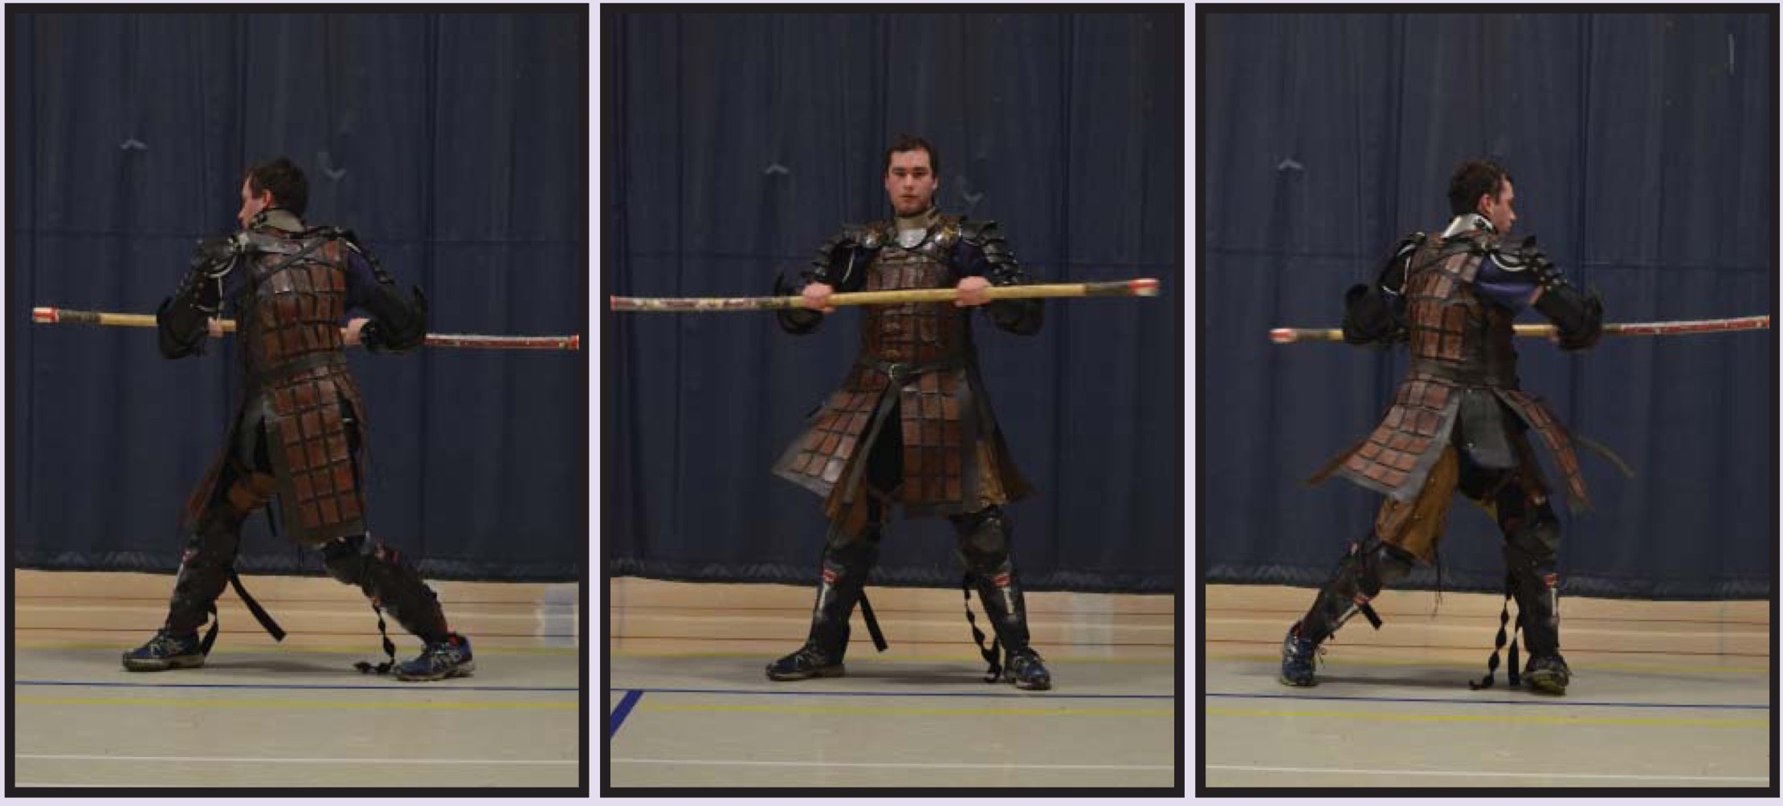
Can you twist side-to-side through a good range and without pain? Basic shot mechanics for the various weapons forms involves twisting motions. Power is usually generated from a forceful rotation of the hips. Without sufficient flexibility and core strength to allow these movements in a stable, controlled fashion, there is a high risk of injury - back or groin strain, over-rotating a knee, damaging a shoulder.

Our predecessors who originally evolved the chivalric fighting arts came from a much harsher time in terms of physical demands. Unlike today, desk jobs were much more rare. Those of certain classes and cultures were conditioned to hold a sword from a very young age, others used shovels and pitchforks in their early youth. Please look at yourself in an honest, critical way. If you are a computer engineer by day and a video game champion by night, you can still be an excellent sword fighter, but do yourself the favor of preparing your body for the workload weapons fighting places on your physical structure. Your skill level will benefit, as will the duration of your career. If you already regularly exercise, adjust your program to compliment the special requirements of Heavy List Combat.

I'll see you on the field.

[1] Proper Plank.
http://greatist.com/fitness/perfect-plank

[2] Advanced training option for 'getting up'. https://www.youtube.com/watch?v=2vWKMuDH528

[3] Rotational strength training option.
http://www.menshealth.com.sg/fitness/best-new-move-standing-russian-twist

[4] Basic shoulder flexiblity
https://www.youtube.com/watch?v=2e68jkvZowM

[5] Basic shoulder flexiblity
https://www.youtube.com/watch?v=js4wA4f2lac

[6] Balance training.
https://www.youtube.com/watch?v=KRJDeq9Gg8c

[7] Foundational Training.
http://www.youtube.com/watch?v=vOgxWp0WyiI&list=PLh4zJ2i6o6DKZT5K_RMlTwVtT3XzQiMYh&feature=share

[8] Shoulder Presses.
https://www.youtube.com/watch?v=jLd6MS9B-jY

[9] Tabatas.
http://greatist.com/fitness/tabata-protocol-interval-training-032713

[10] Peak Eights. https://www.youtube.com/watch?v=_NmNS75w9hI

[11] Lunges 1. https://www.youtube.com/watch?v=Z6H-VijOBB8

[12] Lunges 2. https://www.youtube.com/watch?v=FUX6Pz8vV0s

[13] Lunges 3. https://www.youtube.com/watch?v=t_BjD8p5mQ8

Baron Matthew Moraveous Avdenmork is mundanely a physical therapist with a special interest in, of course, sport specific conditioning. Please make sure you are medically able to participate in athletics before following any of this advice.

Many thanks to Lord Matthew MacGyver for assisting with photos.

------
Copyright 2017 by Matthew Begnoche. <matthewmb at gmail.com>. Permission is granted for republication in SCA-related publications, provided the author is credited. Addresses change, but a reasonable attempt should be made to ensure that the author is notified of the publication and if possible receives a copy.

If this article is reprinted in a publication, please place a notice in the publication that you found this article in the Florilegium. I would also appreciate an email to myself, so that I can track which articles are being reprinted. Thanks. -Stefan.

<the end>

