bld-a-javelin-art - 4/26/15

"How to Build a Thrust and Throw Javelin" by THLady Ingilborg Sigmundardottir of Caid.

NOTE: See also the files: axes-msg, Lite-Lg-Hrnss-art, W-T-Shields-art, SCAweapons-msg, Fightng-Small-art, melee-tactics-art, pottery-wepns-msg.

************************************************************************
NOTICE -

This article was submitted to me by the author for inclusion in this set of files, called Stefan's Florilegium.

These files are available on the Internet at: http://www.florilegium.org

Copyright to the contents of this file remains with the author or translator.

While the author will likely give permission for this work to be reprinted in SCA type publications, please check with the author first or check for any permissions granted at the end of this file.

Thank you,
Mark S. Harris...AKA:..Stefan li Rous
stefan at florilegium.org
************************************************************************

You can find more work by this author on her household site: http://www.argentlupus.com/housestrongbow

How to Build a Thrust and Throw Javelin
by THLady Ingilborg Sigmundardottir of Caid

Introduction:

The purpose of this article is to give a brief overview of the construction of
the Thrust and Throw Javelin for SCA combat use. As with any tutorial, this is meant to serve as a general guide. The assistance and tutelage of an experienced combat archer or Marshall is invaluable in these matters. These items are legal in Caid. Please check your local kingdom rules for applicability.

Disclaimer #1: This is by far not the only method extant for building Thrust and Throw Javelins. This particular design has been found to work the best in the Kingdom of Caid, after many prototypes of different materials construction were beaten to pieces by our fighters.
Disclaimer #2: Please check with your local Marshallate before buying/building/using Thrust and Throw Javelins.
Disclaimer #3: The Charter Plastics polyethylene pipe I sell does not fit together tightly. Hammering it together with a lubricant is unnecessary: however, we have found to our dismay that the inner pipe can shift under heavy usage conditions and destroy your thrusting tip head from the inside out. Thus, the instructions for gluing the pipes together and then drilling/tying them as additional security are included.
Disclaimer #4: Do not use any PVC component in your javelins. If you don't want to use a rubber stopper other things can be used, but do not use PVC end caps. Polyethylene end caps are available, but they are expensive.
Disclaimer #5: Do not cover the entire shaft of your javelin with tape. This is not necessary, adds dead weight, and the markings stamped on the side of the pipe need to be visible and readable by the inspecting Marshal. And, worst of all, if you coat your entire javelin with yellow duct tape it could possibly be mistaken for a ballista bolt and cause a terrible accident on the field.

Materials you will need:

- One five foot straight length of 1" diameter 160 psi Siloflex-equivalent polyethylene pipe. Please refer to www.combat-archery.com for a list of equivalent brands approved for making javelins.
- One five foot straight length of 3/4" diameter 160 psi Siloflex-equivalent polyethylene pipe.
- PVC pipe cutters, or a hacksaw
Size 6.5 white gum rubber stopper, available from home brewing stores.
- Vinyl sleeve "Trailer Ball Hider" available at auto parts store, which will hold to 2" diameter. (See the photo). Trim it to fit if necessary.
- 2" circles of blue camping mat or any good quality closed cell foam, you may cut with scissors or hot wire. You will need 3-5, depending on the thickness.
- 2" diameter leather disc (use scrap leather)
- 1" circle of blue camping mat foam.
- Fins (optional): Look here for fin patterns you can cut out and use. One pair, short or long as you prefer. - Leather punch (optional)
- Drill with small bit.
- 1" high quality monofilament strapping tape. Please buy the good stuff, Scotch 3M is highly recommended. If you buy cheap strapping tape you can save a few dimes at the cash register, but you will regret it later when the tape fails prematurely due to cheap adhesive and you have to restrap your whole javelin.
- Duct tape, red for the thrusting tip and then your choice of colors for the rest.
- Glue. Nothing really bonds Siloflex to Siloflex. However, the best found thus far is "Liquid Nails" brand contact cement. This is available at any home repair or hardware store in anything from small 1 oz tubes (all you need) to 5 gallon buckets.
- Tying material. I use 80 lb test braided fishing line doubled in a leather sewing needle: nice and fine and lies flat when tied, and have never had a problem. However, parachute cord or polypropylene line will work just as well.
- Blunt leather sewing needle. If you're using braided fishing line you will be very happy to have this. If using parachute cord, etc, this is unnecessary.
- Single edge razor blade, or utility knife.
- Label, indelible marking pen and clear packing tape to cover your label.

The rest of this tutorial is broken up into ten different parts, many with a series of steps.

Part One: Prepare the Javelin Staff
Part Two: Make the Foam Thrusting Head
Part Three: Prepare the Fins
Part Four: Install the Rubber Stopper
Part Five: Install the Thrusting Tip
Part Six: Duct Tape the Thrusting Tip Into Position
Part Seven. Install the Fins (Look here for fin patterns you can cut out and use)
Part Eight: Duct Tape the Fin Mounts
Part Nine: Install the Butt Plate
Part Ten: Label your Javelin

Part One: Step One

Put one pipe inside the other: Stand up. Find your 3/4" diameter pipe and with either the PVC pipe cutter or a hacksaw, trim off about a 1/2 to 1" piece of it to make room for the rubber stopper.

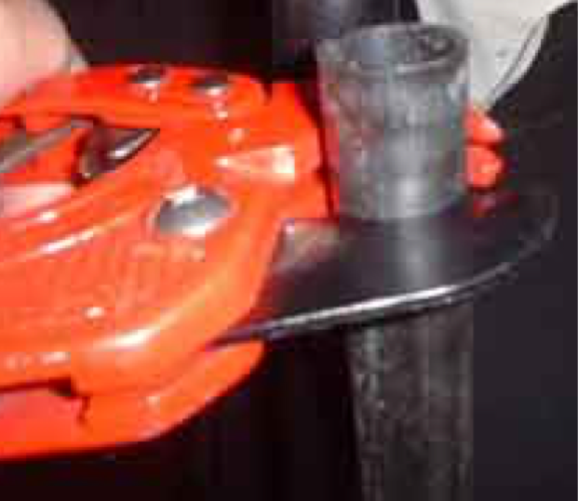

Part One: Step Two

Place a very thin bead of the Liquid Nails contact cement around one end of the 3/4" pipe and slide it into the 1" diameter pipe.

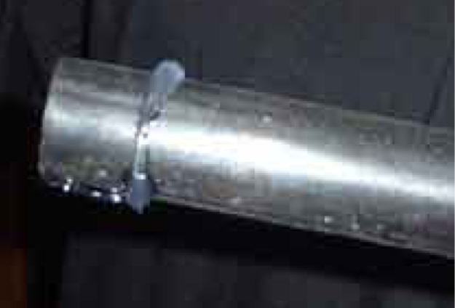

Part One: Step Three

The glue will entrain itself right down into the pipe as you push, but having a paper towel handy is a good idea.

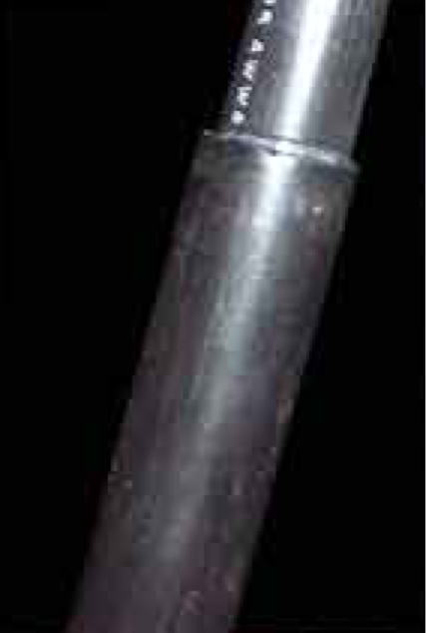

Part One: Step Four

Push till the ends at your end are equal.

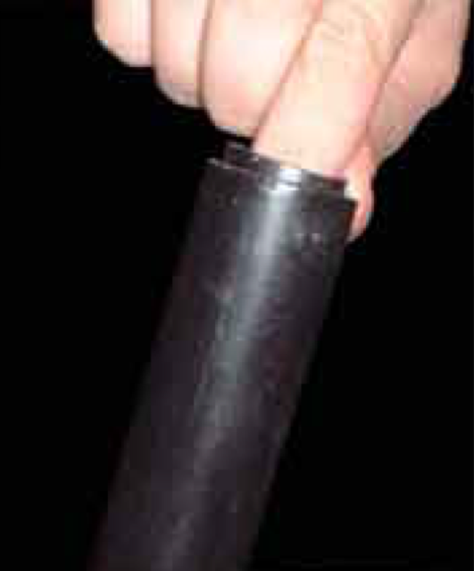

Part One: Step Five

Punch the holes for the stopper.

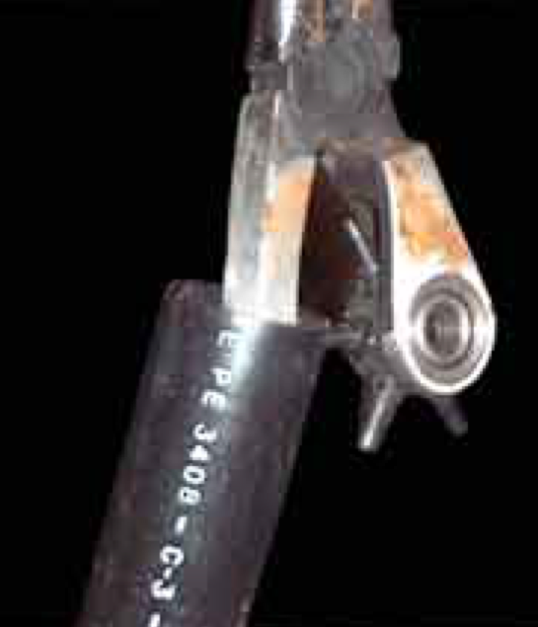

Part One: Step Six

Flip the javelin shaft over. You'll see that the shorter inner pipe is below the edge of the outer, as it should be. Take your leather punch or drill and punch/drill 6 equally spaced holes around the circumference of the outer pipe only. These will serve to tie your stopper in place. Make the diameter of your holes comparable to the size of the cord you are using to tie on the stopper/tie the pipes together.

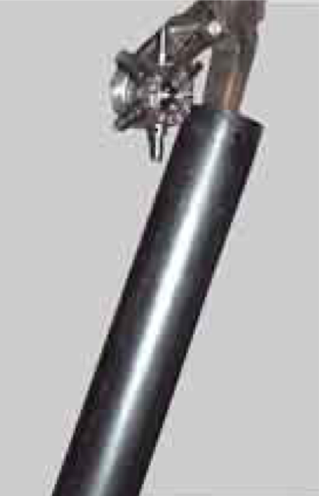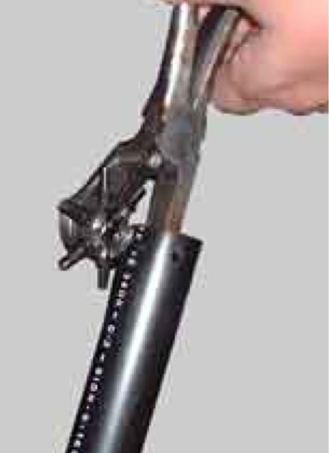

Part One: Step Seven

Drill/tie the pipes together. Take your drill and drill 2 holes in a cross configuration just below the holes you punched, through both pipes.

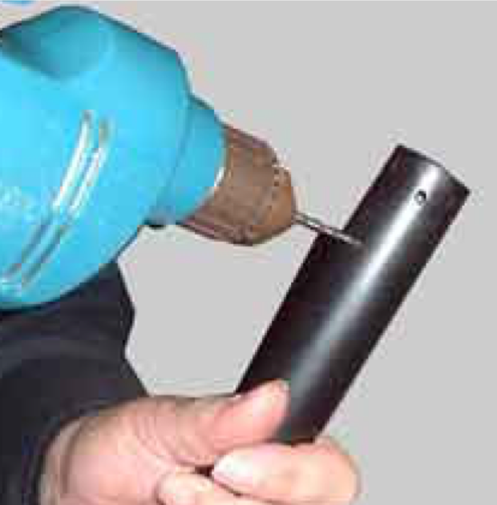

Part One: Step Eight

Your javelin shaft is now ready.

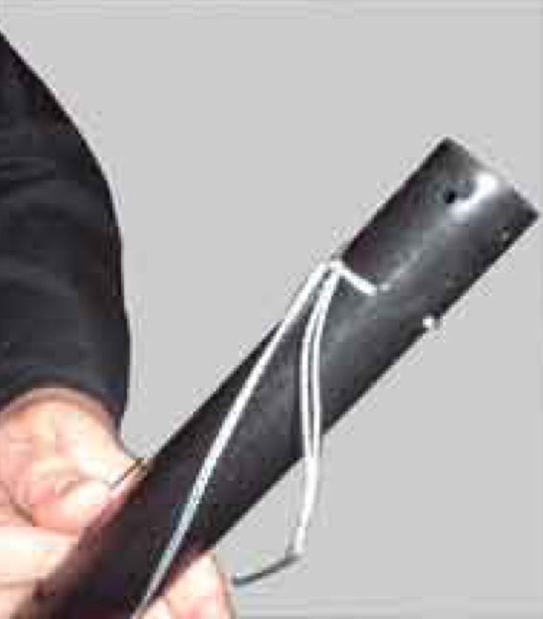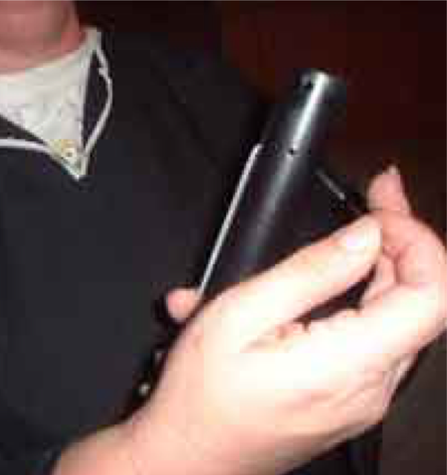

Part Two

Get out the vinyl trailer hitch sleeve.
Using blue camping mat foam or whatever type of closed cell foam you have, cut out three to five 2" diameter circles of the foam depending on the foam's thickness (you need to have at least 2" of foam between the tip of the javelin and the rubber stopper) and stuff them into the trailer hitch sleeve. Do not jam them in too tightly, they will seat themselves once the tip is placed on the javelin and you want a little give. If you have a flair for neatness and extra performance, on your last foam circle cut out the center of it to a diameter of about 1" so that it looks like a ring. This will allow your rubber stopper to seat inside the thrusting tip head and give you greater stability and less lateral movement when you stab someone with it.

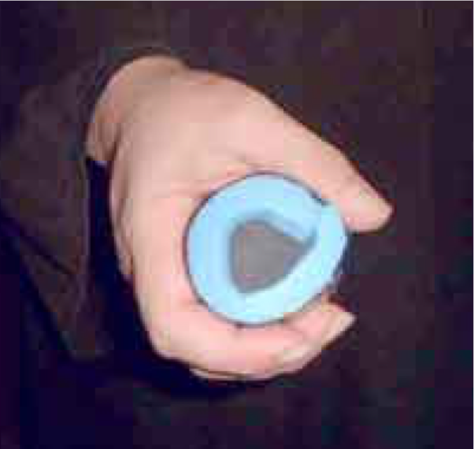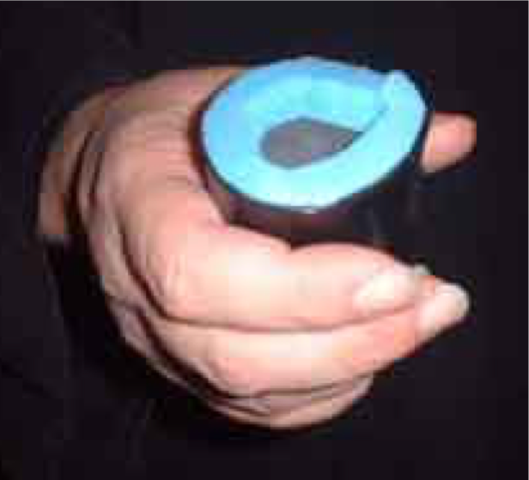

Part Three

Use plain old cheap blue foam closed-cell camping mat for the fins. If you like to throw the javelins a long distance and want the best spin and stability use the long pattern, but if you plan mostly on thrusting and throwing shorter distances use the short pattern. You also can certainly use no fins at all. You will need a pair. Lay the patterns on the foam mat, draw around them and then cut them out with heavy scissors or a hot wire foam cutter available at craft or floral stores.

Choose your favorite color of duct tape and cover the fins with a single layer of duct tape. Make sure all foam is covered. Snip the tape to fit.

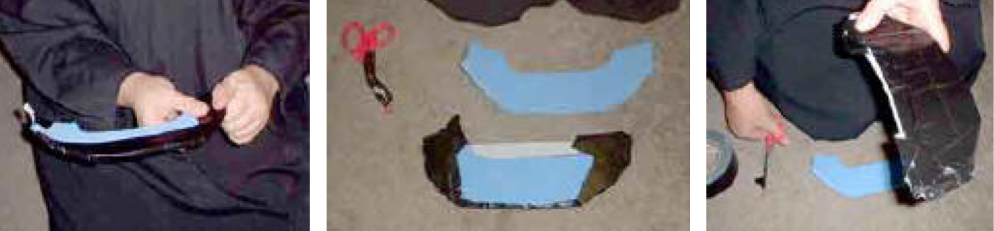

Part Four: Step One

Get comfy in your recliner. Have your cord/thread ready. While holding the javelin between your feet, wedge the rubber stopper in place into the end that has the holes. It will go in about 1/3 of the way.

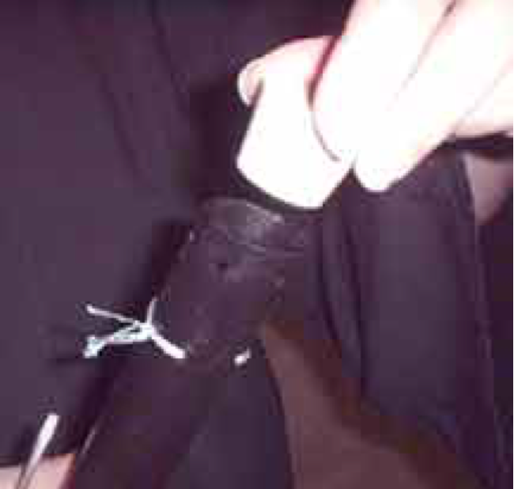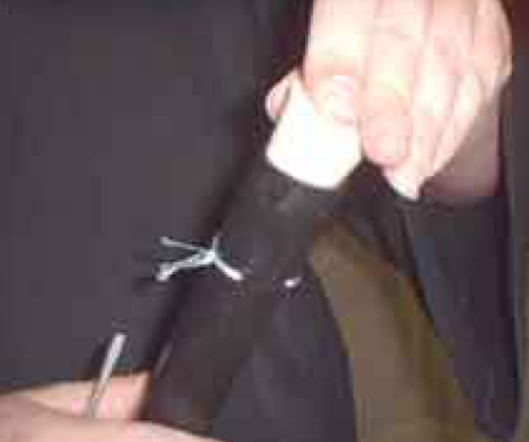

Part Four: Step Two

A small screwdriver is useful to wedge the edges into place: pounding it into place is pointless.

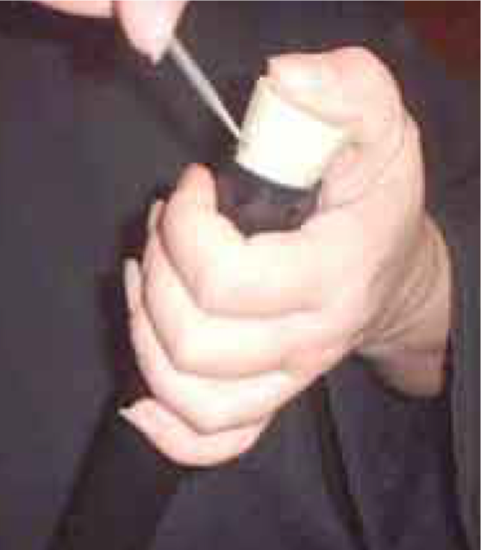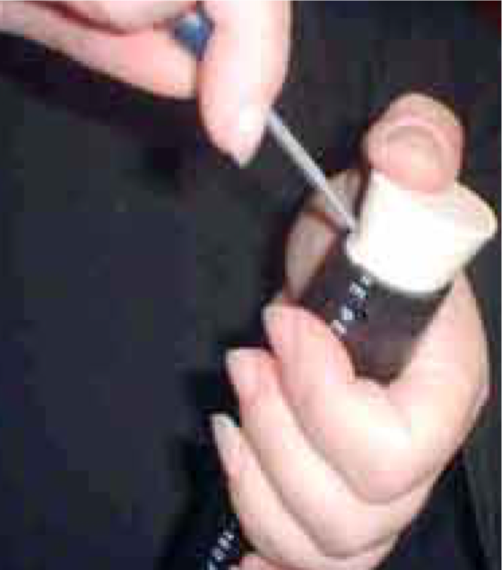

Part Four: Step Three

Use your fishing line/cord to lace it into place.

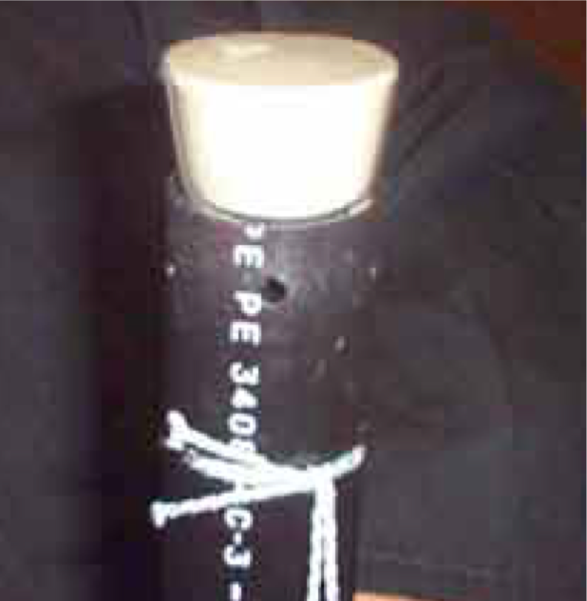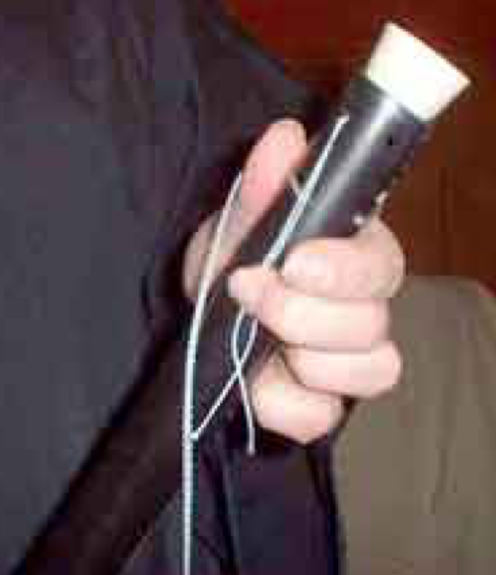

Part Four: Step Four

Lace the cord/fishing line over the top of the rubber stopper repeatedly, the more the better.

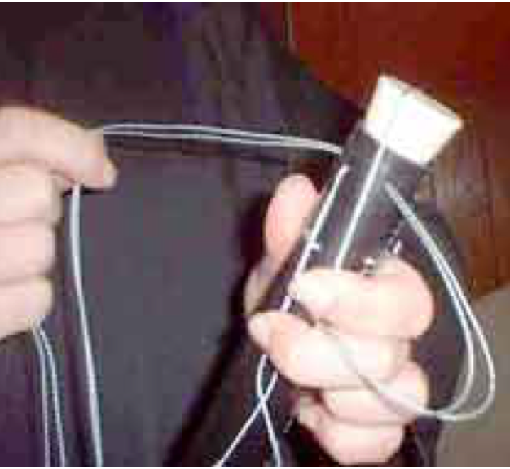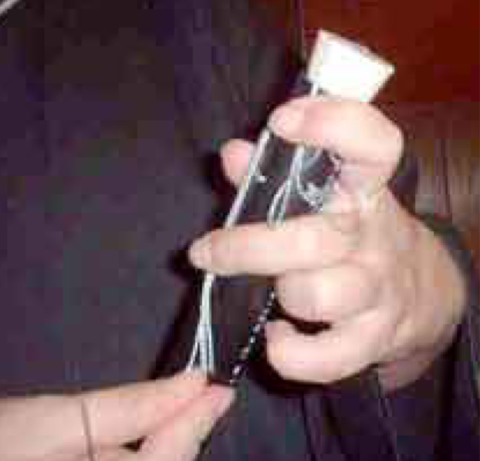

Part Four: Step Five

Tie the ends on the side of the pipe—not the top. Use a square knot.

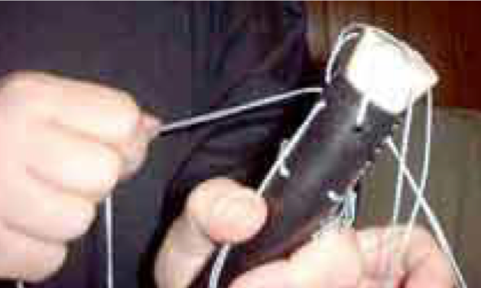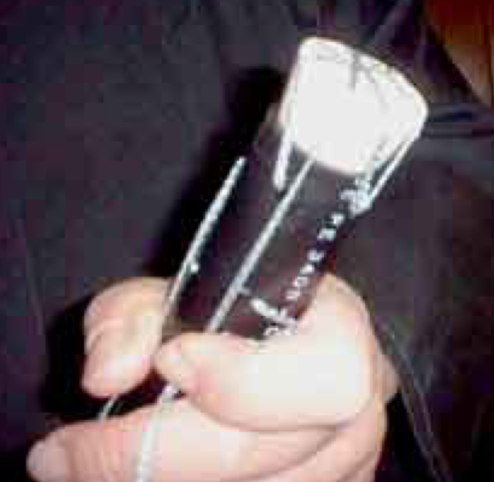

Part Four: Step Six

Trim the ends of the cord, not too short though.

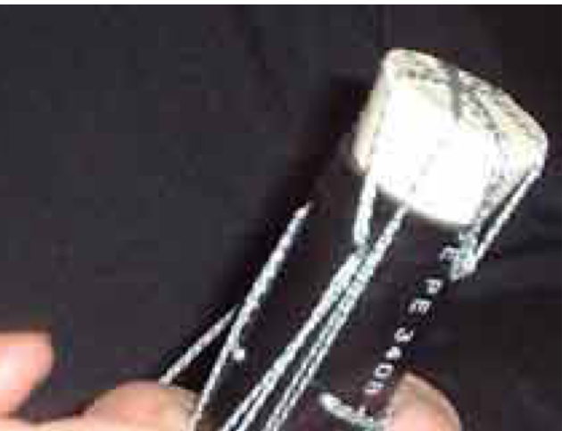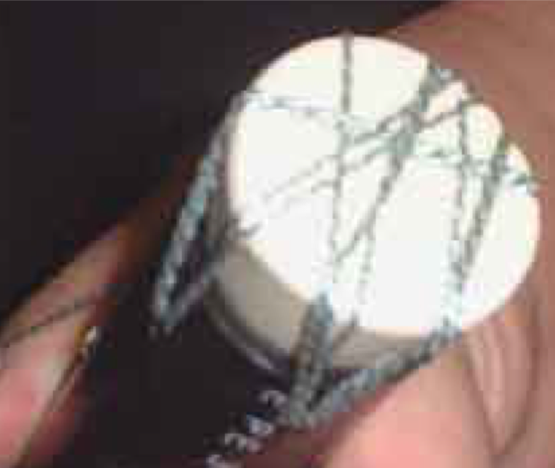

Part Five: Step One

Get out the thrusting tip head you made earlier and put it in your lap. Pull 6 pieces of your strapping tape about 24 inches long, your lap is a good place for these. Pull an additional two 1 foot pieces and place these handy as well. Press the tip against a wall or the floor firmly to seat it but don't get too carried away with this, as you want some give.

Part Five: Step Two

Put the thrusting tip head over the rubber stopper and center it, if you used a ring piece of foam for your last one it will do this very nicely.

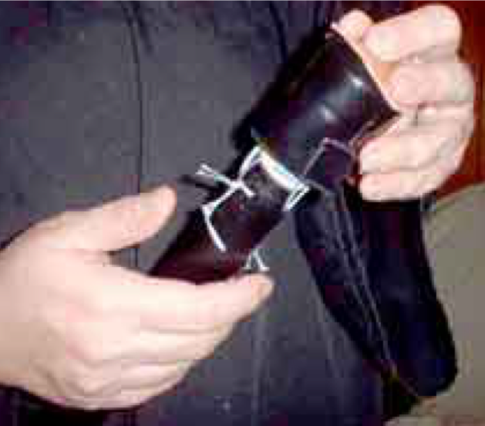

Part Five: Step Three

Turn the javelin so the thrusting tip is towards you, and center it with your hand while bracing it with your feet. Put the 2" leather disc on top of the thrusting tip head.

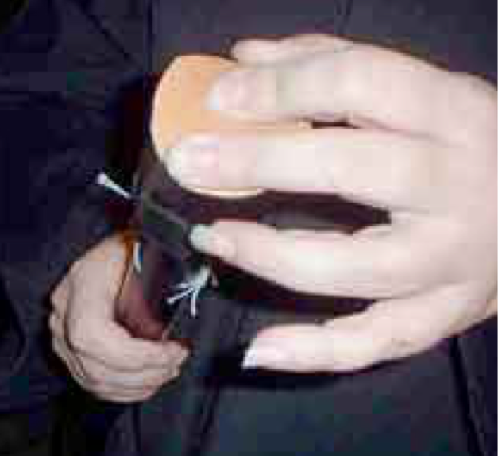

Part Five: Step Four

Pressing the whole thing down gently but firmly with one hand, peel off the first piece of strapping tape and center it over the striking face of the thrusting tip.

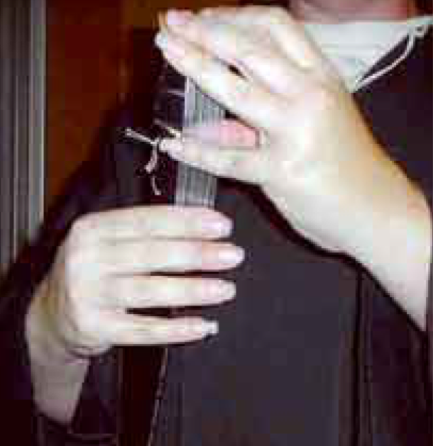

Part Five: Step Five

Smooth the tape down the sides of the pipe making maximum contact, firmly but not tightly.

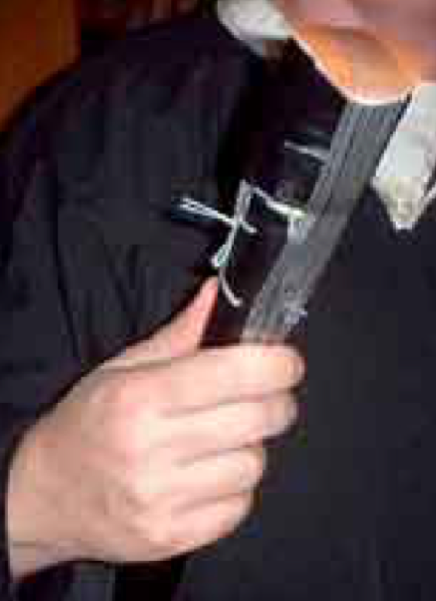

Part Five: Step Six

Repeat this with the other five pieces of strapping tape until it has made a star pattern.

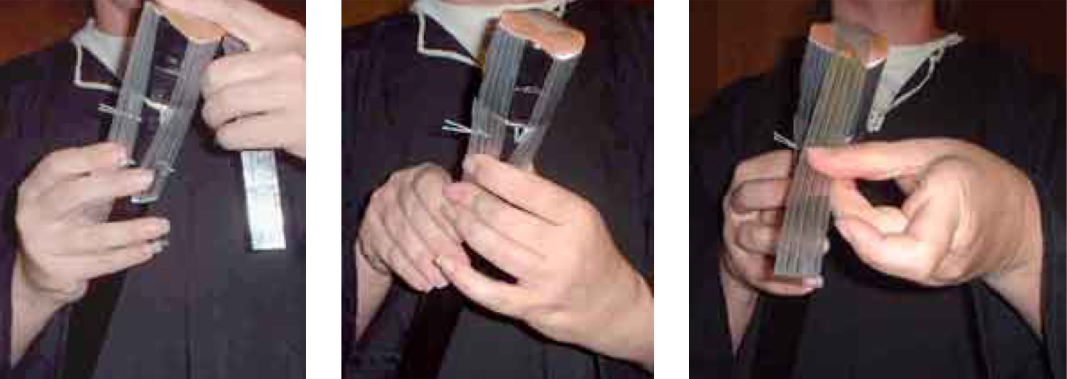

It should stay in place reasonably well now, as seen below.

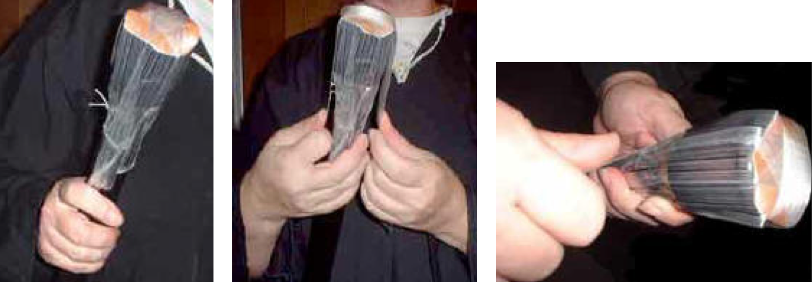

Part Five: Step Seven

Now comes a critical step. Center the thrusting tip once more and get the first piece of shorter strapping tape. This will anchor your thrusting tip in place for you. Place this piece of tape horizontally at the point where the bottom of the thrusting tip meets the neck of the pipe and begin to wind it around the pipe as tightly as you physically can. Keep the thrusting tip centered as the tape begins to tighten down and the bottom edges of the thrusting tip sleeve bend inwards.

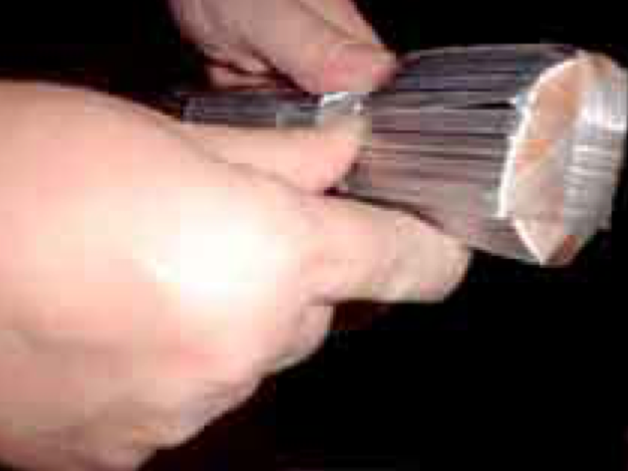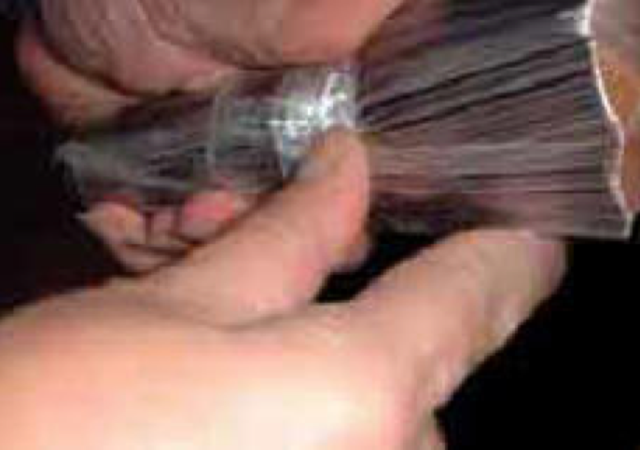

Pull tightly and keep the thrusting tip centered till the tape is all gone. Take the second piece and repeat this process below the first piece. Your thrusting tip is now locked into position.

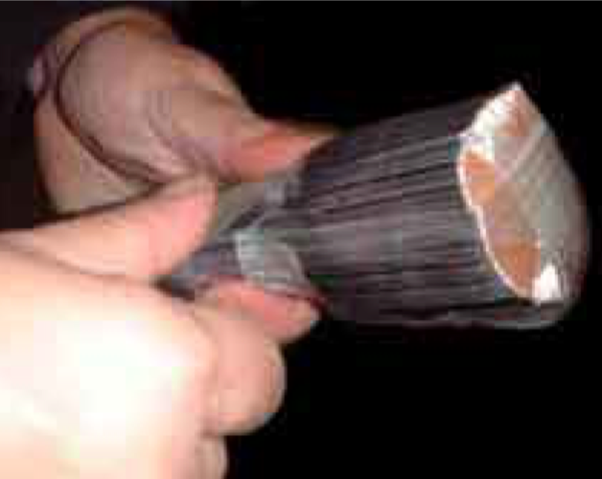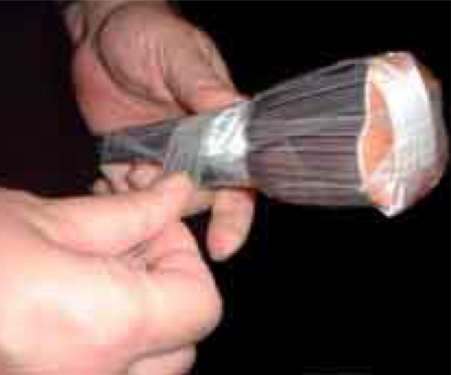

Part Six: Step One

Pull two 18 inch or so sections of red duct tape and cover your thrusting tip with them in a cross configuration.

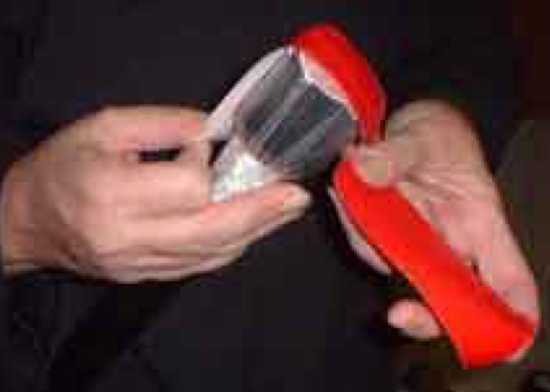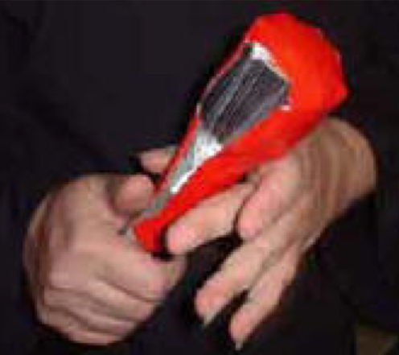

Part Six: Step Two

Smooth down the tape as much as you can. The vinyl sleeve must be completely covered. Use a third piece if you must.

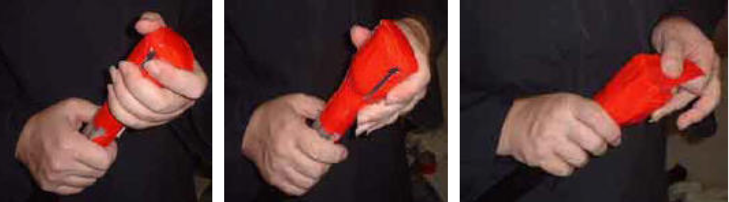

Part Six: Step Three

Pull two 1 foot sections of any color duct tape and wrap them around the neck of the thrusting tip/pipe junction just as you did the strapping tape.

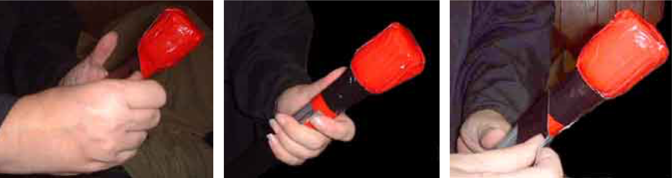

Part Six: Step Four

Use the razor blade/utility knife to trim off any tape ends, which protrude below this tape. If your cord that ties the pipes together is below this, use a third piece of tape wrapped laterally around the pipe to cover this up. You are now done with the thrusting tip!

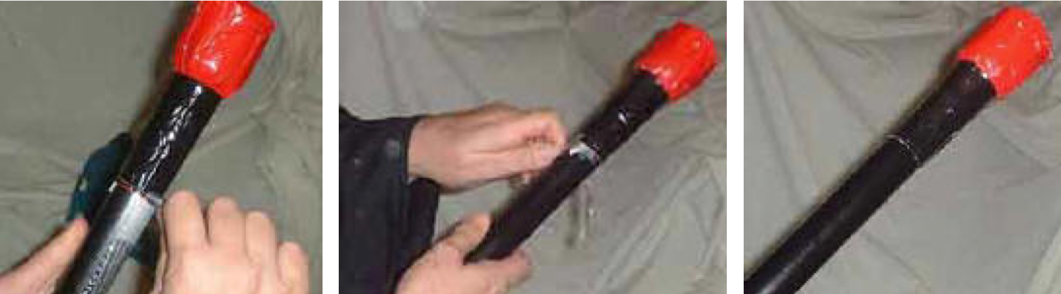

Part Seven: Step One

You don't have to do this, but the javelins really will fly better if you do. As I mentioned earlier, whether or not to use the long or short fins is up to your style of use.

OK, you want them. Turn the javelin 180 degrees so the thrusting tip is at your feet and hold it between your feet. Have some espresso as installing fins takes some fine fingernail work and patience.

The best place to mount the fins is about 1/2 to 1" above the butt end of the javelin. Remember that in order for them to spin properly, you will be mounting them diagonally. Look at the finished pictures of the fins so you can get an idea of what you are going to do. Pull two 2 foot pieces of strapping tape.

Take your first fin and line it up with one end of each fin on opposite sides of the javelin: ie: the leading edge on the right and trailing edge on the left. Be sure to line it up exactly equally.

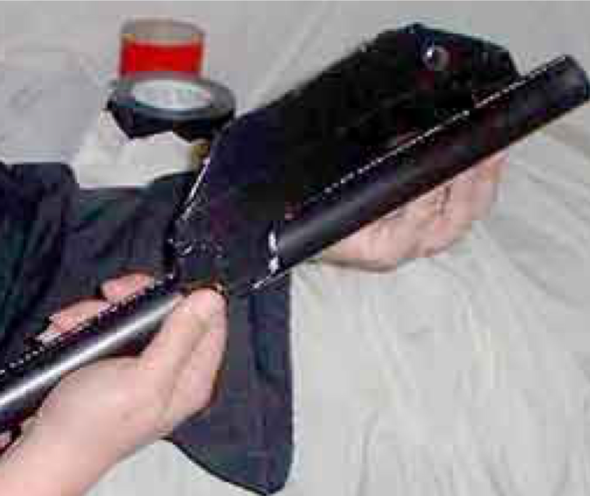

Part Seven: Step Two

Tape the leading edge down with one piece of your pulled strapping tape and let the rest loosely stick to the pipe. Now take your second fin and place it equally forward and on opposite sides of the pipe; ie the leading edge on the left and the trailing edge on the right.

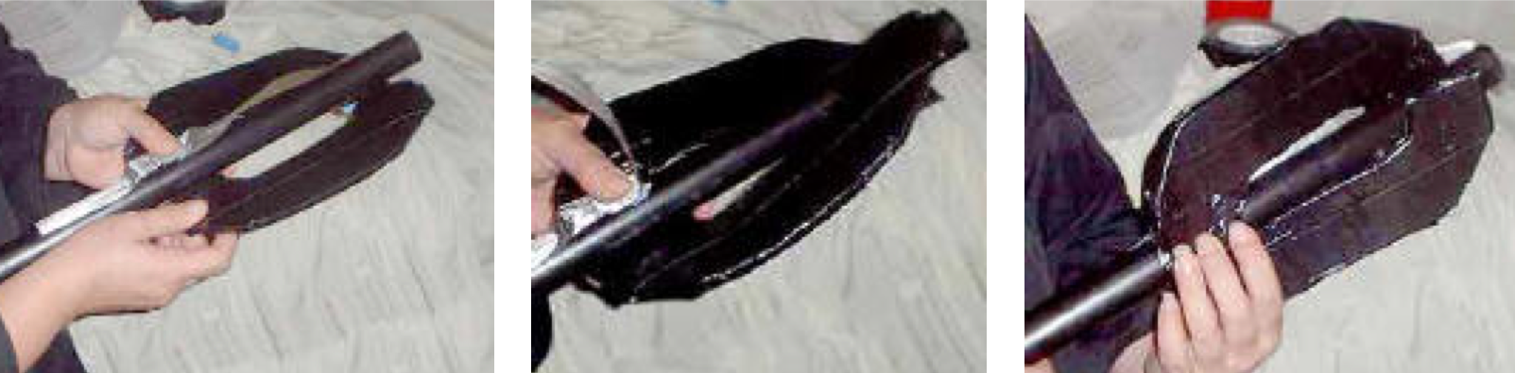

Part Seven: Step Three

Tape them down along the length of the pipe, pressing firmly to compress the foam a little. It won't hold but don't worry, we'll get to that in a minute.

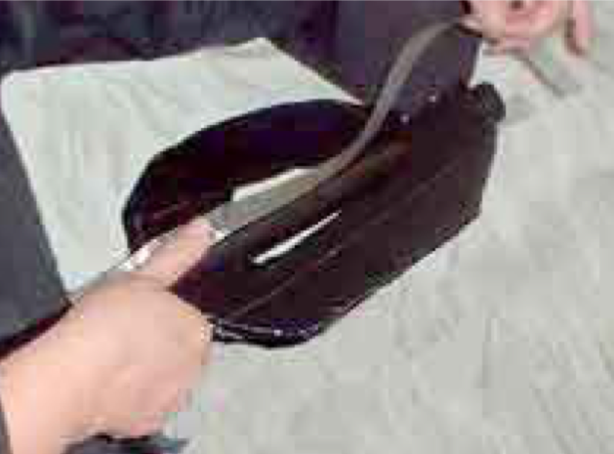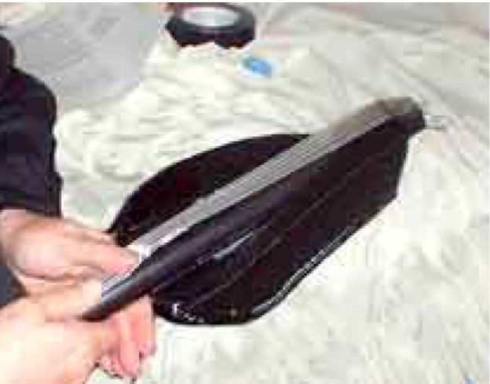

Part Seven: Step Four

Pull four 1 foot pieces of strapping tape. Take the first piece and begin to wrap it around the pipe just in front of the leading edge of the fins. Pull it tight, so tight the foam compresses. With the second piece, repeat at the back ends of the trailing edges.

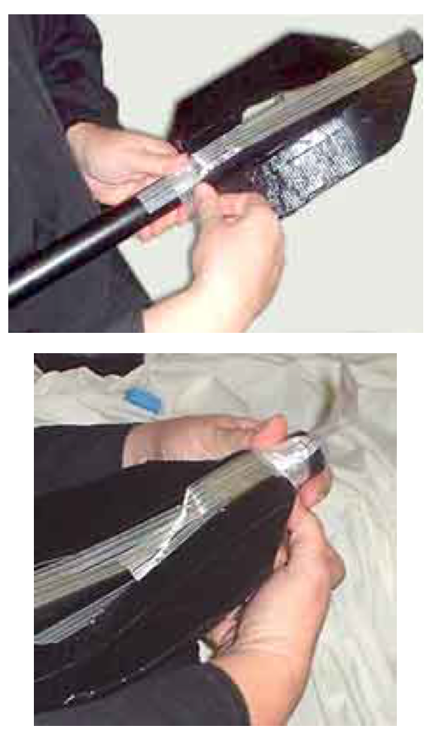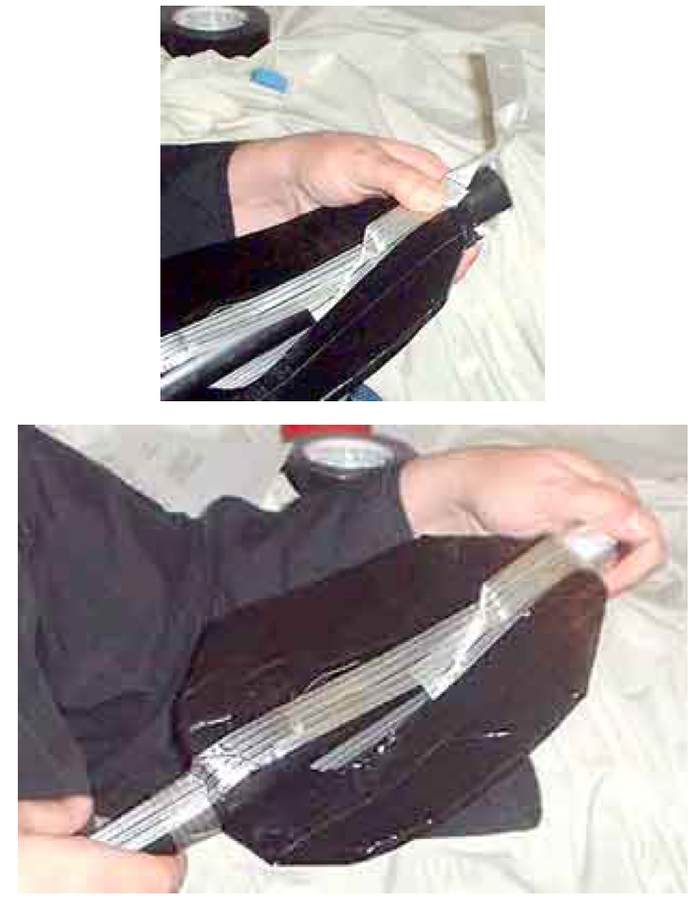

Part Seven: Step Five

Now comes the tough part. The fins also have to be tape wrapped around the pipe just behind their trailing edges. Pull the fins up a little so you can get your fingertips under them and wrap the tape around tightly so the foam compresses behind there. You will rediscover a few cuss words as you do this.

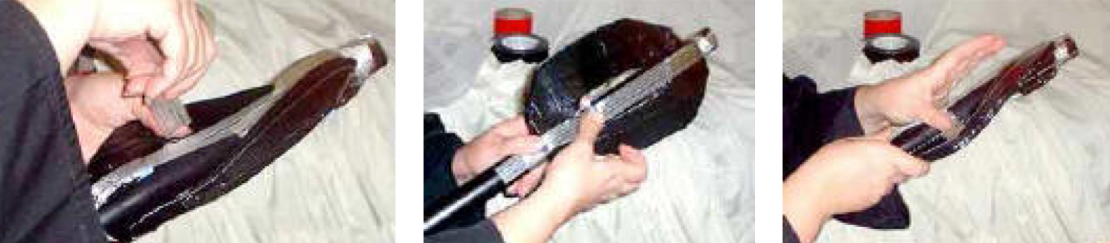

Part Seven: Step Six

Do both inside corners, front and back. Now your fins will not come off!

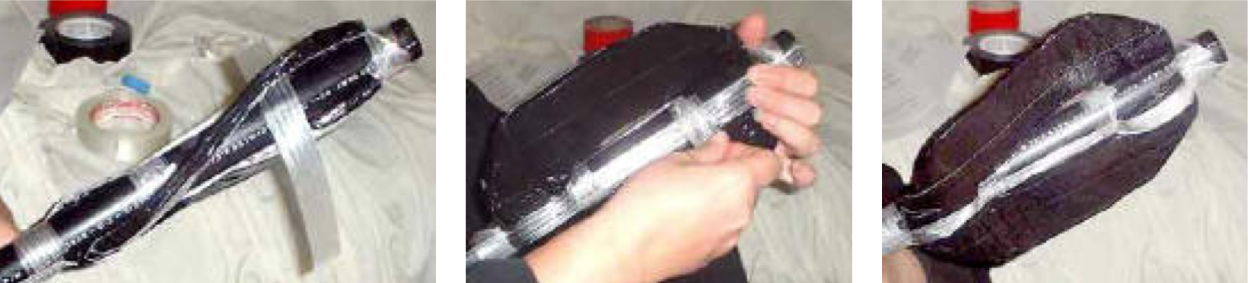

Part Eight: Step One

The strapping tape that holds the fins into place must be covered with duct tape. So pull two 2 foot and 4- 6 1 foot pieces of your choice color duct tape, preferably a color that matches the fins so your javelins will look smart. Cover the strapping tape first longitudinally down the pipe with the long pieces and then with the short pieces wrap them around the pipe circumferentially.

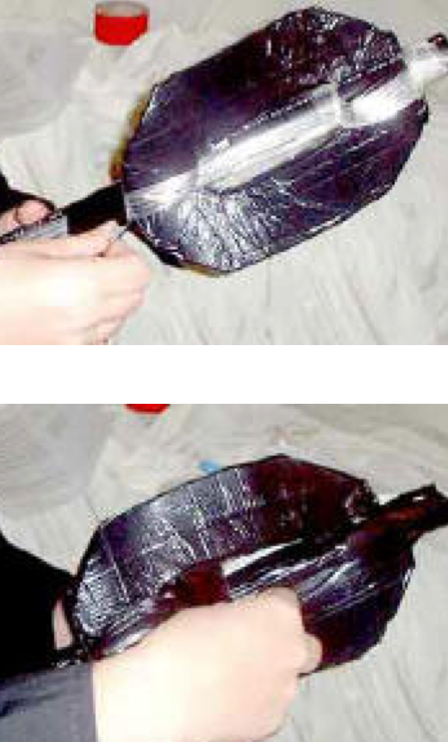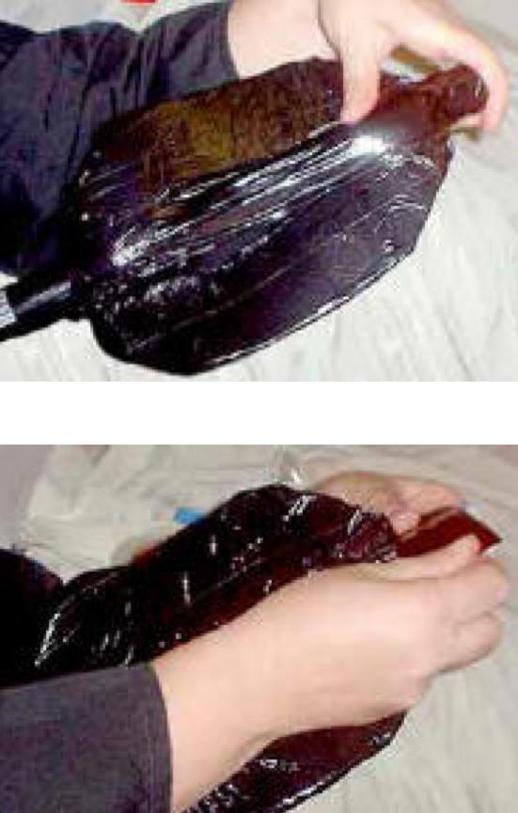

Part Eight: Step Two

Cover strapping tape or it will degrade in the sun and all your nice work be lost: and the smoother the duct tape the more aerodynamic your javs will be.
If any strapping tape ends stick out beyond the duct tape, again use your razor blade or utility knife to trim these off.

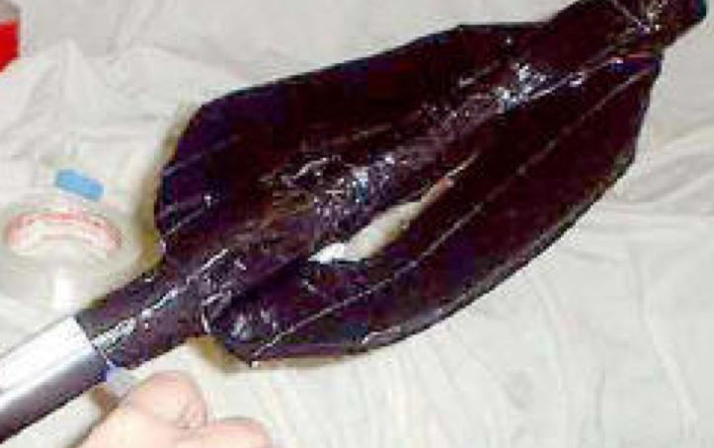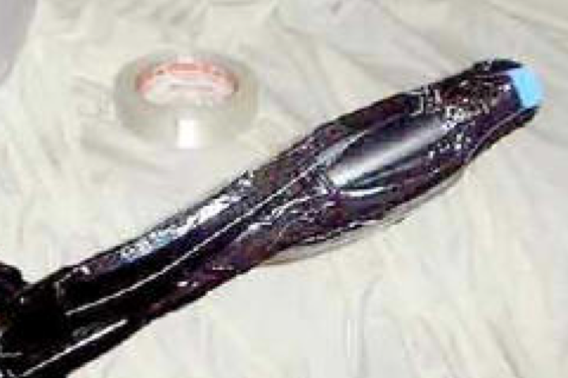

Part Nine:

Install the Butt Pad:

Hush that laughing. Find the 1"diameter blue foam circle cut earlier and pull two 1 foot sections of any color duct tape, preferably a color that matches your fins. Center the pad on the butt end of the javelin and tape it in place. Remember that the marshal has to peel this back in order to inspect your javelin's construction, please make it easy for him/her to do this.

Part Ten:

Your javelin must be labeled in English with your name, kingdom, and local area of residence/warband. The more info the better, as javelins are gleanable and your jav is probably going to go a heck of a lot of places once you toss it on the battlefield. Affix the label and cover it with clear packing tape to protect the writing from dirt, moisture, and trampling. You can crest it also with bands of colored duct tape for quick identification on the field.
You are done. Go out and learn to get good with throwing it.

About the Author:

Ingilborg Sigmundardottir is an 11th century Norsewoman. Her husband died long ago on a campaign, and her fair daughter sailed away on a longship to be wedded to a brave Viking prince. She spends her crone years as an accomplished healer, birthing the babies of her village and tending wounded warriors of all types. She contemplates the White Christ, whose teachings she finds sensible and fascinating. She is known as a very accomplished archer, meadmaker, and Healer. She lives away from her village in the surrounding forest and is rarely seen among the villagers, but is intensely loyal to them and offers the services of her bow whenever her village is threatened. Her cottage is rich with plants of all types and she keeps the company of wolves, and the wiser of the villagers know that in times of extreme, she is quite capable of running with them whenever necessary.

Roberta Ashley is a 21st century Norsewoman, a very accomplished anesthetist who is all too often seen in the hallways of various healing institutions in the City of Angels, where she assists in the birthing of babies and the tending of wounded warriors of all types. She is an accomplished archer, meadmaker, and practices in her spare time a very ancient form of Eastern hands-on healing when it is needed. Her cottage in the more remote canyons of the San Gabriel Mountains is rich with plants of all types and she keeps the company of two rescued captive bred wolves, Cheyenne and Mai-Coh. The wiser of her colleagues know that in times of extreme, she is probably quite capable of running with them whenever necessary.

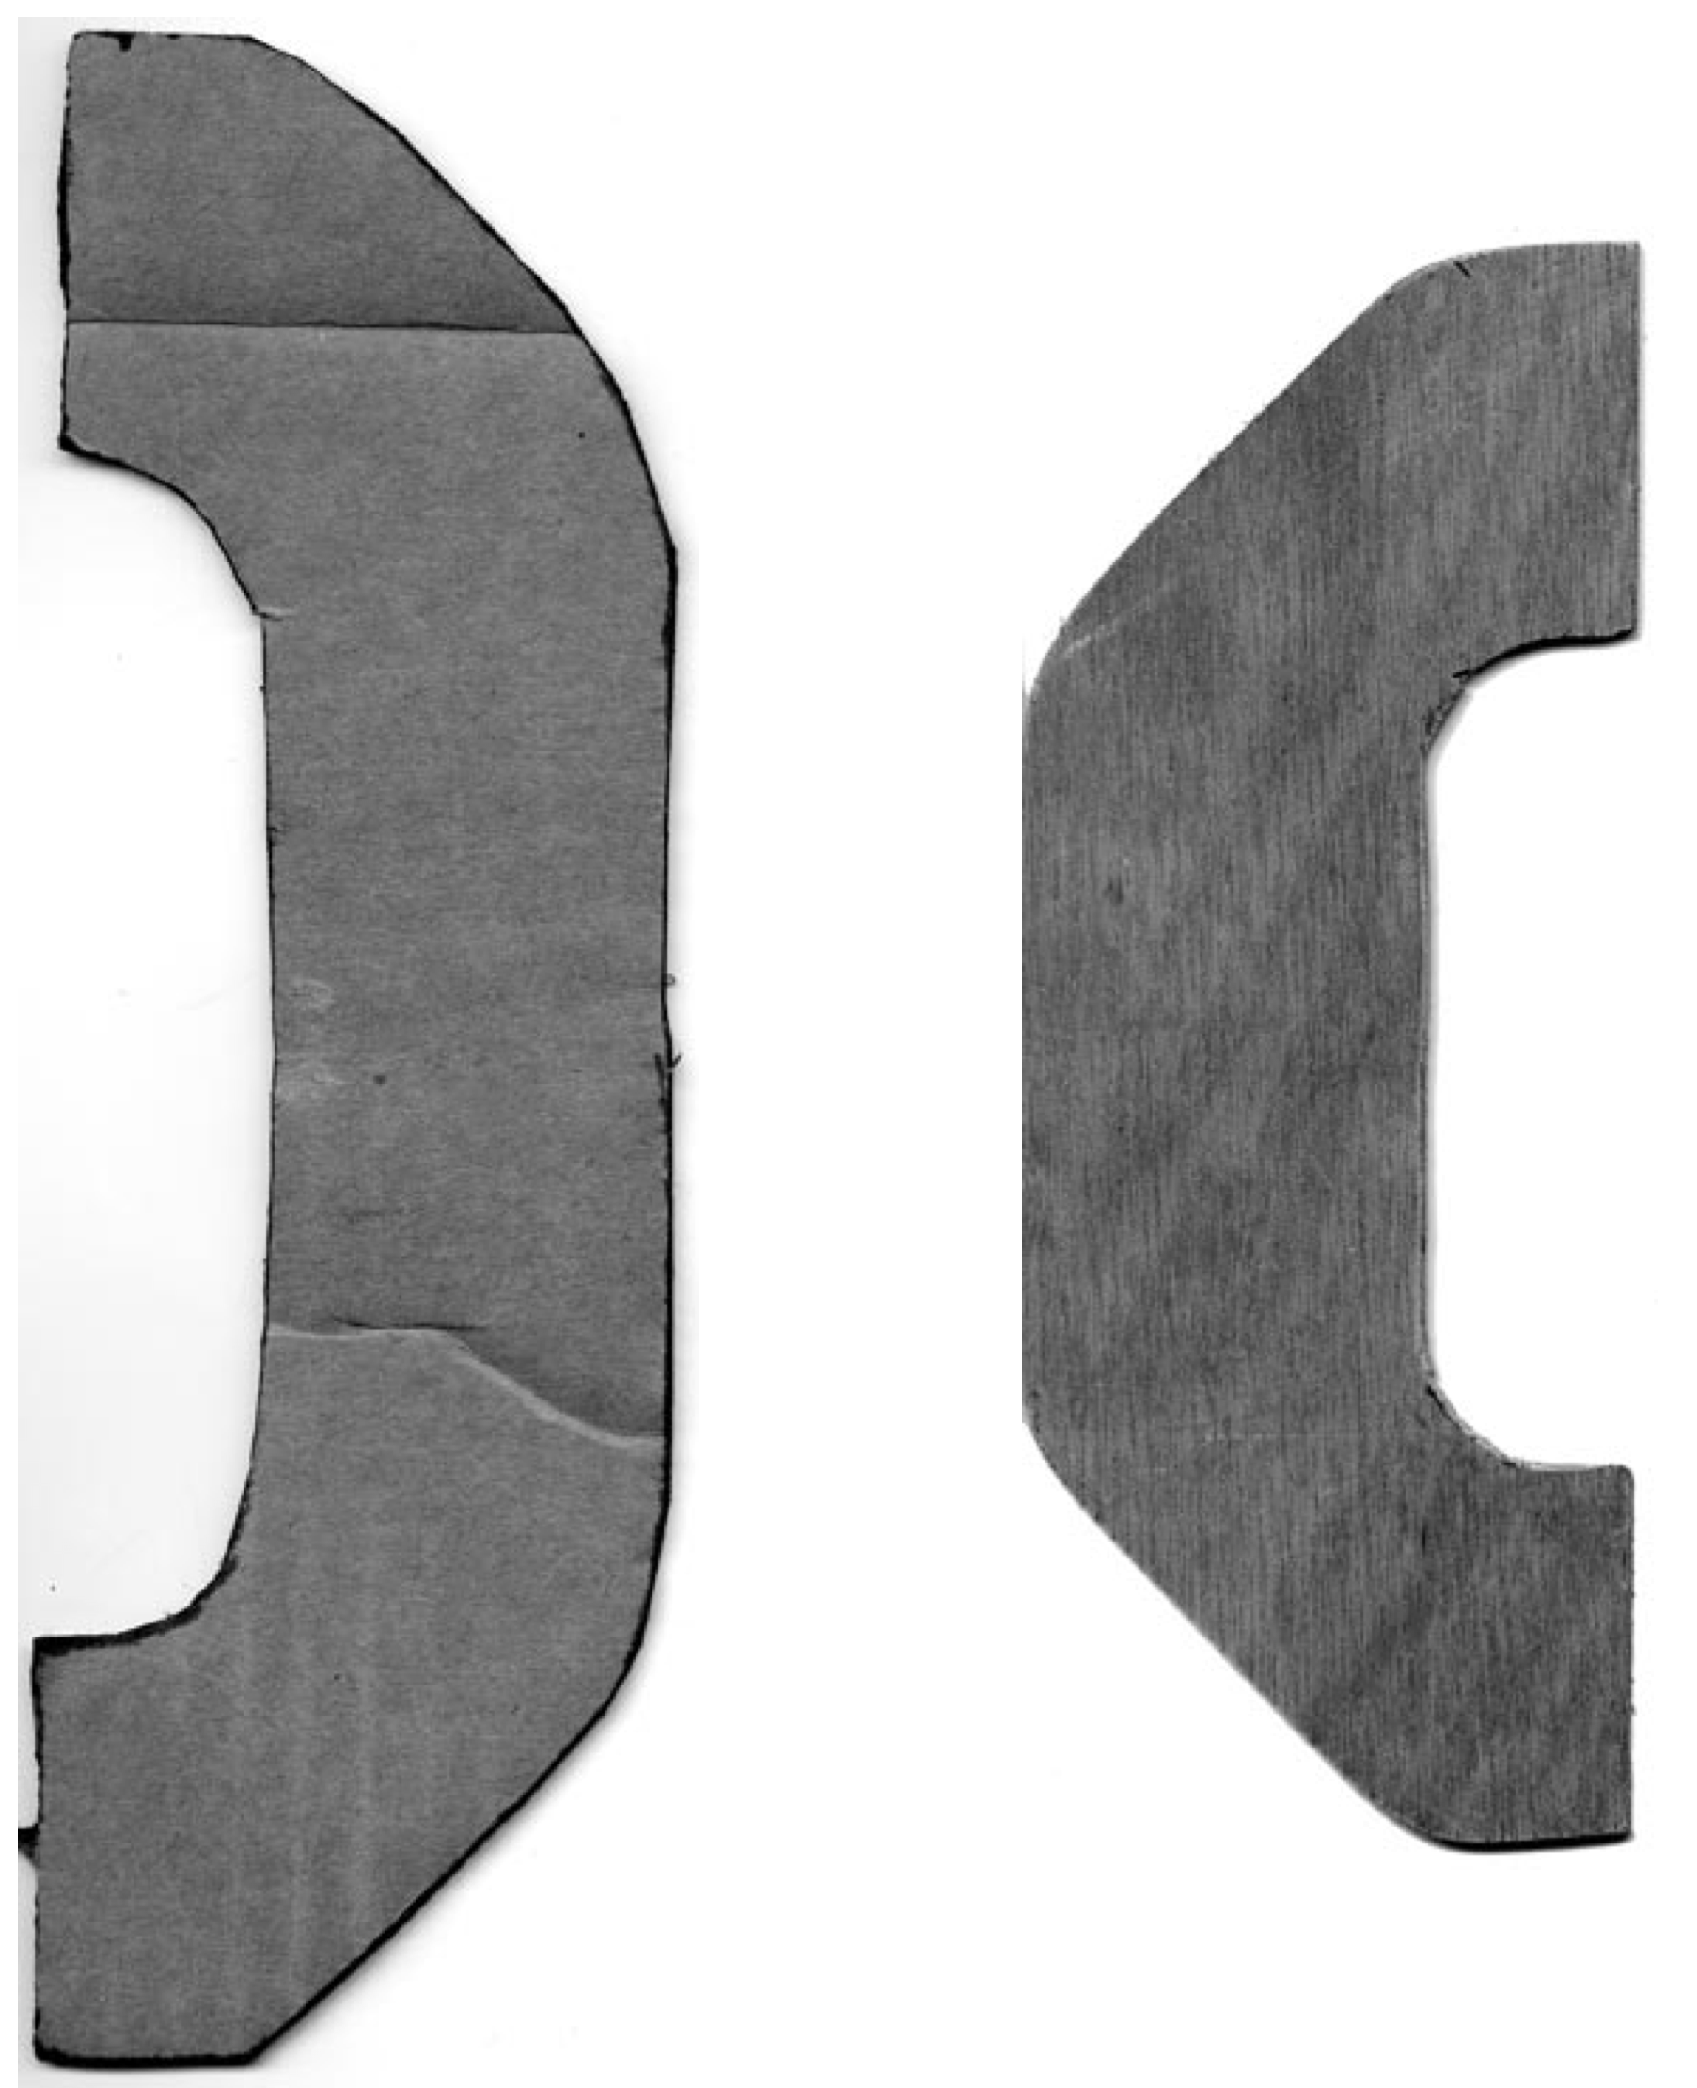
------
Copyright 2008 by Roberta Ashley. <rashley731 at aol.com>. Permission is granted for republication in SCA-related publications, provided the author is credited. Addresses change, but a reasonable attempt should be made to ensure that the author is notified of the publication and if possible receives a copy.

If this article is reprinted in a publication, please place a notice in the publication that you found this article in the Florilegium. I would also appreciate an email to myself, so that I can track which articles are being reprinted. Thanks. -Stefan.

<the end>

