boffer-weapns-msg - 1/24/11

Making and using boffer weapons in the SCA.

NOTE: See also the files: gorgets-msg, pottery-wepns-msg, SCAweapons-msg, W-T-Shields-art, Sword-Fighting-art, tourn-ideas-msg, chd-actvites-msg, children-msg.

************************************************************************
NOTICE -

This file is a collection of various messages having a common theme that I have collected from my reading of the various computer networks. Some messages date back to 1989, some may be as recent as yesterday.

This file is part of a collection of files called Stefan's Florilegium. These files are available on the Internet at: http://www.florilegium.org

I have done a limited amount of editing. Messages having to do with separate topics were sometimes split into different files and sometimes extraneous information was removed. For instance, the message IDs were removed to save space and remove clutter.

The comments made in these messages are not necessarily my viewpoints. I make no claims as to the accuracy of the information given by the individual authors.

Please respect the time and efforts of those who have written these messages. The copyright status of these messages is unclear at this time. If information is published from these messages, please give credit to the originator(s).

Thank you,
Mark S. Harris AKA: THLord Stefan li Rous
Stefan at florilegium.org
************************************************************************

Date: Sat, 21 May 2011 23:20:18 +1000
From: Raymond Wickham <insidious565 at hotmail.com>
Subject: Re: [Lochac] Boffer weapons.
To: <lochac at lochac.sca.org>

<<< I'm looking for some simple, coherant instructions for making good, sturdy,
SCA-legal boffer weapons for 12 year olds and older. The kids (and adults)
in question would like boffer swords, boffer "polearms", boffer daggers, and
shields. Can someone point me in the right direction please? I'm sure there
is a website out there somewhere, I just don't know where to look... >>>

These might give you a start

http://www.thealmightyguru.com/Boffer/

http://www.knightrealms.com/joomla/index.php?option=com_content&task=view&id=49&Itemid=62

Date: Sun, 22 May 2011 14:21:01 +1000
From: "Brett Hollindale" <agro at powerup.com.au>
Subject: Re: [Lochac] Boffer weapons.
To: "The Shambles: the SCA Lochac mailing list"
<lochac at lochac.sca.org>

<<< Umm, is there such a thing as SCA-legal boffer weapons since 12 year-olds
can't fight and there are no Society rules for boffer combat? Aren't they
just toys, not sporting equipment?

Cian, the unsure >>>

Fair comment - I am not aware of specifications on boffers but I use class
18 pressure pipe - the spec for javelins used in war - but in 15mm size.
This slides nicely into the black neoprene foam used for hot water pipe
insulation. The whole thing is about 31mm diameter so it looks quite like
an SCA sword. I make handguards out of garden hose.

The thing about boffers is that you need to control your force and
targeting. No headshots (unless you are in helmets) and no "excessive
force".

Agro

Date: Sun, 22 May 2011 02:14:08 -0500
From: Stefan li Rous <StefanliRous at austin.rr.com>
Subject: Re: [Lochac] Boffer weapons.
To: Lochac maillist <lochac at lochac.sca.org>

Anika/Lyssa asked:
<<< I'm looking for some simple, coherant instructions for making good, sturdy, SCA-legal boffer weapons for 12 year olds and older. The kids (and
adults) in question would like boffer swords, boffer "polearms", boffer
daggers, and shields. Can someone point me in the right direction please? I'm sure there is a website out there somewhere, I just don't know where to look..>>>

Boffer weapons are used in the Kingdom of Ansteorra's Teen Boffer
Divison (Ages 13-15) and perhaps in other SCA kingdoms as well.

This page gives the regulations and a step by step construction guide
for a sword.
http://youth-combat.ansteorra.org/sword_div3.htm

Stefan

Date: Sun, 22 May 2011 22:08:27 +1000
From: Karen Hovenga <khovenga at tpg.com.au>
Subject: Re: [Lochac] Boffer weapons.
To: "The Shambles: the SCA Lochac mailing list"
<lochac at lochac.sca.org>

The instruction to my children was always, "test the other kid's sword to
make sure you're happy to be hit with it".

Especially important after we discovered the kid who had wrapped an iron bar
in foam and duct tape - a looooong time ago.

There you go, a standard: Be prepared to be hit with it.

Sara

Date: Sun, 22 May 2011 20:39:15 +0800
From: Columb mac Diarmata <columb.mac.diarmata at gmail.com>
Subject: Re: [Lochac] Boffer weapons.
To: "The Shambles: the SCA Lochac mailing list"
<lochac at lochac.sca.org>

On Sun, May 22, 2011 at 8:08 PM, Karen Hovenga <khovenga at tpg.com.au> wrote:
> There you go, a standard: ?Be prepared to be hit with it.

I've had a fair bit of involvement in a local science fiction
convention (GenghisCon, geddit?) where they do a foam-weapon
tournament every year, with a weapon-making workshop the night before.

The quality control is pretty simple, we (the guys running the
workshop and tournament) get the people to wind up and hit us as hard
they can with the weapon in the upper arm (while we hold the other
hand up against an accidental face hit). That sometime takes a bit of
encouragement and 2, 3+ attempts. If the result is grey, I'll get one
of the more experienced guy to put in a hard shot. The result should
sting and turn red, but shouldn't bruise or make the muscles sore.

It that was OK, we take the weapon and give them a reasonable (say,
swung at SCA bottom-end good/top end light level of force) hit back in
the same way. If they aren't willing to be hit, or the first hit was
too painful, the weapon fails.

The game itself is played to touch, with masks, and is not even a pale
shadow of how much fun rattan is :). Convention people, especially
kids, cheat so much...

The main thing we learned is that *mass* is more important than
padding. Use light, open-cell foam rather than camp mat and a design
where the blade is about 50% air and has room to flex (get fatter,
flat to flat) when it hits. Agro's design sounds pretty good, so long
as you remember to have enough foam past the end of the pipe, but not
so much that it tears off.

Also, getting welts (from not enough padding) is much, much better
than getting head-swim (from too much mass).

I'm also a big fan of keeping a kid's game a game and not weighing it
down with rules, other than rule number one:

Don't make the other kids cry.

Columb

Date: Sun, 22 May 2011 18:39:11 -0700 (PDT)
From: Corin Anderson <lochaclist at yahoo.com>
Subject: Re: [Lochac] Boffer weapons.
To: "The Shambles: the SCA Lochac mailing list"
<lochac at lochac.sca.org>

I've just made some boffers for my 4 1/2 year old.

What I did was cut three silhouettes of a sword blade, 10 cm wide with a rounded
tip, out of of blue camp mat foam. I made them as long as the foam mat was wide.

Then I cut a 2 cm wide slot out of the center of one of the pieces from the hilt
end to about 10 cm from the tip. After that I sandwiched the three layers
together with some quick grip so that the piece with the channel was the middle
layer.

(The quick grip instructions say to cover the two surfaces to be glued and wait
until they are 'tack free' before pressing them together. I find that you can
just cover one surface and press the two together immediately. I suspect the
foam is porous enough that the solvents can evaporate quickly even when the
pieces are joined).

Once the glue was dry (I left it for a day but an hour would do) I inserted a
length of 19 mm electrical conduit into the channel in the middle layer of the
foam sandwich. I made a set of quillions in the same way and slid that on
underneath the 'blade'. At 2 cm wide the channel was a tight fit on the conduit.
I had to slowly ease the blade and quillions on to the conduit but I suspect
that was a good thing.

I taped the quillions to the blade with cloth tape, then cloth tapped the
'cutting' edge. After that it all got covered in long strips of duct tape (not
spirally wrapped).

To prevent punch through I inserted a rubber chair tip 'into' the 'pointy' end
of the conduit and taped it in place. An archery blunt would probably do the
same job. I used two rubber chair tips for the pommel; one that just fit the 19
mm conduit and a larger one that fit over that, and taped it in place with
electrical tape.

The result has a pleasing, to my eye, flat bladed profile and hits much softer
than the cylindrical foam wrapped around conduit version I'd made for him
earlier.

This may sound like a lot of effort but it really was quick to do.

I can link to some pictures if anyone is interested.

Corin

Date: Mon, 30 May 2011 00:25:56 -0700 (PDT)
From: Corin Anderson <lochaclist at yahoo.com>
Subject: Re: [Lochac] Boffer weapons - Some construction pics
To: "The Shambles: the SCA Lochac mailing list"
<lochac at lochac.sca.org>

A couple of images of my recent boffer construction:

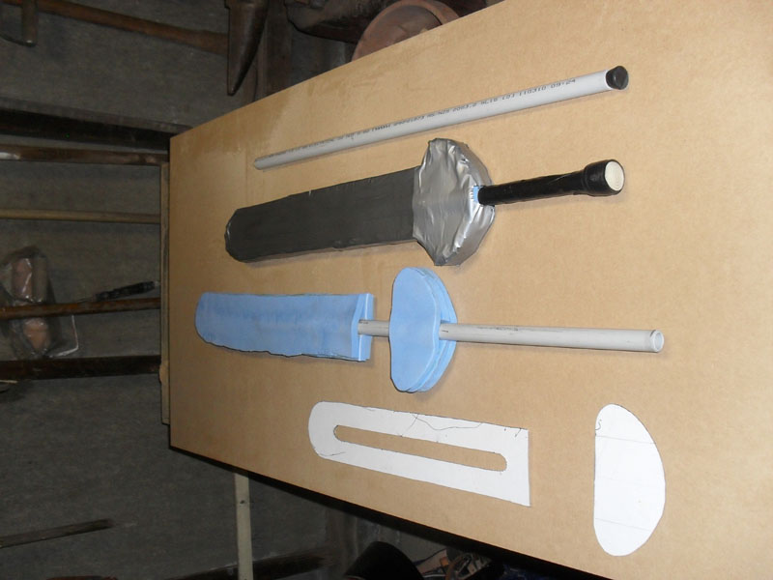

http://img593.imageshack.us/img593/1435/boffer1.jpg

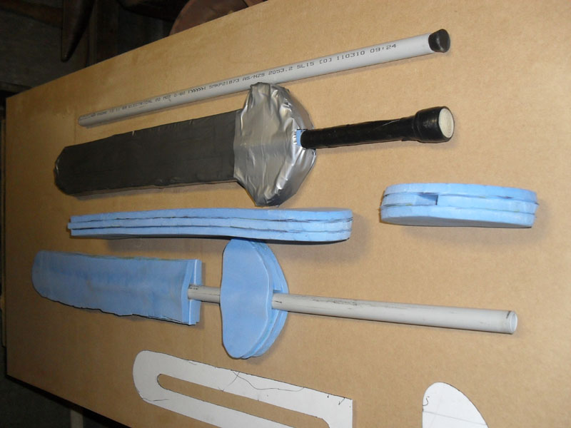

http://img69.imageshack.us/img69/884/boffer2.jpg

You can see how the cardboard pattern has the slot for the center section. It
goes all the way to the bottom on the actual foam piece but I've left some card
at the bottom of the pattern to hold it together.

The second image shows unfinished sword and quilliuon pieces from the side to
demonstrate the sandwich construction.

I used a small rubber commercial chair tip to fill the business end of the
tubing and prevent punch through. The image shows an archery blunt. If I used a
blunt I'd chamfer the edge with a sharp knife to bring the blunt diameter down
to match the tubing outside diameter (makes it easier to stuff the tube inside
the foam sandwich).

Having the blunt / tip inside the tubing means any thrusting force can only
force the tip into the tube and it won't cut through (it's probably overkill but
not really difficult).

Corin

<the end>

