Cast-Wood-Mlds-art - 7/29/15

"Pewter-Casting in Wood" by Lady Shara of Starwood, OVO, CMC, AoA

NOTE: See also the files: casting-msg, casting-lnks, pewter-msg, wood-msg, merch-woods-msg, woodworking-msg, Tool-Making-art, chip-carving-msg.

************************************************************************
NOTICE -

This article was submitted to me by the author for inclusion in this set of files, called Stefan's Florilegium.

These files are available on the Internet at: http://www.florilegium.org

Copyright to the contents of this file remains with the author or translator.

While the author will likely give permission for this work to be reprinted in SCA type publications, please check with the author first or check for any permissions granted at the end of this file.

Thank you,
Mark S. Harris...AKA:..Stefan li Rous
stefan at florilegium.org
************************************************************************

You can find more of Lady Shara's assorted work on her blog at: http://www.myspace.com/windsingersmoon

PEWTER-CASTING IN WOOD (03-27-09)
by Lady Shara of Starwood, OVO, CMC, AoA

I'm a woodcarver.
That's my identity.

I'm also an artist-researcher-costumer/seamstress-herbal gardener-architect wanna-be-embroiderer-writer-and a dozen other hats. But at heart, I'm just a craftsman with a passion for playing with my imagination.

I was packing for Gulf Wars, when my friend, Sandy, in Australia, presented me with a challenge.

'Carve a wooden mold and cast pewter in it'.

I knew that Stefan would most likely be at GW, and he'd have his casting stuff there.

The night before I left for the War, I went out and found a piece of hardwood. It was cheap hardwood, 'free' in fact. I sawed it off a slating board from a garden bench that had given up the ghost. If this experiment didn't work, nothing was lost but my carving time.

I searched my museum catalogs for a good project. I found a Medieval medallion that looked cool; I could've picked a less complicated piece, but I was really curious to see how much detail I could get in a cast and to best determine how much detail would be lost in subsequent castings. It took me a few minutes to cut the wood to size using my Japanese pull saw. I'm a real stickler for the use of traditional hand tools.

The piece of board had old flaking varnish on it. I laid the best side on a sheet of sandpaper on a table and sanded off all the varnish. This gave myself bare wood to draw my design on, and a flat work surface to make solid contact with a facing slab of soapstone. The soapstone was necessary. It was to help draw the hot metal down into the mold. The retained heat in the stone would do that.

To start the work of carving the mold, I first made a xerox the exact size of the original. Then I made a back-up copy, as I'd be cutting up the first one. I cut the first one out with small curved scissors. I then laid the cut-out on the wood in the best place for the mold cavity, spacing it far enough from the sides and the bottom to minimize any splitting, while leaving enough room toward the top, for a proper sprue.

I drew the outline on the wood with a pencil, and penciled in the sprue opening. If your tools are limited, take an angle point Exacto knife and go around the pattern lines with the knife at a sleight, inward, (toward the inner part of the mold) angle. You don't want to cut too deeply, (and you Don't want to make any undercuts). Wrapping all but about an 8th of the tip in masking or electrical tape will help you judge the depth. I have OOODLES of carving tools to chose from, so this wasn't anything I needed to do. (Not to mention a life-time of working with those tools)

Once the outline has been defined, I used a shallow sweep (curve) gouge to clean out all the wood in-between the cuts. I flattened the bottom uniformly. Using my cut-out pattern, as a guide I drew a line down the center. The design was a balanced one, a central pair of martini glasses, between the heads of two lions with open mouths. Below the glass shapes, was a single branch with leaves. I drew those in and carved them, first. There was a border around the piece, two angled cuts set it in. Then I drew in the lions and decorative dots, and carved those. Then carved in the sprue. At the bottom of the mold I did something seemingly unusual. I used the tip of the knife, to twist a 1/16 the dot of wood out, at the low point of each low portion of the mold. Then I cut a tiny sliver of wood out, between the dots and my mold.

We're taught to carve 'vent' lines in soapstone, for the air to escape so the metal can reach into the smallest parts of the mold. But over the years, I've seen a number of period molds in books, and a number of them have these small 'dots' instead of vent lines, especially at places where the mold tapers to a point. They may have been interpreted as merely a part of the finished design, and after some experimentation, they can, apparently, be used as such, if they fill with metal.

I happen to own a real Medieval casting mold.

It makes 3 different pendant-type castings. The molds go to within a 16th of an inch of the lower edge of my precious mold, there are no vent lines. But all three shapes have some form of tiny 'dot' at their furthest design points. My mold is finely cast in bronze. CLEARLY the mold was a prized possession to it's owner. Not only in it's intricacy, but in the mold itself. It's shaped like a small (2.5 x 2.75 inches) 3-petaled 'purse'. The back side has a lightly etched decorative scroll-work design. This mold was Clearly the work of a master, who took pride in his work.

(I will include photos, if I'm able)

The wooden mold took me only an hour to carve. A similar soapstone one, would have taken me Much longer to do.

So here's the question.

Do you need/want to make 25? 50? 100? castings from your mold?, or only a few, for personal use?, perhaps only one, Good casting?.

Good soapstone for making molds, is not easy to find for the beginner. Trying to find it to get started, may be more trouble than it's worth, if you only want a single piece, or several different pieces. And like Stefan has so often pointed out, it's going to cost you. The cost to buy it, sight-unseen, x 2 for the shipping.

Your pewter is easier to find.

For limited production, you can't beat a wood mold. It can be as cheap, as free. Learning to think and carve in reverse,....ummmmmm,...That can be a bit tricky, even to me. It requires a totally different mindset to what I'm used to doing.

Now.
As to what to 'do' next.
Take some baby powder and sprinkle it in the mold. Shake it, to make sure it coats all the wood mold interior,...then knock it on the edge of the table to remove the excess, following this, with blowing on it. THEN take your finger and rub the remaining powder coating into the pores of the wood.

This will seal them and act as an insulation to the wood, from the hot metal, thereby prolonging the usefulness/life of the mold, as well as a lubricant to assure the cooled metal releases easily from it.

In tiny areas, take a stylus or a pin with the head embedded into a small dowel or a bamboo skewer point, and burnish the powder into the tiniest details. If you round the blunt end of the skewer on a piece of sandpaper, to gently curve the edges of it, it will work great to burnish the inside of the rest of the mold.

Next, back the mold with a piece of warm soapstone, and proceed to cast, as you would when using a soapstone mold.

Before I started this experiment, I took a photo of my finished mold carving, to be able to compare it, later, with my mold after a set number of castings had been made.

My friend, Sandy, who clearly had experience with this sort of thing, since he's the one who'd suggested I try it, had told me to coat the inside with powder. That had not occurred to me, but once told, it made perfect sense.

Sandy had warned me that I wouldn't get but a few castings off the mold before charring would erode my carving, but the wood was free, and was destined for the woodpile for my firepit use, so I Really had nothing to lose, and hopefully knowledge to gain. It was a win/win situation.

As it was, I repeated my powder coating before each casting, and after 6, quit, for now, delighted to have gotten more castings off it than I'd dared hope for. I think I'm going to leave that mold alone. It's done it's job, and exceeded all expectations. When I get a chance, I'm going to get a new piece of maple and carve a different artifact, and keep a photo record on that, also, and ; a before casting pix, a pix of the mold after 3, 6, 9, 12 castings, and as many groups of 3 as I can do, before the mold becomes un-usable, and then a last pix of that, and the last casting to come off it. There was minor scorching on the lower face of the wood. Coating, The wood surface, alas, may have prevented that.

I LOVE experimental archeology. I love making the discoveries and keeping records so the experiments can be duplicated if they work, or altered until they Do work, with a written and photographic record to back it all up. I've now proven that the wood molds DO work, for pewter casting. I accepted the challenge, and Stefan and I are now able to benefit from what I've learned, as may others.

Good luck.
YIS
Shara

(p.s. Stefan, remember the tiny cracks at the bottom edge of the wood, and the single long crack with the grain across the base of the carving, between mold and vent dots? Well, you and I thought these were caused by the heat of the soapstone. We were mistaken.

When I got home, I enlarged my first, before casting, pix of the mold, and all these things were clearly, already in the wood. The Only thing the heat of the metal and soapstone did, was to open that bottom horizontal mold crack, a bit more (You can see on the casting I gave you, where the metal seeped into the crack there) The earliest attempts it was not so noticeable. I kept the 5th casting (and have been cleaning it up, at home) and gave you the last, (the 6th to be cast) The only serious charring, after 6 casts, was at the sprue end, where the metal was thickest and stayed hottest.

I'm gonna call this one a success.) Now, I'm off to try and make some clear pix of my Medieval Mold for you to see, and perhaps include it with the article

Photos:

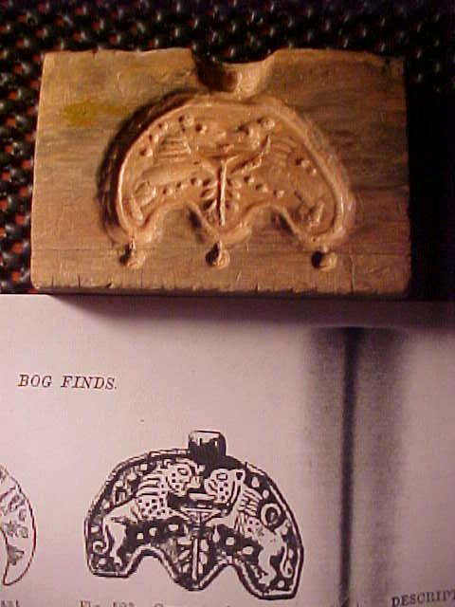

First pix of mold, before any casting : (and pix of museum Catalog page) (you can clearly see cracks, we discovered, later)

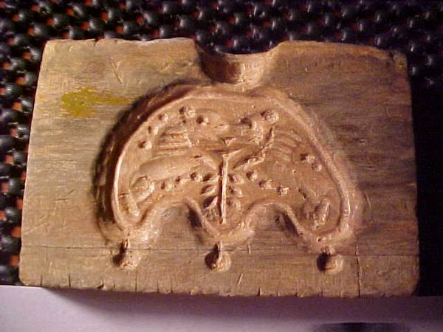

Close up photograph of the wooden mold.

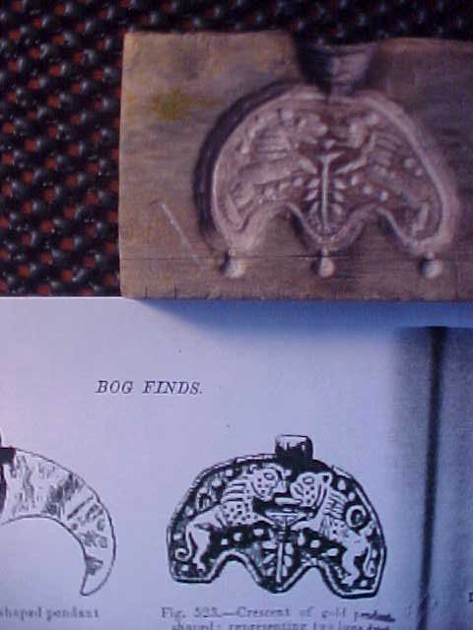

Mold, after 6 castings.

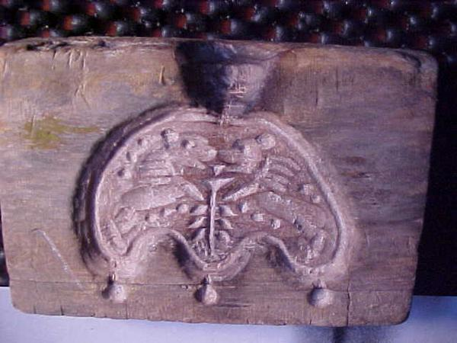

Closer, showing mild scorching and slightly more pronounced cracking.

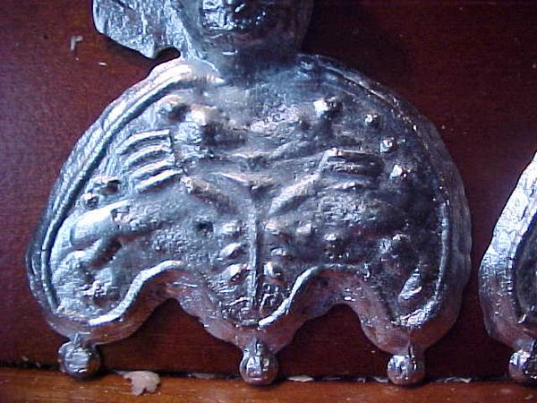

Very first casting, note dusty look where I didn't get the powder well rubbed in on the upper portion. Also note good clear air-'dots', at bottom, where no other vents were used, these may become part of my future molds.

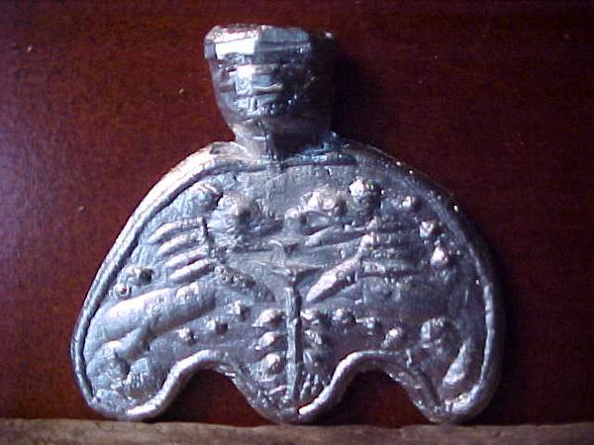

My copy, almost cleaned up,...was from the 5th casting, and was the best of the lot. Stefan got the 6th and last casting.

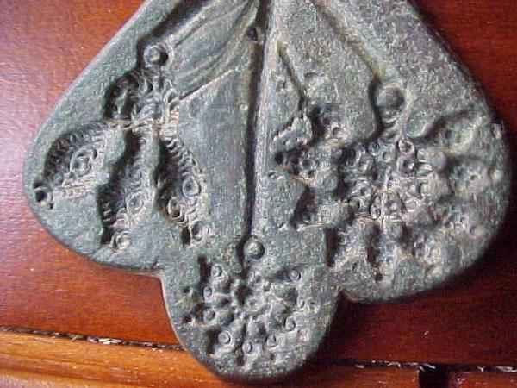

Medieval Mold, of cast bronze, most likely for gold earrings. Note the small dots and closeness of mold to edges.

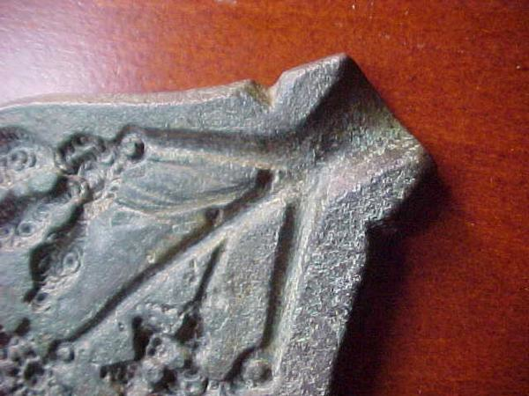

Close-up of Sprue area and notches near top.

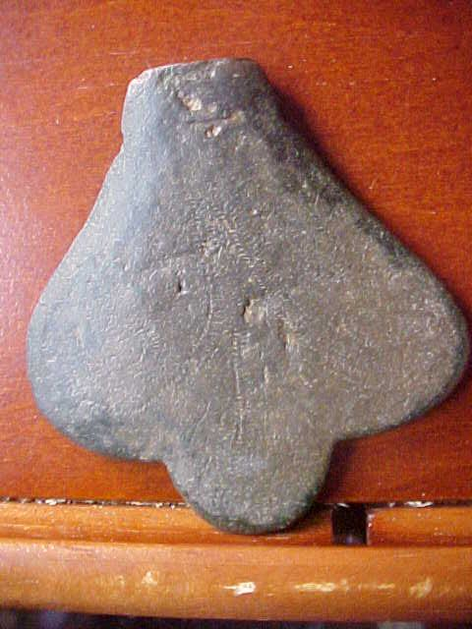

And the back of the medieval mold. You can barely make out the delicate spiral decorations swirling down from the sprue end.

------
Copyright 2009 by R.D. Wertz. <windsingersmoon at yahoo.com>. Permission is granted for republication in SCA-related publications, provided the author is credited. Addresses change, but a reasonable attempt should be made to ensure that the author is notified of the publication and if possible receives a copy.

If this article is reprinted in a publication, I would appreciate a notice in the publication that you found this article in the Florilegium. I would also appreciate an email to myself, so that I can track which articles are being reprinted. Thanks. -Stefan.

<the end>

