Gem-Cutting-art - 4/25/15

"Gemstone cutting and polishing in the 12-15th century" by Lord Silvius Foppa.

NOTE: See also the files: lapidary-msg, A-Lapidary-art, polishing-msg, Intaglio-Gems-art, Rock-Crystal-art, amber-msg, Emeralds-art, Rubies-Spphrs-art, Semi-Pre-Gems-art.

************************************************************************
NOTICE -

This article was submitted to me by the author for inclusion in this set of files, called Stefan's Florilegium.

These files are available on the Internet at: http://www.florilegium.org

Copyright to the contents of this file remains with the author or translator.

While the author will likely give permission for this work to be reprinted in SCA type publications, please check with the author first or check for any permissions granted at the end of this file.

Thank you,
Mark S. Harris...AKA:..Stefan li Rous
stefan at florilegium.org
************************************************************************

Gemstone cutting and polishing in the 12-15th century
by Lord Silvius Foppa

Gem cutting and polishing is described in ON DIVERS ARTS, book III, ch 95 "Polishing Gems" by Theophilus (1132-33 AD).

SAFETY: Inhaling rock dust causes silicosis (white lung). Always cut with the stone wet. Water can encapsulate the dust while you are cutting the stone. A dust mask is recommended. Eye protection and hearing protection should be worn when operating lapidary machinery. Station cleanup after cutting is necessary to control rock dust, as the water evaporates.

The process of gem cutting can be broken into the following steps: dopping, forming, grinding, and polishing. The following process describes the cutting of cabochons from agate or jasper.

DOPING is the act of cementing the stone to a stick (called a dop stick) of similar thickness with wax or pitch. The wax or pitch is melted, and the stone is heated. One end of the stick is brought to temperature in the melted wax, and then this is pressed to the heated stone. Both are then allowed to cool to room temperature. Wax or pitch can be removed by heating, or by placing it in a very cold environment. Green dop wax is available at any lapidary supply, and is still used today. Some waxes were available in the 12th century.

FORMING involves rubbing the stone against sandstone to abrade the stone to the desired shape. Theophilus states this involves both hands on the dop stick, implying that considerable force is required to shape the stone to the desired shape. Take care to not overheat the stone - add water to this process frequently. Several medieval gemstones retain surface inclusions because the cutter was unwilling or unable to remove them in this step (ex: Crown of Charlemagne). Forming is where most of the stone is abraded, uses the coarsest sandstone or grit, and takes the longest amount of time (this is still true today, although sandstone wheels have been replaced by diamond-grit wheels on modern lapidary equipment to allow the lapidary to cut harder stones.).

GRINDING is the act of rubbing the shaped stone on wood or leather to remove scratches applied by the sandstone while forming. This is done by putting finer scratches in the dopped stone. Theophilus states that "powdered emery (corundum) or powdered tile are used with (lime wood or leather) and spit to polish the stone." This is technically still grinding, but once the scratches pass 600 grit (modern) fineness they are no longer so detectable by the human eye without help. Lime wood is preferred because it has large grain structure, which retains the gem powder used for grinding. This technique was used until the last 40 years in faceting, when plastics, steel, and resins replaced wood as the surface-material of choice for cutting.

The act of crushing or abrading emery or tile does not produce uniform grit size, and using too large a grit will put larger scratches in your stone. To resolve this, the powder must first be sorted by fineness. This can be done with multiple water vessels that are about half full. Pour the powdered material into one vessel that is half full of water and shake. Wait a specified amount of time, then pour the water into the second vessel. Repeat to 3rd vessel. Repeat to 4th vessel. Repeat to 5th vessel. The grit that collects in the first vessel is coarse. The grit in the second vessel is finer than the grit in the first vessel, and so on, until you get to what remains in vessel #5. The grit in vessel #1 should be reground. The grit in vessels #2-4 are suitable for GRINDING on limewood or leather. The contents of vessel #5 should be used as a pre-polish (final grind) before moving on to the next step. Note that this also applies to tile dust, and is a step not mentioned by Theophilus – I came across the sorting in a 19th century blacksmithing tome, but it makes sense – without sorting the grit or polish the finest you will be able to achieve is about 300 grit, and stones in period are more polished than that; this could be a "trade secret" or assumed knowledge that prevents a layman from succeeding in following these directions. Always wash your stone and hands between grits to prevent the contamination of the finer grit with coarser grit.

POLISH – Theophilus says "put some tile dust mixed with saliva on a goat skin that is fastened to the bottom of a piece of wood with nails. Rub the stone on the goat skin with saliva until clear."

Polishing is removing the finest eye-visible scratches, which usually disappear between 600 and 2000 grit. Some water is necessary to this step to keep the stone from cracking, you want the surface of the stone to get warm so it will polish correctly by rubbing it repeatedly over the wet leather and ground tile. Do not get the stone too warm, as it can melt the wax and the stone pops off the dop stick, or if it overheats the stone can crack (Glass is especially prone to this, as is obsidian (volcanic glass)). It is best to paint the dust on the center of the leather with a moistened paint brush.

The goal of polishing is to produce a "water glass" finish. This test is fairly simple. Dip the stone on the dop stick in a glass of water. Observe the stone. Dry the stone with a clean cloth. Observe the stone again. If the wet stone looks the same as the dry stone in full sunlight or good light, then it is said to have a "water glass" finish. On conventional light bulbs, this usually means you can read the writing on the tip of the bulb in the reflection on the stone (ie "GE 100Watt").

Theophilus mentions no use of machinery in this process. Sometime in the 13th-14th century, the use of waterpower was introduced to the process of grinding and polishing, using enormous water powered sandstone grinding wheels and buffing wheels, such as the ones around Idar-Oberstein (see Weiherschleife, a water-powered lapidary factory on the Idar river built in 1634, operated until 1945, and now a museum). Powdered tile or stone and water are used for polishing.

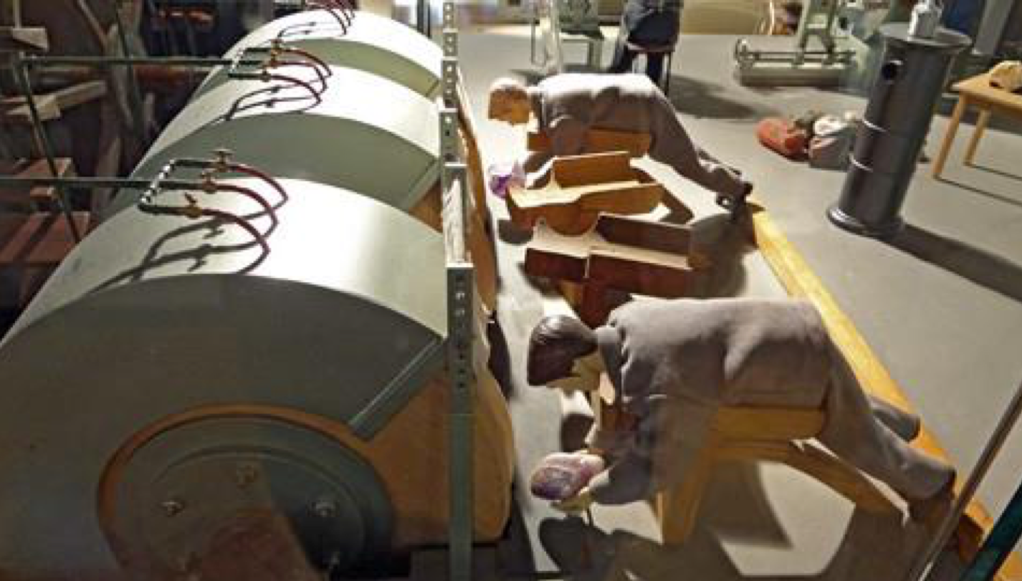

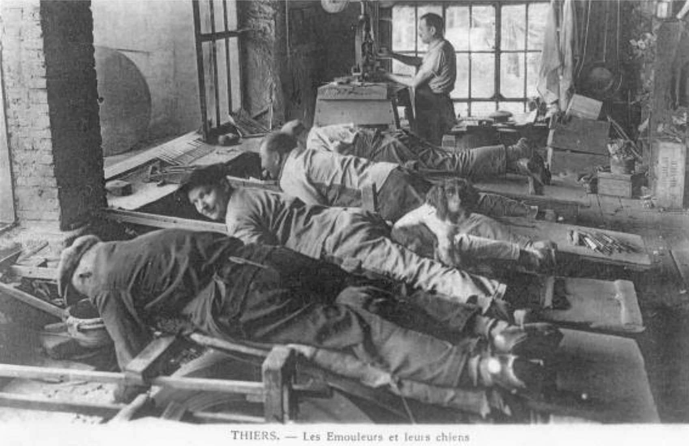

https://www.youtube.com/watch?v=a65en6Oh8jE

Historische Weiherschleife
Tiefensteiner Strasse 87
55743 Idar-Oberstein, Germany

"Rock Crystal is water hardened into ice, which is then hardened through many years into stone. It is cut and polished in this way.

Take some chaser's pitch, about which we spoke above [III-59], and put it on a fire until it melts. Then cement the crystal with it to a long piece of wood of comparable thickness. When it is cold, rub it with both hands on a piece of hard sandstone, adding water, until it takes the shape you want to give it. Then [rub it] on another stone but finer until it becomes completely smooth. Now take a flat, smooth lead plate and put on it some moistened tile (which has been abraded to dust on a hard hone) and polish the crystal on it until it becomes brilliant. Lastly, put some tile dust moistened with saliva on a goat skin that has been stretched on a piece of wood and fastened to the underside with nails. Rub [the crystal] on this until it is completely clear.

If you want to carve a piece of rock crystal, take a two to three year old goat and bind its feet together and cut a hole between its breast and stomach, in the place where the heart is, and put the crystal in there, so that it lies in its blood until it is hot. At once take it out and engrave whatever you want on it, while this heat lasts. When it begins to cool and become hard, put it back in the goat's blood, and take it out again when it is hot, and engrave it. Keep on doing so until you finish the carving. Finally, heat it again, take it out and rub it with a woolen cloth so that you may render it brilliant with the same blood."
...
"In the same way onyx, beryl, emerald, jasper, chalcedony and the other precious stones are cut, ground, and polished. A very fine powder is made from fragments of crystal. This is mixed with water and put on a smooth flat piece of lime wood and the same stones are rubbed on it and polished. Hyacinth, which is harder, is polished in the following way. There is a stone called emery, which is crushed until it is like sand, then placed on a smooth copper plate and mixed with water and the hyacinth is shaped by rubbing on this. The washings which run off should be carefully collected in a clean basin and allowed to stand overnight. On the following day the water should be entirely removed and the powder dried. Afterwards put it on a smooth flat limewood board, wet it with saliva, and polish the hyacinth on it. Gems made of glass are also ground and polished in the same way as rock crystal."

- Theophilus, ON DIVERS ARTS, III, ch 95. P. 189-191, translated from latin by John G. Hawthorne and Cyril Stanley Smith. 1963 (orig 1132-33)

If you want to learn more about cutting gems, please contact your local gem and mineral club. These folks can often be found at gem shows or in the phone book, and teach classes for a small fee (As of this writing my local club, Arlington Gem & Mineral, www.agemclub.org charges $3/hr to members for classes not requiring an outside instructor). These clubs often teach cabochon cutting, faceting, silversmithing, glass work, chasing & repousse, tool making, and much more, often have lapidary equipment available at certain times of the week for use by members, and organize field trips for members who want to find their own rocks.

BIBLIOGRAPHY

Kraus, Pansy D., Introduction to Lapidary, Chilton Book Company, Radnor, Pennsylvania, 1987

Theophilus, On Divers Arts, Dover Publications Inc, New York, 1963

Fun4All11, Historische Weiherschleife bei Idar-Oberstein, youtube, 2013

------
Copyright 2012, 2015 by Donald Whitney. <Dwhitney98 at hotmail.com>. Permission is granted for republication in SCA-related publications, provided the author is credited. Addresses change, but a reasonable attempt should be made to ensure that the author is notified of the publication and if possible receives a copy.

If this article is reprinted in a publication, please place a notice in the publication that you found this article in the Florilegium. I would also appreciate an email to myself, so that I can track which articles are being reprinted. Thanks. -Stefan.

<the end>

