Paintbrsh-Fur-art - 10/1/19

"Making Paint Brushes Using Fur" by Lady Samin.

NOTE: See also the files: brushes-msg, fur-msg, horsehair-msg, pigments-msg, Tool-Making-art, art, Ink-Making-art, quills-msg, writing-inst-msg.

************************************************************************
NOTICE -

This article was added to this set of files, called Stefan's Florilegium, with the permission of the author.

These files are available on the Internet at: http://www.florilegium.org

Copyright to the contents of this file remains with the author or translator.

While the author will likely give permission for this work to be reprinted in SCA type publications, please check with the author first or check for any permissions granted at the end of this file.

Thank you,
Mark S. Harris...AKA:..Stefan li Rous
stefan at florilegium.org
************************************************************************

Making Paint Brushes Using Fur
by Lady Samin

A special thank you to Lord Godefroy du Lyon of the Kingdom of North Shield for providing the fur used to make all of he brushes used for this handout, and for my students to use in this class.

Materials:

• Hot water
• Cup or jar
• Feather with solid quill
• Silk thread
• Bee's wax
• Stick for a handle
• Fur of some kind, prepped for hair removal
• Knife / scissors
• Flea comb
• Velcro stick
• White and black fabric or paper
• Small vial
• T-Pins
• Gum Arabic
• Cheese glue
• Bamboo skewer or tooth pic
• Paper towels

A bit about fur:

There are various types of hair within one animal's fur. The long, straight and thick guard hairs are the ones needed for paint brushes. The other ones are discarded. This is not always an easy task. Fox, coyote, cat and others are so mixed together it can be a challenge. Other animals are a bit easier; mink and beaver have guard hairs that extend well above the rest of the fur making them easier to harvest. In the photo below and to the left, of cat hair, there are four categories of hair. Only the three guard hairs on the left are usable for brush making. Between species the guard hairs differ too, as seen in the diagram on the right. The hairs are, from left to right; 1-Kolinsky sable, 2-sable, 3-nylon, 4-Ox, 5-squirrel, 6-sheep, 7-mongoose, 8-horse, 9-badger, and 10- (hog) bristle.

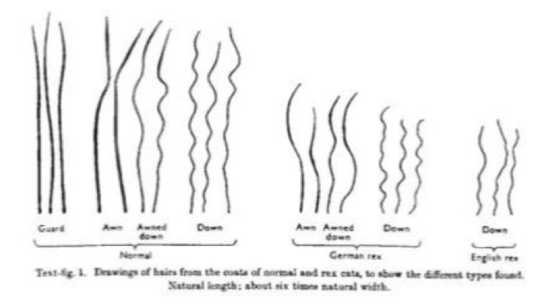
Figure I The Journal of Genetics

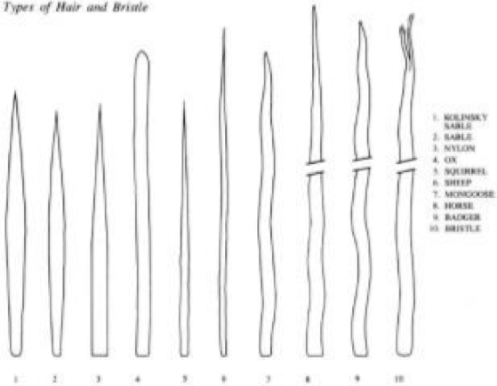
Figure II Art Hardware (L., 1987)

Besides the visual differences of these hairs, there are two traits that effect how a brush will function. The first are scales. Natural hairs have scales, which trap and hold liquids, and slowly, release it. More scales mean a better absorbency of paints, and a natural feed to the tip of the hair for good control Fewer scales or no scales at all (synthetic fibers) let the liquid immediately flow to the tip and can result in uncontrolled release of paint. The second trait is "spring", or resiliency. Some hairs will return to their original shape better than others after use. The better the "spring", the better you can control of the tip of the brush. Lack of spring can mean the brush is so soft that you cannot determine, by feel, if it is touching the surface you are working on. These two features will strongly determine the quality of your brushes.

I have tried many furs, fox, coyote, mink, ermine, beaver, muskrat and most recently, squirrel tail. So far muskrat and squirrel have produced the best brushes, followed by beaver.

If you get furs that have been used on a garment, check to make sure it has guard hairs.
Often, they are shaved off to give a smooth appearance and cannot be used to make a brush. You can see the cut guard hairs in this coat that was given to me.

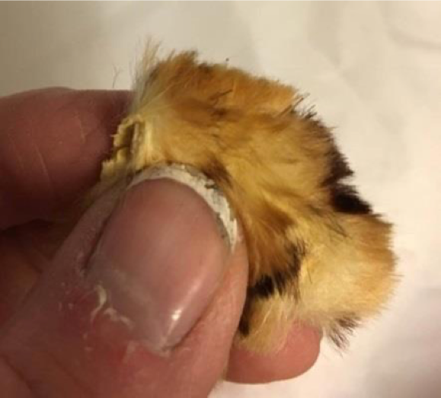

Fur Prep:

If the fur is from a fresh kill, according to Cennini, it should be thoroughly washed and boiled about an hour to two, then left to dry. It is not necessary to have the hide completely dry before removing the hair. An alternative method is to de-hair the hide by soaking the fresh hide for three hours or more in hot water, and then scraping the hair off. (De-flesh it first). You can see this process in this video:

https://www.youtube.com/watch?v=BvLWeB6kluk (Hot water method for dehairing rawhide).

It is important not to over-heat the water, keep it under 140 degrees Fahrenheit.

If the fur has been processed (i.e. you buy it on-line or from a re-sale store as a garment) do not boil it, it has already been through a lot! It should be washed thoroughly, but gently, to remove oils and dirt, and to make working with it more sanitary.

Furs from discarded garments need a light touch when washing. Use a shampoo for this (not dish washer liquid) – it is hair after all. Let the fur air dry. The hide doesn't have to completely dry.

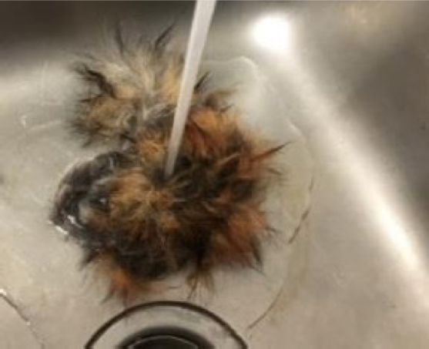

These brushes will be made according to the instructions given by Cenninni in his book "Il Libro dell A'rte", written in fifteenth-century Florence.

Procedures:

Quill Prep:

Wash the feathers, (they do not need to be dried) then fill a cup or jar with boiling, or near boiling water and place the feather into it, quill side down. Let it rest there for 20 or more minutes. Add more hot water if needed. The washing is for cleanliness, the soaking to soften the quill. Soaking the feathers, helps to prevent the quill from splitting during cutting and brush making.

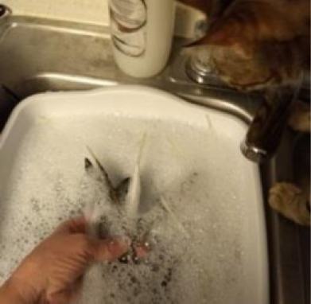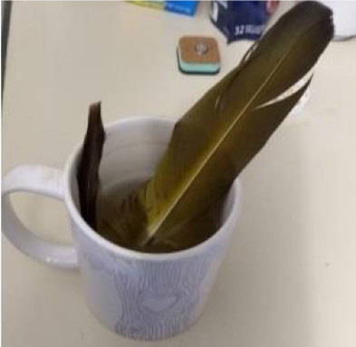

Thread prep:

Pull about a two-foot bit of silk thread across some bees wax several times to coat it. Set aside.

Stick prep:

Take a feather from the cup (after it has soaked about 20 minutes, to soften it up a bit, and compare your stick diameter to your quill diameter. Use a pen knife (or vegetable peeler in this class) to shave it about the size of the quill diameter, and so it will go into the quill from the wide end, about halfway. It should have a snug fit, but not too tight (you don't want to split the quill). Set it aside with the thread and quill. Doing these prep steps makes the brush assembly later on go much faster and smoother.

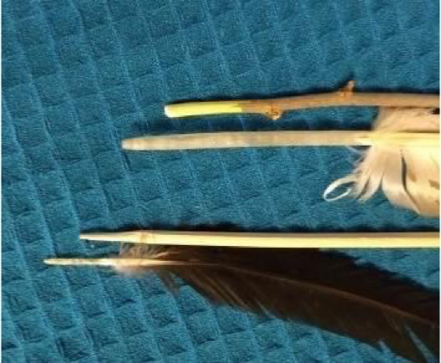

Brush Head:

You can start gathering the hairs while you wait for the feathers to soak.

1. Gather guard hairs: Gather Twice as many as you think you will need! While the feather is being softened up in the water, collect the guard hairs from the fur. To do this, take the dry fur and use a comb or brush to brush it until it is soft and not matted down against the skin, as is usual after washing. I use a flea comb for this. Take a small bit of fur in one hand and hold it up perpendicular to the attached skin. Use a scissors to cut it off as close to the skin as possible. On left will be fox and the right is beaver in the following pictures. I always keep the hairs pointed so the tip end is to my right, and lay them on a marked paper towel. The uncut end has the nicely tapered ends that will make a good brush tip. The cut ends are blunt and do not make a good brush tip. It is often difficult to tell the difference just by looking.

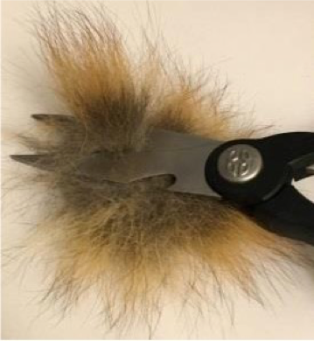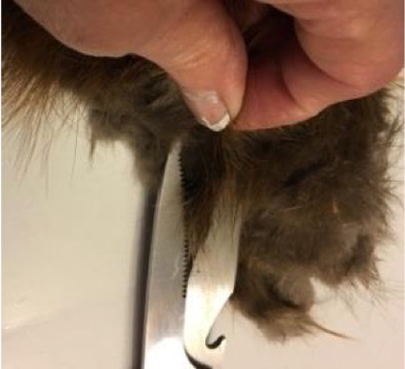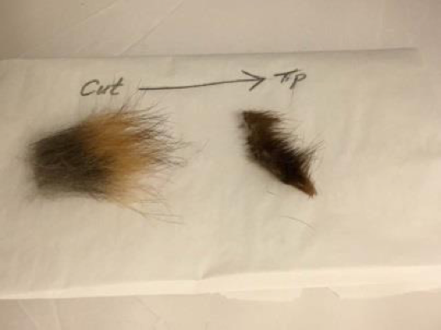

2. Hold the hairs by the cut end and brush away the under fur. Then reverse it, and hold the hairs by the uncut end and brush away again. Use the Velcro if you need to, to get rid of the under fur. You won't get it all, but at least get the bushy parts.

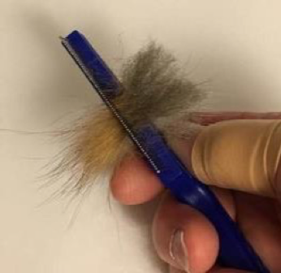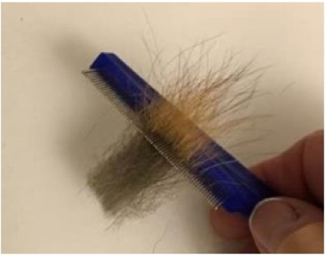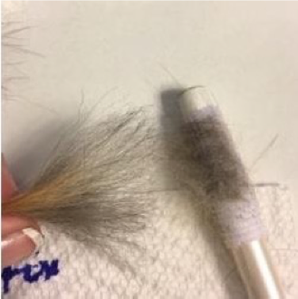

3. For very fluffy hair, like fox and coyote, hold the hair by the cut end and fan it out a bit, use your fingers or a tweezers to pull the guard hairs out. They are thicker and straighter than the rest.

4. It is tempting to gather the fine hairs that are "kind of" straight, but don't use them, they are too soft. Most of the fur will be discarded.

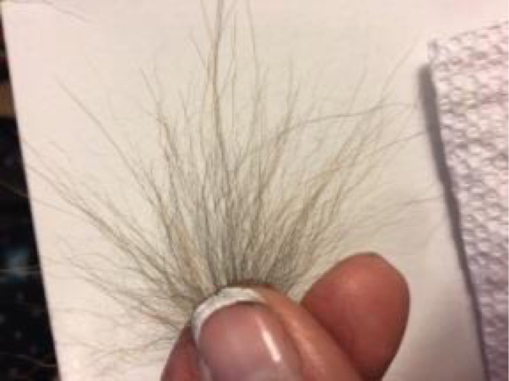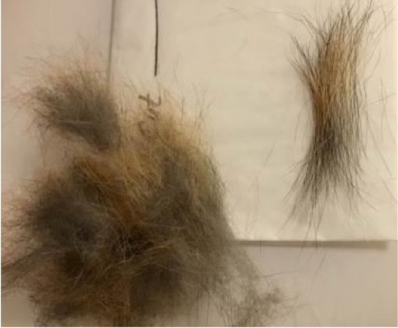

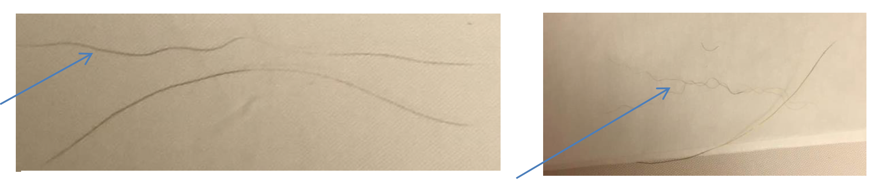
In the above two photos, the hairs marked by the blue arrow, cannot be used. The straight (or slightly curved) hair is good for use in making a brush.

ONLY take the straight THICK guard hairs. There will be other straight hairs too, but they will be very fine, and not suitable for the brush. Once you have gathered the guard hairs from that bit of fur, put the underfur into a discard pile, and cut off another section of fur. Do this until you get the amount of hair that you think you will need. You might find some Velcro helps pull out the underfur.

5. Some other types of fur are different. Mink and beaver have a short compact underfur, and the guard hairs extend well above it. This makes gathering them a bit easier. Comb the same way you did for the fox, but you will see almost all of the underfur comes off at once. Beaver is much like mink, but longer and easier to harvest.

Mink Fur

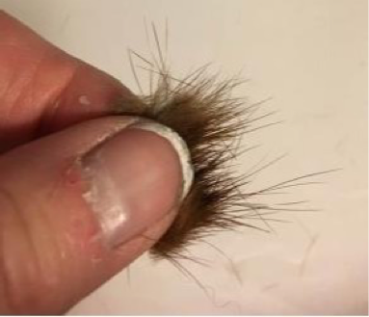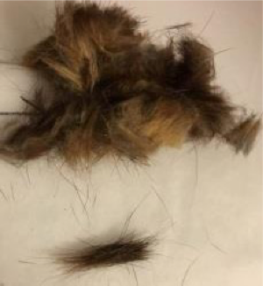

Beaver Fur

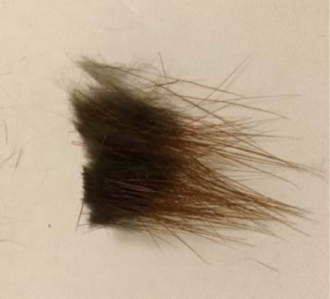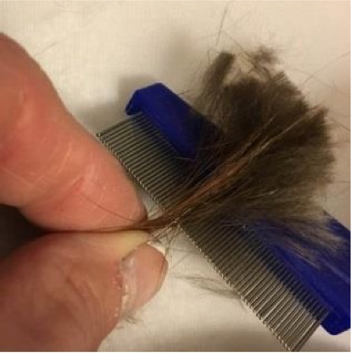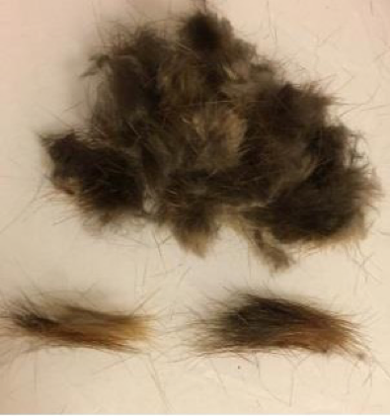

6. Sorting the hairs: Now gather all the hairs that you collected and hold the UNCUT end. Use the flea brush again to comb from your fingers towards the cut end to pull out any under fur that you may encounter. Then hold the cut ends in your hand and fan out the UNCUT ends. Pull out and discard any non-straight hairs and any very fine hairs, until only the thicker guard hairs remain. This can be very time consuming, but it will make the difference between a brush that just "looks" like a brush, and one that will actually work well.

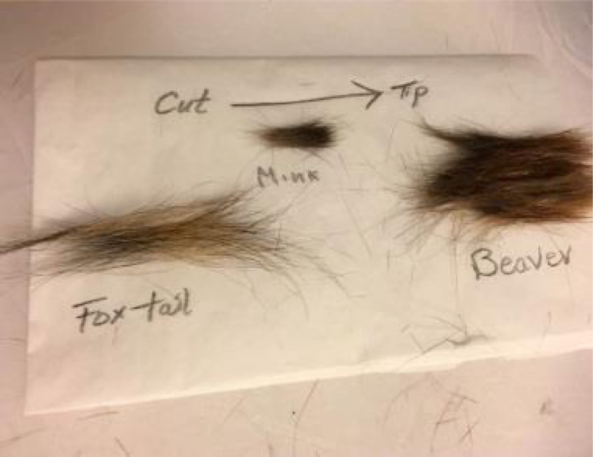

7. Fitting the head to the quill: Cut off a very small section at the very tip of the narrow end. You don't want to cut too far up, or the opening will be too big (you can always enlarge it later if you need to). Then cut the feather off above that spot as far as you can – without going into the feather part, or the part that has a grove on it. If you cut up too high the quill will split. Make this top cut at a 45-degree angle (see the pic below). Use the pin or toothpick to pull out the membrane that is inside of the quill. A skewer might help with this as well.

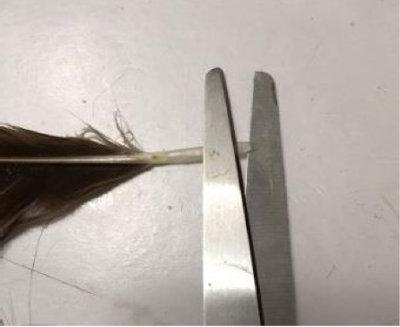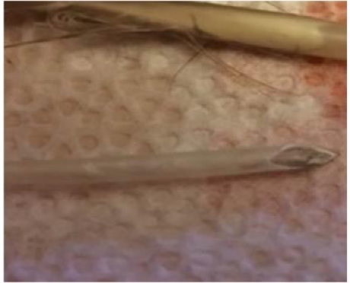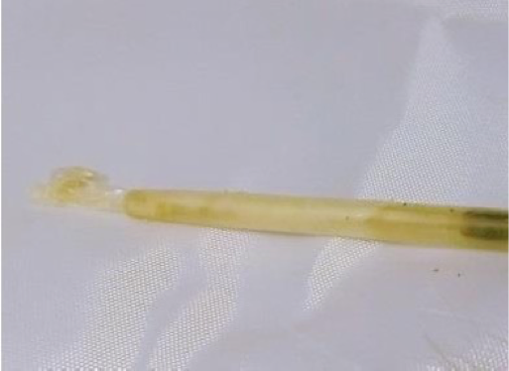

8. Gather the guard hairs you collected and tie them tightly together in the center. This is a prep step and it does not matter if they are very even right now. Dip it into the gum Arabic from the uncut tip to the knot and use your fingers to make a point, let it dry for a few minutes.

<Pics to be added later>

9. When it is dry, take this bundle of hair that resembles a brush-head, feed it into the top of the quill at the angled cut, feeding in the uncut tip first. It should go through without binding, but not be too loose either. As it emerges from the other end, it should create a snug fit at the tip. If there are gaps or it is too tight, add or remove hairs, until you get a good fit. The photo on the left shows a lose fit. More hair needs to be added to that one. Once you get a good fir, rinse off the gum Arabic, untie or cut off the thread, and spread the hairs out on a paper towel to dry – make sure you keep them parallel and have the tips all pointed in the same direction!

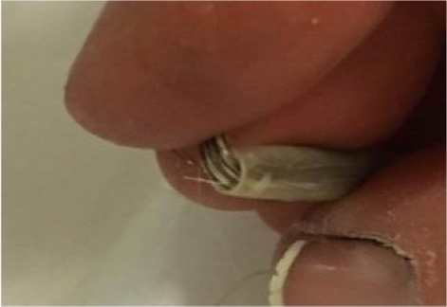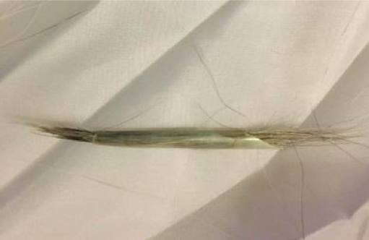

10. Making the hair tips even: Put the hairs, UNCUT side down, into the ceramic vial. You can make a small paper "funnel" to help the hairs slide in.

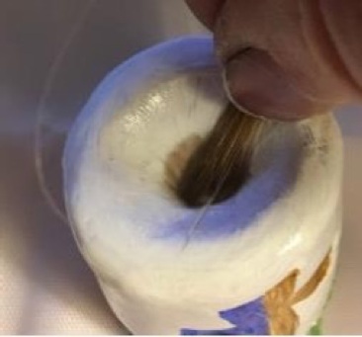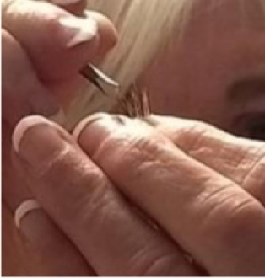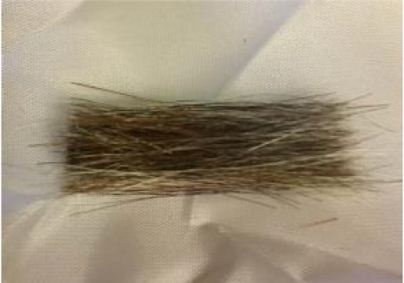

11. Tap the vial on the table to jostle the hairs; they should start to fall to the bottom of the container. After a minute or so of this tapping, carefully remove the hair from the tube. If there are little fuzzy hairs, or odd hairs, pull them out with the tweezers. Repeat until the hairs are even. Fuzzy hairs that you missed will show up now, so combing again can help get rid of them. You will lose a surprising number of hairs this way, which is why you need extras, to replace them if needed to keep you fit (in the quill) good. Do it again until you are satisfied that your brush head is free of unwanted hair, and the ends are even. A few stray ends are ok. You will take care of them later.

If you find that you have a difficult time getting them even, you can cut off some of the length (at the cut end) to make it a bit shorter (but keep in mind the length you will need for the brush head – so it fits into the quill half way with the painting tip sticking out). This helps because as the hair gets closer to the hide, it tends to get more curvy and therefore will tangle up with other hairs, and not slide past them as easily.

12. Once you have a good brush head shape, tie the hairs using the waxed bit of silk thread that you prepared earlier. To do this, put one end of the thread between your teeth. Holding the hairs in your non-dominant hand, use your other hand to wrap the thread around the bundle about in the center (or closer to the uncut ends – depending on how long you want the brush to be). Then make a knot and pull it tight. You may want to make a second knot a bit further up the brush towards the cut end of the hairs as well. I have also successfully tied the brush head by "lassoing" it while it is in the vial, if there is enough sticking out to do so. If it shifts, or you don't get a good tip. Remove the thread and try it again until you are satisfied with it. A second bit of string and second knot further up, towards the cut end, can help keep it together securely.

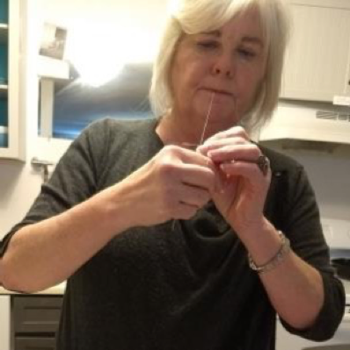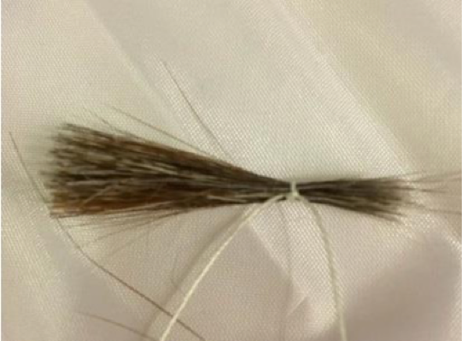

13. Again, dip the tip end of the brush head into the gum Arabic and use your fingers to bring it to a nice point. Let this dry for a bit

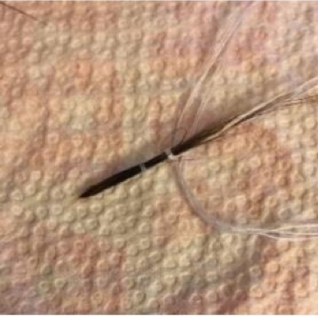

14. While it dries, lay the brush head next to the quill to figure out how much of it you want to emerge from the small end to make the brush. Note where the halfway point of the quill tube is, and then CUT the ends of the hair at that mark. If you need to, add another knotted string so it doesn't fall apart when you cut it (if the knot is above the cut mark). Note: the shorter the brush head sticks out of the quill, the firmer it will be and the better it will work.

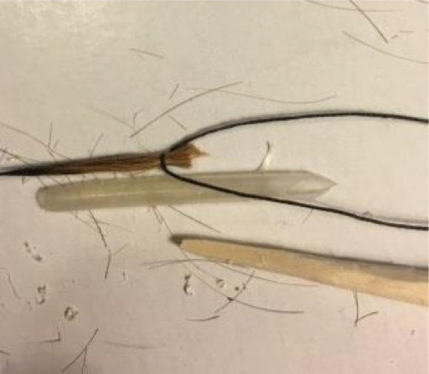
The end of the brush head and the end of the handle should meet at the center of the quill.

15. Take the dried brush head and feed the tip of the brush into the quill from the end with the angled cut – not too far at this point! While the cut ends of the hair are still not into the quill, put a glob of cheese glue onto those cut ends. Rub it in so it gets between the ends a bit, and don't be skimpy here.

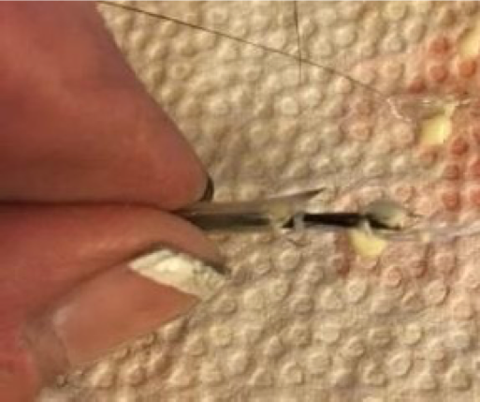

16. Now gently push the brush head through the quill. Use the skewer to help it along if you need to. Push and pull gently to get the hairs positioned correctly. The end of the hairs should stick out a bit (no more than a half inch, and the cut ends should be about half way through the quill tube. Add a drop more glue to the tube and push it down to the ends of the hairs.

17. Dip the brush handle end into the glue so it gets a generous coating of glue on it. Insert it into the angled cut end of the quill, until it meets the cut ends of hair at the center of the quill. If they don't meet, you will have a weak point that can easily break. More glue is better than not enough. If it gushes out – it's OK. Cut the threads about two inches long, put glue on them, and wrap them around the brush, gluing them down.

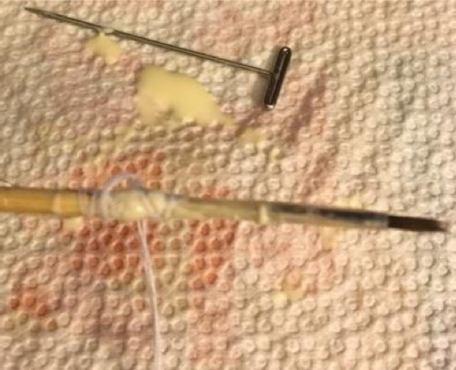

18. Re-dip the brush head into gum Arabic, form a point with your fingers, and let it all dry completely.

19. Once it is thoroughly dry, (overnight is best) bend the brush hairs to release the gum Arabic. It should do so easily. Now fan out the brush head, and look for any stray hairs, pull them out with a tweezers one at a time. DO NOT CUT THEM. The tips are naturally tapered and should help form the head into a nice pointed tip. If you cut hairs at the tip, they become blunt and will hinder the formation of a nice tip.

I must give credit to my able assistant, Jinjin, who supervised, advised, and administered feather disposal throughout my paint brush making sessions while I prepared this handout.

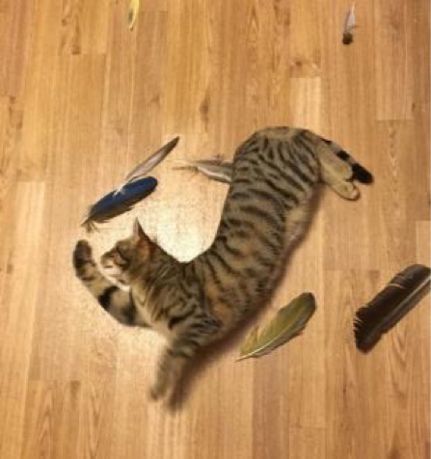

------
Copyright 2017-2018 by Sala E. Chapman. <salachappy at gmail.com>. This handout may be shared, however, it may not be altered or amended in any way without the express written permission from Lady Samin (Sala Chapman).

If this article is reprinted in a publication, please place a notice in the publication that you found this article in the Florilegium. I would also appreciate an email to myself, so that I can track which articles are being reprinted. Thanks. -Stefan.

<the end>

