Playing-Cards-art - 2/23/17

"Some 15th Century Playing Cards" by Claricia filia Wilelmi dapiferi.

NOTE: See also the files: games-cards-msg, Cards-a-Dice-art, Tarot-Crd-Ruls-art, paper-msg, papermaking-msg, inks-msg, p-printing-msg, woodcuts-msg.

************************************************************************
NOTICE -

This article was added to this set of files, called Stefan's Florilegium, with the permission of the author.

These files are available on the Internet at: http://www.florilegium.org

Copyright to the contents of this file remains with the author or translator.

While the author will likely give permission for this work to be reprinted in SCA type publications, please check with the author first or check for any permissions granted at the end of this file.

Thank you,
Mark S. Harris...AKA:..Stefan li Rous
stefan at florilegium.org
************************************************************************

Some 15th Century Playing Cards
by Claricia filia Wilelmi dapiferi

The set of cards was made for Lochac Largess Swap II:

The brief I got was: Not girlie, no jewellery, no fancy trims, nothing strongly smelling. So that pretty much excludes most of the stuff I normally do so she is going to extend me right "outside the box" and "off the reservation". I don't make alcohol or cook as my work involves food safety and I am over-cautious about swapping home-made consumables with people I don't know.

What could I do for an ex baroness whose persona is a merchant in mid to late 15th Century Wales/London???

"EX-Baroness" should theoretically mean more free-time.

"15th Century merchant" means money and the excesses of the Nouveau Riche.

SOOO....what did the nouveau riche do for entertainment in the 15th Century?? Evidently they played cards like there was no tomorrow. Once printing presses increased the production of playing cards, the craze was so all encompassing that they passed laws to prevent common workers playing cards when they should be working. Cards were made out of many things from paper to leather to gilded silver sheets (A lovely complete set dated 1616, below, recently sold at Chrisite's Auction House for an obscene amount). Using the suits; Roundel, Cup, Mace and Swords. Even as late as the early 20th Century, isolated people were regularly using DIY packs.

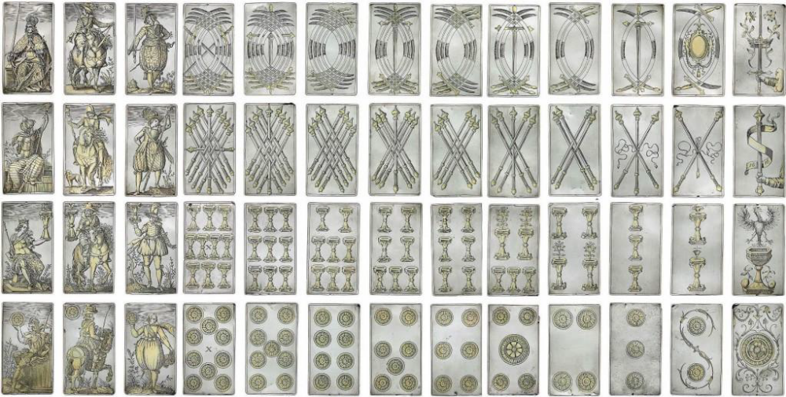

Most of the paper or layer-board cards, which exist today, were failed blocks used as card in book binding as the functional decks were used until they disintegrated or split up. Cards had plain white backs until the 19th Century and were often used as calling cards hence a pack, which had ceased to be playable would not have stayed together – even when it was discarded.

Prior to the printing press, cards were still made using block prints, stencils and individually hand drawn (if you were very rich). After printing became a boom industry, hand colouring might still be done on the higher value packs.

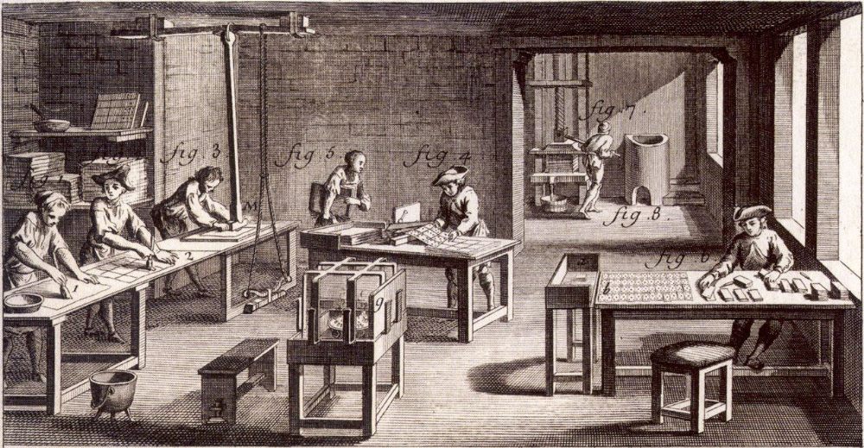

Above: illustration of Card Maker's Workshop from L'Encyclopedie by Diderot, d'Alembert, Paris, 1751. At the left-hand side we can see pasting operations and polishing by means of flints fixed to apparatus suspended from the ceiling. In the back room freshly pasted sheets are being pressed and the excess water squeezed out into the bucket. In the central area, sheets of cards are being cut using a cutting machine whilst at the right-hand side finished cards are being inspected and sorted into complete packs

So how to make the cards??

Using the above picture of a 1751 workshop combined with statements that the paper in 15th Century England was some of the finest ever made, to accommodate the new Guttenberg press, being made of cellulose with gelatine sizing to add strength, it seemed that using gelatine to laminate the cardstock would have potential. After asking questions all over the internet, I also got opinions that casein glue or starch might be options. I made trials of both gelatine and casein (milk glue) to see which I like best. Initially I thought the casein worked better, but after 2 days drying under pressure, the smooth feel and crisp "hand" of the gelatine won me over. It is also much easier to make – and given that the gluepot in the picture appears to show a need for heating, I am quite convinced that the finest cards would have been made with refined gelatine laminations of high-cotton paper, especially as gelatine was already the sizing and cardstock could be made as part of the papermaking process by simply stacking the layers together and pressing – a possible use for irregular sheets???

My choices were limited by availability so I had the local Paper shop order in some "parchment" paper for me as this was the highest cotton content I could readily obtain. For the glue I used 1 teaspoon of gelatine in about ¾ cup of boiling water. The paper did not stick well together unless the paper was quite damp so each set of 3 sheets was assembled and quickly placed between greaseproof (waxed) paper, under the weight of a heavy book. Any delamination should be able to be rectified by using a similar solution and dipping the affected area before drying under pressure. Now, on to the images, which were done on a 4th sheet.

Let me say, I am not a confident freehand artist, in fact I haven't drawn anything from scratch since I got 0/5 for artistic skill at Teachers College (I was slightly mollified that a girl who made a living from Art for 3 years was scored 1/5!!!). I did take heart in the fact that most of the suit pips could be done by stencil or simple block print. I chose a nice pack of 6 pencil erasers from the cheapie shop and set about chopping them into shapes. Suits were not set in stone and all manner of options have been seen. Cards could have themes (like hunting with hounds, horns, lances and flowers) and many arrangements of suits and numbers. Tarot decks were very popular but there did tend to be more tarot style decks further south in Europe and the deck we normally use is based on the French Deck.

The Germans had a wider variety of suit options. Because I did not feel able to do a full pack of face cards, I opted against the Tarot deck and because I wanted the deck to be playable, I felt that an unfamiliar number of cards would not be in any way useful, I opted for the standard 52 card, 4 suited deck. I wanted to use Roundels, because they are easy. Cups, because they are not too bad to draw. Maces, because they seem to be the original clubs and Swords because – hey swords.

Roundels: Easy, I have a nice hole punch set that goes up to super large so I used this to cut a round pip block. To make sure the cards fitted, I made a template within which I had to fit all pips. Roundels may also represent money – which is good for the deck for a merchant. Plain yellow roundels looked a bit weedy, so I cut off a few more bits and got a target like effect

Cups: The first cup I did looked awful once stamped. It took me 3 or 4 attempts to get something vaguely discernable as a cup but I think this eventually turned out OK. The Ace of cups in the silver deck had a nice daisy growing out of it and I wanted to personalise the set for Anwyn by changing the flower into the vegetable Lamb as this is her desired device. Since it has not being registered, I did not want to make it totally about the Heraldry, more a nod to the desired theme and I felt one image would be about right.

Mace: A straight line, small enough to fit up to 10 on a card is not that easy to do with a scalpel. I think the top is fetching but I had to muddy up the colour a little to stop it looking like asparagus. The handle is a separate stamp and looked good on the Ace but became too much for higher pips.

Swords: This was horrible. To do straight sword looked too much like the mace. To use scimitars, I could not get them to fit on the card and look like anything more than a blur... 2 hours later I gave up and looked for any other recognisable shape! Shields. This is readily identifiable from the other suits, now what to place on them... A quick look at Welsh Heraldry – nothing I can scale down easily but the colour red is quite dominant so red it is, with a little white for contrast. Done.

Face cards: The King is always depicted seated. This seems to be a very early convention in playing cards. The Knave is also quite common but the Queen was not quite as ubiquitous. Some suits had an upper and lower Knave – distinguished as to whether the pip identifier was placed High or Low. Other decks had a mounted knave/knight/cavalier and an unmounted knave. One of the few sets complete enough to use with an image sufficiently clear for me to trace over was the slightly-too-late a period silver set. Also given that the image was very detailed, I had to simplify as I traced. I was actually quite pleased with how these worked out. Looking at both the gilding on the silver deck and a reproduction deck, the colouring is more to add a splash of colour than to actually seem like a miniature portrait (though full sets of miniature portraits certainly do exist) and to this end, I chose the simplification and colouring to look more "impressionist" like the early 15th Century cards (last ones below) than "photographic".

I believe that a 15th century merchant would have owned playing cards, they would have been largely block printed but would have had some hand colouring and maybe a little personalisation so I think the final set I made fairly reproduces the calibre of card a Merchant living between London and Wales may have used to while away long Winter evenings or used to wager with fellow travellers. It is not the family heirloom deck that may have been given for Weddings but that may well have been more for the Aristocracy than the Merchant class anyway. The colour blue was an expensive pigment and is the only thing unlikely to have been seen on an extant deck – but I do love blue and she is a rich merchant...

And now a few more pictures of extant and reproduction cards

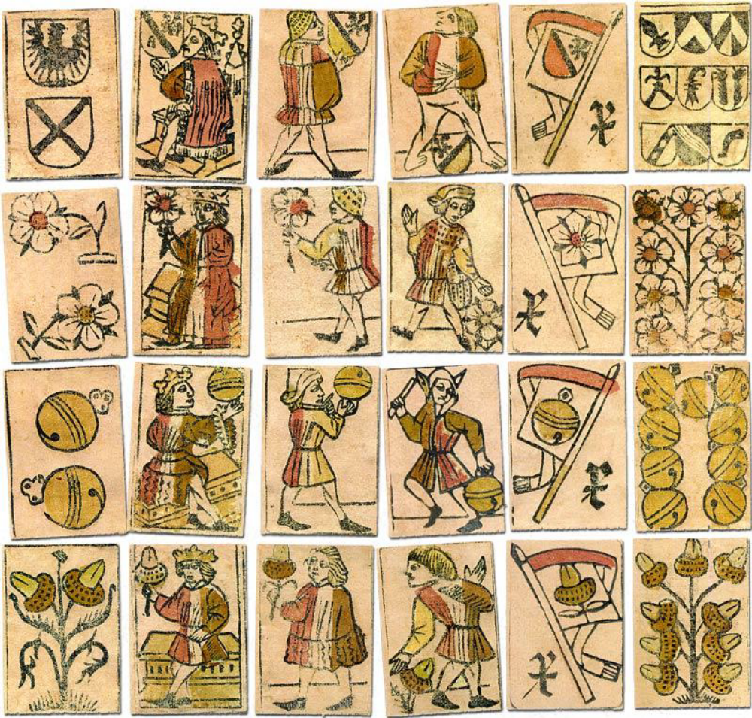
Above: cards from reprint by AGM Müller in 1998.

A second set of antique Swiss playing cards was discovered in May 2011 at Nidwaldner State Archives inside the covers of an old book during restoration. The cards were 'reconstructed' into a reproduction pack of 48 cards.

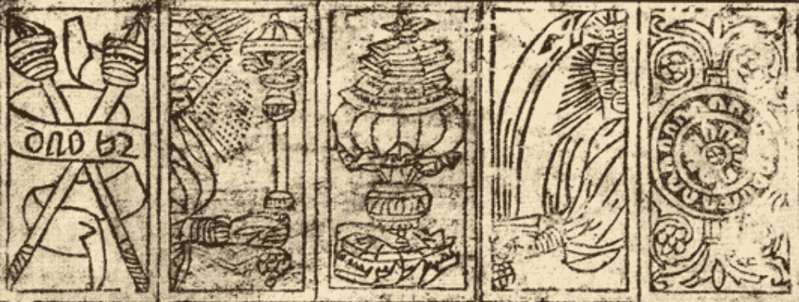

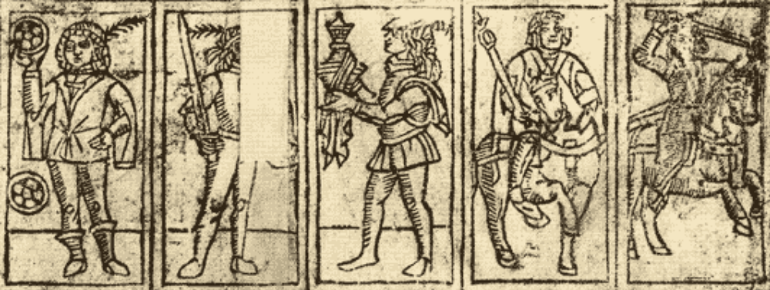
XV century Italian playing cards

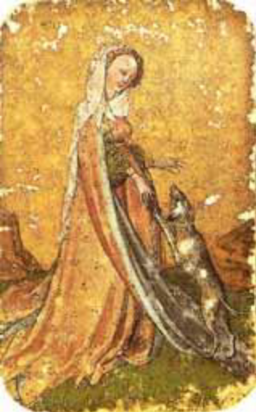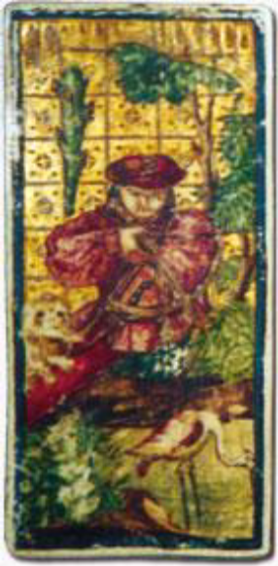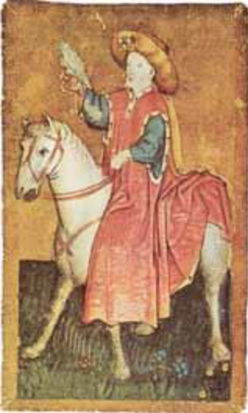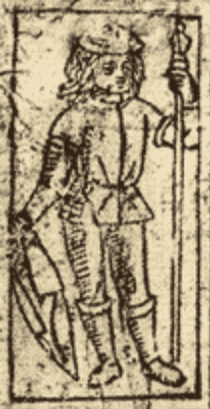
A random selection from Pinterest

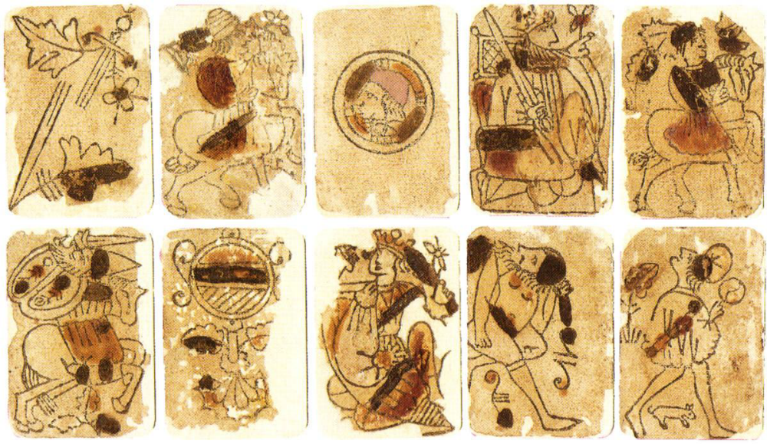
Cards from a primitive Latin suited pack, possibly of Swiss or German origin for export to Spain, dated by paper analysis as "early XV century", which makes this one of the earliest known surviving packs of playing cards. There are Moorish influences in some of the cards: see the double-panelled Saracenic shield on the cavalier of swords (bottom row).

Northern Italy adopted the well-known 52-card scheme (values 1 through 10, and three courts), and the 40-card scheme (values 1 through 7, and three courts).

· Central and southern Italy use 40 cards (same as above).

· Spain uses both 40- and 48-card decks (the latter has values 1 through 9).

· Portugal too now uses a 40-card deck, though slightly different from the Spanish one: 1 to 8 (but without a 7), and three courts.

· Many central and northern European areas such as France, Germany (but not in the south), the Netherlands, Hungary, the Czech Republic, Slovakia, Croatia, tend to use 32 cards, starting either from 1 (in French-suited packs) or from 2, i.e. deuce (in German suited ones), then 7 through 10, and three courts.

A 24-card pack is used in southern Germany and Austria for the game of Schnapsen.

Southern Germany, Austria and Switzerland use 36 cards (same as above, but with 6s, as well).

The map below refers to the composition of regional patterns used for local games
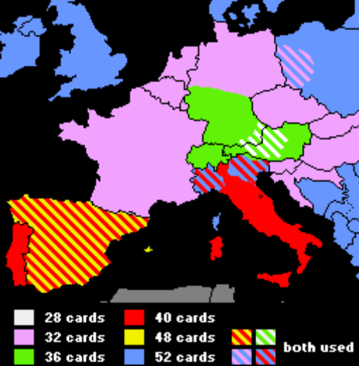
http://a_pollett.tripod.com/cards.htm

And now for the cards I made (kindly photographed by the recipient, as I forgot to do so)

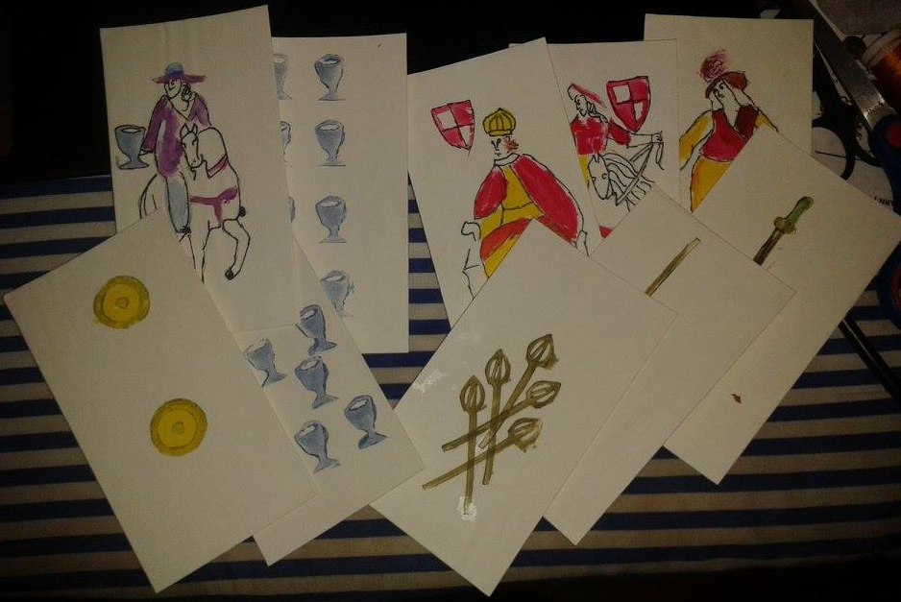

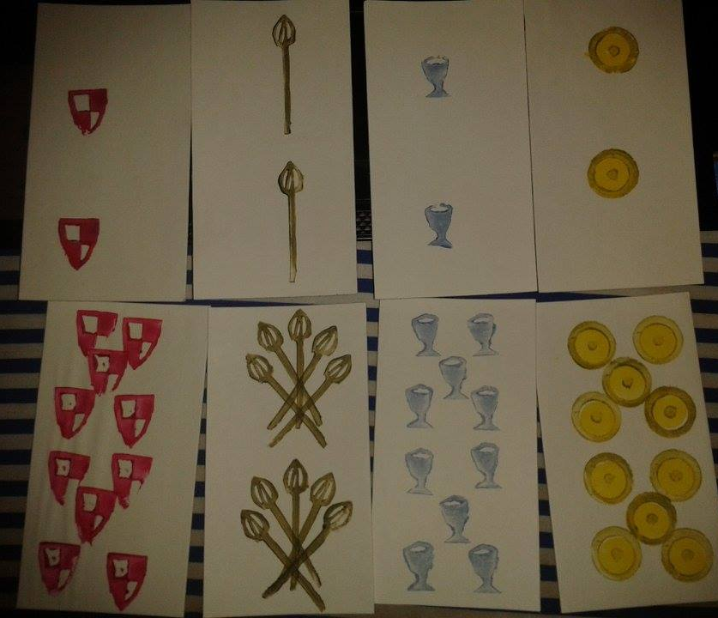
A general Selection of cards

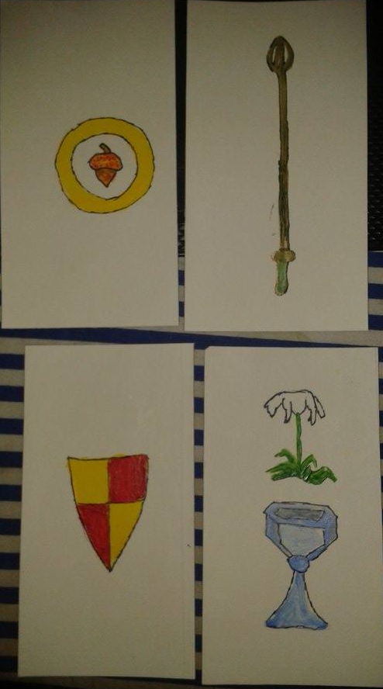
Aces High

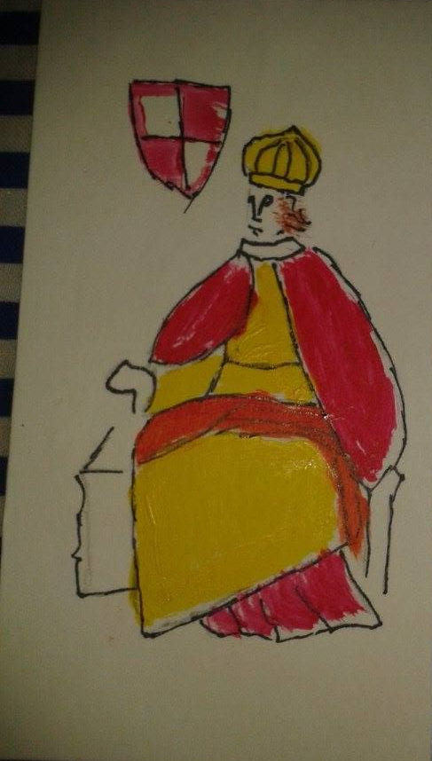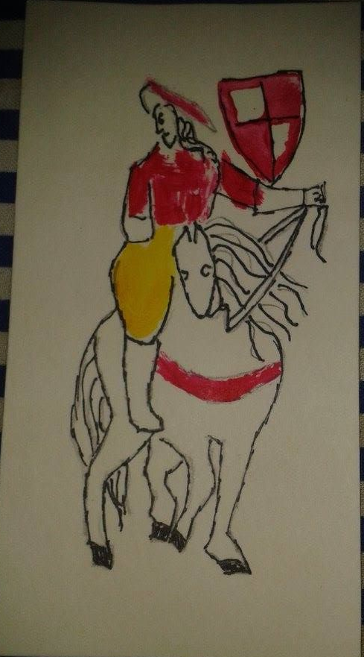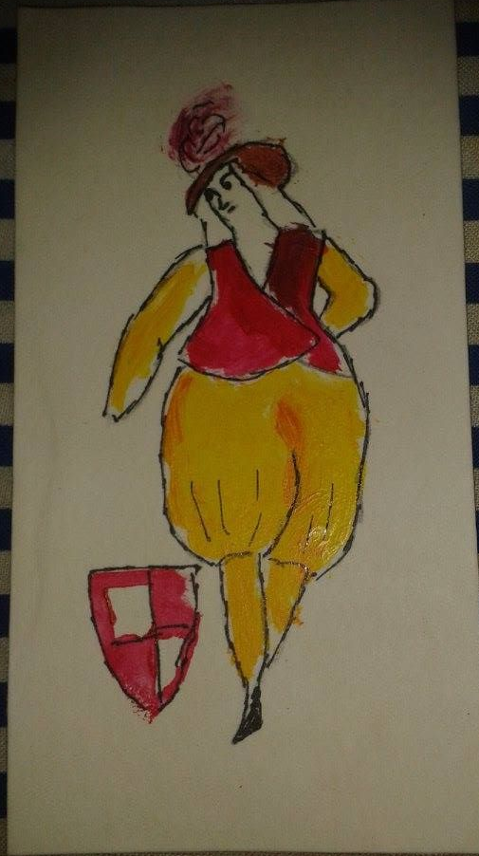

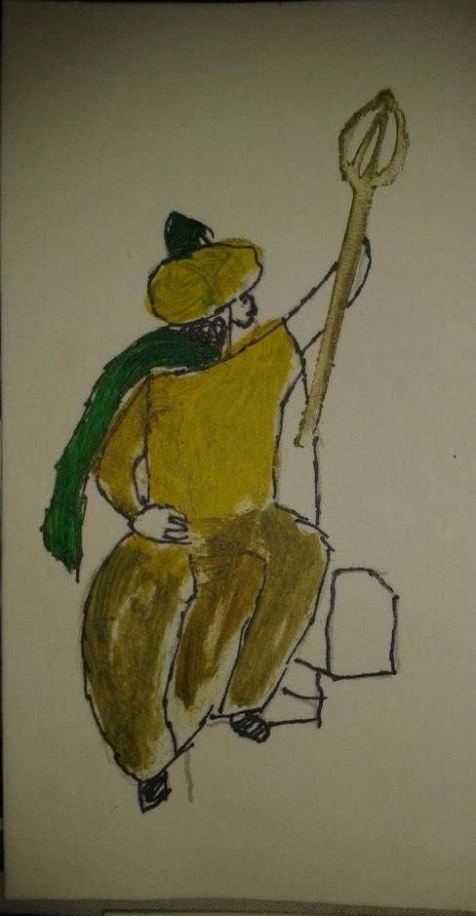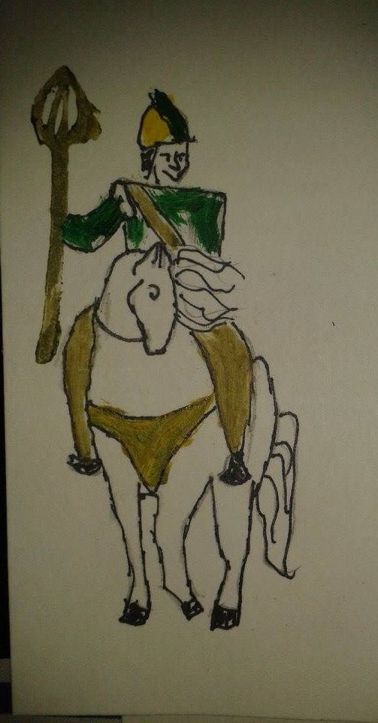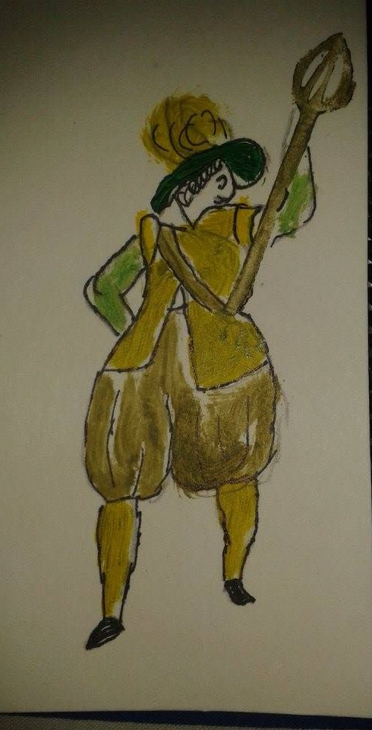
Shields and Maces with Kings, Knights and Knaves.

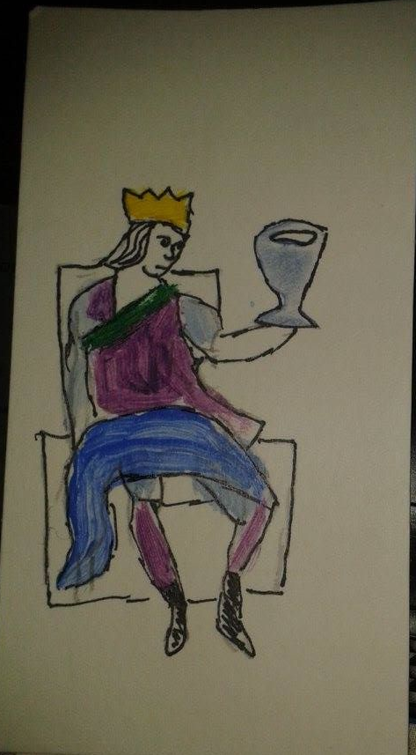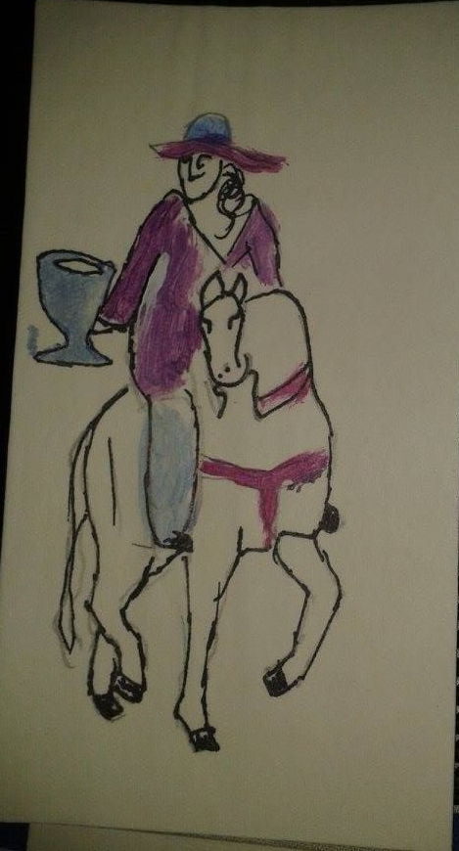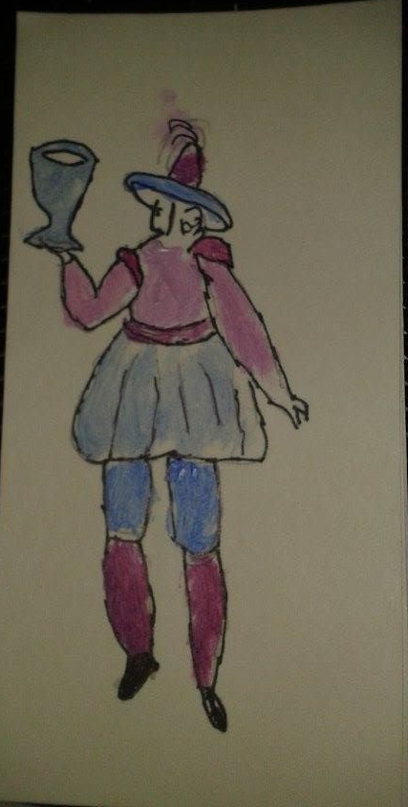

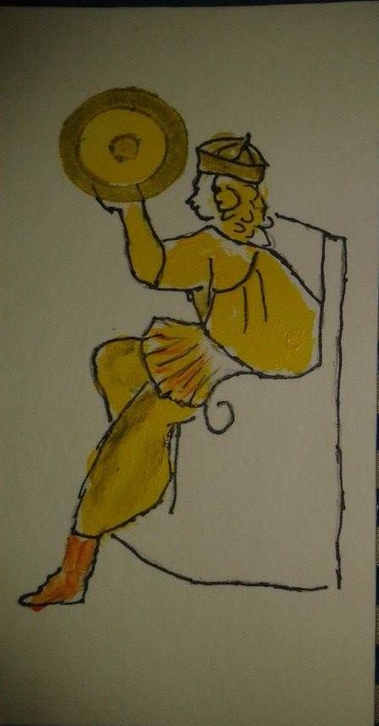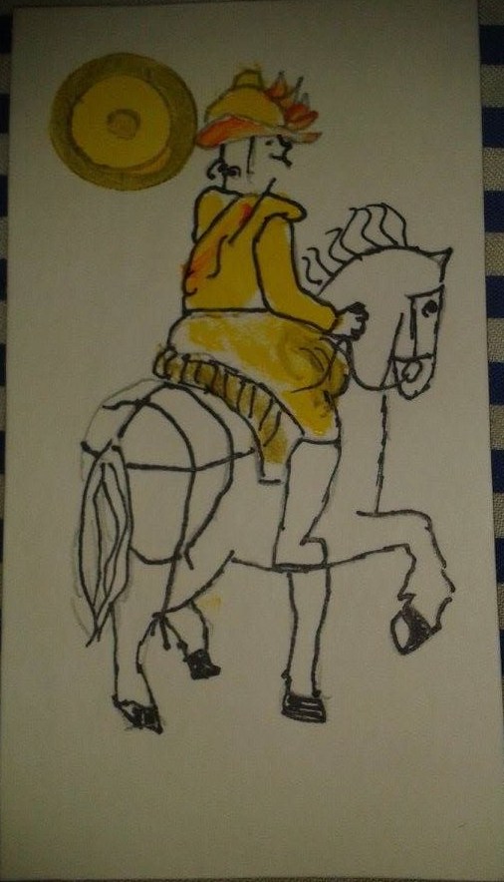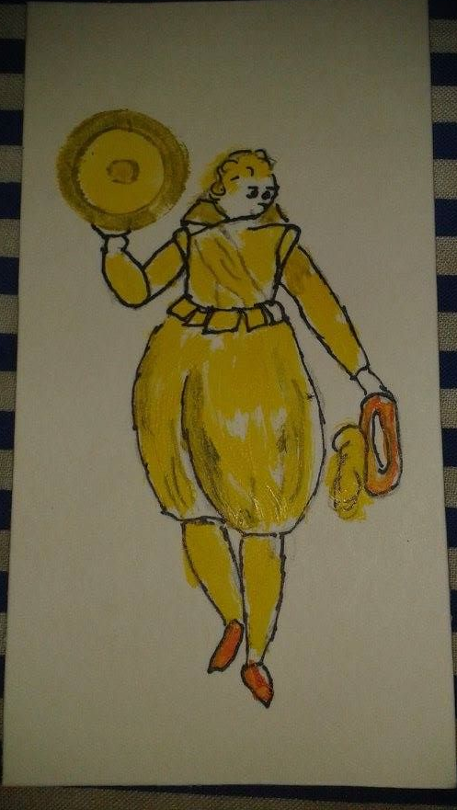
Cups and Roundels

------
Copyright 2015 by Lynlee O'Keeffe. NSW, Australia. <lynleeok at hotmail.com>. Permission is granted for republication in SCA-related publications, provided the author is credited. Addresses change, but a reasonable attempt should be made to ensure that the author is notified of the publication and if possible receives a copy.

If this article is reprinted in a publication, please place a notice in the publication that you found this article in the Florilegium. I would also appreciate an email to myself, so that I can track which articles are being reprinted. Thanks. -Stefan.

<the end>

