Hors-Gme-Eqmt-art - 8/16/09

"Equipment for Equestrian Games" by Lady Lyonet Lamoureux.

NOTE: See also the files: Int-Equestran-art, Horse-Games-art, Horse-Barding-art, horses-msg, Horse-n-t-MA-art, horses-bib, horses-lnks, p-horses-bib, saddles-msg, Stirrups-Hist-art.

************************************************************************
NOTICE -

This article was submitted to me by the author for inclusion in this set of files, called Stefan's Florilegium.

These files are available on the Internet at: http://www.florilegium.org

Copyright to the contents of this file remains with the author or translator.

While the author will likely give permission for this work to be reprinted in SCA type publications, please check with the author first or check for any permissions granted at the end of this file.

Thank you,
Mark S. Harris...AKA:..Stefan li Rous
stefan at florilegium.org
************************************************************************

This article is part of a series of articles originally written for "The Avantgarde", the newsletter for the Principality of Avacal in the Kingdom of An Tir.

All the rules quoted here are based on the "An Tir Book of the Horse", which is the handbook of equestrian rules for the Kingdom of An Tir. Much of it is common in other kingdoms, but you should check your local rules and regulations before starting any equestrian activities.

Equipment for Equestrian Games
by Lady Lyonet Lamoureux

This issue will detail equipment needs and specifications. Many of the items required can be used for more than one event. For example, if you manufacture your ring tilting spear in the proper fashion, it can also serve as your pig-sticking spear.

General Rules Regarding Equipment Use and Requirements

Riders must hold their lance or spear in a vertical position until advancing at a target. Once you have completed your attempt to strike your target, raise your lance or spear back to a vertical position, immediately.

In case of Emergency or loss of control DROP YOUR WEAPON. To drop it safely, hold it out parallel to the ground and let go. Do not throw your weapon or spike it as this creates a safety hazard.

As in all forms of SCA martial activities, a call of Hold! means stop everything you are doing. In the case of equestrian it also means bring your horse to a standstill as quickly as safely possible and do not continue the course until the Equestrian Marshal approves it.

Typically only one horse is allowed on a course at a time. If more than one course will be run simultaneously, or if in a match race situation, then these courses must be separated at a minimum by a list rope.

Tournament planners are responsible for providing all equipment necessary for setting up the tourney courses (standards, targets, list ropes, etc.). Providing weapons (swords, lances, spears, etc.) is the responsibility of the riders. Some areas may eventually have loaner gear available, but since this activity is so new, do not expect there to be weapons available for your use.

A note about minors: it is expected that the new rules will limit minor participation to those who are 10 years old or older. Minors are allowed to compete in all games played by the adults, and are under the same authorization requirements. They are not allowed to use live steel for any of the games. If minors are expected at your tourney, you should make sure that options for them to compete exist. For example, in the Pig Sticking game, targets could be created so that they can be picked up with a Velcro tipped spear instead of live steel.

Tilting Styles

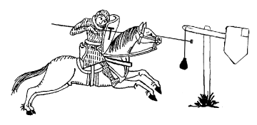Norman/Frankish: The rider holds his lance across his horse's neck and spears the target on the opposite side from his lance arm. This method requires that the target be higher than for Persian so that the lance is not jostled by the horse.
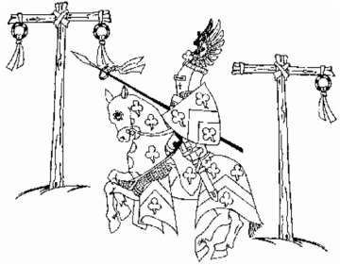
Saracen/Persian: The rider lowers his lance vertically on the same side of the horse as his lance arm. This method allows the target to be lower than for the Frankish Method

General Tourney Field Requirements

The area required to hold an equestrian tourney depends upon which games you will run. Some games require more space than others, so keep this in mind when designing your course.

In general a field measuring 180 feet long by 60 feet wide should be sufficient to run all the games and have several set up at the same time. Smaller areas can be used, but may involve having to set up and take down some pieces of games equipment after each run. If you plan on having more than one horse competing simultaneously, you may need an area that is wider.

The tourney site should be set up much like a heavy fighting/rapier field. The field should be completely encircled so that should a rider be thrown, the horse will likely remain contained on the field. Solid fencing is preferred, but at minimum a bannered list rope is acceptable. Natural barriers such as a steep hill or very thick tree line (anything that a horse is unlikely to attempt to negotiate) may be acceptable as a barrier, check with the Equestrian Marshal for confirmation. In all cases, a rope or fence barrier must be in place between the field and any spectators present.

Luxuries such as a large sunshade should also be considered. Always remember your horses when designing comforts. Horses like shade too! And, as in any form of martial activity, water must be available for both riders and horses at all times.

Games Equipment:

In all cases the term 'standard' represents a stand or post used to mount additional equipment. Each type of game will determine the height requirements. All standards must be stable, meaning they will not topple if a horse happens to bump into one, or a rider strikes their target too strongly, however they should give under extreme pressure, so as to not trap and panic a horse if they get caught up in one. Anything used as a base for the standard should provide stability, but not be too wide as to cause a horse to trip over it while performing the game.

Ring Tilt

- 3 standards topped with T-Bar mountings, approximately 7 feet in height. T-Bars should be equipped with a system to fasten rings so that they hang below the T and will break free upon being speared.

- 12 rings – either 4 each of 2", 4" and 6" diameter or 2 each of diameters 1" to 6". Rings should be coloured or have ribbons attached to increase visibility.

- 7' to 10' lance or spear is suggested, with a tip no larger than the smallest diameter ring. It may be as short 5'5" or as long as can safely be handled by the rider. It can be made of rattan, hardwood dowel, or poltruded fiberglass. The tip should not be live steel. The shaft should be a minimum of 1 ¼" thick. Wooden and rattan lances must be wrapped lengthwise and spirally with fiber tape. Avoid selecting wood that has a grain that runs slantwise through the shaft so reduce the chance of breakage. A mark should be made at the 5" point. The rider should not hold the lance forward of this mark in order to keep the tip forward of the horse's face. Particularly long-necked horses may require that the lance be held farther back along the shaft.

Quintain or Tilting the Mock Knight

- 1 quintain, approximately 8' tall, heavily weighted at the base, with a shield firmly bolted to the right arm and a sand bag filled with rags or foam suspended from the left. It is recommended that the quintain be built up on the base of a wooden box to maximize stability. The top of the quintain should rotate with low resistance so as to maximize rotation of the shield, but should be stiff enough not to rotate unless struck. All construction should be wood since it will be struck many times and needs to be able to handle that kind of punishment. Try this link for instructions: www.duchytarragon.com/Building%20A%20Quintain.htm

- Quintain lance at least 1 1/4" in diameter. It may taper the last four feet to no less than 3/4" at the tip. The tip should be covered with hard leather or rubber. They can measure 8' to 15' long, but generally they should be 9' to 12' long. You should add weight at the non-striking end to improve balance. It must be made of poltruded fiberglass or weapon grade rattan. You may fit the lance with a counter weight and/or a vamplate, but these should be well attached. Always check your lance for deterioration. The lance may only be spliced once along its length. At the splice, a solid nylon rod a minimum of 1 foot in length and 1 inch in diameter should be used. The rod should be permanently affixed in the core of one half of the lance to be spliced such that the other half of the lance can be slid over the nylon rod to create a tight splice. The splice should then also be wrapped with several layers of fiber tape when in use. A schedule 40 PVC end cap should be permanently affixed on the striking end of the poltruded fiberglass shaft under the heavy rubber end as well as on the counter weight end.
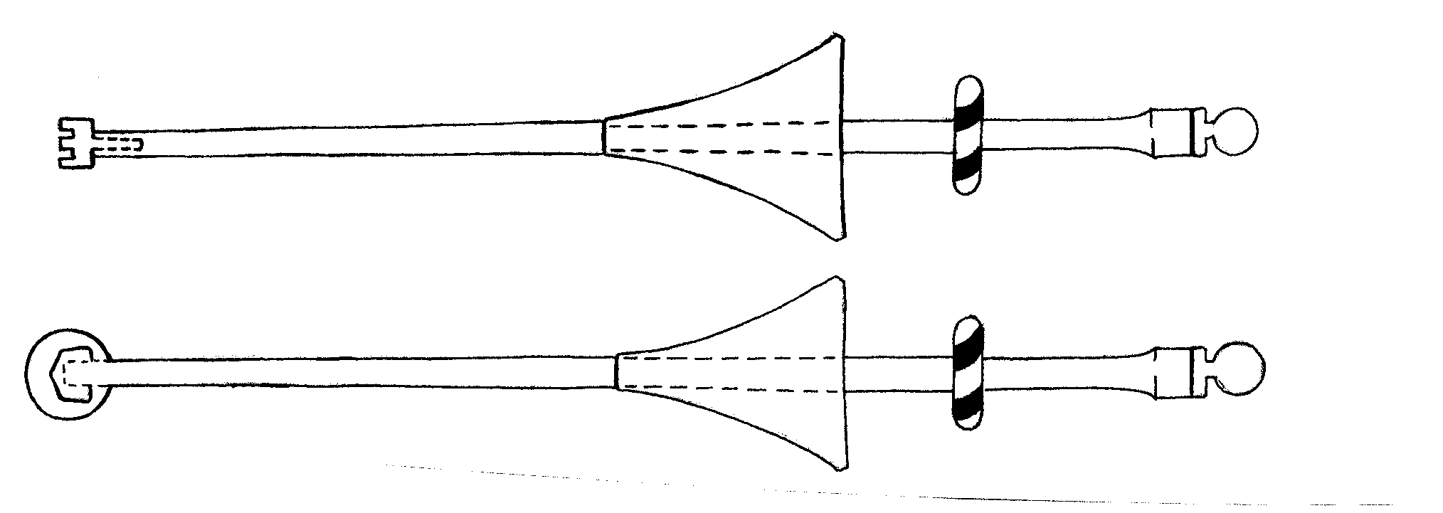

Meridiase Coronelle Tips: These rubber lance tips are constructed of rubber boat rollers, wooden or nylon dowel, and a heavy washer. The boat roller is cut in half and castellation cut into the surface creating four flat points. The dowel is inserted and the washer and a PVC sleeve is used in the place of the PVC end cap.
Beheading the Enemy

- 5 standards from 4' to 7' high. The tops should have a Velcro or other mounting to attach the targets, and a way to attach a cord or bungee to prevent the target from going too far away from the pole.

- 5 Styrofoam balls, wig stands, or rolled foam, which should be reinforced with strapping tape. Velcro or cord/bungee cord should be attached to the base to be mounted on the standard.

- Wooden sword or mace. Any rider may use a padded short sword or mace up to a maximum of 36" total length. The marshal may require a rider to use a shorter weapon if they feel the rider lacks control of their weapon and constitutes a safety hazard. The weapon must have all striking surfaces padded with a minimum of ½ inch of closed cell foam. The foam should be covered with duct tape or fiber tape. The core and handle of the weapon may be of rattan, silo flex, rattan-cored silo flex, or foam filled golf tube. The use of lanyards is discouraged.

In an effort to achieve a more period feel and look, some kingdoms allow riders who have earned an Intermediate or Advanced Rider Authorization to have the option of using bare, wooden short swords. The equestrian marshal has the final, and only say, whether you will be allowed to use one of these weapons in tournament. These wooden swords must be constructed from hard woods, no softwoods are allowed. The bare weapon may be up to a maximum of 40" total length. The striking surfaces and points must be smooth and blunt. All joinery must be solid and without significant play, upon inspection. Metal may be used in the cross-guard and hilt for decorative or weighting and/or balancing purposes, but must be blunt and securely attached. The total weight of the weapon should be less than 2.5 lbs.

- Cones, barrels or similar equipment to mark the starting and turning points on the course.

- 1 stopwatch.
Pig Sticking (also called Tent Pegging)

- 7' to 10' lance or spear. The same general spear standards for shaft length and construction as the Ring-Tilting lance also apply to Pig-Sticking. The main difference is that the Pig-Sticking spears need to have a live steel point for piercing the targets

- 3 styrofoam blocks, these may be of various sizes, wrapped in strapping tape and covered by cloth.

- Lure coursing machine, if the moving targets option is planned.

Reeds

- 10 standards from 4' to 6' high. The tops should have a Velcro or other mounting to attach the targets, and a way to attach a cord or bungee to prevent the target from going too far away from the pole.

- "Reeds": 10 reed targets between 4'-6' high. The reed targets can be all the same length or in decreasing heights. Velcro or cord/bungee cord should be attached to the base to be mounted on the standard

- This is a sword game, not a mace game, and requires a padded sword per Beheading the Enemy.

Javelin Toss (also called Spear Throw)

- 1 target, usually a drum-shaped object at least 2' in diameter, with a heavy cardboard or canvas face, attached to a 4' by 8' stand. The drum should be filled with compacted foam. You can also use hay bales or other alternatives if they can be braced so as not to move when struck.

- Light spears or javelins, 6' to 8' long, with live steel points.

- Some barrier, hay bales for example, to make the lane the horse must travel and to protect against bounce back.

Cup Carry (Tankard or Chalice Race)

- 1 or more goblets of the same size.

- Water.

- Stopwatch.

- Pole, barrel, or similar equipment to mark the starting and ending point and additional pieces to mark out turning points and/or hazards.

Flag Race

- Two 6' by 8' poles with pennants or flags attached to one end. Each should be a different color.

- 2 flag holders.

- A tube 3' high and 4" in diameter or a barrel or hay bale (if flag pole is sharpened at lower end) may be used.

- Stopwatch.

Flat Work

- Printed text and diagram of the course should be provided to the judge(s) and riders before the walk through.

- 4 or more cavaletti or 4" by 4" turned poles at least 9' long and painted to contrast with the ground.

- Poles or weighted 5 gallon buckets with staffs or shrubs may be used for bending (turning) obstacles. These must not tip over if brushed by horse or rider, or blown over by the wind.

- A water hazard may be constructed using a 4' by 8' sheet of plastic or tarp. Make a 3" to 4" depression 36" by 7 feet in the ground; spread the plastic over and fill with water. Carefully cover the edges of the plastic with dirt; lay a ground pole on each side of the water, parallel with the track.

Relay Race

- Some hand-off, such as a baton (basic relay), small flags or banners (Retrieved the Banner) or potatoes or gold painted rocks (Loot the City)

- Pole, barrel, or similar equipment to mark the starting and ending point and additional pieces to mark out turning points and/or hazards.

Equipment for the "Take the Message to the Duke" option:
- 1 message, this can be a scroll or letter, to be handed off between members of the relay team. Alternately you can set up several pieces of a message tapped to a pole that must be retrieved individually.
- 1 Duke or other person the message is to be delivered to.

Ribbon Race

- Several pieces of ribbon or twine 12" to 14" long. It is suggested that the length of the ribbon can vary based on the authorization level of the riders competing.

- Pole, barrel, or similar equipment to mark the starting and ending point and additional pieces to mark out turning points and/or hazards.

- A stopwatch.

Squire Rescue (or Rescue the Maiden)

- Chalk or some non-hazardous material for marking the lane.

- A dummy, or for the advanced version, an athletic volunteer who is qualified as an advanced rider.

- Stopwatch

Quests

- Equipment required is entirely dependant upon the quest and its set up/design.

Mounted Archery

- All archery equipment (bows, arrows, targets) and range must be inspected by a warranted SCA archery marshal before use. It is acceptable and encouraged that the Equestrian Marshal may also serve as the Archery Marshal if they hold the appropriate warrants. All equipment used must be legal under the An Tir archery rules.

- Bow Weight (pull poundage) is not to exceed 35.

- Archery Target used must meet SCA archery target specifications.

- A barrier of some type that will not allow the horse and to pass closer than 10 yards (30 feet) to any target to prevent danger from the bounce back of arrows.

- Beyond the target area there must be a wall or archery-proof net, or a clear area a minimum of 100' long and 120' wide (60' on either side of target). The Clear Area for targets used "in motion" shooting may be overlapped. A second barrier should be placed parallel to the first, 10 feet apart (wider as needed for chariots), thus creating a lane for the archers to ride down

Mounted Combat

As with all equestrian rules, those for Mounted Combat are still being rewritten and will likely be extensive. Rather than print all the out-dated equipment rules them here, I suggest anyone interested in Mounted Combat should go to the An Tir web site (www.antir.sca.org/Offices/Marshallate/Equestrian/eq-rules.php) and read the posted versions.

Have fun! Be safe!

The An Tir Book of the Horse (ABotH) is still in rewrite status. As a result, the information here is not guaranteed to be accurate for use in An Tir. The information in this article was taken from sources in other Kingdoms as well as the Inter Kingdom Equestrian Competition (IKEqC) rules. Any differences from the forthcoming rewritten ABotH will likely be minor.

Thanks to the equestrian community of the Kingdom of Aethelmarc for their detailed specifications.
------
Copyright 2008 by Lya Lamoureux. <lyalamoureux at gmail.com>. Permission is granted for republication in SCA-related publications, provided the author is credited. Addresses change, but a reasonable attempt should be made to ensure that the author is notified of the publication and if possible receives a copy.

If this article is reprinted in a publication, I would appreciate a notice in the publication that you found this article in the Florilegium. I would also appreciate an email to myself, so that I can track which articles are being reprinted. Thanks. -Stefan.

<the end>

