Horsebread-art - 2/8/15

"Horsebread" by Madonna Contessa Ilaria Veltri degli Ansari.

NOTE: See also the files: saddles-msg, Sadle-Blankts-art, Stirrups-Hist-art, Women-Riding-art, Horse-n-t-MA-art, Horse-Barding-art, Horse-Games-art, Desen-Y-Horse-art.

************************************************************************
NOTICE -

This article was submitted to me by the author for inclusion in this set of files, called Stefan's Florilegium.

These files are available on the Internet at: http://www.florilegium.org

Copyright to the contents of this file remains with the author or translator.

While the author will likely give permission for this work to be reprinted in SCA type publications, please check with the author first or check for any permissions granted at the end of this file.

Thank you,
Mark S. Harris...AKA:..Stefan li Rous
stefan at florilegium.org
************************************************************************

Find more work by this author on her page at:
http://ilaria.veltri.tripod.com/index.html

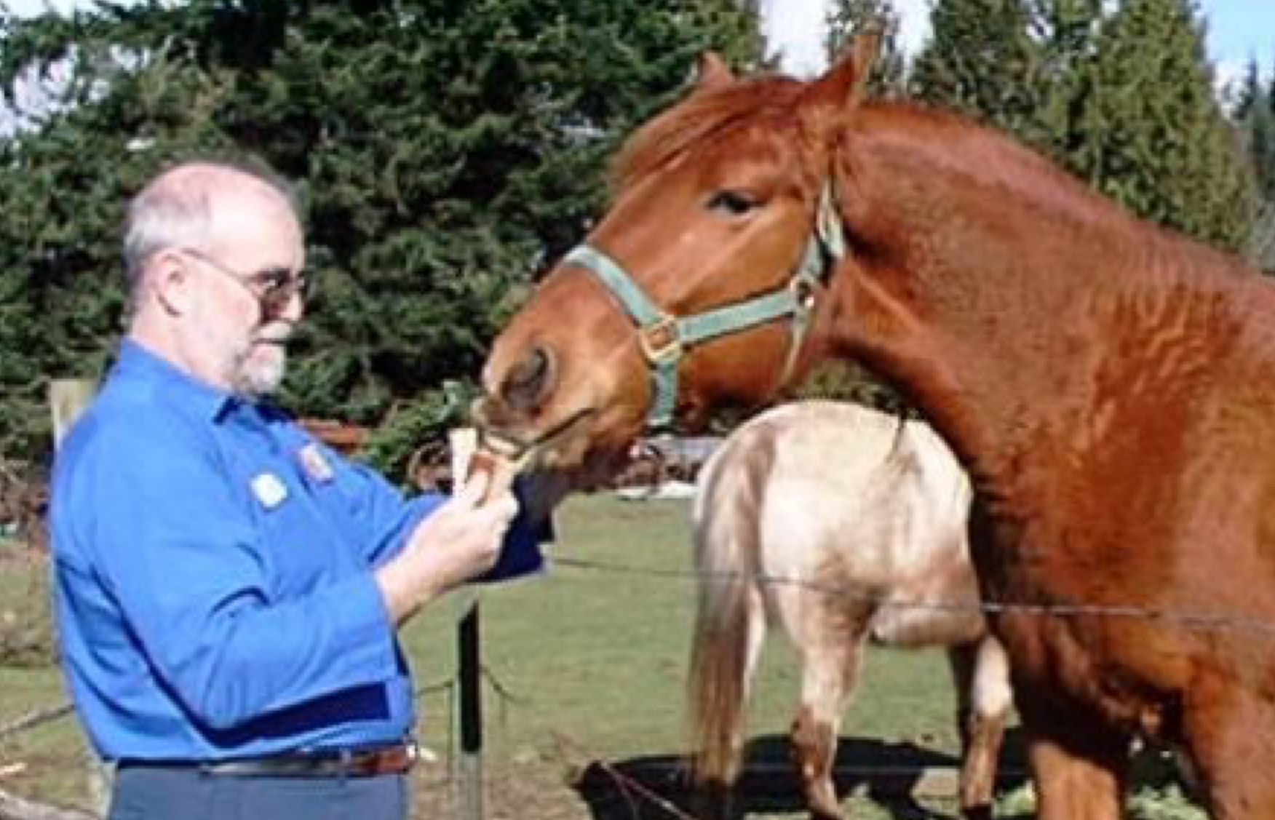
My husband feeding October Dawn(Toby) some horsebread.

Horsebread
by Madonna Contessa Ilaria Veltri degli Ansari

A findings paper on making medieval horse feed.

I've been toying with the idea of horsebread for a while. Originally, I found a reference to "horsebread" in a manual on keeping horses. It refers to how many loaves of horsebread each horse got in addition to hay and grain.

Horsebread. Horsebread? What the heck is horsebread?

Who, what, when, where, why.

When is pretty easy, they used it in SCA period at least from the 1350's. I found it mentioned in The Horse in Medieval England. That is what caused me to be interested. I've found that it didn't go out of "style" till quite modern times (well into the 1800's).

(The Horse in Medieval England, pg 16 "These peas and beans were converted into horsebread. . .")

Who used it is pretty easy. Horse keepers gave it to the horses as part of their feed. Who made it though? There are references to different kinds of bakers, some of which could bake horsebread and some not. Those who couldn't make horsebread generally made the finer sorts of bread.

What is it? Bread to feed to horses. But then there are references to people eating it too.

Why did they use it? There must be a reason for it. Would there be a reason of economy or convenience? Perhaps both?

How was it made? Are there any recipes out there? That would be "what" too!

Where in Europe? England for sure, chances are good that it was used elsewhere.

While the original mention I found was mid-1300's, Gervase Markham, Chris Marlowe, and Ben Jonson are late 1500-early 1600's and there are mentions of horse bread right up to this. the 20th century.

Research

"O, brave, Robin! shall I have Nan Spit, and to mine own use? On that condition I'll feed thy devil with horse-bread as long as he lives, of free cost."
(Christopher Marlowe Dr. Faustus, scene VIII)

"The bread was suitable for horses, nay, heavier than horse-bread, and the drink tasted of charcoal. The rest of the stuff the cook served up consisted of things the Dean had brought along for our personal consumption."
(Richard Eedes, Iter Boreale (1583) The philological museum)

"You thread-bare, horse-bread-eating rascals, if you would needs have been meddling, could you not have untied it, but you must cut it; and in the midst too! ..."
(Ben Jonson, Every Man Out Of His Humour, Page 4,
http://www.simonova.net/library/371-4.html)

"NO Hostler or Inholder shall make his Horse-bread within his Hostery, but Bakers shall make it; and the Assize shall be kept, and the weight be reasonable, after the price of Corn in the Market adjoyning; and they shall sell their Horse-bread, Hay, Oats, Beans, Pease, Provender, and all kind of Victuals, both for Man and Beast, at reasonable gain, having respect to what the same shall be sold for in the Market adjoyning, without taking any thing for Litter."
(Dalton's the country justice, 1690 Chap. 56. 57. Archives of Maryland, definitely not medieval or renaissance but interesting.)

Ok, we know that horsebread was eaten by people, too.

Googling horsebread, reading books, asking on email lists, anyone know anything about horsebread? Are there any extant recipes?
Gervase Markham, that prolific writer has some!!

"Take two bushels of good clean beans and one bushel of wheat, and grind them together. Then, through a fine [sieve], bolt out the quantity of two pecks of pure meal, and bake it in two or three loaves by itself. The rest sift through a meal sieve and knead it with water and good store of barme [yeast]. And so, bake it in bread loaves and with the coarser bread feed your horse in his rest."
(Gervase Markham Country Contentments, 1615)

"take a strike (about a bushel) of beans and two pecks of wheat and one pecke of rye, grind these together, sift them and knead them with water and barme, and so bake them thorowlie in great loaves, as a pecke in a loaf: and after they are a day olde at the least, your horse can feed on them, but not before. . .some. . .say that common baker's horse-bread, that is made of branne and wheate chyssel (rough coarse meal with lots of bran and twiggy bits, fashionable for people in the 20th century, barely fit for animal food in the 16th) shall do as much good: but if they knew how many inconveniences are found by this common horse-bread, they would (without doubt) alter their opinions."
(Gervase Markham's How to chuse, ride, traine and diet. . . )

Pretty typical for period recipes. Few instructions.

Of course scratch cooks still cook this way.

My mum taught me to make bread when I was about 10 by giving me a big bowl, a wooden spoon, and a sack of flour. She showed me how to put "this much" water in the bowl with 1 packet yeast, "that much" flour and some sugar and salt to make a "sponge". Let it sit in a warm place to start the yeast working.

After it has risen a bit, you add in flour with a wooden spoon till it has the right "feel". Then you turn it out on a floured board and knead it till it is "done", and let it rise again. Punch it down, divide it into loaves and allow to rise again and pop it into the oven at 350 till it is golden brown and sounds hollow when you tap on it with your knuckle.

Rather medieval!

Ok we have the "how" in making horse bread, but; What kind of beans?

"Everyone" knows that most beans are New World. Fava beans are "old world", (pre-Columbus) and there is some speculation that other types are as well, but most of the "beans" we know today are "new world". Of course by 1615 people had access to all kinds, but the first mention I have of horse bread is before Columbus.

(The Horse in Medieval England Pg. 16, "In another account (1359) Bothe states that 16 quarters 6 1/2 bushels of peas and beans have been turned into 3375 loaves.")

Peas and beans are often mentioned in one breath and are closely related. What about peas and other pulse? Peas are known all through Pre-sixteenth century Europe and various other legumes are as well.

In the "history of peas" website, the author speaks of Romans eating peas, and probably taking them to Britain. (http://www.freshforkids.com.au/peas.htm)

"It appears that for most of the history of peas, the pods ripened on the plant. Peas were dried and stored for food in winter. According to the Horticulture Department of Texas A and M, green peas, used as a vegetable, are not mentioned until after the Norman Conquest in 1066. In Old English they were called pise, probably related to the French, pois."
(http://www.killerplants.com/whats-in-a-name/20030103.asp)

"In 1597, John Gerard listed six 'species' of peason, although they were probably varieties of the garden pea. (The singular was pease.) "There be divers sorts of Peason...some of the garden, and others of the field, and yet both counted tame..." Those he considered wild simply did not produce large or many pods."
(http://www.killerplants.com/whats-in-a-name/20030103.asp)

On Stefan's Florilegium there is quite a discussion on breads and legumes.

The general consensus is that various legumes were used in breads, at least the coarser sorts of breads, and that many peas that we have available are medieval. The general consensus was that black-eyed peas are definitely old world.

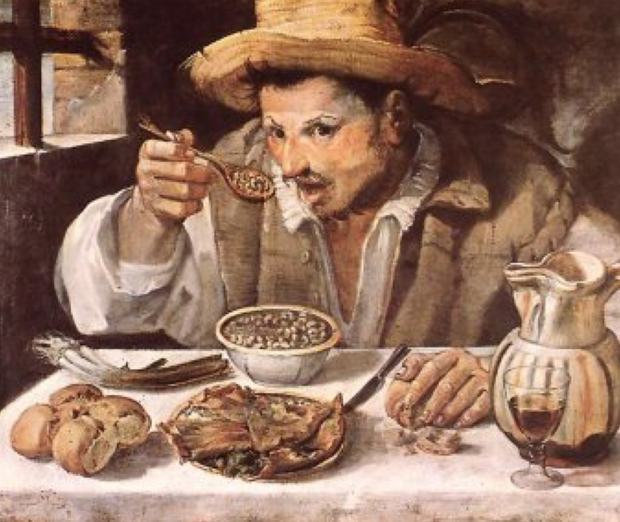
The picture "The Bean Eater" by Annibale Carriacci
Although painted well after Columbus, has a nice view of black-eyed peas.

Split peas are Victorian, whole peas are what they cooked with in period, but Anne-Marie Rousseau has experimented with peas and made soup with both whole peas and split peas and the properly strained finished product was the same. (Verbal communication and also on Stefan's Florilegium.)

I have easy access to both yellow and green split peas, black-eyed peas, which could also could be called a shell bean, and various sorts of beans. I do not have easy access to fava beans either whole or ground except in pre-packaged falafel mix, or to whole peas other than the black-eyed type. I can get them but they are twice as expensive as any other kind.

By the late 1500's there is plenty of reason to think that beans other than fava would be available, so I chose the easiest to get and cheapest one. Pinto beans. 19.2 cents a pound at the Safeway. Pretty cheap for small quantities.

I bought the pinto beans, green and yellow split peas, black-eyed peas, and some pearled barley. (Pearling is a milling process that takes off some of the bran. Barley is a very coarse grain.) I didn't buy wheat as I knew that the mill always has both a soft white, (Soft white wheat has a lower percentage of protein(gluten) and so is better for pastry). and hard red winter wheat.(This particular wheat has about 16% protein(gluten) making it best for bread.

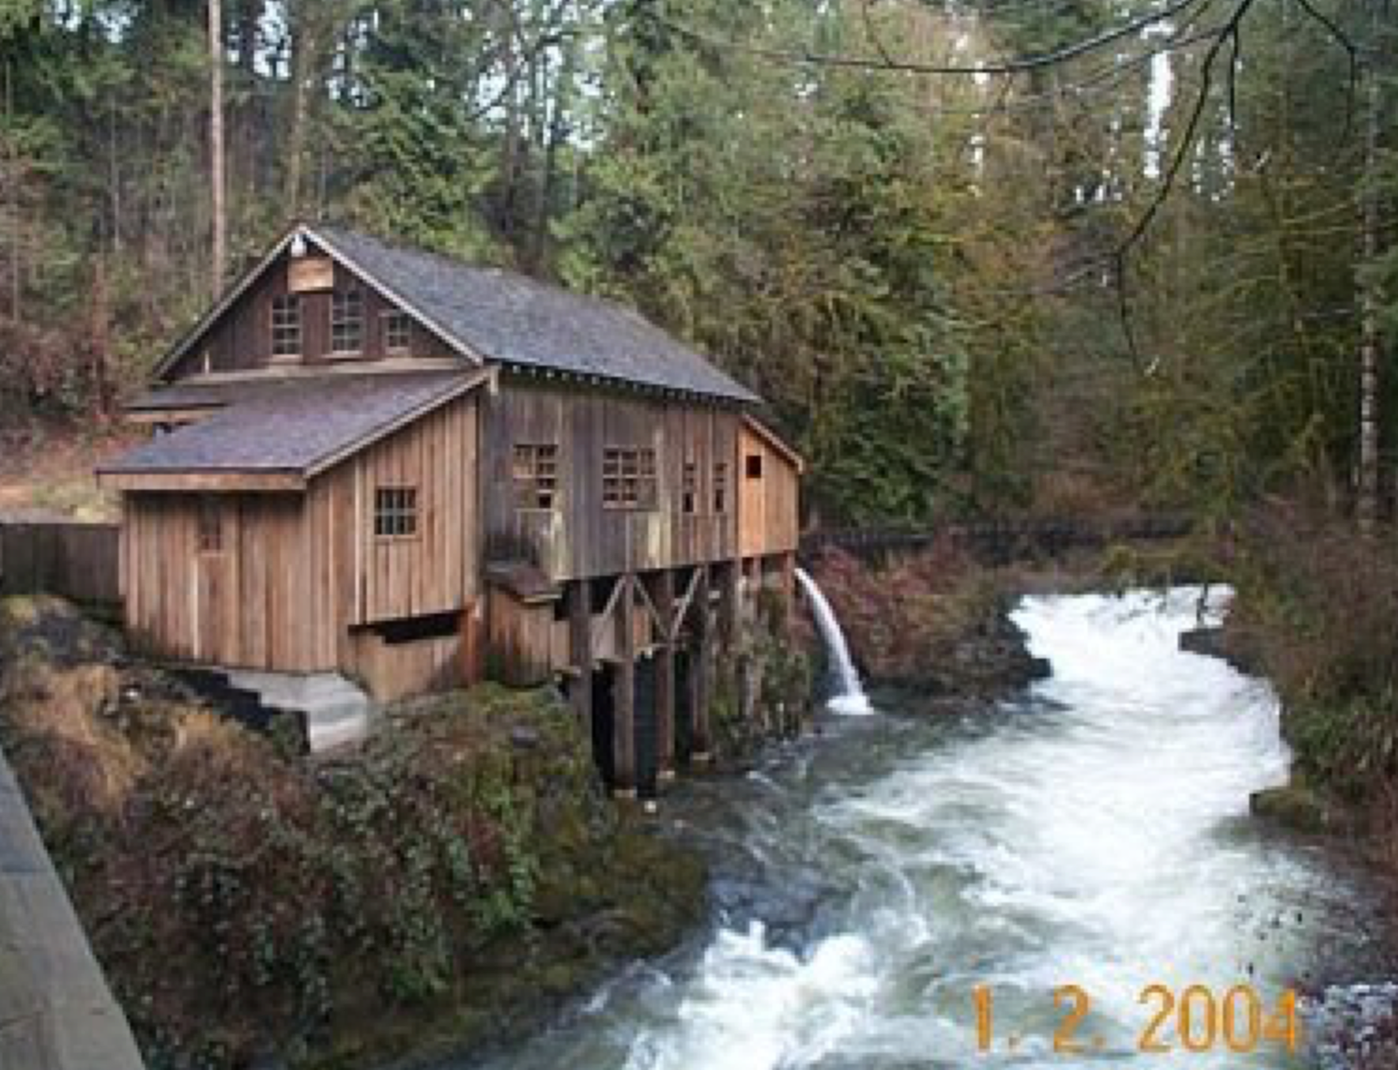

There is a working period grist mill close to where I live. It isn't a medieval period mill, (unlikely on the West Coast of US) it's an 1840's one, but is a stone mill run by water. Much closer to the "real thing" than buying the flour pre-ground. Nice and fresh too. I took my legumes and barley over for grinding. It rather entertained the volunteer guys who were there that day.

The pintos ground into nice almost white flour with the hulls rather coarse and easy to sift out. The pease ground into a meal similar to cornmeal at the same setting. We chased them through the mill with hard red wheat to get the beany taste out of the mill (that being a concern for the modern millers) and I took about 10 lbs of that home, too.

Making the bread

I decided to make several types. First I bolted out the coarser stuff and made a loaf of "human bread" using equal parts beans and wheat, and one of equal peas and wheat, and a "horse bread" of equal parts beans and wheat and one of equal peas and wheat. I then made one with the coarser stuff at a 2-1 ratio of beans to wheat, and the last 2-1 with peas.

Since many bread recipes call for ale barm for leavening, and I don't have any, I am using regular bread yeast. I know that the various strains of yeast can change the flavor of the breads, but I don't think the horses mind and as we are making the lowest form of human bread, I doubt subtle flavorings were a concern for horsebread in period.

Bolting

First I used a metal sieve to get out the really coarse pieces and then tried using a piece of linen even-weave fabric meant for cross-stitch for the finer product. The finest flour did come through the linen but it made a big mess with dust rising in the air, and was very slow, so I got a fine strainer and used that instead. The product was coarser than through the linen but it took less time. Good kitchen help is pretty hard to come by these days.

The finer stuff was used for the "human bread". Everything else, including the coarse stuff sieved out, went into the "horse bread". No wastage.

I used my Mum's time tested method using the bean/wheat flour and the modern yeast in packets to see what happened. It would have been much more period to bake it in a wood fired oven, but I don't have one, so electric it was.

The first batch was equal parts wheat flour and bean flour. The first loaf of "fine human-grade horse bread" passed muster at work, when I took it in. Almost everyone who tried it pronounced it delicious , and I told them what was in it first! (The one man who didn't like it said it tasted like the horse was still in it, but he later admitted he didn't like bread!),

Of course it was warm and there was lots of butter, do you suppose that was part of it???

I saved some of the sponge from the first batch to leaven the next one. It would be interesting to try to "catch" yeast, but I bake rarely and probably don't have many of the "good" strains around.

The second batch was everything I had sieved out of the first and extra flour of both sorts.

Testing

When cool, I tried to feed it to my horses. They let me know that it was "interesting". The first sniff was ok and Toby took some out of my hand. Misty snuffled and tasted it also. The sheep liked it and so did the chickens, but chickens will eat anything, so they don't count. I've been giving it to the horses as out of hand "treats" and they like it well enough to be a treat. They say it would be even better dipped in molasses.

Feeding Horses

I am convinced that horse bread is a very reasonable solution for the ongoing problem of how do you feed your horses. They require a massive amount of feed and in a medieval economy, it must have been a logistical nightmare, especially when travelling.

A working horse can put away 25 lbs. of hay and 10 lbs. of concentrate a day (or more!). They do not "require" legumes, but the protein and other food values are better in legume hay, vetch, clover and alfalfa (lucerne), or in the beans themselves. Working horses in the middle ages worked MUCH harder than the average horse today. Logging horses and high level endurance or eventing horses are probably the closest modern equivalents to a medieval working horse.

High quality grass hay has pretty much all the nutrients a full-grown horse at rest needs. (Rest meaning hanging out like most modern horses do, with maybe an hour of riding a day.) You really only need to add salt and water to keep a horse on good grass.

However if you want the horse to work hard, or your hay isn't good quality, you will need to add more nutrients to the diet. (Good grass has enough nutrients for a working horse, but there isn't enough time for them to eat enough of it.) This is where concentrates come in. Plain grain might be all you need, but adding legumes or other foods might be more cost effective. It all depends on the economy. If you have a really good hay crop this year and a good oat crop, that is what you will feed, however if it rains during haying, the oats get blight, but you have a good bean crop, guess what? In a medieval economy you just couldn't import feeds for your horses. If you were very wealthy, you might move the horses to a better area, but if not you fed them what you had.

Horses will willingly eat just about any sort of grain that I have tried to feed them. However, horse bread has beans or peas in it. Horses will not eat beans by themselves, at least not that I've been able to see. I tried to feed them some. They are actually sort of picky eaters and any time you add a new food you have to get them used to it. So you get them used to eating bread, then if you grind up the food and bake it into bread they will already be used to eating the product so will be happier about eating it. I consider that horsebread is the period analog for the pellets we use today. You can chop the bread into small pieces and either feed it dry or wet it for a mash.

Modern pelleted feeds have roughage, various grains, generally corn and oats, sometimes soybean meal, often with molasses to make it tasty. If you think of the bread as the equivalent of pelleted feeds it doesn't seem so strange.

Grains and legumes together make much more complete proteins than either separately and so is better for the eater. Cooking the grains and legumes, sometimes make the nutrients more digestible. Baking it into bread makes it easier to carry around and store. Baking it into bread also makes it easier to feed to someone who might turn his or her nose up at the original product.

Mention pea soup to 25 people and many will go YUCK. But I'll bet you could feed them bread with peas in it and they wouldn't even notice. (Maybe not 2-1 peas to wheat, but 1-1 wheat to peas tastes fine to me.)

Bread is also less sensitive to vermin attack. It is absolutely amazing how fast rats can carry off an entire bag of grain. One grain at a time! They also spoil what is in the bag with their droppings. The bread would be nibbled away, but would be harder for rats to "store", and would not be spoiled like a bag is.

Bread also allows you to easily use the parts of foods that humans are not going to use. Spent barley malt from brewing can be used as part of the bread, this can add a bit of sweetness that the horses will like, the coarse stuff left after bolting goes into it also. In an economy where nothing is wasted, this is important, and useful.

My take is that the whole point of horse bread is to convert easy to get foods that are cheap, but that horses will not eat, into easy to store and carry foods that horses will eat.

I allowed several loaves to dry out near my woodstove until they were rather inert lumps that would keep for a long time, as long as they were kept dry. The only problem I had with the drying process was if the loaf was cracked it molded inside before it dried throughly.

I think that for "traveling food" for animals or even people if you are hungry enough, they are quite reasonable. Just break them up with an ax, "melt" them in some liquid and you are ready to eat.

Bibliography and works cited Books, papers, poetry, and plays:

Eedes, Richard,
"Iter Boreale" (1583) The philological museum, a hyper text edition by dana f sutton, university of california, irvine http://eee.uci.edu/~papyri/eedes/notes.html#162

Freeman, David W., PhD, PAS, Dipl.ACAN
"Energy Sources in Horse Feeds: Facts behind Fat, Fiber and Starch" (paper) Oklahoma State University

Heresbachius, M. Conradus, (collected by) councellor to the high and mightie Prince, the Duke of Cleue, Foure Bookes of Husbandrie, Newly Englished and increased by Barnabe Googe Esquire. London, 1596 T. Este for Thomas Wight

Hewitt, Herbert James
The Horse in Medieval England, J.A. Allen & Co. Ltd., London 1983

Jonson , Ben
Every Man Out Of His Humour,
http://library.floresca.net/371-2.html
or
http://www.simonova.net/library/371-4.html

G. M., (Gervase Markham?)
The English Husbandman, the first part: 1613, Printed by T. S. for John Browne, and are to be sould at his shop in Saint Dunstanes Church-yard.

G. M., (Gervase Markham)
A Way to Get Wealth, The first five books gathered by G.M. the last by Master W.L for the Benefit of Great Britian. The Fourteenth time Corrected and Augmented by the Author. Printed by T.B. for Hannah Sawbridge, at the Bible on Lydgate Hill, 1683

Markham, Gervase,
Markhams Maister-peece, or what doth a Horse-man lacke. Printed by Nicholas Okes and are to be sold by Arthur Iohnson, dwelling at the signe of the white Horse neere to the great North door of St Pauls Church, 1610.

Markham, Ieruis(Gervase),
A discource on Horsmanshippe, at London, Printed For I.C. for Richard Smith, and are to be sold at his shop at the West-door of Poules. 1593 Markham, Ieruis(Gervase), How to chuse, ride, traine, and diet both Hunting-horses and running Horses, At London, Printed by Iames Roberts, 1599. Markhams, Gervas, Markhams Faithfull Farrier, Printed at London by T.C. for Michael Sparke, and are to be sold at the Blue Bible in Greene Arbour, 1635

Marlow, Christopher, (1564-1593)
THE TRAGICALL HISTORY OF D. FAUSTUS. AS IT HATH BENE ACTED BY THE RIGHT HONORABLE THE EARLE OF NOTTINGHAM HIS SERUANTS.
The Harvard Classics. 1909–14.
http://www.bartleby.com/19/2/18.html

Morrison, Frank B.
Feeds and Feeding, abridged Eighth edition, The Morrison Publishing Company, Ithaca, NY, 1949

Bean Bread
http://members.aol.com/Tursiops45/BoiledBeanBread
and
http://www.powersource.com/cocinc/cookbook/beanbrd.htm

Bob's Red Mill
http://www.bobsredmill.com

Bread and Butter in the Medieval Household http://web.onetel.net.uk/~booksearch/walpurgis/bread.htm

Fooles and Fricassees: Food in Shakespeare's England http://www.folger.edu/public/exhibit/Fooles/Fooles.htm

Forage/Feed Analysis Summary: 1992-1996
http://www.ads.uga.edu/annrpt/1997/97_015.htm

Horse Feeds and Feeding http://www.traill.uiuc.edu/horsenet/paperDisplay.cfm?Type=paper&ContentID=35

Spending Too Much Money on Horse Feeds?
http://members.aol.com/VWHenry/feeding.html

Stefan's Florilegium
http://www.florilegium.org/files/FOOD-BREADS/bread-msg.html http://eee.uci.edu/~papyri/eedes/notes.html#162
------
Copyright 2004 by Lynda Fjellman. <lyndafjellman at yahoo.com>. Permission is granted for republication in SCA-related publications, provided the author is credited. Addresses change, but a reasonable attempt should be made to ensure that the author is notified of the publication and if possible receives a copy.

If this article is reprinted in a publication, please place a notice in the publication that you found this article in the Florilegium. I would also appreciate an email to myself, so that I can track which articles are being reprinted. Thanks. -Stefan.

<the end>

