Side-Saddle-art - 2/7/15

"A Sidesaddle" by Madonna Contessa Ilaria Veltri degli Ansari.

NOTE: See also the files: saddles-msg, Sadle-Blankts-art, Stirrups-Hist-art, Women-Riding-art, Horse-n-t-MA-art, Horse-Barding-art, Horse-Games-art, Desen-Y-Horse-art.

************************************************************************
NOTICE -

This article was submitted to me by the author for inclusion in this set of files, called Stefan's Florilegium.

These files are available on the Internet at: http://www.florilegium.org

Copyright to the contents of this file remains with the author or translator.

While the author will likely give permission for this work to be reprinted in SCA type publications, please check with the author first or check for any permissions granted at the end of this file.

Thank you,
Mark S. Harris...AKA:..Stefan li Rous
stefan at florilegium.org
************************************************************************

Find more work by this author on her page at:
http://ilaria.veltri.tripod.com/index.html

A Sidesaddle
by Madonna Contessa Ilaria Veltri degli Ansari

GOAL

To create a workable "medieval" style side-saddle having seen only pictures and knowing no- one who has ridden in one.

PRELIMINARY DOCUMENTATION

I started by looking through practically every book I could and noting women riding. Here are a few highlights. In the Greek and Roman worlds, women were not portrayed on horseback often. Most of the women who are, are Goddesses and they are usually shown aside.

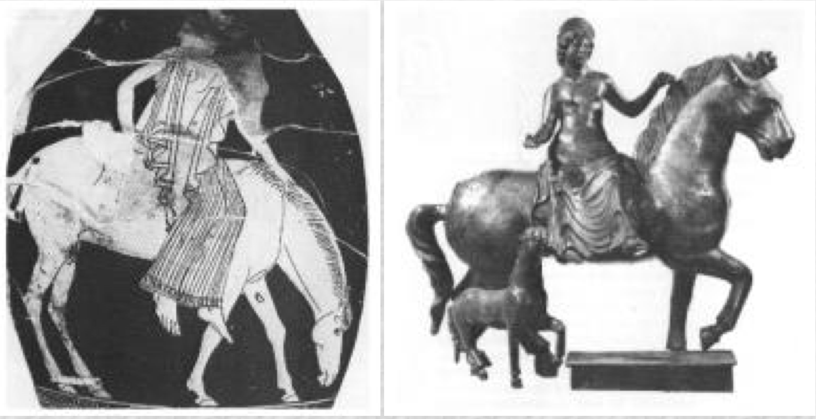
a. Drawing of an ancient Greek woman riding aside
b. Statue of the Celtic Goddess Epona, Patroness of the Horse, in a Gallo-Roman Bronze. Bibliotheque Nationale

I found an 11th c. painting of Mary and Joseph fleeing into Egypt. In this plate Mary rides aside and both her feet are in stirrups. I am of the opinion that this is unsafe. I also found a written reference in Hispanic Costume, that spoke of women using one or two stirrups on their saddles.

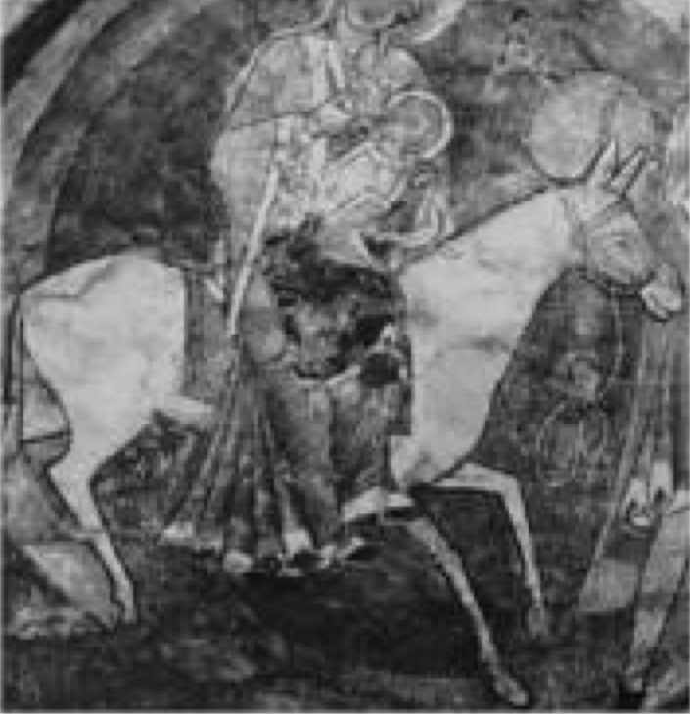
Le Petit-Quevilly, Saint-Julien, choir vault, Flight into Egypt, Detail of a vault painting. c.1183. (Dodwell)

Women are seen riding astride frequently through all of our period. Women seem to have ridden both astride and aside concurrently and all through period. Most books say that women rode only aside after about 1300 but I find that the pictorial evidence says differently. Aside seems to have been the more "ladylike" way to ride, but women of strong character seem to have broken with this regularly. As an example, in The Canterbury Tales, the Prioress rides aside and the Wife of Bath rides astride.

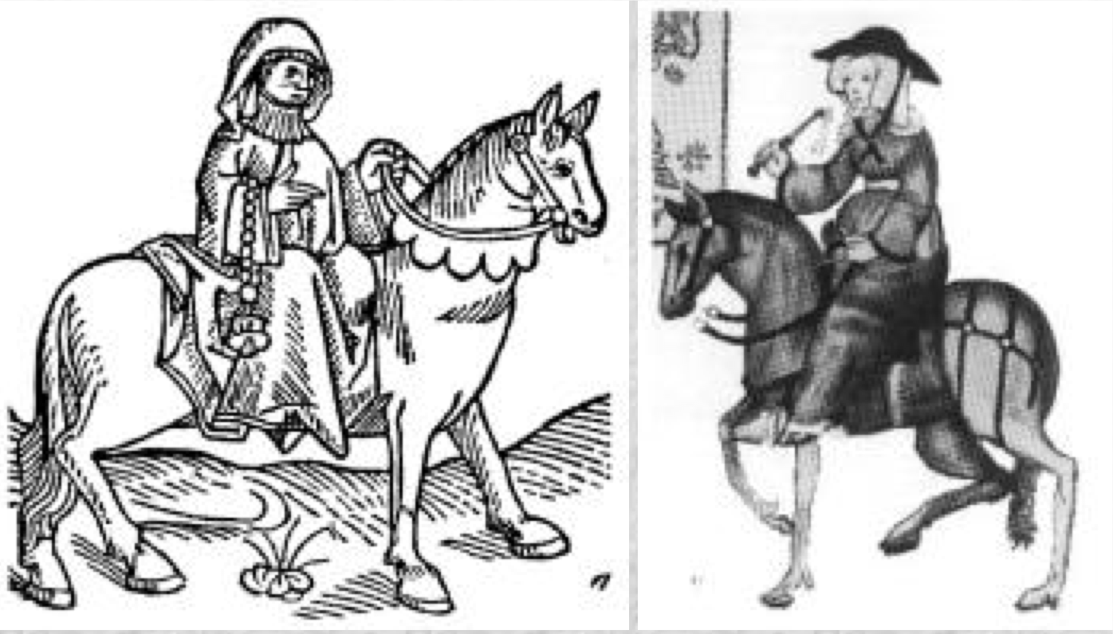
a. The Prioress from The Canterbury Tales, this version was printed in 1532
b. The Wife of Bath, from the Canterbury Tales, the Ellesmere Manuscript, c.1410, the Huntington Library, San Marino, CA.

The Virgin Mary is generally portrayed aside, though there are some portrayals of her riding astride. Women seem to ride astride or aside depending on fashion. Even in the late Renaissance women ride astride, the next plate shows Queen Isobel of France by Velasquez, I am sure that there are many who will contest this but with much study, I have come to the conclusion that she must be riding astride, as there is no room for the leg to be thrown over and you cannot see her right foot as you would if she were in the modern aside position. Also the pommel of her saddle is clearly visible. I believe she is riding astride wearing a farthingale.

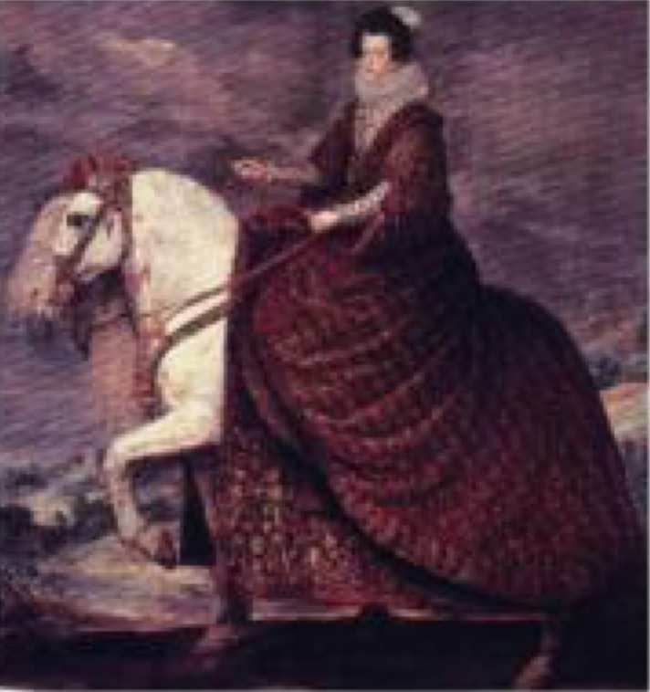
Queen Isabel of France by Velasquez

By contrast here are two pictures which clearly show the sidesaddle of that time. Note in the first, the women's body is slightly twisted on her horse and the right knee and both feet are clearly visible. Even where the fashion is for extremely long skirts the right toe is visible through the skirt. In the second, the lady is wearing trousers and therefore clearly shows her leg position. These ladies are riding in the "modern" position. At this time women rode both on sideways facing planchette sidesaddles and the more modern style.

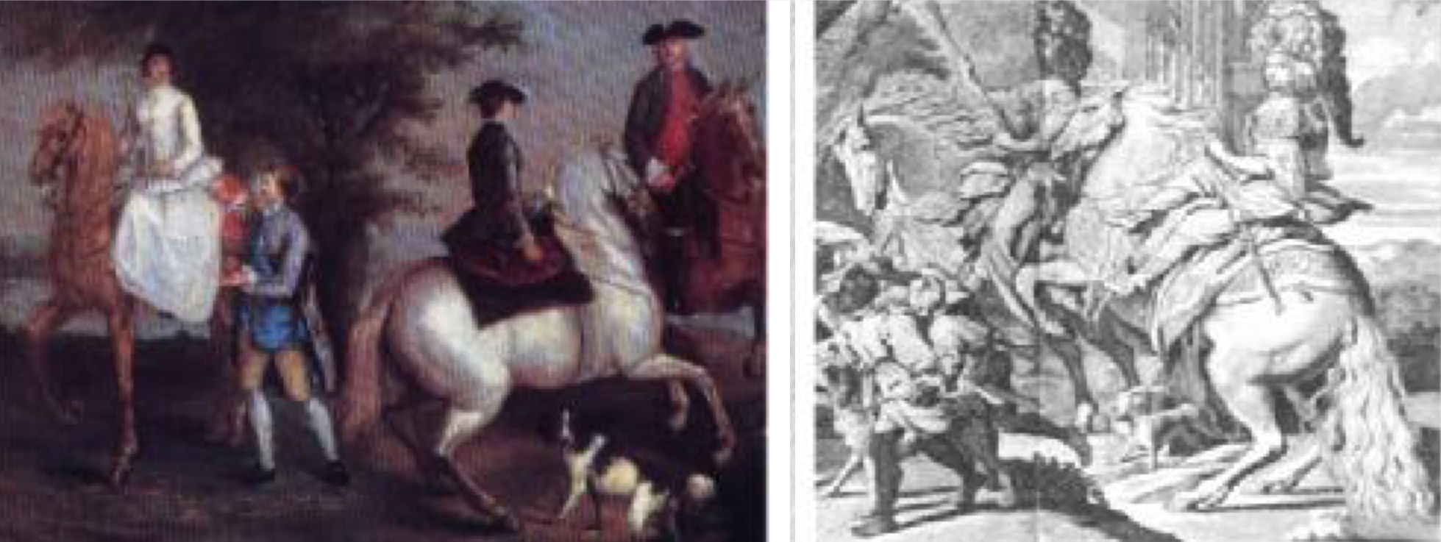
a. "Family Hunting Party"(1755/6) by Judith Lewis
b. A plate from a privately printed book commemorating a party held by the Duke of Savoy in 1674

There are many examples of women riding astride.

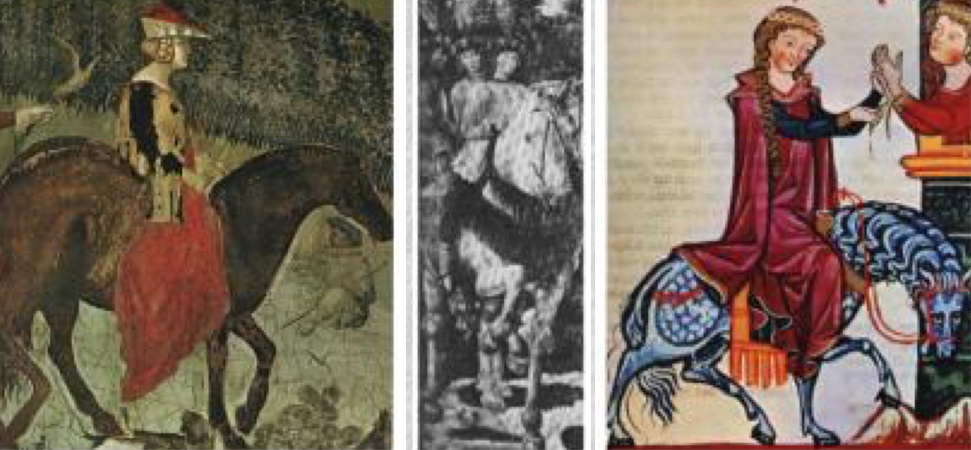
a. Detail from "The Effects of Good Government" by Lorenzeti
b. The sisters and cousin of Lorenzo de Medici, from the fresco, Journey of the Magi by Benozzo Gozzoli in the Riccardi chapel ca.1459
c. Detail from the Minnesanger Manuscript

There are even more of women riding aside, in the completely sideways style. My thoughts on this are, why would someone ride this way if they couldn't go where they pleased, comfortably? After all I had found modern writers who said that ladies couldn't ride faster than a walk and that they couldn't guide their own horses. A quick glance at the historical record proved this last one wrong.

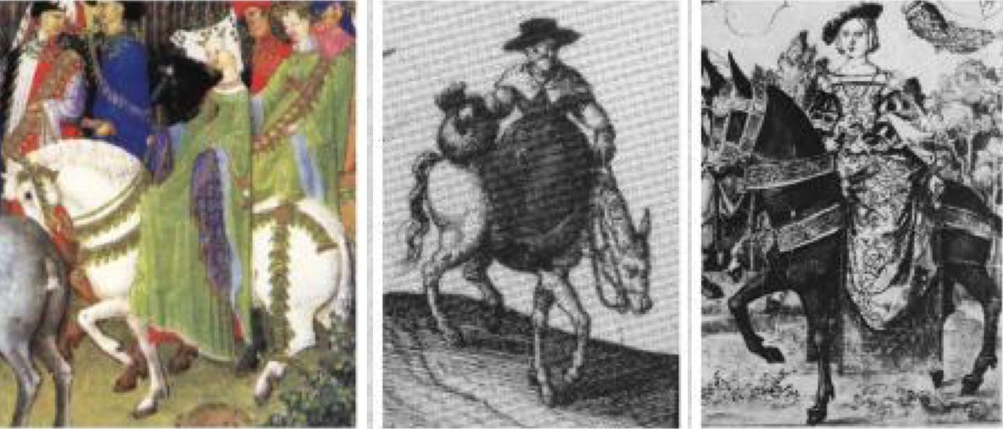
a. Detail from Tres Riches Heures de Duc de Berry
b. Detail from Two countrywomen, two fishwives and a water-carrier by J. Hoefnagel, 1574
c. Mencia de Mendoza, detail of tapestry cartoon by Bernart van Orley, ca.1530

Women also seemed to ride either "handed".

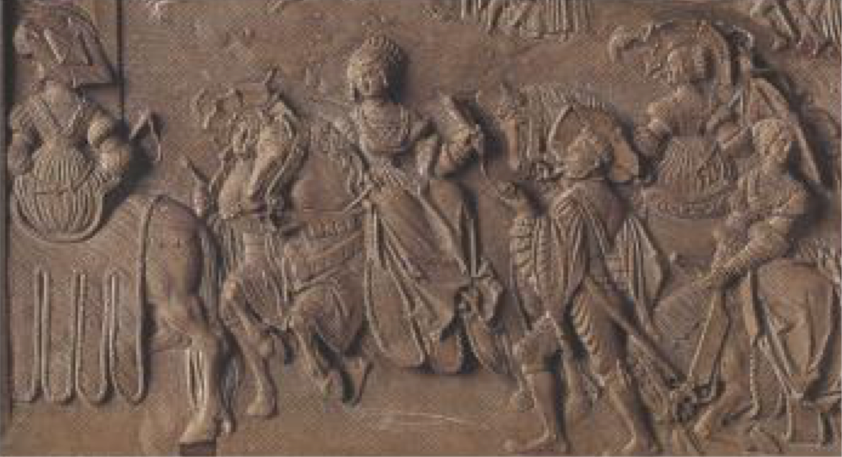
Detail from an allegory of Vices and Virtues, early 16th c. German

Modern women generally ride aside only to the near (left) side unless there is some physical handicap, which precludes this. I remember reading somewhere (unfortunately I forget where!) that the Spanish ladies, who accompanied Katherine of Aragon to England, rode on the "wrong" side from the English Ladies, so there probably are regional preferences but I don't yet know what they were. I also don't yet know if women were "flopped" by "Artistic License".

I have been looking for pictures of women's saddles, either extant or in portraits, and haven't seen many.

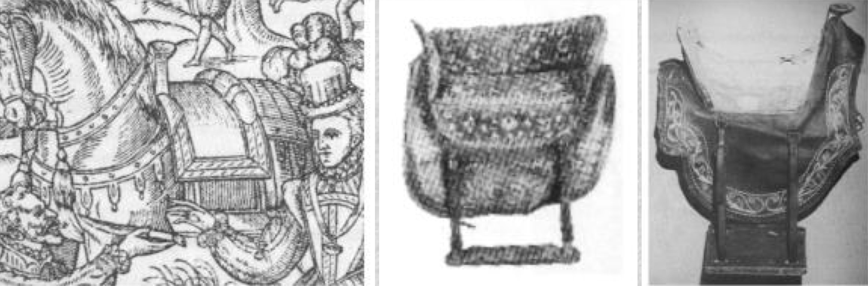
a. Detail of Queen Elizabeth I's saddle from the Booke of Venerie by G. Turberville, 1572
b. Probably 17th c. sidesaddle from the Hermes Museum in Paris
c. Mexican sidesaddle with planchette, 18th c., LA County Museum of Natural History

Most saddles are shown with someone in them.

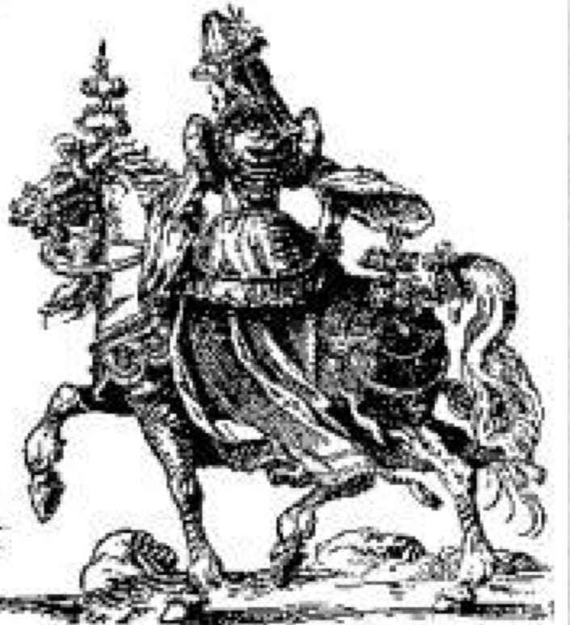
16th c. Lady from Horses in Shakespeares England by Anthony Dent

There is a real difference between a "medieval" and a "modern" sidesaddle. On a "modern" saddle the rider faces directly forward with one foot in a stirrup and the other knee over a horn.

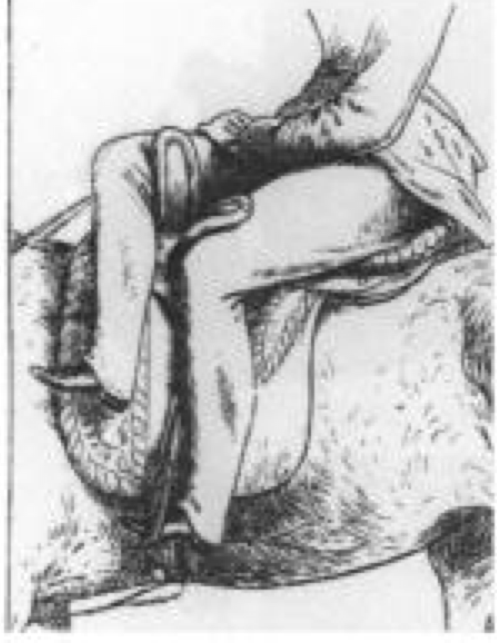
Final Position from S. Sidney's Book of the Horse, 1874

On a "medieval" saddle the rider sits facing directly sideways and must twist in the body to face forward. Her feet are usually both on a board.

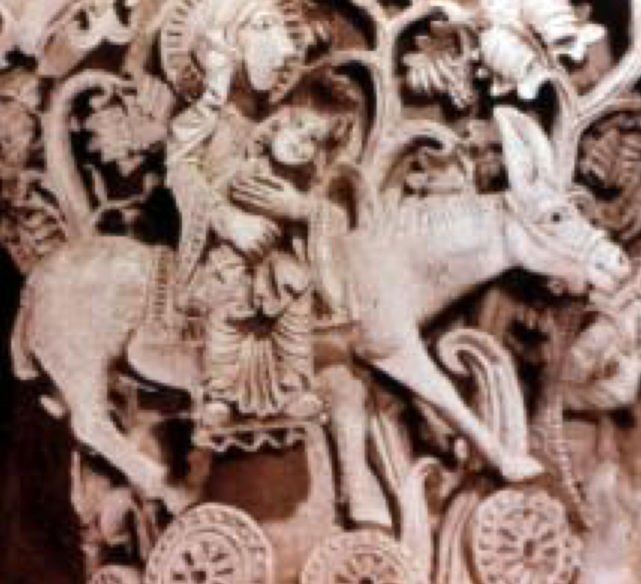
Flight into Egypt

I have little to prove it, but my guess is that women "scooched" around to the front on their saddles and finally threw one knee over a modified pommel to create the "modern" version. I do know that some women were already riding in the "modern" position as early as 1495 when Albrecht Durer made this print. Note how similar the position is to the Victorian era one.

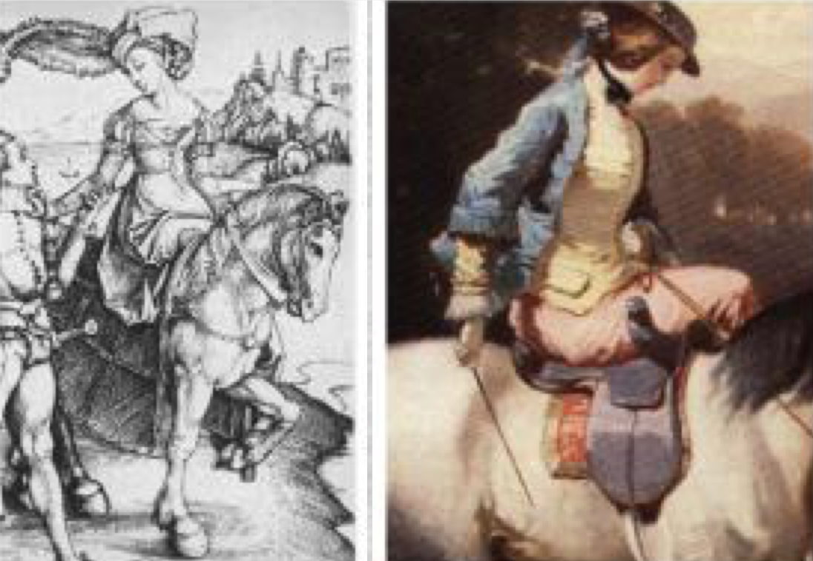
a. Detail from The Lady and the Landsknecht by Albrech Durer ca.1495
b. Detail from An Elegant Equestrienne on a Grey by Alfred de Dreux

Building the Saddle

Ever since Edward and I got interested in horses at Twenty Year Celebration, I have been making tack for whatever horse I happened to have access to. When my friend the Honorable Lady Darya found a picture of a "medieval" sidesaddle, I decided to build one like it. It is probably 17th century but I have no firm date for it yet.

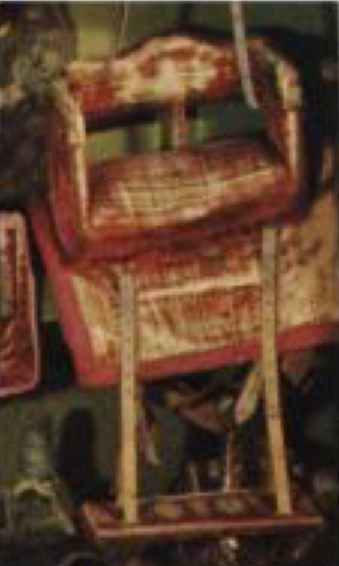
A probably 17th c. sidesaddle from the Hermes Museum in Paris

I chose this design because of the high cantle and pommel and the backrest. It looked like it would give good stability. I also chose to attach it to the horse with two girths and use a crupper and breast collar. Since I had no idea of what to expect, I decided to go for as many safety features as possible. I knew I could use just a plain breast collar and crupper as the Italians of my period often used fairly plain breast collars and breechings or cruppers, sometimes with a bridle to match.

STEPS

Over the years I have torn apart a number of saddles of various types to see how they were built. I have also read every book on saddle making I could find. I decided to tear apart an old western saddle and use the tree. When I got it all apart I decided it was not right for a side-saddle like the one in the picture as I wanted it to have a very flat seat. I decided to build the tree.

To save wear and tear on my feet and Briar's [her horse's] nerves I made a plaster-cloth mold of her back to fit the parts, so I wouldn't have to keep going out to try things on her.

As I wanted the saddle's seat to be very flat and chair-like, I decided to start with flat pieces of wood on top and build the bars up underneath to fit my horse. I got some 1/4-3/8" thick by 6-8" wood, I'm not sure what variety, but as both softwoods and hardwoods are used in tree-making, I figured that wouldn't matter. I found some nice stiff paste epoxy and set to work building the bars. After I had the basic shape, I flaired in the angles with balsa wood. I then constructed the pommel and cantle of two thickness' of 1/2" plywood, laminated (for non-breakableness, and cost) and attached them to the bars with wood screws and L brackets. If I had been making this in the "period" manner I would have started with a thick piece of wood and carved it down for the bars and used planks for the pommel and cantle, and of course I would not have used epoxy. Hide glue is the more authentic glue. I might have used the L brackets but I might have just drilled holes and laced it together with rawhide strips or nailed it together.

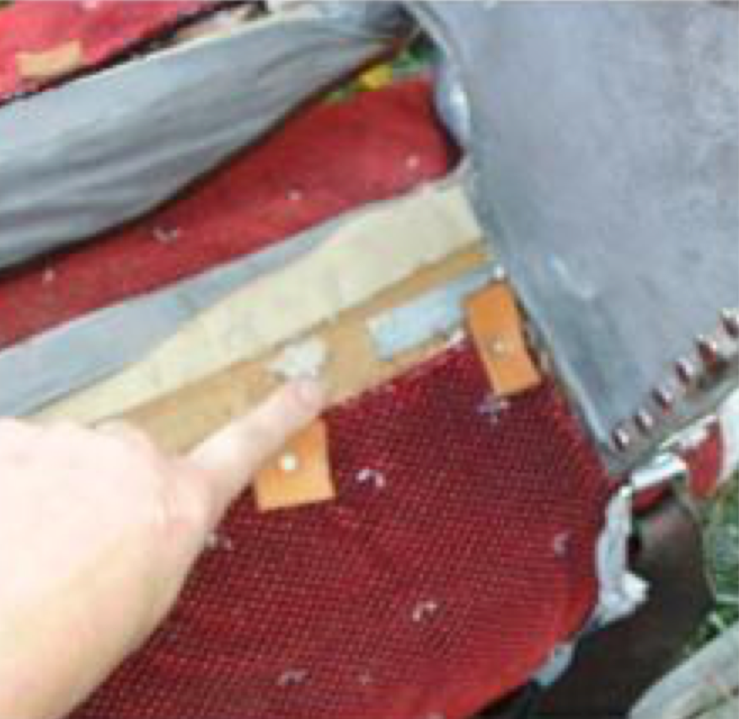

After this it was simple upholstery. I padded the underside with closed cell foam, held with hot glue and covered it with thick garment leather. If I had been making this in a "period" manner, I might have not padded the underside, and used pads instead, but many "modern" saddles of "old" style, are stuffed in a way similar to English saddles with horsehair, wool or some other resilient fiber.

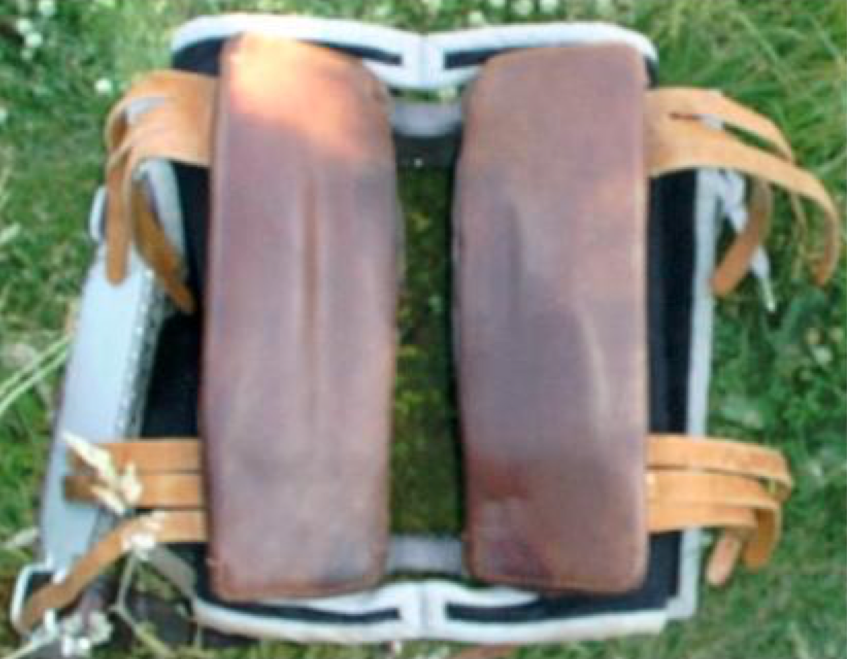

I decided on modern English style billets and girths and attached the billets with screws into the tree. Of the extant period side-saddles I know of, none of them show how they were attached to the horse. The pictorial record isn't much better. I know from looking at pictures that people used both one and two girths, and some of them went all the way over the saddle. There are pictures of saddles held to the horse with large buckles reminiscent of a Western cinch, but there are many small buckles extant, which made me lean toward the English style. I wanted to use girths I already had rather than make my own for this project.

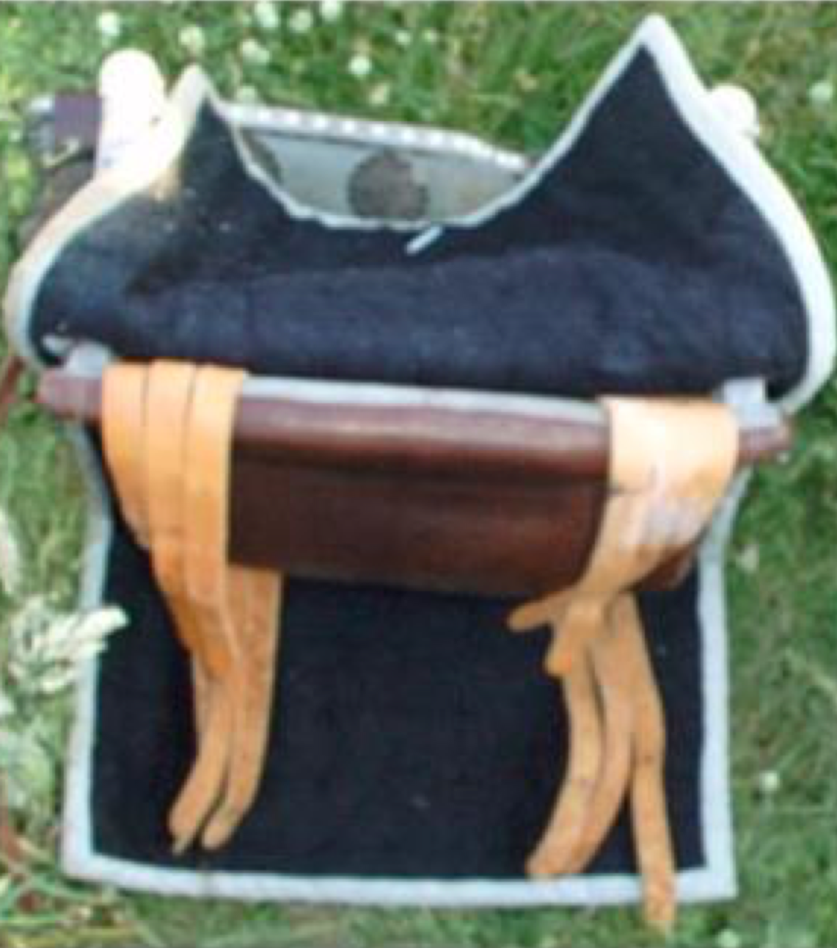

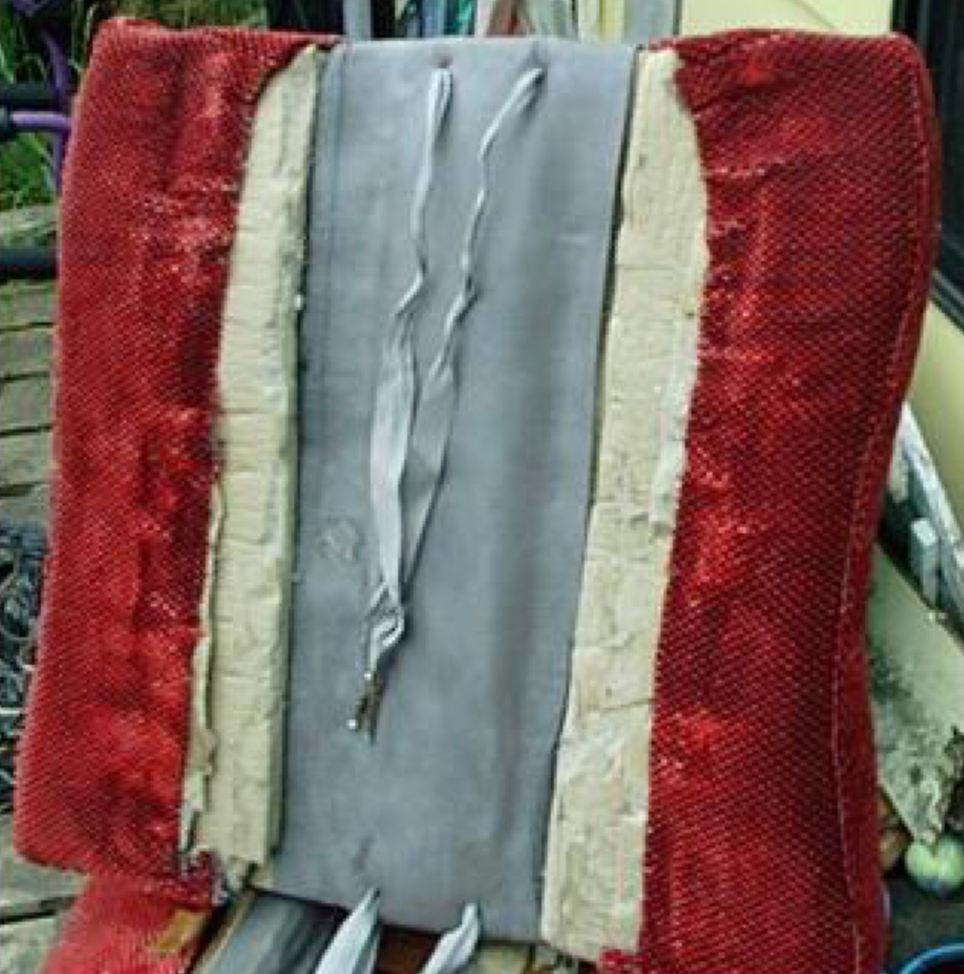
Underside of seat pad showing layers of closed cell foam with gray leather to cover gullet area and red upholstery velvet covering edges.

I then made a pad for the seat, also of closed cell foam, to fit the tree, and covered the top, sides and part of the underside like a cushion with upholstery velvet, with piping at the edges. Again if I had been making this as a "true Medieval" saddle I wouldn't have used closed cell foam. I attached the seat to the pads with ties to make it easily removable.

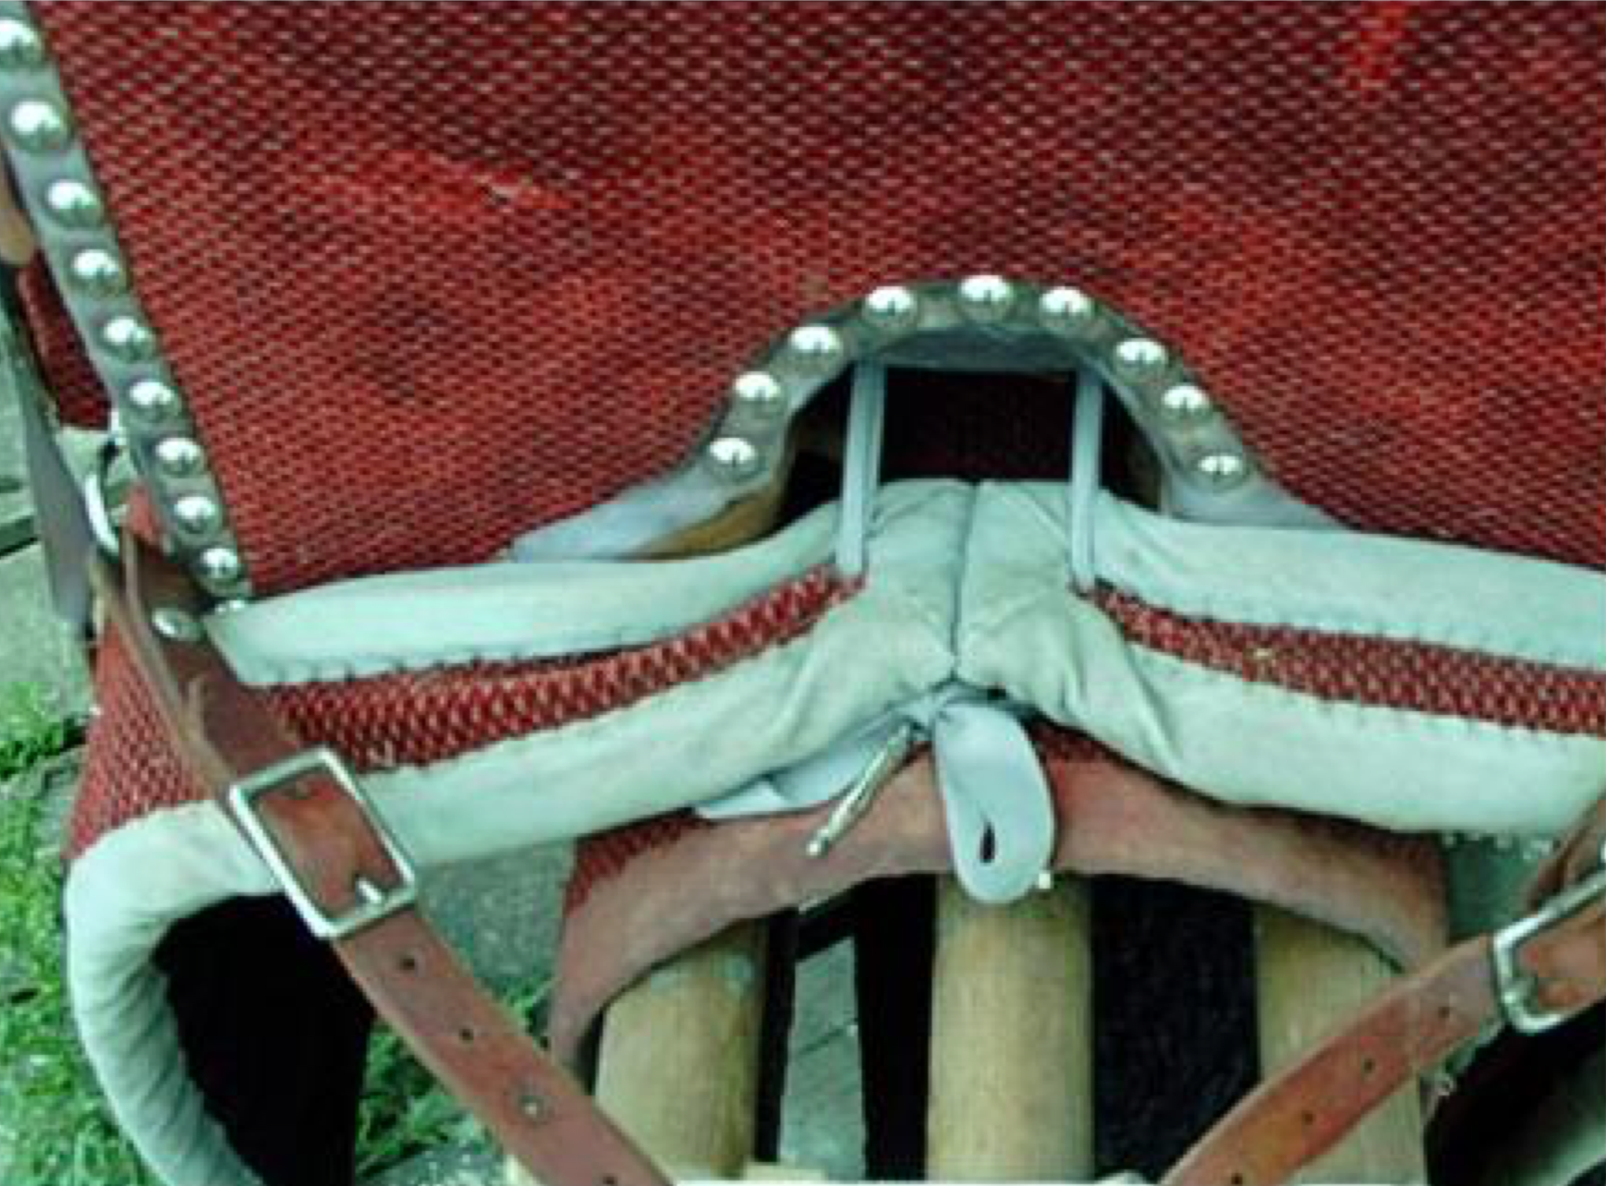

I covered the pommel and cantle with upholstery velvet outside and garment leather inside and covered the top edge with foam and leather. I used upholstery tacks to edge it.

Then I made the pads. One underpad acts as a blanket and the other pads the sides and covers the sides of the saddle to make it "finished". These I attached by screws and ties.

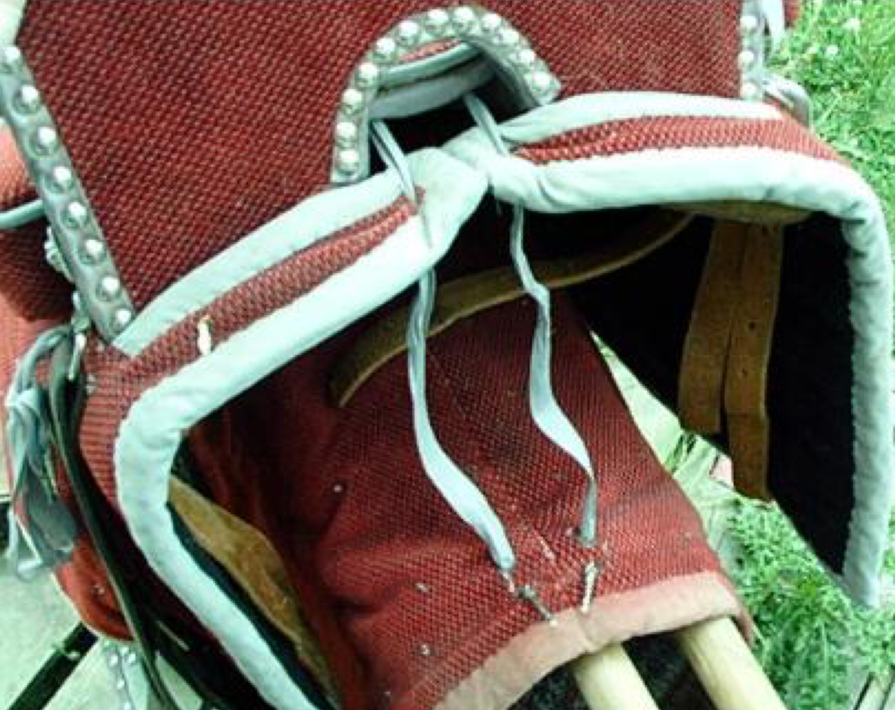

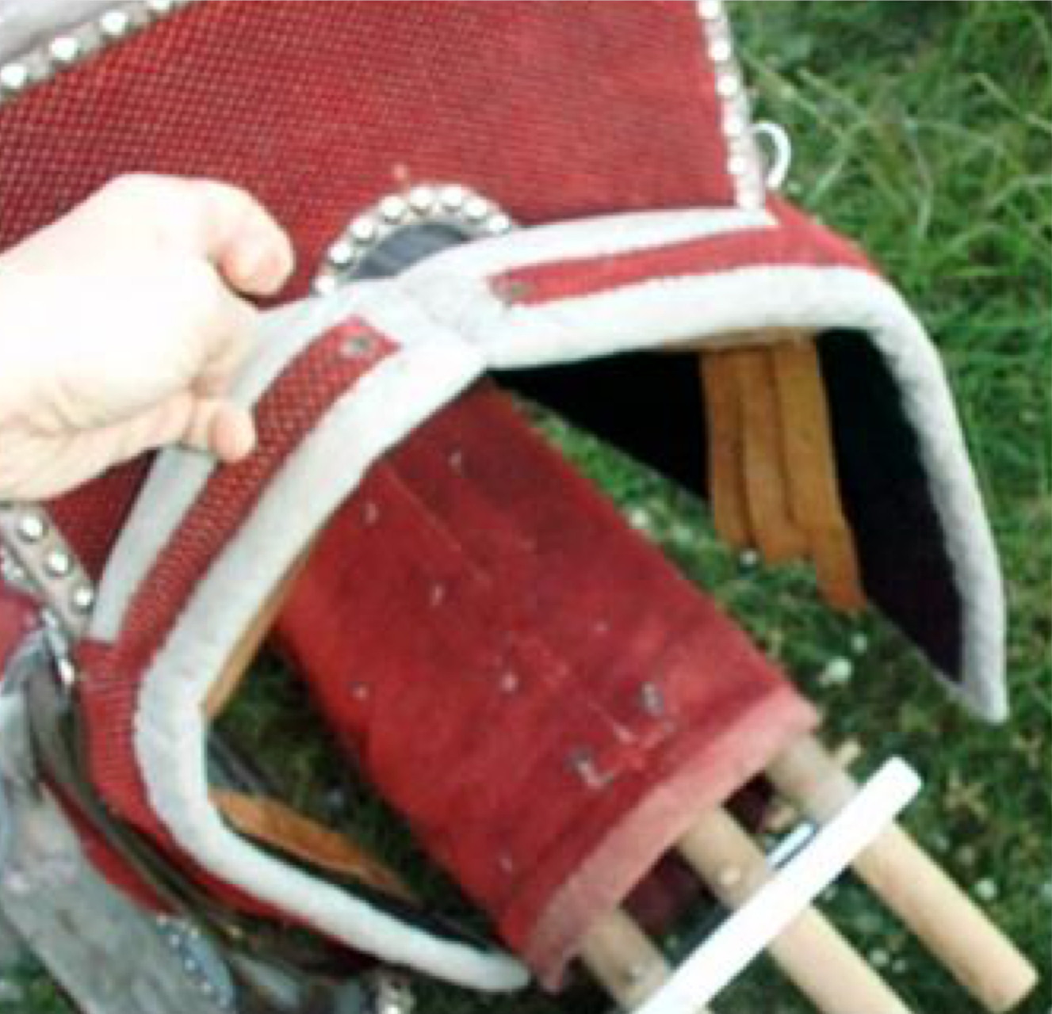

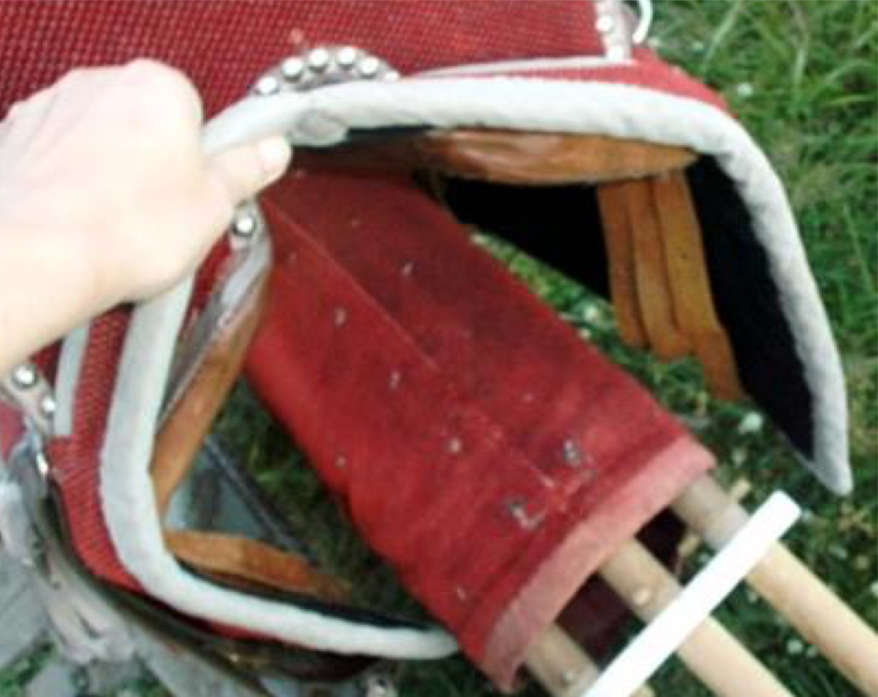

The pads and seat are removable for cleaning and to make it easy to revise if I decide to. I chose to use closed cell foam because it is inexpensive. I didn't know as I was making this saddle whether it would be possible to ride it or not and I didn't want to expend too much on what would be the first try. In period, of course, there was no closed cell foam. They would have used felt for padding, and felt is still one of the reliable pads for a horse's back. However foam is better than felt for most padding purposes, just talk to any fighter.

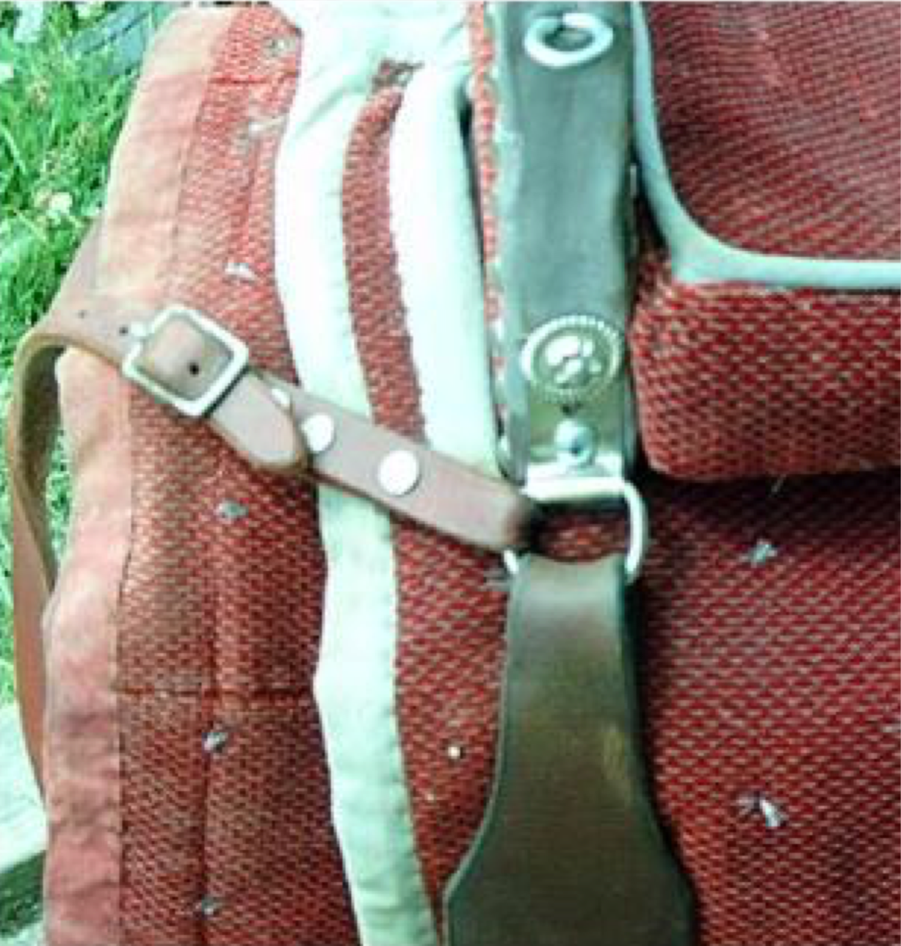

The planchet is attached to the saddle by D-rings on the cantle and pommel. The planchet leathers are purchased Australian stirrup leathers and the planchet itself is a piece of 1X6 cut to shape, painted gray, with leather and tack edging and decoration. The leathers are held to the planchet by drawer pulls.

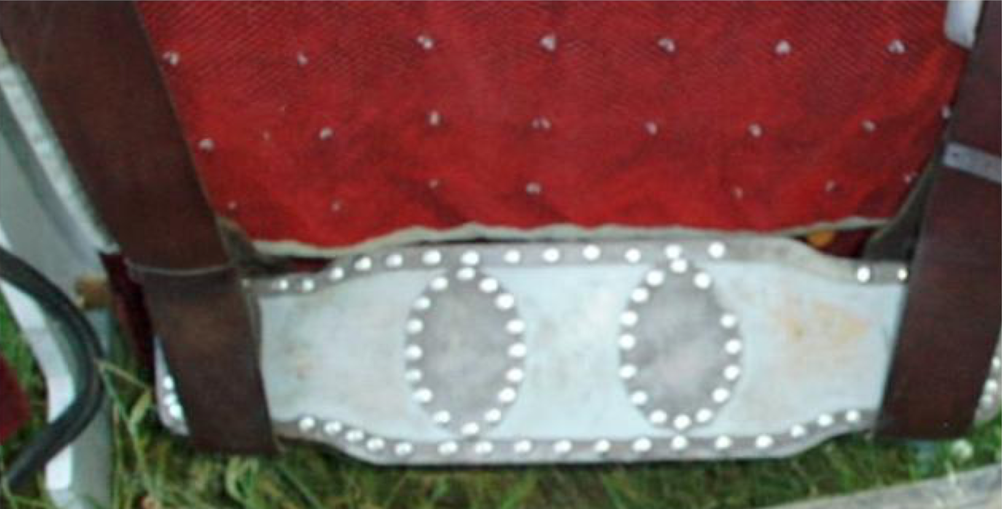

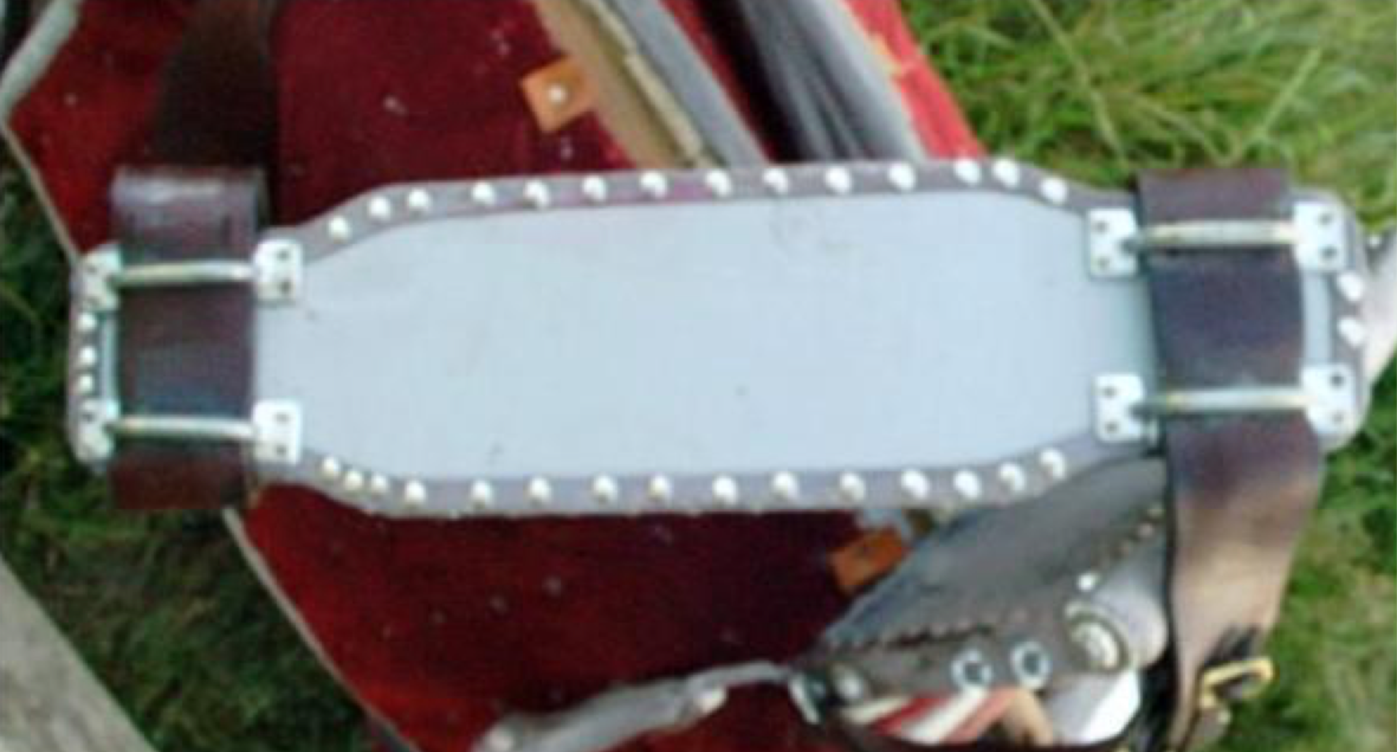
Views of top and bottom of planchette

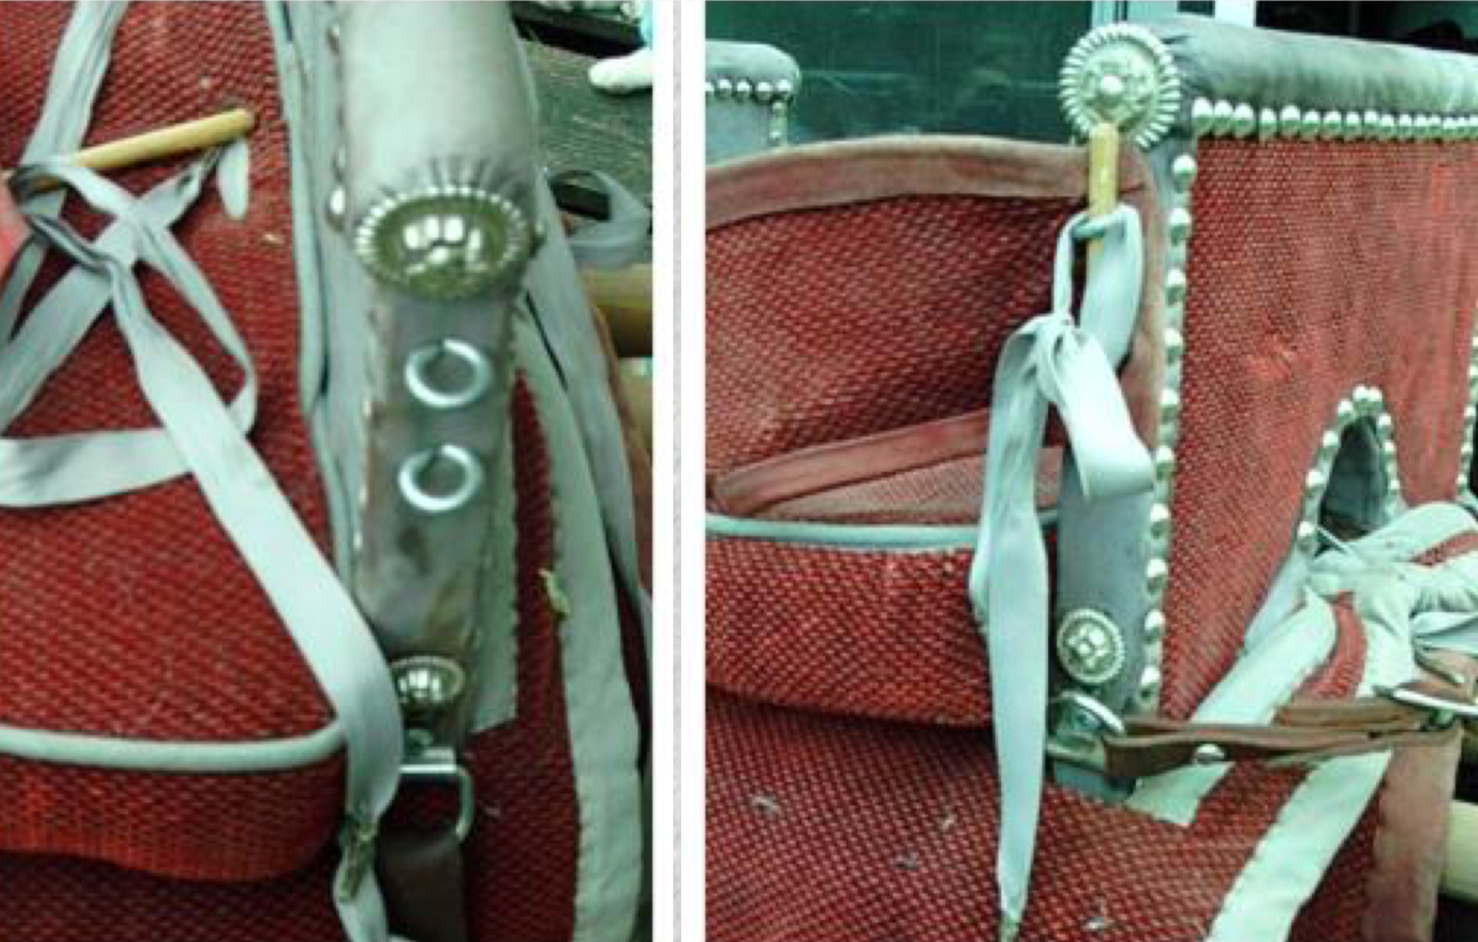
View of back attachment with and without dowel and ribbon

The back is made of fabric and cardboard laminated with glue and edged with leather. It's attached by means of eye screws and dowels.

This saddle and the one I used for inspiration are reversible. That is, you can sit the horse to either the near or off side. I think that this is due to fact that either side was correct in our period.

Finally I decorated the ends of the pommel and cantle with purchased screw back rose conchos, and put one in the center front of the pommel so it would be easy to tell which end was front.

---------
I built this saddle because I am a member of the Society for Creative Anachronism, a non-profit educational organization that studies the Middle Ages and Renaissance.

I've been active with horses in this group for about 20 years and have been researching riding styles for most of that time. Women's riding especially interests me, and I have devoted much of my research time to it. I could never figure out why women were willing to ride in a style that all the popular (modern) authors say was dangerous or at least not comfortable. I decided that I needed to make one to do a little empirical study on the subject.

This saddle is now over eight years old. I haven't used it in the few years as it was fitted very closely to my horse and she has died of old age.

We did use it for several years though. It is comfortable to ride in, although strange at first. The motion goes side to side (mine) rather than the usual front and back. I found I liked to ride to the offside. That way I could "steer" with my left hand and use the "weapons" with my right.

It is quite safe. I only ever came out of it once and I ended up sitting upright on the ground.

I found that I could do everything I wanted to on it except mount from the ground. I am 5'10" and my horse was 15 hands. Though I can get my foot to the planchet from the ground, it is uncomfortably high. So I always used a mounting block.

My horse gave me no trouble with it. I put it on her and got on. She neck reined and went with "kissy" noises. She needed minimal leg cues anyway and one sided cues didn't seem to bother her. I didn't bother with lead changes, letting her choose for herself which to take, when playing games on this saddle. Riding at the canter is no problem and quite comfortable sideways. The major problem with riding completely aside is looking behind you.

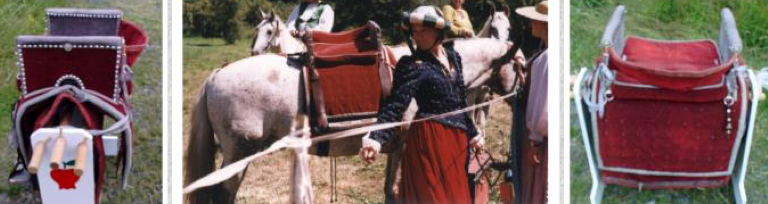

Bibliography

These are by no means the only books I looked at in compiling this paper, but it hits the highlights.

EQUUS, The Horse in the Roman World, Ann Hyland, Yale University Press, New Haven and London, 1990

The Fourteenth & Fifteenth Centuries, a visual history of costume, Margaret Scott, B T Batsford, Ltd. London 1986

Hispanic Costume, 1480-1530, Ruth Matilda Anderson, Printed by order of the Trustees The Hispanic Society of America. New York 1979

The Horseman's Progress, "The Development of Modern Riding", Vladimir Littauer. D. Van Nostrand Co., Inc. Princeton, NJ 1962

Horses and Horsemanship Through the Ages, Luigi Gianoli, Crown Publishers, New York 1967

The Howell Book of Saddlery and Tack, ed. Elwyn Hartley-Edwards Howell, New York 1988

Horse Tack - The complete equipment guide for riding and driving, Ed. Julie Richardson, William Morrow and Co. Inc., London 1981

Late Gothic Europe, 1400-1500, the history of dress series, Margaret Scott, Mills & Boon Ltd. London, Sydney, Toronto 1980 Humanities Press, New Jersey

The Life, History and Magic of the Horse. Donald Braider, Madison Square Press, Grosset & Dunlap, Publishers, New York, 1973

Man and the Horse, A. Mackay-Smith, J.R. Druesedow, T. Ryder. Simon and Schuster, New York, 1984

The Medieval Horse and its Equipment c. 1150-c.1450, ed. John Clark. Museum of London, London, 1995

Medieval Pagent, Brian Holme, Thames and Hudson, New York, 1987

The Pictorial Arts of the West 800-1200 C.R. Dodwell, Yale University press, New Haven & London, 1993

The Reign of Chivalry, Richard Barber, St. Martin's Press, New York, 1980

Renaissance Dress in Italy 1400-1500, the history of dress series. Jacqueline Herald, Bell & Hyman, London 1981. Humanities Press, New Jersey

The Royal Horse of Europe, Sylvia Loch, J.A. Allen & Co. Ltd., London, 1986

The Saddle of Queens, Lida Fleitmann-Bloodgood. J.A. Allen and Co., London 1959

Saddles, Russel H. Beatie, University of Oklahoma Press, Norman & London, 1981

The Sixteenth Century, A visual history of costume, Jane Ashelford. B T Batsford Ltd. London 1983 Drama Book Publishers New York

Woman & Horses, Gillian Newsum, Howell Book House, Inc., New York, NY, 1988
------
Copyright <year> by Lynda Fjellman. <lyndafjellman at yahoo.com>. Permission is granted for republication in SCA-related publications, provided the author is credited. Addresses change, but a reasonable attempt should be made to ensure that the author is notified of the publication and if possible receives a copy.

If this article is reprinted in a publication, please place a notice in the publication that you found this article in the Florilegium. I would also appreciate an email to myself, so that I can track which articles are being reprinted. Thanks. -Stefan.

<the end>

