horse-games-msg - 7/15/18

Ideas for period and SCA games for equestrian events.

NOTE: See also the files: Horse-Games-art, Hors-Gme-Eqmt-art, Horse-Sense-art, Mkg-Quintain-art, Rd-b4-Prince-art, Rng-Tlt-Stnds-art, Equ-Grnd-Crew-art.

************************************************************************
NOTICE -

This file is a collection of various messages having a common theme that I have collected from my reading of the various computer networks. Some messages date back to 1989, some may be as recent as yesterday.

This file is part of a collection of files called Stefan's Florilegium. These files are available on the Internet at: http://www.florilegium.org

I have done a limited amount of editing. Messages having to do with separate topics were sometimes split into different files and sometimes extraneous information was removed. For instance, the message IDs were removed to save space and remove clutter.

The comments made in these messages are not necessarily my viewpoints. I make no claims as to the accuracy of the information given by the individual authors.

Please respect the time and efforts of those who have written these messages. The copyright status of these messages is unclear at this time. If information is published from these messages, please give credit to the originator(s).

Thank you,
Mark S. Harris AKA: THLord Stefan li Rous
Stefan at florilegium.org
************************************************************************

From the fb "SCA Equestrian" group:

Joshua Haller
July 6 at 9:29 AM
I'm looking for out-of-the-box kind of games to play with horses whether individually or in a group something you do with your horse or you do in training camp whatever just I don't want to see stuff like this spoon in the egg or the Dollar Ride something out of the box something unusual.

CuMhara O'Holyhead
Egg and spoon is a go-to, for our 4-H games.

Catalog race--ride down, find your page number, rip out the page, and ride back.

Baby bottle--riding double, front person holds the baby bottle, back person drinks it down--first empty wins.

Ribbon race--crepe paper held by teams (usually teams of two, but we've done teams of four--it gets harder!) Last to rip it wins.

CuMhara O'Holyhead
Chin apple--tuck the apple under your chin. Last to drop it wins.

Musical feed bags (can make them shields for SCA). Just like musical chairs. You can also use hula hoops. You can change the rules--back foot on bag, dismount to bag, front foot on bag--to mix it up.

CuMhara O'Holyhead
An obnoxious game is battle ball. We have three barrels in the arena. We have three teams. Say six balls on each barrel. You have to collect balls from the other two barrels, and put them on your barrel, while the other teams are stealing your balls. We usually time this.

Jacqueline Grant
Buy one of the giant balls and play soccer. Picasso is a maniac with one.

Elisha Day
Broom ball. Dodge Ball and brooms while mounted, trying to score points and not hit your horse.

Kirsten Swenson
A fun one in the summer is bobbing for apples. Ride up, bob, keep it in teeth while remounting and ride back. Great way to cool off.

Kathleen Haak
Broom polo

Seonaid Welch
Slow-race in a specified gait. Break gait and you're out, LAST person across the finish line wins.

Kerri Sher
I have ridden a poker trail. There were five stations to stop at where you pick one card. The person with the best hand at the end wins.

Trista Fahle Lutz
Ribbon race, but with a lance. Way harder than it looks!

CuMhara O'Holyhead
I'm going to have to try this, as it sounds way easier. I could be missing something.

Trista Fahle Lutz
You have to be very consistent about keeping your horses an equal distance apart. Do figure 8s, swap who is on inside/outside, go single file, do turns. Harder the faster you go. It's great.

Anne-Peryn Nicholls
Joshua Haller birjas and the game Dave Kaemmerer showed us at 50th year that was a little like la Crosse come to mind. There's a Spanish game where you throw sticky darts or clay balls filled with a marking powder/liquid. I'll have to find the reference again.

Dave Kaemmerer Anne-
Peryn Nicholls Daiku is a cross between lacrosse and polo with 5 balls on the field for each team and both teams using poles with nets at end to throw or block the balls in a single goal.

Mishee Kearney
Cornhole from horse back,

Have also done capture the flag

Tippet Tag is also a lot of fun

CuMhara O'Holyhead
Sack race--ride down, dismount, two people put legs in sack and lead horse.

Don't do this with horses who aren't used to crazy.

CuMhara O'Holyhead
Beer or wine cup--where you fill it with drink or koolaid--the one with the most liquid left at the end wins. Usually a Walking horse.

Dan Scheid
broom stick polo.. with a soccer ball.. not a safe game but man is it fun

David Parish-Whittaker
Since Mistress Bridget didn’t respond to my shameless tagging of her, I went out and did my own internet research. The game is unimaginatively called “the game of reeds”, here depicted in a 1623 painting, but attested to in late 16th century Portugal. The reeds had a sticky tip (pitch?) and the shields were made Out of leather.

For Master Damales’ recommendation of bean bags, there was also a contemporary “carousel joust” where the contestants threw clay projectiles at each other.

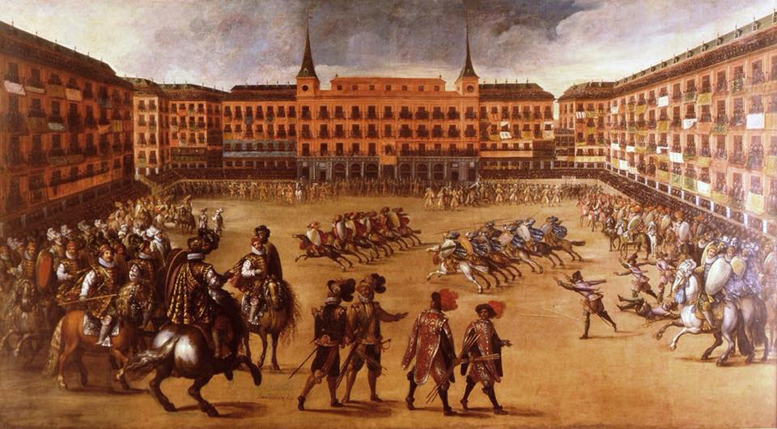

David Parish-Whittaker
Omg. I went down an Internet googling hole and found out that the game originated with the Anatolians in the 11th, and was called Jareed. It became a major sport with the Ottomans, and presumably got picked up by the Portuguese through the usual cultural cross-pollination. As far as I can tell, no shields in the Turkish version.

And guess what, they still play it today in Turkey!
https://m.youtube.com/watch?v=4PvxlgUHUSA

Jennifer Jobst
Yay research! Yup, game of reeds has been around for a long time. I think there’s a reference to it in 10th c Spain too. Def something I’d love to see us playing cause it’s hella fun!

Kat B
Playing catch with tennis balls.

Elisha Day
Sheep hearding. 6 small stuffed sheep on head poles. Collect the sheep, while weaving the poles, put them in a basket at the far end without dropping any, run back to start. Fastest time wins.

Neal Zeman
Sword fighting with pool noodles, water balloon fights. Nerf gun fights.

CuMhara O'Holyhead
We also do the Stick the flag. You have the standard three barrel set up, with a bucket of sand on each of the close barrels. There is a stick in one bucket. You are timed, and have to ride on the outside of the barrels, pick up the stick out of the first bucket, do the lap, then stick the stick in the other bucket on the way home.

Requires one hand riding and control.

CuMhara O'Holyhead
Similarly, we put a bucket on each of the barrels, kids ride around the outside and have to put a softball in each bucket on the way around.

It’s harder than it sounds.

Jessica Kelly Smith
Pony soccer. Using one of the big balls the horses are ridden to hit the ball with the front legs to goals on each end of the arena. As they get more comfortable with it the game goes from a walk to a pretty quick pace

Hilary Hargreaves
Kings Closet. A minimum of two teams. 1-2 riders per team and 1 tolerant horse. A min of 2 containers (aka Closets) of clothing, each with the same # and type of articles. For example a hat, long sock(s), long sleeve and short sleeve shirt, bandana, pajama pants, poncho, sweat pants, foam sun visor, novelty head band with ears or antenna, scarf and or sash, bows/ribbons, parade jewelry like bead necklaces and gaudy medallions, etc. Duplicate each item the best you can so you have one in each container. Thrift shop and dollar tree/five below finds. Or empty out your own closet!

The closets are at the start line. The event is timed. On "go" each team dresses one rider and the horse (the horse must "wear" at least one article of clothing, you can require more). Depending on the skill of the riders and the disposition of horses rules can be decided on whether the rider must be mounted or unmounted while dressing. Once the horse and rider are dressed they race to a barrel, go around it, return to the closet, undress, putting clothing back into closet and then repeating the process for their team mate. If you have a mixed group of skill levels, try to pair a lower level rider with an experienced rider.

Trista Fahle Lutz
This could be really cool with "armour" instead!

Hilary Hargreaves
Trista Fahle Lutz so long as people and horses are used to the sounds and feel of armor yes. My own horse took quite the offense to someone's clinking squeaking chainmail before he had the opportunity to authorize for jousting and left him unceremoniously on the ground. Likewise there are people who do not have a developed independent seat and their seat becomes precarious with having to cope with the armor. Helms that limit the site can also mess with people's balance unless they have had the opportunity to acclimate.

Trista Fahle
Lutz Hilary Hargreaves hence the quotation marks. doesn't necessarily have to be real armour.

CuMhara O'Holyhead
Rescue race. Race down, second rider jumps on, race back.

CuMhara O'Holyhead
My least favorite is the boot race. Everyone gives up one boot. Boots get tossed in a pile. Everyone races to the pile, finds their boot, puts it on, and the first one back wins.

CuMhara O'Holyhead
Classic Simon Says. Red light green light

Hilary Hargreaves
There is also "Pato" (the Duck game). It is the national game of Argentina. We did a variation of this game with a rubber chicken that made all sorts of silly noises. But you can use a stuffed animal. Be aware that if you use animals that make noises, some horses may not want to participate. The variation we used was a goal at either end of an arena (you can use hula hoops, boxes, buckets, manure tubs). The original game uses a pole with a ring and net.

You have teams, it may be made up of player-versus-player or multiple player teams. Care must be taken to match Riders of similar skill or at least horses of similar disposition and be clear as to how opposing Riders may approach each other. Such as you may only approach at a walk or trot. You can also divide your arena up into three sections so that half of the arena's length, in the middle, is where you may canter and opposing team members cannot steal the duck. The quarter sections of the arena, in front of each goal, riders must walk and stealing the duck is allowed.

So basically you attempt to steal the duck from the player who possesses it and you attempt to put the duck in the goal. You may designate a goals for each team or you may make both goals viable for scoring by each team.

Obviously it is important to make sure that you adjust the rules of this game to the skill level and the dispositions of the horses involved to minimize collisions, falls and horses kicking or biting at each other (and accidentally riders too).

Rebecca Hukle
we play capture the flag, each person has a flag or bandana attached to their pants (through belt loop loose) and we steal each others flags, last one with all the flags wins... all flags in same place on each person.

Joshua Haller
Rebecca Hukle sounds just like tabard tag.

Anja Smith
Ok I got a ton. Set up cavaletti or what cha ma call it poles that are a bit off the ground. You gotta walk over them (snake line pattern) and lead your horse at the same time without stepping off and it's timed. Yoga ball. You get off pick up ball and get on with it (sounds easier than it is). Wheelbarrow race. You get four bales of hay and have to get off horse, load them up, and run a snake pattern around comes while leading your horse. Also timed. Someone attaches a marker to a broom handle and on a tree there's paper with balloons around it dangling. Now you gotta write the name of the ride down as well as date. Timed as well.

Egg ride. Beginning of the ride eggs are handed out. You have to carry the egg in your pocket the whole ride without breaking it. At the end it's the spoon ride at walk trot canter without losing it. Dragging garbage bags or rattle can bags on a rope behind you around comes with tennis balls on them. Hanging up clothes from a basket from your horse. Another fun one is you hang up a pvc pipe in an angle at horse height. Now you're giving a measure cup. You get water, pour it in on one side and ride real fast to the other to catch it all again. Two barrels are set up with a long tarp in one side. You ride in between, grab the tarp over the horse and put it in the other barrel. The bobbing Apple's game but instead a bowl full of flour and two dice. You gotta get that with your mouth. No hands...

Apple fritter eating challenge. One for your horse and one for you. You compete against several others and it's timed. Oh and if your horse doesn't want to. Eat it or has half eaten it and then doesn't want it anymore you'll still have to eat it :-p

Riding with a partner around a course holding a plastic tarp in between you. Timed.
Throwing balls in a basket from the horse out.

Untack, get on bareback without help and ride around a course, tack back up, now get on from the right and go back around again.

Step up Bridge game... Your horse has to get on a Bridge but one foot first, then wait five seconds, then the other, 5 sec, then one back foot, wait, and second. Then ride to middle, stop and wait five sec. Then go to the end, one foot down and wait, second, wait and same with Hinds.

Tree log coddling. Horse has to step over it, one foot on the left of the log, right on right side. So the log is laying straight in front of you. Now make your horse walk straight with your horse taking any of the legs away from the sides. And now you gotta do the same but backwards (oh yeah that one is hard), backing your hprse up a hill in hand or under saddle. Mailbox. Ride to the mailbox, open it, look what's in it, take the envelope out and show to Horse, now ride to the second mailbox and put the letter in that.

Get off the Horse, now send you horse on a loose rope next to a pile of hay. Your staying behind. The horse cannot touch the hay. Gotta wait 10 seconds. Then ask horse to back up, again loose rope. Btw my kid didn't even wait five sec that little pig lol.

I got tons more btw. I've done these challenges for 14 years. Super fun. ;

Mishee Kearney
5:18pm Jul 12
Photo from Atlantia page of tippet tag ( the tippets are on our arms, people are on two teams, you get “out” by having your tippets taken off by an opposing team member)

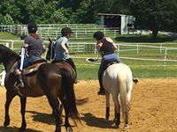

Mishee Kearney
6:23pm Jul 12
photo from east kingdom equestrian page of cornhole

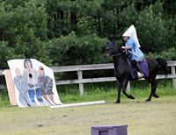

Kristine Kaemmerer
5:20pm Jul 12
On Daikyu, add in that once one team has all their balls in a special ball is thrown in to toss in for the winning score.) Normally a target at the end (similar to bean bag target but high up and about 12" diameter shared by both teams and a target to toss the balls into, with a foul line - area you can't be into toss in the winning score usually marked with lumber on the ground or short tipable fencing.

We usually use racket balls, a red team and a blue team and put headbands on the players, so people know who they are playing with or against. Bonus ball was yellow, so someone called it the quiddich.

Kristine Kaemmerer
Heraldic madness.
4 sets of reeds painted all the heraldic colors and metals. Plus reed stands, divided field open at ends maiden at end to claim for bonus points for collecting and riding back or kill if she's the 'wrong' color. This can lead to wresting matches...

Either players bring their blazon/flag to the field or draw from the color bag and the metal bag. Only one chip of each color and metal.

two poles/portable holes with hooks to hold flags put up in colors/metals drawn. This is so the onlookers can see who is trying to get what reeds. Two sashes for riders to wither wear or put on sword hilt (to remember not to 'kill' the reeds on your side. Reeds are set up in random clusters like a battlefield, not straight lines, but sides should match layout.

Lay once riders are ready to race and 'kill' the reeds.

Positive points for killing opposing colors. Negative points for killing friendly colors.
Can give extra points for bringing their banners/blazon to the field to add to ambience.
Encourages people to get their heraldry passed and bring it out to the field to show off.
Can be set to do by gait if wish, faster is more fun for audience. But need to encourage all to play or at least cheer others on.

Kristine Kaemmerer
Fox hunt with spears and 50 foot rope with stuffed fox followed by several hounds.

Pulling animal runs the drag rope. Once past a reasonable distance (can't hit animal or rider with spear so 30 feet?) the chasing team gets to ride to attempt to spear the fox.

Used this as an if you get to this point before x amount of time, tie breaker. One got the fox and one got a dog rest missed. Only 6 or 7 advanced to this point after a brutal multitask course Points were not announced in advance. Reeds, waterfall, rings, apple chop, fish pond, water hazard, grab and raise an item by backing equine, bridge and tipping bridge. Can't recall what else was planned or done.

Kristine Kaemmerer
6:54pm Jul 12
bridge to boat.
small pallet can ride on to lumber laid out in boat shape. [You] have to walk the 'deck' to get onto the boat, head in and back up and after waiting go back out onto the deck.

<the end>

