horse-reins-msg - 8/28/15

Period horse reins and re-creating them.

NOTE: See also the files: Horse-Barding-art, p-saddle-bags-msg, saddles-msg, Side-Saddle-art, Sadle-Blankts-art, horse-barding-msg, lea-tooling-msg.

************************************************************************
NOTICE -

This file is a collection of various messages having a common theme that I have collected from my reading of the various computer networks. Some messages date back to 1989, some may be as recent as yesterday.

This file is part of a collection of files called Stefan's Florilegium. These files are available on the Internet at: http://www.florilegium.org

I have done a limited amount of editing. Messages having to do with separate topics were sometimes split into different files and sometimes extraneous information was removed. For instance, the message IDs were removed to save space and remove clutter.

The comments made in these messages are not necessarily my viewpoints. I make no claims as to the accuracy of the information given by the individual authors.

Please respect the time and efforts of those who have written these messages. The copyright status of these messages is unclear at this time. If information is published from these messages, please give credit to the originator(s).

Thank you,
Mark S. Harris AKA: THLord Stefan li Rous
Stefan at florilegium.org
************************************************************************

From the fb "SCA Equestrian" group:

Kate Reis
August 23 at 7:26pm · Morning View, KY
When making rein covers - how long do you usually make them??? Two feet sound good?

Anne-Peryn Nicholls
Figure out the shortest you will hold your reins. A couple inches closer to the bit would be one end, the bit would be the other. I find rein barding gets in the way if it's too long.

I also recommend attaching them to the reins at both ends. They look better when they don't bunch up.

The hours of Duke de Berry has lots of examples of rein covers. So does Foissart.
August 23 at 9:18pm

Kristine Kaemmerer
Or make them as a second set and let them be pretty while you work off your leather ones. I think our leather ones are back 52inches from the bit and have a 1 foot span where our hands go that isn't large and scollopy.

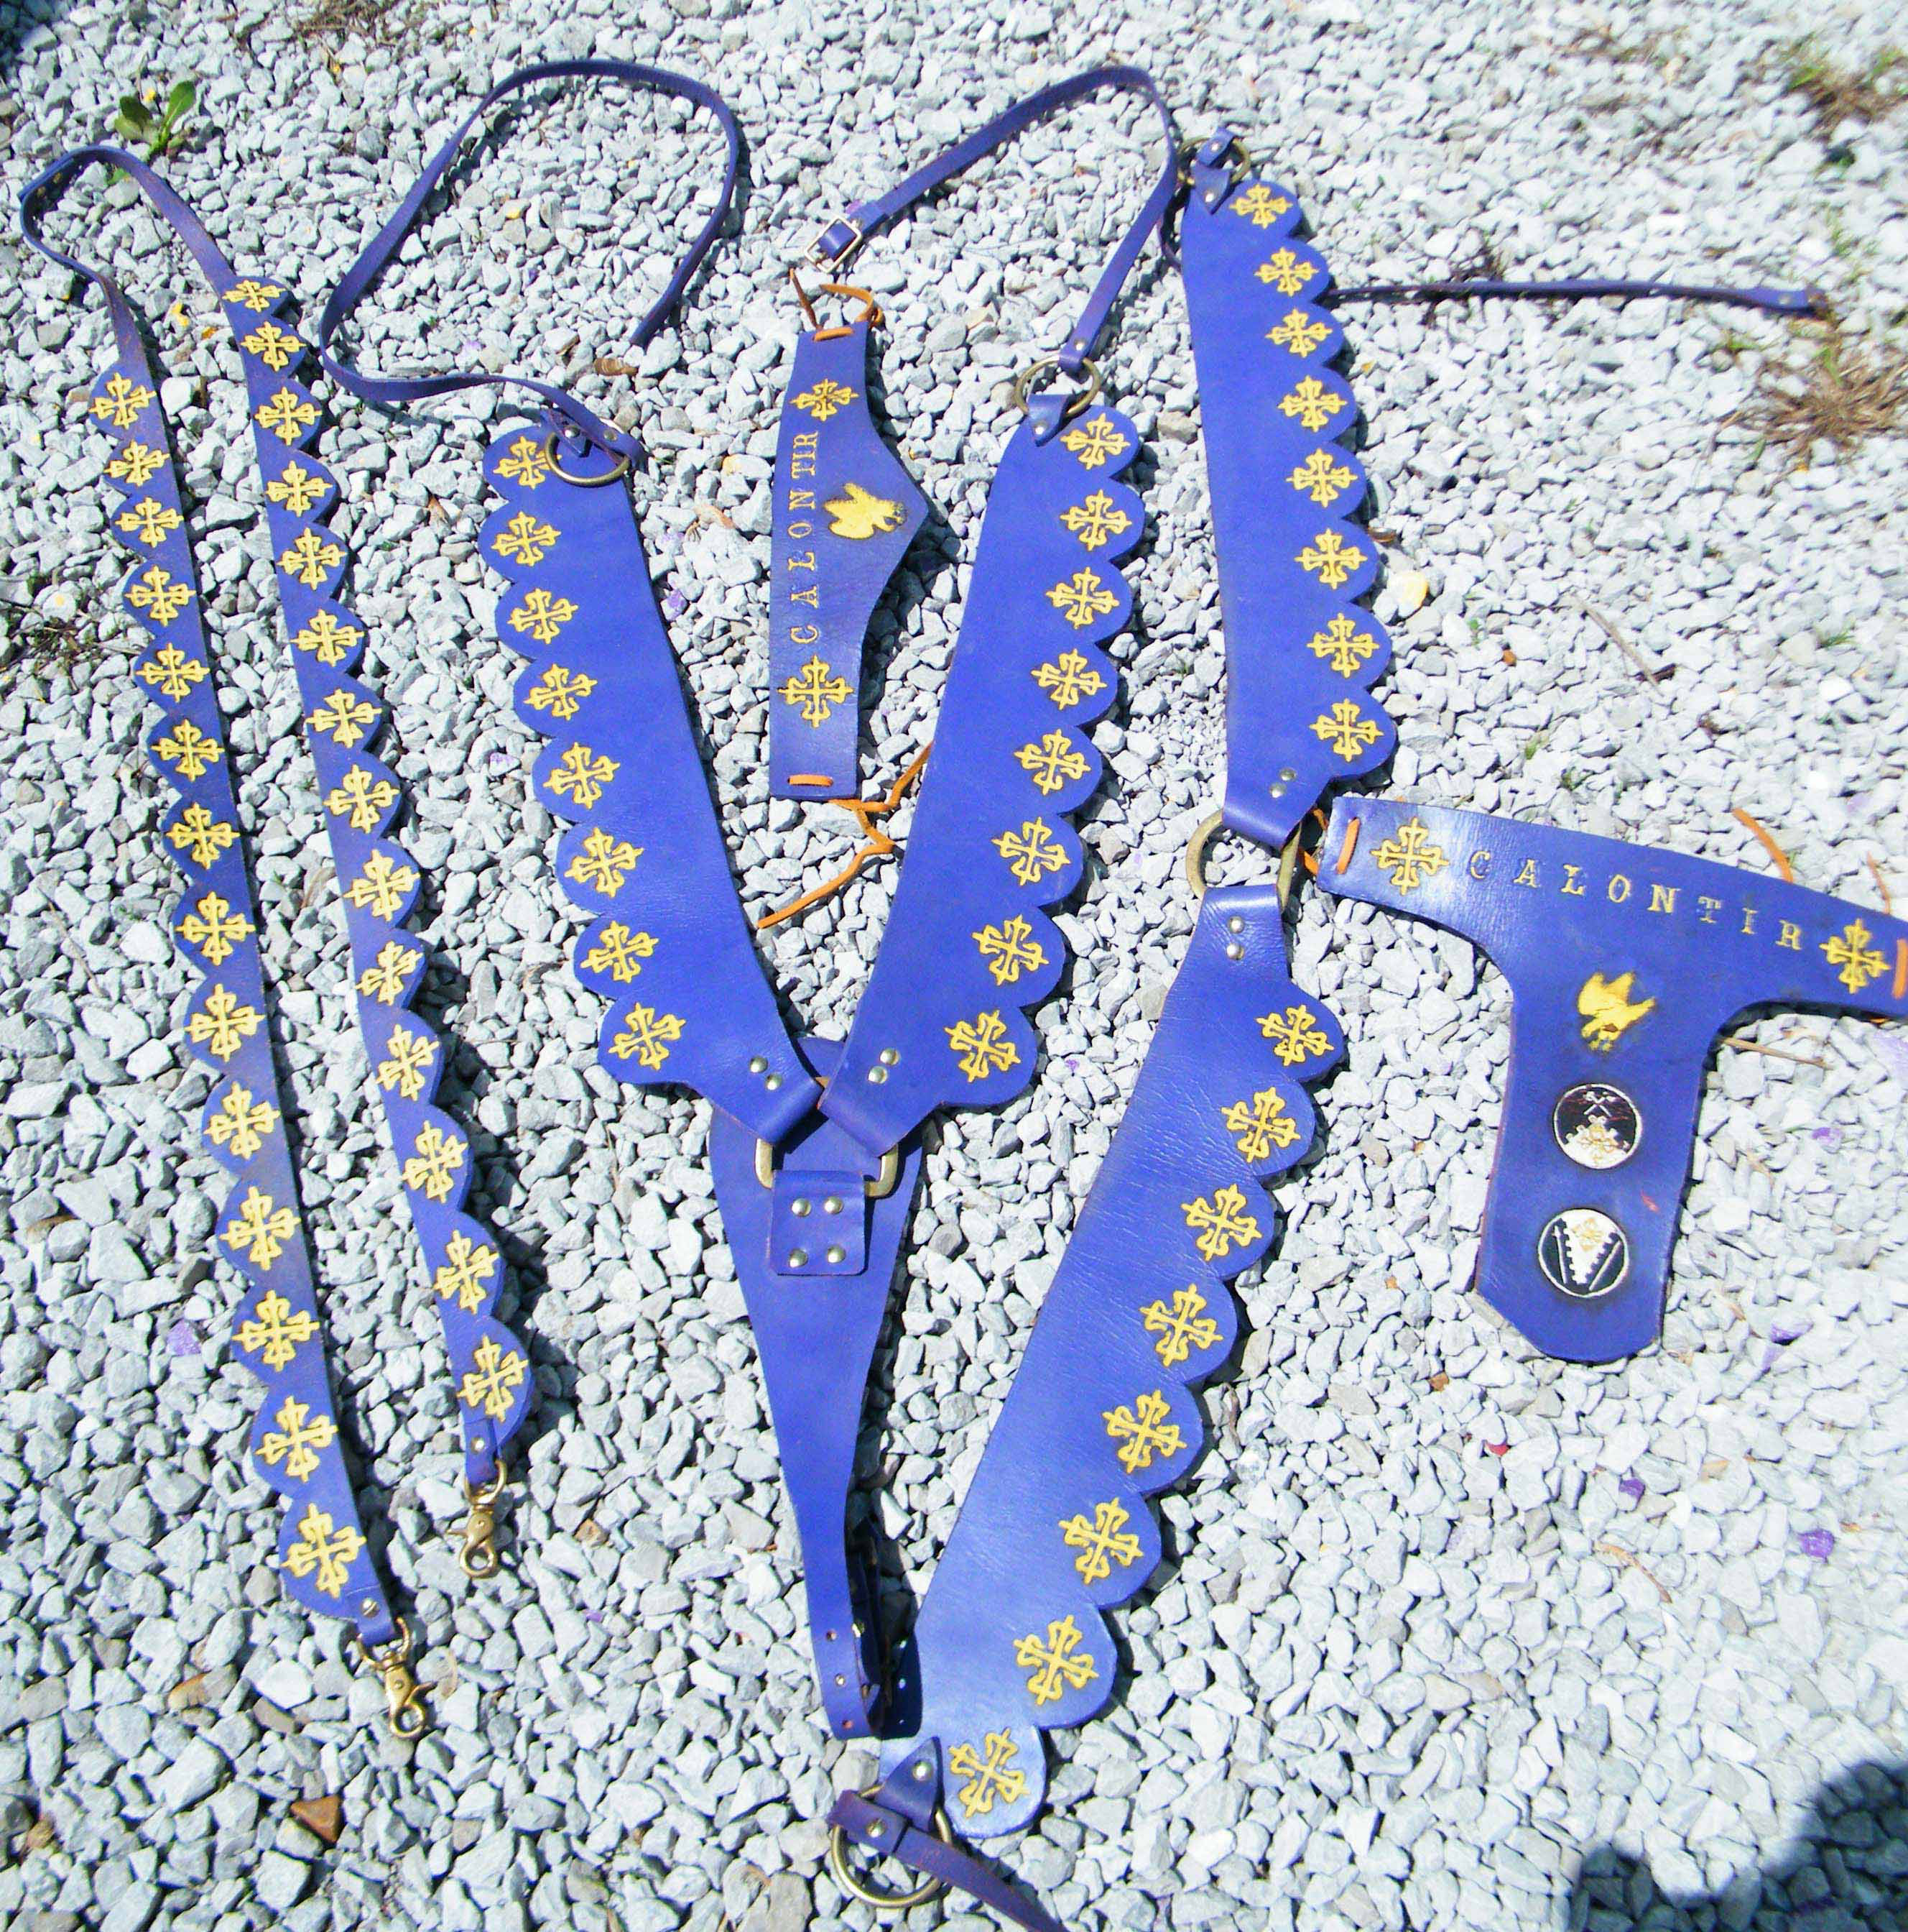

Thick leather and branded.

The fabric set will be tied into a braided set of reins. I'll try and get a picture of them later.

Marleen de Kramer
If you look closely at historic paintings, they often have two sets of reins. The wide, decorated one attaches to the top of the bit (they nearly all use curbs) and lies over the horse's neck/withers fairly tight, where it acts as a sort of side rein. The rider holds a thinner pair, usually the same colour, that goes to the shanks of the curb. That's how they don't get tangled in the scalloping. ETA: on closer inspection, it looks like the side rein acts on the shanks of the curb and the riding rein is at the top, sorry for the confusion!)
August 24 at 7:39am

Anne-Peryn Nicholls
Marleen de Kramer - I don't think they are side reins. I ride with two sets of reins, the leverage set lays on the horse's neck and is there for "emergency breaks" while I normally steer with the snaffle set. Works well.
August 24 at 10:36am

Marleen de Kramer
Hmmm, I read an article about it recently, where someone actually experimented with them and using them as a fairly tight side rein gave the head carriage you always seem to see in the illustrations, even though the riders don't take up much contact with the "snaffle" rein. (If you look, the plough horse in October, it has a totally different posture, so it's not just a stylistic element.)

Marleen de Kramer
@ Alissa White - here's a high-res version of the hunting scene. https://upload.wikimedia.org/.../Fr%C3%A8res_Limbourg... The black horse in the background, with the blue tack, appears to have a bridle made of a series of tassels, rather than leather straps. Also, there you have both versions being used, the man on the grey with the blue bridle uses the riding rein on the snaffle and the decorative one on the shanks, while the arrangement is reversed in the August falconry one I posted earlier.

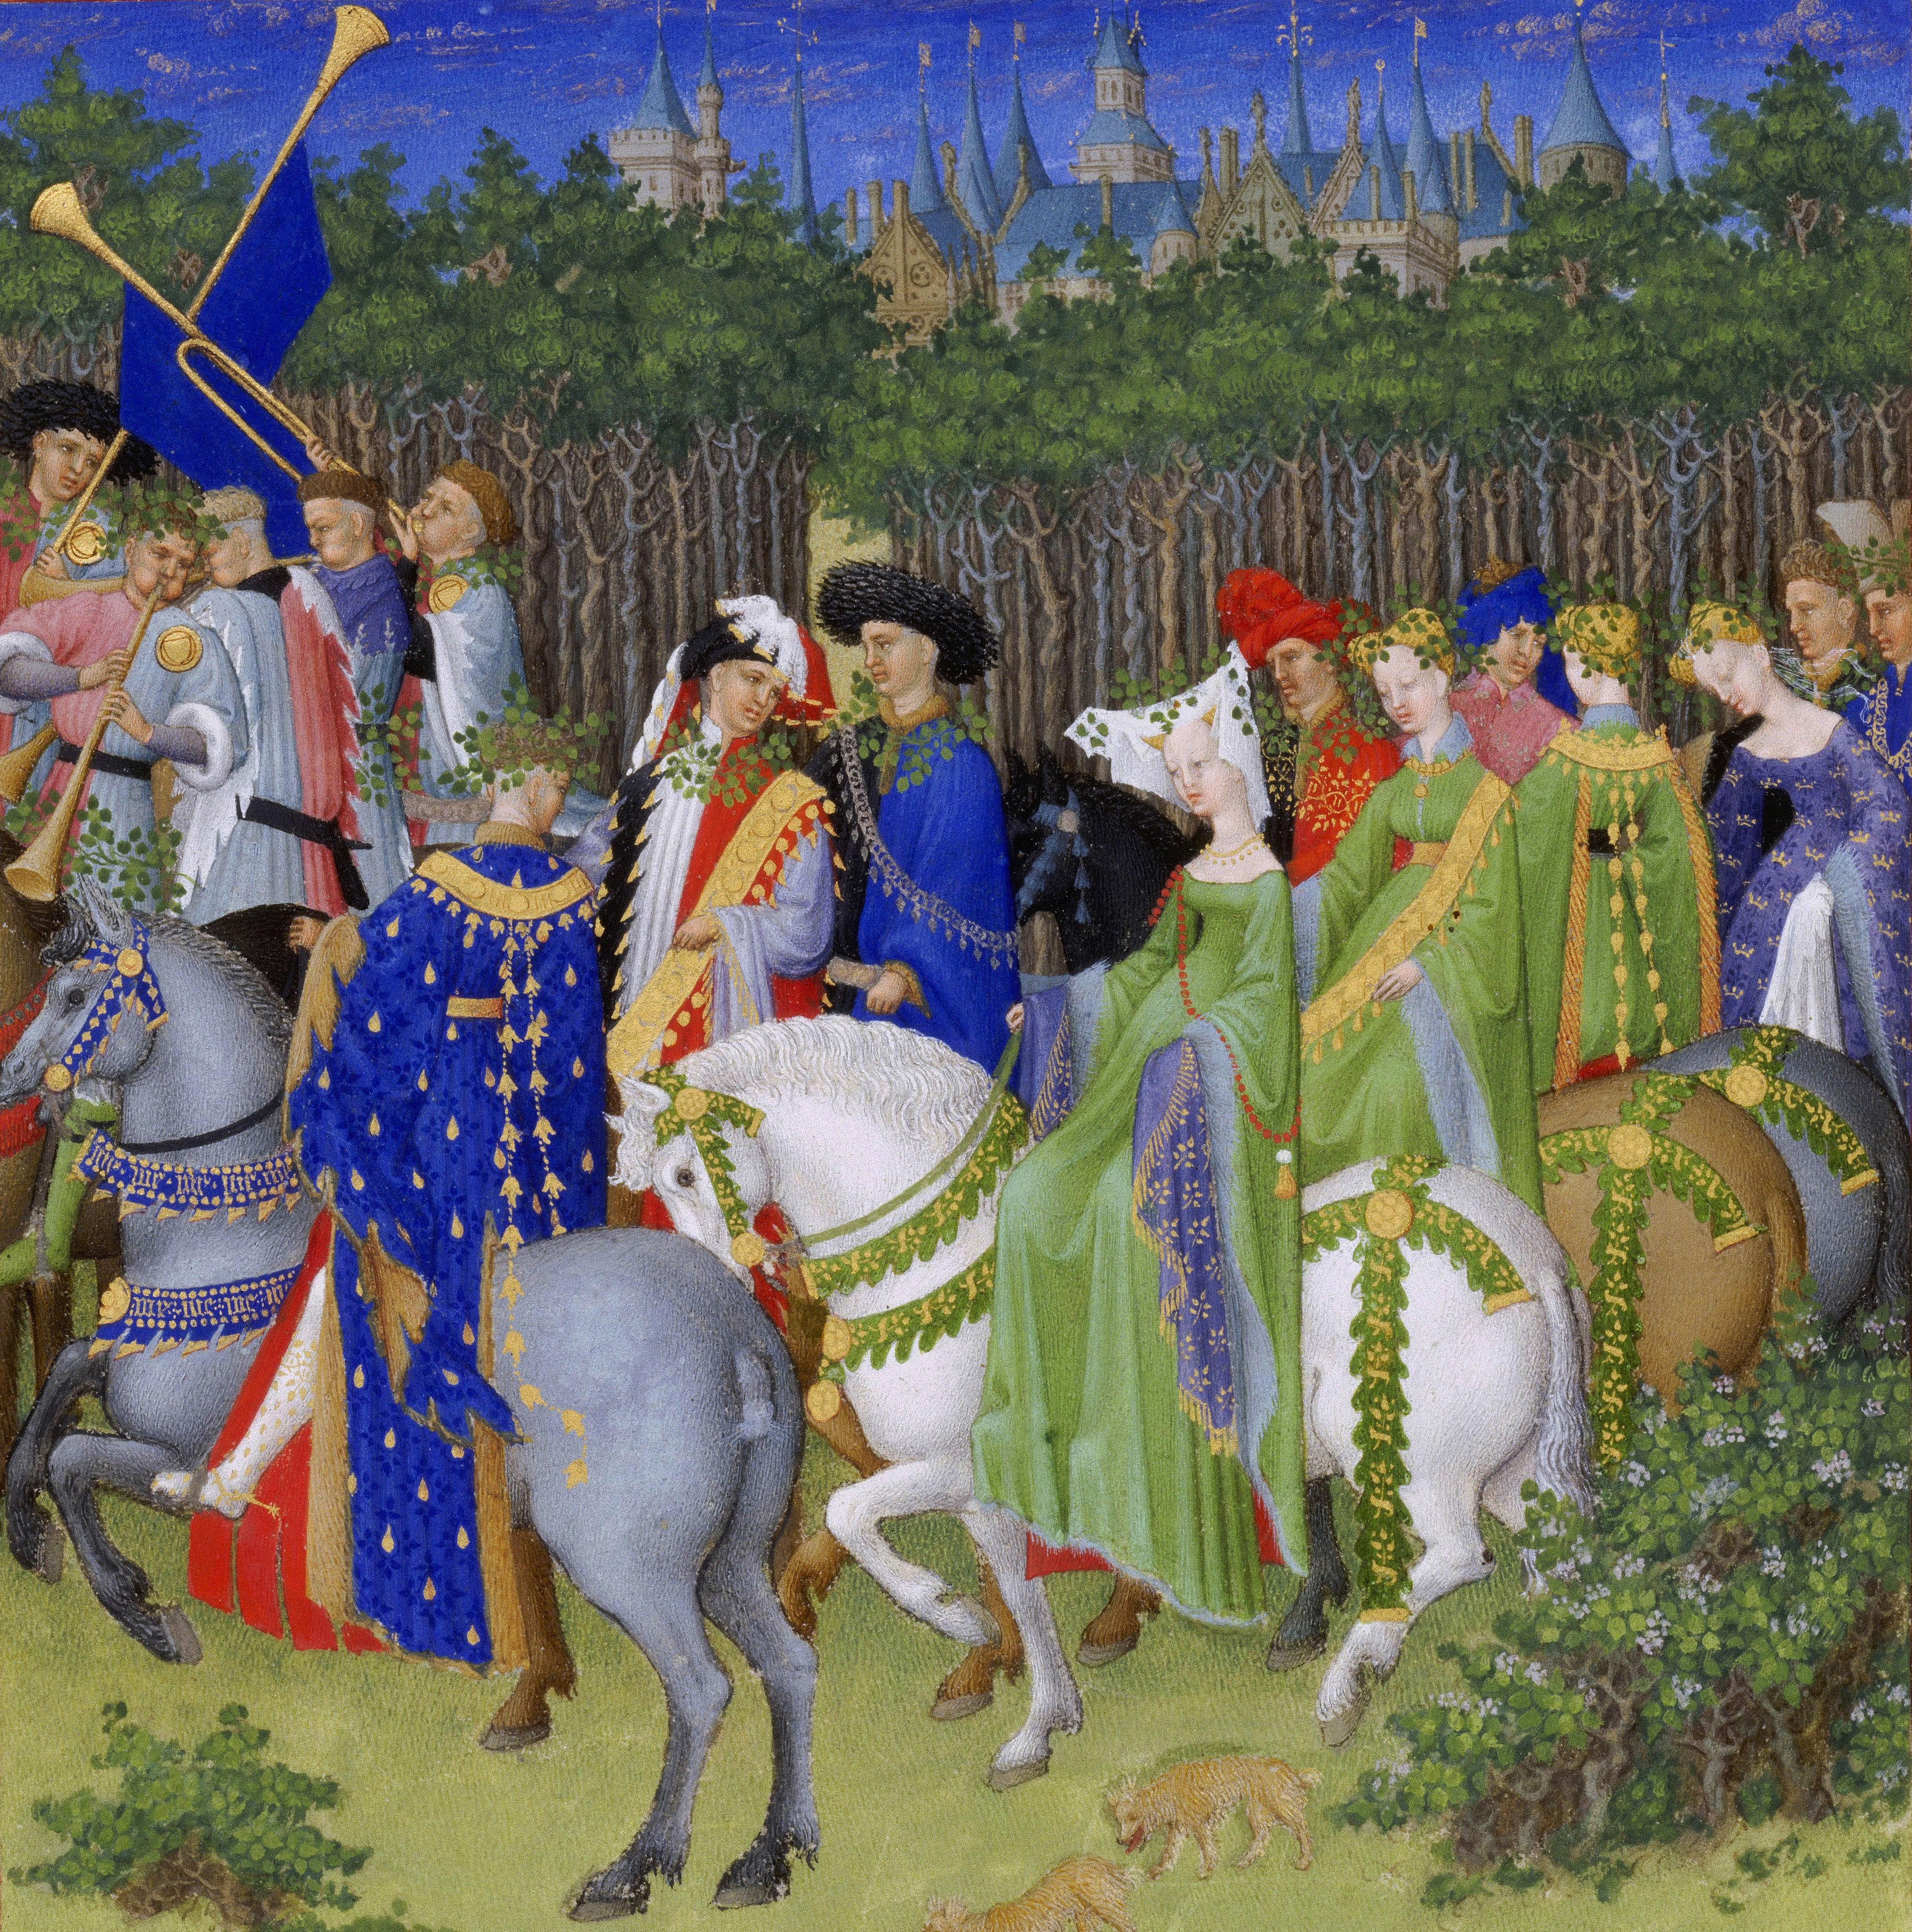

Patricia Cross
I can't brain this morning. Any idea how I'd set up this double rein effect without switching out the loose ring snaffle I normally ride in?
August 24 at 8:22am

Kate Reis
Could hook on to the loops for the bit on the actual bridle instead of the bit?

Marleen de Kramer
You could just attach both sets to a loose-ring snaffle - just make sure you put the ones you actually ride with on *top* of the decorative ones you hang over the neck, and make the decorative one relatively light and slightly longer so it doesn't drag on the mouth...

Marleen de Kramer
(The lady in green in the hunt scene seems to have only a snaffle - hard to tell with the large gold fittings.)

Patricia Cross
Hrm. I was hoping for a solution that didn't involve hanging the decorative ones from the same ring. Maybe I'd be better off switching to a different bit for this setup so I don't confuse or annoy my sensitive-mouthed horse.

Marleen de Kramer
Which style of bridle to you use?

Kate Reis
Like I said - try to attach to actual bridle at point of connection to bit. Then the pressure is not on his mouth.

Marleen de Kramer
Or maybe attach the reins to a thin, flat ribbon at the ends and slip it under the bridle (either under the noseband, or give it a decorative noseband that matches your tack/barding if you have none yet.)

Rain Chocholka
Someone told me that adding weight to a bit helps keep the horse's head down. In these images, it looks like one set is in use and the other was just decorative. Maybe it has the same effect of the horse dropping it's head. I'll have to try it on my horse and see how it works. Otherwise, I make rein covers around 24" long so that they do not get in the way of my hands. The longer the rein needed, the longer the rein covers.

Anne-Peryn Nicholls
Marleen de Kramer - on head set - different types of horses can have different head sets. My Kiger mustang carries his head & neck higher than my grade (probably QH) mare. Spanish horses were prized by those of means. The head set could indicate the kind of horse. Also, a plough horse works better when it can lower it's head so the artwork itself tells us a bit about the type of horse and what it's used for. Side reins - I define them as attaching the bit to the saddle around the rider's knee. Attaching them to a leverage bit would be quite harsh and not needed for a well schooled horse, again prized by those of means. I haven't seen evidence of side reins in western medieval/renn art work, I'd be interested if you come across examples.
August 24 at 10:43am

Marleen de Kramer
The only example I know was on a painting of a musician's horse, but then, he did need both hands free!

Anne-Peryn Nicholls
Alissa White - do you mean are the decorative rein covers fabric? Yes, in many instances.

Alissa White
Anne-Peryn Nicholls the style on the blue and red (tassel) stuff in duc de berry... Rein covers and the rest. More likely to be leather or fabric or a combination?

Anne-Peryn Nicholls
Could be either or both. Though a lot of the "tassels" look like dagging to me. We have some extant tournament barding, some fabric, some with leather reins. But I can't think of an example of leather rein covers for pleasure riding.

Anne-Peryn Nicholls
We do see in some extant belts and dog collars with an inner leather part that gives structure to a velvet cover. Take a look at the horse armor at the MET in NY and the Spanish royal collection (Madrid?) for examples.

Alissa White
The red tassels look like leather fringe or something to me, I can't imagine sewing dags that tight together.

Anne-Peryn Nicholls
If they are leather, such as on the bridle, the dagging would be pretty easy.

Alexis Garrigues
I used harness leather for my dagged harness, based on the Duc de Berry May image above. I've always read these harnesses as being being leather, and functional, even if they are covered in velvet or other fabrics. The use is so widespread that I doubt it is purely decorative. Also, the fabric-only reproductions tend to crinkle, bunch and droop in a way that I do not see in any of the period art or surviving pieces. I agree with Anne-Peryn Nicholls that the broad, decorated reins are usually left lying on the horses neck as a back-up set, while the narrow reins are generally used. What I've noticed is that the most common arrangement is: the narrow reins attached to the snaffle position, and held in the hand, and the wide reins attached at the curb position and lying on the neck. There are images where the position is switched, and at least one I've seen where the rider is holding the broad rein. I suppose that then, as now, people had their preference with a given horse.
August 24 at 2:35pm

Marleen de Kramer
I'm thinking of making a tasseled set based on the lead horse in the August image, but constructing it around webbing to keep its shape better. I fight in particolour, so getting my horse dressed in it too will keep the theme!

<the end>

