Eat-Brioche-art - 1/15/17

"Let Them Eat Brioche" by Lady Judith bas Rabbi Mendel.

NOTE: See also the files: bread-msg, Bread-Hist-art, breadmaking-msg, cheese-breads-msg, leavening-msg, Wheat-2-Flour-art, yeasts-msg, Ancent-Grains-art.

************************************************************************
NOTICE -

This article was added to this set of files, called Stefan's Florilegium, with the permission of the author.

These files are available on the Internet at: http://www.florilegium.org

Copyright to the contents of this file remains with the author or translator.

While the author will likely give permission for this work to be reprinted in SCA type publications, please check with the author first or check for any permissions granted at the end of this file.

Thank you,
Mark S. Harris...AKA:..Stefan li Rous
stefan at florilegium.org
************************************************************************

Let Them Eat Brioche
by Lady Judith bas Rabbi Mendel, OM

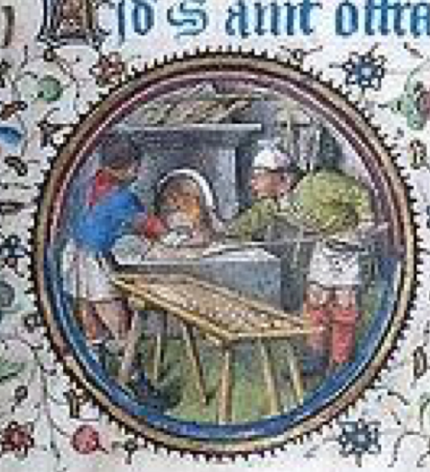

On a whim I decided I wanted to learn to make brioches. [1] Then I discovered it was medieval bread, and thus this project was begun. I have baked bread for years, and several years ago I learned to bake using sourdough in order to experiment with what might have been medieval challah. Unlike that bread, brioches are not specifically a Jewish food (like most of my other cooking experiments), but I did find it in a cookbook of kosher French recipes,[i] and Jews were involved in grain commerce in France during the Middle Ages [ii] and were frequently in business as bakers. [iii] It is reasonable to surmise brioches were eaten in the homes of wealthy Jewish families.

The earliest references to brioches date from 1404 [iv] though some sources put its creation as far back as Roman times. [v] Pliny the Elder wrote about how the Gauls skimmed the foaming head off their ale and made a lighter kind of bread than everyone else. [vi] Calvel in The Taste of Bread states that brioches date back so far it would be foolish to try to figure out even the period when it first began to be made. [vii] A decree issued February 17, 1436 mentions brioches among other fine white breads. [viii]

The origins of the word "brioche" are also under debate. It appears in Cotgrave's 1611 A Dictionarie of the French and English Tongues, where it is described as, "a rowle, or bunne, of spiced bread." He says it comes from Normandy, which makes sense because that region was known from the Middle Ages for its butter, an important ingredient in the brioches [ix] Another theory is that it is related to brie, the cheese and a region of France, and possibly the place the bread was first made. Those who argue for this origin are also of the opinion that the cheese was an ingredient in the bread.[x].[2] Larousse Gastronomique says that the word comes from the Old French term "broyer," which means "to beat or pound." In doing this research I came across a quote in a book from 1783 written by Pierre Jean- Baptiste Le Grand d'Aussy. In a section where he is writing about breads of the 17th and 18th centuries he comments:

There was in Paris, towards the same time [the 16th century], a particular, very white bread, which, without being as hard as biscuit, was nonetheless of so hard a dough that it could only be kneaded with the feet, or even with a brie or a wooden bar, as is still done with Italian pasta. [xi]

The "brie" referred to here is not a lump of soft cheese. According to the Académie française, it is a baker's term that means a bar that can be used to beat dough. The traditional recipes for brioches call for the butter to be beaten, and "brie" turns out to be a dialectical form of "broyer," [to beat]. So the word brioche could come from the brie cheese sometimes used as an ingredient, or from that region of France, or from the technique of making the dough which involved beating, or from the wood used to do that beating, or maybe some other unknown source. All are plausible. Some food historians state that the ending of "brioche" is related to the French word "hocher," which means "to shake," but it seems more likely that it comes from "oche," a French suffix used to make a noun. [xii]

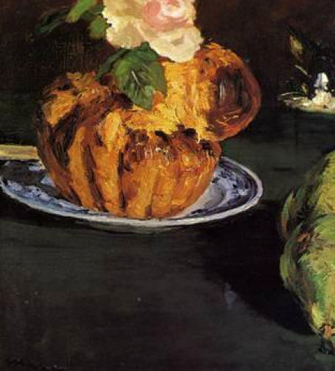
A Still Life with a Brioche, Edouard Manet, 1880

FRENCH BREAD IN THE MIDDLE AGES

According to bread historian, Jim Chevalier, it was during the Middle Ages that bread went from being simply a sustaining loaf to being available in many variations. [xiii] Medieval/Renaissance bread made in France had a number of characteristics that stayed consistent. [xiv] When the bread was made with wheat flour, they used soft wheat. Unlike the English, French bread bakers did not use beer barm to leaven the dough. In the 17th century the Paris Faculty of Medicine decided, after several months of discussion, that beer yeast was unhealthy and should be forbidden because its bitter flavor came from rotting barley. [xv] Jean Liébaut [xvi] in his extensive writing on French bread in 1570 stated that French bakers continued to use sourdough as their leavening, but notes that Flemish bakers used yeast skimmed from the top of boiling wheat and commented that their bread was lighter than what French bakers were making. All this discussion of beer barm though would not have been necessary if there had been no one using it—there must have been bakers using the beer yeast, but clearly sourdough was the preferred method of leavening.

Sourdough of this period in France was made from the same grain as the bread it was going into. Liébaut gives instructions on the care of sourdough, specifying that in the summer more water should be added at noon, at five, and at nine. He recommends using different strengths of leavening depending on the region of the country. What is striking is that he does not comment about how to make sourdough, a topic of much discussion in later centuries. [xvii] Baker's yeast came into use in the 1800s.

Milk was often an ingredient in bread, but no details are given in period sources about amounts or when it was added. In most parts of France, little or no salt was added to the dough except for the bread being consumed by the nobility—and that is definitely what brioche was. It is a bread of conspicuous consumption—it takes 2-3 sticks of butter, 7 eggs, and at least a pound of pure white flour—only the wealthy could afford such a decadent recipe. [3] Liébaut advised that salt and other spices like anise be added while the bread was being kneaded. He also described bread from Rheims made with honey, pepper, or cinnamon. [xviii] He mentions sugar in small quantities being added to special breads and pastries. [xix] In his description of a pastry that sounds very similar to brioches, he specifies that it is made with butter. [xx] In his dissertation on bread Liébaut includes advice about what water to use in making it, preferring spring water over that drawn from a well. [xxi] Nicolas de Bonnefons' Delices de las campagne, published in 1662, includes a recipe which uses cheese and butter but no eggs. [xxii]

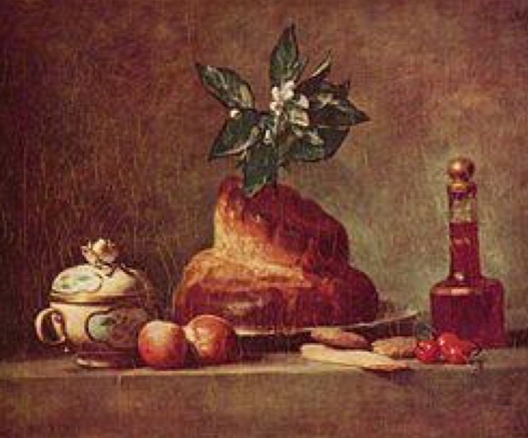
Still Life with Brioche, Jean-Baptiste-Siméon Chardin, 1763

BRIOCHE RECIPES

Numerous descriptions of a light white bread made with butter and eggs can be found, but no recipe until 1742. The oldest surviving brioche recipe comes from the Suite des Dons de Comus. That book includes two brioche recipes, in fact, and both use relatively little butter and call for brewer's yeast. I have included them with rough translations in the appendix. Because it uses beer barm, I did a number of brioche experiments with the foam from fermenting beer and this recipe. I managed to make a tasty mild roll, but because the dough does not hold its shape well; they are all just small round rolls. The recipe notes that the brioches will be small.

Cotgrave's definition of brioche is that it was a roll or bun of spiced bread. The Gauls were known to have added anise and cumin to their bread, while the Franks used cinnamon and cloves. The herbs prevalent in different regions of the country were often added to the breads made in that area.[xxiii] Taillevent in the 14th century used cinnamon, ginger, and long pepper in bread. [xxiv] Liébaut wrote of a spiced bread from Rheims which was made with honey, pepper, and cinnamon. [xxv] Louis Eustache Ude, chef to Louis XVI and the Earl of Sefton, recommends adding some saffron soaked in fortified sweet wine to the brioche dough.[xxvi]

The use of fluted tins, so distinctive of brioches today, began in the 1800s. [xxvii] Elizabeth David thinks they had bands made of parchment to help the brioches keep their shape. [xxviii] The use of cake hoops made of rounded metal placed on flat pans can be dated to the 17th century, when they were mostly used in England and Holland. [xxix] Ude included a brioche recipe in his cookbook, published in 1824. His recipe does not say to use tins, and he recommended using well-buttered paper cases to make large brioches. [xxx] The illustration included in this documentation by Manet shows the distinctive fluted sides, and it comes from 1880, while the still life by Chardin painted in 1763 shows smooth sides with a few notches. It occurs to me that those notches come from cutting off the parchment rings before baking the brioches; otherwise those areas would stay pale. From experimenting I found that the rings needed to be cut off part way through the baking or the brioches lost their shape.

The most familiar version of brioches has a topknot. In my search through many recipes I came across two very different sets of instructions about how to shape it. Julia Child and numerous other bakers advised making the brioches like a snowman, with a big ball of dough and a smaller one placed in an indentation in the top of the larger ball. The disadvantage of this technique is that the top ball can easily fall off. The other set of instructions is what I used, and involves shaping the dough to be like a bowling pin, poking a hole in the larger end, and inserting the head of the pin through the hole (see illustration on the page with the recipe). This method, easily done in period, has the advantage that the head of the topknot stays attached. There is no way to know which method was used in period, or even if brioche a tête was a shape medieval bakers made. The early recipes give no instructions about what shape to form the dough. [xxxi] Discussions of the development of brioches mention numerous shapes, including loaves, but only a few food historians attempt to state vaguely when the various shapes began to be made.

RECIPE DEVELOPMENT

In creating a medieval brioche recipe, I started by trying to find a "traditional" recipe for it, knowing all the problems that come from relying on that adjective. Almost every recipe I found called for using a mixer. It was when I looked in older cookbooks that I found instructions for making it by hand, but they were accompanied by warnings not to panic. [xxxii] It became clear that this project was going to involve lengthy manipulation of the dough. Rose Beranbaum in The Bread Bible described watching bakers in Lyon prepare brioches. They told her to rompre the dough, and when she asked what that verb meant, they demonstrated lifting the dough and tossing it over on itself. [xxxiii] Ude, writing in 1824, says to fraiser the dough, a technique of repeatedly pushing the dough out on the countertop.

Many of the recipes (both modern and older) call for letting the second rising take place in the refrigerator, not something that would be possible year-round in period. The medieval baker in winter could have put the dough outside, but in midsummer that would not be an option. Paula Wolfert though described how brioches were made by one of Escoffier's students and it involved going down to the cooler cellar of the bakery to mix and proof the dough, which was allowed lengthy rising times.

'Each afternoon the fourteen-year-old Jean-Claude and the man old enough to be his great- grandfather would go down to the cellar of the bakery (where it was quite cold) to prepare the yeast-flour-milk mixture for brioche. While the levain [4] was 'working up,' they would beat together a mixture of flour, eggs, and butter until it became a smooth, light, elastic dough. They would then spread this dough out on the work table, place the very soft levain in its center, and, with the help of a dough scraper and an intricate series of foldings, enclose it securely in the dough. They then left the dough to rise in the cellar for a long while, on the old man's theory that a long slow rise developed a better-structured crumb and a tastier brioche. The risen dough was then 'knocked down' and left overnight to ripen in the same cold cellar room. Finally, it was shaped and brought upstairs to the warm, humid baking room for its final rise before going to the oven. In the words of Jean-Claude, the dough then exploded into a light, spongy cake with all the attributes of a perfect brioche: a hairline crust, an even crumb, and a delicious, even egg and buttery flavor.'

Using a cellar would have been an option in period. My house in the winter is barely 65°, but I tried one experiment using our cellar where the temperature stays at 51° and found it made a great difference in the texture.

By comparing numerous recipes, I put together a basic recipe and then started testing it. I based the amounts on a recipe I found in Escoffier, but included details and techniques I found in other cookbooks and began baking. The log of these experiments can be found in the appendix.

I started by making modern brioches to learn how to handle the dough. The first try succeeded, but I found the taste boring, so I did a second test browning half the butter before using it. That imparted a much stronger butter flavor and was more interesting. I then replaced the modern yeast with sourdough and found that I needed much less butter. I cut the amount of butter by one-third, which meant one less stick of butter. I then did a series of sourdough brioche experiments, trying an overnight rise, baking on a stone, changing the amount of sugar, using bolted flour, adding spices, but the real problem I faced was that the sourdough brioches did not rise very high. During this time I spent a few days in the Berkshires and took my sourdough with me to feed it. I discovered it went wild with the spring water from Gould Farm. At the same time I replaced the grocery store butter with European butter, and used farm-fresh eggs, also from Gould Farm. The brioches rose as high as they had with modern yeast. The next experiment was to replace half the butter with softened brie cheese, to try what many food historians thought early brioches would be like. It came out great, much to the delight of my family.

Then I did a series of experiments using beer barm and the 1742 recipe. The texture improved when I used only the yeast that settled out of the foam, and all my beer barm experiments showed the crumb proof of leaven in action. These brioches were much smaller and did not keep their shape well, but they were tasty. The 1742 recipe notes that these brioches will be small.

In the meantime I had found Paula Wolfert's description of using the cellar to make brioches, and decided to try those instructions. The results were truly amazing—light, feathery, delicate, with no hint of sourdough. I redid several of my earlier experiments using this method of two long risings in the basement with excellent results. Like many breads, the sooner you eat it after baking, the better it is, but it makes excellent French toast and bread pudding. And that bread pudding is what inspired this entire project.

My Medieval Brioche Recipe

9 1⁄2 oz. white bread flour
9 1⁄2 oz. all-purpose flour
1 t. salt (0.25 oz.)
1.5 oz. sugar or honey (~3 T.) 2 T. milk
~1⁄3-1⁄2 c. sourdough starter
7 oz. butter (divided), the best butter you can find,
3 oz. of that amount needs to be at room temperature
7 eggs, of those 6 need to be at room temperature

1. In medium bowl, sift the two flours together. (Don't skip this step.) Remove about 1⁄2 cup and set aside.

2. Make sure the sourdough is about the same consistency as the softened butter; add flour or water to make it that way. Use some of the flour you just sifted to thicken the sourdough. Cover & set aside.

3. Melt 4 oz. butter in a pan (not microwave). Watch over it carefully because you want it to brown just slightly. Set it aside to cool.

4. Add salt and sugar to the bowl of flour and stir to mix the dry ingredients.

5. In a separate bowl, mix milk, cooled browned butter, and 4 eggs. Stir to mix.

6. Mix together the flour in the bowl with the liquid mixture. It may be slightly gloppy. If it is too liquid, add some of the flour from the 1⁄2 cup you set aside. Work mixture in the bowl until you have a mass that can hold together. Place dough on a flat surface (preferably marble).

7. You do not knead this dough. Instead you raise it up about 8-9 inches and drop/throw it back onto the board; fold over. Repeat. Try not to get the heel of your hand doughy; just use your fingers. I keep a dough scraper in my left hand, and handle the dough with my right. Work the dough in this fashion for about 10-15 minutes. It will become silkier.

8. Make a well in the dough. Break one egg into that well and work it into the dough. Don't despair! It will work. Mash the lumps in the dough on the counter or between your fingers, and keep working the dough. Once you have finally gotten the dough together again and it is smooth, repeat the process: make a well, break an egg into the well, and work the dough. Be encouraged—the second egg is easier to work into the dough.

9. Pat the dough out into a rectangle about 1⁄2 - 3⁄4 inch thick.

10. Place the remaining 3 oz. butter on the counter. Cover with wax paper and whack it with a rolling pin until it is about 1⁄4 inch thick. Use the dough scraper to divide it into 3 sections, approximately the same size. Scrape up 1⁄3 of the butter and place on top of the dough. Fold the dough over the butter. Work the dough by lifting it and tossing it down until the butter is incorporated. Repeat the process for the other two sections of butter, flattening the dough each time, folding it around the butter, and then working the dough on the counter until the butter is mixed in.

11. Pat the dough into a rectangle. Smooth the sourdough mixture over it. This time you do NOT work the dough. Fold the dough over and over to make a series of folds, with the two layers staying separate.

12. Place the dough in a clean bowl and cover the bowl with a plate. Let rise.in cool place, like a basement—somewhere around 50°. Leave it there 8-10 hours.

13. Work the chilled dough, making sure the sourdough is thoroughly incorporated. Pick it up and drop it on the counter and fold it over. Replace the plate on top of the bowl and let rise a second time in the basement for 8-10 hours.

14. Lightly grease brioche pans or muffin tins. Or just use a greased cookie sheet. If you are using brioche pans, put the pans on an ungreased cookie sheet. If you are using a greased cookie sheet, you can make rings from 2x8 inch strips of parchment paper.

15. After the dough has risen, place the dough on the counter. Divide the dough into as many brioches as you plan to make (I have been making 20 or so.) Use a scale to evenly divide the dough—I found that each brioche takes 2 oz. of dough. Make 20 (or however many) balls of dough.

16. Take one ball and roll it out to be slightly like a bowling ball (see picture). If you use the side of your hand or your thumb rubbing sideways, you can make a neck with a round head on the left side of your thumb. Use your fingers to make a hole in the fatter/larger part of the brioche. Pick it up and stick the head through the hole and then place brioche in tin. (YouTube videos show this process if my description doesn't make sense.) If the dough is too sticky or too gooey, spread a bit of flour on the counter, but use as little as you can.

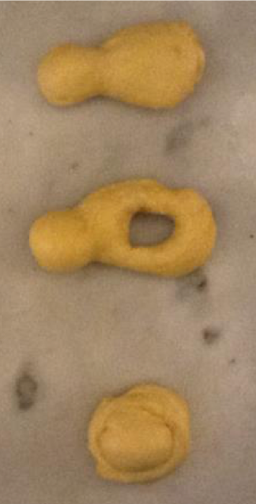

17. Cover with dish cloth and let brioches rise a third time, but this time at room temperature. When brioches have risen, preheat the oven to 400F. Make sure the rack is in the middle of the oven.

18. Prepare egg wash: mix egg yolk with 1 T. water, and a pinch of salt.

19. After 2 – 3 hours when dough has risen, brush the brioches with egg wash. (If you want even shinier brioches, wait a few minutes and glaze it a second time.)

20. Bake 15-17 minutes until golden.* Remove from oven and take out of tins immediately. Let cool slightly before eating.

*If you are using parchment rings, after 5 minutes of baking, remove the pan from the oven. Rip the rings off carefully from around the brioche, and quickly return them to the oven for the remaining 10-12 minutes of baking.

Appendix
Brioche Recipes, 1742, Paris
Printed in Suite des Dons de Comus

Rough translations are my own

Pâte à Brioche. Prenez le tiers de la farine que vous voulez employer, mettez-y un demi quarteron de beurre sur quatre litrons de farine. Détrempez ce tiers de farine avec de l'eau chaude, ensorte qu'elle soit bien maniable. Faites la revenir dans un endroit chaud. Il lui faut une heure l'hyver et un quart d'heure l'été. Mettez votre farine sur la table. Faites un trou au milieu, et y mettez une once de sel fin, trois livres de bon beurre, dix-huit oeufs, un peu d'eau. Maniez bien les oeufs et le beurre, ensuite la farine. Mettez votre levain dedans par petits morceaux. Maniez la pâte par trois fois avec la main. Ensuite vous l'assemblez et la mettez dans un linge poudré d'un peu de farine. Laissez reposer dix ou douze heures, ensuite vous en formez des brioches.

Brioche Dough. Take a third of the flour that you want to use, and put in it an eighth of the butter on 12 quarts[5] of flour. Work those thirds of flour with hot water, until the dough is manageable. Put it back in a warm place for an hour in the winter and 15 minutes in summer. Put your flour on the table. Make a hole in the middle, and put one ounce of fine salt, three pounds of good butter, 18 eggs, a little water. Work the eggs and the butter well, then add the flour. Add the leaven in small pieces. Work the dough by hand three times. Assemble it all together and put it on a linen cloth that has been sprinkled with a little flour. Let rest 10 or 12 hours, then you form the brioches.

Brioche. (Entremêts froid) Prenez un boisseau de farine, plus ou moins. Mettez votre farine sur le tour. Otez-en le tiers dont vous ferez un levain avec un quarteron de levure de bierre et de l'eau chaude. Vous la pétrissez un peu molle, vous la moulez un peu et la faites revenir dans une nape bien enveloppée pendant une demie heure. Avec le reste de la farine, vous faite votre pâte. Vous y mettez un quarteron de sel fin, quarante oeufs, et quatre livres et demie de beurre bien manié. Vous le mêlez par petits morceaux avec les oeufs dans [p. 128] le milieu de votre farine, et un peu d'eau. Maniez-les bien, à mesure, prenez de la farine. Quand le tout est bien mêlé ensemble, vous le paitrissez deux ou trois fois, vous l'étendez et y mettez de votre levain par petits morceaux. Maniez bien le tout ensemble, et lui donnez trois tours avec la main. Laissez-le-reposer une demie journée avant que de vous en server. Ensuite vous prenez tel morceau que vous voulez, et le faconnez dessus. Dorez and faites cuire au four. On en fait de petites.

Brioche. (Cold desserts) Take a bushel of flour, more or less. Put your flour on the [turn?]. Set aside a third of the flour which you will make a sourdough with a handful (small quantity) of beer yeast and warm water. You knead it a little until soft, you shape it carefully and put it back well-wrapped in a towel [6] for half an hour. With the rest of the flour, you make your dough. You add a handful of fine salt, forty eggs, and four and a half pounds of well-kneaded butter. You mix it in small pieces with the eggs in the middle of the flour, and a little water. Handle them well, cautiously adding flour. When it is all well blended together, you [?] it two or three times, you spread out the dough and place on it the leavening in small pieces. Blend everything together well and give it three turns by hand. Let it rest for half a day before you use it. Then you take as large a piece as you would like and shape it. Glaze and bake it in the oven. They are actually small.

To compare my recipe with this one, I used a bread baker's technique of calculating amounts based on percents, using the amount of flour as 100%. This method allows comparisons when recipes call for very different amounts.

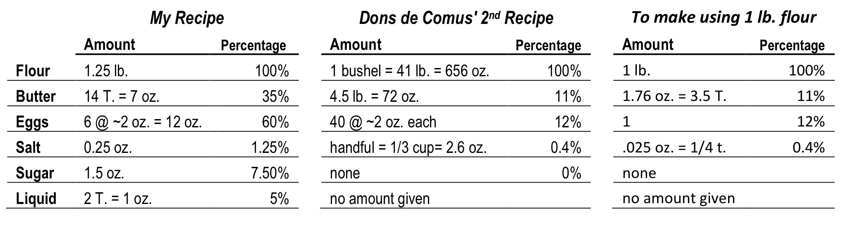

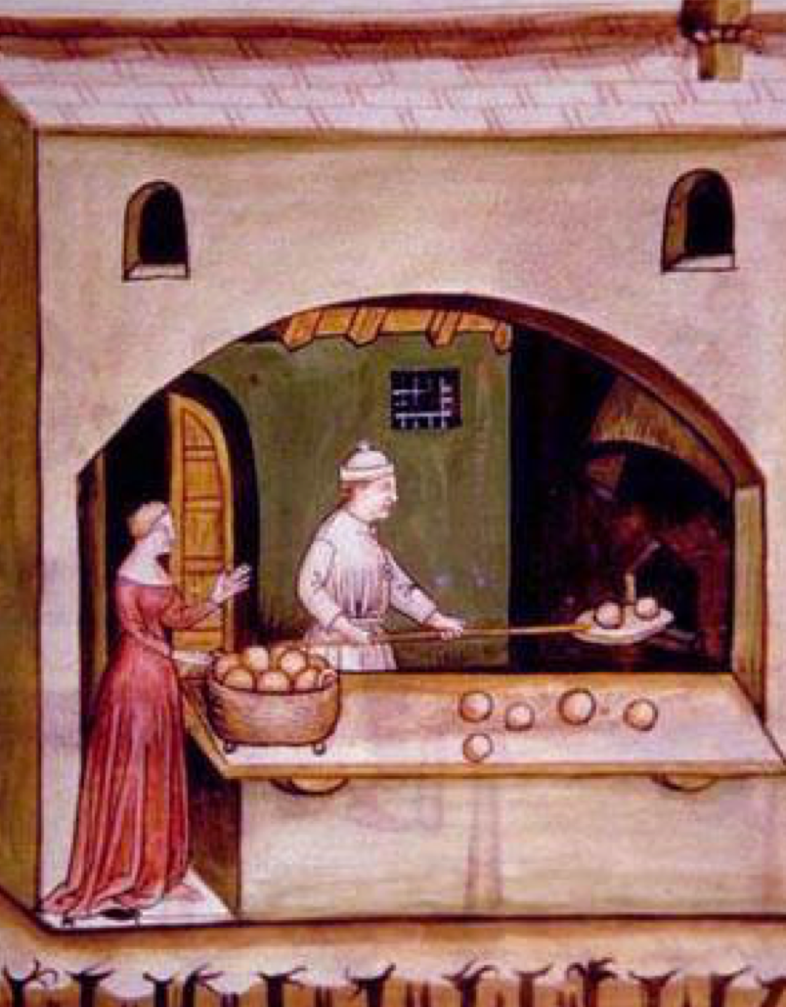
[8]

Brioche Experiments

First Try – used modern yeast

I wanted to make sure the basic recipe was workable and produced a pleasing brioche before I started fiddling with the recipe. I also wanted to master the technique of working with the dough on a recipe that had not been changed much.

Dough too sticky. Ended up deciding to ignore instructions that said not to add any additional flour and worked at least 1 cup more in. Some of it I used when I was shaping the rolls. I knew from watching YouTube videos what the dough should act like, and floured the board so dough could be shaped. Texture good, but taste was slightly uninteresting (but I’m probably the only one who would complain).

Second Try – used modern yeast, browned butter

Increased initial amount of flour from 1 pound to 1 1⁄4. Used suggestion given in one cookbook to brown the melted butter to add more flavor. Knew what to expect in mixing and working the dough. Still needed to flour board when shaping rolls. Texture good; taste improved noticeably.

Third Try – used sourdough

Used a bit more flour (figured on sourdough lump having more flour than yeast lump did); did not brown butter. Added more flour after first rising because it had become too soft. Rising is not just slower but the dough spreads out, making it hard to judge whether it has doubled. Noticed after 2nd rising that the dough is very greasy. This may explain why older recipes for brioches that did not use modern yeast had less butter. I had to add more flour and use a floured board to shape dough which was extremely soft and greasy. Tried shaping two rolls to rise without any pan. Dough does not taste of sourdough at all. Took an extra 10 minutes to cook until golden on top. Looking at the brioches during baking, I notice that butter is bubbling along edges of tins. Just out of oven only have the very faintest hint of sourdough flavor, more in aftertaste than initial. Texture is denser. Next day the sourdough flavor continues to be mild. Two without pan don’t have the defined shape of the ones in the tins, but they taste all right.

Fourth Try – used sourdough, decreased butter, rose overnight

Increased initial flour. Decreased softened butter by half (only one stick instead of 2). Let second rising take place overnight, following directions given in some recipes. In morning the dough had a top sheen of butter, but the dough doesn’t look doubled. It needed less flour to cover the board when shaping the brioches, and made fewer and smaller brioches than the third try. Not done on top after 15 minutes baking; after 20 when removed the bottoms were too done. Reducing butter is a good improvement; sourdough flavor comes through stronger, probably because of the longer rising. Don’t think I’ll do that again.

Fifth Try – used sourdough, browned butter, decreased sugar

Decreased sugar to 1 oz. Decreased softened butter that was spread on dough by 2 tablespoons. Browned the butter that was melted. Having made 5 batches in only a few days, I found that my hand was cramping as I tried to do the first mixing and manipulating of the dough. Found dough needed less flour to become a manageable lump—didn’t use all of 1 1⁄4 lb. of flour in the initial mixing. Weather is warmer today, so that also may affect the dough. I haven’t been weighing eggs, and their size may also have an impact. Same problems with rising I have been having. Very mild taste. The browned butter makes the butter flavor come through even though the amount is less. Sourdough flavor is mild, but don’t notice reducing sugar made any difference in taste. Baked in 20 minutes. Flavor and texture is good, but the brioches aren’t very tall.

Sixth Try – used European butter, day-old farm-fresh eggs, and spring water

Had to take sourdough with me on a trip to the Berkshires and discovered it became very active with the water there. Brought some of that water home with me. Also purchased eggs at Gould Farm, and European butter at Guido’s. Used the amount of sugar in the original recipe. Large eggs from Gould Farm are bigger than large eggs from the grocery store. These brioches had the same problems with rising, but finished brioches are much taller. Flavor very good, and you have to be looking for it to detect any sourdough flavor. Texture very good.

This picture compares the height of the brioches from different batches. Batch #2 used modern yeast.
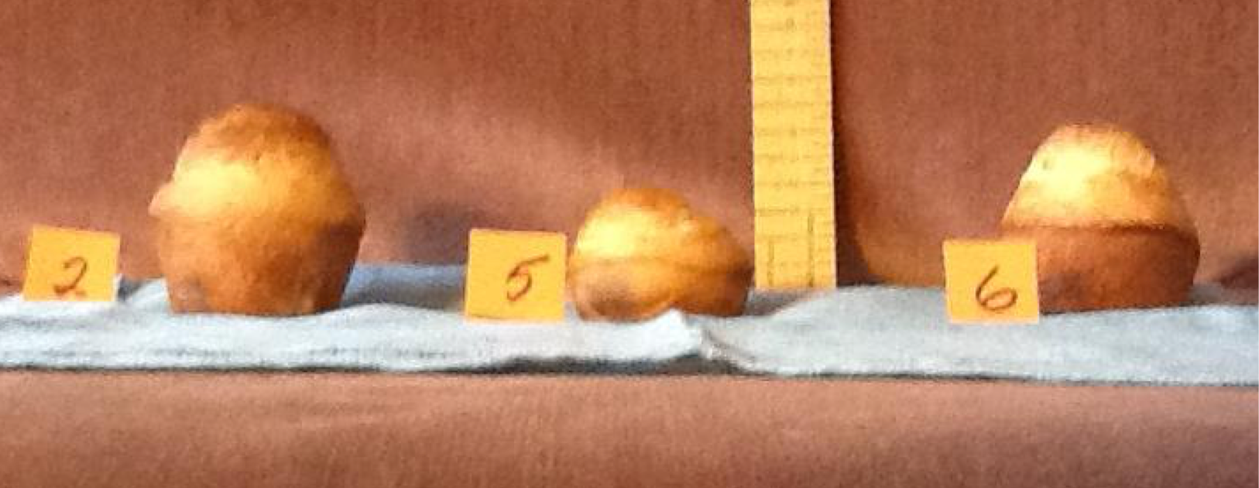 [7]

Looking at them all together, it is noticeable that batches 5 and 6 have a brown line where the dough touched the highest point in the tin. I suspect it may be either a sign that there is still a bit of extra butter that oozes out and browns there as the brioches bake, or it may be where the egg wash puddled a bit.

Having mastered the basic brioche, I then did some experiments using cheese, beer barm, and adding spices to make it the “spiced bread” that Cotgrove described in 1611.

Seventh Try – replaced softened butter with same amount of Brie cheese without rind

Weighed 4 oz. of Brie (at room temperature and rind removed). Beat it like I do the softened butter and blended it in. It mixed pretty easily. When it came time to shape the brioche I found a few little lumps of brie, but I smooshed them and worked them in. Dough handles differently; it is silkier and easier to work with. Had a harder time getting these out of the tins after baking. The baked brioche have a slightly different taste, with a hint of the sour tones of brie, but if I didn’t know that it had that cheese in it I would have attributed the flavor to the sourdough. Texture is great; very light.

Eighth Try –used bolted flour; added cinnamon to dough; baked on stone

Sieved nearly 3 pounds of Bob’s Red Mill Stone Ground Whole Wheat Flour twice through a very fine sieve that removed half of the flour as bran. Mixed 3⁄4 lb. flour and made the standard way. Grated some cinnamon (not cassia) into the dough as I mixed it together. Found I kept adding more flour because it handled differently; the best description is that it felt sandy. Dough was darker because there was still some wheat germ in the flour. I also experimented with baking on a pizza stone in the oven, which meant that I sprinkled semolina flour on the cookie sheet as the formed brioche rose the last time so they would not stick. Tastes fine, but I don’t taste any cinnamon; rose as high as the brioche made with white flour. Semolina on bottom gives the brioche a sandy texture to the tongue; don’t use again. Don’t notice any difference from baking on stone, unlike bread where it changes the texture of the bottom of the loaf. Don’t think I need to use again.

Ninth & Tenth Try – tried making it with bottled beer barm

Used an ale I purchased. Agitated bottle slightly, then poured into glass and scooped foam into a pitcher. Added water and allowed to sit overnight. This technique of washing the barm allows the other flavors to separate from the yeast. Next morning found nothing had settled and water was cloudy throughout.xxxiv Used 2 cups of this liquid and added approximately 1 t. barley malt syrup and enough sifted bread flour to make a thick batter. Let sit for 6 hours. Then added 1 egg and worked dough to be smooth. Then added 1⁄4 t. salt and 3 3⁄4 T. softened butter (in 3 pieces) and worked the dough. Let rise overnight. After 14 hours, nothing looked different, but dough had distinctive taste. Shaped into balls of two sizes: 1 ounce, and 1 1⁄2 ounces. Instructions say these rolls are small. Shaped some into the traditional topknot (tête) shape.

Used rest of cloudy water to do second attempt. Added barley malt syrup and bread flour to make a ball of dough. Let sit for an hour. Like previous attempt, added egg, salt, and butter working the dough after each addition. Let rise overnight. Again it looked like little had changed, but the taste was blander. Shaped into balls like before. Noticed this dough had bits of floury dough that hadn’t been incorporated into the larger mass of dough.

Found all the beer yeast brioche had a hard time keeping its shape. Formed them into balls, which flattened out and didn’t rise a great deal. I tried making the top knot (tête) on a few in each attempt, and all of them flattened out, becoming almost indistinguishable from the others.

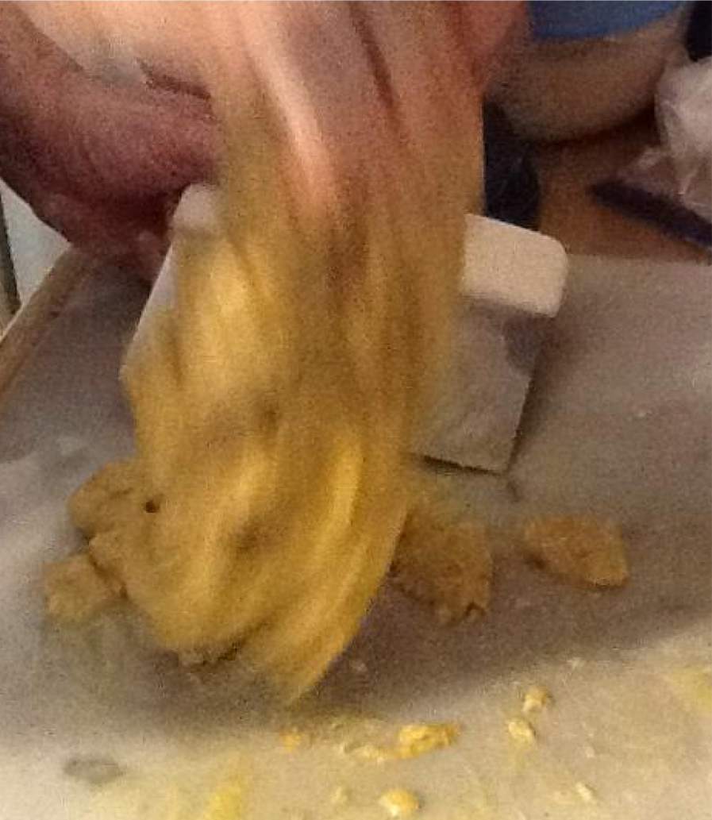
Working the brioche dough

Eleventh Try – foam from brewery fermentation – attempt 1: liquid unadulterated

Got foam from Barrington Brewery in Great Barrington, Massachusetts, a microbrewery which makes traditional English beers. When I got home, the foam had dissipated and I had very hoppy bitter dark brown liquid with some yeast separated out in the bottom of the container. Stirred what I had and separated it into 3 portions.

This try I used a cup of the brown liquid with the yeast in suspension. I sifted 1 lb. flour and removed 2 c. flour. To the smaller amount flour, I added to the brewery liquid and formed ball. I let that ball of dough with the yeast sit for an hour. To the remaining flour, I added 1⁄4 t. salt and some warm water. I worked the dough until it became silky. It was very sticky so I worked more flour into it, but it stayed sticky and not a ball. Added egg, butter, and yeast ball as I had been doing, and let the dough rise overnight, shaped into rolls, and let rise again. Tastes very bitter, not initially but after chewing a bit; it is a late developing flavor. Threw the remaining ones away.

Twelfth Try – foam from brewery fermentation – attempt 2: concentrated yeast

Took a cup of liquid (see #11 above) and mixed with equal part of spring water from Gould Farm. Let sit overnight. Brown color still permeated liquid. Carefully removed top 1 3⁄4 c. of liquid, leaving the concentrated yeast. Sifted 1 lb. flour, removed 2 cups. Made a dough ball using the concentrated yeast at the bottom, another 1⁄4 c. liquid, spring water and the 2 c. flour to form a ball of dough with yeast. Set it aside to rise for 1⁄2 hour. With larger quantity of flour, I added 1⁄4 t. salt, 1⁄2 c. liquid, and Gould Farm spring water until I had a stiff dough. Worked it, but was difficult to do because the dough was so much stiffer. Add egg, butter, and yeast ball, working ball of dough each time. Dough stayed much stiffer. Let rise overnight. Good taste, only the barest hint of beer flavoring but you really have to be looking for it. Silky texture.

Thirteenth Try – foam from brewery fermentation – attempt 3: leftovers

Took 1⁄4 c. remaining liquid from 12th Try (half spring water, half beer liquid from beer foam) and used it and some spring water to make ball of leaven. Don’t know if it has any yeast in it, but wanted to try and find out. Added more spring water to make up dough. Made like all the rest. Flavor is still mild, not beery. Was sure this was going to be a flop and it wasn’t. Crumb unevenly distributed with more air holes toward top of roll, but mouth feel is silky.

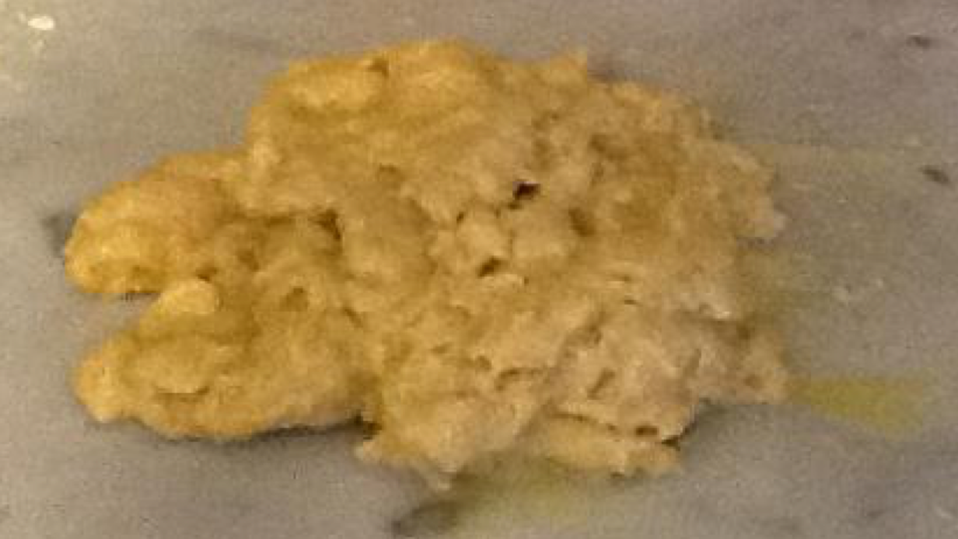
The point of despair; it will never come together as dough.

Fourteenth Try- back to basic recipe with sourdough; used cellar and long rising times; used honey in place of sugar; tried parchment paper hoops instead of tins

Replaced sugar with honey. This time I followed the times and techniques Paula Wolfert described Escoffier’s student doing (see page 4). Folded dough over and over the sourdough spread on top of it. Let rise 10 hours in basement where temperature is 51°. Then worked dough to make sure sourdough was all incorporated. Then let dough rise a second time in the basement for another 8 hours. Shaped into rolls, and then let rise in kitchen for 1 1⁄2 hours. WOW! My, oh my! This batch came out airy, feathery, not a hint of sourdough. Wow! In my 4th experiment I tried letting the dough rise overnight, and that time found the sourdough flavor was stronger, but nothing else changed. Two long rises in cool temperatures makes a huge difference. The dough also was much easier to handle and needed less flour in shaping; it acts like I see on YouTube videos instead of staying soft. Wow again!

Parchment bands didn’t work—I tried two heights. The thinner ones (3/4 inch wide, the size of a muffin tin) acted like belts, with the dough rising above and below and many of them toppling over. The wider ones (1 1⁄4 inch wide; also the size of muffin tins) also didn’t work, but kept the rolls from falling over. Their disadvantage is that the brioche did not brown in the places where the band was. Can’t tell if honey made any difference; don’t taste the change.

The success of this technique of 2 long rises in the basement means I now have to redo some previous attempts using this method.

Fifteenth Try – Redid Experiment #7 with Brie cheese and 2 long rises in cellar

Remaining Brie has become stronger since I used it last. Did previous experiment replacing the softened butter with Brie cheese. Had to work dough longer to get rid of lumps. House not as warm as it was last time so third rising took longer. Tried parchment rings 1 1⁄2 inches wide. Removed them before baking, except one that I removed after 5 minutes of baking. All except that one became misshapen in the oven—clearly the rings have to be removed after the initial period when the yeast has been killed off by the high heat. Will try this with next attempt. Served at potluck when many people liked it a lot. The Brie flavor is stronger, but jam completely obliterates that flavor. Texture is like last time—feathery.

Fifteenth Try – Redid Experiment #8 with bolted flour, with 2 long rises in cellar

Used bolted flour and made basic recipe with two long risings in the basement. Made parchment rings 2 inches wide this time. After 5 minutes of baking, I removed the cookie sheet and carefully ripped them from around each brioche. The bolted flour acted a bit differently (less absorbent), but the results were excellent—can’t tell that it is not modern white flour. The brioches kept their round shape.

Sixteenth Try – Added herbs and spices

Normally these spices would have been added at the beginning, but since I wanted to try several different spices using one batch, I added them at the point the dough was worked well after the first rising. I chose these spices because I had come across references to them being used in brioche of the time: pepper, cloves, cinnamon, and ginger. Hard to figure out exactly how much to add because I did not want the spiciness to be overwhelming. Flavor is very mild. Next time I should add a bit more spice.

Out of curiosity, I calculated that in the process of learning how to make medieval brioche, I used:

8 lb. butter
12 dozen eggs

Bibliography

Beranbaum, Rose Levy. The Baking Bible. Boston: Houghton Mifflin Harcourt, 2014.

Calvel, Raymond. The Taste of Bread. Translated by Ronald Wirtz; Edited by James MacGuire. New York: Springer Science+Business Media, LLC, 2001. Chevalier, Jim. Chezjim.com/food/pre-v/ (Viewed 1/11/16)

Chevalier, Jim. "French Bread History: Late Medieval Bread." Bread History Lounge. June 12, 2015. (Viewed June 22, 2015.)

Chevalier, Jim. "French Bread History: Making Medieval/Renaissance Bread. Bread History Lounge. August 7, 2015. http://leslefts.blogspot.com/2015/09/french-bread-history-making.html (Viewed January 6, 2016.)

Chevalier, Jim. "French Bread History: Renaissance/Sixteenth Century Bread." Bread History Lounge. August 7, 2015. http://leslefts.blogspot.com/2015/08/french-bread-history.html (Viewed August 8, 2015.)

Child, Julia. From Julia Child's Kitchen. NewYork: Alfred A Knopf, 1975. Clayton, Bernard Jr. The Complete Book of Breads. NY: Simon and Schuster, 1973.

Cotgrave, Randle. A Dictionarie of the French and English Tongues. Facsimile Reprint by Georg Olms Verlag, Hildesheim, 1970.

David, Elizabeth. English Bread and Yeast Cookery (American Edition). NY: Viking Press, 1980.

Davidson, Alan. The Oxford Companion to Food. Oxford: Oxford University Press, 1999.
Decker, Terry. "Stefan's Florilegium: Beer Bread." October 14, 27, 1997; March 30, 1998; January, 7, 1999. http://www.florilegium.org/?http%3A//www.florilegium.org/files/FOOD- BREADS/yeasts-msg.html (Viewed January 15, 2016.)

Escoffier, Auguste. The Escoffier Cookbook and Guide to the Fine Art of Cookery: For Connoisseurs, Chefs, Epicures Complete with 2973 Recipes. New York: Crown Publishers, 1969.

"Everything2: Brioche." http://everything2.com/title/Brioche. (Viewed November 4, 2015)

"Food Timeline: Bread" http://www.foodtimeline.org/foodbreads.html#breadhistory (Viewed 1/11/16)

"Food Timeline: Brioche." http://www.foodtimeline.org/foodbreads.html#brioche (Viewed 1/11/16)

Ketcham, Alex. "Baking with Barm: Part II of the Surprisingly Long History of Brewing Mugs' Shot IPA." http://www.historicalcookingproject.com/2015/01/baking-with-barm-part-ii-of.html (Viewed January 17, 2016.)

The King Arthur Flour Baker's Companion: The All-Purpose Baking Cookbook. Woodstock, Vermont: The Countryman Press, 2003.

Kindstedt, Paul. Cheese and Culture: A History of Cheese and Its Place in Western Culture. White River Junction, Vermont: Chelsea Green Publishing, 2012.

Le Grand d'Aussy, Pierre Jean-Baptiste. Histoire de la vie privée des Français depuis l'origine de la nation jusqu'a nos jours, 1783. Translated by Jim Chevalier, and titled Bread, Pastry and Sweets in Old Regime France. North Hollywood, California: Chez Jim Books, 2014.

Le Trésor de la Langue Française Informatisé, "Brioche." and "-Oche" http://atilf.atilf.fr/dendien/scripts/tlfiv5/advanced.exe?8;s=2088996975; http://atilf.atilf.fr/dendien/scripts/tlfiv5/advanced.exe?8;s=2490080865; (Viewed November 4, 2015; January 24, 2016.)

Lersch,Martin. "Baking with Hefeweizen Yeast." September 6, 2010. blog.khymos.org/2010/09/06/baking-with-hefeweizen-yeast/ (Viewed January 17, 2016.)

Marin, Francois. Suite des Dons de Comus ou L'Art de la Cuisine, Reduit en Pratique. Paris, 1742.

"Market of Choice: Artisan Breads." http://www.marketofchoice.com/bakery/artisan-breads (Viewed 11/4/155)

Marks, Gil. Encyclopedia of Jewish Food. Hoboken, NJ: John Wiley & Sons, Inc., 2010. Montagne, Prosper, editor. Larousse Gastronomic. New York: Clarkson Potter Publishers,
2001.

Nathan, Joan. Quiches, Kugels and Couscous: My Search for Jewish Cooking in France. NY: Alfred A. Knopf, 2010.

Nelson, Cassandra, aka Cassandra Matis. Email correspondence on using barm in bread. January 17, 2016.

Oliver, Raymond. Gastronomy of France, translated by Claude Durrell. Cleveland: World Publishing Company, 1967.

Pepin, Jacques. La Technique. NY: Times Books, 1976.

Roden, Claudia. Book of Jewish Food: An Odyssey from Samarkand to New York. Knopf, 1996.

Signori, Paolo. "Pandoro Cake: How to Become a Mass Marketer from a Local Market." British Food Journal. 106, Issue 10/11, p. 714-721.

Tannahill, Reay. Food in History. New York: Three Rivers Press, 1973 and 1988.

Ude, Louis Eustache. The French Cook. Originally published in 1828. https://books.google.com/books?id=qYMEAAAAYAAJ&printsec=frontcover&dq=the+french+ cook+ude&hl=en&sa=X&ved=0ahUKEwiDie3qt8bKAhVEVj4KHTYvBEYQ6AEIKzAA#v=o nepage&q=the%20french%20cook%20ude&f=false (Viewed January 25, 2016)

Wheaton, Barbara Ketcham. Savoring the Past: the French Kitchen and Table from 1300 to 1789. New York: Scribner, 1983.

Wolfert, Paula. "eG Forums: Brioche by Hand vs. Mixer. Comment December 27, 2004." https://forums.egullet.org/topic/58209-brioche-by-hand-vs-mixer/ (Viewed January 24, 2016)

FOOTNOTES

[1] I debated the plural of "brioche." Is it like "deer," or does an S get added? In French the S is silent. I followed the rule given in dictionaries to add the S, but I've never heard it pronounced.

[2] Gastronomy of France in the discussion of brie cheese tells a story about Charlemagne's fondness for the cheese and suggests that he may also be responsible for the creation of brioches using that cheese.

[3] Marie Antoinette's famous comment that if the poor could not afford bread they should eat cake is a mis-translation. She actually said, "Let them eat brioche" ("S'ils n'ont pas de pain, qu'ils mangent de la brioche."), probably not realizing how impossibly expensive that alternative was.

[4] "Levain" means the lump of dough with sourdough

[5] Literally a litron is 1/10 of a bushel, (1 bushel = 32 quarts). So 3.2 quarts x 4 = 12.8 quarts. It works out to 14 lb. flour.

[6] "Nape" is the 12th century form of "nappe."

[7] I notice that all three brioches have a slight shadow cast on the side from the label telling which batch the brioche came from. These shadows should not be mistaken for overly done sections of the roll.

[8] I note that the baker in this picture from the Tacuinum Sanitatis is wearing a hat very similar in shape to the Jews' hats.

ENDNOTES

[i] Nathan, Joan. Quiches, Kugels and Couscous: My Search for Jewish Cooking in France.

[ii] Nathan, p. 127

[iii] Roden, p. 42.

[iv] Le Trésor de la Langue Française Informatisé gives its etymology as, "1404 (Denombr. du baill. de Rouen, A.N. P 307, fo 108 ro dans GDF. Compl. : Deux pains, quatre brioches"

[v] Market of Choice, no page number;

[vi] Tannahill, p. 52; also Signori in preview says Pliny wrote about a bread made of butter, eggs, delicate flour, and oil.

[vii] Calvel, p. 149

[viii] Chevalier, "Late Medieval," p. 10; Chevalier is not specific about who issued the decree and my attempts to find out more online have so far been futile.

[ix] Davidson, p. 107. Also Larousse Gastronomique notes that the cities of Gournay and Gisors in Normandy are known for making excellent brioche.

[x] See, for example, Oliver, p. 96, 160.

[xi] Chevalier, "French Bread History: Renaissance/Sixteenth Century Bread," p. 3

[xii] Le Trésor de la Langue Française Informatisé

[xiii] Chevalier, "Late Medieval," p. 1-3 contains an extensive discussion of this point; Chevalier, "chezjim"

[xiv] Chevalier, "Making Medieval/Renaissance Bread"

[xv] David, p. 90

[xvi] Jean Liébaut was the son-in-law of the author of l'Agriculture et maison rustique, written in 1564. Liébaut expanded the work and included the most extensive information on French and European baking written until then. xvii Chevalier, "French Bread History: Renaissance/Sixteenth Century Bread," p. 4, 5

[xviii] Chevalier, "French Bread History: Renaissance/Sixteenth Century Bread," p. 7

[xix] Chevalier, "French Bread History: Renaissance/Sixteenth Century Bread," p.8

[xx] Chevalier, "French Bread History: Renaissance/Sixteenth Century Bread," p.8-9

[xxi] Chevalier, "French Bread History: Renaissance/Sixteenth Century Bread," p.6

[xxii] Wheaton, p. 180-181

[xxiii] Chevalier, "Making Medieval/Renaissance Bread," p. 19

[xxiv] Chevalier, "chezjim"

[xxv] Chevalier, "French Bread History: Renaissance/Sixteenth Century Bread," p.7

[xxvi] Ude, p. 386; he is definitely out of period but gives clues to tastes and variations of brioche

[xxvii] Davidson, p. 107

[xxviii] David, p. 497; Food Timeline

[xxix] Food Timeline, quoting Elizabeth David

[xxx] Ude, p. 385

[xxxi] Wheaton, p. 181; see also the 1742 recipe in the appendix

[xxxii] Clayton, p. 511

[xxxiii] Beranbaum, p. 484

[xxxiv] Learned later that the wheat beers do not separate into sections in water, unlike other beers.
------
Copyright 2016 by Katie Mendelsohn. <mcmendelsohn at optimum.net>. Permission is granted for republication in SCA-related publications, provided the author is credited. Addresses change, but a reasonable attempt should be made to ensure that the author is notified of the publication and if possible receives a copy.

If this article is reprinted in a publication, please place a notice in the publication that you found this article in the Florilegium. I would also appreciate an email to myself, so that I can track which articles are being reprinted. Thanks. -Stefan.

<the end>

