Wheat-2-Flour-art - 8/8/14

"From Wheat to Flour – a Hands On Approach" by HL Czina Angielczyka

NOTE: See also the files: Ancent-Grains-art, flour-msg, leavening-msg, yeasts-msg, grains-msg, bread-msg, BNYeast-art, boulting-msg, breadmaking-msg.

************************************************************************
NOTICE -

This article was submitted to me by the author for inclusion in this set of files, called Stefan's Florilegium.

These files are available on the Internet at: http://www.florilegium.org

Copyright to the contents of this file remains with the author or translator.

While the author will likely give permission for this work to be reprinted in SCA type publications, please check with the author first or check for any permissions granted at the end of this file.

Thank you,
Mark S. Harris...AKA:..Stefan li Rous
stefan at florilegium.org
************************************************************************

Class notes from her talk at the Ansteorra King's College event, 2012

From Wheat to Flour – a Hands On Approach
by HL Czina Angielczyka

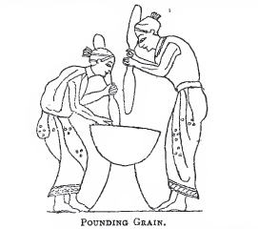
Mortar and Pestle:
- Ancient method of breaking apart grains for cooking or baking.
- Paleolithic through modern (aboriginal)
- Suitable for removing the hard, non-edible outer shell from certain grains, which is necessary for the making of flour.

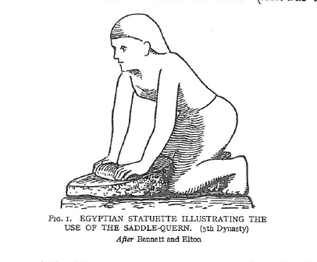
Saddle Quern:
- More efficient than mortar and pestle
- Egyptian (2400BCE) through modern (aboriginal)
- When used with a 'hopper', became more efficient in adding grain and removing flour (Olynthus style, 500BCE)

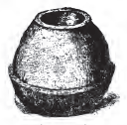
Rotary Quern:
- Most efficient method for handgrinding grain
- 1200BCE – modern
- Different sizes and styles of stones
- Led to the invention of watermills, windmills, and animal mills
- Used throughout the iron age, but fell out of favor when large-scale milling came into power.

Decline of Rotary Querns:
- Larger scale = more product for less work
- Automation = water power, wind power, animal power
- Church and noble controlled the mills – handmilling becomes contraband

Improvements to the Basic Quern:
- Addition of a rynd – allows better flow of grain and flour
- Striations – allows flour to move between stones

Iron Age Wheats and Grains:
- Barley
- Emmer
- Einkorn
- Spelt
- Common Wheat
- All have varying levels of gluten, which affect the 'rising' power of the bread
- Common wheat became the most useful and popular for bread, although others were used for brewing and in less hospitable climates

Bread Recipes:
- Variations on flour, water, and salt, possibly oils
- Addition of yeast will create 'rising' bread
- Spelt will make a sourdough, although it takes a bit of work
Works Consulted

Ashton, John. The History of Bread from Pre-Historic to Modern Times. London: Brooke House Pub. Co, 1904.
Bennett, Richard, and John Elton. History of Corn Milling. London: Simpkin, Marshall and Co. etc., 1898.
Buckley, D.G., and H. Major. "The Quernstones." Roman Castleford: excavations 1974 - 85. Ed. H.E.M. Cool and Ed. C. Wakefield: West Yorkshire Archaeology Service, 1998. 241-246.
Cubadda, Raimondo, and Emanuele Marconi. "Spelt Wheat" in Pseudocereals and less common cereals : grain properties and utilization potential. Ed. Peter S. Belton, Ed. John R. N. Taylor. Berlin, New York: Springer, 2002. 153-175. Print.
Curtis, Robert. "Food Processing and Preparation." The Oxford handbook of engineering and technology in the classical world. Ed. John Peter Oleson. Oxford: Oxford University Press, 2008. 369-392. Print.
Curwen, Cecil. "More about Querns." Antiquity. 1942: 15-32.
Curwen, Cecil. "Querns." Antiquity. 1937: 133-151.
Forbes, R. Studies in Ancient Technology (vol III). Leiden New York: E.J. Brill, 1993. Print.
Heslop, D. H. The Excavation of an Iron Age Settlement at Thorpe Thewles, Cleveland, 1980-1982. London: Council for British Archaeology, 1987: 84-89.
King, William Ross. "Notes on Querns, with special reference to one of unusual form found in a Moss near the Meikle Loch, Aberdeenshire." Proceedings of the Society of Antiquaries of Scotland. 1872-1874: 419-24. <http://ads.ahds.ac.uk/catalogue/adsdata/arch-35-1/dissemination/pdf/vol_010 /10_419_424.pdf>
Perkins, Steve. Hertfordshire Puddingstone. East Herts Geology Club, 2005. <htp://www.ehgc.org.uk/Steve_s_leaflet_ver2_.pdf>
.Pliny the Elder. The Natural History. John Bostock, M.D., F.R.S. H.T. Riley, Esq., B.A. London. Taylor and Francis, Red Lion Court, Fleet Street. 1855.
Rahtz, PW. "Medieval Milling." Medieval Industry. Ed. DW Crossley. London: Council for British Archaeology: 1981. 1-15. Print.
Spratt, D. A. (ed) Prehistoric and Roman archaeology of north-east Yorkshire. London: Council for British Archaeology, 1993.
Stathakopoulos, Dionysios C. Eat, drink, and be merry (Luke 12:19): food and wine in Byzantium : papers of the 37th annual spring Symposium of Byzantine Studies, in honour of Professor A.A.M. Bryer. Ed. Leslie Brubaker and Ed. Kallirroe Linardou. Aldershot, England Burlington, VT: Ashgate, 2007. 27-37. Print.
------
Copyright 2012 by Cynthia Sebolt, <czinaangielczyka at gmail.com>. Permission is granted for republication in SCA-related publications, provided the author is credited. Addresses change, but a reasonable attempt should be made to ensure that the author is notified of the publication and if possible receives a copy.

If this article is reprinted in a publication, please place a notice in the publication that you found this article in the Florilegium. I would also appreciate an email to myself, so that I can track which articles are being reprinted. Thanks. -Stefan.

<the end>

