Bo-Quail-Eggs-art - 11/19/17

"Boiled Eggs with Pine Nuts - Ovis Hapalis" by Maries Agorius Donatus Minius Germanicus, nicknamed Maximus.

NOTE: See also the files: eggs-msg, nuts-msg, egg-whites-msg, egg-storage-msg, eggs-stuffed-msg, German-Eggs-art, pickled-eggs-msg, Roman-Bread-art, garum-msg.

************************************************************************
NOTICE -

This article was added to this set of files, called Stefan's Florilegium, with the permission of the author.

These files are available on the Internet at: http://www.florilegium.org

Copyright to the contents of this file remains with the author or translator.

While the author will likely give permission for this work to be reprinted in SCA type publications, please check with the author first or check for any permissions granted at the end of this file.

Thank you,
Mark S. Harris...AKA:..Stefan li Rous
stefan at florilegium.org
************************************************************************

Boiled Eggs with Pine Nuts - Ovis Hapalis
by Maries Agorius Donatus Minius Germanicus,
nicknamed Maximus

From Apicius, 329

Latin:
In ovis hapalis: piper, ligustcum, nucleos infusos. Suffundes mel, acetum; liquamine temperabis.

English:
For soft-boiled eggs: pepper, soaked pine nuts. Add honey and vinegar and mix with garum.

Ingredients:

- 4 small chicken or quail eggs
- 200 grams pine nuts
- 2 teaspoons ground pepper
- 1 teaspoon honey
- 4 tablespoons garum (anchovy paste can be used as a substitute)

Modern Recipe:

- First, soak the pine nuts in water overnight.
- The next morning, drain the water and grind/mortar and pestal the pine nuts finely. (some recipes do not have this step)
- Mix in the honey, garum, and ground pepper.
- Heat up the sauce, careful that the sauce is not burned!
- Meanwhile, place the eggs in a pan or small pot full of cold water and bring it to a boil.
- If using chicken eggs, boil for about 3.5 minutes; if using quail eggs, about 1 minute.
- Take the eggs off the heat and plunge them into cold water to cool them.
- Carefully peel the eggs.
- Place the whole eggs into a deep serving bowl. (some recipes cut the egg in half.)
- Pour the pine-nut sauce over the eggs and serve.

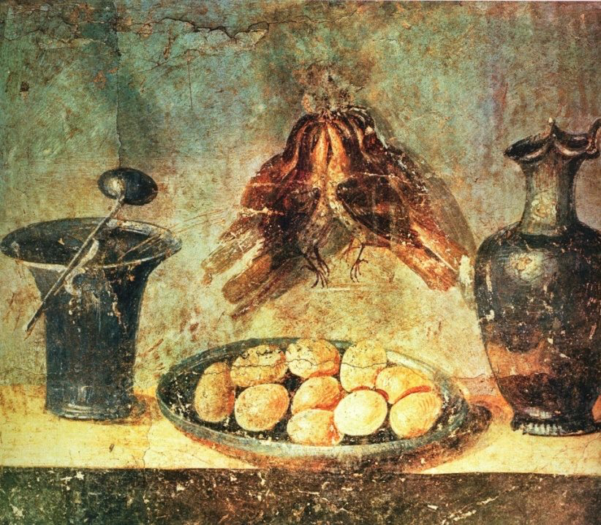.

------
Copyright 2017 by Joshua Davis. < amishfrankenstein at hotmail.com>. Permission is granted for republication in SCA-related publications, provided the author is credited. Addresses change, but a reasonable attempt should be made to ensure that the author is notified of the publication and if possible receives a copy.

If this article is reprinted in a publication, please place a notice in the publication that you found this article in the Florilegium. I would also appreciate an email to myself, so that I can track which articles are being reprinted. Thanks. -Stefan.

<the end>

