Explr-Pottage-art - 6/30/18

"Exploration of Pottage" by Lady Ysabel de la Oya.

NOTE: See also these files: porridges-msg, caldron-cookg-msg, onion-soups-msg, pea-soup-msg, soup-msg, stews-bruets-msg, carrots-msg, onions-msg.

************************************************************************
NOTICE -

This article was added to this set of files, called Stefan's Florilegium, with the permission of the author.

These files are available on the Internet at: http://www.florilegium.org

Copyright to the contents of this file remains with the author or translator.

While the author will likely give permission for this work to be reprinted in SCA type publications, please check with the author first or check for any permissions granted at the end of this file.

Thank you,
Mark S. Harris...AKA:..Stefan li Rous
stefan at florilegium.org
************************************************************************

Exploration of Pottage
by Ysabel de la Oya

In the 14th century most people lived in simple homes. The kitchen, as we know it, didn’t exist in the homes of a common villager. Most cooking was done on a hearth made of stones with venting in the roof. People of higher income or status, may have a hearth that looked much like a chimney. Most cooking was done on a spit or in cookpots on or near the fire. (1)

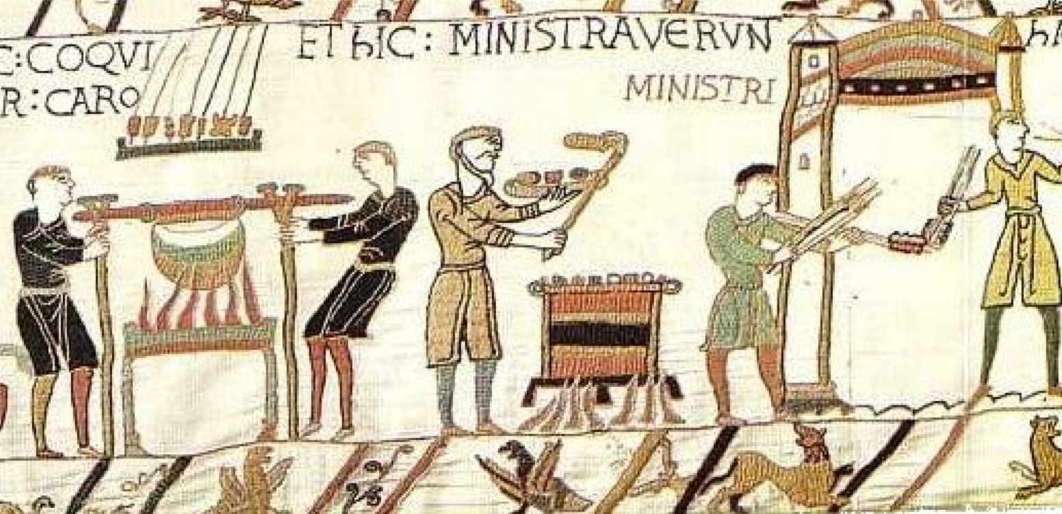
A cookpot used over fire, in a section of the Bayeux Tapestry, 11th Century. ( 2)

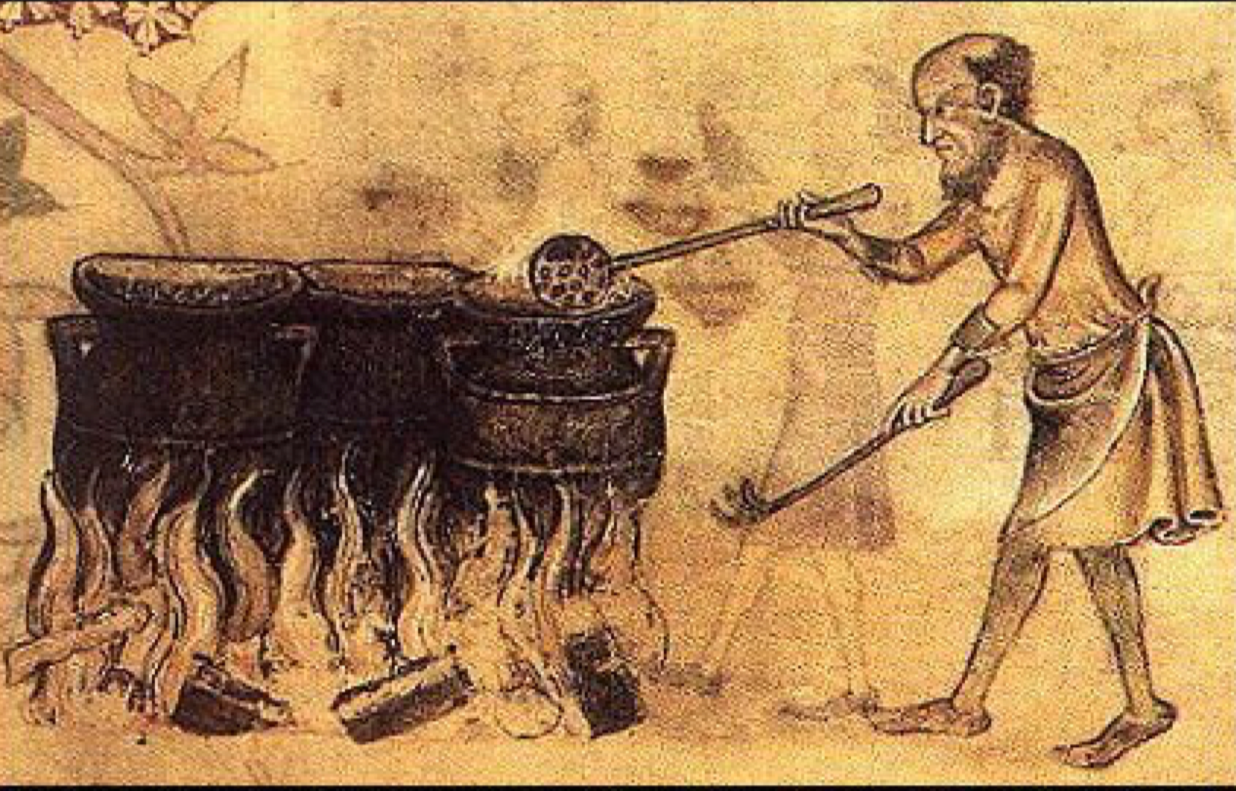
Cookpots used over fire, from the The Luttrell Psalter, 1325-1335 ( 3)

Pottage and bread were some of the mainstays of the 14th century. Villagers would pay for grain to be ground at the mill, then again for the bread to be baked. A simpler, and more economical solution, for an average villager was pottage. The pottage could be made in a single pot, and without a trip the mill or baker.(1)

Simply, a pottage is a stew or soup cooked in a pot and could be made from pretty much anything edible that you could get your hands on. (1) It could be very thick, very thin, or anywhere in between. The basis of a pottage would a bit of meat (on days it was allowed), salted fish, stock, vegetables, beans, some type of thickener (often breadcrumbs, grains or ground almonds), some herbs, and salt. However, not all pottages had all elements. The more money you had, the more meat you put in your pot. Pottage would have likely been served simply and eaten out of a wooden bowl. (4)

A fourteenth century poem written by William Langland (5) contains a passage that describes what a village commoner would have available to them:
“ ‘I have no penny’ quoth Piers - ‘Pullets for the buy
Nor neither geese nor piglets - but two green cheeses
A few curds and cream - and an oaten cake
And two loves of beans and bran - to bake for my little ones
And besides I say by my soul - I have no salt bacon
Nor no little eggs, by Christ - coppops for to make
But I have parsley and leeks - and many cabbages” (6)

This passage illustrates that cabbage, leeks, and parsley were widely available. Vegetables and herbs such as these would be commonly grown by villagers themselves. A common person with a access to a bit of land would have a garden and would grow anything from vegetables like turnips, onions, leeks, beans, and cabbages to herbs and flavorings like garlic, sage and parsley.(4) This access to fresh produce would allow anyone to add bulk, nutrition, and flavor to any pottage.

The produce that would be grown would change through the year a great deal. What is in your pot at the beginning of the season would change slowly through the weeks as different produce was ready in the garden. (7) In fall and winter (and early spring), for example, turnips, apples, and cabbages would be available and at their peak, while radishes and spinach were available in full spring and early summer. Foods like asparagus start to be available in summer and broad beans in summer and early fall. (8). In order to make cheese, rennet must be made from the stomach of a lamb not yet weaned, so a lamb needed to be slaughtered in the spring. (7) Due to the hardship and expense of keeping animals over the winter, many would be slaughtered in November, adding more available meat to the pottage mix. (4)

The church was also a huge influence on the daily diet of the 14th century. The church banned eating meat for a full half of the calendar. In addition to Lent and Advent, meat consumption was forbidden on Wednesdays, Fridays, and Saturdays. Allowed on most fast days, eggs were also banned during Lent. At the time, the laws of the church were taken very seriously, and anyone caught eating meat on a fast day, would find themselves in legal trouble, not to mention the peril to their immortal soul. As a result, what was in your pottage greatly depended on what day of the year it was. (4)

Procuring fish could be difficult as well. While fish was allowed on fast days, fresh fish was not accessible to most common people. The commoners were not allowed to fish in bodies of water near their homes, as they would be owned by the church, or gentry and nobility. Some lakes and rivers were open to fishing, if you paid rights to the owner. This was a costly prospect that many could not afford. What was on for offer, however, was salted, preserved fish. Eels, being abundant in rivers, could also be a relatively inexpensive option. As a result, while the upper and monistic classes ate fresh fish, the middle and lower classes ate salt fish or eels. (4)

For most of society, however, meat in general was scarce. If an animal such as a cow, ox, or sheep was owned, it would be so valuable as a working animal, fiber, or milk producer. Meat at market would be expensive. These animals would only be slaughtered at the end of their lives, and would produce a tougher meat. Poultry, also, were of a much higher value laying eggs and would also only be eaten at the ends of their lives. Such tough meat, from older, working animals and poultry, work perfectly in a long, slow cooking method such as stewing in a pottage. (4)

Also influencing what was in your pottage were the prevailing health theories of the day. At this time Western Society believed that health was influenced by four humors, or fluids, that made up the body. This system of scientific belief had been in existence since 400 BCE, having been put forth by Hippocrates. The liquids consisted of blood, phlegm, black bile, and yellow bile. Each liquid had a corresponding quality, blood was sanguine, phlegm was phlegmatic, black bile was melancholy, and yellow bile was choleric. In 14th century medicine, any illness was due to an imbalance of these humors. (9)

Each humor had properties that could be combated or aided by properties in food.

Blood (sanguine) was hot and moist, phlegm (phlegmatic) was cold and moist, black bile (melancholy) was cold and dry, and yellow bile (choleric) was hot and dry. You could judge what humor was not in balance based on a person’s behavior. Someone suffering from too much black bile, for example, would suffer from an excess of sadness or be delusional. (10)

For another example, cabbage was considered warm and dry. It would be used to combat a wet illness, and could “remove obstructions”, but was considered bad for the intestine. Fennel, also warm and dry, was thought to help with eyesight and fever, but causes problems with menstrual flow. Cucumbers, on the other hand, were cold and wet, and helped with hot fevers but causes pain in the groin.( 11)

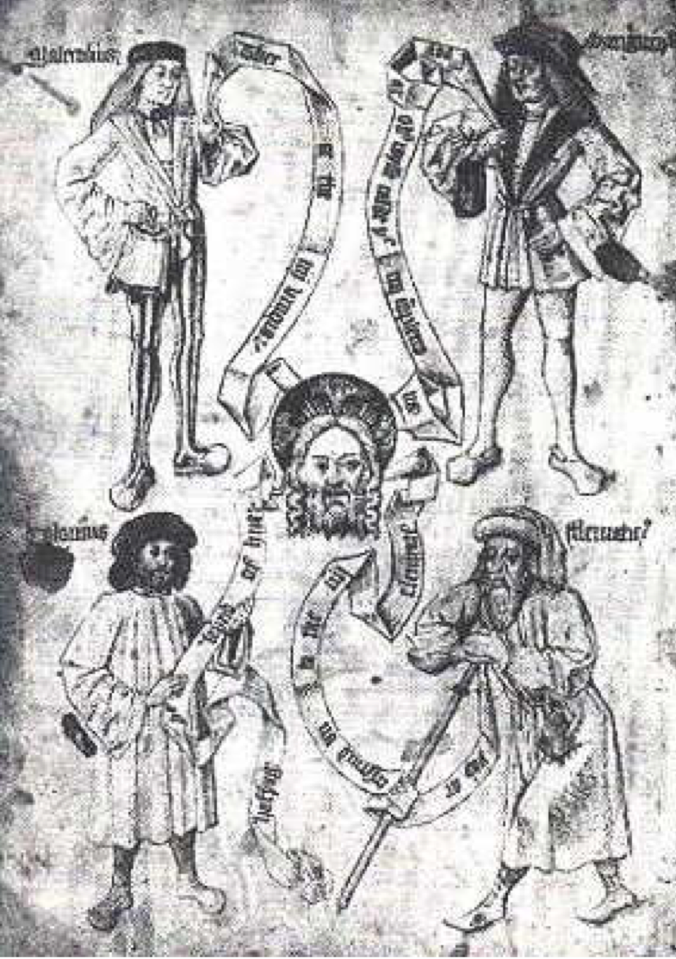
The Humours portrayed as Four Men. (10)

Pottage for Meat Days: Bruet of Sarcynesse

“For to make a bruet of sarcynesse, tak þe lyre þe fresch buf & ket it al in pecis, & bred, & fry yt infreschgres. Takitvp&dryeit,anddoytinavesselwyþat wyn&sugur&powdreof clowys. Boyl yt togedere tyl þe flesch hae drong þe lycoure, & tak almande mylk & quibibz, macis & clowys, and boyle hem togedere. Tak þe flesch & do þerto & messe it forth. “( 12)

Take the flesh of fresh beef and cut it into pieces and bread and fry it in fresh grease. Take it up and dry it, and do it in a vessel with wine and sugar, and powder of cloves. Boil it together until the flesh has drunk the liquor and take almond milk and cubebs and mace and cloves and boil them together. Take the flesh and do thereto and mess it forth,

This is a 14th century English dish. The recipe, as given, would be for a person of very high means. It is entirely meat and spice, and thus would have been very expensive, and not have too much bulk. My redaction could have been made by someone in the middle part of society. They may make this on a special occasion, since the ingredients would still have been quite expensive. This dish of course would only been eaten on days where meat was allowed.

I decided to add onions, garlic, mustard greens, and water to approximate how a person in the merchant classes may prepare a pottage for a special guest that had a lot of meat and spices, but also had vegetables for bulk. I have also used butter and vegetable oil to to fry the meat in, but in period, they would most likely have used rendered fat, like lard. I could not find lard at my local store. I could not find cubebs and opted to use grains of paradise and black pepper. Mace is omitted because I went shopping thinking I had mace, only to discover I had none.

Redaction
2 lbs stew meat
1⁄4 cup butter
1⁄4 cup cooking oil
1 cup breadcrumbs
1 cup red wine
1 cup almond milk
4 cups water
2 onions
1 head garlic
1 cup chopped mustard greens
1 tbls sugar
1 tsp cloves
2 tsp black pepper
1 tsp grains of paradise
Salt to taste.

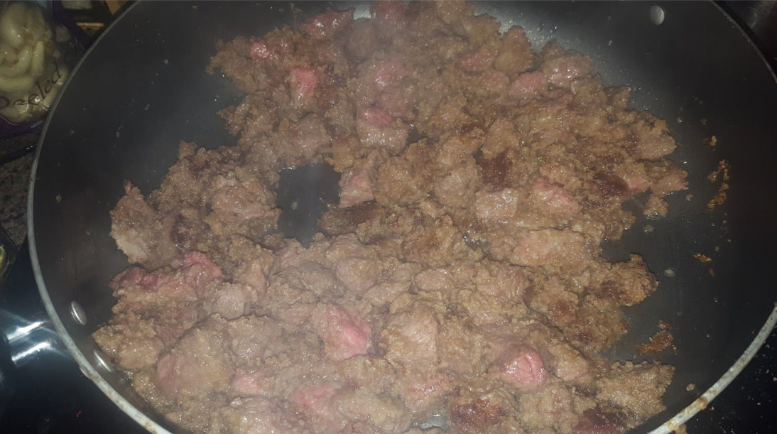
Frying of Beef and breadcrumbs

Cut the beef into small cubes (I cut the beef stew pieces that come from the store in half) and roll in breadcrumbs. Fry the beef in butter and oil, searing the meat, but not quite cooking it. I found I didn’t need to Chop the onions, garlic and greens, fairly small. Add the beef to pot with the wine, sugar and cloves and cook until the wine has just about disappeared. The, add the liquids and the rest of the vegetables, herbs, and spices and cook on med low/simmer for an hour. Salt as needed, to taste.

Almond Milk
2 cups ground almonds
4 cups water.

Seep ground almonds in water for an hour, strain.

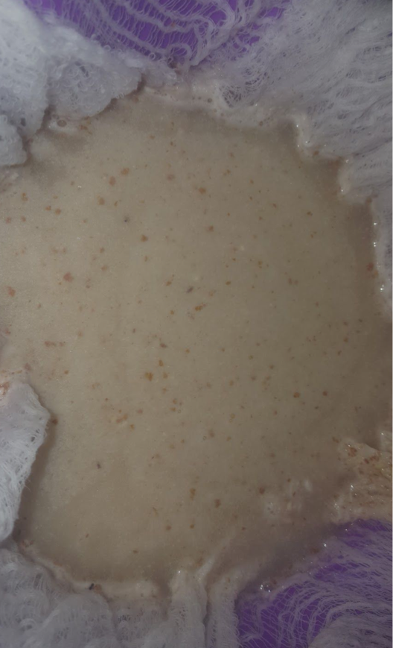
Production of Almond Milk

Pottage for Fast days: Caboches in Potage

“Caboches in Potage Take caboches and quarter hem, and seeth hem in gode broth with oynouns ymynced and the whyte of lekes yslyt and ycorve smal. Ad do þerto
safroun & salt, and force it with powdour douce.” (12)

Take cabbages and quarter them, and seeth them in good broth with onions minced and the white of leeks cut and carved small. And do thereto saffron & salt, and force it with powder douce.

This is a 14th century English dish. As written it is a very simple dish that would seem to be possible for even the poorest person if were not for the very expensive spices.

I decided to make this a pottage that even the poorest person with a garden could make. I’ve omitted the spices and added herbs, which could be grown. I’ve also added fennel, garlic, and green onion. For the broth, I’ve made a vegetable stock. Being meatless this would be a perfect for a fast day, even lent.

My Redaction:

7 cups vegetable stock
1 cabbage
2 onions
1 bunch green onions
1 fennel bulb
6 leeks
1 head of garlic
1 bunch of parsley
2 sprigs of rosemary
6 sage leaves
Salt to taste

Chop the cabbage, onions, green onions, fennel, and whites of the leeks fairly small and smash the garlic cloves. Add all to the vegetable stock cook on med low/simmer for an hour to an hour and a half. Salt as needed, to taste, keeping in mind the stock is salted.

Vegetable Stock
18 cups water
3 tablespoons kosher salt
2 onions
1 small head of garlic
Bottom half of green onion bunch
Fronds and stem of fennel bulb
Greens of a leek
6 thin carrots
2 sprigs of rosemary
6 sage leaves
Handful of parsley

Roughly chop all vegetables and peel the garlic. Add herbs, garlic, and vegetables to salted water in a large pot and allow to simmer for three hours. To concentrate flavor, boil for a few minutes to evaporate water.

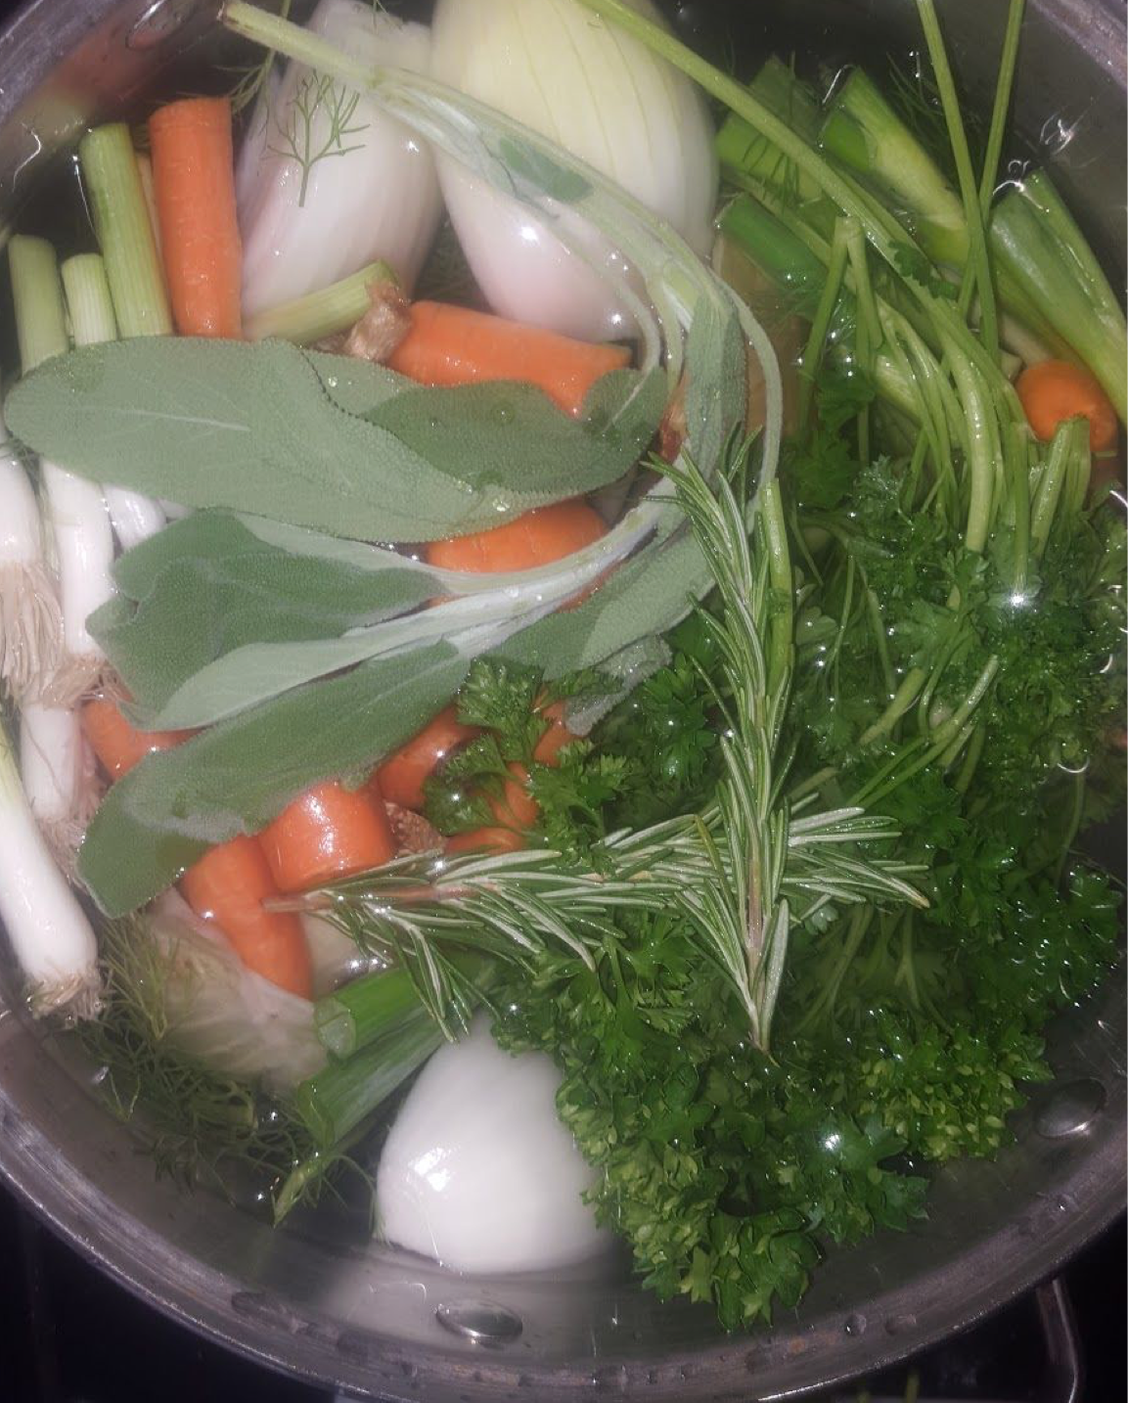
Vegetable stock at very beginning of cooking.

Works Cited

1. Gies, Frances, Joseph Gies, Frances Gies, Joseph Gies, Frances Gies, Joseph Gies, Frances Gies, and Joseph Gies. Daily life in medieval times. New York: Black Dog & Leventhal, 2002. Print.

2. "The Bayeux Tapestry." Khan Academy. N.p., n.d. Web. 5 Apr. 2017. <https://www.khanacademy.org/humanities/ap-art-history/early-europe-and-colonial-am ericas/medieval-europe-islamic-world/a/bayeux-tapestry>.

3. International, American. "Life In A Medieval Castle Medieval Food." Castle Life - Medieval Food . N.p., n.d. Web. 10 Apr. 2017. <http://www.castlesandmanorhouses.com/life_04_food.htm>.

4. Mortimer, Ian. The time traveler's guide to medieval England: a handbook for visitors to the fourteenth century. New York: Simon & Schuster, 2010. Print.
5. "Piers Plowman." Piers Plowman (Middle English, tr. into Modern English); Prologue. Harvard , n.d. Web. 5 Apr. 2017. <http://sites.fas.harvard.edu/~chaucer/special/authors/langland/pp-pro.html>.

6. Quennell, Marjorie, and C. H. B. Quennell. A History of Everyday Things in England. London: B.T. Batsford, 1956. Print.

7. Tudor Monastery Farm: 01. Prod. David Upshal. Perf. Ruth Goodman, Peter Ginn, Tom Pinfold. Tudor Monastery Farm, episode 1. BBC , n.d. Web. 5 Apr. 2017.

8. "Seasonality Table." BBC Good Food. N.p., n.d. Web. 10 Apr. 2017. <https://www.bbcgoodfood.com/seasonal-calendar/all>.

9. Dellureficio, Anthony J. "The Biology Book: From the Origin of Life to Epigenetics, 250 Milestones in the History of Biology.. by Michael C. Gerald, with Gloria E. Gerald. New York: Sterling. 528 p.; ill.; index. 2015." The Quarterly Review of Biology 91.2 (2016): 199-200. Web.

10. Matterer, James L. "The Preparation of a Medieval Feast following the Four Humour System of food and diet." Messe it Forth. Gode Cookery, n.d. Web. 01 Apr. 2017. <http://www.godecookery.com/feastpre/feastpre.htm>.

11. Matterer, James L. "Tacuinum Sanitatis." Tacuinum Sanitatis . N.p., n.d. Web. 10 Apr. 2017. <http://www.godecookery.com/tacuin/tacuin.htm>

12. Hieatt, Constance B., and Sharon Butler. Curye on Inglysch: English culinary manuscripts of the fourteenth century (including the Forme of Cury). London: Published for the Early English Text Society by the Oxford U Press, 1985. Print.

------
Copyright 2015 by Michelle Araj. <michellearaj at gmail.com>. Permission is granted for republication in SCA-related publications, provided the author is credited. Addresses change, but a reasonable attempt should be made to ensure that the author is notified of the publication and if possible receives a copy.

If this article is reprinted in a publication, please place a notice in the publication that you found this article in the Florilegium. I would also appreciate an email to myself, so that I can track which articles are being reprinted. Thanks. -Stefan.

<the end>

