Easy-Banners-art - 4/5/14

"Down and Dirty Banners" by Baroness Sine ni Dheaghaidh, OL.

NOTE: See also these files: banners-msg, flags-art, Stndrds-Banrs-art, silk-banners-msg, applique-msg, Couching-art, silk-msg, embroidery-msg.

************************************************************************
NOTICE -

This article was submitted to me by the author for inclusion in this set of files, called Stefan's Florilegium.

These files are available on the Internet at: http://www.florilegium.org

Copyright to the contents of this file remains with the author or translator.

While the author will likely give permission for this work to be reprinted in SCA type publications, please check with the author first or check for any permissions granted at the end of this file.

Thank you,
Mark S. Harris...AKA:..Stefan li Rous
stefan at florilegium.org
************************************************************************

Down and Dirty Banners
by Baroness Sine ni Dheaghaidh, OL.

Historic Style

1. No shield-shaped banners

2. Pennons: Small triangular-shaped or swallow-tailed. Seen in Period on Knight's lances. Currently useful as Eric flags or to mark campsite boundaries.

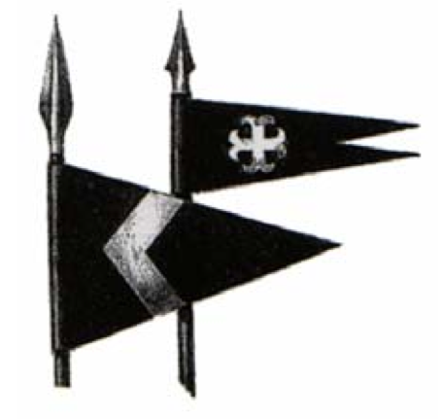

3. Banners: Used for armorial display. In Period were carried before the owner as a sign of his feudal rights. The banner bore the owner's coat of arms. These banners were double-sided with the dexter side of the arms always next to the staff. They where hung with a crossbar at the top to keep the banner displayed.

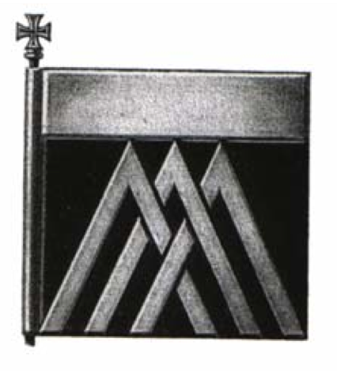

4. Standards: (known in the SCA as a "war banner") A large flag in pennon shape with either swallow or rounded tails. It varied in size according to the rank of the owner. The standard was decorated and charged as follows: Next to the staff was the badge of the Kingdom to which the owner owed allegiance. The rest of the surface was used to display the arms of the owner. Sometimes a motto was also used on the standard. The standard was often trimmed with gold fringe or a single row of small alternating squares of the two main tinctures of the owners arms. (This is called compony)

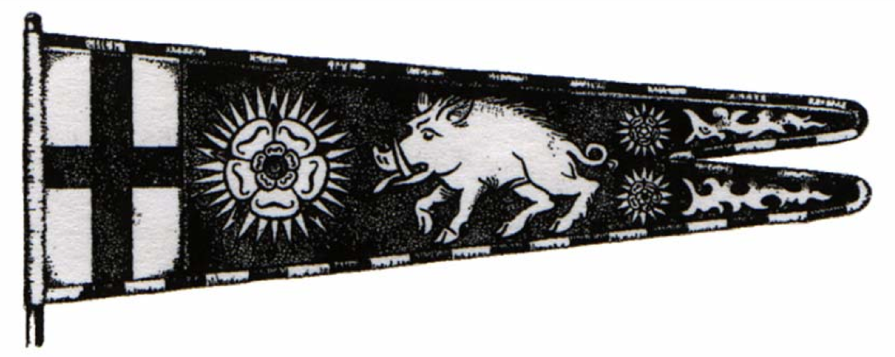

Banner How-To

Materials:

1. Fabric: Trigger or sports cloth (cotton-poly) It's washable and doesn't fade in sunlight.

2. Paint: Acrylic fabric paints (and an assortment of various sizes of brushes)

3. Trim: Extra Wide, Double Folded bias tape (Wrights)

4. Patterns: Pictorial Dictionary of Heraldry, on-line clip art and fonts and friendly artists.

5. Miscellaneous: light table (glass sliding door), transfer web (Wonder-Under, Stitch Witchery and others), transfer pencils, light weight cardboard (for drawing patterns), iron and ironing board, sewing machine (one that will do a nice satin stitch), pens (I use the very fine tip Sharpies to trace designs onto banner using light table) and access to a copy machine that makes poster size copies.

Construction:

1. Appliqué: Trace design onto fabric. Cover area with Wonder-Under, cut out and iron onto banner. Then satin stitch around edges with your sewing machine. Practice on scrap fabric before you attempt this if this is your first try. You will get better!

2. Painting: Transfer design onto banner using light table or other method. If banner fabric is light you may want to try transfer pencils...but remember that unless your design is symmetrical, it will be reversed...to prevent that, turn your design over and trace from the back side. If painting a light color over a dark fabric, you may have to use several coats.

3. Sewing: To finish banners when painting and appliqué is complete, place banners together back to back. Fold down hem on tops and insert tabs at equal intervals. Sew. Then enclose sides in Extra Wide, Double Fold bias tape and stitch down. (Tabs are made by deciding the size tabs needed and making a pattern, allowing enough fabric to sew and turn the tabs. Turn tabs, press and fold. Then insert in top of banners and sew upper seam.)

For ties on side, sew folded bias tape in desired length and sew on sides at measured intervals.

For finishing standards, after painting and/or appliquéing designs, sew first section of standard to the main section with a French seam. This is sturdy and neat. If designs are symmetrical, standard can be one layer thick and but you must match up your sewing on each side so it doesn't show. Add tabs as explained above. Finish by enclosing entire standard in bias tape trim.

4. Patterns: Maintain a pattern file and SAVE all your patterns. You never know when you might need them again, and it's lots easier to save them than to recreate them!

Care of Banners and Standards:

Do NOT fold painted banners and/or standards. This could cause the paint to crack and flake off. They will last longer and look better if you roll them up and store them in a bag or wrapper on their sides. They may be machine washed (gentle cycle) and dried (low). After several years the paint may need a touch up...or maybe not! If you take care of your banners and standards they will look beautiful for years...even if they have suffered though Pennsic dust and rainstorms!

Bibliography

Draconarius, Bruce and Yoshio, Akagawa. A Pictorial Dictionary of Heraldry. SCA Publication, USA: 1988.

Friar, Stephan and Ferguson, John. Basic Heraldry. Hong Kong: Bramley Books, 1993. Grant.

Francis J. The Manuel of Heraldry. Edinburgh: John Grant, 1913.

Hope, W.H. St John, Heraldry for Designers and Craftspeople. New York: Dover Publications, 1999 (original published in 1913).

Norris, Herbert. Costume and Fashion Volume II. New York: Dover Publications, 1999 (originally published in 1927).

On-line Resources

http://dragon_azure.tripod.com/UoA/ArmorialDisplay.html
This is an excellent site about period banners.

http://www.kwantlen.bc.ca/~donna/sca/flags/
More information about period style banners.
------
Copyright 2011 by Jane Sellers, 7066 N. NC Hwy 109, Winston-Salem NC, 27107. <sinebee at triad.rr.com>. Permission is granted for republication in SCA-related publications, provided the author is credited. Addresses change, but a reasonable attempt should be made to ensure that the author is notified of the publication and if possible receives a copy.

If this article is reprinted in a publication, please place a notice in the publication that you found this article in the Florilegium. I would also appreciate an email to myself, so that I can track which articles are being reprinted. Thanks. -Stefan.

<the end>

