Pnted-Wal-Hng-art - 8/23/17

"Tudor Painted Linen Wall Hanging" by Lady Adelaide Sarsfield.

NOTE: See also the files: embroidery-msg, Bayeux-Tapsty-art, Bayeux-Tap-DH-art, fab-painting-msg, Hist-of-Quilt-art, silk-banners-msg, banners-msg, Sheetwalls-art.

************************************************************************
NOTICE -

This article was added to this set of files, called Stefan's Florilegium, with the permission of the author.

These files are available on the Internet at: http://www.florilegium.org

Copyright to the contents of this file remains with the author or translator.

While the author will likely give permission for this work to be reprinted in SCA type publications, please check with the author first or check for any permissions granted at the end of this file.

Thank you,
Mark S. Harris...AKA:..Stefan li Rous
stefan at florilegium.org
************************************************************************

Tudor Painted Linen Wall Hanging
by Lady Adelaide Sarsfield

Shire of Cum an Iolair
Kingdom of Calontir

Summary:

Embroidered tapestries, such as the Bayoux Tapestry (1066), and woven ones, such as The Unicorn Tapestries (~1500), were rare, as they were extremely expensive and laborious. Painted linen wall hangings, also referred to as water works, were first mentioned in England in the 14th century. Shakespeare refers several times to such painted cloths: Robert Arden, his grandfather, had eleven of them. Estienne Perlin, writing in 1558, remarks that ‘the English use many hangings, painted cloths (toilles pinctes), which are well done … you can enter few houses but you find such cloths’. By the 1640’s, these decorative textiles were considered old fashioned. (Owlpen Manor Estate)

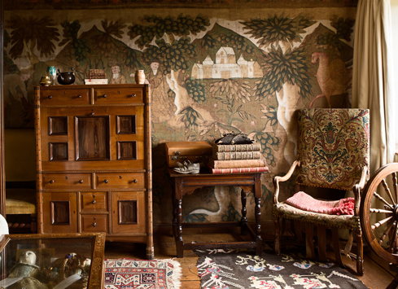

THE LIVELY PAINTED CLOTHS in Queen's Margaret's Chamber at Owlpen are said to
be unique as a complete decorative scheme of such work still in situ in England. (Owlpen Manor Estate)

As painted linen wall hangings do not last as long as their counterparts, the best resources I have found are made by museum historians in England. Other documentation is found by researching historical wills, inventories, and account books. One English historian, Melissa White (who was my original inspiration for this project), imagines that in the environment of a Tudor era home, this type of textile would only last a few years, at most. (Melissa White)

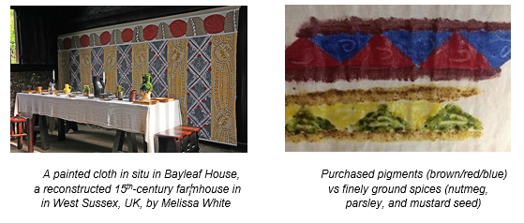

As I have painted often, but never with egg tempera, I felt some research and experimentation was desperately needed. I watched many videos online, and also purchased a contemporary book on using egg tempera. The book taught me how to create the paint properly, processing the yolk so that none of the membranes or whites of the egg get into the paint. It also explained different layering techniques and texturing, which were great to try out during my experiments. (Robert Vickery) However, I knew that my finished textile would need to be able to roll or fold up, in order to transport it to sites, it would not be feasible to do much layering and texturing. In my experiments, I found this to be true – areas that were too thick or had too many layers would tend to flake off. Perhaps if the textile were, indeed, affixed permanently to a wall, it would last longer and not be so fragile.

Imagining that the typical Tudor home would have access to various herbs and spices, I used my mortar and pestle to finely grind a few different colored spices, to see how they worked for pigments. They perhaps needed more grinding, or strained through cloth to get the bits out, but the vividness of the tubes of paint I had purchased was clearly evident, and preferable. Of course, the nutmeg made me long for the holidays – in July, no less – and a nice tall glass of cold egg nog.

Items:

Frame: Stained wood frame of pine. This also acted as a stretching frame, during the sizing step of the process. At home, I have hooks on my wall that the top rail will rest upon, although there are references of them being applied directly to the wall, similar to wallpaper. The frame itself is not necessarily part of my project, just simply a method of display. I make no claim to any Sciences, including Woodworking.

Fabric: Four yards of optic white linen from Carolina Calicos, purchased at Pennsic. I felt the pattern would stand out well against the bright white. A natural color, instead of bright white, would probably have been more accurate to the time period, but here I made my decision based on aesthetics. The extant pieces at the Owlpen Manor shows they used 42 inch unbleached linen canvas. (Owlpen Manor Estate)

Sizing: Rabbit glue was the period method used to size fabric for painting. Today, it is still used to size canvas, but also commonly used to seal instruments such as violins, so that they can easily be steamed to be taken apart for repairs. Due to this contemporary use, rabbit glue is still available at a relatively low cost, in granule form, which is then boiled for a few minutes to dissolve. I have also noticed that the rabbit glue gives a tiny hint of sparkle to the linen, up close. Twelve tablespoons of the granules were used.

Paint: Sennelier Egg Tempura paint pigments were used. While the paint set I purchased came with a bottle of contemporary medium, I opted for egg yolk to bind the pigments to the linen. I found that the egg yolks did not have a strong odor, unlike their counterpart, yet they worked just as well. Fifteen egg yolks were used in this project, with the egg whites being made into meringue cookies, and many of the shells were crushed and mixed in the soil of my garden.

Brushes: A four-inch painter’s brush was used to apply the rabbit glue during sizing. As the egg tempura paint works much like gauche, so my illumination/watercolor brushes worked perfectly.

Miscellaneous: Straight pins and woolen twine, to help with stretching during sizing.

Process:

As the wall hanging would be customized to fit the frame it would hang on, I began with this. A previous attempt at a frame was modeled after a friend’s practice pell, which, in retrospect, may have been too beefy for such a light item. Therefore, the frame I built this time was much daintier.

After the frame was complete, I hung the raw linen on it, to see what width it should be. From experience, I already knew the wall hanging would have a seam in the center. Once measured, I cut the pieces to size, and hand stitched them together and hemmed the edges. The top and bottom were made into sleeves to fit the top and bottom rails of the frame.

Once the linen was hung properly, it needed to be stretched. The top and bottom rails provided vertical stretching, but from previous experience, I knew it would also need stretching horizontally. To achieve that, I used a woolen twine, wrapped around the side poles of the frame, and attached to the edges of the linen using straight pins. Once it was strung up, the string could be tightened (such as with a bodice), and thus the fabric was made taut.

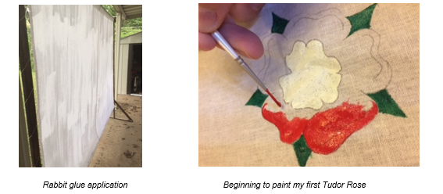

Boiling the rabbit glue for about 5 minutes, I applied it immediately to the linen, ensuring even application. Before the glue dried too much, I had to remove the twine, pins, and rails, or they would have been stuck there permanently: especially the lower rail, as all the glue tends to drip to the bottom.

The next step was to pencil the design on. Historically, there were two design themes: repeating designs, such as Melissa White used above, and descriptions of important events, as used in the Owlpen Manor Estate (mainly illustrating the Biblical story of the life of Joseph and his brothers) and the Tudor Merchant’s House (below). The design selected was one I found on The Tudor Group’s website (The Tudor Group UK), described as a painted linen wall hanging that one of their resident historian/artists, Mark Goodman, had created for display in their museum. I found that the simple Tudor rose design to be very pleasing to the eye and relatively easily duplicated, and as a lot of it would need to be done freehanded, any slight spacing or size misjudgments may be forgiven.

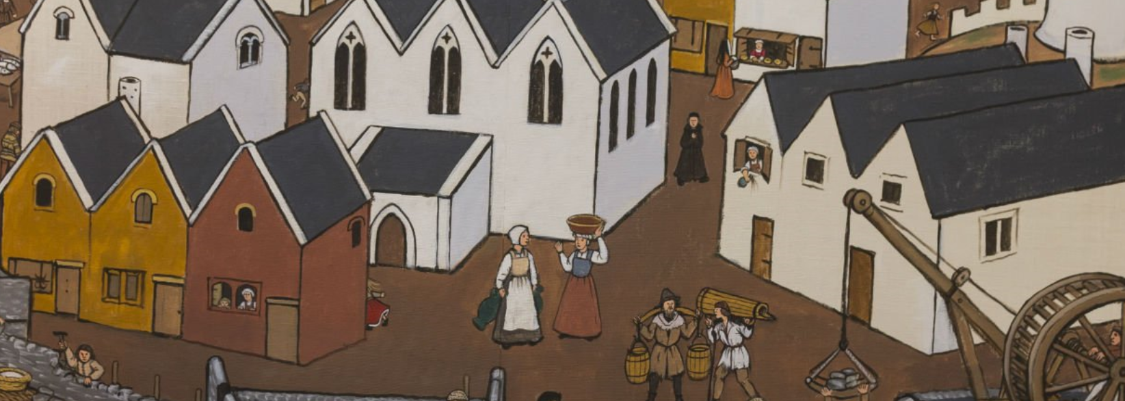
Tenby as it was in 1457 when Jasper Tudor rebuilt the walls.
Devised by Anthony Barton of York and
Dr. Charles Kightly, and painted by Barton in 2012. (Tudor Merchant’s House)

However, I did notice that many of these museum creations did not typically follow strict current day standards of symmetry – a line that seemed it should be drawn using a straight edge would not be, and the painting so large, that it tended to drift off the mark, and was still pleasing to the eye for its inconsistency. This unevenness is evident in Melissa White’s work for the Bayleaf House. I still used a yardstick to measure the center of each rose, and had the outside shape of the rose, and rough outline of the design in between, on a template to use. I did keep in mind that any pencil marks on the linen may show through the paint, and if it were not painted over, they may not fully erase. Most lighter colors of egg tempera would show anything underneath it, which is one reason it is so versatile a medium, although the white is simply white gauche, so it is opaque. Besides using the two templates and a yardstick, the rest of the work is freehanded. Every rose is unique!

The Tudor Rose is the result of Henry Tudor marrying Elizabeth of York – The House of Lancaster’s red rose, and the House of York’s white rose, combined to create a Tudor Rose, both red and white. The Tudor Rose has been used by every British Monarch since Henry VII, as a Royal Badge.

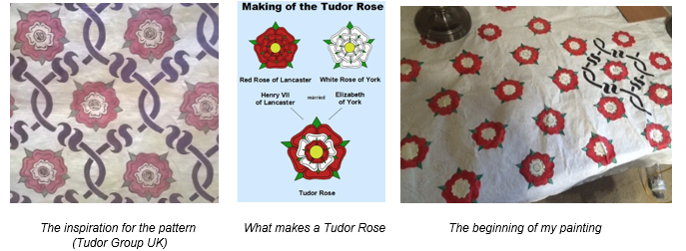

I plan to create several of these painted wall hangings, and bring them to events as the theme suits. They are intended to be used as backdrops for photos, gracefully divide a room, to camouflage mundanities, and, in general, improve the atmosphere of any given event. While they don’t seem to be suited well for camping events (they probably would not handle wet weather or excessive winds), if I ever find myself in the possession of a large enough pavilion to require a dividing wall inside, these would make a very lovely wall.

My very first piece was the Norse themed one that I gifted to Their Majesties, Logan and Ylva, at the Feast of Eagles, one of my local shire’s events, earlier this summer.

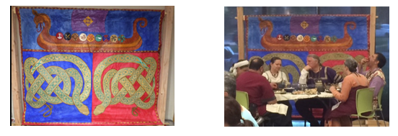
References:

Tudor Merchant’s House - Dr Charles Kightly, an expert in historic interiors, advised to use brightly painted linen cloths to improve the historic atmosphere of the Tudor Merchant’s House in England. https://www.nationaltrust.org.uk/tudor-merchants-house/features/the-painted-cloths-at-tudor-merchants-house

The Tudor Group: A modern reproduction of a Tudor painted cloth. Painted on linen canvas using pigments that were known and used in the period. Such painted cloths were fairly common items displayed in people’s homes in the sixteenth century. https://www.facebook.com/TudorGroupUK/photos/a.262393380474441.59881.262392557141190/1083601658353605/?type=1&theater

Melissa White, artist and historian at the Bayleaf Manor, UK, discusses the recreation of historic painted linen wall hangings. http://www.ft.com/cms/s/0/8e55f480-e61a-11e5-a09b-1f8b0d268c39.html

Owlpen Manor Estate, an excellent resource for images and references to Shakespeare quotes, and also lists surviving pieces of Tudor linen wall hangings. http://www.owlpen.com/manor/painted-cloths

New Techniques in Egg Tempera, by Robert Vickery (1989). A famous contemporary artist shows his revolutionary new techniques for painting in a centuries-old medium, egg tempera. (Book on display table)

------
Copyright 2017 by Lee Waldack. <Lee.waldack at gmail.com>. Permission is granted for republication in SCA-related publications, provided the author is credited. Addresses change, but a reasonable attempt should be made to ensure that the author is notified of the publication and if possible receives a copy.

If this article is reprinted in a publication, please place a notice in the publication that you found this article in the Florilegium. I would also appreciate an email to myself, so that I can track which articles are being reprinted. Thanks. -Stefan.

<the end>

