Aerial-Screw-art - 12/16/10

"Proving Leonardo's Aerial Screw - A Model of Flight" by HL Hucbald ap Urp, JdL.

NOTE: See also the files: med-machinry-lnks, medieval-tech-msg, timeline-art, Arch-Chem-Nms-art, p-asbestos-msg, p-petroleum-msg, Tool-Making-art.

************************************************************************
NOTICE -

This article was submitted to me by the author for inclusion in this set of files, called Stefan's Florilegium.

These files are available on the Internet at: http://www.florilegium.org

Copyright to the contents of this file remains with the author or translator.

While the author will likely give permission for this work to be reprinted in SCA type publications, please check with the author first or check for any permissions granted at the end of this file.

Thank you,
Mark S. Harris...AKA:..Stefan li Rous
stefan at florilegium.org
************************************************************************

You can find more articles by this author on his website at: http://www.hucbald.ramst

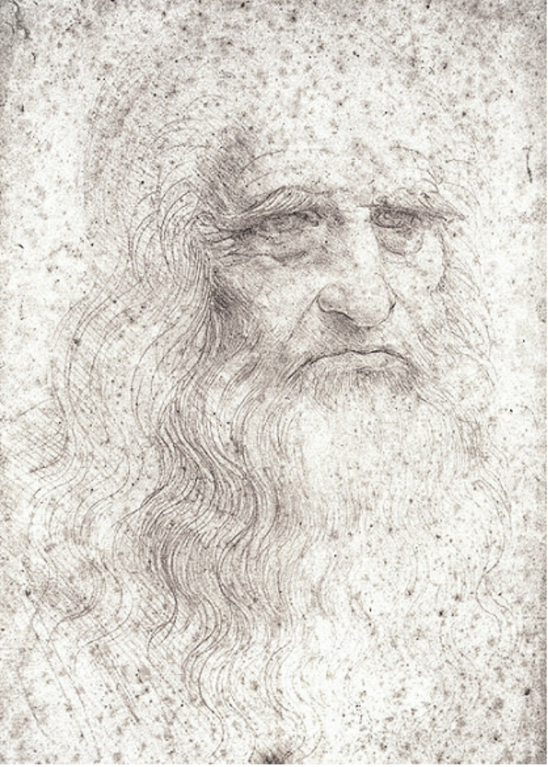

Proving
Leonardo's Aerial Screw

A Model of Flight



By H.L. Hucbald ap Urp
August 30, 2006 (A.S. 41)

Introduction

When I first started this experiment my intention was to see if there was any possibility that one of Leonardo da Vinci's most well known inventions was actually an attempt to improve an existing item. Leonardo did make improvements to many items that were known to him but certainly did some scientific research such as his research into the flight structure of bird wings.

As an example of Leonardo making improvements to items it can be clearly identified by the Gutenberg press. Gutenberg made his first publication from his press in the year 1452, the same year that Leonardo was born. Later, Leonardo would make his own printing press that was an improvement by allowing multiple movements to be carried out by a single person.

What was discovered by this experiment was interesting to say the least. The findings of this experiment show that Leonardo may have not pursued the aerial screw if he had actually done the same experiment. However, it is also quite possible that this little experiment, if carried out, could have lead to understanding of the potential of the aerial screw and other devices.

At this time I ask the reader to consider if the aerial screw will fly or not and to consider reasons to back up their choice. This will serve to heighten the sense of scientific discovery as the reader continues through this document.

Statement of Theory

Although Leonardo invented the aerial screw it may be possible that he was only trying to improve upon an existing device. While it is well known that Leonardo had made many studies into flight one of the most interesting sketches attributed to Leonardo is the aerial screw.

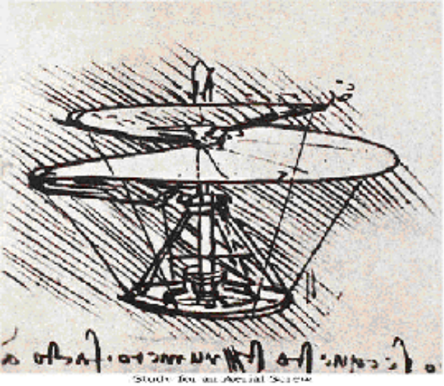
At the time that the drawing of the aerial screw was made there was available a child's flying toy. This toy had migrated from China and is still called a Chinese Flying Top. It consisted of feathers attached to a stick that when the stick was spun between ones hands would fly into the air. The modern equivalent to this hasn't changed much but replaces the feathers with a modern propeller.

If Leonardo had thought to test his theory of the aerial screw it is unknown but certainly he knew of this child's toy and could have made a similar model using an aerial screw. It is my belief that Leonardo may have tried this and discovered much about his aerial screw idea.

This may explain why the drawing is unique in his sketches and no model or larger device was built as far as we know. Most certainly if the full size device had been built there would have been a record of it somewhere.

The building of a model based on the existing Chinese flying top may have caused Leonardo to abandon the aerial screw as a method of flight.

The Experiment

By building a Chinese flying top that uses an aerial screw I hope to reveal what Leonardo discovered. This will be built based on the drawing in his notes.

The model will have two complete revolutions to the aerial screw and be made rigid through the use of a wire that follows the perimeter of the fabric. The fabric that I will use will be a canvas of modern origin that should be fairly close to what is suggested in his notes.

"I find that if this instrument made with a screw be well made – that is to say, made of linen of which the pores are stopped up with starch – and be turned swiftly, the said screw will make its spiral in the air and it will rise high. Take the example of a wide and thin ruler whirled very rapidly in the air, and you will see that your arm will be guided by the line of the edge of the said flat surface… You can make a small model of pasteboard, of which the axis is formed of fine steel wire, bent by force, and as it is released it will turn the screw."
Leonardo da Vinci – comment with sketch of aerial screw.

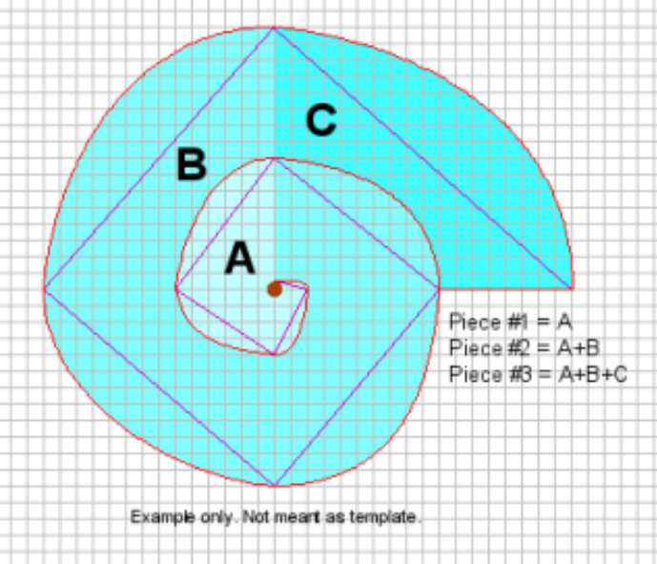

A simple dowel will be used for the shaft. To affix the aerial screw to the shaft two small holes will be drilled in the shaft to insert the wire. The wire will be closely wrapped around the shaft for a few turns and snipped close to the shaft. The wire should be sufficient to hold the aerial screw to the shaft.

To create the pattern for the fabric the basic pattern will be laid out on graph paper increasing in distance from the center by ½ inches each quarter turn. Once two complete revolutions are drawn a cut line will be drawn from the inner most point to the outside.

When using the pattern on the graph paper it will be necessary to reuse the middle pieces when outer pieces are used. The first revolution will be cut out and then drawn onto the fabric. The pattern piece will then be taped back into position and the next revolution will be cut free of the pattern, including the initial piece. This will then be cut out of the fabric and the process repeated until the pattern has been replicated from the fabric.

Once all the fabric pieces have been cut out they can then be stitched together to form the screw pattern out of the fabric.

Next the wire will be stitched to the fabric screw making sure to leave a length at each end so that the excess wire can be neatly tucked into the small holes in the shaft. Then the wire can be wound tightly around the shaft.

Test Flight

Leonardo stated that the aerial screw would need to turn very quickly to take flight. I took the aerial screw that I had built between my hands then spun quickly and let go.

The result was a very unstable rotation that quickly dropped to the floor.
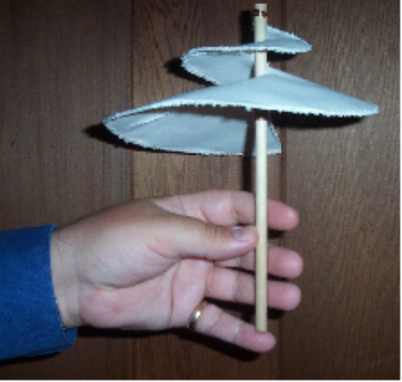
The first thing that I noticed was that by its nature, the helical screw has a heavy side to it. It will always be unbalanced unless its shape is changed. If this device had taken flight the wobble would have made it impossible to control. It certainly would have crashed quickly.

The second thing that I noticed about this was that the aerial screw had generated a breeze but not as downward thrust. The breeze was felt on my arms as a crosswise breeze from the aerial screw.

This was an 'eureka' moment that required some thought.

Quickly I tried the spin again with the same results but further understanding. The aerial screw will never fly.

Explanation of Results

Two major factors are at play with the aerial screw. The first is the unstable rotation. The pattern of the helical screw is weighted to one side. The side that has the furthest out point will always be the heaviest and therefore will cause a spin to wobble.

The wobble could be overcome using weights and even altering the spiral to spin back in on itself to counter balance the weight. This could be overcome but in itself would not be sufficient for flight.

The second major factor comes from the pattern of the aerial screw also. This pattern is a form of Archimedes screw that is available from Antiquity. But one thing is missing from the aerial screw that the Archimedes screw had and that was containment.

The same pattern can be found in a modern drill bit which incidentally actually does work like an Archimedes screw although it looks similar to the aerial screw. A drill bit has two machines that it is made from, a cutting edge and the screw. The cutting edge trims small bits of the material being drilled and the screw allows the shavings to travel upward till they reach the surface. Upon reaching the surface the shavings immediately spread out because they are no longer contained.

With the aerial screw the expectation is that the air will be forced to travel the revolutions and come out the bottom as a form of thrust. However, as I mentioned above there is a sideways breeze. I'll call this spillage.

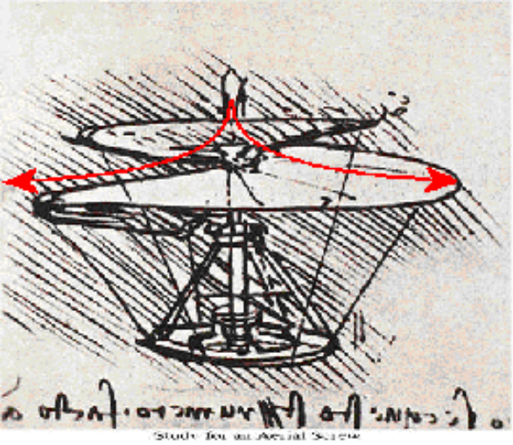
The spillage is simply because the screw is not contained. With the drill bit example the first machine, the cutting edge, creates yet another machine. The third machine is containment that makes it possible for the second machine, the screw, to do its job. As the shavings are cut away they want to travel outward but can't so they travel upward until free and form a pool at the top. The same is true for the air traveling through the aerial screw. If not contained, the air will spill to the sides. No downward thrust is possible.

Leonardo missed that for an Archimedes screw to operate properly it must be contained. In missing this he also did not fully appreciate what he needed to accomplish which was thrust. Thrust is a necessary element for powered flight.

Impact of This Experiment

When I set out on this experiment, I tried to keep an open mind and not think of whether it would work or not. All that I had wanted to show is that it might have been possible that Leonardo had created a model version of his famous aerial screw to help validate his theory that an aerial screw could take flight and that by creating the model the idea was 'borrowed' from a child's toy available at the time.

From this experiment I'm sure that if Leonardo had tried to build a model version he would have quickly realized that it would not work and was certainly no improvement on a Chinese flying top. This might be why the aerial screw is not pursued with further drawings and notes. As with so much of historical studies, we will never truly know.

This experiment did offer insight into other machines available in Leonardo's time such as the containment for the Archimedes screw and the balanced rotation of the flywheel. Regardless, Leonardo is attributed to being the inspiration of Igor Sikorsky's invention of the helicopter.

Conclusion

Leonardo probably did build a model to test his theory of aerial screw flight but quickly realized that this would not work. If he had realized that the screw needed to be encased he also would have realized the need for even faster spinning to overcome the extra weight.

The testing of a model would show the aerial screw to be a non-effective method of powered flight. I am fairly certain that Leonardo 'borrowed' the idea from the Chinese flying top which was most likely taken from seeds fluttering from heights in nature. Leonardo probably tested his model and abandoned the concept.

Interestingly enough, Leonardo doesn't seem to have realized how close he was to discovering one of the principals of powered flight; the principle of thrust.

Bibliography

C.H. Gibbs-Smith Leonardo da Vinci's Aeronautics, "A Science Museum Booklet" 1967

"Johannes Gutenberg and the Printing Press", About.com
Aug 3, 2006 < http://inventors.about.com/library/inventors/blJohannesGutenberg.htm >

"The Inventions of Leonardo da Vinci – Traveling Exhibition Information Packet", The Exhibition Aliance
Aug 5, 2006 < http://progress.acctek.com/ea/documents/37.pdf >

"CONTENTdm Collection", Brigham Young University – Harold B. Lee Library
Aug 8, 2006
<http://contentdm.byu.edu/cdm4/item_viewer.php?CISOROOT=/Civilization&CISOPTR=354&REC=13 >

"Principles of Helicopter Aerodynamics", J. Gorgon Leishman – University of Maryland
Aug 10, 2006 <http://assets.cambridge.org/052166/0602/sample/0521660602wsn01.pdf>

"Leonardo Da Vinci and codes", About Facts Net
August 30, 2006< http://aboutfacts.net/People38.htm >
------
Copyright 2006 by Ron Sharcott, 1879 Kings Road, Victoria BC, Canada V8R 2P2. <hucbald at ramst.ca>. Permission is granted for republication in SCA-related publications, provided the author is credited. Addresses change, but a reasonable attempt should be made to ensure that the author is notified of the publication and if possible receives a copy.

If this article is reprinted in a publication, I would appreciate a notice in the publication that you found this article in the Florilegium. I would also appreciate an email to myself, so that I can track which articles are being reprinted. Thanks. -Stefan.

<the end>

