An-Arab-Jelly-art - 2/25/20

"Not an Arab Mead" by Baron Caleb Reynolds. An Arab medicinal jelly for coughs and sore throats.

NOTE: See also the files: honey-msg, jellied-milk-msg, Wine-Jellies-art, wine-jelly-msg, cough-powder-art, p-medicine-msg, grapes-msg.

************************************************************************
NOTICE -

This article was added to this set of files, called Stefan's Florilegium, with the permission of the author.

These files are available on the Internet at: http://www.florilegium.org

Copyright to the contents of this file remains with the author or translator.

While the author will likely give permission for this work to be reprinted in SCA type publications, please check with the author first or check for any permissions granted at the end of this file.

Thank you,
Mark S. Harris...AKA:..Stefan li Rous
stefan at florilegium.org
************************************************************************

You can find more work by this author in his blog at:
https://calebreynolds.blogspot.com/

Not an Arab Mead
by Baron Caleb Reynolds

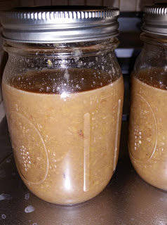

In the Fall 2001 edition, Tournaments Illuminated published an article by Forester Nigel FitzMaurice entitled "An Arab Mead." The article was popular as brewers, in the SCA, site it constantly. At the 2019 AEthelmearc War Practice I encountered yet another person who made the mead described by Forester. His source material was "Aqrabadhin of Al-kindi", or more accurately, Martin Levey's translation: a scholarly text that had a very limited publication. [1]

His article always seamed odd, to me. The lack of the source material and the supposition that the Muslim ban on alcohol was a matter of "hair-splitting" rather than one of faith. Another year passes and another person offers a bottle of "Arab Mead" along with some kind of comment along the lines of Muslims can drink mead because it's made with honey. Or, a comment disparaging Muslims at some level of offensiveness.

Here is Forester's text from the TI:

==========

The Muslim attitude toward alcoholic spirits is well known, and of old date. Proscriptions in the Qur'an against the imbibing of wine occur several times in very specific and uncompromising terms. Therefore, I was greatly surprised and interested to unearth in the course of research into early cordials a Muslim recipe for what is clearly a variety of mead (or, more properly, a sort of sack pyment).

{removed a paragraph describing the Aqrabadhin of al-Kindi by Abu Yusuf Ya'qub ibn Ishaq al-Kindi}

What follows is a redaction of the recipe. What have been modified are the measurements, which have been recast into modern equivalents. Additionally, some of the ingredients have been simplified (e.g., the original recipe calls for .11 oz. of cardamom and .11 oz. of lesser cardamom, and specifies Ceylonese as the variety of cinnamon referenced).

Five gallons of the best juice from pulp of the grape is taken. It is cooked over a low fire until its foam disappears. Then eight pounds of the best genuine honey is put in. It is boiled over a low fire until its foam also disappears. One half of it evaporates. Then .22 ounce is taken of...
Cardamom (Elettaria cardamomunq)

and .10 ounce each of...
Cinnamon (Cinnamomum zeylanicumi
Clove (Caryophyllus aromaticusy
Long pepper (Piper retrofractum)

(They are) well pulverized and put into a fine linen cloth. Then it is thrown into the decoction after the froth has been removed. When the cooking is over, it is possible to introduce the hand into it. The powder is macerated into it strongly. It is taken out and .33 ounce of Saffron put into (the liquid). It is put into flasks and the tops are stoppered. After a little sun is allowed on it, one may use it. The older it gets, the better, Allah willing.

I'm not surprised that "the older it gets, the better"; the real question in my mind is why the writer doesn't warn that the flasks would likely explode after a few days. Perhaps if one did not tightly seal the stoppers, fermentation gasses could escape without violence. Grape pulp is an excellent source of natural yeast and, under the conditions as described in the recipe, fermentation of the honey would be a likely, though not absolutely certain, result. The only thing that would prevent it, in fact, would be the boiling process. But this recipe specifies a "low fire", and it is not unreasonable that enough yeast would survive to take advantage of conditions afterward.

What this describes, therefore, is a type of mead that technically would be a sack pyment. Pyments are meads utilizing grape juice as a base. (Other varieties are Braggot, a combination of a grain base such as ale with honey; Cyser, a blend of apple and honey; Melomel, a blend of fruit juices other than apple, grape, or mulberry with honey; Metheglin, an herbal mead; and Morat, a mulberry honey mix). A variety is called a "Sack" if it contains an extra amount of honey or other sweetener; eight pounds of honey to five gallons of grape juice certainly qualifies this as a sack.

The significance in all this, aside from the value and interest in the recipe itself, is the light it sheds on the Muslim attitude toward intoxicants. It generally assumed that because of the Qur'an's strongly negative stance, intoxicants of all sorts banned, or at minimum heavily restricted. To large extent this is accurate. Yet, the above recipe shows that the situation is considerably more ambiguous than what is seen at first glance. Within the sphere of medicine, a great deal more leeway can be drawn on than permitted in general society.

Further evidence of this can be seen in other Muslim medicinal formularies which comment on sakanjubin (known in the West as oxymel), a compound of vinegar, honey, and any of a variety of herbs, spices, or other flavoring agents. Sakanjubins have been used for a very long time in the Near East as tonics, restoratives, and elements in more complex medicines. I assumed when I first approached the subject that the vinegars prescribed would be non-alcoholic in source, but that turned out not to be the case. Almost invariably, vinegar used for manufacturing sakanjubin is described as "wine vinegar".

=====================

The remainder of the article (two paragraphs) is about how the Qur'an only bans "khamt", or wine from grapes. As I have stated, this article seem odd to me and has been stuck in my brain for the last 18 years. [2] Several things stick out:

1) Forester's opinion about the Muslim attitude towards alcoholic beverages are in stark contrast with what I know about the Islamic faith and with the attitudes of Muslims whom I have met, over the years.

2) His redaction does not mention fermentation. At all. While the Qur'an does allow the consumption of alcohol as medicine (the Aqrabadhin of Al-kindi does have a recipe that calls for the oil of mustard and sesame seeds to be mixed with wine), [3] an Arabic medical text would most likely not contain recipes for alcoholic, social beverages. Many other people take the view that this article is "proof" of Middle-Eastern booze.

"This recipe could go either way, it might make a delicious non-alcoholic syrup, or a delicious alcoholic mead. What tips me off for fermentation is to place it in the sun for a little while: covered, the heat would help fermentation, and uncovered would give the opportunity for catching wild yeast for a wild ferment. The fact that it is cooked does not necessarily mean it is boiled, several medieval English recipes use the words boiling and simmering while from context it is clear the must never got hot enough to melt wax. As yeast can survive temperatures slightly higher than the melting point of wax, it is feasible, as the must is heated over a slow fire, that ambient honey yeast survived to kickstart fermentation without the need for a wild-ferment. Of course the biggest clue is that the older it gets, the better it becomes, God willing, which would not be the case with sterile fruit syrup (think of store bought pasteurized apple cider which goes bad, as compared to farm bought fresh apple cider, which goes fizzy!)." [4]

3) Forester equating sakanjubin, a non-alcoholic syrup made of equal parts vinegar and either sugar or honey, and oxymel, a fermented honey beverage flavored with vinegar. They are not the same thing.

4) He calls his redaction a mead, when clearly it is a spiced wine: a hippocras. There is five time the amount of grape juice than honey: it is a wine, not a mead.

5) The lack of the original source recipe; or even what page on which it may be found. Add to that, his missing work on how he figured out what amounts to use makes it difficult to see if he was correct in his assumptions. Furthermore, since he was using a limited print, academic text, it was almost impossible to do any additional research on this recipe: his redaction appears to be the only English translation available on the Internet.

Almost impossible, to do additional research.

Point of fact: the Health Sciences Library of the University of Buffalo owns a copy of Martin Levey's book, the same one that Forester used. Another point of fact: faculty of UB can check out library books at will. Third point of fact: my friend, Doctor Cathy, (THL Beatrice de Winter), requested UB's copy for me to work with. The book has the English translation on the left hand page and an image of the Arabic text on the right hand page. Martin Levey's translation is as follows:

===============

108. Syrups, electuaries, and others. The best resat jellies are taken in the winter for a stiff neck. It is useful, with God's help. Ten dawarig of the best juice and pulp of the grape is taken. A dawarig is four and a half ratls. It is cooked over a low fire until its foam disappears. The the {sic} best genuine honey is put in. The proportion is one ratl of honey for every five ratls {of grape juice}. It is boiled over a low fire until its foam also disappears. One half of it evaporates. Then one dirham each is taken of lesser cardamom, cardamom. Ceylonese cinnamon, clove, and long pepper. It is well pulverized and put into a fine linen cloth. Then it is thrown into the decoction after the froth has been removed. When the cooking is over, it is possible to introduce the hand into it. The powder is macerated into it strongly. It is taken out and three dirhams of saffron put into [the liquid]. It is put into flasks and the tops are stoppered. After a little sun is allowed on it, one may use it. The older it gets, the better, God willing. [5]

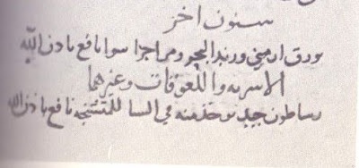

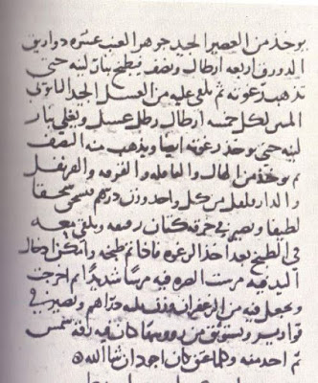

===================

Let us take a closer look at the second sentence of this recipe, "The best resat jellies are taken in the winter for a stiff neck." Resat jelly? That doesn't sound like a mead. Page 271 defines resat jellies as, "In the East, resat is called faludhaj, and in the Maghrib sabuniyah (Dozy, I:525)." The Internet has recipes for modern resats, faludhaj, and sabuniyah, that are deserts. More like Chuckles(tm) candy or Turkish Delight. "Thicker puddings like khabis and faludhaj were made with wheat starch, rice flour, or crushed almonds, and sometimes with pureed carrots, melon, apples, or quince. Sweetened with honey, they were spread on flat platters and copiously sprinkled with powdered sugar." [6]

Does not sound like a beverage, at all. It doesn't give any dose size, or instructions on how to take. "...taken in the winter for a stiff neck", suggests that it is rubbed on a stiff neck. This doesn't sound correct: the end result sounds sticky and if this were a poultice, shouldn't it at least recommend how often to change it? Other recipes, in the text, that call for poultices recommend how often to change them. My opinion was that "stiff neck" was a mistranslation and that it should be "sore throat". That would make more sense within the context of the recipe. Although, if the text had said, "take one spoonful as needed," it would make our job easier.

I had a conversation, about this recipe, with Baroness Sadira Bint Wassouf and she let me know that she had a few Arabic speaking students in her English as a Second Language class, and would be happy to ask one of them to take a look at the original text. I had sent her a scan of the last paragraph of the original text (the first three lines of the English text). I did not send the entire Arabic text as I did not want to take advantage of my unknown translator. The E-mail that I received back was as follows:

Dear Baron Caleb,

SO {sic} exciting to be a part of this because the translator was fascinated about how Arabic has changed. She checked and checked her translations. You were right!

Look at the three longer lines of text: the phrase at the far left of the first and third line are the same. They mean "If God wills" It is not the usual phrase "Inshallah" but one that has a similar meaning there is one very long word to the right of the first line that indicates the country of origin that was unfamiliar to the translator (names and borders of countries have changed). In the middle of the shorter (second line) is a shorter word that means "cough" or "sore throat" The whole thing basically says to take the medication for a cough or sore throat but that it is also good for other things such as "jerking" - maybe trembling, seizures, or palsy - and that if God wills, it will work. While it mentions curing "other things" it only gives the two examples.

Your translator is Fonoun Muthana, a brilliant young woman from Yemen who is a scholar in any language. She is an amazing person with deep curiosity about any new topic.

My own observation is that a term meaning "if God wills" is used in many food recipes as well. Everything in life is Inshallah. Although I cannot speak or read my own cultural language (Arabic), that concept is part of my very being. So Inshallah enjoy the result!

Such fun!
Sadira

Lady Fonoun Muthana has by deepest respect and thanks for helping. Within the context of the recipe, we can safely conclude that this recipe is not a social beverage, it is a medicinal jelly. Let us dissect the recipe, line by line, and see if we can make some sense of it.

"Ten dawarig of the best juice and pulp of the grape is taken. A dawarig is four and a half ratls."

On page 25, Martin Levey tells us that one ratl is equivalent to 406.25g, with the following caveat from the author: "The weights mentioned in the text are those of ninth-century Baghdad....Very little is known of the exact weights of the units in most periods and most areas of the medieval Islamic world. The above values must, therefore, be considered uncertain subject to further research."

1 ratl = 406.25g
45 ratls = 18281.25g
18281.25g = 40.3lbs

So, 45 ratls of grapes is about 40 pounds. Forester equates this with 5 gallons of grape juice, [7] but the recipe calls for 40 pounds of juice and pulp, not just grape juice.

"It is cooked over a low fire until its foam disappears."

This is somewhat, self explanatory. Cooking grape pulp does produce a lot of foam. Just put your pot off-set on your burner and the foam will move to one side of the pot, making it easier to skim off.

"The the {sic} best genuine honey is put in. The porportion is one ratl of honey for every five ratls {of grape juice}. It is boiled over a low fire until its foam also disappears. "

I do not know what is meant by "genuine" honey. Surely they didn't have HFC/honey blends. Perhaps this could mean the best honey off of the comb. Or honey that hasn't been watered down.

1 ratl fo honey for each 5 of grapes.
45 / 5 = 9 ratls of honey
9 ratls = 3656.25g
3656.25g = 8.1lbs

"One half of it evaporates."

The recipe calls for cooking the "must" until it stops foaming up and until it is reduced by half. Reducing 48 pounds of juice, pulp, and honey by half would take a long time. Long enough to kill off any yeast that might be on the grapes or in the honey. And, reducing 5 gallons of grape juice by half doesn't sound like making wine. But, we have already discovered that this recipe isn't for a beverage, it is for a jelly. The low heat would let the mixture cook down without destroying the natural pectin found in grapes. Pectin is the fruit equivalent of gluten, and allows jellies to form and hold their shape and consistency.

"Then one dirham each is taken of lesser cardamom, cardamom. Ceylonese cinnamon, clove, and long pepper. It is well pulverized and put into a fine linen cloth. Then it is thrown into the decoction after the froth has been removed."

1 dirham is 3.125g or 0.11 ounces. [8]

Take 0.11 ounces of the following:
Lesser, or green, cardamom,
Greater, or black, cardamom,
Clove,
Cinnamon,
Long pepper.
Smash or coarsely grind them and put them in a cloth tea bag, or infuser ball, and drop into the liquid.

Forester lumps both varieties of cardamom together. The original text calls for two separate varieties. Cardamom and lesser cardamom. There are three varieties of cardamom: lesser, greater, and white. White cardamom, comes from China and my sources state that it lacks the sharp flavor of the other two varieties but it adds aroma. I was unable to find any reference to white cardamom in medieval Middle Eastern recipe books, so I will assume that the second cardamom required must be greater cardamom.

"When the cooking is over, it is possible to introduce the hand into it. The powder is macerated into it strongly. It is taken out and three dirhams of saffron put into [the liquid]."

I think that this was translated out of sequence. It doesn't flow correctly. Are we to reduce the "must" by half, remove it from the heat, and then add in the spices just long enough for the "must" to cool down enough so that you wouldn't burn your hand? To my mind, we are told to let it cool to bath temperature before adding the saffron. 0.33 ounces of saffron threads, not powder, please. But I think that the spices, in the bag, would be more effective if it was included throughout the cooking.

"It is put into flasks and the tops are stoppered. After a little sun is allowed on it, one may use it."

I read this as after the "must" cools completely, move it to containers that can be sealed. The word flask implies a narrow-necked container designed for liquids. But that would not be useful for a jelly. Any wide-necked container would work. Seal the container to keep bugs, yeast, or microbes out of it, and let it sit in the sun until the jelly firms up.

"The older it gets, the better, God willing."

This is not a reference to fermentation. People who make and preserve their own jams and jellies will tell you that jars that have been "put up" for a few months, taste better than freshly made jams and jellies.

My redaction:

Take 40 pounds of fresh squeezed grape juice and pulp and place it into a non-reactive pot over low heat. Take 8.1 pounds of honey, wildflower is fine, and add it to the grape pulp. Bring up to a low boil and skim any foam from the surface. Cook until it no longer foams up. Place the pot off center on the burner so that the foam collects to one side of the pot. Cook until it reduces by half, stirring regularly so that the sugars do not burn. While the liquid is reducing, put 0.11 ounces of the following into a spice bag or a tea ball: green cardamom seeds; black cardamom seeds, cinnamom, cloves, and long pepper: all coarsely ground or crushed. Add the spice bag into the liquid. Once the liquid has reduced by half, remove from the heat and allow to cool enough so that you can put your hand into it without burning yourself. Remove the spice bag and add in 0.33 ounces of saffron threads, the good stuff. No need for a spice bag. Move into a container, or containers, that can be stoppered shut, and place it/them in a warm area. If you have a clean, brewing bucket, that will work. Leave the container(s) for a couple of hours until the jelly firms up and sets. Move into mason jars and either park in the 'fridge or "can" them so that they will not spoil.

48 pounds of jelly is a lot of jelly. Unless you know how to preserve, and have all of the necessary equipment, this might be a bit too much for one person to deal with.

This project:

In order to experiment with this recipe, I decided to reduce the amounts to a more manageable level. We will start out with 1/16th of the amounts mentioned in the recipe.

I used:
2.5 pounds of white, seedless grapes
0.5 pounds of wildflower honey.
1 pod of greater, or black, cardamom,
The equivalent volume of:
Lesser, or green, cardamom,
Clove,
Cinnamon,
Long pepper.
A pinch of Sargol saffron.

I started off trying to figure out what 1/16th of 0.11 ounces would be. [10] I was unsuccessful. So I guessed. My container of greater cardamom was 0.5 ounces. I selected one pod and declared that to be the right amount. I then tried to match up the volume, by eye, of the other spices.

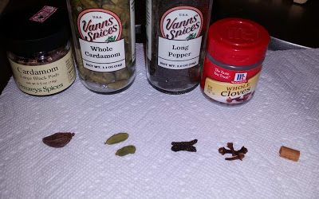

I chose to use Saigon cinnamon because I like the sweet taste of the region and the brand, I that ordered, was USDA certified organic, which not only means that the trees were grown without the use of pesticides or chemicals, but that it is certified to be Cinnamon loureiroi, and not bark from any other tree. Pease use fresh spices, not pre-ground. The cloves I had in the house, nothing special about them. The saffron was a gift from family friends who brought back a lot of it from Kuwait. The cardamons and the long pepper were purchased for this project.

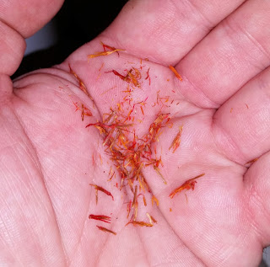

These spices went into a linen spice bag and then hit with a hammer. I used a ball-peen hammer, but you can use any kind of hammer to crush your spices. You do not have to grind them up, since they will be contained in the spice bag, and not integrated into the puree. We just want to make it easier to extract the oils from the spices. I was a little concerned about the amounts required: 0.11 ounces for 48 pounds of grape and honey? Surely that couldn't be enough. But, when I tapped the spice bag, with the hammer, my kitchen was filled the aroma of far away lands.

I was going to use wine grapes, but I wasn't looking forward to peeling the skins off a couple of pounds of them. Then I realized that while wine grapes have thick skins, [9] grapes grown for out-of-hand snacking have thin skins. And no seeds. I saw no reason why I couldn't throw 2.5 pounds of grapes into a pot and pulverize them with a stick blender. I could have used a food processor, but I didn't want to dig it out, clean it, use it, clean it again, and then put it away. Smashing the grapes with the stick blender was very therapeutic. I converted the grapes into a slurry, then added in the honey. The honey was pasteurized and filtered and I saw no reason to add it in only after the grape slurry stopped foaming up.

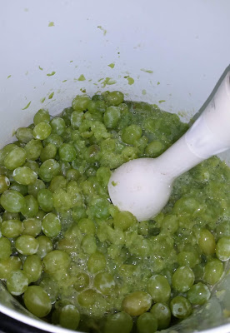

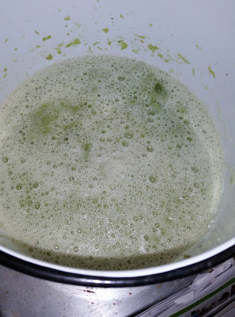

I used wildflower honey because that is what I had in the house. I will not take the time, in this paper, to explain my opinion of honey farming in the middle ages, except to say that the bee industry of today, which can move hives from one field of mono-crops to another, did not exist in the SCA time period: hives were near farm lands and gardens and a variety of crops were grown simultaneously. This means that the bees, which collected nectar from every available source, produced a blend of honey, not a singular variety. Clover or wildflower honey, I feel, is closer to period honey, than buckwheat, rosemary, apple wood, sage, lavender or other specific varieties.

I turned the burner to medium-high and started stirring. My stove is electric and I do not think that, for this dish, there would be a difference between gas, electric, or an open fire. Nor do I think that my ceramic-lined steel pot adds or takes away from any period cooking vessel. After about 15 minutes, I had collected all of the foam and scum from the surface of the liquid. I then added the spice bag. I used a silicone spatula with serrations on one side; I used those serrations to measure the depth of the liquid and to tell me when I hit the half way mark.

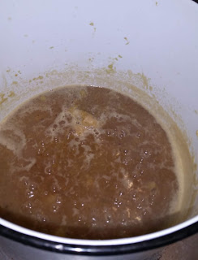

I backed the temperature down to medium, as medium-high was causing the liquid to boil too hard. Even dropping the temperature down, I still managed to caramelize some of the sugar, and the liquid started to darken. It took about 45 minutes to reduce down by half. I turned the heat off and let it sit for 15 minutes. After which I removed the spice bag and added in the saffron. I added in a pinch, because I forgot that the recipe called for three times the amount of the other spices. I had already cleaned up and moved the jelly to mason jars before I had realized my mistake. I let the proto-jelly sit for another 20 minutes before moving to three, clean mason jars. The jars sat on the counter for another hour, and then I moved them into the refrigerator.

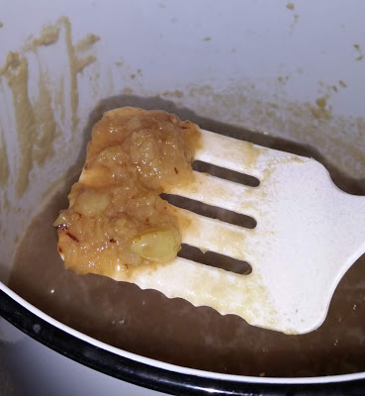

When I put the proto-jelly into the jars, it had the consistency of applesauce. After an hour, it had firmed up into a jelly, but not as firm as a store bought jelly, or a home-made one with added pectin. But, still firm enough to be scooped up with a fork. I suppose that if I had used red grapes, which contain more natural pectin, I would have ended up with a firmer jelly. However, I prefer the flavor of white grapes to red, and I was unable to find any red grapes, locally, that did not taste of Welch's grape jelly.

As to flavor: quite nice. It does have the consistency of chunky applesauce and the cinnamon and cardamom play well together, giving the jelly a sweet, peppery-cinnamony taste. The cloves are all but undetectable and the saffron is lost under the other spices. It is tasty off of a fork as well as spread on toast. Since no dosage is listed, I cannot tell you how much to take for a sore throat. One thing that peeked my curiosity was the size of this recipe. 2.5 pounds of grapes, and etc, filled a little more than two and half 16oz mason jars; say about 40oz of jelly. If I had used the original amounts, I would have filled about 40 mason jars. This is a lot of jelly. Particularly for a cough remedy. Was the sick person expected to eat it 3 meals a day? Or was the expectation that if one person, in the household, got sick, everyone in the household would as well, so make enough for a whole family.

Aside from coughs and sore throats, this jelly is delicious. I found very similar jelly recipes on the Internet, although none with the same mixture of spices. These types of jellies are used as the filling for a number of deserts. I found one called, "Baghdad Lasagna" which calls for a jelly made of apples, quinces, honey, saffron, sumac, and rosewater, layered between filo dough. My cough remedy would work equally well as a desert.

I do not know why Forester Nigel FitzMaurice took the time to present this jelly recipe as if it was an alcoholic beverage. I cannot believe that it was an accident, particularly since he was reading the same textbook that I used. It would be as if I were to give you a redaction of what I call a 12th century German poset [11] calling for barley, currants, cinnamon, nutmeg, ginger, and cream and hid the original recipe called "a dish of sweet frumenty". [12] Just because the ingredients can be used to make more than one thing does not mean that they are interchangeable. Forester could have published his "mead" as an homage: "These spices taste really good, so I used them in my hippocras." There is nothing wrong with creating one's own "period" recipe based on ingredients available at a given time and place. But, there is something under-handed in changing a historical recipe and not documenting what you changed and why you did so.

The SCA is a historical organization, and even though the majority of us are amateur historians, one of our jobs is to research and interpret medieval recipes so that they can be re-created in a modern kitchen [13]. We should do so to the best of our ability, and we should be up front and honest in what we discover and how we use our discoveries in our project. It is disingenuous to provide false information under the guise of being an "expert". Particularly if you are the only one who gets to see the original source.

It took me about 18 years to get my hands on Martin Levey's book so that I could check on this "mead", and it was worth the wait. While I had the book in my possession, I scanned it from cover to cover, so that I would always have access to this rare publication. I will spend the next few years reading through it and trying my hand recreating as many of the medicinal remedies as I can. At least the ones that do not call for poison or parts of endangered species.

Bibliography:

Cooperson, Michael; Perry, Charles; Toorawa, Shawkat M. "Scents and Flavors: a Syrian Cookbook." New York University Press. New York. 2017.

Elska á Fjárfelli. "Medieval Arabic Alcoholic Honey Beverages." A most copious and exact compendium of mediaeval secretes collected by THL Elska á Fjárfelli. Posted, Thursday, January 19, 2017. bookeofsecretes.blogspot.com/2017/01/medieval-arabic-alcoholic-honey.html.

Faith Freedom International. "Mohammed's Tipple"...., forum09.faithfreedom.org/viewtopic.php?f=20&t=14105&start=0.

Goldstein, Darra. "The Oxford Companion to Sugar and Sweets." Oxford University Press, 2015.

Gordon, Bruce R. (Forester Nigel FitzMaurice) "An Arab Mead." Tournaments Illumanted. Issue 140, Fall 2011. p17-8

McGee, Harold. "On Food and Cooking: The Science and Lore of the Kitchen." Simon and Schuster, 2007.

"The Medical Formulary, or Aqrabadhin of Al-kindi." Translated with a study of its materia medica by Martin Levey. University of Wisconsin Press. Madison, WI. 1966.

Meri, Josef W. "Medieval Islamic Civilization: An Encyclopedia, Volume 1" Psychology Press, 2006

Meyer, F. G.; Trueblood, E.E.; Heller ,J. L. , editors. "The Great Herbal of Leonard Fuchs." 1542 edition. Stanford University Press, Palo Alto. CA. 1999.

Sadira Bint Wassouf. (May 25, 2019). Personal interview.

Sadira Bint Wassouf. "Re: Arabic Text." Message to Caleb Reynolds. 7/16/19. E-mail.

Toussaint-Samat, Maguelonne. "History of Food." Translated from the French bu Anthea Bell. Barnes & Noble Books. 1992.

Vaughan, J. G.; Geissler, C. "The New Oxford Book of Food Plants." Oxford University Press, Oxford. 1997.

Weiss Adamson, Melitta. "Food in Medieval Times." Greenwood Publishing Group, 2004.

Zaouali, Lilia. "Medieval Cuisine of the Islamic World: A Concise History with 174 Recipes" Univ of California Press, Sep 14, 2009

Footnotes

[1] 1000 copies according to my research.
[2] As of the writing of this paper.
[3] #145 - Drug for White Leprosy, p158.
[4] Elska
[5] p120-2
[6] Goldstein, p43.
[7] A pint's a pound, the world 'round. Eight pints to the gallon.
[8] p25
[9] You can insult them all day long and all they will do is let out a little wine.
[10] 0.0069 ounces
[11] Ale mixed with milk or cream along with herbs and spices. Was popular, in Europe and America, up until the mid 19th century.
[12] A dish best described as barley risotto. Can be made sweet or savory.
[13] Or in a medieval kitchen, if you happen to have one.
--------
Copyright 2020 by Caleb Ronsen. <jcronsen@verizon.net>. Permission is granted for republication in SCA-related publications, provided the author is credited. Addresses change, but a reasonable attempt should be made to ensure that the author is notified of the publication and if possible receives a copy.

<the end>

