Patrnstrs-101-art - 2/15/18

"Paternosters 101" by Lady Emma de Davyntre.

NOTE: See also the files: rosaries-msg, Psaltrs-Rose-lnks, beads-msg, gem-sources-msg, jewelry-msg, pearls-msg, Semi-Pre-Gems-art, ivory-msg.

************************************************************************
NOTICE -

This article was added to this set of files, called Stefan's Florilegium, with the permission of the author.

These files are available on the Internet at: http://www.florilegium.org

Copyright to the contents of this file remains with the author or translator.

While the author will likely give permission for this work to be reprinted in SCA type publications, please check with the author first or check for any permissions granted at the end of this file.

Thank you,
Mark S. Harris...AKA:..Stefan li Rous
stefan at florilegium.org
************************************************************************

Paternosters 101
by Lady Emma de Davyntre

History

Paternosters were the precursor to the Rosary as we know it in modern times. The chaplets with the drops commonly found in the modern Rosary didn’t start showing up until about the 15th century, however the Paternoster continued to be used into the 16th century, as evidenced by the paintings on the next page. The Paternoster used in the Roman Catholic faith can be traced back as far as the 11th century. It is said that, in her will, the Lady Godiva donated a ‘circlet of gems’ to a monastery in the mid 11th century. Since this was during a time where a majority of the population was illiterate, the Paternoster became a useful tool for everyday people to be able to memorize and recite simpler prayers as opposed to reciting all 150 psalms.

Paternosters were often strung on loops or were created as a straight line to be hung over a belt. These prayer beads were made of various materials like wood, bone, glass, or semi-precious materials like agate, amber, jet, and jasper. Some of the most precious materials used for Paternosters were pearls, coral, rock crystal, and silver or gold gilt. These beads would then be strung on cotton, linen, hemp, or silk cording. In many paintings, there is shown a varying amount of slack in the cord. It is thought that this slack allowed for movement on the string as one counted their prayers (like on an abacus). Depending on the affordability of the user, a Paternoster could not only be a display of piety, but a display of wealth during a time when the Church frowned upon extravagant jewelry.

The word Paternoster refers to the latin phrase meaning Our Father. The Our Father was the main prayer that was recited by the user, represented by beads called gauds (from the latin gaudere - to rejoice) and were often larger and more precious than the others. The second prayer was the Ave Maria, also known as the Hail Mary. Paintings vary on the number of beads used for aves and gauds, but the standard way of stringing them consists of ten aves (decades) and a gaud bead (as seen in the modern Rosary). However, period paintings vary on this number as well. Charms, medallions, and crucifixes were used as decoration. One of the most common, it seems, is that a paternoster ended in a tassel, either on one end of a linear string or on both.

Sources:
Paternoster-row.medievalscotland.org
Paternosterguild.com

Images on Next Page:
Portrait of a Woman in a Leopard Cloak by Jan Cornelis Vermeyen (Dutch, ca. 1500-ca. 1559)
Portrait of Philippe I de Croÿ, 1460, Koninklijk Museum voor Schone Kunsten, Antwerp.
"Meister von Frankfurt" Antwerpen Kreuzigungstriptychon der Frankfurter Patrizierfamilie Humbracht 1504-1508 Frankfurter Städl
Paternostermaker, from the Stadtbibliothek in Nurnberg
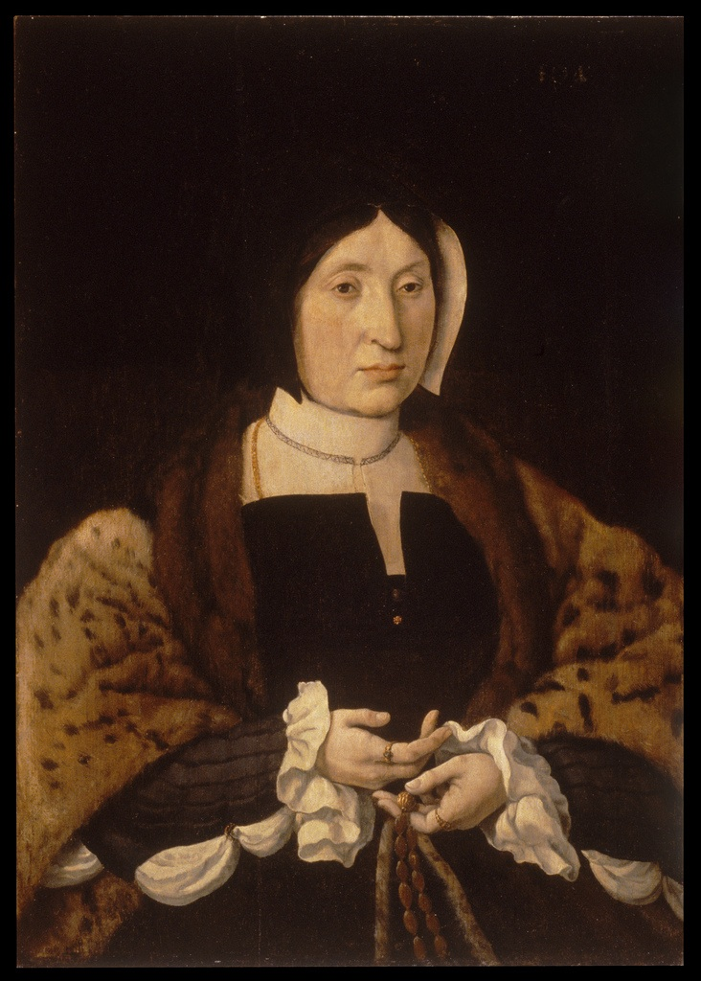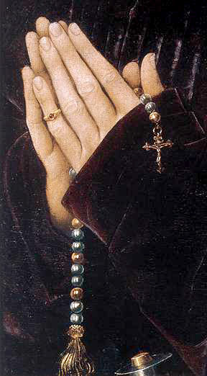
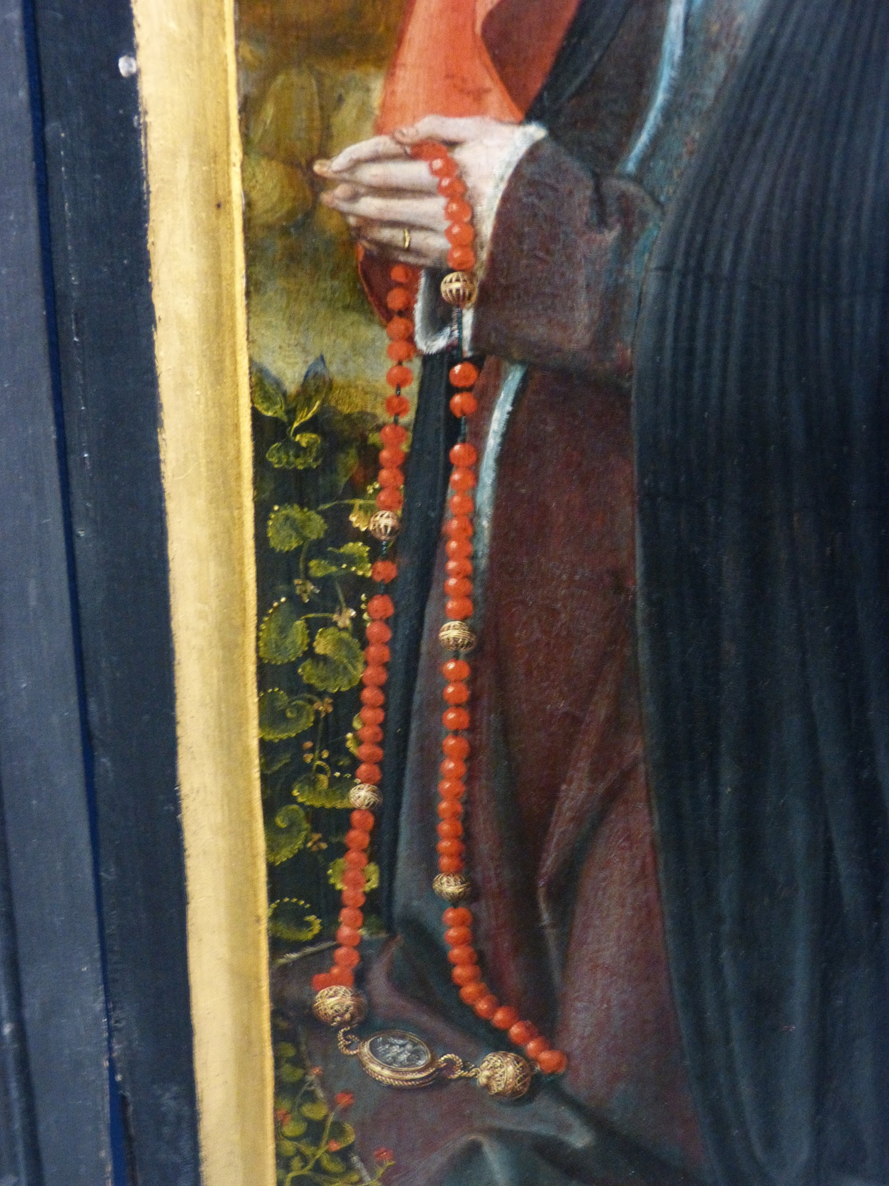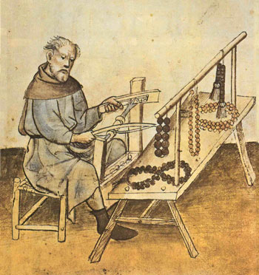
Historical references from various time periods

Creating the Paternoster
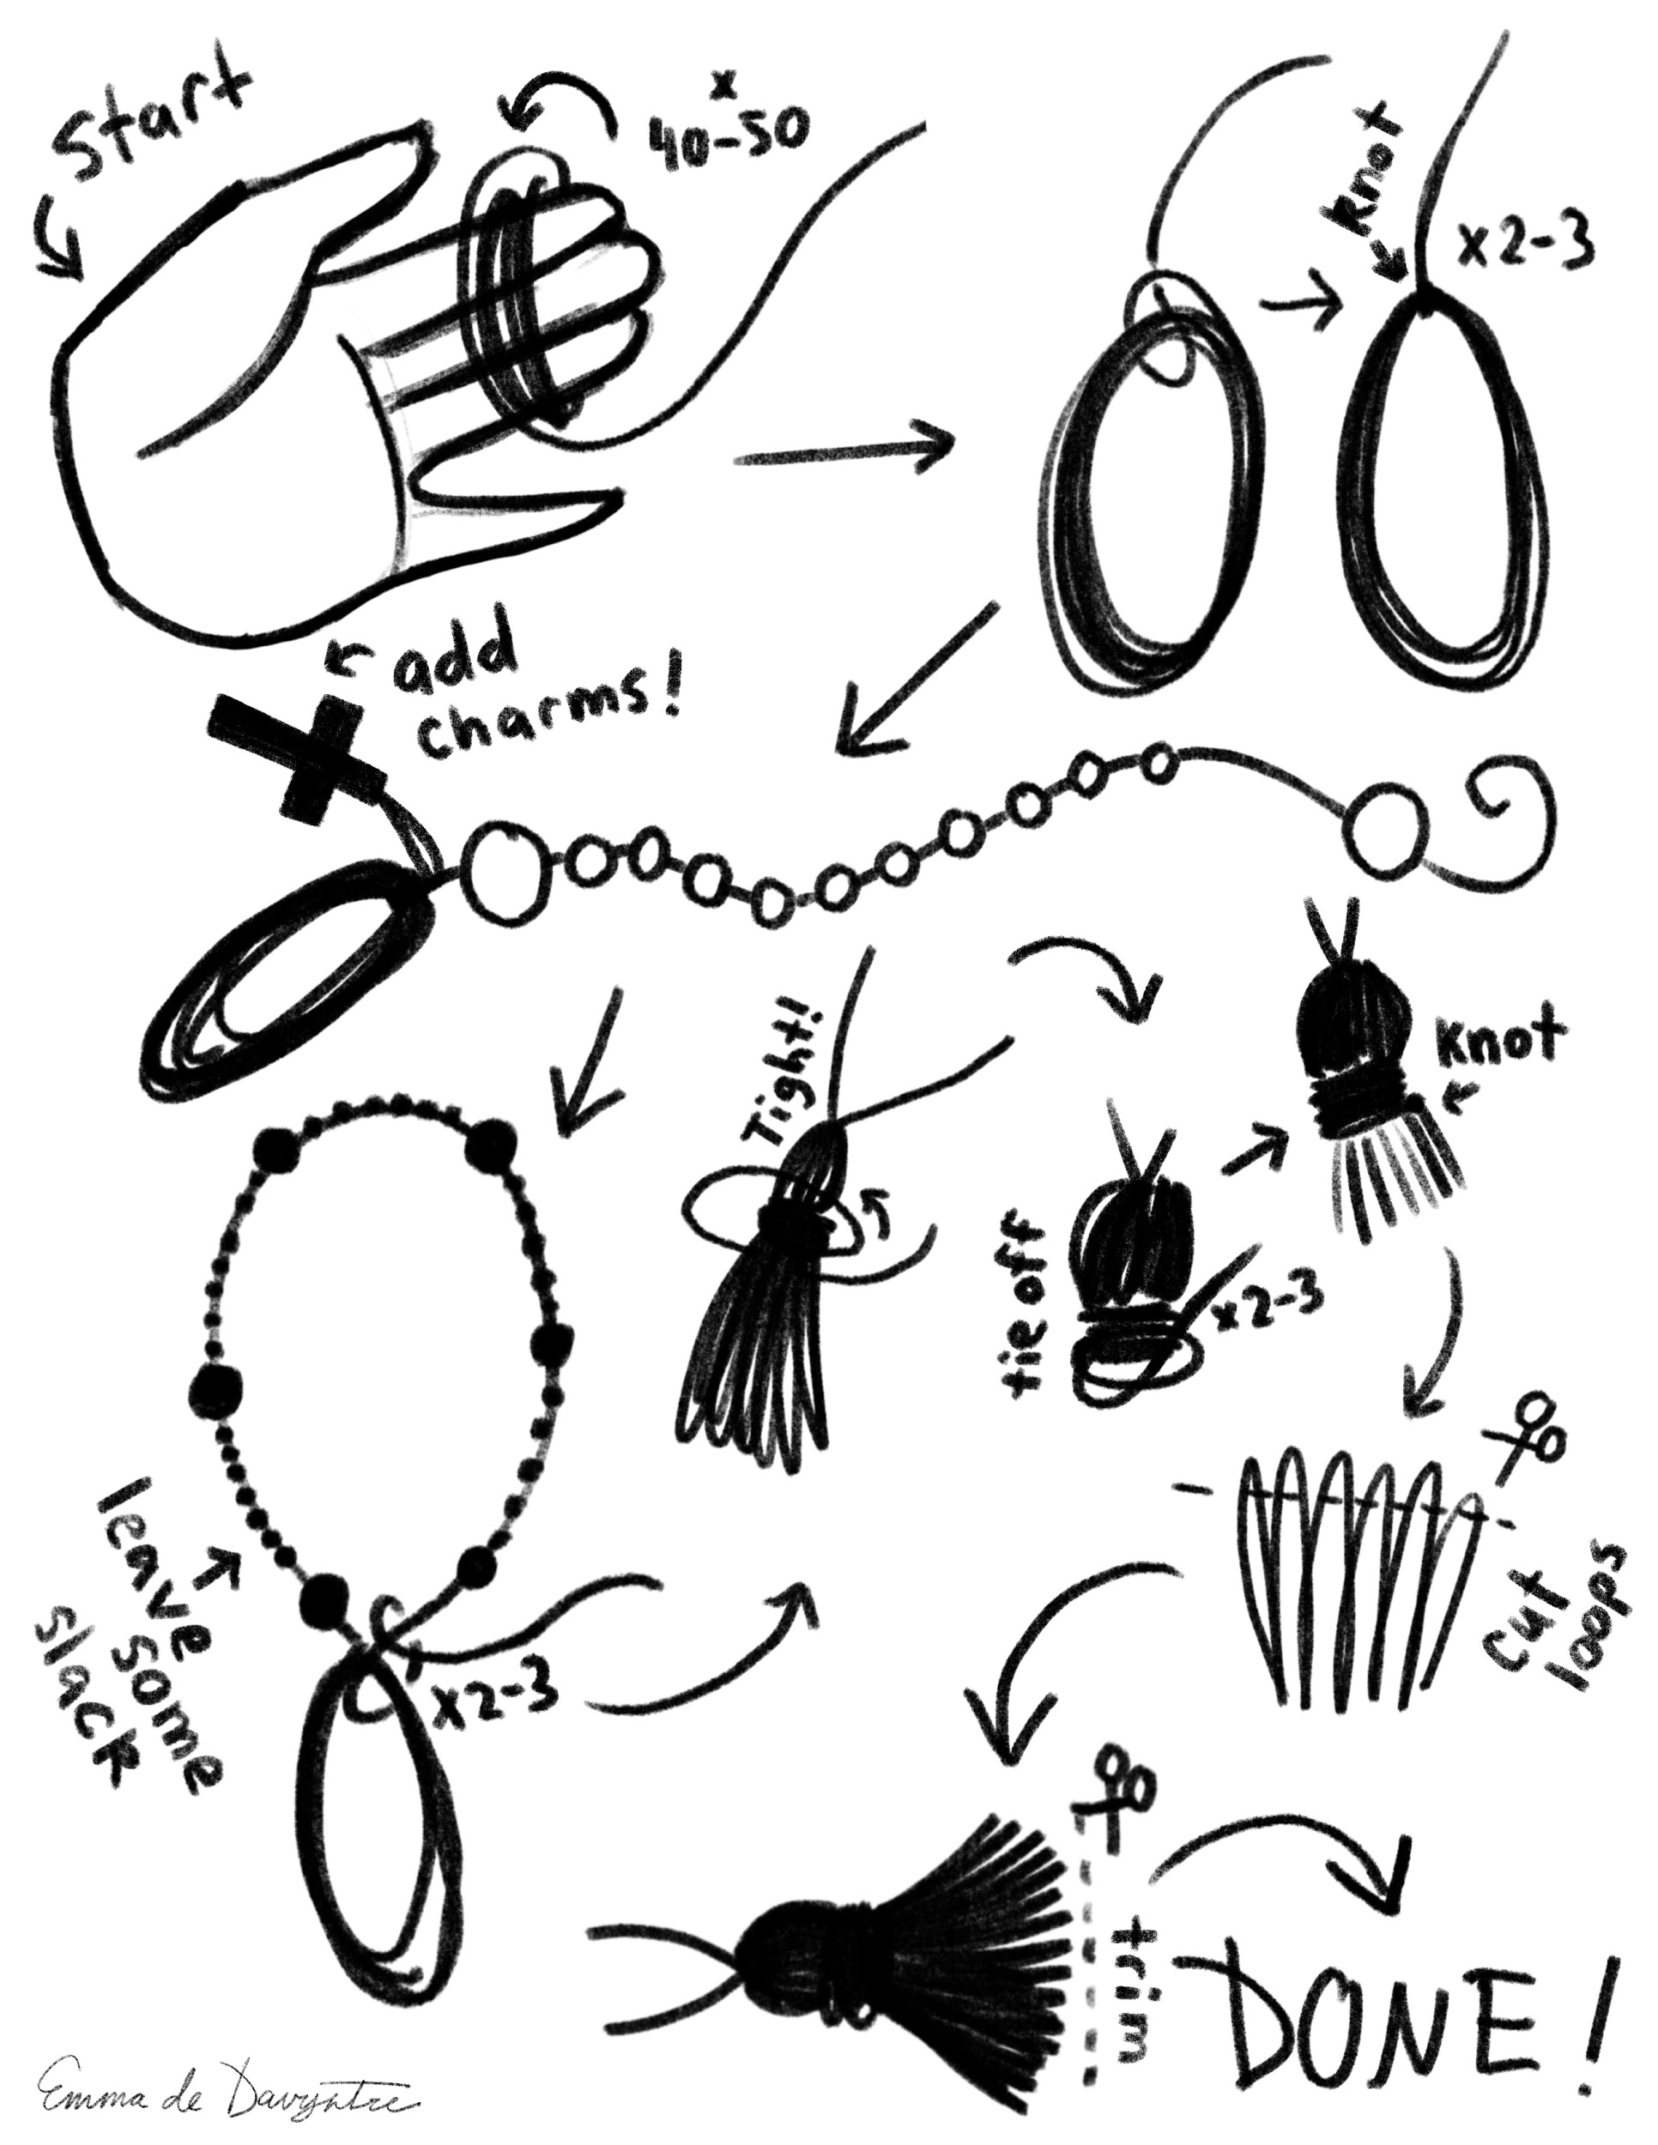

Breakdown of Construction

Based on paintings and extant pieces, construction of a Paternoster appears to be fairly simple. This lesson will be based on the looped style Paternoster, starting with the beginnings of a tassel and looping the string around to end and complete the tassel. This is how I create the tassels, and is not based on historical evidence.

To begin your Paternoster, start by dividing up your beads - counting out 50 ave beads and 5 or 6 gaud beads. You want to make sure that there is a way to differentiate between the aves and the gauds, whether by size, color, or material of the beads.

To create the tassel, I loop my thread (either cotton, silk, linen, or hemp) around three fingers. I use cotton embroidery thread skeins most often for my paternosters and usually end up using an entire skein for a single Paternoster. Loop the thread around your fingers around 40-50 times, just make sure you have enough thread left to be able to string your beads and to be able to complete the tassel at the end. I usually try and keep around an arm’s length or more left.

Once you have your loops, take the thread and tie it at the top - I do this by looping the remaining thread through the loop to hold them all together. I tend to knot it through the loop 2-3 times to make sure it’s good and secure.

From there, I start stringing my beads. Some people prefer to use a needle when beading, I usually just wet the end of my thread if the holes of the beads look large enough. If not, I sometimes will use Fray Check to make the end of the thread rigid and twist it smaller so it will thread more easily. You can also use a bead reamer to make the holes bigger.

String a gaud bead on first, then follow with ten ave beads, then a gaud followed by ten more aves. Continue doing this five times (or more, depending on your preference). You can end the loop with a sixth gaud bead or leave it out if desired to make a continuous loop.

Now you will want to take the thread and tie it through the tassel loop once more, tying it like you did previously to complete your loop. Leave some slack in the string so you can move the beads around.

When secured, you will now be finishing your tassel. There are a few methods you can use, but the one I found that works for me is to smooth out the threads and simply begin wrapping the remaining thread around them. Make sure it’s tight so that the tassel will not unravel. Finish by knotting the thread in place.

Once that is done, you will want to cut the loops and trim them to the desired length. Paintings seem to favor shorter tassels.

You have now completed your first loop-style Paternoster!

Uses for Paternosters in the SCA

Despite their religious origins, Paternosters were also used as a display of wealth. In this sense, a Paternoster can simply be used as decoration on your belt - you can also make the string longer and wear as a necklace. You can go as decorative or as plain as you like! Make sure that the cording is strong so that if you wear it on your belt, it won’t be as likely to break. I use cotton most often.

The nature of the string is to have some slack so you can move the beads around as you pray. I also use this as a sort of fidgeting device. I sit and count and move the beads around if I need something to distract me.

The Paternoster has been around since allegedly the 11th century and was popular into the 16th century, so as a Persona piece, it is a valid accessory for your garb! Create one in your heraldic colors or the heraldic colors of someone you love, your consort, or your fighter as a favor or token.

Speaking of favors, Paternosters can make great gifts to others. Charms, pendants, or religious imagery can personalize a Paternoster. Using the heraldic colors of a group or household can make for lovely largess!

Thank you for taking my class!
Lady Emma de Davyntre

------
Copyright 2017 by Eva Duplan>. Evaduplanart at yahoo.com. Permission is granted for republication in SCA-related publications, provided the author is credited. Addresses change, but a reasonable attempt should be made to ensure that the author is notified of the publication and if possible receives a copy.

If this article is reprinted in a publication, please place a notice in the publication that you found this article in the Florilegium. I would also appreciate an email to myself, so that I can track which articles are being reprinted. Thanks. -Stefan.

<the end>

