P-Papermaking-art - 5/10/17

"Period Papeermaking" by Lady Aveline de Ceresbroch.

NOTE: See also the files: paper-msg, parchment-msg, pasteboard-msg, framing-velum-msg, A-Book-Press-art, Blk-Walnt-Ink-art, early-books-msg, inks-msg.

************************************************************************
NOTICE -

This article was added to this set of files, called Stefan's Florilegium, with the permission of the author.

These files are available on the Internet at: http://www.florilegium.org

Copyright to the contents of this file remains with the author or translator.

While the author will likely give permission for this work to be reprinted in SCA type publications, please check with the author first or check for any permissions granted at the end of this file.

Thank you,
Mark S. Harris...AKA:..Stefan li Rous
stefan at florilegium.org
************************************************************************

Period Papeermaking
by Lady Aveline de Ceresbroch

Barony of Shadowed Stars (Fort Wayne, Indiana)
Kingdom of the Middle
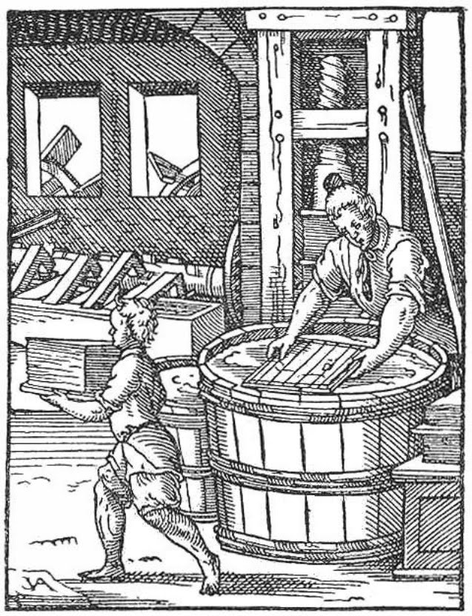

WHAT IS PAPER?

According to dictionary.com, paper is "a substance made from wood pulp, rags, straw, or other fibrous material, usually in thin sheets, used to bear writing or printing, for wrapping things, etc."

"To be classed as true paper the thin sheets must be made from fibre that has been macerated until each individual filament is a separate unit; the fibres intermixed with water, and by the use of a sieve-like screen, the fibres lifted from the water in the form of a thin stratum, the water draining through the small openings of the screen, leaving a sheet of matted fibre upon the screen's surface. This thin layer of intertwined fibre is paper." – Dard Hunter, Papermaking: The History and Technique of an Ancient Craft, 1947.
So… what is not paper, but often confused with it? Parchment (split skin of sheep), vellum (calfskin), papyrus (laminated stalks of a plant), rice paper (spiral-cut inner pith of a plant), and tapas (beaten bark) or liber (bark), among others.

THE HISTORY OF PAPERMAKING

For nearly two millennia, the invention of papermaking was attributed to imperial court official Ts'ai Lun both in the Far East as well as throughout Europe. Ts'ai Lun showed the Emperor his innovation in the first year of Yuan-Hsing in 105 AD, wherein Tsai'Lun was praised and thereafter heralded as a national hero.

However, nineteenth and twentieth century scholars began to suspect that papermaking actually dated back as far as the second century BC, based on references in a few early Chinese documents, as well as several fibrous fragments that could not be definitively identified. Then, in 2006, a piece of paper (made of linen fibers) with a map drawn upon it was found at Fangmatan in China's northeast Gansu Province and has been since dated to sometime between 176 and 141 BC. Though hotly contested to be "paper" (as is defined today) by most Chinese cultural officials, many independent scholars now affirm that paper pre-dates Ts'ai Lun's presentation to the Emperor in 105 AD. Contemporary paper scholars and papermakers still herald Ts'ai Lun as the first man to make paper using the methods similar to what we use today. It was he who began using the macerated and fibrillated fibers of trees and plants to make paper by matting those fibers together.

It is said that the Chinese shared papermaking with Korean Buddhist priests sometime between the second and fifth centuries AD. Later, Korean monks shared the trade of papermaking with the Japanese around 610. After the Battle of Talas in 751 on the border of modern-day Kazakhstan and Kyrgyzstan, two Chinese prisoners-of-war shared the secrets of papermaking with their Muslim captors while under duress. There was a long-standing tradition of the Muslims in that era that they would release prisoners-of-war if a prisoner could teach ten Muslims valuable knowledge or skills. The existence of a paper mill is then documented in Samarkand, Uzbekistan later that year, in Baghdad, Iraq in 793, in Cairo, Egypt between 900 and 1000, and in Fez, Morocco around 1100. The Muslim Moors brought papermaking to the Iberian Peninsula (modern day Spain) sometime in the late eleventh or early twelfth century. A paper mill was built in Xàtiva, Spain by 1150 and in Hérault, France in 1189. Later, the Fabriano paper mill was established between 1268 and 1276 and while some scholars claim that it was the first paper mill to use water power to drive the fibrillation or pulping process – to macerate the fibers before matting them together – other scholars believe it is much more likely that the first water-powered paper mill actually dates to 1282 in Xàtiva. The first permanent paper mill north of the Alps was in Nuremburg, Germany, established in 1390. Dozens of other paper mills began to spring up around Europe between the end of the fourteenth century and the fifteenth century. Paper became commonly accessible in Europe during the thirteenth century and was considered quite affordable by most in the upper classes of Europe by the fourteenth century.

MATERIALS USED IN PAPERMAKING

Most people assume that paper was always made of wood or, if not, cotton. Initially, paper was made from raw materials or byproducts of other crafts, such as fragments of flax, wood, bark, and other plant and tree parts. Analysis of 84 Chinese paper documents dated between the 4th and 7th Centuries showed linen, silk, mulberry bark, rope, and hemp fragments among others with significant mechanical treatment in the preparation of the fibers, which included chemical maceration (most likely cooking in a lye solution) – a process which had begun to be used during this time.

As papermaking techniques developed, paper would later be made of the rags of old clothes and other fabrics that were no longer of use to their owners. Although the development of "rag paper" was often attributed to the Muslims during the Middle Ages, testing in 1911 showed that rag paper was occasionally made between the 4th and 8th Centuries in East Turkestan and China. Furthermore, scientific examination of extant paper samples, show that of 500 Arab manuscripts examined, none were made purely of cotton fibers and, in fact, few manuscripts had any cotton fibers in them at all. Instead, most Muslim manuscripts were made of flax and hemp bast fibers, similar to European rag papers made from worn out textiles. Additionally, microscopic evaluation in 1886 and 1887 showed that the fibers in Arab papers versus the fibers in European papers were less fibrillated and macerated with more individual fiber ends unharmed – which scholars conclude was because there was "less heavy mechanical treatment." This also meant that Arab papers had less strength and weaker cohesion than European papers.

Later analyses of the primary materials used to make paper in Europe between 1400 and 1800 reveal that most of the papers were made of linen and hemp, with hemp comprising up to 75% of the paper's composition in the earlier years of that range. Other fibers also used occasionally in Asian, the Middle Eastern, and European paper mills were mulberry, ramie, wood and bark, and straw.

The following chart by M. Th. Mareau shows us how the raw material of flax gets translated into a sheet of paper and includes the work and loss that occurs during the transition from plant to paper:

Condition of the Material | Kilograms | Pounds
Raw picked flax | 100.00 | 220.46
Dry flax | 25.00 | 55.12
Rippled flax | 17.50 | 38.58
Retted flax | 4.40 | 9.70
Combed flax | 4.18 | 9.22
Spun thread | 3.55 | 7.83
Linen cloth | 2.84 | 6.26
White linen | 2.41 | 5.31
Papermaking | 1.69 | 3.73

PAPER AND ITS MANY USES
Originally, paper was used for packaging, but the Chinese quickly figured out that the new paper could be used for writing messages. The oldest recorded document on paper in Europe was a deed of King Roger of Sicily, dated to 1102; a notarial register written in Geneva dates 1154; and the oldest known imperial deed of Frederick II is dated in 1228. One of the main reasons to use paper over vellum is that paper was more difficult to make a "modification" in ink on – and therefore was a great medium for official documents.

The first wire mold is identified as having originated in Spain and has been dated to 1150. Before that bamboo molds were the most common in China. Later, the "fence" or "deckle" was invented by Europeans; a deckle was better able to hold the fibers in a formation within the boundaries of the deckle to create more perfect shapes of paper. Rigid wire molds are better to create rag paper because it held the fibers together better.

MAKING PAPER

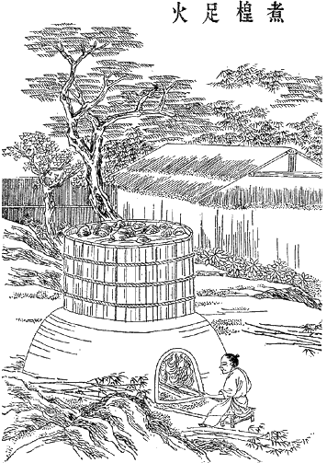

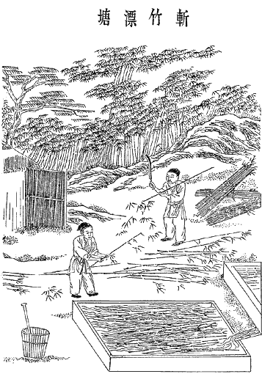

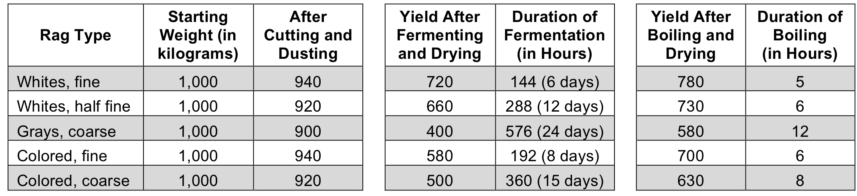

Step #1 – Gather together the materials to be used to make the pulp. Dampen the materials and leave them out to ret or ferment and begin disintegration (also called maceration). During the Middle Ages and Renaissance Era, the materials would then be soaked and "bleached" in a solution of lye that was also called "buck" (water that is leached through ashes) or sometimes buttermilk or sour milk. The bucking process would include soaking the rags in the buck for five to six days, then mill washing it, laying it out on the grass while watering it several times a day to keep it damp and sun bleaching the fibers, then repeating the soak in the buck. This process is called the "Old Dutch Method" and took at least six days and upwards of six to eight months, depending on that mill's process. Around the eighteenth century, paper mills began boiling and bleaching the rags or materials in chlorine bleach to speed up the breakdown of the materials, as well as to produce a whiter paper.

Step #2 – The fibrillation process comes next. This is the process whereby visible fibers are further "mashed up" to break the ends of each fiber into the individual filaments that comprise each (visible) fiber. This step is key to the process because the materials would not matte together otherwise; the fibrillated fibers will catch or snag on each other this way. The oldest documented way of fibrillating the materials was through manual grinding with a mortar and pestle. Later, the Muslims created the first paper mills with an automated process called stamping or beating; they began using trip hammers powered by hand or by animals in order to fibrillate large quantities of materials into fibers. Eventually, it would be the Europeans who would mechanize the process of fibrillation in the twelfth century through the application of water power. Sometime between 1650 and 1680, the Hollander Beater was invented by the Dutch and variations of that same machine are the primary mechanism in which commercial pulp is still made today.

Step #3 – Once the materials have been macerated and fibrillated, it is time to transfer the pulp into a large tub or vat. Traditionally, these vats would hold approximately 330 gallons and the semi-solid liquid of water and pulp would be kept warm and be constantly agitated so that the fibers would not settle to the bottom.
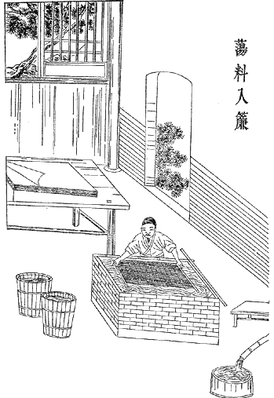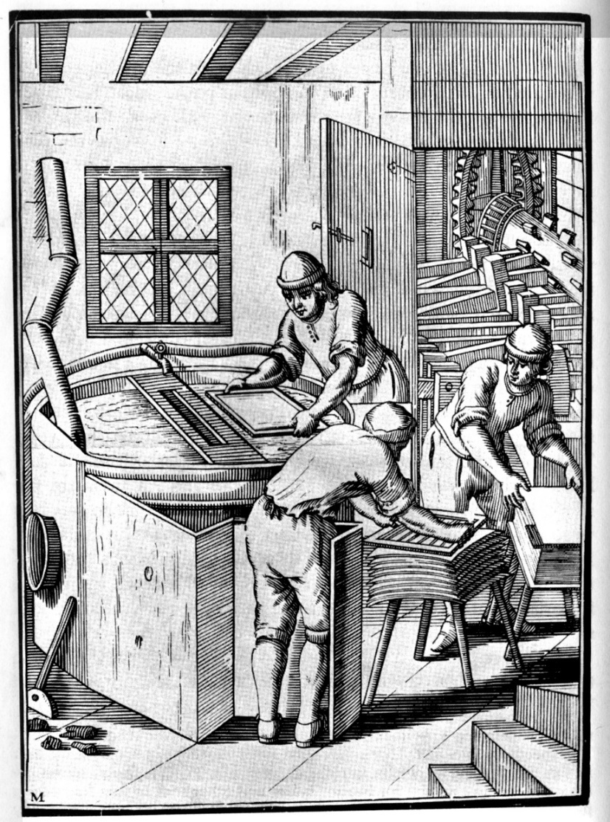

Step #4 – To be the most effective, paper mills would often employ at least two tradesmen to work at each vat. The first tradesman was called a Vatman, whose job it was to dip the mould and deckle into the vat of pulp to form a layer of the matted fibers on the mould. The Vatman would then remove the deckle and hand off the mould to the Coucher.

Step #5 – The Coucher would then remove the wet piece of paper by rolling the mould face down onto a stack of felt to be pressed. The Coucher would then hand the first mould back to the Vatman to repeat the process and the Vatman would hand the Coucher a second mould that had been prepared while the Coucher was couching the first sheet. It is estimated that together the Vatman and Coucher could produce up to 750 sheets of paper a day just by themselves (this number gets larger with the introduction of an optional Layman in a Step #6).

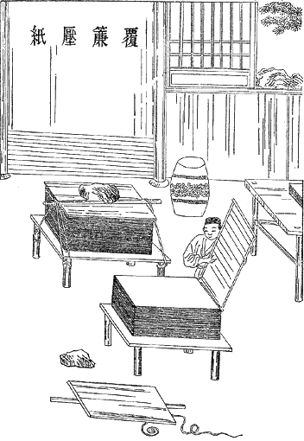

Step #6 – Once a stack of paper had been placed between sheets of felt (this is called a post), the post would then be squeezed in a press to attempt to extract as much water as possible before the drying process. (Please note: It is extremely important to not press the stacks of paper and felt too hard as, you can squeeze the matted paper apart and ruin the sheet in the process.) A tradesman called a Layman would free up each sheet of paper from the post, remove the felts, and place the paper in a neat pile. This pile was again subjected to pressure and more water was removed. This process was repeated several times. Once the sheets were nearly dry, they would be stacked directly on top of each other into a "pack" and squeezed again until the Layman was satisfied as much water as possible had been squeezed out. While working in tandem, a Vatman, Coucher, and Layman could produce up to 4,000 sheets of paper per day.

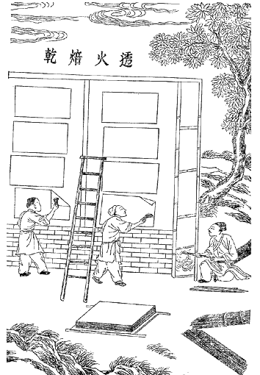

Step #7 – Once the paper has been squeezed of excess water, the Layman would take the sheets of paper to be hung to dry. Paper was usually dried in groups called "spurs" of either four to five sheets or six to seven sheets, because drying the sheets in groups kept them from curling or wrinkling. Sometimes paper is dried suspended from ropes in a specially constructed drying loft; other times paper is hung over a piece of rope, rod, or drying rollers. The ropes were usually made of horse or cow hair and would be coated with beeswax to prevent leaving an imprint in the paper. Other techniques include drying paper while it is attached to clips to try to stretch or maintain the paper's size (which will otherwise shrink during the drying process). However, it should be noted that when paper is stretched it becomes much weaker; hanging paper is generally stronger than stretched paper, all other things being equal.

Step #8 – This step is optional, depending on what the desired use of the paper is. If one planned to use the paper for writing/calligraphy or painting/illumination, this step of sizing is essential. Otherwise the ink or paint would bleed on the page. If the paper was intended for packaging, wrapping, or watercolor painting in which bleeding was desirable, this step is unnecessary. Initially, sizing was done with starch, particularly throughout the Muslim world of papermaking. Sizing with starch was the universal standard through nearly the end of the thirteenth century, when papermakers in Europe began to experiment with gelatin sizing. The paper was dipped into a vat containing animal size, a gelatinous and glutinous substance made by boiling parchment or leather shavings in water. Later, paper mills began adding alum to the gelatin sizing. Sizing the paper gives it a relatively impermeable surface. After sizing, the paper was once again pressed and dried. Additionally, ground limestone, chalk, and sometimes seashells were used to either whitewash/bleach the paper or as part of a sizing solution – scientific analysis hasn't been able to definitively pin down at which point this was added.

Step #9 – The last step, which is also optional depending on the intended use, is a finishing process. Each sheet of paper is smoothed or burnished by rubbing it with a smoothing stone (also called a Glazier's Stone), similar to the stones used for "ironing" fabrics. This process yields a smoother surface and also helps to close the pores of the sheet even further in order to prevent bleeding even more successfully than just sizing the paper. This step would likely have been done if the intended use of paper was for writing or painting; if the paper was intended for printing, it was less likely; and if the paper was for packaging or something else, this step would have been skipped altogether. During the Middle Ages and Renaissance Era, a "successful" Glazier might burnish up to 3,000 sheets of paper a day.

GLOSSARY

Bucking – The process of bleaching linen rags with a solution of lye water (buck) so that paper would be whiter.

Burnishing (also called Polishing or Glazing) – The act of smoothing out the surfaces of individual pieces of paper by pressing them with a smoothing stone.

Coucher – A tradesman that would roll the newly-made piece of paper from the mould onto a piece or stack of felt and then hand the mould back to the Vatman.

Couching – The process of pressing the initial wet paper form, to remove as much water as possible before hanging the paper to dry.

Deckle (also called Fence) – A removable wooden rim which could be fitted onto the mould to make it into a tray-like sieve with a raised edge.

Exchanging – The act of the Layman taking two posts or packs of paper and exchanging sheets of paper between the two in an alternate fashion in order to then press the post or pack again. This process results in a smoother, more polished surface.

Fiber – A thread or a structure resembling a thread that typically gives texture or substance and imparts elasticity, flexibility, and tensile strength.

Fibrillation – The act or process of forming fibers or fibrils.

Filament (also called Fibril) – An individual strand that naturally winds up to create a fiber.

Glazier – The tradesman or tradeswoman who would glaze, polish, or burnish papers as the finishing touch in the papermaking process. By pressing paper between a smooth stone (also called the Glazier's Stone) and a tanned chamois or sheepskin, the imperfections of a sheet of paper would be pressed down or smoothed together.

Inclusion – Speck(s) of impurities such as hairs, bugs, and/or whole fibers that get trapped in the paper during the couching process. For example, there is a 15th Century paper that has a mosquito embedded in the surface of the paper. Sometimes inclusions are added intentionally, in order to create an artistic aesthetic (i.e. adding pressed flowers, leaves, glitter).

Layman – The tradesman who freed up each sheet of paper from the post, removed the felts, and placed the paper in a neat pile. This pile was again subjected to pressure and more water was removed. This process was repeated several times. The paper was then taken to be dried.

Maceration – To soften by steeping or soaking to separate an object into its individual elements.

Mould – An oblong rectangular wire sieve mounted on a wood frame. Traditionally the wires of the mould are brass.

Pack – The pile of mostly-dried paper sheets stacked directly on other mostly-dried paper sheets which is stacked and squeezed in a press to extricate the last of the water in the paper sheets that can be squeezed out before the paper is hung to dry.

Papermaker's Tears – Blemishes on the paper caused by water being dripped on the freshly formed moist paper, which causes a thin spot in the paper.

Post – The pile of sandwiched wet paper and felt that is later stacked and squeezed in a press.

Press (also called Screw Press) – A press where much of the water was pressed out of paper. Sometimes presses are incredibly large and complex, taking an immense amount of pressure from all of the workers in the mill to turn out to help pull the long wooden lever which turned the screw and reduced a post of paper from about two feet to six inches in thickness. Other times, presses are as simple as two pieces of wood to sandwich the pile of wet paper and four screws in each corner with wing nuts on each, which could gradually tighten the press to squeeze out excess water.

Promener (also called Shaking the Sheet) – The action of shaking a mould gently from right to left and then left to right immediately after lifting the mould out of the vat, in order to distribute the pulp. This motion is followed by the serrer movement in order to bind and matte the pulp together.

Pulp – A semi-solid mass of water and macerated and fibrillated materials, usually comprised of some combination of linen, hemp, cotton, bamboo, mulberry, ramie, wood and bark, and/or straw.

Ream – Usually 500 pieces of paper.

Serrer (also called Shutting the Sheet) – The action of shaking a mould gently away and back towards oneself (or to and fro) immediately after lifting the mould out of the vat and doing the promener movement, in order to distribute the pulp. As if riddling, this binds and mattes together the pulp.

Size – Animal size is a gelatinous and glutinous substance made by boiling parchment or leather shavings in water. While this is the tradition form of size, other substitutes were frequently used beginning in the Nineteenth Century, such as rosin and alum internal size.

Sizing – The act of adding size to a sheet of paper. Sizing the paper gives it a relatively impermeable surface.

Spurs – Stacks of four to five or six to seven sheets of paper that were stacked upon each other for the drying process.

Stamping (also called Beating) – The automated or mechanized process wherein tools are used to fibrillate fibers, often with trip hammers or a Hollander Beater.

Vatman – A tradesman that would take a mould, fit it with a deckle, and then dip the mould and deckle into a vat so that the pulp-solution could be drained through the mould to leave a layer of matted fibers on the mould. Traditionally, the Vatman would then remove the deckle from the mould and hand the mould off to the Coucher. While the Coucher was doing his job, the Vatman would work with a second mould and then exchange it with the empty mould from the Coucher.

Watermark (also Le Filigrán or Wasserzeichen) – An area of thinness in a piece of paper, which is created by soldering a wire (in the shape or form of the papermaker's choosing) to the wire mesh of the paper mould. The soldered wire creates a mark which is elevated above the surface of the wire mesh and therefore causes a thinning of the layer of pulp. Watermarks first appeared in 1282.

BIBLIOGRAPHY AND REFERENCES

Briquet, C.M., Les Filigranes: Dictionnaire Historique des Margues du Papier, 1907. https://doc.rero.ch/record/23217/files/ob_447_1.pdf (French)

Castagnari, Giancarlo, "Excerpts of the 1st Convention in Italy on industrial paper archaeology" from "The Industrial Paper Heritage in Italy: Its history, places and enhancement," Paper History, Vol. 20, Issue 2, 2016, p. 19-20. http://www.paperhistory.org/Archive/iph2-2016.pdf (Accessed March 18, 2017)

Helle, Torbjörn, "Paper and the history of printing," Paper History, Vol. 19, Issue 2, 2015, p. 14-22. http://www.paperhistory.org/Archive/iph2-2015.pdf (Accessed March 18, 2017)

Jixing, Pan, "Review on the debate of paper history during recent 30 years in China," Paper History, Vol. 15, Issue 2, 2011, pp. 6-12. http://www.paperhistory.org/Archive/iph2-2011.pdf (Accessed March 18, 2017)

Kazuyuki, Enami, et al, "Origin of the difference in papermaking technologies between those transferred to the East and the West from the motherland China," Paper History, Vol. 14, Issue 2, 2010, p. 12-22. http://www.paperhistory.org/Archive/iph2-2010.pdf (Accessed March 18, 2017)

Munsell, Joel, Chronology of the Origin and Progress of Paper and Paper-making, Fifth Edition, 1876. https://archive.org/details/chronologyorigi00munsgoog

Rischel, Anna-Grethe, "Julius von Wiesnder and his importance for scientific research and analysis of paper," Paper History, Vol. 18, Issue 1, 2014, pp. 31-38. http://www.paperhistory.org/Archive/iph1-2014.pdf (Accessed March 18, 2017)

Thompson, Susan, "Paper Manufacturing and Early Books", Annals of the New York Academy of Sciences, Vol. 314, 1978, pp. 167–176.

http://the-orb.arlima.net/encyclop/culture/books/medbook1.html
http://paper.lib.uiowa.edu/index.php
http://www.paperhistory.org/dabro.pdf
http://users.stlcc.edu/nfuller/paper/
http://www.crt.state.la.us/louisiana-state-museum/online-exhibits/maps-of-louisiana-and-new-world/the-art-of-papermaking/
https://en.wikipedia.org/wiki/History_of_paper
https://en.wikipedia.org/wiki/Papermaking
https://en.wikipedia.org/wiki/Paper_mill
http://news.xinhuanet.com/english/2006-08/08/content_4937457.htm
https://monoskop.org/images/7/7d/Needham_Joseph_Science_and_Civilisation_in_China_Vol_5-1_Chemistry_and_Chemical_Technology_Paper_and_Printing.pdf
http://www.chinasage.info/inventions.htm
http://papermoulds.typepad.com/
http://www.dardhunter.com/
http://www.peacepaperproject.org/dardhunter.html
https://www.si.edu/mci/downloads/relact/chinese_prints.pdf
http://www.ateliermanufactura.com/historie-vyroby-papiru/#toggle-id-1 (Czech)
http://www.museodellacarta.com/default.asp (Italian and English)
http://handpaper.freyerweb.at/about.php?lang=en (German and English)
------
Copyright 2016 by Tonia Brown. <harpyandhag at gmail.com>. Permission is granted for republication in SCA-related publications, provided the author is credited. Addresses change, but a reasonable attempt should be made to ensure that the author is notified of the publication and if possible receives a copy.

If this article is reprinted in a publication, please place a notice in the publication that you found this article in the Florilegium. I would also appreciate an email to myself, so that I can track which articles are being reprinted. Thanks. -Stefan.

<the end>

