Sc-Ink-Charts-art - 1/30/20

"Scribal Ink Charts" by Honorable Lord Ian the Green.

NOTE: See also the files: inks-msg, Oak-Gall-Inks-art, Blk-Walnt-Ink-art, iwandpc-msg, quills-msg, writing-inst-msg, parchment-msg, calligraphy-msg.

************************************************************************
NOTICE -

This article was submitted to me by the author for inclusion in this set of files, called Stefan's Florilegium.

These files are available on the Internet at: http://www.florilegium.org

Copyright to the contents of this file remains with the author or translator.

While the author will likely give permission for this work to be reprinted in SCA type publications, please check with the author first or check for any permissions granted at the end of this file.

Thank you,
Mark S. Harris...AKA:..Stefan li Rous
stefan at florilegium.org
************************************************************************

Scribal Ink Charts
by Ian the Green

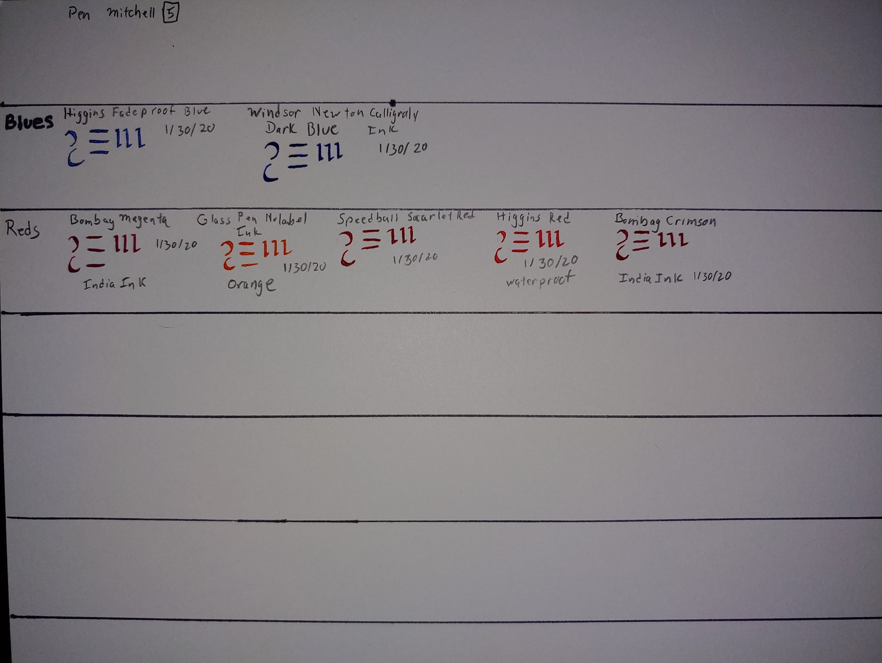

I highly recommend that if you play with inks, any colors, that you make one. Try to put colors on the same lines or sections. Label them clearly with color, brand, their name for the color, and date you put it on.

Because inks can look different depending on the size of pen you are using, labeling the pen size is a very good idea as well. For me, I'm keeping the whole sheet, the same pen size. But you don't have to. You can set this up however it makes sense to you.

Over time it is a good idea to do this on different kinds of paper and supports. Inks that look one way on Bristol vellum probably look the same on bristol smooth, but do they look the same on arches hot press? Cold Press? How about on pergamenata or on parchment/velum? Also, it is a good idea to do this on different colors of support.

As Clayton Woods said, "... be sure to note which support you're doing this on. Company, product line, weight, and finish, all of it that you can get." I obviously need to go back and label this with that information as well. If for nothing else to be a good example.
,
You will develop quite the ink chart library over time. And it will prove to be invaluable to you over time as well.

---------------
Copyright 2020 David Roland. <ianthegreen01 at gmail.com> All Rights Reserved. Permission for use and reproduction for personal use to members of the Society for Creative Anachronism granted.

If this article is reprinted in a publication, I would appreciate a notice in the publication that you found this article in the Florilegium. I would also appreciate an email to myself, so that I can track which articles are being reprinted. Thanks. -Stefan.

<the end>

