Flyng-Dragons-art - 3/4/15

"Flying Dragons" by Lord AElfred se leof. A guide to constructing mediaeval European kites.

NOTE: See also the files: p-kites-msg, dragon-kites-art, Korean-Kites-art, medievl-kites-art, Medievl-Kites-bib, silk-msg, linen-msg, parchment-msg, paper-msg.

************************************************************************
NOTICE -

This article was submitted to me by the author for inclusion in this set of files, called Stefan's Florilegium.

These files are available on the Internet at: http://www.florilegium.org

Copyright to the contents of this file remains with the author or translator.

While the author will likely give permission for this work to be reprinted in SCA type publications, please check with the author first or check for any permissions granted at the end of this file.

Thank you,
Mark S. Harris...AKA:..Stefan li Rous
stefan at florilegium.org
************************************************************************

You can find more work by this author at: http://www.nps.id.au

This article was first published in Cockatrice 30 (April 2006), the A&S newsletter for Lochac.

Flying Dragons
by Lord AElfred se leof

1 Introduction

I live in a very windy place. So, when it came time to run the inaugural event for the Shire of Colles Ardorum in A.S. XXXIX, I thought a kite-flying competition was in order. As it turned out, the wind blew especially fiercely on the day of the event and it became possible for almost anything to fly, including our tents and fighters' shields. In this article, I'm going to look at getting things to fly under more, er, challenging conditions.

Kites have a very long history in China and surrounding countries, where they have been known since at least 400 BC. However, while one Archytas of Tarentum is reported to have constructed a "wooden bird" in Greece as early as 400 BC, reliable evidence of kites in Europe does not appear until the fourteenth and fifteenth centuries AD. In this article, I'll only cover European kites.

The only work that I am aware of to give a comprehensive history of kites is the book by Clive Hart [2], and I've largely relied on Hart's chapter on early European kites for background information and translations of period sources. Hart has also written a book on the history of thought in flying [1], which chronicles the more imaginative but less practical side of the subject.

Hart's books are difficult to find, but another book by David Pelham [3] is widely available, has a passable history section and contains images of all of the major period depictions of kites (also reproduced in this article). Pelham also gives a lot of advice about designing and flying kites that has been advised by modern physics.

Three distinct kinds of kite are depicted in European literature of the SCA period. I've made an attempt at building and flying all of them. I'll describe each kind (and attempt) in turn in the following sections.

2 Fundamentals

Mediaeval European kites are variously described as being made out of linen, silk, parchment or paper, using wooden rods for the frame. My kites are mostly made from cotton that I found in my costume off-cuts and oak or ramen dowel that I found in my archery graveyard.

The instructions for making the pennon kite described in Section 4 say that the frame is attached to the fabric by placing loops of thread on the fabric at the attachment points, and fastening the frame to these loops. It doesn't say how the fastening is done and none of the other period expositions I have seen give any indication at all as to how the frame is attached.

I used one of two methods depending on which one seemed more convenient at the time:

- cut a notch or drill a hole in the frame piece and use this anchor a few loops of thread sewn around the frame piece and into the fabric – this seems similar to what is described above; or sew a little pouch into the fabric that the end of the frame can be inserted into – this is the standard modern method described by Pelham.

- Knowing a few basic knots is helpful for fastening different parts of the frame to one and other, and attaching the bridle and tether. I got by primarily on reef knots and square lashing but you can find many more interesting knots in Pelham's book or manuals for other knotintensive activities.

Since a kite depends on its balance for remaining aloft, it is important for the construction to be well-balanced. A kite with more lift or weight on one side than the other will tend to roll or flip. Larger kites are easier to balance because they require less accuracy. Pelham recommends that kites should be at least a meter in one dimension, though it is possible to make smaller kites that fly quite adequately given sufficient attention to detail.

3 Windsocks

Long before true kites were known Europe, "windsocks" were used as a form of banner. These windsocks took the form of tubes or cones of material that were flown at the top of rigid poles, and could be decorated to represent dragons and the like. The wind would make the sock fill out, but they could only remain aloft by virtue of the rigid pole they were attached to.

The earliest known depiction of a kite in Europe is found in Walter de Milimete's De Nobilitatibus (1326), which shows three soldiers flying a dragon-shaped kite above a city (Figure 1). They appear to be using it to drop a bomb on the city they are attacking; unfortunately, none of the sources I have found report any text that accompanies the picture.

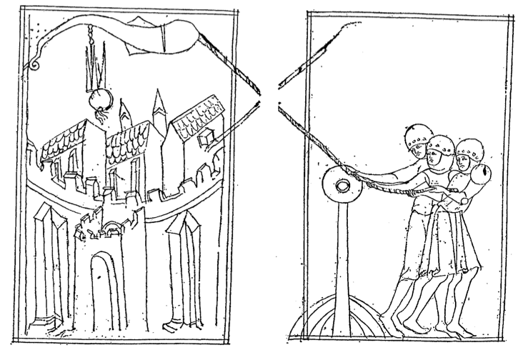
Figure 1: Dragon kite from Walter de Milimete's De Nobilitatibus (1326

A similar depiction can be found in Konrad Kyeser's Bellifortis (1405), shown in Figure 2.

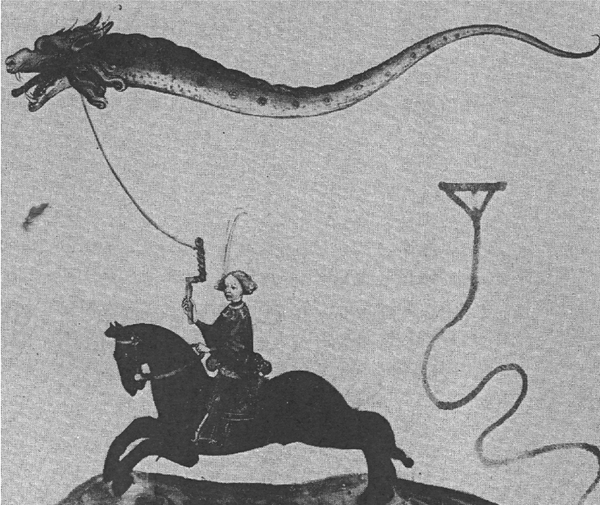
Figure 2: Drachenflieger from Konrad Kyeser's Bellifortis (1405)

The kites depicted by de Milimete and Kyeser have been the source of some controversy amongst kite historians. The pictures clearly show objects that fly of their own accord, since they are flown from a rope. But how do they fly?

Historians give two lines of thought. Some writers suggest the hot-air principle: in order to make their windsock dragons look more threatening, people made fires in their mouths, which led to hot air being funneled into the windsock, and this, in turn, caused the windsock to float. Alternatively, Pelham suggests that windsock dragons could fly using the same principles as a modern box kite. Plans for such a kite are actually given by Daniel Schwenter in Deliciae Physicomathematicae (1636), reproduced here as Figure 3.

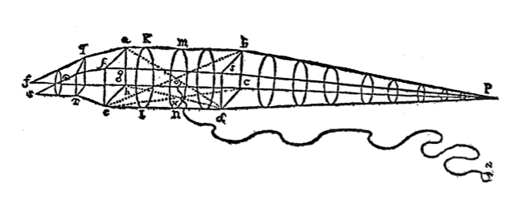
Figure 3: Schwenter's plans for a windsock kite (1636)

I tried making a kite along the lines suggested by Pelham and Schwenter. I bought some rattan rings from a craft store, lashed them to dowel to make a cylinder, and then covered the wall of the cylinder in cotton voile. I added wings by adding a piece of dowel perpendicular to the cylinder at its midpoint, and adding fabric in the obvious way (Figure 4).

Even in a fairly strong breeze, however, my drachenflieger didn't fly. The wings shown in period manuscripts – and by my kite – are just not big enough to generate the lift required to launch the frame into the air. As Pelham suggests, I imagine it is possible to make something like this that flies like a modern box kite, but it requires more engineering nous than that depicted in the foregoing figures.

I am inclined to accept Hart's argument that de Milimete and Kyeser are not depicting windsocks at all, but pennon kites. These kinds of kites will be described in the next section.
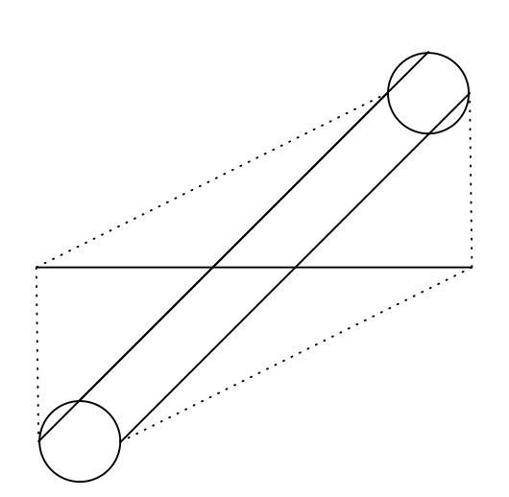
Figure 4: My design for a windsock kite (the tail has been omitted to save space). Solid lines indicate the frame and dotted lines indicate the edge of the fabric.

4 Pennon Kites

Hart's contention is that the text accompanying Kyeser's drachenflieger describes a kind of two-dimensional kite also described in an anonymous manuscript known as Vienna Codex 3064, dated to around 1430. This manuscript describes a long flat kite painted to resemble a dragon (Figure 5). This kind of kite is referred to as a pennon kite.

The codex says that the head of the dragon is made from a broad sheet of parchment, cut and painted to resemble a dragon's head. A pair of flat sticks are fastened in a diagonal cross over the face of the dragon, such that the sticks are bowed out from the parchment by about the width of two fingers. That is, the sticks are longer than the diagonal of the parchment and need to be bent slightly to be fit into the corners of the parchment. If necessary, the frame can be re-inforced by adding more sticks down the vertical centreline and horizontal top of the parchment. The parchment itself is re-inforced wherever the frame is attached to it by adding more parchment to these points.

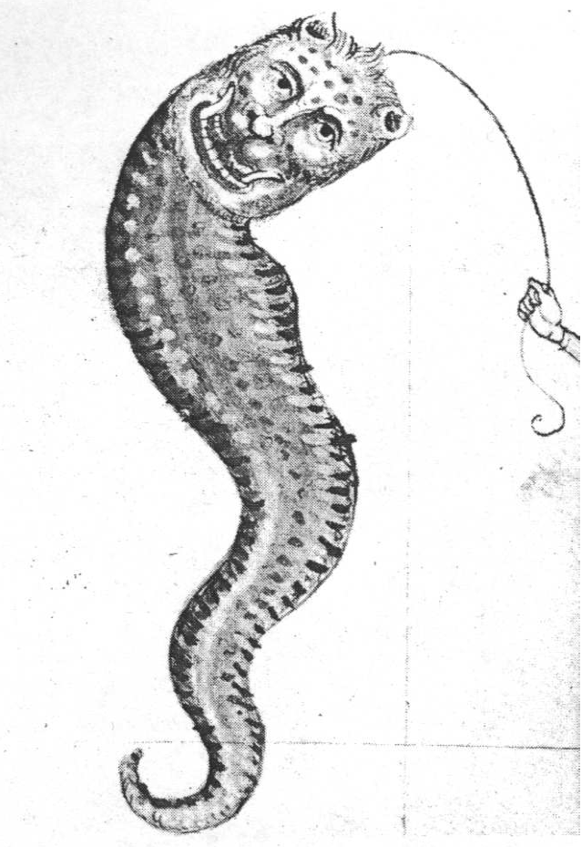
Figure 5: Pennon kite from Vienna Codex 3064 (c. 1430)

The body of the dragon is then made from silk and sewn to the bottom edge of the head. To judge by the picture reproduced as Figure 5 here, the body is simply a very long isosceles triangle – eleven ells long (12-13m) according to the text.

The text describes an option of adding wing-like decor to the tail, and adding a fin on top of the kite. The fin is made by making an incision in the middle of the tail two to three ells (2.5-3.5m) from the head, and sewing into this a pocket of silk about a span and a half (30cm) deep. This pocket will then fly up in the wind to give a more three-dimensional look to the kite.

Three loops for attaching the tether are sewn into the dragon's face at points between its eyes. The tether is attached to the lowest loop in a light wind, the middle loop in a moderate wind, and the top loop in a strong wind. Moving the tether like this alters the angle at which the wind blows into the kite, which adjusts the balance of lift and drag experienced by the kite.

Figure 6 shows the plans for my pennon kite (which has not had its head cut into shape). I used an A2 sheet of cardboard for the head, and reinforced all of the points at which the frame and tether are attached by gluing a thin piece of leather to the cardboard. The frame is made from lengths of wood with a 20mm × 5mm cross-section, with the 20mm side to the cardboard. The tail of my kite is about seven meters long and made from poplin. I omitted the fin.

It took a reasonably strong breeze to get the kite into the air, but it looked quite spectacular once it got up there. After a few flights, the tether tore the loops from the cardboard, damaging the cardboard so that it had to be replaced.
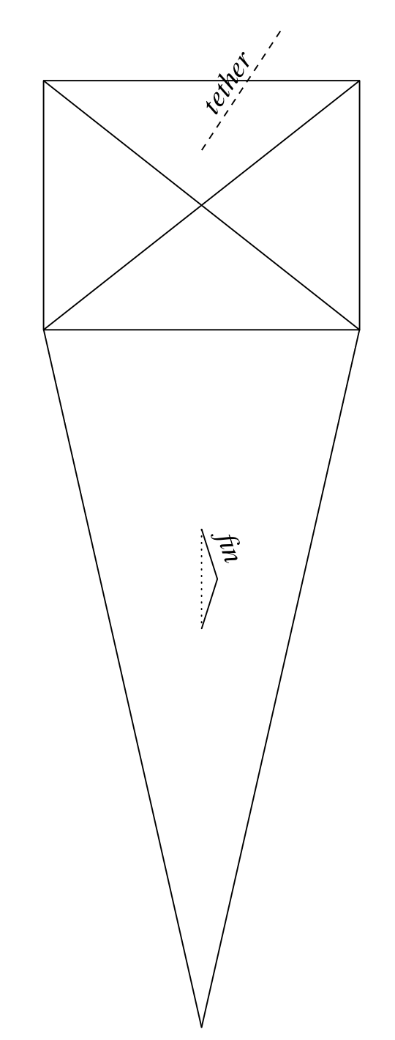

Figure 6: Plans for a pennon kite. The tail is not to scale.

5 Planar Kites

The last kind of kite known in period is probably the easiest one to make and kites of this kind are still common today – almost everyone would be familiar with the diamond-shaped kite made from two sticks. Depictions of diamond-shaped planar kites first appear in Europe early in the seventeenth century (e.g. Figure 8), but a rectangular kite of very similar construction is described by Giovanni della Porta in his Magia Naturalis in 1558. Hart suggests that knowledge of this kind of kite was probably brought back to Europe via trade routes to south-east Asia, where similar kites have been in use for centuries. I am not aware of any specific evidence for the origins of these kites, however.

Della Porta describes a "flying dragon" made by forming a rectangle out of thin rods, with one dimension being half again as long as the other. The rectangle is reinforced by adding two cross-pieces, either on the diagonals or horizontally and vertically. The rectangle is covered with cloth, and a long tail is made from a cord with papers tied to it at regular intervals.

Finding the right length for the tail requires some trial and error. The tail is required to stabilize the kite and, if it is too short, the kite will tend to roll and flip. On the other hand, if the tail is too long and heavy, the kite will not be able to lift it. Pelham suggests that a good rule of thumb is for the tail to be about seven times the length of the kite. The papers on my kites are about a handspan apart but I'm not aware of any theory on this subject.

Rather than attach the tether directly to the kite, the kite is attached via a bridle. This is a loose length of cord that connects the front and rear of the kite. The tether is then attached to a point on the bridle so that the kite flies at angle to the tether. As with the pennon kite, the best angle to use depends on the strength of the wind – strong winds call for lower angles to the wind while weak winds call for higher angles. The angle at which the kite flies can be adjusted by moving its point of attachment to the bridle.

Figure 7 shows a diagram of della Porta's kite, using square reinforcing. I made a kite according to this plan using 4mm dowel for the sides and 8mm dowel for the reinforcing, and poplin for the fabric. The kite flies in a fresh breeze but is erratic and tends to crash often – possibly because my joints have a little bit of movement in them and this destabilizes the frame.

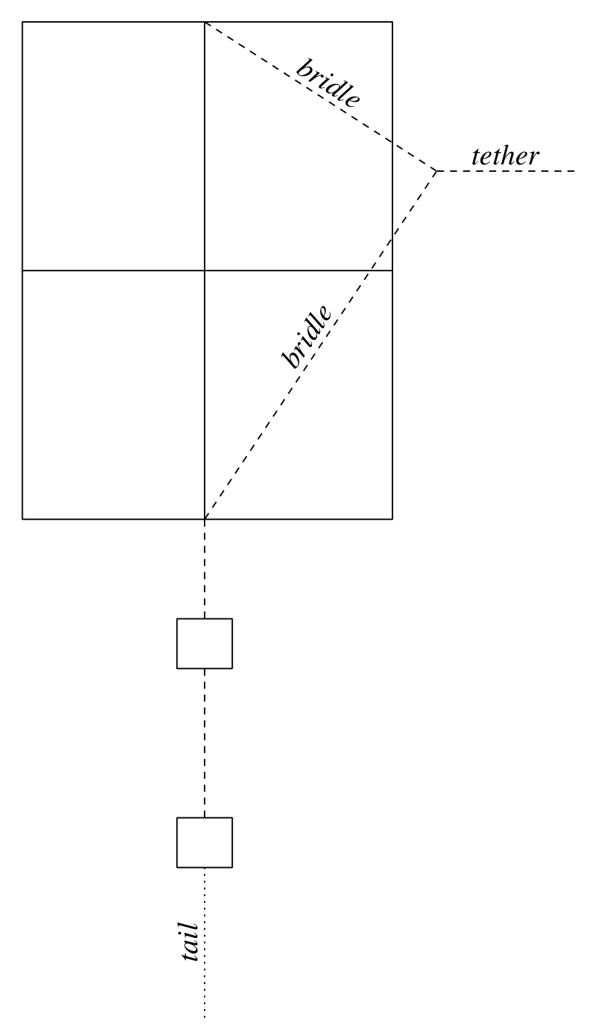
Figure 7: Plans for della Porta's rectangular kite.

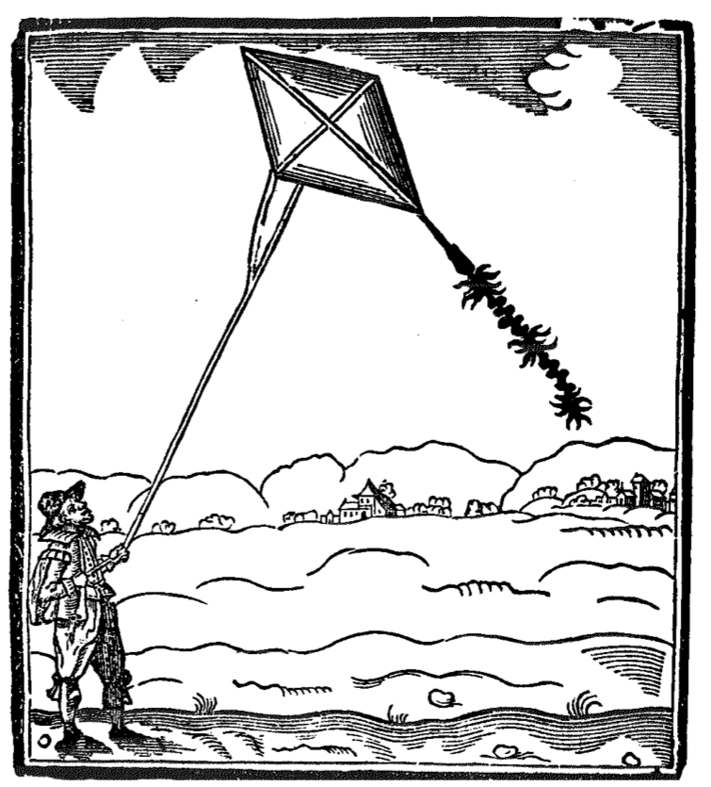
Figure 8: "Fire drake" from John Bate's The Mysteryes of Nature and Art (1634)

I found a diamond-shaped kite similar to the one shown in Figure 8 to be somewhat easier to make, and the result flies much better. It doesn't require the dowel around the sides, so there is only one joint to make. It isn't as spectacular as the pennon kite, however.

6 Kites Not to Try at Home

Getting a kite to fly was enough for me. Della Porta goes on to report various uses to which others had put their flying dragon, most of which are probably illegal in modern jurisdictions.

Some people are reported to attach lanterns to their kites. Others are a little more flambouyant and attach a series of small parcels of gunpowder to the tether. The gunpowder is lit by attaching a match to a ring and causing the ring to slide up the tether (using some undisclosed method). Upon reaching the kite, the fabric is set alight and the kite destroys itself. Bate also has firecrackers attached to the tail of his kite, and douses the kite in oil before sending it up so that the burning kite will "shew very strangely and fearefully".

Della Porta also reports people who tie kittens or puppies to their kites in order to enjoy the animal's cries as it is taken into the air. This prompts him to make a bizarre suggestion that a man who was trained from birth to beat large wings attached to his arms would eventually grow strong enough to fly. In fact, Marco Polo, writing in 1282, describes how Chinese sailors tested the fortune of a ship for the year by seeing whether or not a man could be borne aloft by a kite in a strong wind. Polo also notes that only a fool or drunkard would subject himself to such danger.

References

[1] C.Hart,TheDreamofFlight:AeronauticsfromClassical Times to the Renaissance, Faber London, 1972. ISBN 0-57109-886-X.

[2] C. Hart, Kites: an Historical Survey, Second Ed., Paul P. Appel, Mount Vernon, USA, 1982. ISBN 0- 911858-40-7.

[3] D. Pelham, Kites, Overlook Press, Woodstock, USA, 1976. ISBN 0-58567-017-0.

------
Copyright 2006 by Nicholas Sheppard. <nps at nps.id.au>. Permission is granted for republication in SCA-related publications, provided the author is credited. Addresses change, but a reasonable attempt should be made to ensure that the author is notified of the publication and if possible receives a copy.

If this article is reprinted in a publication, please place a notice in the publication that you found this article in the Florilegium. I would also appreciate an email to myself, so that I can track which articles are being reprinted. Thanks. -Stefan.

<the end>

