Finger-Weavng-art - 12/20/16

"Finger Weaving, Beginner's Diagonal Weave" by Mistress Gwendolen Wold.

NOTE: See also the files: Fngrlop-Laces-art, Stick-Weaving-art, knitting-msg, macrame-msg, Makng-Tassels-art, naalbinding-msg, sprang-msg, Sq-Lucet-Cord-art.

************************************************************************
NOTICE -

This article was added to this set of files, called Stefan's Florilegium, with the permission of the author.

These files are available on the Internet at: http://www.florilegium.org

Copyright to the contents of this file remains with the author or translator.

While the author will likely give permission for this work to be reprinted in SCA type publications, please check with the author first or check for any permissions granted at the end of this file.

Thank you,
Mark S. Harris...AKA:..Stefan li Rous
stefan at florilegium.org
************************************************************************

You can find more work by this author on her website at:
http://tangibledaydreams.blogspot.com

Finger Weaving, Beginner's Diagonal Weave
by Mistress Gwendolen Wold

I was wandering around the internet the other night, and came across various pages that mentioned finger weaving. It is a method of weaving/braiding that doesn't need a loom, which intrigued me. I wanted to make a belt for a costume I am putting together, so I decided to give it a try. I used the instructions here: http://www.nativetech.org/finger/beltinstr.html , and the video here: http://www.youtube.com/watch?v=GtBME0YFrLk to get me going, and then just played it by ear from there. I'm not sure if what I did is the 'right' way to do this, but it worked. I have a book or two on order that should give me some more pointers.

So, here's what I did:

I figured out how long I wanted to make my belt, and measured threads 4x that long. I'm using some super bulky 'Cozy Wool' yarn to learn on, and measured 4 light and 4 dark threads. I lined up the ends, and folded the yarn in half to find the middle point, then looped that middle point around a handy desk drawer handle with a lark's head knot. Then I tied a stick to the handle, and wrapped the yarn around the stick, alternating colors.

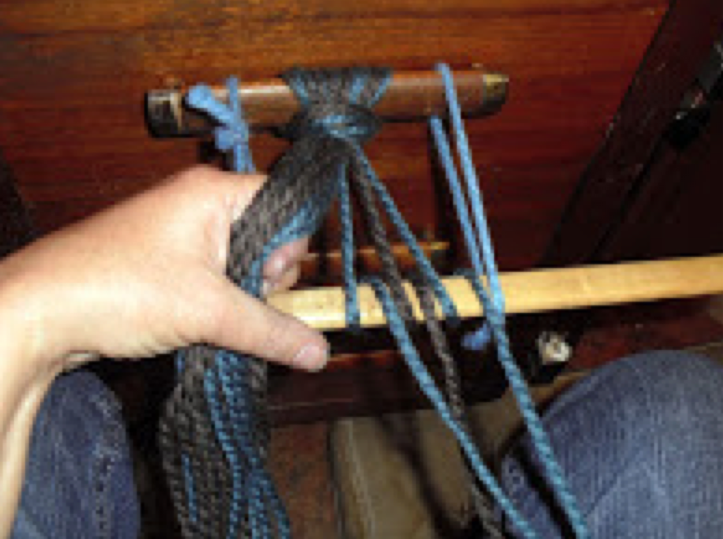

Then I separated the colors out into upper and lower threads. The color of the right most thread is the lower threads. The space in between the colors is the 'shed', where the active weaving yarn goes through.

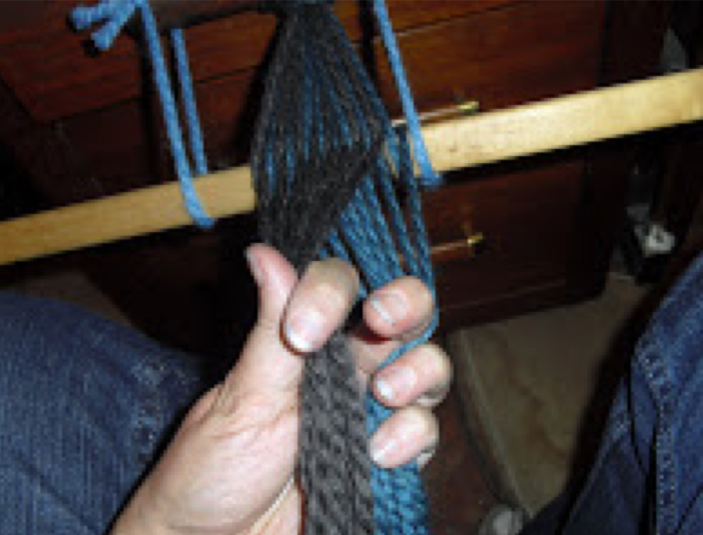

Here's the start of the first repeat: I held the yarn in my left hand, with my index finger separating the two colors into a shed. I picked up the right most thread with my right hand.

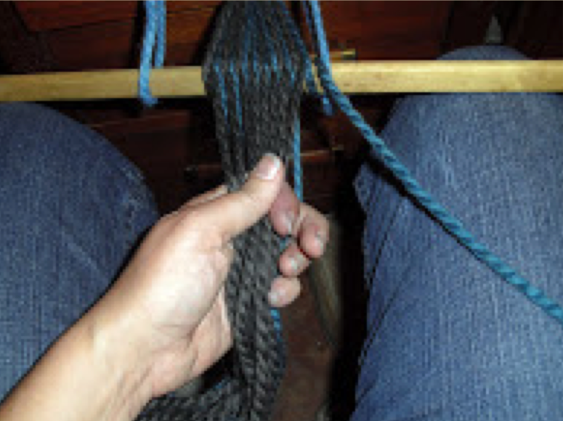

The right most thread went through the shed, and out the left side. I'm holding the yarn in my right hand now, again with my index finger in the shed. My left hand is pulling the weft (the active weaving yarn) all the way through and out the other side. This yarn gets parked up separately to the left for a moment while I change the shed and...and...Huh. The weaving takes two hands. The camera takes a hand. Can I take pictures with my feet? Heh. Nope. Hold on...

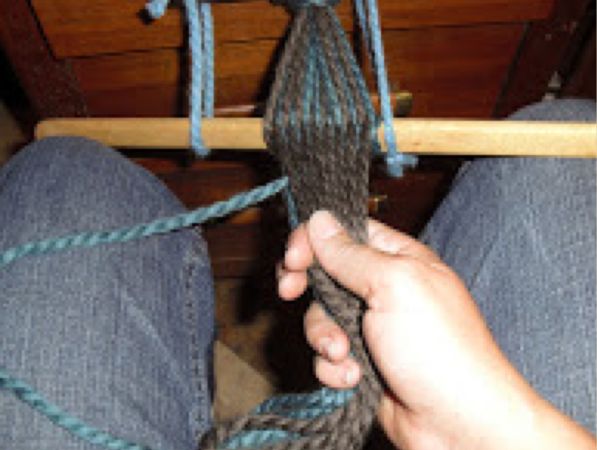

Ah ha! I knew I had teenagers for a reason. I wove a bit while my daughter got down here, then handed her the camera. Ok, back up a little bit. I'm going to take it from the beginning of the repeat again. I've picked up the right most thread in my right hand, while holding the shed open with my left.

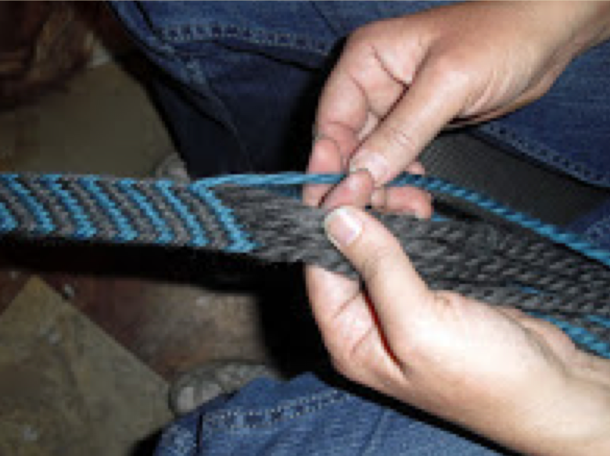

The weaving thread goes through the shed, and out the other side, while my right hand is holding the bundle of warp threads.

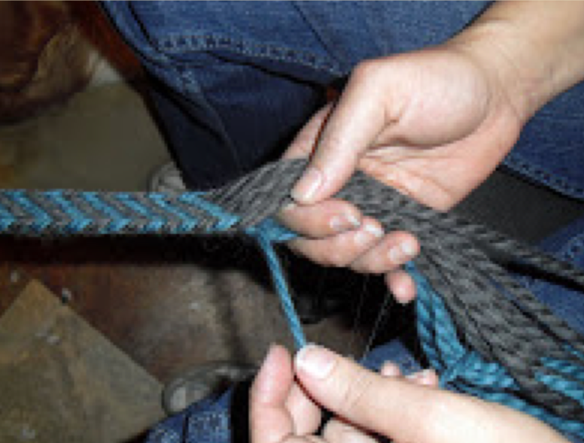

Now, I need to change the shed. I'm going to transfer the warp yarn in order from my right hand to my left hand. The threads that were on the bottom go on the top, and the threads that were on top go to the bottom. My index fingers are keeping the opening for the shed.

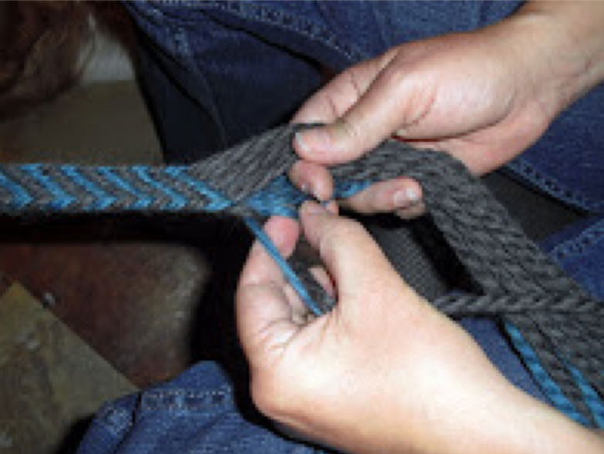

Like this.

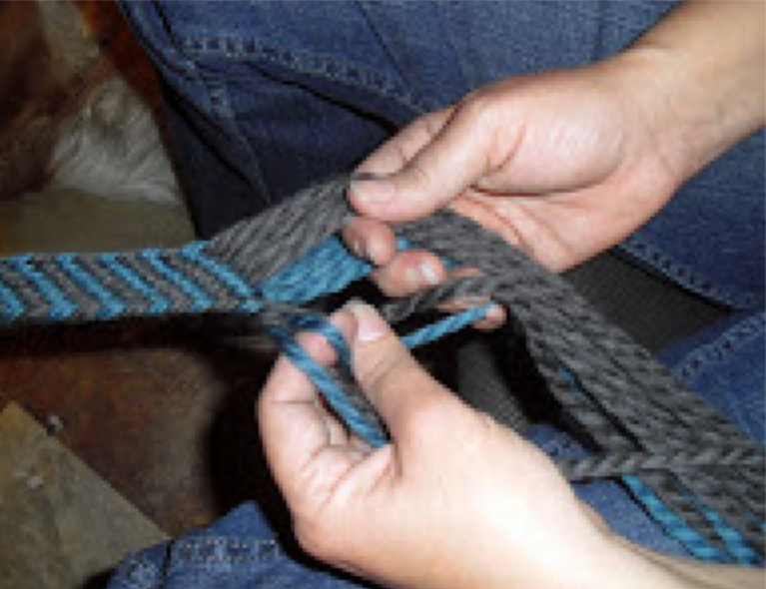

Keep working my way across, making sure to take each thread in order.

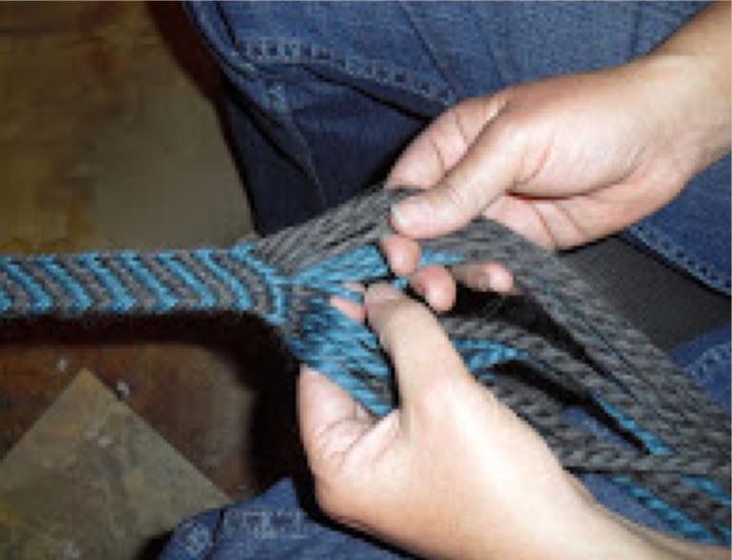

Once I get the shed changed, I separate out the two colors and tug gently to tighten up the previous stitch.

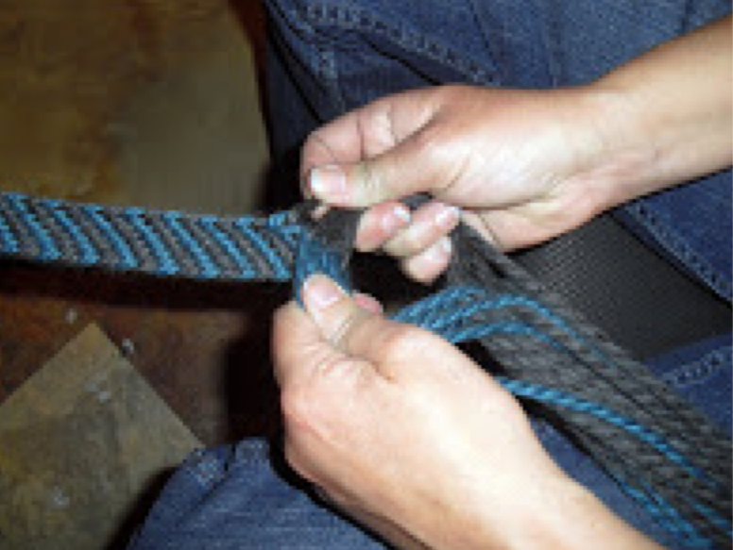

Then I hold the bundle in my right hand again, and tug gently on that last weft thread. This tightens everything back into place and keeps the edges even.

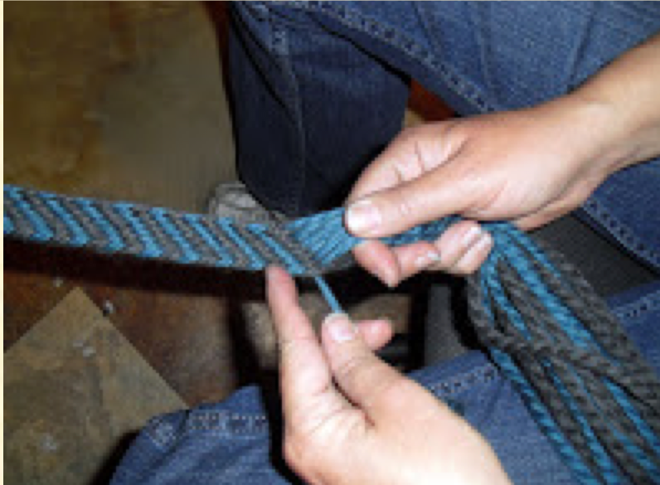

The previous weft thread gets added to the bundle in my hand, becoming a warp thread again.

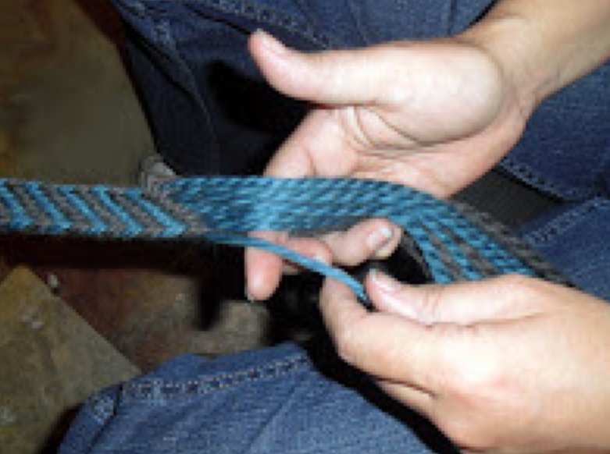

We're back to the beginning. I pick up the right most warp thread...

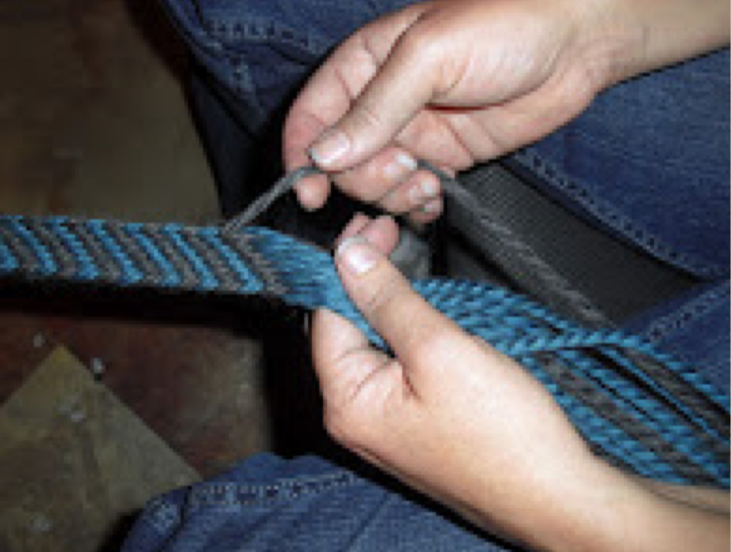

And turn it into a weft thread, pulling it through the shed. At this point, I sometimes use my fingers to comb out the un-woven threads that are hanging there, to clean out any tangles.

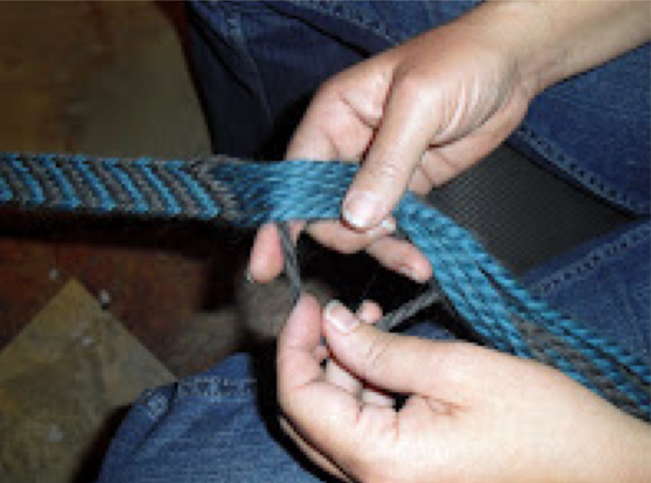

Now, you're back to changing the shed. The sequence is: weave the right most thread through the shed to the left side, comb out the tangles in the dangling warp threads, change the shed, and tighten things up.

When I needed to stop, I separated out the top and the bottom groups of yarn, and chained them up crochet style. Each bundle got looped over the hanging stick, and the active weft thread got draped over separately. That made it easier to find my place when I went back at it.

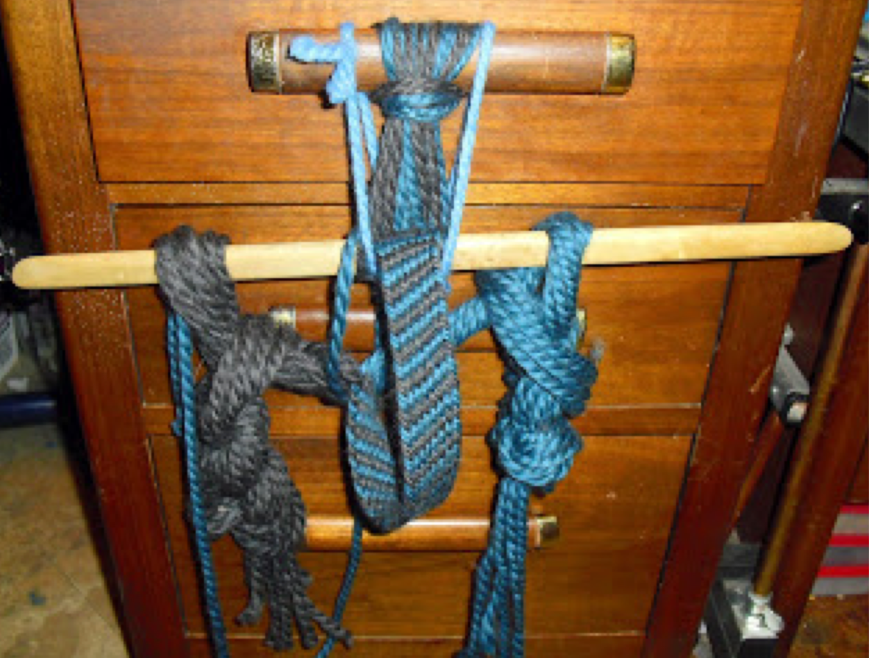

Here's my finished belt. Not bad for a beginning piece!! I just knotted the ends to make fringe to finish it off.

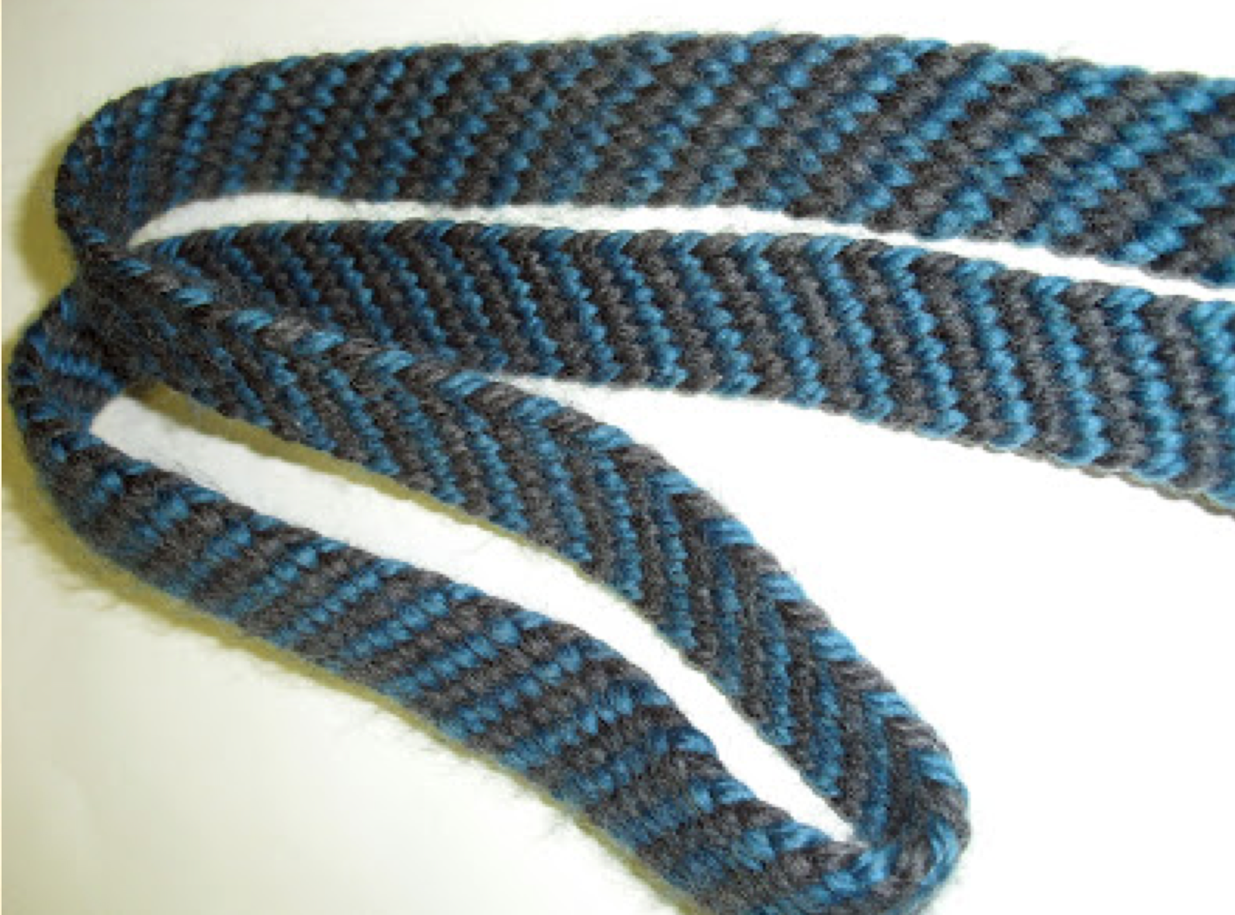
------
Copyright 2011 by Melissa McCollum. <lissagwen at cox.net>. Permission is granted for republication in SCA-related publications, provided the author is credited. Addresses change, but a reasonable attempt should be made to ensure that the author is notified of the publication and if possible receives a copy.

If this article is reprinted in a publication, please place a notice in the publication that you found this article in the Florilegium. I would also appreciate an email to myself, so that I can track which articles are being reprinted. Thanks. -Stefan.

<the end>

