Refilsaum-art - 10/17/19

"Refilsaum" Handout - Laid and couched work" by Racaire.

NOTE: See also the files: Couching-art, embroidery-msg, emb-blackwork-msg, P-Emb-Frames-art, emb-linen-msg, p-x-stitch-art, Blackwork-Emb-art, 8-P-Stitches-art.

************************************************************************
NOTICE -

This article was added to this set of files, called Stefan's Florilegium, with the permission of the author.

These files are available on the Internet at: http://www.florilegium.org

Copyright to the contents of this file remains with the author or translator.

While the author will likely give permission for this work to be reprinted in SCA type publications, please check with the author first or check for any permissions granted at the end of this file.

Thank you,
Mark S. Harris...AKA:..Stefan li Rous
stefan at florilegium.org
************************************************************************

You can find more work by this author on her website at:
http://www.racaire.at/

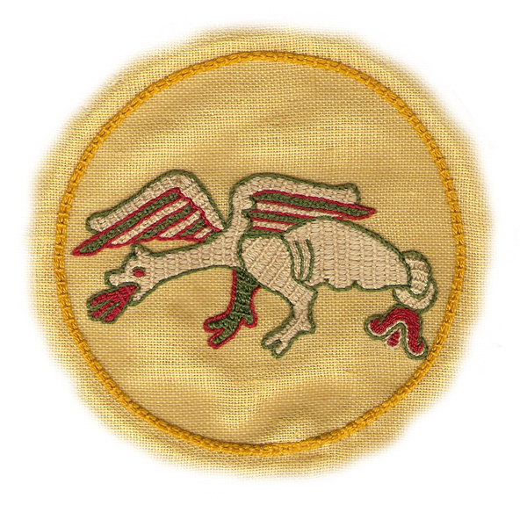

"Refilsaum" Handout
(laid and couched work)
v.2.0

by Racaire
Shire Ad Flumen Caerulum
Kingdom of Drachenwald

Many thanks to Jane Stockton (Laren) for her help, her inspiration & enthusiasm.

Use of Refilsaum embroidery:

In the past this type of embroidery was mainly used for wall hangings.

Large areas could be covered very quickly with this technique. Because of the threads used at that time and the big distances between the "holding stitches"- the threads could easily catch on things and therefore this technique was not so good for day to day wear or use.

Different types to use Refilsaum:

Use I) Figures: embroidered
Background: empty

Examples: Bayeux-tapestry (11th century)
(Ground fabric: Linen, Embroidery: Wool)

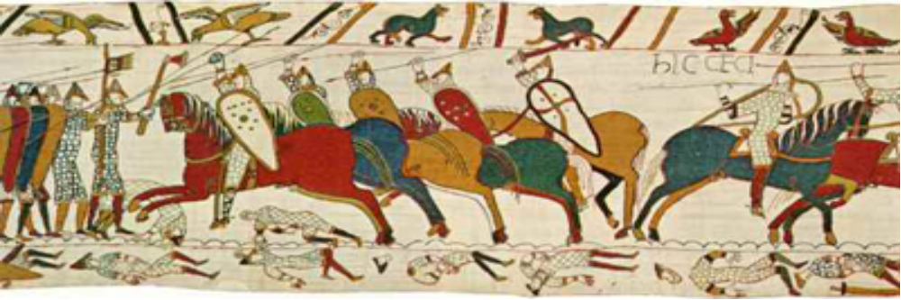
Source of this picture: unknown

Use II) Figures: empty
Background: embroidered

Examples: Wall-tapestry Iceland (14th century)
(Ground fabric: black Wool, Embroidery: - (Wool?))

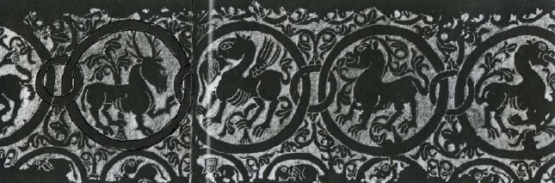
Source of this picture: "Das Stickereiwerk" written by Marie Schuette and Sigrid Müller-Christensen
Verlag Ernst Wasmuth, Tübingen

Use III) Figures: embroidered
Background: embroidered

Example I: Marien-tapestry Iceland (14th century)
(Ground fabric: Linen, Embroidery: Wool, white Linen)

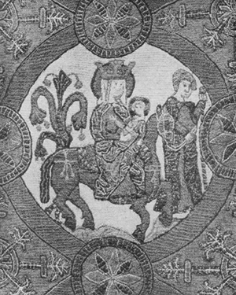
Source of this picture: "Das Stickereiwerk" written by Marie Schuette and Sigrid Müller-Christensen
Verlag Ernst Wasmuth, Tübingen

Example II: Altar Frontal (Draflastadir Church) Iceland (16th century)
(Ground fabric: Linen, Embroidery: Wool, Linen)

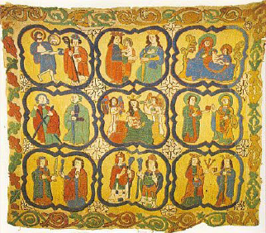
Source of this picture: http://medieval.webcon.net.au/loc_scandinavia_iceland.html
Refilsaum Technique:

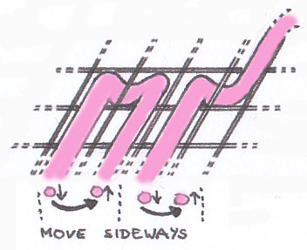  A 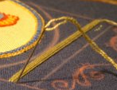 | A) First make the "basic"-threads:  Start every "basic"-thread moving sideways next to the point where the last thread left the surface…
B 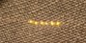  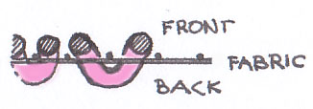 | ⇨ B) …that's all what you see of the "basic"-threads at the back - most of the thread stays on top of the embroidery.
C 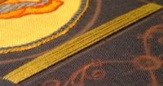 | C) Finished laying 12 "basic"-threads.
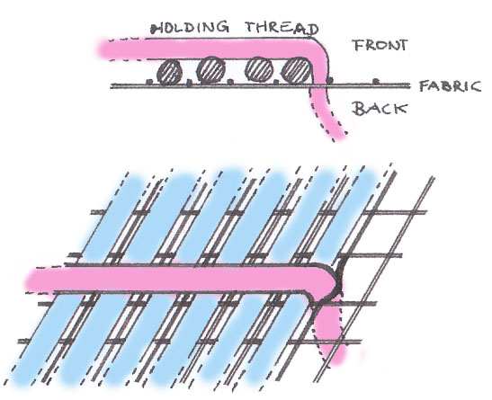  D 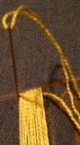 | D) After the "basic"-threads the holding threads have to be done.
E 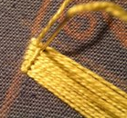 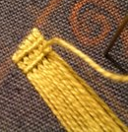  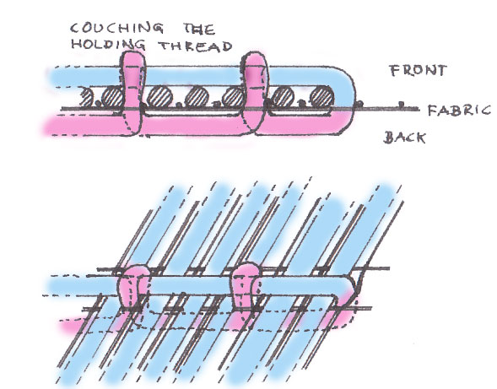 | E) Many technique descriptions for the "Bayeux" stitch show that first all the holding stitches are made and than couched…  …but I prefer to make a holding stitch and couch it while "going" back to the beginning of the holding stitch and so on…
F 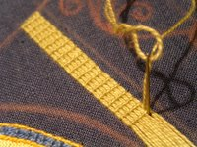 | F) Repeat it until you get to the other end of the basic threads...
G 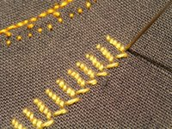 | G) A look at the back of the couched holding threads.
(http://racaire.blogspot.com/2005/12/photo-documentation-of-my-bayeux.html)
Other techniques used with Refilsaum:

Bayeux-tapestry:

The outline of the motives is done in stem stitch. Font, faces, hands, figures & other motives are done in stem-, chain-, and split stitch.
Nearly the whole area-wide embroidery is worked in Refilsaum only some small motives are worked with another couching stitch technique.
You will find a direction change of the Refilsaum inside some sections - because usually the "basic"-threads follows the longest distance. Example: the direction of the "basic"-threads of the leg is different than the "basic"-threads of the body, but all threads belong to the same section.

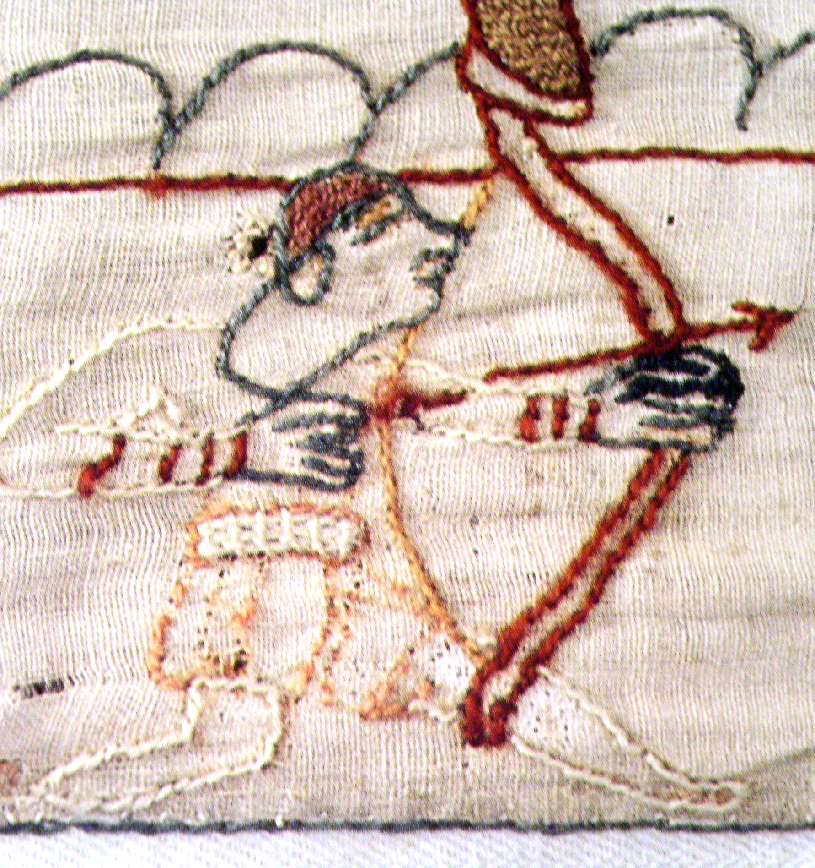
Source of this picture: "Der Teppich von Bayeux" - David M. Wilson

Bibliography:

Books: "Das Stickereiwerk" Marie Schuette, Sigrid Müller-Christensen
Verlag Ernst Wasmuth Tübingen 1963

"Der Teppich von Bayeux" David M. Wilson
Sonderausgabe 2003, Parkland Verlag, Köln,
ISBN 389340040-0,
(ISBN 0500251223 in English)

"The Embroidery Stitch Bible" Betty Barnden
(Krause Publications, Reprint 2004,
ISBN 0-87349-510-1)

Internet: "In Praise of the Needle" Jane Stockton - http://needleprayse.webcon.net.au
Handout "Scandinavian Laid and Couched Cushion"
"historical needlework resources" http://medieval.webcon.net.au

Concerning the photos in the section: "Different types to use Refilsaum:" – photos marked with "source unknown" – the copyright holders are not known. If you know the copyright holders please write me a message that I can add the information.
Handout "Refilsaum" - Appendix

FAQs:

Holding classes can be very interesting and during some of this classes additional questions concerning the technique occurred - I hope that the new section "FAQs" helps to solve this additional questions.

1) Laying the "basic"-threads:

Lay the "basic"-threads from one border ("A") of the section to the border of the opposite side of the section ("B")

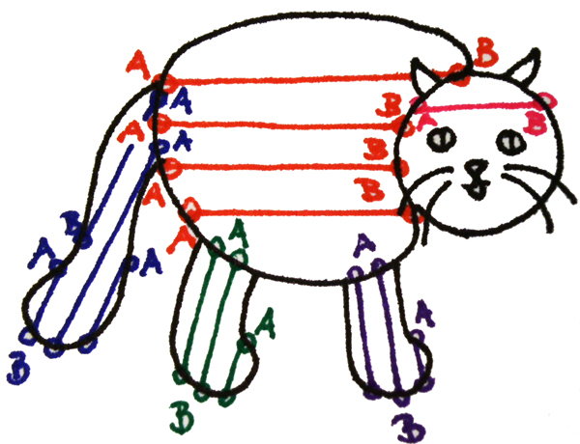

2) Direction of the basic threads:
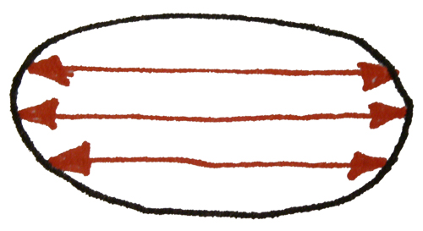
As long as I don't want to make a special surface pattern with this technique, I lay the threads over the longest distance or in the direction where I think that it will take the shortest time to finish the section. It's faster to lay some very long "basic"-threads, than a lot of short "basic"-threads and afterwards laying the holding threads and couching them is not as labour-intensive and time-consuming as laying the "basic"-threads.

The direction inside one motive can change from one section to the next and also inside a section.

3) Changing directions inside a section:

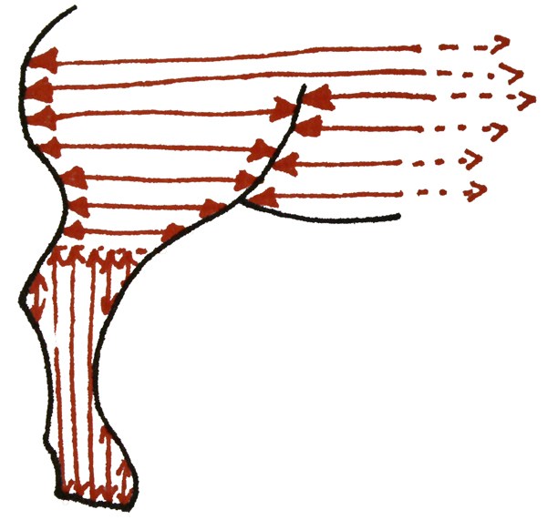
Sometimes it can be helpful to change the direction of the "basic"-threads inside a section and yes, it's period to do this!

To get a smooth changeover between the two parts I make one more holding thread over the changeover-line of the new section and couch it.

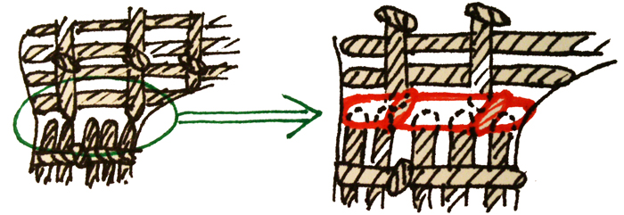

Some examples for changing directions inside a section found in the Bayeux-Tapestry:

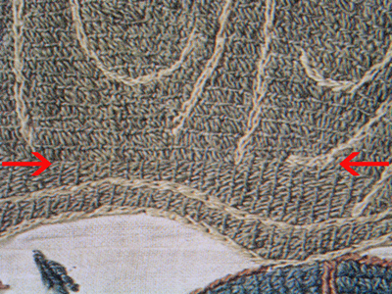

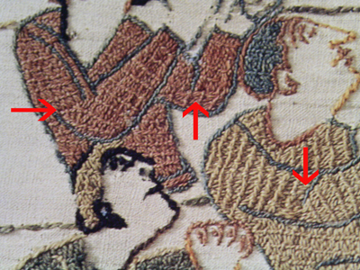

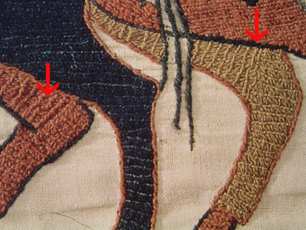
Source of this pictures: "Der Teppich von Bayeux" - David M. Wilson

…and this examples inspired me for my "how to work round shapes":

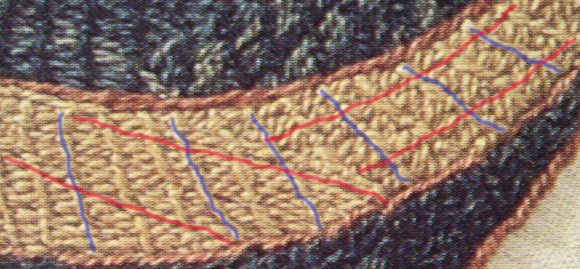

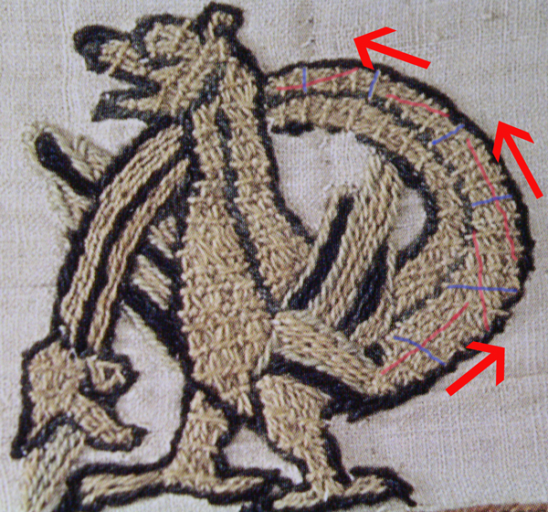
Source of this pictures: "Der Teppich von Bayeux" - David M. Wilson

(red lines: direction of the basic threads, blue lines: direction of the holding threads)

3.1) My "how to work round shapes":

This is my interpretation of filling round shapes (based on pictures from the bayeux tapestry)

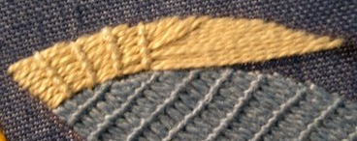 | Step 1: The second line of basic threads has to be worked staggerd to get round the corner  -> than the next holding stitches can be made  -> the holding stitches can be couched...
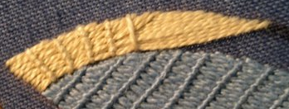 | Step 1.1: make a new "holding stitch"
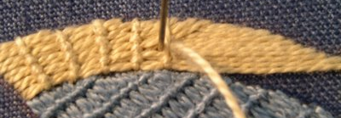 | Step 1.2: "couching" the holding stitch  (than again step 1.1 and 1.2 until you can continue with Step 2)
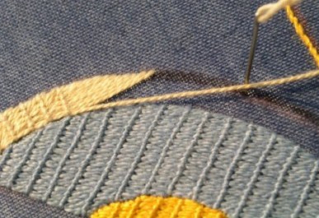 | Step 2: for the next basic threads I have to look how much I can move (condition: the thread should stay as straight as possible)
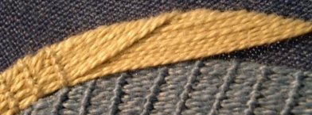 | …than continue with Step 1.1 and 1.2 and additional with Step 2 when you need more basic threads until…
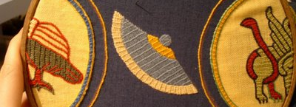 | …until the section is filled.
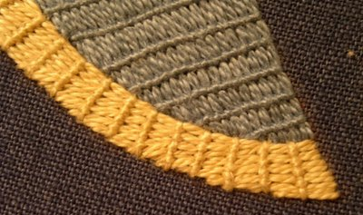 | Detail
(http://racaire.blogspot.com/2005/12/bayeux-stitch-and-round-shapes.html)

4) Filling the background:

Sometimes, if there is a big difference between the colour of the background and the thread, the background can shine through more than normally. I found two possible ways for me for 'cheating':

4.1) New threads behind the "basic"-threads:

This technique is very simple - you just add new threads behind the "basic"-threads.

The threads you use should have the same colour like the thread used in the section.

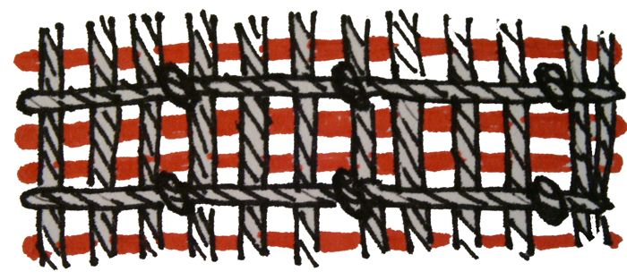
You can use as many threads as you like as long as they fit into the room between the holding stitches without disturbing the surface.
4.2) Adding additional "basic"-threads:

Working this technique I prefer to start underneath one of the holding threads and to end underneath a holding thread (or to start/end at the edges of a section).

The new thread should also have the same colour like the thread used for the section.

Again you can add as many threads as you like or need - normally I use this technique wherever a "hole" is visible in the surface of the "basic"-threads after I finished the section.

Sometimes I use technique 4.1, sometimes 4.2 or both – I would recommend to use the technique that fits best for your work and functioning.

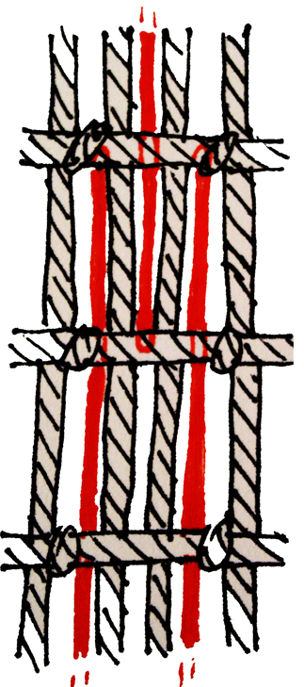

Good luck for your embroidery projects & don't forget to have fun while working at them!

Please don't hesitate to contact me if you have further questions concerning this technique.

Yours in Service
Racaire

------
Copyright 2010 by Racaire. <ego at @racaire.at>. Permission is granted for republication in SCA-related publications, provided the author is credited. Addresses change, but a reasonable attempt should be made to ensure that the author is notified of the publication and if possible receives a copy.

If this article is reprinted in a publication, please place a notice in the publication that you found this article in the Florilegium. I would also appreciate an email to myself, so that I can track which articles are being reprinted. Thanks. -Stefan.

<the end>

