Dptych-Sndial-art - 8/25/10

"A Diptych Sundial" By H.L. Morgaine Essex And H.L. Hucbald ap Urp.

NOTE: See also the files: sundials-msg, calendars-msg, clocks-msg, Time-Keeping-art, Watches-art, bells-msg, time-art.

************************************************************************
NOTICE -

This article was submitted to me by the author for inclusion in this set of files, called Stefan's Florilegium.

These files are available on the Internet at: http://www.florilegium.org

Copyright to the contents of this file remains with the author or translator.

While the author will likely give permission for this work to be reprinted in SCA type publications, please check with the author first or check for any permissions granted at the end of this file.

Thank you,
Mark S. Harris...AKA:..Stefan li Rous
stefan at florilegium.org
************************************************************************

You can find more articles by this author on his website at: http://www.hucbald.ramst.ca

A Diptych Sundial
For
Sealion War
June 10th 11:30 AM
A.S. 41 (2006)

by
H.L. Morgaine Essex
and
H.L. Hucbald ap Urp

A Diptych Sundial

Sundials can be built in varying shapes and sizes. The common sundial that we usually think of is a horizontal sundial. The sundial casts a shadow onto a horizontal plane that is marked to indicate the time. The shadow moves across the surface of the sundial as the sun moves across the sky. This requires that the sundial be oriented towards the Earth's North-South pole.

The shadow is cast by a gnomon which means "indicator" or "one who discerns" in Latin. The gnomon is angled at the same angle as the latitude from which the sundial is placed. This makes the gnomon parallel to the Earth's axis and must be adjusted at different latitudes.

The same principal is true for vertical sundials. Vertical sundials were installed on the walls of tall buildings so that they would be visible from afar. The gnomon, as with a horizontal sundial, is angled for the latitude in which it is used.

By combining a horizontal and a vertical sundial a small portable sundial can be created called a diptych sundial. The two sundials share a common gnomon. As the diptych is oriented the two sundials cast shadows onto the sundial faces. When the diptych reads the same time on both sundials, then the diptych is properly aligned to tell local time. As an additional benefit the diptych is aligned to true North. This allows the diptych to act as a compass.

The earliest diptych sundial dates from the mid 15th century and versions continue to be made into the mid 18th century. These all have in common the vertical and horizontal sundials and gnomon. Later versions starting in the 16th century include compasses for easy alignment and begin to include adjustable gnomons along with charts of cities to determine gnomon angle settings (latitude).

Early mathematicians such as Ptolemy were aware that the length of a day varied irregularly throughout the calendar. This is because of the elliptical orbit of the earth around the Sun and varies throughout the year. The Equation of Time can be seen below.

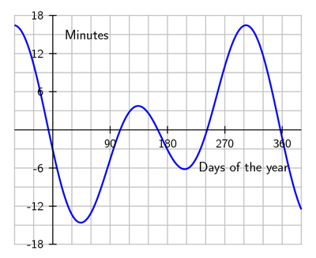
June 10, 2006 = 161st day of the year (note: at about the 165th day, there is no adjustment)

A Bit on the Math

The angle of the shadow lines displayed on the surface of either a vertical or horizontal sundial is 15 degrees for each hour.

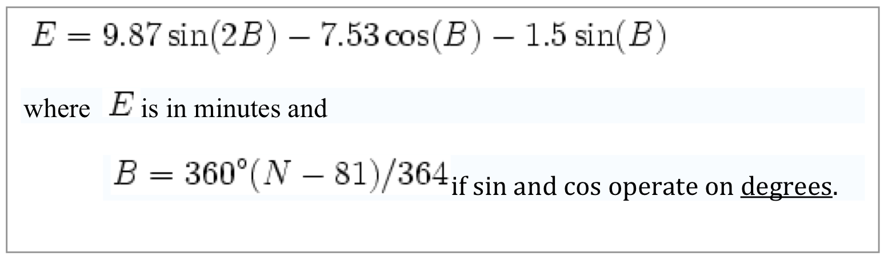
Source: http://en.wikipedia.org/wiki/Equation_of_time

This shows the Equation of Time as calculated for June 10th (day 161) which would be 46 seconds fast. From year to year this calculation may vary by up to 20 seconds.

Euclid

Euclid of Alexandria lived between 325BC and 265BC and was one of the great mathematicians. Amongst his writings is The Elements which is the foundation for what we call Euclidian Geometry. Euclidian Geometry was used for calculating three-dimensional space for more than 1500 years. The mathematics for calculating the declination of celestial objects was used throughout the Middle Ages.

Euclidian Mathematics was eventually replaced by Cartesian Geometry, a merging of algebra and geometry, which was created by Rene Descartes b1596-d1650.

Ptolemy

Claudius Ptolemy lived from 85AD to 165AD. Ptolemy expanded on Euclid's geometry. While a renown geographer he also excelled in astronomy and created the geocentric theory that the Sun revolves around the Earth that survived for 1400 years. This was later replaced with the heliocentric model in which the Earth revolves around the Sun created by Nicolaus Copernicus b1473-d1543.

Ptolemy's work of compiling astronomical data in The Almagest and mapping data in The Geography was used throughout the middle ages as a basis for most work in developing astrolabes, quadrants and other devices used for time measurement and geographical positioning.

Creating a Diptych

Because of time and budget limitations, non-period materials and techniques were used in creating a version of a diptych.

The panels are made of wood. These are the surfaces of the horizontal and vertical sundials. Most diptychs were made from ivory or box wood. Several examples of period pieces are made of brass.

For the ornamentation on the diptych, brass was used. The fittings are commonly found in hardware stores and/or hobby stores. This is to add look and feel to the diptych.

The gnomon is made from black cording. Without spending time tracking down linen to make a period gnomon a substitution was made here by using a close approximation.

Acrylic craft paint was used on the inside surfaces of the diptych. While acrylics are modern, paint itself is not. Many diptychs show inlaid ivory with graduations marking hours. Later versions are indeed painted as they shown vivid colours but this is rare. A simple painting was used to show contrast and may be considered as a substitution for the use of ivory.

For the outer surfaces, the designs were burned into the wood. The technique is ancient but the tool used was a modern electric wood burning tool.

Sources

Carl Sabanski "The Sundial Primer" My Sundial.ca.
June 4, 2006 <http://www.mysundial.ca/tsp/horizontal_sundial.html >

"Cladius Ptolemy" The MacTutor History of Mathematics archive.
April 1999, May 30, 2006 < http://www-history.mcs.st-andrews.ac.uk/history/Mathematicians/Ptolemy.html >

"Declining Vertical Sundial Calculator" Derbyshire Sundials
September 20, 2004, June 5, 2006 < http://www.sundials.uklinux.net/wd_calc.htm >

"Diptych." Wikipedia: The Free Encyclopedia.
April 8, 2006, May 28, 2006 < http://en.wikipedia.org/wiki/Diptych >

"Equation of Time." Wikipedia: The Free Encyclopedia.
May 24, 2006, May 31, 2006 < http://en.wikipedia.org/wiki/Equation_of_time >

"Euclid of Alexandria" The MacTutor History of Mathematics archive.
January 1999, May 30, 2006 < http://www-history.mcs.st-andrews.ac.uk/Mathematicians/Euclid.html >

"Gnomon." Wikipedia: The Free Encyclopedia.
May 27, 2006, May 29, 2006 < http://en.wikipedia.org/wiki/Gnomon >

Gudrun Wolfschmidt "A Historian Looks at Astronomy in the Classroom" University Hamburg, Math Department.
June 30, 2000, June 4, 2006 <http://www.math.uni-hamburg.de/math/ign/xyz/ca00-v5.htm >

Karen Mulcahy "Bits of Map Projection History" Hunter College, Geography Dept.
July 14, 1997, May 31, 2006 http://www.geo.hunter.cuny.edu/mp/mapintro.html

"Nicolaus Copernicus" The MacTutor History of Mathematics archive.
November 2002, May 30, 2006 < http://www-history.mcs.st-andrews.ac.uk/history/Mathematicians/Copernicus.html >

"Ptolemy." Wikipedia: The Free Encyclopedia.
May 31, 2006, June 2, 2006 < http://en.wikipedia.org/wiki/Ptolemy >

"René Descartes" The MacTutor History of Mathematics archive.
December 1997, May 30, 2006 < http://www-history.mcs.st-andrews.ac.uk/history/Mathematicians/Descartes.html >

"Sundial." Wikipedia: The Free Encyclopedia.
May 28, 2006, May 28, 2006 < http://en.wikipedia.org/wiki/Sundial >
------
Copyright 2006 by Ron Sharcott, 1879 Kings Road, Victoria BC, Canada V8R 2P2. <hucbald at ramst.ca>. Permission is granted for republication in SCA-related publications, provided the author is credited. Addresses change, but a reasonable attempt should be made to ensure that the author is notified of the publication and if possible receives a copy.

If this article is reprinted in a publication, I would appreciate a notice in the publication that you found this article in the Florilegium. I would also appreciate an email to myself, so that I can track which articles are being reprinted. Thanks. -Stefan.

<the end>

