BD-Hand-Cart-art - 10/28/15

"Breakdown Hand Cart" by Lord Gregor Reinhardt von Holstein and Baroness Genoveva von Lübeck.

NOTE: See also these files: carts-msg, Cart4Pennsic-art, Dog-Carts-art, wheelbarrows-msg, dog-carts-msg, p-backpacks-msg.

************************************************************************
NOTICE -

This article was added to this set of files, called Stefan's Florilegium, with the permission of the author.

These files are available on the Internet at: http://www.florilegium.org

Copyright to the contents of this file remains with the author or translator.

While the author will likely give permission for this work to be reprinted in SCA type publications, please check with the author first or check for any permissions granted at the end of this file.

Thank you,
Mark S. Harris...AKA:..Stefan li Rous
stefan at florilegium.org
************************************************************************

You can find more work by these authors on their website at:
http://honorbeforevictory.com

Breakdown Hand Cart
by Lord Gregor Reinhardt von Holstein and Baroness Genoveva von Lübeck

A cart is very handy to have at Pennsic and other large SCA events. Gregor designed this cart to breakdown flat for easy transport, yet be easy to assemble and pull. It features legs that allow the cart to rest flat. The wheels are reinforced with metal for longevity. And all the wood and parts can be purchased from your local hardware store for ease in creating your own cart.

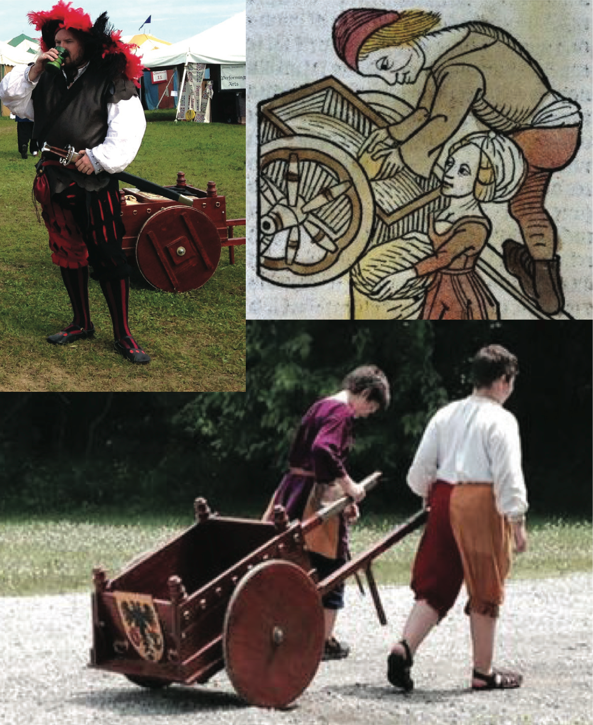

Notes on Making Your Hand Cart

• The boards for the base were made of three lengths of 12" planks laid next to one another, and then supports were screwed in (from the top down) to keep the three boards together. The side walls cover the screws once assembled.

• The wheels are sold as rounds, or tabletops, at the home improvement stores (we bought these at Lowes). A 1" strip of aluminum is nailed to the circumference of the round wood to minimize wear and tear on the wheels.

• The cart design was inspired by period carts, but the need to have it breakdown flat did necessitate changes.

• We originally had some issues with the steel collars coming loose on the wheels because of the vibration, so we added hitch pins to keep them in place.

• This cart is the perfect size for going to the market, transporting class materials to Pennsic University, and for doing ice runs. We even made a little tip box for our son to collect ice run tips!

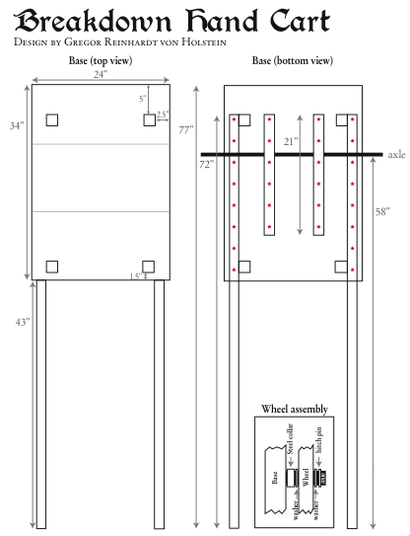

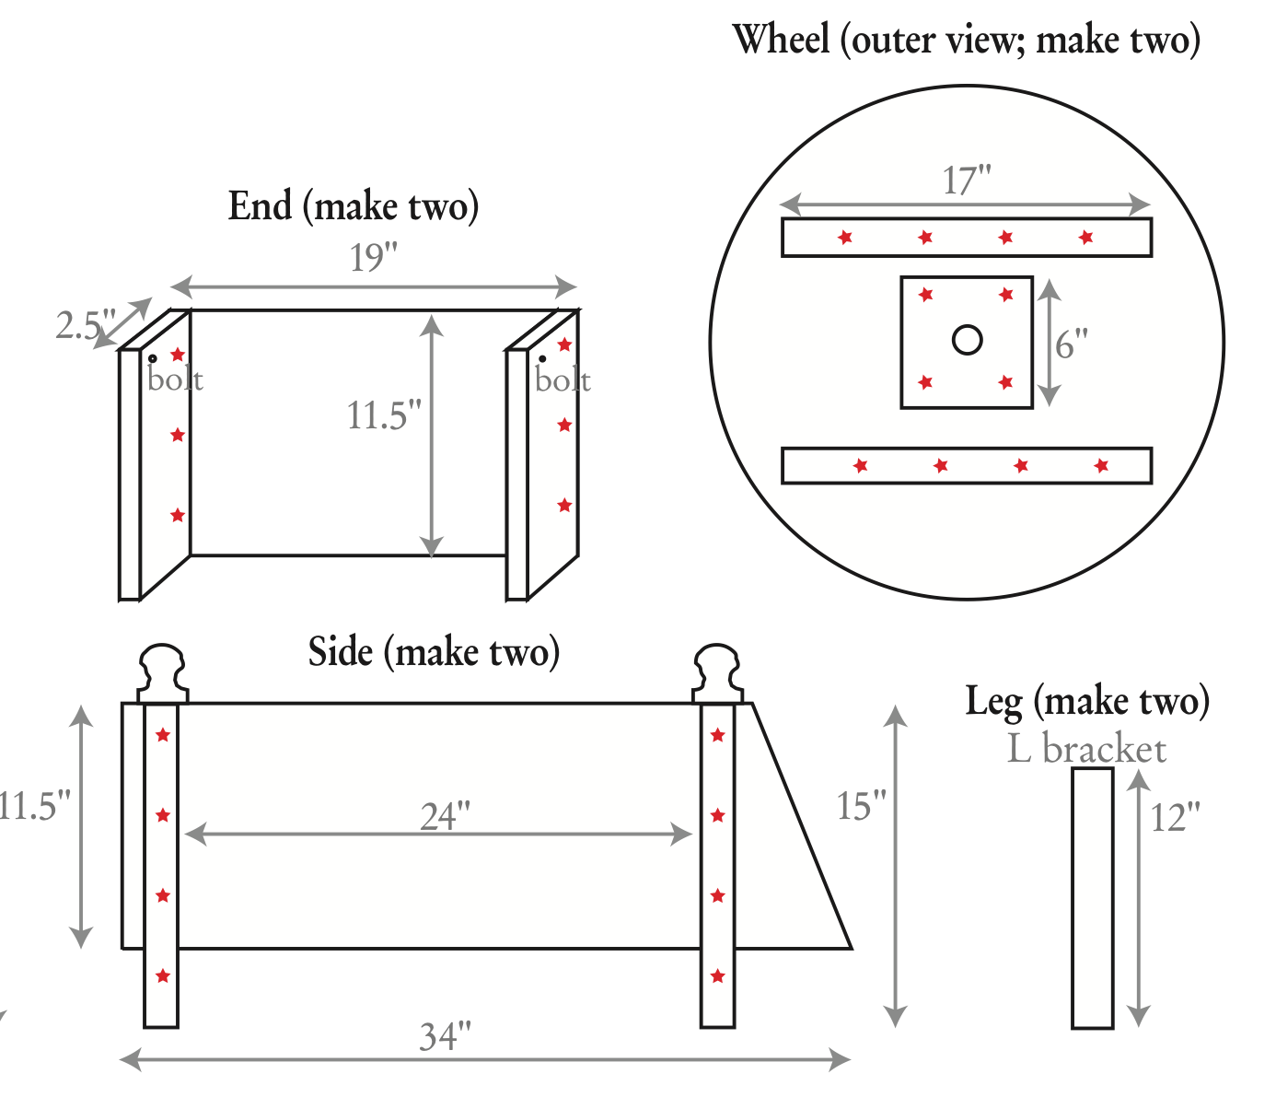

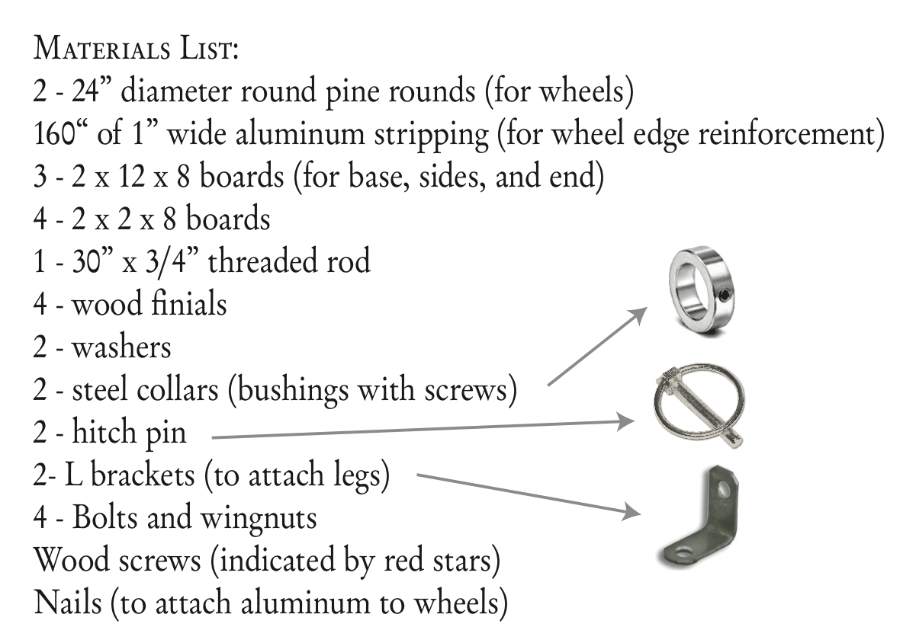

About the Authors, Contact Details, and Copyright Notice

Lord Gregor Reinhardt von Holstein and Baroness Genoveva von Lübeck reside in the Barony of Cynnabar within the Kingdom of the Middle. We enjoy helping anyone interested in getting the most out of their SCA experience. You can e-mail us at gregor.von.holstein at gmail.com and at genoveva.von.lubeck at gmail.com.

Please visit our web site at http://honorbeforevictory.com where you’ll find tutorials, projects, photos, articles, and information!

This publication is protected under the US Copyright Act of 1976 and all other applicable international, federal, state and local laws, and all rights are reserved. You may use the pattern we developed to create carts, and you are free to sell the carts you make. You may not sell the patterns themselves in hardcopy or in digitized form, and you may not reprint or repost the patterns in any form without my express permission. When in doubt, please e-mail us.
------
If this article is reprinted in a publication, please place a notice in the publication that you found this article in the Florilegium. I would also appreciate an email to myself, so that I can track which articles are being reprinted. Thanks. -Stefan.

<the end>

