Cart4Pennsic-art - 8/10/14

"On the Design and Making of a Collapsible Cart for Pennsic AKA: A Shopping Cart for Your Lady" by Lord Rhys, Capten gen y Arian Lloer.

NOTE: See also the files: carts-msg, wheelbarrows-msg, Dog-Carts-art, woodworking-msg, tools-msg, Lea-Hardware-art, Trestle-Table-art, 6-board-chest-art.

************************************************************************
NOTICE -

This article was submitted to me by the author for inclusion in this set of files, called Stefan's Florilegium.

These files are available on the Internet at: http://www.florilegium.org

Copyright to the contents of this file remains with the author or translator.

While the author will likely give permission for this work to be reprinted in SCA type publications, please check with the author first or check for any permissions granted at the end of this file.

Thank you,
Mark S. Harris...AKA:..Stefan li Rous
stefan at florilegium.org
************************************************************************

On the Design and Making of a Collapsible Cart for Pennsic
AKA: A Shopping Cart for Your Lady
by Lord Rhys, Capten gen y Arian Lloer
Privateer for the Midrealm



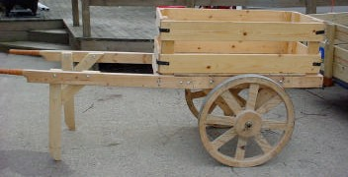

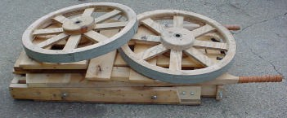

My good friends of the Sca,

Last year I constructed "A Cart For Pennsic". It was made closely following the design by Honourable Sergeant Avery Austringer and his plans can be found at http://home.i1.net/~avery/cart/cart.html. Over the last year, I have made a number of adaptations in my cart to fit my needs. This design would never have happened without the hard work and design Lord Avery put into the original. All of my redesign was done after I built Lord Avery's version. But, I must admit, my wife says I may not dismantle and rebuild it again unless I build her a totally new one.

This project requires the original design. Rather then duplicate his instructions, I have only made notes on my variation. This is a direct adaptation allowing the cart to be broken down for storage and transportation to and from events. It also has front legs and removable sides. Lord Avery's cart will cost slightly less to make, but requires a trailer to carry it in and a place to store it between events. These adaptations are by no means all that can be done with the basic design. Make any modifications that fit your needs. As a Laurel I know would say LUDI FAC!, or Have Fun, Make Stuff!

General notes and features:

• The redesign allows the cart to be put in the back of a van, on a car top carrier, or even in a back seat. For car top, please make sure all smaller parts are in the car.

• The largest piece is about 2 feet by 4 feet when disassembled. Even with all parts on top of it, it only requires about twelve inches of space.

• Between events, I use a rope and pulley to hoist the cart (broken down) to the ceiling of my garage.

• It requires no tools to assemble or disassemble. Only wing nuts and lynch pins.

• It has front legs to stay stable and level when not in use.

• The sides are removable to become a flat cart or a table. Or simply remove the front and back walls for long items.

• It makes an excellent mobile water station on a battlefield.

• These variations add about $25 to the cost of the project, for a total of around $75.

• Lord Avery recommended Thompson's Water Seal to protect the wood. Unfortunately, I found it tended to leach onto anything I put against the cart in storage, and I especially wanted to protect items put in the cart. Since this version can be stored in a garage or shed, I recommend a coat of Tung Oil, Polyurethane, or nothing at all.

• A word of warning for those Pennsic bound. If camping with a large group, be prepared to lend out the cart a lot. Mine has carried armor, ice bags, list poles, an entire pavilion, rolls of fabric, and who knows what else. My Lady has found it makes an excellent shopping cart, especially if I am along to push the cart and pay for her purchases. I found 500 pounds made it squeak like crazy, and put a slight wobble in the wheels, but nothing an extra spacer would not fix.

Materials List: (Additional materials used for this adaptation.) Sheet metal to band the wheels.

3 - 2 x 4 x 8 foot boards
2 - 1 x 6 x 8 foot boards
2 - 4in 5/16ths hanger bolts
4 - 4in 5/16ths carriage bolts
8 - 6in 5/16ths carriage bolts
2 - 4in 5/16ths hanger bolts
14 - 5/16ths washers
14 - 5/16ths wing nuts
8 - double-headed 16 penny nails
8 - 16 penny nails
2 - Lynch Pins large enough to slip easily over the axle
2 inch and 3 inch deck screws

Step One:
The framework and wheel carriage

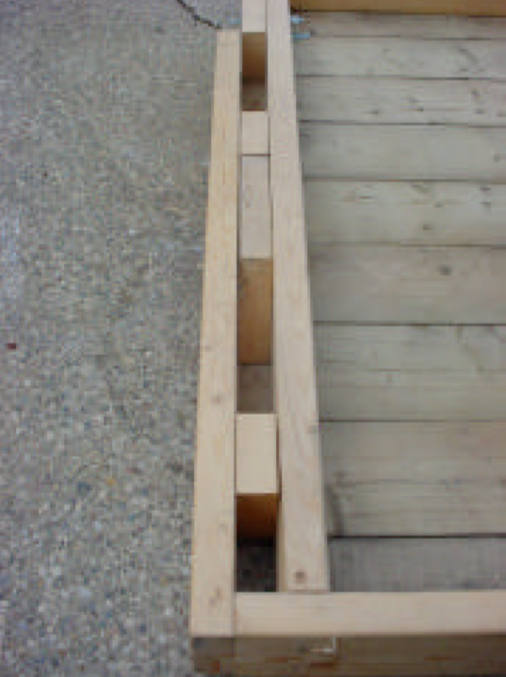

This is the most complicated part of the adaptation. Rebuilding the frame to make the wheel carriage removable was a challenge. But, pockets for the trusses did the trick, allowing stability with out the crossbar. Lynch pins are the perfect thing to replace the caps on the wheel hubs.

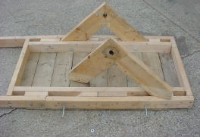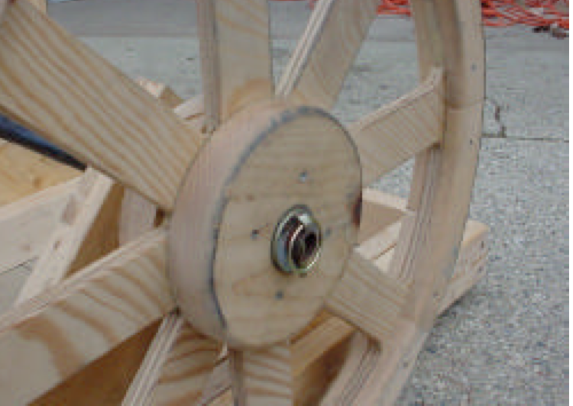

Additional materials cutting list:

2 – 45 3/4 inch 2 x 4 (or equal to the length between the crossbars)
2 – 3 1/4 inch 2 x 4
2 – 18 1/4 inch 2 x 4 Miter ends to 45 degrees in opposite directions like a pyramid
2 – 6 1/4 inch 2 x 4

Eliminate the 21 inch cross brace between the two trusses. From the handle end of the cart (the front), put in the new pieces in this order from the crossbar to the end of the cart: A 3 5/8ths inch space that becomes the pocket for the stake rake. Then the 6 1/4 inch block. Next, a 5 inch space for the truss pocket. Followed by the 18 1/4 inch block with two 45 degree miters. Next, another 5 inch space for the other end of the truss. And last goes the 3 1/4 inch block, leaving another 3 5/8th inch space at the end. The 45 3/4 inch piece goes along side these and use enough 3 inch deck screws from both the inside and out to make everything tight. Trim the tips of the wheel trusses to fit in the pockets. They will be very snug. Slip them into the pockets made for them and drill an 11/32nds hole through the center of each 5 inch pocket and the trusses. Use 4 - 6 inch carriage bolts to secure the trusses in place. The last step is to alter the axle hubs. Instead of using caps on the black pipe drill a hole through the pipe to fit the lynch pins. Use enough washers on the pipe to keep the wheels snug. Slip in the lynch pins and flip them over to finish this step.

Step Two:
Removable Arms

I got the whole thing to break down and realized it was still 8 feet long. But a quick cut or two, and the whole cart can go into the back seat of a car.

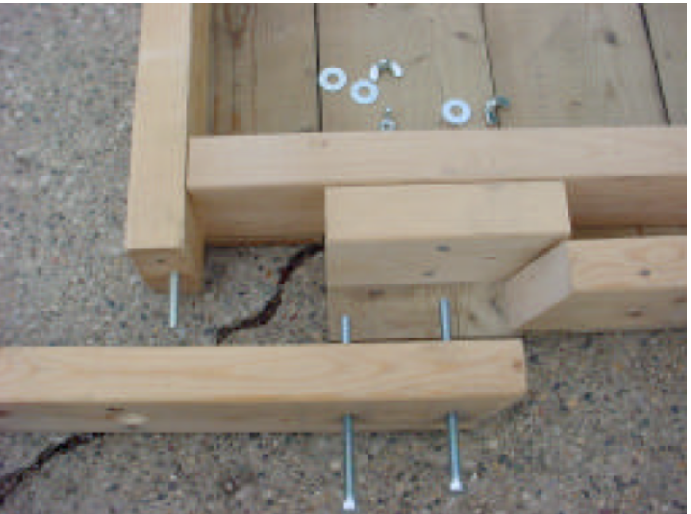

Additional materials cutting list:

None

A quick and easy fix. Mark a spot on the arms where the pocket for the wheel trusses start. Drill two 11/32nds holes for carriage bolts through the spacer between the wheel truss and stake rack pockets. Drill a 1/4 inch hole where the cross bar meets the arm. Enlarge the hole in the arm only to 11/32nds and make a 1 1/4 inch counter sink with a fostner bit for the wing nut. Remove the 8 foot arm from the frame and cut at about a ten degree angle towards the handle. Put a 5/16ths x 4 inch hanger bolt into the crossbar. Permanently attach the shorter part of the board back to the frame and reattach the arms with 2 - 6 inch carriage bolts and the hanger bolt using washers and wing nuts.

Step Three:
The Front Legs

One problem I had with the original cart was to let go of it, you had to tip it down and everything slid to the front. Legs stabilize the cart without getting in the way when moving it.

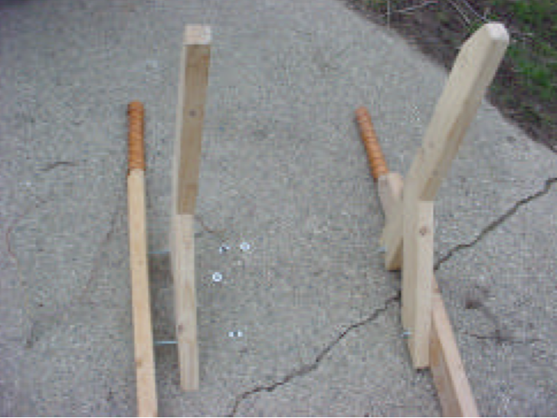

Additional materials cutting list:

2 - 2 x 4x28 inches
2 - 2 x 4x20 inches mitered 45 degrees towards the center like a pyramid

This step uses the same methods as the wheel trusses on page 3 of Lord Avery's design to create half-lap joints. Half-lap the legs and the braces together on a 45 degree angle, using a table saw with a dado blade. Do not half-lap the arms and the top of the legs, as that would reduce the strength of the arms. I used two legs for looks only, not for any additional strength. The wheels hold the weight of anything in the cart, the legs are there only to make things level. The legs are just surface mounted 18 inches from the tips of the handles using 4 – 4 inch carriage bolts. I put a 30 degree angle at the bottom of each leg to reduce the surface in contact with the ground.

Step Four:
Banding the wheels

After spending a lot of time making wheels the last thing you want is for them to be damaged. Band them with metal, you wont regret it.

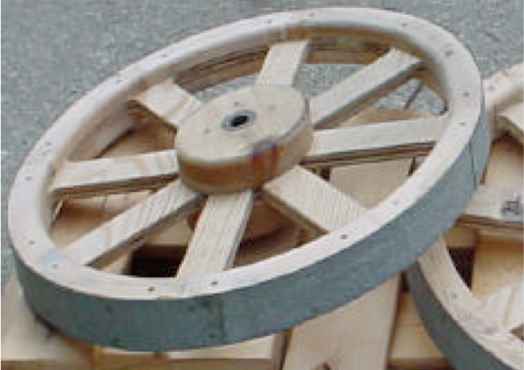

Additional material cutting list:

8 - 2 1/2 x 30 inch strips of sheet metal

This is actually a lot simpler than it looks. I went to a heating and cooling shop, one that actually installs duct work. For about $8 they used their break machine to make me the 8 strips of metal. It is a bit thin, but I have been using it for a year, and I should get one more year before I have to redo the banding. To attach the banding, use simple 1 inch finish nails allowing about an inch of overlap. They go right through the metal and into the wheel with no problems.

I have not had any problems with nail heads wearing off to this point. To replace the metal, just pull it off and start over. But, this is a cheap method of protecting all the hard work.

Step Five:
Stake Rack Sides

Removable sides make the cart into a quick table or battlefield water station. The ends can be popped off for long items.

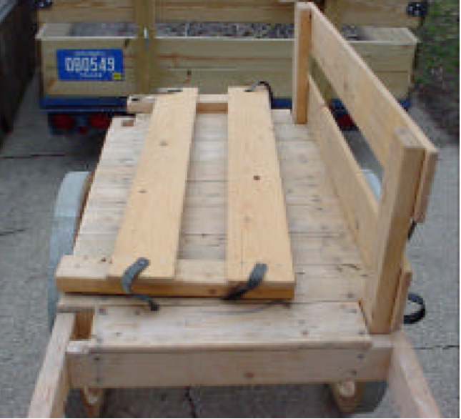

This is the first modification I made and it was really because Lord Avery left the box pretty much up to the maker. I wanted something very versatile, but strong enough to support the weight I might put in it. When strapped to the front and back, the sides can support any weight without spreading apart at the top.

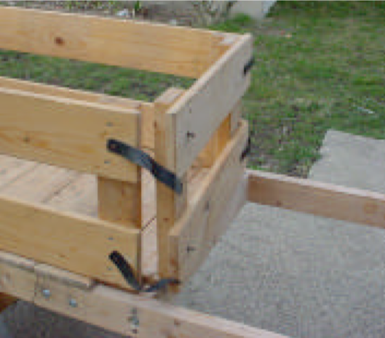

Additional materials cutting list:

4 - 2 x 4 x 19 inches
4 - 2 x 4 x 15 inches
4 - 1 x 6 x 47 inches
4 - 1 x 6 x 23 3/4 inches
8 - 7 inch x 1 inch medium weight leather straps

Having made the stake rack holes in step one, this step is easy. Note there are no holes for the end pieces, they are held on with straps. When putting on the deck, leave the stake rack holes uncovered. The deck must go on before this step.

Remove the wheels and trusses from the cart. Put the cart flat on the ground with the deck side up. Put the 19 inch 2 x 4s through the stake rack holes in the deck top. Using 2 inch deck screws, attach a 47 inch 1x6 right where the deck meets the 2 x 4. Attach a second 1x6 flush to the top of the 2 x 4s. Repeat for the other side. The 15 inch 2 x 4s get their 1x6s set flush with the top and bottom allowing a 1 3/4 inch over hang on each side of the 1x6s.

To attach the leather straps, put the front and back sides on the cart where they will normally go. You will need to use a hacksaw to shorten the 16p nails and double headed nails to 1 3/4 inches. Otherwise they will go through the stakes. Nail one end of the strap to the center where the 2 x 4 and 1x6 intersect on the out side of the cart. And put a double-headed nail at the same location on the end. Hold the strap around to find where it meets the double- headed nail and cut a small slit like a button hole so that the strap will slip over the nail. Allow a small amount of slack in case of shrinkage of the leather. Repeat the step at the top and bottom of all four corners. A little mink oil applied occasionally will keep the leather safe from weather.

Step Six:
Leather Hand Gripes

Anyone who has gone up and down the hills at Pennsic will appreciate not having to carry their armor. However, I wanted to make sure the cart had safe easy to grip handles with no splinters.

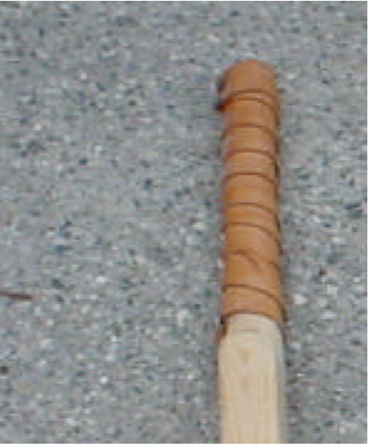

Additional materials cutting list:

None

I made the handles slightly undersized and wrapped them in leather for a better grip. Simply cut a long strip of leather about 2 inches wide for each handle. Soak the strips in hot water until soft. Then, tack one end of the strip to the end of the handle and wrap. Overlap slightly and tack the other end down. A little mink oil applied occasionally will keep the leather safe from sweat and weather.
------------
Full permission is granted for publication in any SCA related newsletter or publication provided no alterations are made without notifying Lord Rhys in advance. LordRhys at gmail.com

If this article is reprinted in a publication, I would appreciate a notice in the publication that you found this article in the Florilegium. I would also appreciate an email to myself, so that I can track which articles are being reprinted. Thanks. -Stefan.

<the end>

