Nav-by-Stars-art - 2/18/18

"Navigating by the Stars" by Hextilda Corbett.

NOTE: See also the files: Nav-Crosstaff-art, Eng-Quadrant-art, boat-building-msg, Dry-Card-Cmpss-art, p-travl-guides-msg, ship-measure-msg, Worm-Castles-art.

************************************************************************
NOTICE -

This article was added to this set of files, called Stefan's Florilegium, with the permission of the author.

These files are available on the Internet at: http://www.florilegium.org

Copyright to the contents of this file remains with the author or translator.

While the author will likely give permission for this work to be reprinted in SCA type publications, please check with the author first or check for any permissions granted at the end of this file.

Thank you,
Mark S. Harris...AKA:..Stefan li Rous
stefan at florilegium.org
************************************************************************

You can find more work by this author on her website:
http://www.hextilda.com/

Navigating by the Stars
by Hextilda Corbett

Why Learn to Navigate by the Stars?

It's a traditional skill we've used for thousands of years but lost in the past 150 years as electric lights blot out the night sky. We no longer need to rely on the moon to hunt at night nor the sun to show us which direction to go. It's also a useful survival skill, should you ever find yourself without access to a modern compass or GPS. This knowledge would have been commonly used and understood during the medieval era.

Recognizing the Major Constellations

Stars move east to west , rotating around the North Star.

Big Dipper (part of Ursa Major): Look for a ladle in the sky. Visible from the Southern Hemisphere when north of 25oS latitude.

Little Dipper (part of Ursa Minor): The two far stars in the cup of the Big Dipper point to the North Star (Polaris), which is the end of the handle of the Little Dipper. Not visible from the Southern Hemisphere.

Cassiopeia (the Queen): Look for this if you are having trouble spotting the Big Dipper -- the two constellations rotate around the North Star on opposite sides at about the same distance. If she looks like a 3, draw a line to the left until you reach the North Star. If she looks like a Σ, draw a line to the right until you reach the North Star. M - down, W - up.

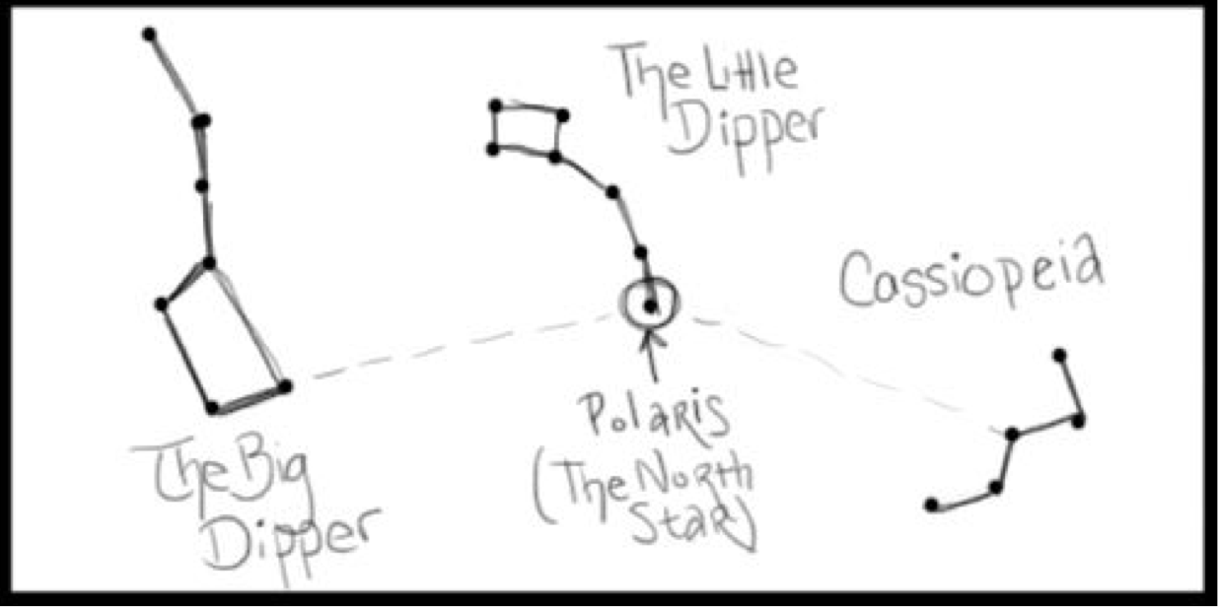

Orion: Look for this famous and distinctive pattern. Seen in the evenings from late autumn to early spring, it is considered a "winter" constellation. Orion's sword always points south . It is visible in the very early mornings during summer. If you can find Orion's belt, the rightmost star -- Mintaka -- rises and sets closest to true east and west.

Southern Cross (Crux): Look for this constellation when south of the equator. The bottom star in the cross (Acrux) points to the south pole. It's the closest visible, easily spotable constellation.

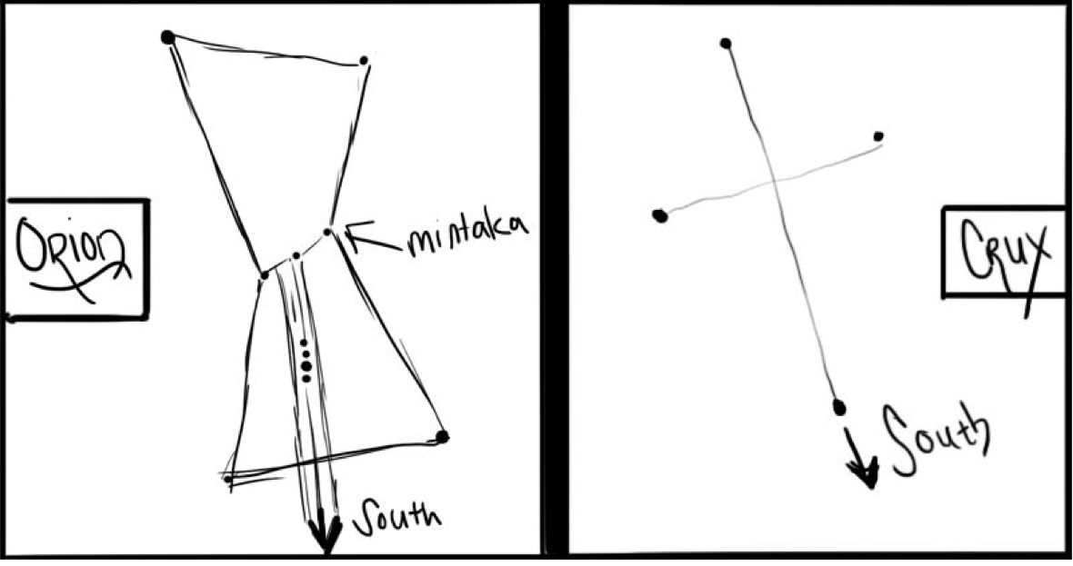

Measuring the Sky

● An extended fist is generally 10 degrees (about the distance the sun travels in an hour). This means each clenched finger is about 15 minutes of solar travel. Very helpful for knowing how far off sunset is!
● An extended little finger is approximately 1 degree.
● If you hold out your three middle fingers, they total about 5 degrees.
● An extended pinky to extended thumb is about 25 degrees.

Finding Your Latitude

Polaris' distance above the ground is your latitude. You can now use your measuring tricks to find your latitude. This means that at the axial north pole Polaris is directly overhead. At Gulf Wars, we are about 31oN.

The Moon

The Moon shows the same face to us as it is tidally locked to Earth. The illuminated part of the moon always points to where the sun is. It moves east to west across the sky. The moon rises one hour later each night. The Moon takes 27.3 days to orbit Earth. The lunar cycle (new Moon to new Moon) is 29.5 days — approximately every four weeks. A full moon rises at sunset.

We see the moon go through four phases from new to full and back to new:

● Waxing Crescent: new to first quarter
● Waxing Gibbous: first quarter to full
● Waning Gibbous: full to third quarter
● Waning Crescent: third quarter to new

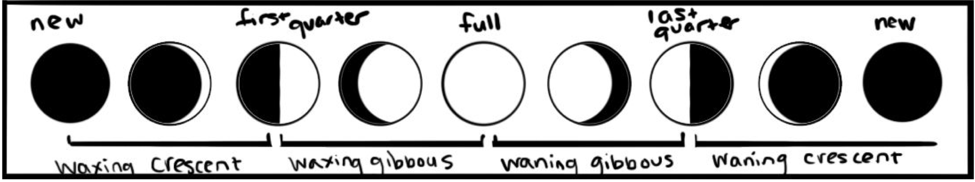

If the moon is a crescent and you're in the Northern Hemisphere, you can draw a line between the "tips" to point you south -- just take the line to the nearest horizon. (If you are in the Southern Hemisphere, they will point you north.)

The Sun

The sun only truly rises in the east and sets in the west around the equinoxes -- March 21st and September 21st (roughly). For a month on either side of these days, you can consider their directions more or less east and west.

● At winter solstice, the sun rises in the southeast and travels to the southwest
● At summer solstice, the sun rises in the northeast and sets in the northwest.
● Remember: the sun goes south for the winter.

Navigating on A Cloudy Day

This is admittedly much trickier. The key is to keep track of landmarks around you when you do have navigation that informs your cardinal directions. You should try to pick a visible landmark in the direction you wish to go.

Simple Compass

A magnetized needle in a piece of cork, set to float freely in a bowl or cup of water, will point to magnetic north. Magnetic north is actually a moving target; it is currently about as close to axial north as it will likely get in our lifetimes. The image to the left shows its movement since 1600 CE across northern Canada. [1]

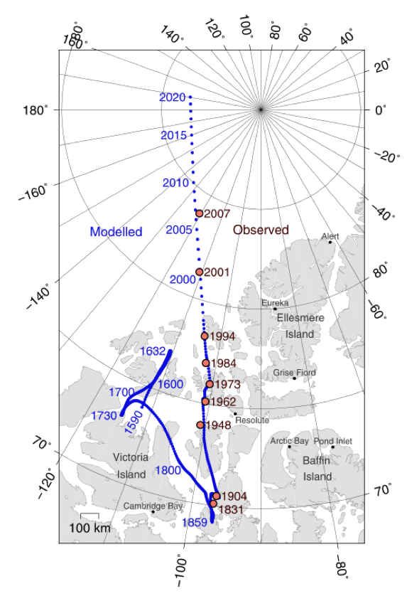

Taking a Survey

To take a survey, you set two sticks in the ground about a yard apart (approximately the distance from your fingertips to the opposite shoulder) and line the tops of the sticks up so that a star is "set" on top of the sticks. Sit still and watch. The star will begin to drift. The direction that it tracks will tell you what cardinal direction you are facing.

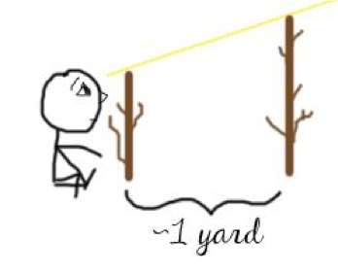

- If the star drifts to the left , you are facing north.
- If the star drifts to the right , you are facing south.
- If the star drifts up , you are facing east .
- If the star drifts down, you are facing west .
- If the star drifts at an angle, you are facing a secondary direction -- southeast, northeast, northwest, or southwest.

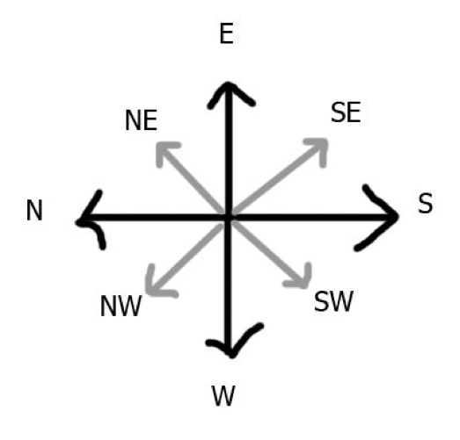
Solar Drift

When the sun is high in the sky, it can be difficult to ascertain its movement. Set a stick in the ground (the longer, the better). Mark where the end of the shadow is. 15-60 minutes later, mark where the shadow's new location ends. If you draw a line between the two, the direction of the line -- from first mark to second mark -- will point roughly east.

Watch It

While a more modern method, you can use an analog wristwatch to orient yourself. Hold the watch level and point the hour hand at the sun. South is about midway between the hour hand and the number twelve in the smaller angle.

Footnotes:

[1}: Image © by Cavit. CC BY 4.0, http://bit.ly/1htZ1pk via Wikimedia Commons

------
Copyright March 2017 by Emily <hextilda42 at gmail.com>. Permission is granted for republication in SCA-related publications, provided the author is credited. Addresses change, but a reasonable attempt should be made to ensure that the author is notified of the publication and if possible receives a copy.

If this article is reprinted in a publication, please place a notice in the publication that you found this article in the Florilegium. I would also appreciate an email to myself, so that I can track which articles are being reprinted. Thanks. -Stefan.

<the end>

