Pilgrims-Trvl-art - 2/23/15

"That Pilgrim's Packing!" by Lady Claude Quincarnon and Lord Ælfred se leof.

NOTE: See also the files: travel-msg, p-backpacks-msg, On-the-Road-art, p-tourism-art, travel-foods-msg, winter-travel-msg, oatcakes-msg, Balled-Mustrd-art.

************************************************************************
NOTICE -

This article was submitted to me by the author for inclusion in this set of files, called Stefan's Florilegium.

These files are available on the Internet at: http://www.florilegium.org

Copyright to the contents of this file remains with the author or translator.

While the author will likely give permission for this work to be reprinted in SCA type publications, please check with the author first or check for any permissions granted at the end of this file.

Thank you,
Mark S. Harris...AKA:..Stefan li Rous
stefan at florilegium.org
************************************************************************

You can find more work by this author at: http://www.nps.id.au

This article was first published in Cockatrice 24 (October 2004), the A&S newsletter for Lochac.

That Pilgrim's Packing!
by Lady Claude Quincarnon and Lord Ælfred se leof

1 Introduction

Well, you're right in a way. Religion is out of bounds in the SCA, we all agree to that rule. And yes, you're right, religion was a great motivation for pilgrims back in the day. Many faithful did make journeys across land and sea to the tombs and shrines of Thomas Becket or St John the Baptist or Mary Magdalen to fulfill promises made in moments of desperate prayer. Many others journeyed in the hope of being cured of some disease or disability. And still more believed that in order to have any chance of escaping the dreaded depths of hell at least one pilgrimage must be made in one's lifetime. So you wouldn't be completely wrong in saying that it's bad form to put an article about pilgrims in Cockatrice.

But let your stringent SCAdian guard down for a moment and remember back to the last time you read Chaucer's Canterbury Tales. They were written in period about a more or less typical group of pilgrims who were on their way to Canterbury to have a look at Becket's shrine. However, few of them were going there for religious reasons. Remember the Wife of Bath who pretty much admits that she sees the pilgrimage as a chance to find yet another husband [1]; the Physician, whose "studie was but litel on the Bible" [2] (meaning that although he read a lot he had no real interest in religious study, and was probably an atheist); the Miller who was "moost of synne and harlotries' [3] (he was sinful and obscene); and the Host, who joins them in order to provide entertainment for the other pilgrims, and perhaps to secure a nice big profit from the party's return journey. In truth, pilgrimage is not out of bounds in the SCA, as long as we remember that everyone had different motivations for doing it.

It is with this in mind that the College of St Malachy is planning to fill out this year's Feast of St Malachy with a pilgrimage to get you pious or pumping before the gorging begins. But whether your reasons for joining us be medical, religious, or simply because you like the idea of a pleasant jaunt up a hill combined with a damn fine feast, you are going to need some special equipment, and that equipment is going to need to be in garb.

Luckily we've done the work for you, and the information below will assist all you would-be will-be travelers in the construction of your pilgrim essentials, that is, a scrip, a staff, and some basic sun protection. So read on, and be informed, and then make the stuff yourself.

2 Travel Gear

Pilgrims travelling on foot are invariably shown to be carrying very little with them. Figure 1 shows some typical pilgrims, equipped with the staff, hat and scrip that forms the basic kit of Christian pilgrims.

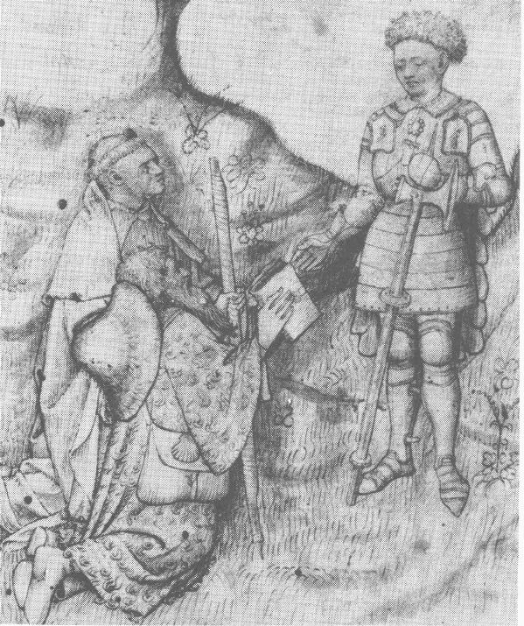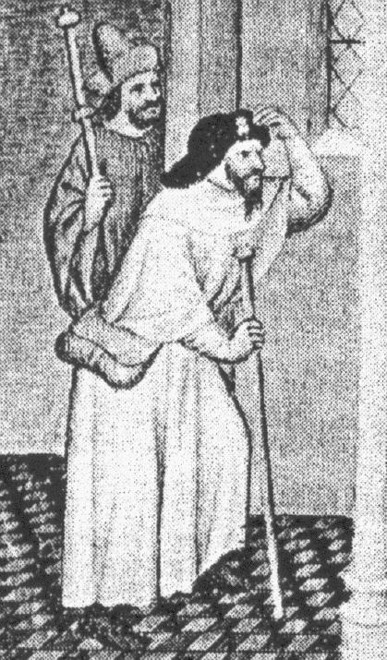

(a) (b)

Figure 1: Fourteenth century pilgrims, (a) from MS Harlean 4826 [4] and
(b) from a manuscript of Marco Polo's travels [6].

2.1 The Staff

In its most basic form, a staff is simply a stick. Their height varies from around the navel to around head height. Many staffs also have a pair of knobs at the top of the staff, such as the one shown in Fig. 1(b), and have some sort of foot that protects the wood from the ground.

The re-created staff does not use a particularly mediaeval construction. It is made from a broom handle, and has a chair leg stopper for the foot. The knobs are made from some large brass nuts found at a scrap metal yard, and fixed to the staff about 20cm apart using an epoxy putty. Readers striving for greater accuracy can no doubt find better ingredients with a little searching (or use an unardorned stick).

2.2 Sun Protection

Like any melanoma-fearing Australian, pilgrims always wear hats and not just shirts but clothing over almost all of their body. Sunscreen is somewhat more modern, however.

The hat shown in Fig. 1(b) is the most common kind that appears in mediaeval depictions of pilgrims. This is a dark, broad-brimmed hat with the brim turned up at the front to display a badge indicating the destination of the pilgrim. Another kind of hat, without the badge, is shown in Fig 1(a), and of course any hat with a brim would suffice to keep the worst of the sun off the traveler's face. There are any numer of people in the SCA who know more about hats than we do so we won't go into detail about them here.

2.3 Carrying One's Belongings

Figure 2, taken from a book of hours commissioned by Anne of Brittany [5], shows a group of fifteenth-century pilgrims sporting a variety of methods of carrying their belongings.

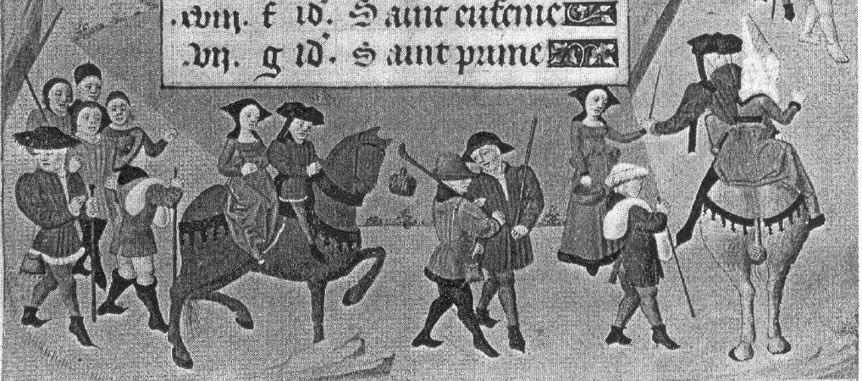
Figure 2: Fifteenth century pilgrims, from [5].

In the middle, two men are carrying their staffs on their shoulders, and one of them has a bottle suspended from the end of the staff. One of the women is also carrying a basket.

The two men next to the horses are carrying bundles on their shoulders. It is difficult to tell from this picture whether they are narrow sacks, or whether they are cloaks or blankets that have been rolled into a bundle. Either would work though it can be uncomfortable to carry heavy loads on one shoulder for a long period of time.

By far the most common device shown in mediaeval depictions, however, is a scrip, or wallet. The scrip hangs from a baldric, and rests on one hip, which leaves the traveler's hands free for other things. This also distributes the weight more evenly than carrying things on one shoulder, though it is not as good as a backpack (which mediaeval travelers do not seem to have used).

The man carrying the bottle in Figure 2 also has a scrip, as does the man on the far left. Plans for making a similar scrip can be found at [7]. To be able to carry enough water, first aid and other equipment for our pilgrimage, we needed something a little larger and in this article we will look at re-creating the fourteenth-century scrips shown in Fig. 1.

The re-created scrip is made from 2mm leather. We also made some fabric scrips while working on the design, but these didn't sit very well unless they were fixed to the baldric by pins or by sewing.

The main body of the scrip is a single rectangle of leather that has been folded in two places, dividing the rectangle 2:2:1 into the front, back and flap, respectively. The scrip is sized to carry an A4 sheet, that is, the front and back are about 300mm × 210mm, plus a generous seam allowance. Do not sew it together immediately.

It is not so easy to see how the scrip is attached to the baldric, or what the strap at the front of the scrip is attached to, so what follows is largely speculative.

Many scrips shown in mediaeval manuscripts appear to be hung from the baldric by running the baldric underneath the (fastened) flap, which has an obvious problem in that the scrip will fall off whenever it is opened. This may or may not be the case for the scrips shown in Figure 1.

After considering and trialing a number of options, all inconvenient, we settled on sewing belt loops on the back of the scrip. The strap is attached at the back of the scrip, runs underneath the body and is buckled to another strap underneath the flap. The construction may look a little haphazard but is more convenient to use than any alternative we could find, and it re-creates the look of the scrip so far as we can examine it.

Sew the belt loops and straps onto the body first, as shown in Figure 3. Note that the upper strap is sewn to the rough side of the leather, while the belt loops and lower strap are sewn to the smooth side. The lower strap should be long enough for the buckle to be hidden by the flap, and the belt loops should be big enough for your baldric to pass through. Once this is done, turn the scrip rough-side-out and sew the front and back panels up the 210mm side. Finally, turn the scrip out and it is ready for use.
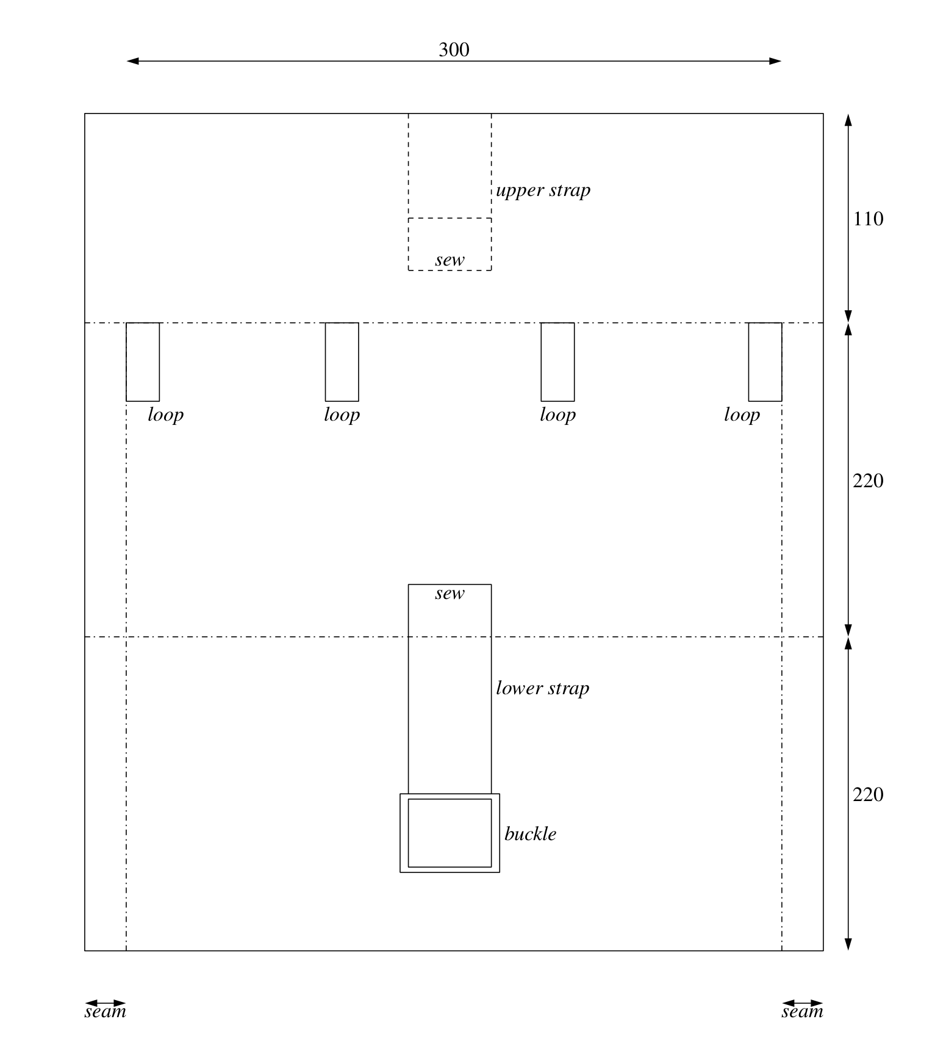
Figure 3: Diagram of the scrip before sewing the sides up. Dimensions are in millimeters.

3 Conclusion

So, there you have it, a rough and ready guide to your mediaeval travel essentials. Of course there is a lot more to be said about travel than what we've covered here, and whole books have been written about pilgrimages in particular. For modern walkers, there are any number of bushwalking guides around in which you can find maps of where to go and advice about what to bring, what to do and what not to do. Happy hiking!

References

[1] Geoffrey Chaucer, The Riverside Chaucer, Oxford University Press, Oxford, UK, 1988, p. 105.
[2] ibid., p. 30.
[3] ibid., p. 32.
[4] From: Julia Bolton Holloway, The Pilgrim and the Book: a Study of Dante, Lang- land and Chaucer, Peter Lang, New York, 1987. ISBN 0-8204-0345-8
[5] From: Norbert Ohler, The Medieval Traveller, translated by Caroline Hillier, Boy- dell Press, Southampton, UK, 1989. ISBN 0-85115-409-5
[6] From: Jonathon Sumption, Pilgrimage: an Image of Mediaeval Religion, Faber and Faber, London, UK, 1975. ISBN 0-571-10339-1
[7] Stephen Wyley, http://www.geocities.com/svenskildbiter/ Craft/psatchel.html, checked August 2004.
------
Copyright 2003 by Nicholas Sheppard. <nps at nps.id.au>. Permission is granted for republication in SCA-related publications, provided the author is credited. Addresses change, but a reasonable attempt should be made to ensure that the author is notified of the publication and if possible receives a copy.

If this article is reprinted in a publication, please place a notice in the publication that you found this article in the Florilegium. I would also appreciate an email to myself, so that I can track which articles are being reprinted. Thanks. -Stefan.

<the end>

